Topic: Structure Diagram
2210/24/M/J/22
2210/24/M/J/21
0478/24/F/M/22
- A food ordering system is an example of a computer system that is made up of sub-systems. The food ordering system:

  - allows the user to enter the details of the food they want to order and to pay for the order
  - displays food available as pictures or as a list.

Complete the structure diagram for the given parts of the food ordering system.
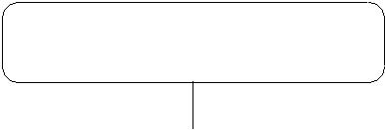

Food ordering system

[4]

2210/23/O/N/23
2210/23/O/N/22
2210/23/M/J/22
2210/23/M/J/21
0478/23/F/M/22
Specimen paper 2B
4 A satellite navigation system is an example of a computer system that is made up of sub-systems.
Part of a satellite navigation system:
- allows the user to enter details for a new destination or select a previously saved destination
- displays directions in the form of a visual map or as a list.

Draw a structure diagram for this part of the satellite navigation system.

Specimen paper 2A

- A satellite navigation system is an example of a computer system that is made up of sub-systems.

Part of a satellite navigation system:
- allows the user to enter details for a new destination or select a previously saved destination
- displays directions in the form of a visual map or as a list.

Draw a structure diagram for this part of the satellite navigation system.

[4]

