Topic: Trace Table
2210/24/M/J/22

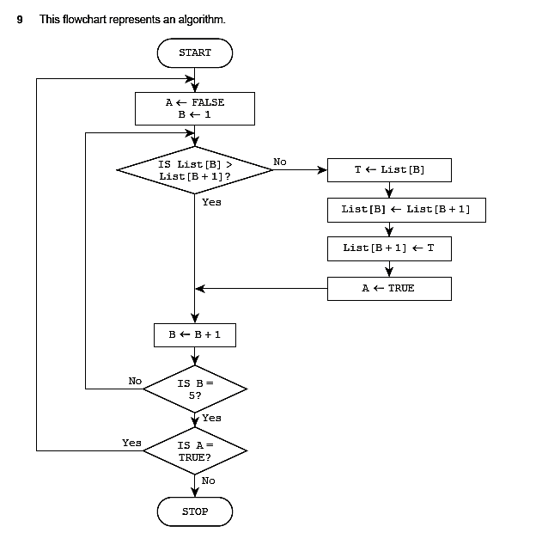

(a) The array List[1:5] used in the flowchart contains this data:

List[1] | List[2] | List[3] | List[4] | List[5]
15 | 17 | 20 | 5 | 9

Complete the trace table using the data given in the array.

A | B | List[1] | List[2] | List[3] | List[4] | List[5] | T
 |  | 15 | 17 | 20 | 5 | 9

[5]

- Describe what the algorithm represented by the flowchart is doing.

...................................................................................................................................................

...................................................................................................................................................

...................................................................................................................................................

............................................................................................................................................. [2]

2210/24/M/J/21
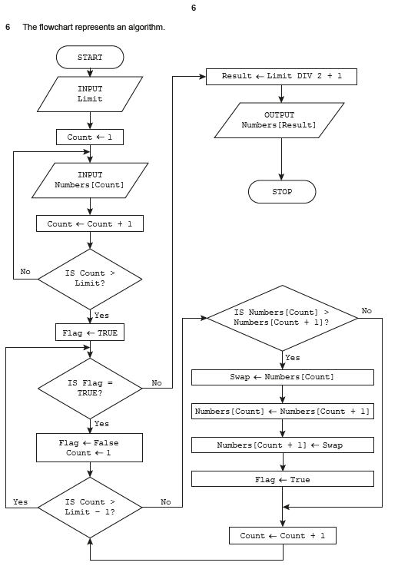

(a) Complete the trace table for the input data:

7, 47, 50, 52, 60, 80, 63, 70

Numbers

Limit Count [1] [2] [3] [4] [5] [6] [7] Flag Swap Result OUTPUT

[7]

- Outline the processes involved in the algorithm shown in the flowchart on page 6.

...................................................................................................................................................

...................................................................................................................................................

...................................................................................................................................................

...................................................................................................................................................

...................................................................................................................................................

............................................................................................................................................. [3]

0478/24/F/M/22
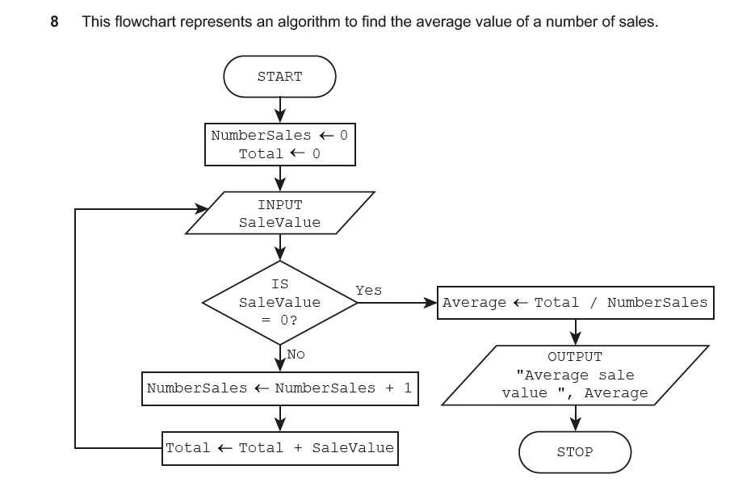

- Complete the trace table using this data: 5.50, 3.40, 6.25, 3.85, –11.00, 0

NumberSales Total SaleValue Average | OUTPUT

[4]

- Identify the error in the algorithm and describe how to correct it.

Error ..........................................................................................................................................

...................................................................................................................................................

Correction .................................................................................................................................

...................................................................................................................................................

...................................................................................................................................................

...................................................................................................................................................

[3]

2210/23/O/N/23
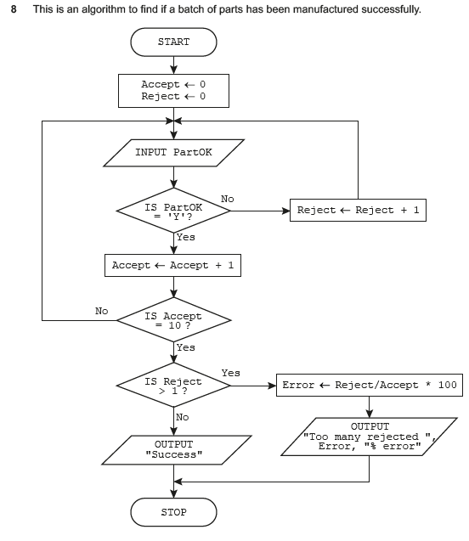

- Complete the trace table using this data: Y, Y, Y, N, Y, Y, Y, Y, N, Y, Y, Y, Y

Accept | Reject | PartOK | Error | OUTPUT

[5]

- Describe how the algorithm should be changed to accept ‘Y’ or ‘y’ for a successfully manufactured part.

...................................................................................................................................................

...................................................................................................................................................

...................................................................................................................................................

...................................................................................................................................................

...................................................................................................................................................

............................................................................................................................................. [3]

2210/23/O/N/22
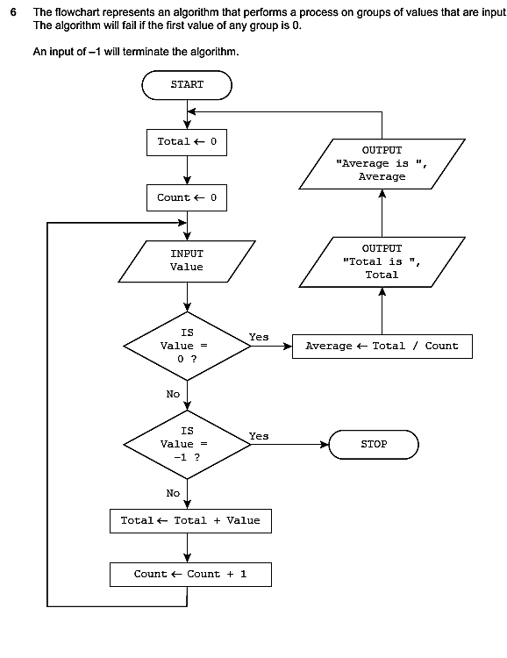

- Complete the trace table for the input data: 25, 35, 3, 0, 57, 20, 25, 18, 0, –1, 307, 40, 0
Value | Average | Total | Count | OUTPUT

[5]

- Describe the purpose of the algorithm.

...................................................................................................................................................

...................................................................................................................................................

...................................................................................................................................................

............................................................................................................................................. [2]

2210/23/M/J/22
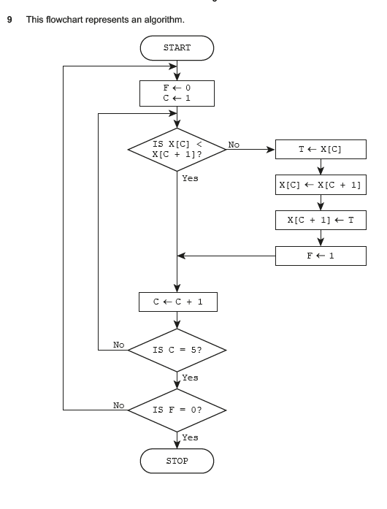

(a) The array X[1:5] used in the flowchart contains this data:

X[1] | X[2] | X[3] | X[4] | X[5]
10 | 1 | 5 | 7 | 11

Complete the trace table by using the data given in the array.

F | C | X[1] | X[2] | X[3] | X[4] | X[5] | T
 |  | 10 | 1 | 5 | 7 | 11

[5]

- Describe what the algorithm represented by the flowchart is doing.

...................................................................................................................................................

...................................................................................................................................................

...................................................................................................................................................

............................................................................................................................................. [2]

2210/23/M/J/21
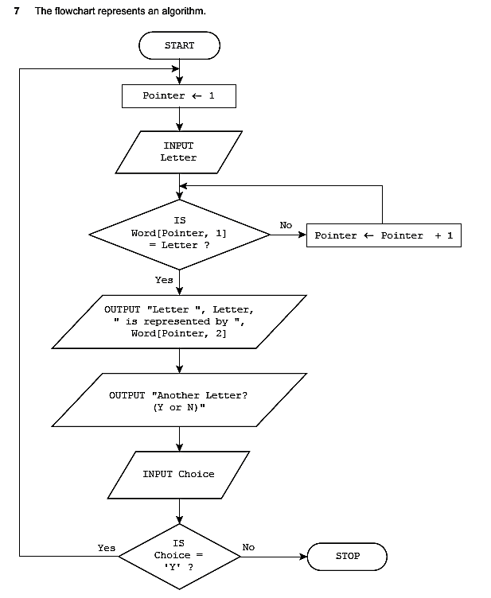

The table represents the two-dimensional (2D) array Word[] which stores the first half of the phonetic alphabet used for radio transmission. For example, Word[10,1] is ‘J’.
Index | 1 | 2
1 | A | Alpha
2 | B | Bravo
3 | C | Charlie
4 | D | Delta
5 | E | Echo
6 | F | Foxtrot
7 | G | Golf
8 | H | Hotel
9 | I | India
10 | J | Juliet
11 | K | Kilo
12 | L | Lima
13 | M | Mike

(a) Complete the trace table for the algorithm by using the input data: F, Y, D, N

Pointer | Letter | Choice | OUTPUT

[4]

- Identify the type of algorithm used.

...................................................................................................................................................

............................................................................................................................................. [1]

- Describe one problem that could occur with this algorithm if an invalid character was input.

...................................................................................................................................................

...................................................................................................................................................

...................................................................................................................................................

............................................................................................................................................. [2]

0478/23/F/M/22
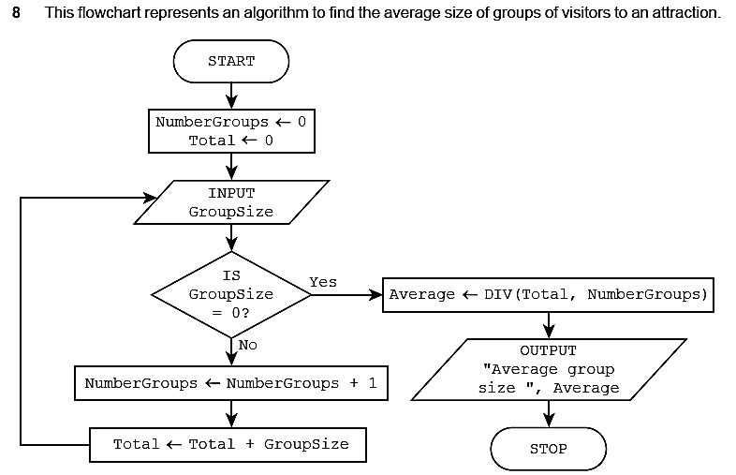

 | Complete the trace table using this data:
7, 10, 2, 8, 3, 9, 0, 6
 | NumberGroups |  |  |  |  |  | Total |  |  |  | GroupSize |  |  |  |  | Average |  |  |  | OUTPUT
[4]

Specimen paper 2B
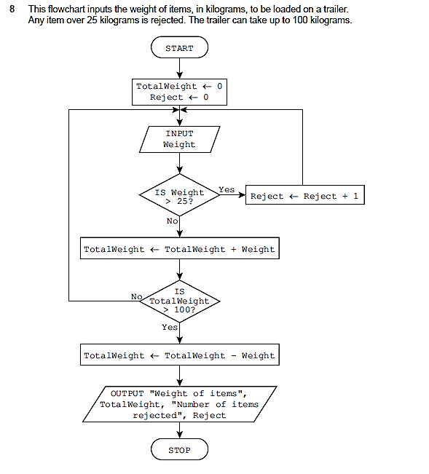
Complete the trace table for the input data:

13, 17, 26, 25, 5, 10, 15, 35, 20, 15

Weight | Reject | TotalWeight | OUTPUT

[5]

Specimen paper 2A
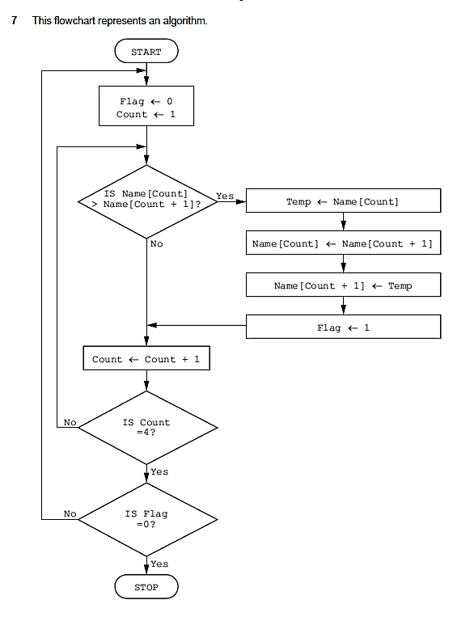

  - The array Name[1:4] used in the flowchart contains the following data:

Name[1] | Name[2] | Name[3] | Name[4]
Jamal | Amir | Eve | Tara
Complete the trace table using the data given in the array.

Flag | Count | Name[1] | Name[2] | Name[3] | Name[4] | Temp
 |  | Jamal | Amir | Eve | Tara

[5]

  - Describe what the algorithm represented by the flowchart is doing.

...................................................................................................................................................

...................................................................................................................................................

...................................................................................................................................................

.............................................................................................................................................. [2]

