Algorithm design and problem solving:
Topic 1:Program development life cycle
A series of structure step / activities that are followed to produce a system.

Four Stages:

Analysis:(Requirement specification)
The first stage of the program development life cycle that involves investigating the problem.
- Abstraction:
- Discard any unnecessary details and information.
- Keeps the key element, required for the solution of the problem.
- Decomposition:
- It breaks down a complex problem into smaller parts, which can be sub-divided into smaller parts, which can be solved easily.

Design:
- This stage is used to show how the program should be developed.
- This stage uses structure charts(diagrams), flowchart and pseudocode.

Coding
- The program or set of programs is developed.
- Program can be written in any programing language for example in Python or Java.

Testing
- Set of programs run many times with different sets of test data.
- To ensure that completed work is working as specified in the program design.

Topic 2: Computer systems
- A computer system is made up of software, hardware, data, communications and people.
- Each computer system can be divided into a set of sub-systems; each sub systems can be further divided into sub-systems until each sub-system perform a single action.

Top-down design:
It is the decomposition of the computer systems into a set of sub-systems, then break each sub system down into a set of smaller sub-systems, until each sub-system performs a single task.

Topic 3: Decomposing a problem
- Input: data to be entered.
- Process: tasks that needs to be performed on input data.
- Output: Information that needs to b display or printed.
- Storage: data that needs to be stored in a file for future use.

Topic 3: Methods used to design and construct a solution to a problem
- Structure diagram
- Flowchart
- Pseudocode

i) Structure diagram.
- It is hierarchical, showing how a computer system solution can be divided into sub-systems with each level going a more detailed breakdown.
- Each sub-systems can be further divided.
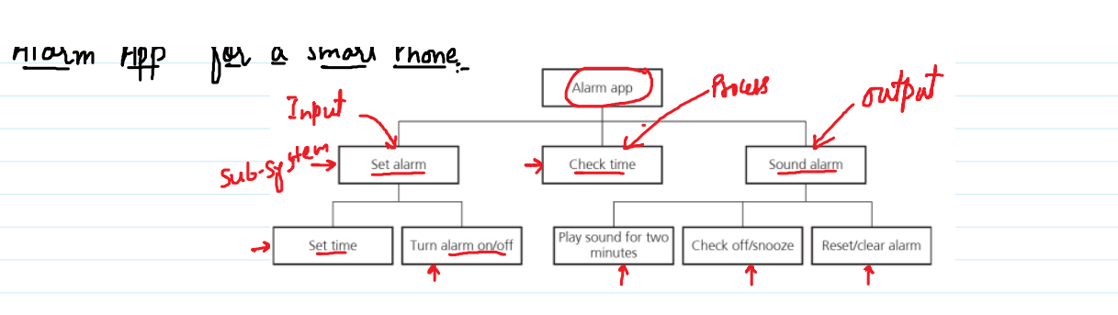
Example 1.
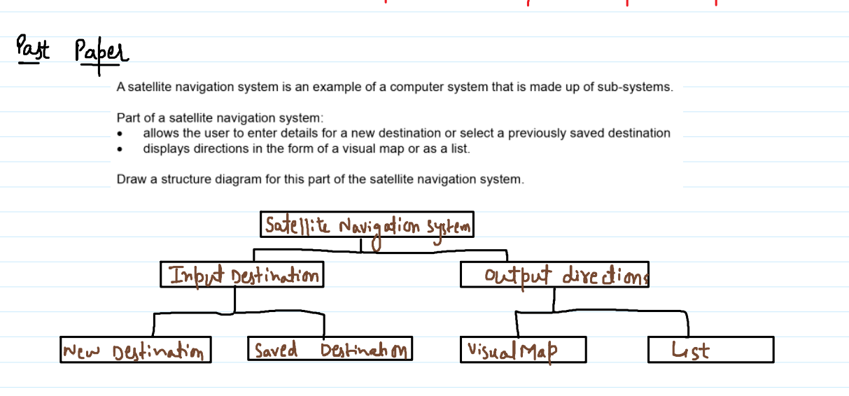
Example 2.

Topic 4: Validation and Verification:

Validation:
Validation is a check that data is reasonable and sensible before it is accepted into the system.

Types of validation check.
- Range check
- Length check
- Type check
- Presence check
- Format check
- Digit check

Range check.
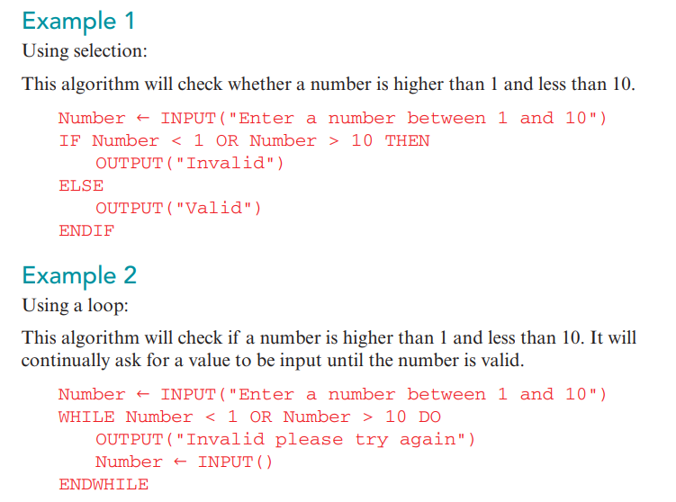
A range check assesses whether data is within one or two bounds. For example, an age must be between 0 and 100.

Length Check.
A type of validation that checks the number of characters is within a set limit.

Example 1
Using selection: (IF…ELSE)
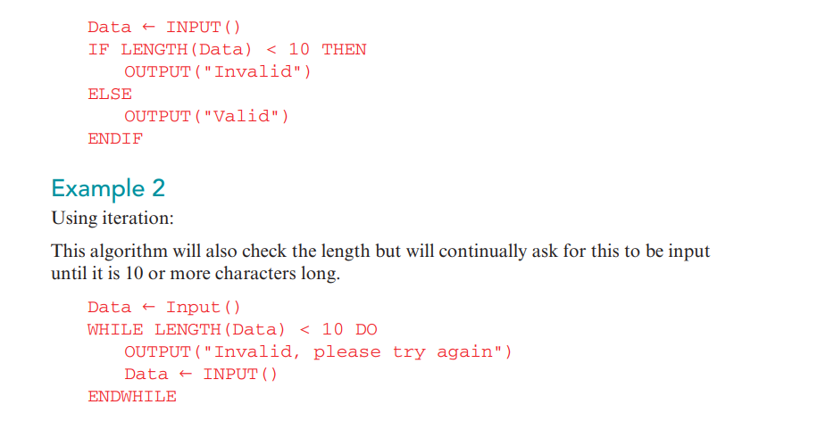
This algorithm will check if the data input has 10 or less characters to be invalid, otherwise (10 or more) it is valid.

Type check.
A type of validation that checks data is the correct data type.
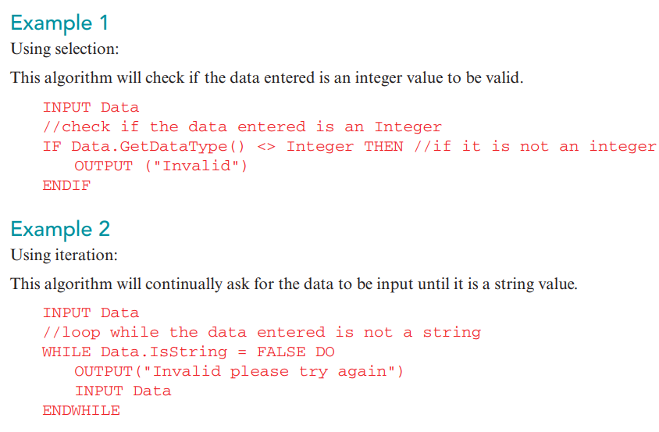

Presence check.
A presence check makes sure that some data has been entered.

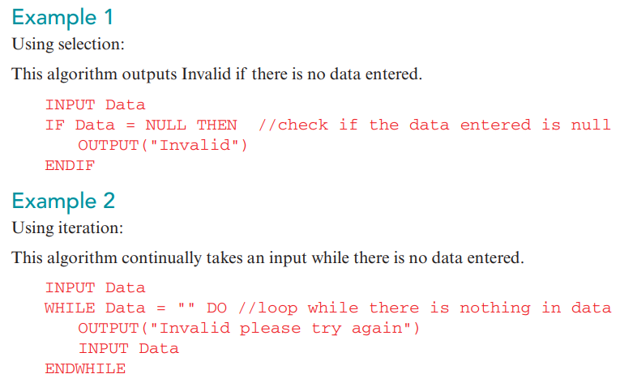
Format check.
A type of validation that makes sure the data meets a specific order, e.g. 1 number, then 3 letters.
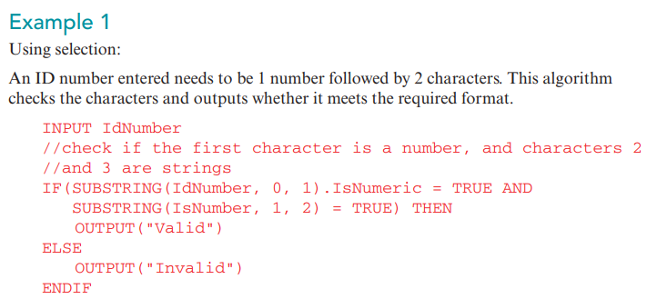

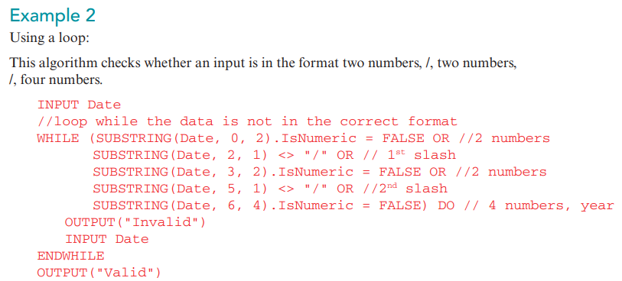

Check digit.
A type of error detection method that is used for data entry. A calculation is performed on the data entered to create a value. Check digit values are compared to see if the data entered is correct.

Verification. (it is used when sign-in).
- Checking that data has been entered accurately copied from one source to another.
OR
- When entering data from another source, for example, a paper copy, it is important to make sure you have entered exactly what was written originally. This is called verification.

Two forms of verification:
- Double entry:
A double entry check is where the same data is entered twice, usually by different people. The computer will then check whether there are any differences in what they each entered.

- Screen/Visual check (Manual Checking): A visual check is where you compare the data entered to the original. For example, reading each line from a paper copy and checking it is identical on the computer.

Test Data:
Example:A system can accept a value from 55 to 75. Write types of test data.

- Normal Test Data: : Data that will be accepted by the program, Within a range. 56 to 74
- Abnormal(error) Test Data Or Abnormal/Erroneous test data: Data that will be rejected by the program.
out of range. Less than 55 (<55), or greater than 75 ( >75).
- Extreme Test Data: lowest and highest normal Test data. Lowest value 55, highest value 75.
- Boundary test data: The largest/smallest accepted values, and their corresponding largest/smallest rejected values.
Extreme+Abnormal { 54,55} , {75,76}

Trace Table:
Trace table: a structure to complete when walking through an algorithm manually, where the values that change are written in each row.
Note: Do practice of past papers questions.

Finding the purpose of an algorithm:
A trace table can help you work out the purpose of an algorithm. By following an algorithm step-by-step you can see what happens to the values, what changes are made, and when these are made. From this you can determine the purpose of the algorithm.
Note: Do practice of past papers questions.

Finding errors in a program and correcting the errors:
To find an error in an algorithm you need to know the purpose of the algorithm. You can then test the algorithm with different data, completing trace tables if needed, to find out what the algorithm actually does. Once you know the difference between what it does and should do, you can start to identify the errors and the changes you need to make.
Important Steps:
- First Check initialization of variable of loop counter.
Example: For index= 0 to 10
Check index (variable name) has been declared or not.
- Loop counter should be correct.
In FOR loop NEXT index
In WHILE loop: index=index+1
In REPEAT loop: index=index+1

- Place of INPUT statement.
- Counter is updated in FOR loop.

