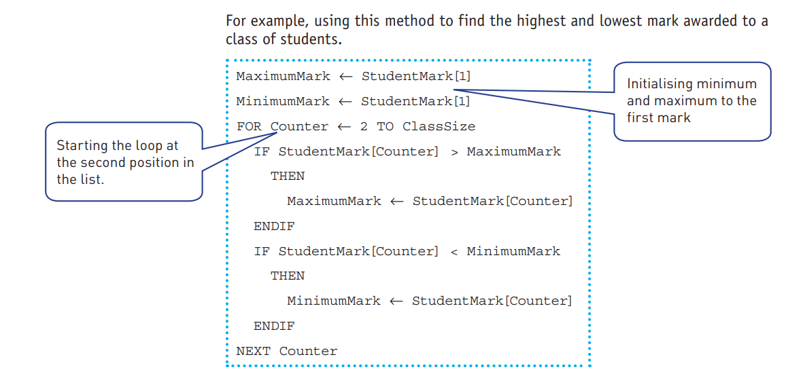
Maximum, minimum and average

Calculate Average in an array.
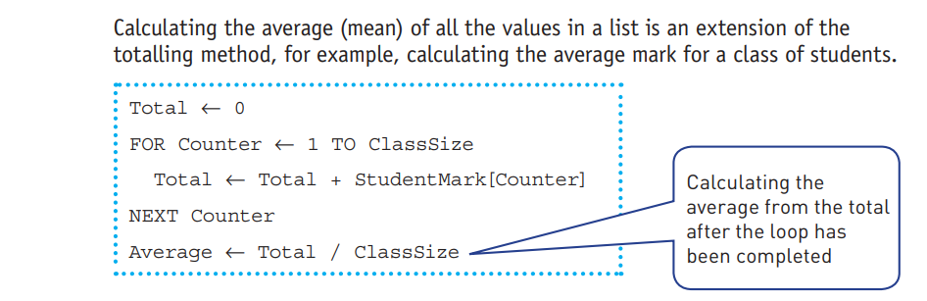

Linear search
Q: An array Studentsnames[] contains 100 names,take a name input and search it in the array.

ANSWEER:
DECLARE name: STRING
DECLARE Found:BOOLEAN
Found=FALSE
INPUT name
FOR count= 1 to 100
IF name=Studentsnames[count] THEN
Found=TRUE
ENDIF
NEXT count
IF Found=TRUE
THEN
PRINT “name found”
ELSE
PRINT “name not found”
ENDIF

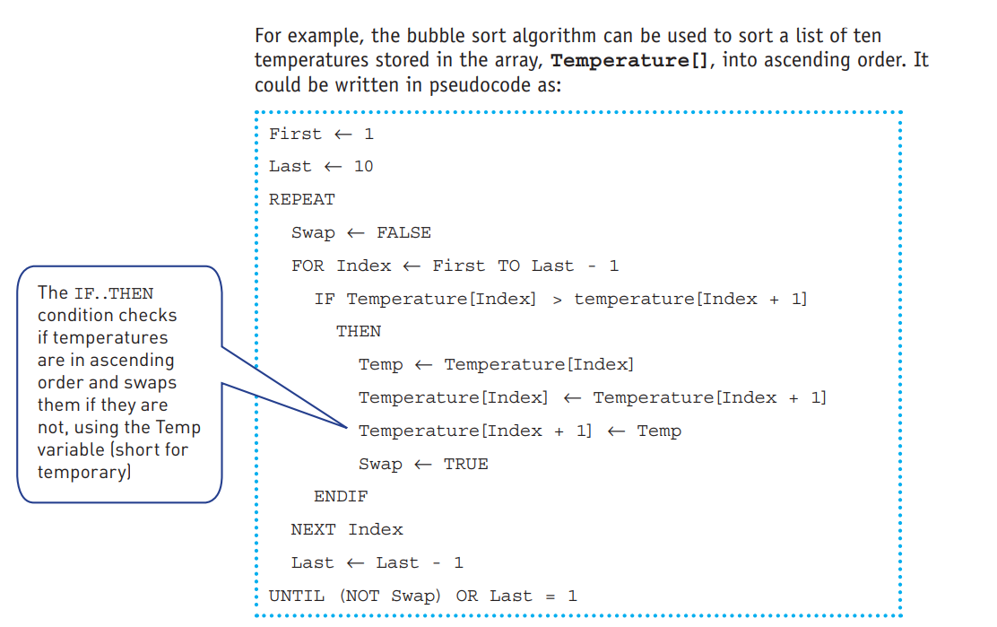
Bubble Sort:

