Programming

identifier:
A name given to a variable, constant, data structure (e.g. array) or subroutine.

variable:
A named memory location that can store data. The data can change whilst a program is running.
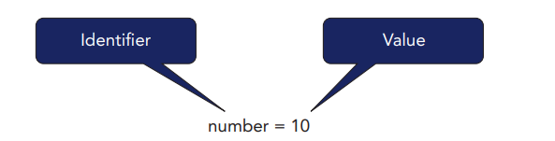

constant:
A named memory location that can store data. The data cannot change whilst a program is running.

Difference between Variable and Constant.
Variables and constants have one main difference.
In a variable, you can change the data while the program is running.
A constant cannot have its value changed while the program is running.
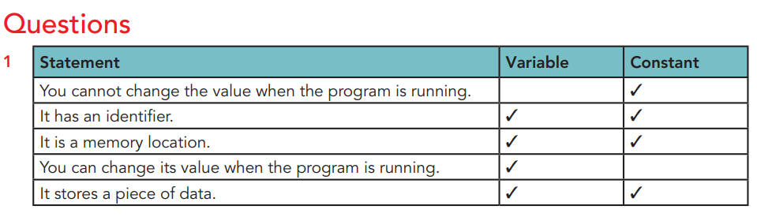

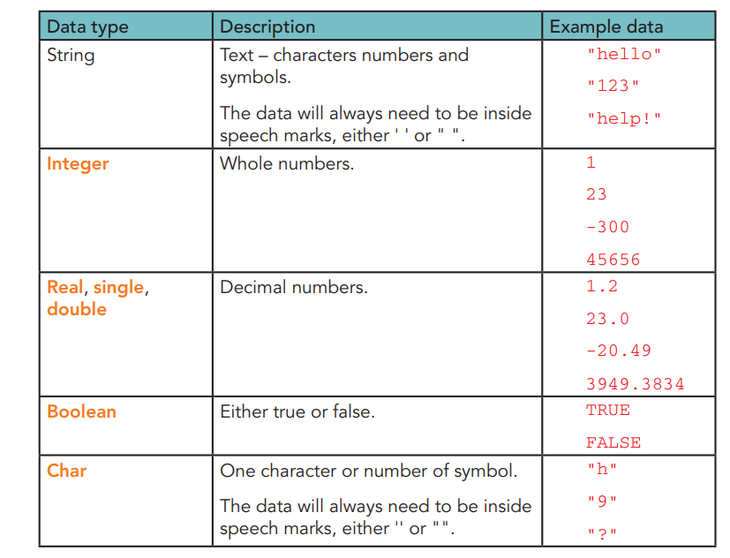
Data types:

“The characteristics of a piece of data. Common data types are string, integer, real and Boolean.”

Examples:
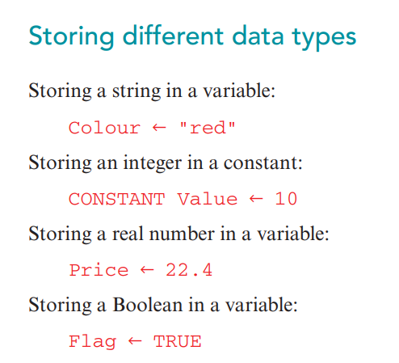

Casting:
- converting data from one data type to another data type.
- Example : Convert a string to an integer: Number = int("123")

Operators:

Arithmetic operators.

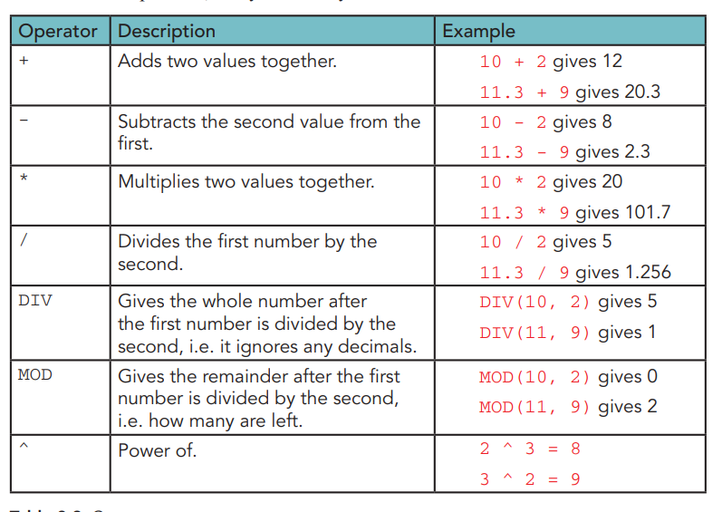
- Arithmetic operators instruct a program to perform calculations

Pseudocode:
A way of writing the steps of an algorithm using plain English and programming-like structure. It is not an actual programming language and cannot be run on a computer.

Source Code:
The actual code written in a programming language (like Python or Java) that a computer can understand and execute after being compiled or interpreted.

Types of structure:
- Sequence (Habit)
- Selection (Choice/Option)
- Repetition (Loop/Repeat/Iteration)

Sequence:
A programming construct. Instructions are run once and in the order they are written.

Example( Pseudocode)
Q: Input radius and display the circumference of circle and volume of sphere.
Begin/Start
DECLARE Radius AS INTEGER
DECLARE Circumf, Volume AS REAL
DECLARE Pi=3.14 As Constant
INPUT Radius
Circumf= 2*Pi*Radius
Volume=( 4*Pi* (r^3))/3
Print Circumf, Volume
End

Selection:
A programming construct. A condition is checked and this determines which code is run, or not run.
There are two forms of selection:
- IF statements
- CASE statements
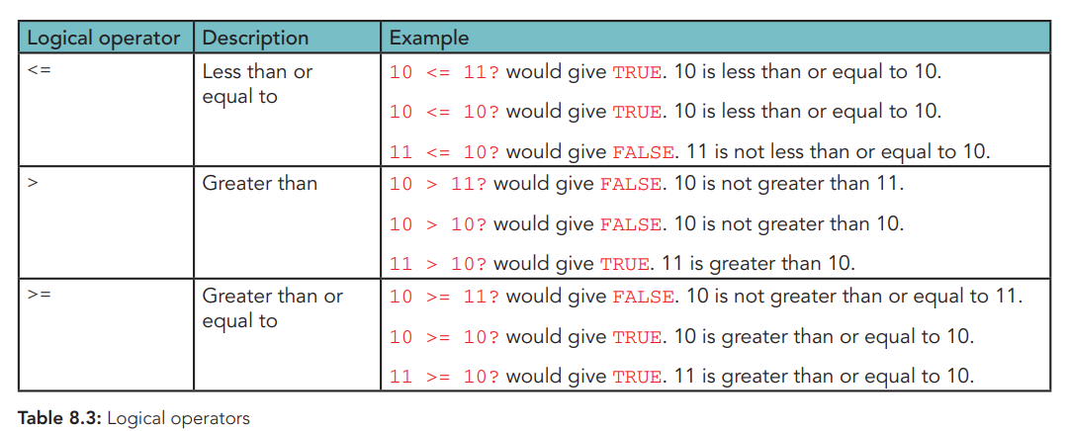
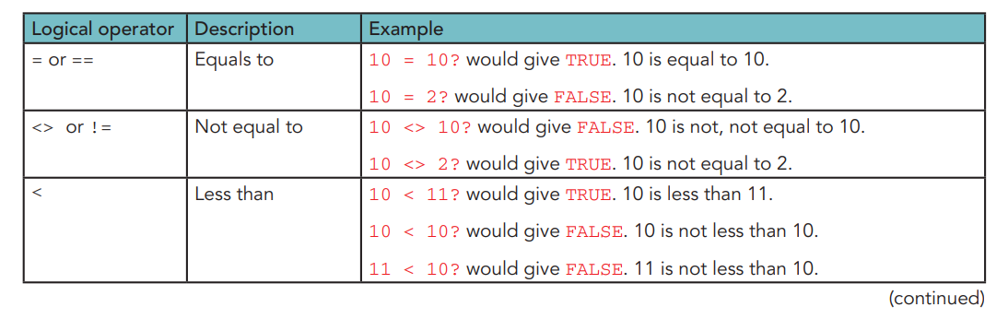
Conditions need logical operators. These allow for comparisons to be made. Table 8.3 describes these different operators. Each statement using a logical operator results in TRUE or FALSE.

IF statements:
The command IF is followed by a condition that is created using the logical operators. There are three stages of IF statements; IF, ELSE and ELSEIF.

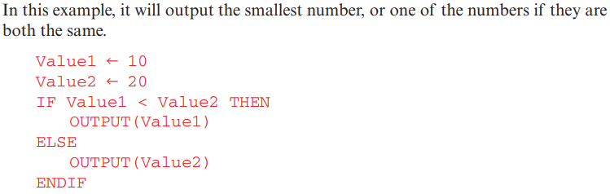
Example:

ELSEIF
This allows for a second condition to be used within the same IF statement. If the first condition is False, then a second condition can be checked.

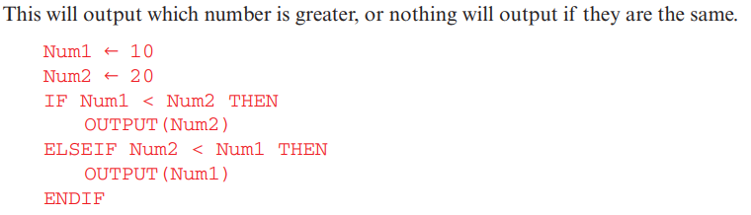
Example1:

Example2:
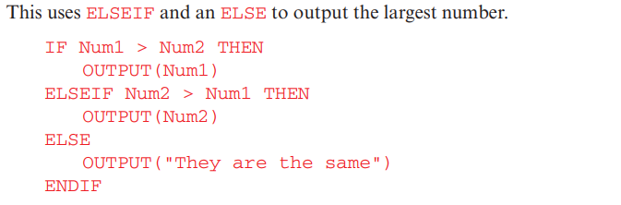

SELECT CASE:
A SELECT CASE statement allows the program to take one variable or value, and then have lots of different options depending what it is equal to.

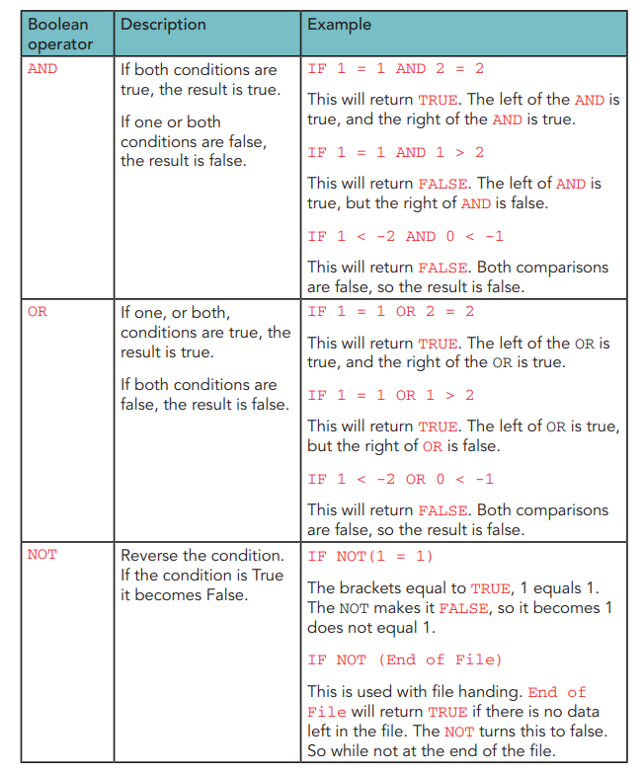
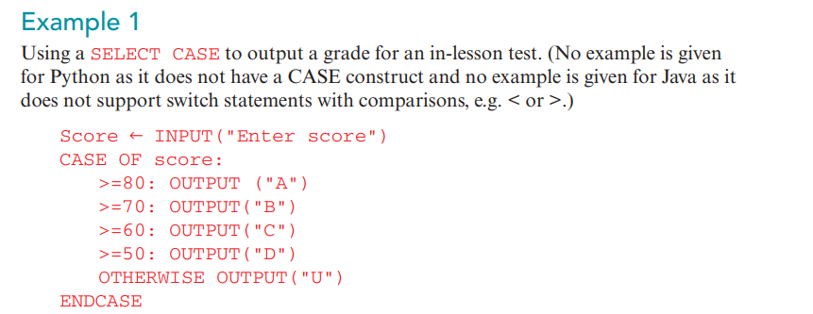
Boolean operators (With IF condition):
- There are three Boolean operators that you can use to join conditions: the AND operator, the NOT operator and the OR operator. These are described in Table 8.4.

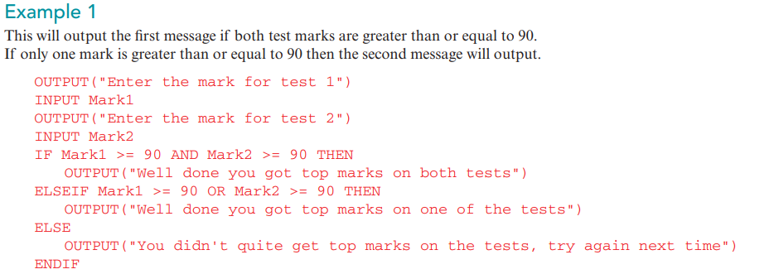
Iteration/Loop:
There are three types of loop: count-controlled, pre-condition and post-condition.

Count-controlled. (FOR To NEXT Loop).
This type of loop uses a counter to run a set number of times. The most common count-controlled loop is the for loop.

Example:
Q: Write an algorithm to input 1000 numbers.
- Count how many numbers are positive and how many numbers are zero. Then output the results. Use either pseudocode or a flowchart.
- Give one change you could make to your algorithm to ensure initial testing is more manageable.
START
CountPositive= 0
CountZero=0
FOR x=1 to 1000
INPUT Num
IF Num> 0 THEN
CountPositive = CountPositive+1
ELSEIF Num=0 THEN
CountZero = CountZero+1
ENDIF
NEXT x
PRINT CountPositive, CountZero
End

Pre-condition: (WHILE LOOP):
- A pre-condition loop tests the condition before starting the loop.
- This means that if the condition is false, the code inside the loop will not run.
- It loops while the condition is true.
- It stops looping when the condition is false. A WHILE loop is a pre-condition loop.

Example:
Q: Write an algorithm to input 1000 numbers.
- Count how many numbers are positive and how many numbers are zero. Then output the results. Use either pseudocode or a flowchart.
- Give one change you could make to your algorithm to ensure initial testing is more manageable.
START
CountPositive= 0
CountZero=0
x=1
WHILE ( x <= 1000)
INPUT Num
IF Num> 0 THEN
CountPositive = CountPositive+1
ELSEIF Num=0 THEN
CountZero = CountZero+1
ENDIF
ENDWHILE
PRINT CountPositive, CountZero
End

Post-condition loop: (REPEAT..UNTIL):
- A post-condition loop runs the code inside the loop once, and then checks the condition at the end of the loop.
- This means that the code will always run once.
- A REPEAT UNTIL loop is a post-condition loop.

Example:
Q: Write an algorithm to input 1000 numbers.
- Count how many numbers are positive and how many numbers are zero. Then output the results. Use either pseudocode or a flowchart.
- Give one change you could make to your algorithm to ensure initial testing is more manageable.
START
CountPositive= 0
CountZero=0
x=1
REPEAT
INPUT Num
IF Num> 0 THEN
CountPositive = CountPositive+1
ELSEIF Num=0 THEN
CountZero = CountZero+1
ENDIF
UNTIL x >1000
PRINT CountPositive, CountZero
End

Totalling:
Totalling is adding together a set of values. To write a program to total you need to:
• Initialise the total to 0. ( always)
• Add the values together (either individually or within a loop).
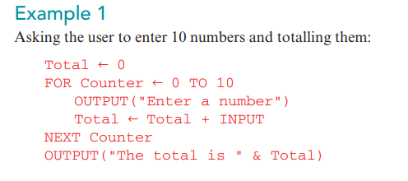

Counting:
Counting is working out how many of something there are. For example how many numbers were entered that were over 10. To write a program to count you need to:
• Initialise a counter variable to 0.
• Increment (add one to) the counter each time an item is entered, or found.

Example:
