ARRAY:
- A data structure
- It is a collection of similar data type
- Where you can store multiple data items, of the same data type, under one identifier

WHY WE USE ARRAY?
- To store multiple values.

Pseudocode Example 1D ARRAY:(How to store/insert/input values in 1D array)
Q1. Ask the user to input 20 numbers and store each in the array Numbers:
DECLARE Numbers: ARRAY [1:20] OF INTEGER
DECLARE counter: INTEGER
FOR counter = 0 TO 19
OUTPUT ("Enter a number")
INPUT Numbers[Counter]
NEXT counter

Example 1D ARRAY:(How to Display/Print/Output values in 1D array)
Q1. 20 values has been stored in an array, display all values:
DECLARE Numbers: ARRAY [1:20] OF INTEGER
DECLARE counter: INTEGER
FOR counter = 0 TO 19
OUTPUT Numbers[Counter]
NEXT counter

2-dimensional arrays:
- An array that has two indices.
- Data is stored in the form of a table.
NOTE: 2D array is used with nested loop( loop within a loop).

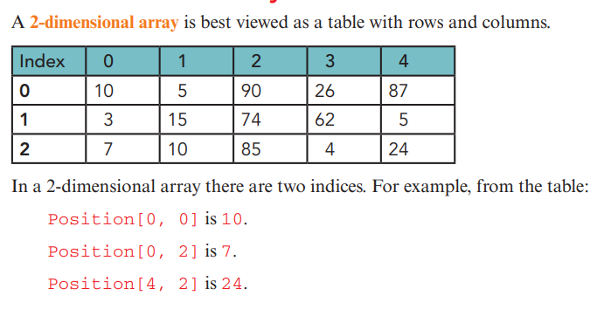

Pseudocode Example: (HOW to store and display data in 2D array)
Q: Store 12 numbers in a 2D array of dimension 3 by 4. Also display all numbers on the screen.
DECLARE Record: ARRAY[1:3][1:4] OF INTEGER
DECLARE row, col : INTEGER
//Take input
FOR row=1 to 3
FOR col=1 to 4
INPUT Record[row,col]
NEXT col
NEXT row
//Display Output
FOR row=1 to 3
FOR col=1 to 4
OUTPUT Record[row,col]
NEXT col
NEXT row

