**Topic: Data Storage**

Reading Time: 15 mins

**·        Note* Highlight important/core points while reading**

·        Read the content and write the answers given in the document in your words, to get the solid grip on topic.

**Data Storage**

Data storage is essential in computers, enabling the preservation and retrieval of digital information. Different types of storage provide varying levels of speed, capacity, and permanence, fulfilling distinct roles in data management.

**Data Storage Figure**

A common diagram representing data storage in a computer includes the following components, structured based on how each one interacts with the Central Processing Unit (CPU) and memory hierarchy:

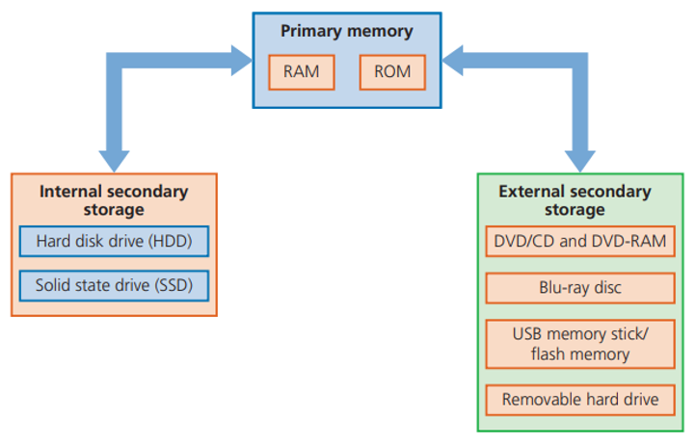

### Working of Each Component in Data Storage

1.      **Primary Storage (Main Memory):**

* **Working**: Primary storage, or main memory, includes RAM (Random Access Memory) which holds data temporarily for immediate access by the CPU. It allows the system to run active programs and access data needed during operation.
* **Features**: Fast but volatile (data is lost when power is off).

2.      **Cache Memory:**

* **Working**: Cache is a small, high-speed memory located within or close to the CPU. It temporarily stores frequently accessed data, minimizing the need to retrieve it from slower main memory.
* **Features**: Extremely fast, enhancing CPU performance by reducing data retrieval time.

3.      **Secondary Storage:**

* **Working**: Secondary storage includes Hard Disk Drives (HDDs) and Solid-State Drives (SSDs), which store data long-term. Unlike primary memory, secondary storage is non-volatile, meaning data is retained even when power is off.
* **Features**: Slower than primary memory but offers high capacity and long-term storage.

4.      **Optical and Flash Storage:**

* **Working**: Optical storage (e.g., CDs, DVDs) and flash storage (e.g., USB drives, memory cards) use different mechanisms to store data. Optical drives use laser technology, while flash drives use electrically programmable memory.
* **Features**: Often used for portability and backup purposes, with flash storage being faster than optical.

5.      **Cloud Storage:**

* **Working**: Cloud storage stores data on remote servers accessed via the internet. Users can retrieve and store data from anywhere, making it ideal for collaboration and remote access.
* **Features**: Allows data access over the internet, but requires a stable connection and depends on service providers for data security.

### Data Storage Categories

1.      **Volatility**:

* Volatile storage (e.g., RAM) loses data without power, whereas non-volatile storage (e.g., SSD, HDD, ROM) retains data permanently.

2.      **Access Speed**:

* Cache memory and RAM provide the fastest access, with SSDs following. HDDs, optical storage, and cloud storage are comparatively slower.

3.      **Capacity**:

* Secondary storage (HDDs, SSDs) and cloud storage provide high capacity, suitable for storing large files and applications.

4.      **Portability**:

* Flash drives and cloud storage offer portability, allowing data to be easily accessed across different devices.

### ****A-Rated Questions/Answers By Examiner****

**Q1**: **What is the main difference between primary and secondary storage?**

**Answer**: Primary storage is temporary and fast but loses data without power, while secondary storage retains data permanently and is used for long-term storage.

**Q2**: **Why is cache memory important in a computer system?**

**Answer**: Cache memory is very fast and stores frequently accessed data, reducing the time needed for the CPU to retrieve data from main memory, thus speeding up processing.

**Q3**: **How does cloud storage differ from physical storage like HDD or SSD?**

**Answer**: Cloud storage saves data on remote servers accessed over the internet, while HDDs and SSDs store data locally on physical devices within or connected to the computer.

**Q4**: **Give one advantage and one disadvantage of optical storage.**

**Answer**: An advantage of optical storage is its durability and suitability for long-term backups. A disadvantage is slower data retrieval speed compared to other forms of storage like SSDs or flash drives.

**Q5**: **Why is secondary storage necessary even though primary storage is faster?**

**Answer**: Secondary storage is non-volatile and provides a larger storage capacity for long-term data retention, which primary storage (RAM) cannot offer due to its volatility and limited size.

### Write your Answers on your Notebook and Verify it on Next Screen

**Q6: What role does volatility play in determining the usage of a specific storage type?**

**Q7: How does flash storage differ from optical storage in terms of functionality and typical use cases?**

**Q8: Why is cloud storage becoming increasingly popular despite needing a stable internet connection?**

**Q9: What are the advantages of using SSDs over HDDs for secondary storage?**

**Q10: How does access speed impact the overall performance of a computer system?**

**6. Answer**: Volatility determines whether data persists without power; volatile storage like RAM is used for temporary data needed by active programs, while non-volatile storage like SSDs or HDDs is used for long-term data retention.

**7. Answer**: Flash storage, like USB drives, is faster and often used for quick data transfer and portability, while optical storage, like CDs and DVDs, is slower but more durable, often used for backups and media distribution.

**8. Answer**: Cloud storage allows users to access and share data remotely, supports collaboration, offers scalable capacity, and provides off-site backup, making it ideal for flexible, remote, and collaborative work environments.

**9. Answer**: SSDs offer faster data access speeds, lower power consumption, and greater durability due to a lack of moving parts, making them ideal for performance-focused applications compared to HDDs.

**10. Answer**: Faster access speeds, such as those provided by cache memory and SSDs, reduce the time the CPU spends retrieving data, thereby improving system responsiveness and processing speed.

### ****Kindly Write down your answers on your Note book and than verifiy it with answers given at the end****

1- Data can be measured in bits.

(a) Give the name of the data storage measurement that is equal to 8 bits.

............................................................................................................................................ [1]

(b) State how many bits there are in a kibibyte (KiB).

............................................................................................................................................ [1]

(c) Give the name of the data storage measurement that is equal to 1024 gibibytes (GiB).

........................................................................................................................................ [1]

(d) A 16-bit colour image has a resolution of 512 pixels wide by 512 pixels high.

Calculate the file size of the image in kibibytes (KiB). Show all your working.

................................................................................................................................................... ................................................................................................................................................... ................................................................................................................................................... ................................................................................................................................................... ...................................................................................................................................................

Answer ......................................................... KiB                                                             [3]

2- Identify one type of storage device that could be built into the portable tablet computer. ........................................................................................................................................... [1]

3- Three types of storage media are magnetic, optical and solid state.

 (a) One example of solid‑state storage is a Solid State Drive (SSD).

Identify one other example of solid‑state storage.

............................................................................................................................................. [1]

(b) Optical storage uses a laser to store and read data from a disk.

Explain how the laser is used to store and read data from the disk.

................................................................................................................................................ ................................................................................................................................................ ................................................................................................................................................ ................................................................................................................................................ ................................................................................................................................................ ............................................................................................................................................. [3]

c) A business is creating a new mobile device that has an SSD as secondary storage.

(i) Give three reasons why an SSD is the most suitable secondary storage for their mobile device.

Reason 1 ........................................................................................................................... ...........................................................................................................................................

Reason 2 ........................................................................................................................... ...........................................................................................................................................

Reason 3 ........................................................................................................................... ........................................................................................................................................... [3]

(ii) Identify two examples of software that can be stored on the SSD.

Example 1 .........................................................................................................................

 Example 2 ......................................................................................................................... [2]