HOTEL MANAGEMENT SYSTEM

A Database Systems (DBS) Mini Project
Technology stack: Python 3 · PostgreSQL · psycopg2
Project title | Hotel Management System (HMS) — a database-driven front-desk application
Subject | Database Systems (DBS) — Mini Project
Course | B.E. Computer Science and Engineering (2nd year)
Student name | ________________________________
Register number | ________________________________
Class / Section | ________________________________
Faculty in-charge | ________________________________
Academic year | 2026 – 2027
Date of submission | ________________________________

Table of contents
1. Abstract
2. Problem statement
3. Objectives
4. Existing system and proposed system
5. Hardware and software requirements
6. Description of functional modules
7. Database design
8. ER diagram
9. Relational schema
10. Normalization
11. SQL commands and queries
12. Application implementation
13. Screenshots and sample outputs
14. Results and observations
15. Conclusion
16. Appendix A — How to create the database and run the project
17. Appendix B — Demonstration sequence
18. Appendix C — Project file structure

1. Abstract
Hotels still lose money and time because room bookings, guest records,
check-ins, check-outs and payments are maintained in separate paper
registers and spreadsheets. The same room gets allotted twice, the bill of
a guest is calculated by hand, and management has no quick answer to
questions such as "How much revenue did we collect this month?" or
"Which room type is booked the most?"
This mini project, Hotel Management System, solves these problems with
a small, complete, database-driven desktop application. All data is stored
in a PostgreSQL relational database consisting of four normalized
tables — customer, room, reservation and payment — protected by
primary keys, foreign keys, NOT NULL, UNIQUE, CHECK constraints and
referential-integrity rules. The front desk staff use a **menu-driven
Python application** that talks to PostgreSQL through psycopg2 and
performs real INSERT, SELECT, UPDATE and DELETE operations using
parameterized queries.
The system covers six functional modules: customer management, room
management, reservation management, check-in/check-out, payment management
and reports. Room availability is calculated date-wise from the reservation
table, the booking amount is computed automatically as *number of nights ×
room price, and check-in/check-out update the reservation and* the room
in one atomic transaction. Five SQL views and thirty-four demonstration
queries (joins, subqueries, aggregates, GROUP BY, HAVING, ORDER BY)
provide the reports needed by the management.
The result is a working, easy-to-understand mini project in which the ER
diagram, the relational schema, the SQL scripts and the Python code all
describe exactly the same database.
Keywords: hotel management, relational database, PostgreSQL, psycopg2,
normalization, ER model, constraints, transactions.

2. Problem statement
A small hotel (about 10–30 rooms) records everything manually:
- Guest details are written in a register. Searching an old guest means
turning pages for several minutes.
- Room allotment is decided by looking at a whiteboard, so the same room is
sometimes given to two guests for overlapping dates.
- The bill is calculated by hand, so arithmetic mistakes happen and the
amount is sometimes not recorded against the guest at all.
- Payment details (cash / card / UPI) are kept in a separate cash book, so
the reception cannot say whether a guest has paid.
- At the end of the month the manager has to add up pages of the register
to find the revenue or the most popular room type.
Problem statement: *Design and implement a database-backed Hotel
Management System that stores customer, room, reservation and payment data
in a normalized relational database, prevents duplicate bookings,
calculates bills automatically, records check-in/check-out and payments,
and produces the management reports instantly — while remaining simple
enough to be understood and demonstrated by a second-year CSE student.*

3. Objectives
1. Design an ER model and a normalized (up to 3NF) relational schema for a
hotel front-desk system.
2. Implement the schema in PostgreSQL with all necessary integrity
constraints (PRIMARY KEY, FOREIGN KEY, NOT NULL, UNIQUE,
CHECK, ON DELETE rules).
3. Build a beginner-friendly, menu-driven Python application using
psycopg2 that performs real database operations for every module.
4. Automate the calculation of the total booking amount
(nights × price per night).
5. Prevent double booking by checking date-wise room availability before a
reservation is stored.
6. Record check-in, check-out and payments, keeping the reservation status
and room status consistent in a single transaction.
7. Demonstrate the SQL concepts required by the syllabus — CREATE TABLE,
INSERT, UPDATE, DELETE, SELECT … WHERE, ORDER BY, aggregate
functions, GROUP BY, HAVING, INNER JOIN, LEFT JOIN, subqueries
and views — with realistic sample data and their actual output.
8. Produce complete documentation: ER diagram, relational schema,
normalization notes, screenshots and a demonstration script.

4. Existing system and proposed system

4.1 Existing (manual) system
Area | How it works today | Problem
Guest records | Paper register | Slow search, torn pages, no backup
Room allotment | Whiteboard / memory | Double booking, no date-wise check
Billing | Manual calculation | Arithmetic errors, no history
Payments | Separate cash book | Payment status of a guest unknown
Reports | Manual counting | Takes hours, often inaccurate
Security | Anyone can read the register | No controlled access

4.2 Proposed (computerised) system
Area | How the new system works | Benefit
Guest records | customer table with UNIQUE email, phone and ID number | Instant search, no duplicates
Room allotment | Availability query on reservation for the chosen dates | No double booking
Billing | total_amount computed by the application and stored | Accurate, reproducible bills
Payments | payment table with method and status | Payment status always visible
Reports | SQL aggregates and views | Instant, accurate reports
Integrity | Primary keys, foreign keys, CHECK constraints | Invalid data rejected by the database itself

Advantages of the proposed system
- Single source of truth — one PostgreSQL database for all modules.
- Data integrity enforced by the DBMS, not only by the program.
- Availability and revenue reports are produced in milliseconds.
- The application uses parameterized queries, so SQL injection is avoided.
- Check-in / check-out are atomic: the reservation and the room can never
disagree.

5. Hardware and software requirements

5.1 Hardware requirements
Component | Minimum | Recommended
Processor | Intel Core i3 (2 GHz) | Intel Core i5 or better
RAM | 4 GB | 8 GB
Free disk space | 500 MB (PostgreSQL + Python) | 2 GB
Display | 1366 × 768 | 1920 × 1080
Network | Not required (single PC demo) | LAN if multiple counters share one database server

5.2 Software requirements
Software | Version used | Purpose
Operating system | Windows 10/11, Ubuntu 22.04+ or macOS | Run the project
PostgreSQL | 16 (14 or later works) | Relational database server
pgAdmin 4 or psql | Any recent version | Create the database, run SQL scripts
Python | 3.10 or later (3.11 used) | Application language
psycopg2 | psycopg2-binary 2.9.x | PostgreSQL driver for Python
Terminal / Command Prompt | Built in | Run python main.py
Text editor / VS Code | Any | Edit the source code

No external Python framework (Django, Flask, Tkinter, pandas, …) is used.
The project needs only the Python standard library plus psycopg2, which
keeps it beginner-friendly.

6. Description of functional modules
The application has a main menu with six functional modules. Each module
has its own sub-menu and calls the functions of one Python file.

6.1 Customer management (`app/customers.py`)
Operation | SQL used
Add a customer | INSERT INTO customer … RETURNING customer_id
View all customers | SELECT … ORDER BY customer_id
Search by ID / name / phone | SELECT … WHERE customer_id = %s OR phone = %s OR LOWER(full_name) LIKE %s
Update details | UPDATE customer SET … WHERE customer_id = %s
Delete a customer | DELETE FROM customer WHERE customer_id = %s

The program validates the e-mail format, the 10-digit phone number and the
ID-proof type before contacting the database. A customer who already has
reservations cannot be deleted — the foreign key from reservation
(ON DELETE RESTRICT) protects referential integrity, and the program
explains this to the user instead of showing an SQL error.

6.2 Room management (`app/rooms.py`)
- Add a room (room number, category, floor, price per night, maximum guests,
initial status).
- Display all rooms and the tariff of every category (with GROUP BY).
- Display currently available rooms.
- Update a room's details or status (Available, Occupied,
Maintenance). A room with a checked-in guest cannot be set to
Available.
- Availability for a date range is computed in the reservation module by
looking for overlapping reservations — this is the correct way, because a
room can be sold today and free next week.

6.3 Reservation management (`app/reservations.py`)
- Book a room: choose the customer (search by name/phone/ID), choose
check-in and check-out dates and the number of guests, then the system
lists only the rooms that are free for those dates and can hold the party.
- Availability check: NOT EXISTS sub-query over reservation with the
overlap test `existing.check_in < wanted.check_out AND
existing.check_out > wanted.check_in`, ignoring cancelled bookings and
rooms under maintenance.
- Bill calculation: total_amount = (check_out − check_in) × price_per_night,
shown to the user for confirmation before saving.
- A payment row with status Pending is inserted in the same flow, so the
payment module always has a record to work on.
- View all reservations (filtered by status or customer), view one
reservation with its payment, and cancel a reservation (only a Booked
reservation can be cancelled; a refundable amount is marked Refunded).

6.4 Check-in and check-out management (`app/frontdesk.py`)
Operation | Reservation status | Room status
Check-in | Booked → CheckedIn, actual_check_in set | Available → Occupied
Check-out | CheckedIn → CheckedOut, actual_check_out set | Occupied → Available

Both statements are executed inside one transaction
(db.run_in_transaction). If the second UPDATE fails, the first is rolled
back, so the database can never end up with a guest inside a "free" room.
The module also lists today's expected arrivals and departures, and offers
to collect the payment during check-out.

6.5 Payment management (`app/payments.py`)
- Record a payment against a reservation (method Cash / Card / UPI,
optional transaction reference).
- Change the payment status from Pending to Paid, or mark a paid amount
as Refunded.
- Display payment details, including a filter for pending payments and the
outstanding amount.

6.6 Reports and search (`app/reports.py`)
1. All reservations (with customer, room, payment status).
2. Currently occupied rooms and the guests staying in them (occupancy %).
3. Rooms available right now.
4. Customer booking history (bookings, completed stays, cancellations,
money spent) — all customers or one selected customer.
5. Total hotel revenue — overall, by payment method and by month, plus the
pending and refunded amounts.
6. Most frequently booked room type.
7. Room-status / occupancy summary and per-room-type performance.
8. Search reservations by customer, by date or by status.

7. Database design
Database name: hotel_db
Schema scripts: sql/01_schema.sql (tables, constraints, indexes, views),
sql/02_sample_data.sql (sample data).

7.1 Entity–relationship summary
Relationship | Cardinality | Meaning
CUSTOMER — makes — RESERVATION | 1 : N | One customer can make many reservations; every reservation belongs to exactly one customer.
ROOM — booked in — RESERVATION | 1 : N | One room can be booked many times (on different dates); every reservation is for exactly one room.
RESERVATION — paid by — PAYMENT | 1 : 1 | Every reservation has at most one payment record (UNIQUE on reservation_id).

7.2 Table: `customer`
Column | Type | Constraints | Description
customer_id | SERIAL | PRIMARY KEY | Surrogate key, auto-incremented
full_name | VARCHAR(100) | NOT NULL, CHECK (length ≥ 3) | Guest name
email | VARCHAR(120) | NOT NULL, UNIQUE, CHECK contains @ and . | Contact e-mail
phone | VARCHAR(15) | NOT NULL, UNIQUE, CHECK 10 digits | Mobile number
address | VARCHAR(200) | — | Postal address (optional)
id_proof_type | VARCHAR(20) | NOT NULL, CHECK IN ('Aadhaar','Passport','Driving Licence','Voter ID') | Type of government ID
id_proof_number | VARCHAR(30) | NOT NULL, UNIQUE | ID number
created_at | TIMESTAMP | NOT NULL DEFAULT CURRENT_TIMESTAMP | Registration time

7.3 Table: `room`
Column | Type | Constraints | Description
room_id | SERIAL | PRIMARY KEY | Surrogate key
room_number | VARCHAR(10) | NOT NULL, UNIQUE | Printed room number, e.g. 101
room_type | VARCHAR(20) | NOT NULL, CHECK IN ('Single','Double','Deluxe','Suite') | Category
floor_no | INTEGER | NOT NULL, CHECK BETWEEN 0 AND 20 | Floor
price_per_night | NUMERIC(10,2) | NOT NULL, CHECK > 0 | Tariff per night
max_occupancy | INTEGER | NOT NULL, CHECK BETWEEN 1 AND 6 | Maximum guests
status | VARCHAR(20) | NOT NULL DEFAULT 'Available', CHECK IN ('Available','Occupied','Maintenance') | Current physical state
created_at | TIMESTAMP | NOT NULL DEFAULT CURRENT_TIMESTAMP | When the room was added

7.4 Table: `reservation`
Column | Type | Constraints | Description
reservation_id | SERIAL | PRIMARY KEY | Surrogate key
customer_id | INTEGER | NOT NULL, FOREIGN KEY → customer.customer_id (ON DELETE RESTRICT) | Who booked
room_id | INTEGER | NOT NULL, FOREIGN KEY → room.room_id (ON DELETE RESTRICT) | Which room
check_in_date | DATE | NOT NULL | Planned arrival
check_out_date | DATE | NOT NULL, CHECK (check_out_date > check_in_date) | Planned departure
booking_date | DATE | NOT NULL DEFAULT CURRENT_DATE, CHECK (booking_date <= check_in_date) | When the booking was made
num_guests | INTEGER | NOT NULL, CHECK BETWEEN 1 AND 6 | Number of guests
total_amount | NUMERIC(10,2) | NOT NULL, CHECK >= 0 | Bill = nights × room price
status | VARCHAR(20) | NOT NULL DEFAULT 'Booked', CHECK IN ('Booked','CheckedIn','CheckedOut','Cancelled') | Reservation life cycle
actual_check_in | TIMESTAMP | CHECK not earlier than check_in_date | Real arrival time
actual_check_out | TIMESTAMP | CHECK not earlier than actual_check_in | Real departure time

7.5 Table: `payment`
Column | Type | Constraints | Description
payment_id | SERIAL | PRIMARY KEY | Surrogate key
reservation_id | INTEGER | NOT NULL, UNIQUE, FOREIGN KEY → reservation.reservation_id (ON DELETE CASCADE) | One payment per reservation
amount | NUMERIC(10,2) | NOT NULL, CHECK > 0 | Amount collected
payment_method | VARCHAR(10) | NOT NULL, CHECK IN ('Cash','Card','UPI') | Mode of payment
payment_status | VARCHAR(20) | NOT NULL DEFAULT 'Pending', CHECK IN ('Pending','Paid','Refunded') | Payment state
payment_date | TIMESTAMP | NOT NULL DEFAULT CURRENT_TIMESTAMP | When it was recorded
transaction_ref | VARCHAR(40) | — | Card / UPI reference (optional)

7.6 Supporting objects
- Indexes on all foreign keys and on frequently filtered columns
(idx_reservation_customer, idx_reservation_room,
idx_reservation_status, idx_reservation_dates,
idx_payment_status, idx_room_type).
- Function fn_stay_nights(check_in, check_out) returns the number of
nights — used by the views and the application.
- Views (5): vw_reservation_details, vw_room_current_status,
vw_payment_details, vw_customer_booking_history,
vw_hotel_revenue.

8. ER diagram
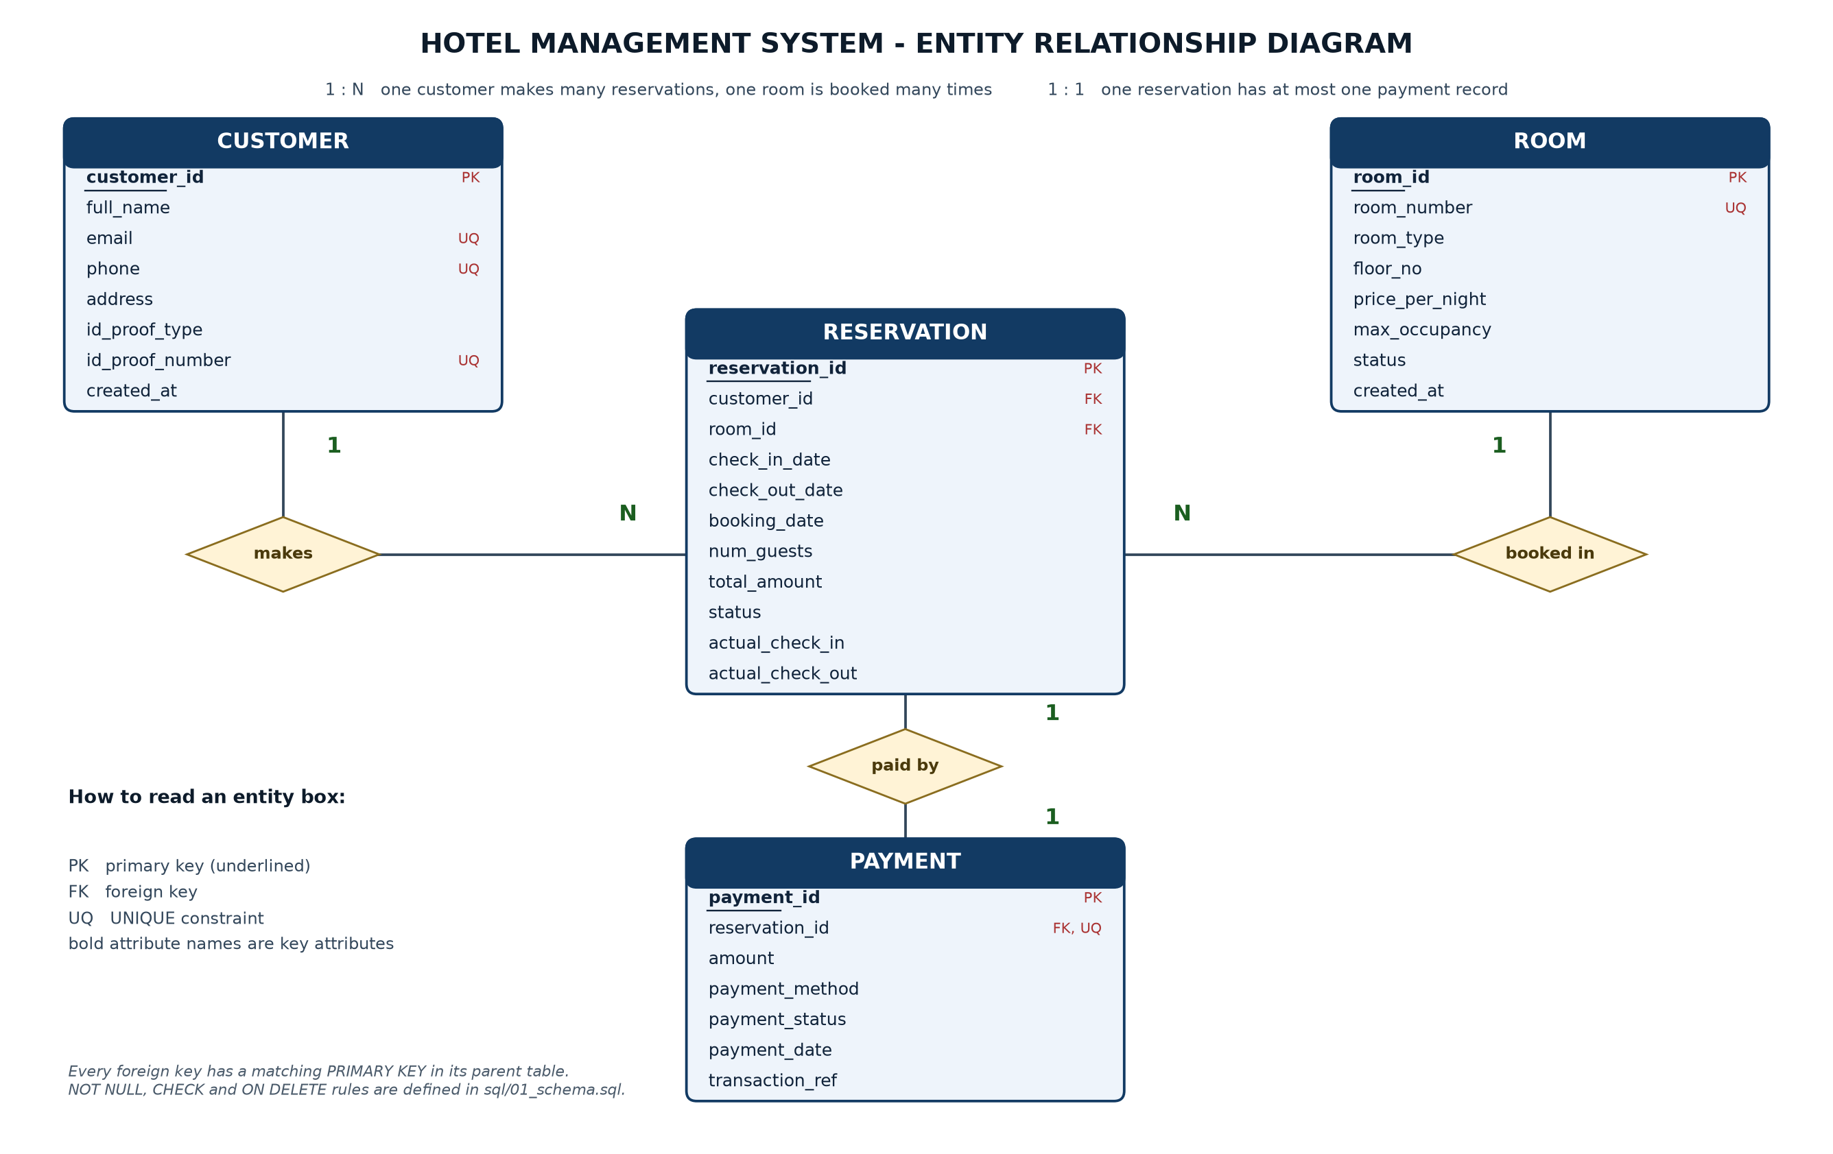
Figure 8.1 — ER diagram of the Hotel Management System (generated by
docs/tools/make_er_diagram.py).*
Reading the diagram
- Rectangles are entities; every attribute of the entity is listed inside.
- PK marks the primary key (also underlined), FK marks a foreign key and
UQ marks a UNIQUE attribute.
- Diamonds are relationships, and the 1 / N marks give the cardinality.
- CUSTOMER (1) ── makes ── (N) RESERVATION: a customer can book many
times.
- ROOM (1) ── booked in ── (N) RESERVATION: a room appears in many
reservations over time.
- RESERVATION (1) ── paid by ── (1) PAYMENT: one payment record per
reservation (enforced by the UNIQUE constraint on
payment.reservation_id).
The diagram matches the implemented schema exactly: the same attribute
names, the same keys and the same optional (NULL-able) columns —
address, actual_check_in, actual_check_out and transaction_ref.

9. Relational schema
Notation: bold = primary key, italic = foreign key,
[UQ] = unique, [NN] = not null.
CUSTOMER (customer_id, full_name, email[UQ], phone[UQ], address,
id_proof_type, id_proof_number[UQ], created_at)
ROOM (room_id, room_number[UQ], room_type, floor_no, price_per_night,
max_occupancy, status, created_at)
RESERVATION (reservation_id, customer_id[FK→CUSTOMER], room_id[FK→ROOM],
check_in_date, check_out_date, booking_date, num_guests,
total_amount, status, actual_check_in, actual_check_out)
PAYMENT (payment_id, reservation_id[FK→RESERVATION][UQ], amount,
payment_method, payment_status, payment_date, transaction_ref)

9.1 Key identification
Table | Primary key | Foreign keys | Other important constraints
customer | customer_id | — | email, phone, id_proof_number are UNIQUE
room | room_id | — | room_number is UNIQUE; CHECK on type, price, occupancy
reservation | reservation_id | customer_id, room_id | CHECK (check_out_date > check_in_date)
payment | payment_id | reservation_id | UNIQUE(reservation_id), CHECK on method and status

9.2 Referential integrity rules
Foreign key | On update | On delete | Why
reservation.customer_id | CASCADE | RESTRICT | A customer with bookings must not be deleted; their history stays intact.
reservation.room_id | CASCADE | RESTRICT | A booked room cannot be removed from the hotel.
payment.reservation_id | CASCADE | CASCADE | If a reservation is removed, its payment record is meaningless and is removed with it.

The application additionally checks these rules and prints a friendly
message before the database has to reject anything.

10. Normalization
Normalization removes redundancy and update anomalies. The design below is
in third normal form (3NF).

10.1 First Normal Form (1NF) — atomic values only
Every column of every table stores a single, indivisible value: no repeating
groups, no comma-separated lists and no multiple phone numbers in one
column. If a guest had two phone numbers, a separate row (a new guest
record) would be needed rather than "98400…, 98401…" in one cell.

10.2 Second Normal Form (2NF) — no partial dependency
2NF applies to tables with composite primary keys. In this design each table
has a single-column surrogate key (customer_id, room_id,
reservation_id, payment_id), so every non-key attribute depends on the
whole key — there is no partial dependency. Example: in reservation,
total_amount depends on check_in_date, check_out_date and
room_id, all of which are attributes of the same reservation row.

10.3 Third Normal Form (3NF) — no transitive dependency
No non-key column depends on another non-key column:
- price_per_night is stored once, in room, not copied into every
reservation; reservation.total_amount is a *derived, stored historical
value* (the price at the time of booking, needed for old bills) and not a
copy of a mutable attribute.
- A room's category, floor and tariff are all properties of the room alone,
so they live in room, not in reservation.
- The guest's name, phone and e-mail live only in customer;
payment contains only payment data and a reference to the reservation,
instead of repeating the customer's name.
- payment_status belongs to payment, status belongs to reservation;
they are never duplicated in another table.

10.4 Decomposition example
An un-normalized booking sheet would look like:
BOOKING (customer_name, customer_phone, customer_email, room_no, room_type,
price, check_in, check_out, nights, total_amount, payment_method,
payment_status)
Problems: the same customer's phone is typed again for every booking (update
anomaly), a new room cannot be recorded without a booking (insert anomaly),
and deleting the last booking of a customer erases the customer (delete
anomaly).
Decomposition:
New table | Attributes kept
customer | customer_id, full_name, email, phone, address, ID proof
room | room_id, room_number, room_type, floor_no, price_per_night, max_occupancy, status
reservation | reservation_id, customer_id, room_id, dates, num_guests, total_amount, status
payment | payment_id, reservation_id, amount, method, status, date

Each relationship that was inside BOOKING is now represented by a foreign
key, and the decomposition is loss-less because every table can be
re-joined on its primary key.

10.5 Why not a separate `room_type` table?
A room_type(room_type_id, category, default_price) table would be
"more normalized", but the category list is fixed by a CHECK constraint and
the tariff differs per room (room 111 costs 4200 while room 105 costs 4000),
so a separate table would add a join without removing any redundancy. For a
college mini-project the simpler four-table design is correct and still 3NF.

11. SQL commands and queries
All statements are in sql/ and were executed on PostgreSQL 16. The complete
output of every query is produced by running
psql -d hotel_db -f sql/03_queries.sql.

11.1 `CREATE TABLE` (excerpt — full script in `sql/01_schema.sql`)
CREATE TABLE reservation (
reservation_id SERIAL PRIMARY KEY,
customer_id INTEGER NOT NULL,
room_id INTEGER NOT NULL,
check_in_date DATE NOT NULL,
check_out_date DATE NOT NULL,
booking_date DATE NOT NULL DEFAULT CURRENT_DATE,
num_guests INTEGER NOT NULL CHECK (num_guests BETWEEN 1 AND 6),
total_amount NUMERIC(10,2) NOT NULL CHECK (total_amount >= 0),
status VARCHAR(20) NOT NULL DEFAULT 'Booked'
CHECK (status IN ('Booked','CheckedIn','CheckedOut','Cancelled')),
actual_check_in TIMESTAMP,
actual_check_out TIMESTAMP,
CONSTRAINT fk_reservation_customer
FOREIGN KEY (customer_id) REFERENCES customer (customer_id)
ON UPDATE CASCADE ON DELETE RESTRICT,
CONSTRAINT fk_reservation_room
FOREIGN KEY (room_id) REFERENCES room (room_id)
ON UPDATE CASCADE ON DELETE RESTRICT,
CONSTRAINT chk_reservation_dates
CHECK (check_out_date > check_in_date),
CONSTRAINT chk_reservation_booking_date
CHECK (booking_date <= check_in_date)
);

11.2 `INSERT`, `UPDATE`, `DELETE`
-- INSERT (Q2): the generated primary key is returned to the caller
INSERT INTO customer (full_name, email, phone, address, id_proof_type, id_proof_number)
VALUES ('Demo Guest', 'demo.guest@example.com', '9000000001',
'1, Demo Street, Chennai', 'Aadhaar', 'AAD999999999')
RETURNING customer_id, full_name, email, created_at;
-- UPDATE with WHERE (Q3)
UPDATE customer SET address = '2, New Street, Chennai'
WHERE email = 'demo.guest@example.com';
-- DELETE with WHERE (Q4)
DELETE FROM customer WHERE email = 'demo.guest@example.com';
Expected output of the INSERT: one row with customer_id = 13. The
UPDATE reports UPDATE 1, the DELETE reports DELETE 1. These three
statements run inside a transaction that is rolled back, so the sample data
stays unchanged.

11.3 `SELECT` with `WHERE`, `ORDER BY`, `LIKE`, `BETWEEN`, `LIMIT`
-- Q5: rooms above 4000, cheapest first
SELECT room_number, room_type, price_per_night, status
FROM room
WHERE price_per_night > 4000
ORDER BY price_per_night;
room_number | room_type | price_per_night | status
111 | Deluxe | 4200.00 | Available
201 | Deluxe | 4500.00 | Available
107 | Suite | 7500.00 | Occupied
108 | Suite | 7500.00 | Available
112 | Suite | 8000.00 | Occupied

-- Q8: what the app's search box runs
SELECT customer_id, full_name, phone, email
FROM customer
WHERE LOWER(full_name) LIKE LOWER('%arjun%') OR phone = '9840012301';
customer_id | full_name | phone | email
1 | Arjun Kumar | 9840012301 | arjun.kumar@example.com

11.4 Aggregate functions, `GROUP BY`, `HAVING`
-- Q11: all five aggregate functions on one column
SELECT COUNT(*) AS total_rooms,
MIN(price_per_night) AS cheapest_room,
MAX(price_per_night) AS costliest_room,
ROUND(AVG(price_per_night), 2) AS average_tariff,
SUM(price_per_night) AS sum_of_tariffs
FROM room;
total_rooms | cheapest_room | costliest_room | average_tariff | sum_of_tariffs
14 | 1500.00 | 8000.00 | 3900.00 | 54600.00

-- Q13 + Q14: per-category statistics, filtered with HAVING
SELECT room_type, COUNT(*) AS rooms,
ROUND(AVG(price_per_night), 2) AS avg_price,
MIN(price_per_night) AS min_price,
MAX(price_per_night) AS max_price
FROM room
GROUP BY room_type
HAVING COUNT(*) >= 3 AND AVG(price_per_night) > 3000
ORDER BY avg_price DESC;
room_type | rooms | avg_price | min_price | max_price
Suite | 3 | 7666.67 | 7500.00 | 8000.00
Deluxe | 4 | 4175.00 | 4000.00 | 4500.00

-- Q12: revenue collected
SELECT COUNT(*) AS paid_transactions, SUM(amount) AS total_revenue,
ROUND(AVG(amount), 2) AS average_payment
FROM payment
WHERE payment_status = 'Paid';
paid_transactions | total_revenue | average_payment
9 | 101100.00 | 11233.33

11.5 Joins
-- Q18: INNER JOIN of three tables
SELECT r.reservation_id, c.full_name, rm.room_number, rm.room_type,
r.check_in_date, r.check_out_date, r.total_amount, r.status
FROM reservation r
INNER JOIN customer c ON c.customer_id = r.customer_id
INNER JOIN room rm ON rm.room_id = r.room_id
ORDER BY r.reservation_id;
First rows of the result (16 rows in total):
reservation_id | full_name | room_number | room_type | check_in_date | check_out_date | total_amount | status
1 | Arjun Kumar | 102 | Single | 2026-10-28 | 2026-11-01 | 6000.00 | CheckedIn
2 | Priya Raman | 104 | Double | 2026-10-29 | 2026-11-02 | 10000.00 | CheckedIn
3 | Rahul Sharma | 107 | Suite | 2026-10-27 | 2026-10-31 | 30000.00 | CheckedIn
4 | Sneha Iyer | 202 | Double | 2026-10-26 | 2026-11-01 | 16200.00 | CheckedIn

-- Q20: LEFT JOIN keeps customers who never booked
SELECT c.customer_id, c.full_name,
COUNT(r.reservation_id) AS bookings,
COALESCE(SUM(r.total_amount), 0) AS booking_value
FROM customer c
LEFT JOIN reservation r ON r.customer_id = c.customer_id
GROUP BY c.customer_id, c.full_name
ORDER BY bookings DESC, c.customer_id;
-- Q21: LEFT JOIN room -> reservation shows the never-booked room
SELECT rm.room_id, rm.room_number, rm.room_type,
COUNT(r.reservation_id) FILTER (WHERE r.status <> 'Cancelled')
AS confirmed_bookings
FROM room rm
LEFT JOIN reservation r ON r.room_id = rm.room_id
GROUP BY rm.room_id, rm.room_number, rm.room_type
ORDER BY rm.room_id;
Room 110 (Double, under maintenance) appears with 0 bookings, which an
INNER JOIN would have hidden.

11.6 Subqueries
-- Q24: scalar subquery — rooms above the average price
SELECT room_number, room_type, price_per_night
FROM room
WHERE price_per_night > (SELECT AVG(price_per_night) FROM room)
ORDER BY price_per_night;
-- Q23: NOT EXISTS — rooms never booked
SELECT room_number, room_type, status
FROM room rm
WHERE NOT EXISTS (SELECT 1 FROM reservation r WHERE r.room_id = rm.room_id);
-- Q26: derived table — the most frequently booked room type
SELECT room_type, times_booked
FROM (SELECT rm.room_type, COUNT(*) AS times_booked
FROM reservation r
INNER JOIN room rm ON rm.room_id = r.room_id
WHERE r.status <> 'Cancelled'
GROUP BY rm.room_type) AS booking_counts
ORDER BY times_booked DESC, room_type
LIMIT 1;
room_type | times_booked
Deluxe | 5

-- Q25: correlated subquery — customers above the average booking value
SELECT c.customer_id, c.full_name, SUM(r.total_amount) AS total_booking_value
FROM customer c
INNER JOIN reservation r ON r.customer_id = c.customer_id
GROUP BY c.customer_id, c.full_name
HAVING SUM(r.total_amount) > (SELECT AVG(total_amount) FROM reservation)
ORDER BY total_booking_value DESC;

11.7 Date-wise availability query
-- Q27: rooms free between two dates (the heart of the booking module)
SELECT rm.room_id, rm.room_number, rm.room_type, rm.price_per_night
FROM room rm
WHERE rm.status <> 'Maintenance'
AND NOT EXISTS (
SELECT 1
FROM reservation r
WHERE r.room_id = rm.room_id
AND r.status IN ('Booked', 'CheckedIn')
AND r.check_in_date < DATE '2026-12-03' -- wanted check-out
AND r.check_out_date > DATE '2026-12-01' -- wanted check-in
)
ORDER BY rm.price_per_night;
Two stays overlap when the existing check-in is before the wanted check-out
and the existing check-out is after the wanted check-in. Cancelled
reservations are ignored, so cancelling a booking frees the room
automatically.

11.8 Views
CREATE VIEW vw_reservation_details AS
SELECT r.reservation_id, c.customer_id, c.full_name AS customer_name,
c.phone AS customer_phone, rm.room_number, rm.room_type,
rm.price_per_night, r.check_in_date, r.check_out_date,
fn_stay_nights(r.check_in_date, r.check_out_date) AS nights,
r.num_guests, r.total_amount, r.status,
COALESCE(p.payment_status, 'Not Paid') AS payment_status
FROM reservation r
INNER JOIN customer c ON c.customer_id = r.customer_id
INNER JOIN room rm ON rm.room_id = r.room_id
LEFT JOIN payment p ON p.reservation_id = r.reservation_id;
View | What it answers
vw_reservation_details | Every reservation with guest, room and payment status (used by most screens)
vw_room_current_status | Which guest is currently in which room
vw_payment_details | Payments with guest and room information
vw_customer_booking_history | Per customer: bookings, completed stays, cancellations, total spent
vw_hotel_revenue | Paid transactions, total revenue, average/min/max payment

11.9 Query index (all 34 queries in `sql/03_queries.sql`)
Query | Concept demonstrated
Q1 | CREATE TABLE AS (table from a query)
Q2 | INSERT … RETURNING
Q3 | UPDATE … WHERE
Q4 | DELETE … WHERE
Q5 | SELECT, WHERE, ORDER BY
Q6 | IN, AND, comparison operators
Q7 | LIKE, DISTINCT
Q8 | Case-insensitive search with LOWER()
Q9 | BETWEEN on dates
Q10 | ORDER BY … LIMIT (top-N)
Q11 | COUNT, MIN, MAX, AVG, SUM
Q12 | Aggregates with WHERE
Q13 | GROUP BY with several aggregates
Q14 | GROUP BY … HAVING
Q15 | HAVING on joined data
Q16 | HAVING on revenue
Q17 | CASE expression + GROUP BY
Q18 | INNER JOIN of three tables
Q19 | INNER JOIN with a filter
Q20 | LEFT JOIN (customers without bookings)
Q21 | LEFT JOIN + FILTER (rooms never booked)
Q22 | Subquery with IN
Q23 | Subquery with NOT EXISTS
Q24 | Scalar subquery
Q25 | Correlated subquery
Q26 | Subquery in FROM + ORDER BY … LIMIT
Q27 | Overlap test for date-wise availability
Q28 | Availability of one specific room (used by the app)
Q29–Q33 | The five views
Q34 | TO_CHAR + GROUP BY for monthly revenue

12. Application implementation

12.1 Architecture
+-----------------------------+
| main.py | menu, dispatch, error handling
+--------------+--------------+
|
+---------+---------+--------+-------------+-----------+
| | | | |
customers rooms reservations frontdesk payments reports
| | | | |
+---------+---------+--------+-------------+-----------+
|
db.py (only place that runs SQL)
|
psycopg2
|
PostgreSQL hotel_db
File | Responsibility
app/main.py | Banner, connection test, main menu, calls the module menus
app/config.py | Reads .env / environment variables for the connection settings
app/db.py | Database class: query, query_one, scalar, execute, execute_returning, run_in_transaction; converts PostgreSQL errors into readable messages
app/ui.py | Table printing, success/error/warning messages, and all validated input helpers (ask, ask_int, ask_money, ask_date, ask_choice, ask_email, ask_phone, confirm)
app/customers.py | Customer management module
app/rooms.py | Room management module + availability query
app/reservations.py | Reservation management module
app/frontdesk.py | Check-in / check-out module
app/payments.py | Payment management module
app/reports.py | Reports and search module

12.2 Programming techniques used (deliberately simple)
1. Functions and modules — one file per functional module, imported by
main.py. No classes are needed inside the modules, apart from the small
Database helper class.
2. Parameterized queries — every value is passed as a %s parameter, so
user input is never concatenated into SQL text:
rows = db.query(
"SELECT * FROM customer WHERE LOWER(full_name) LIKE LOWER(%s)",
(f"%{keyword}%",))
3. Transactions — db.run_in_transaction([(sql, params), …]) commits all
statements or rolls all of them back. Used by booking, check-in,
check-out and cancellation.
4. Input validation — the ui.py helpers re-ask until the input is
valid (dates in YYYY-MM-DD, 10-digit phone, positive money amount with
two decimals, menu options, yes/no answers).
5. Error handling — DatabaseError carries a friendly explanation
(UNIQUE violation, FOREIGN KEY violation, CHECK violation, …);
main.py catches the remaining unexpected errors so the program never
crashes back to a traceback.
6. Views and aggregates — the reports read the five views and use
GROUP BY / HAVING / LEFT JOIN directly in SQL instead of computing
totals in Python.

12.3 Connection settings
app/config.py reads the file .env (next to the app folder) or the
environment variables DB_HOST, DB_PORT, DB_NAME, DB_USER,
DB_PASSWORD (or a single DATABASE_URL). Copy .env.example to .env
and edit it:
DB_HOST=localhost
DB_PORT=5432
DB_NAME=hotel_db
DB_USER=postgres
DB_PASSWORD=postgres
Passwords are never written inside the Python source files.

13. Screenshots and sample outputs
All screenshots are real console output of the program (generated by
docs/tools/make_screenshots.py) and were taken on the sample database.

13.1 Main menu and database connection
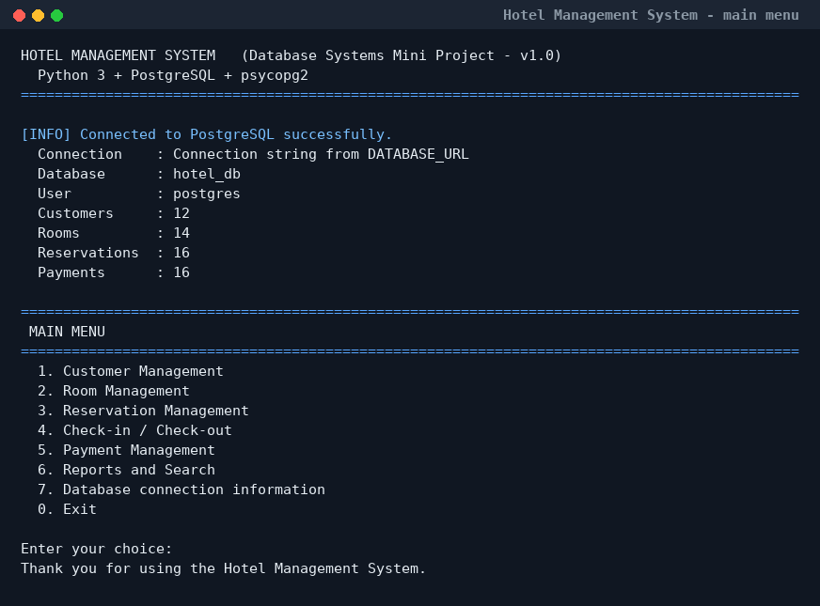
Figure 13.1 — Startup screen: the connection to `hotel_db` is verified and
the row counts prove that the sample data is loaded.*

13.2 Customer management
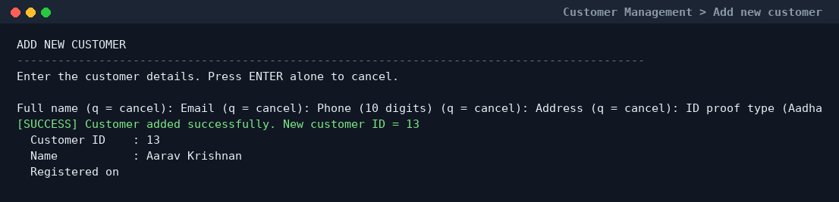
Figure 13.2 — Adding a customer (`INSERT … RETURNING` gives the new ID).
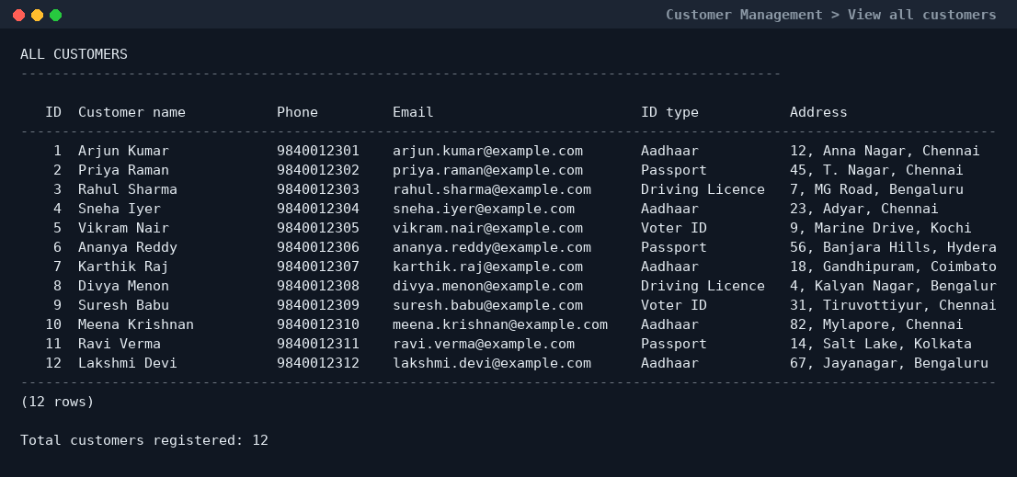
Figure 13.3 — Listing all customers ordered by `customer_id`.
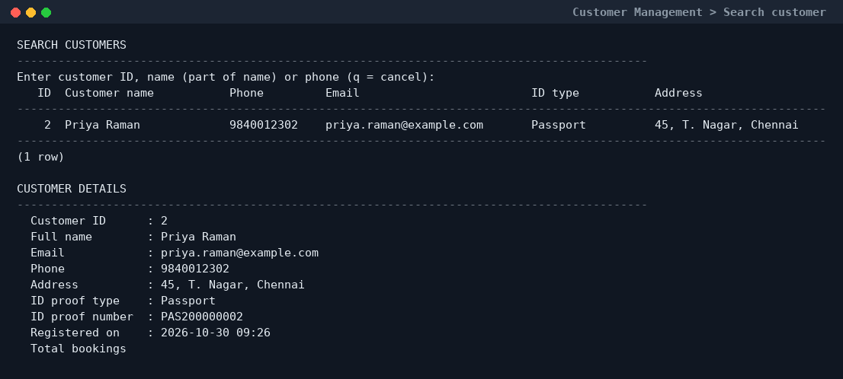
Figure 13.4 — Searching by name (`LIKE`) and showing the booking count from
a LEFT JOIN.*

13.3 Room management
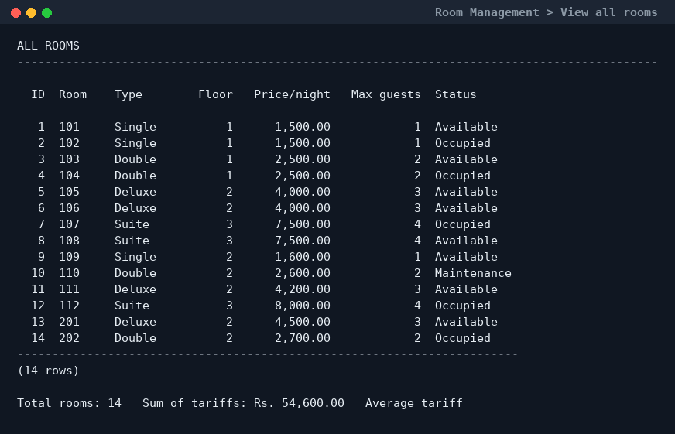
Figure 13.5 — All 14 rooms with category, floor, tariff and current
status.*
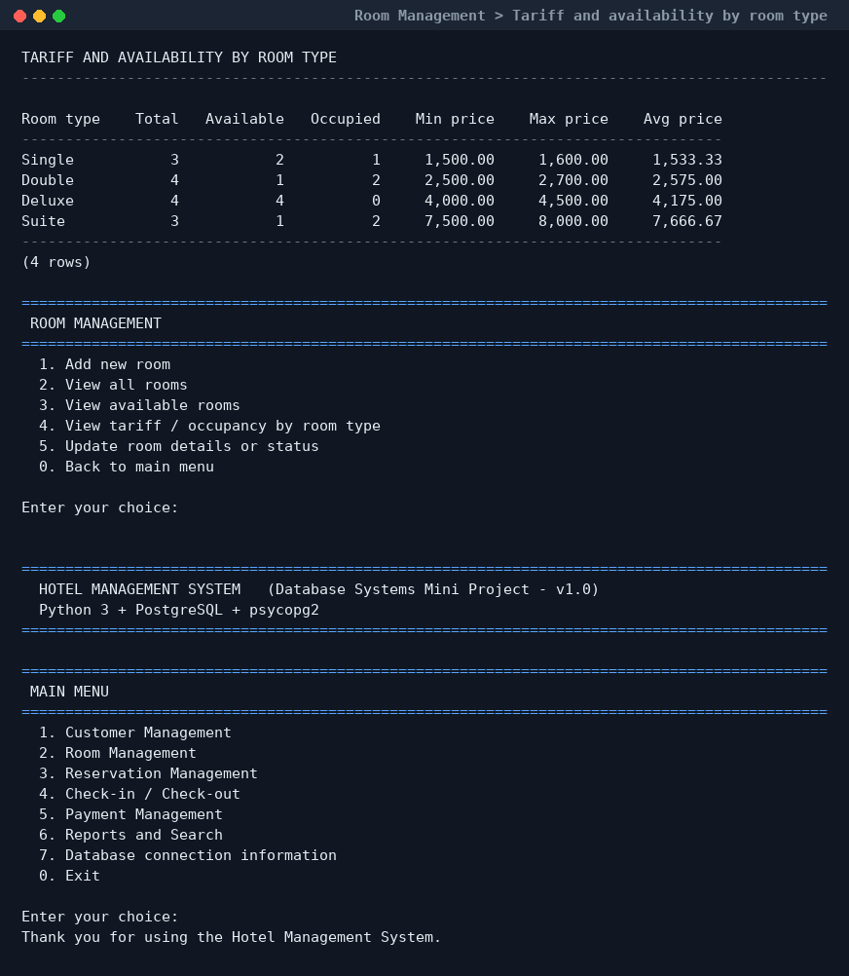
Figure 13.6 — Per-category room count, availability and price range
(GROUP BY with COUNT … FILTER).*

13.4 Reservation management
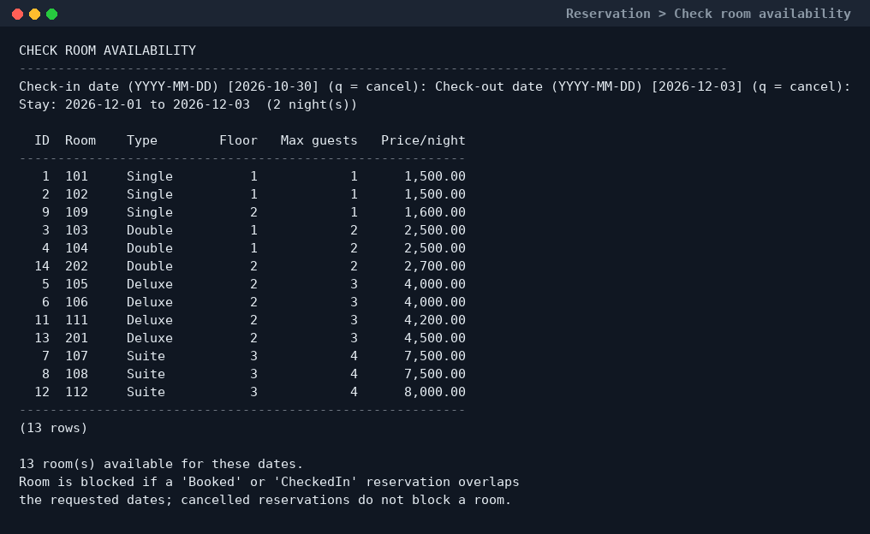
Figure 13.7 — Date-wise availability: only rooms without an overlapping
Booked / CheckedIn reservation are listed.*
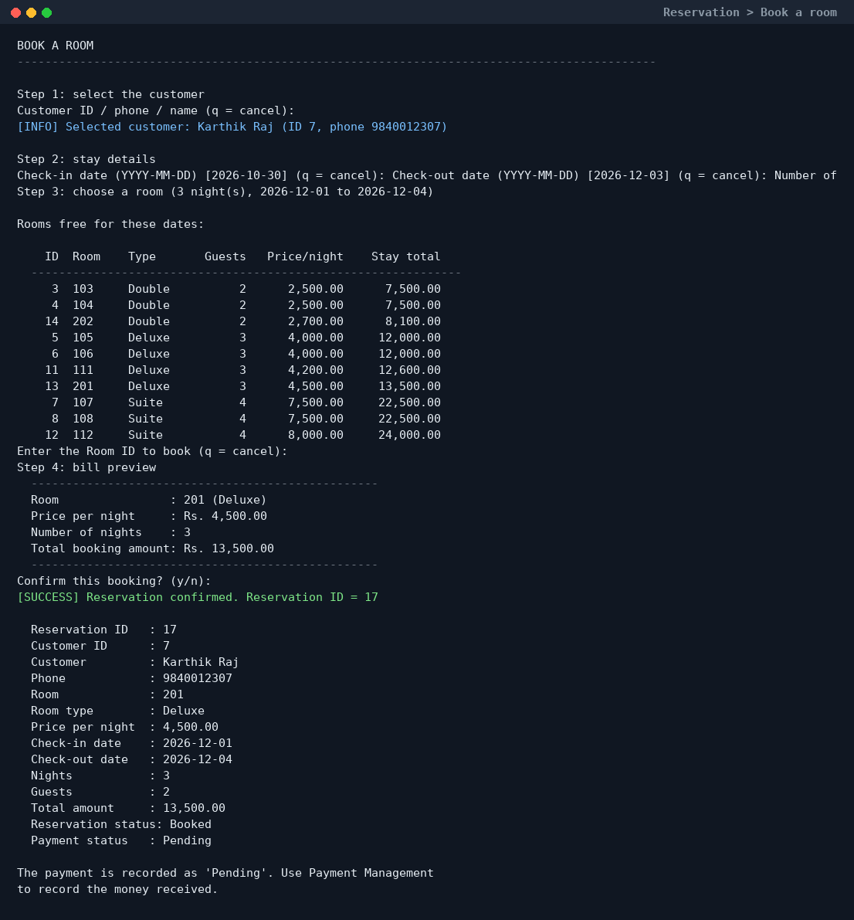
Figure 13.8 — Booking flow: guest → dates → available rooms → bill preview
→ confirmation. The total (13,500.00) is 3 nights × 4,500.00.*
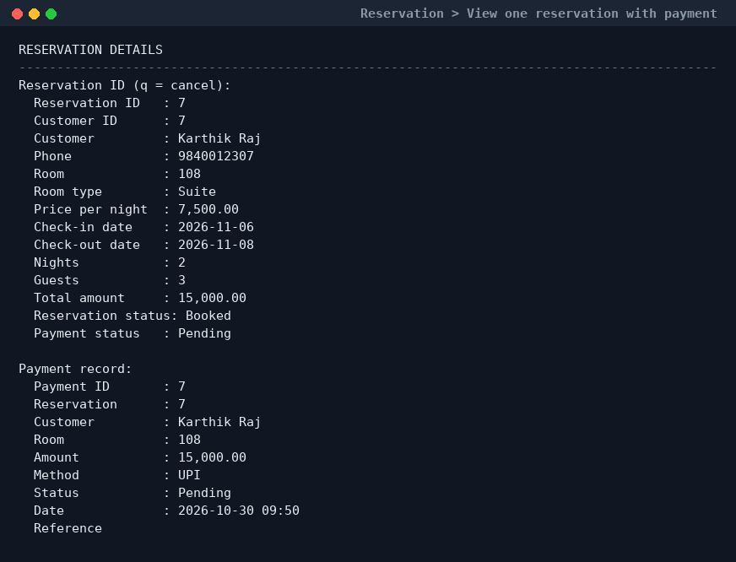
Figure 13.9 — One reservation with its payment record.

13.5 Check-in and check-out
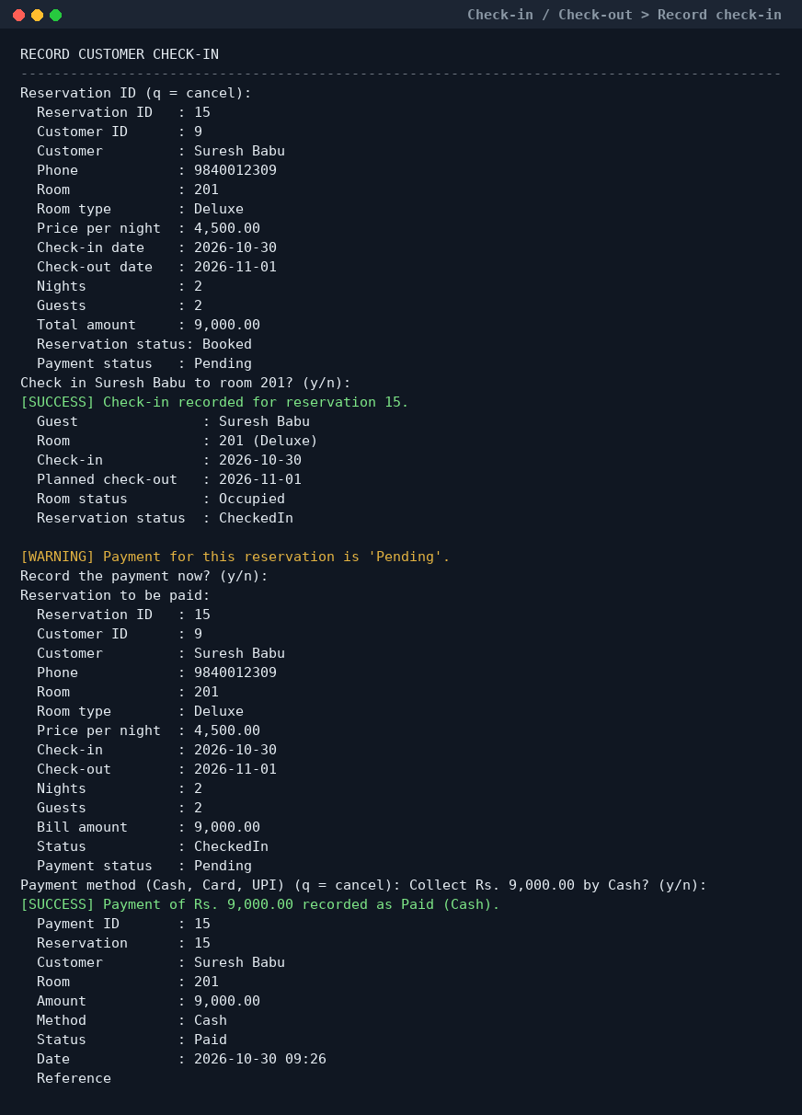
Figure 13.10 — Check-in sets the reservation to `CheckedIn`, the room to
Occupied, and offers to collect the pending payment.*
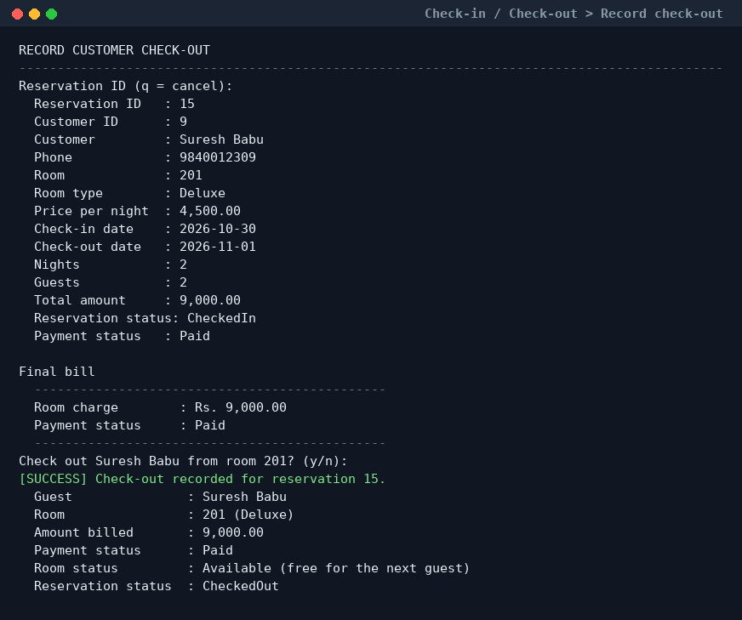
Figure 13.11 — Check-out sets the reservation to `CheckedOut` and frees the
room (Available), in one transaction.*

13.6 Payment management
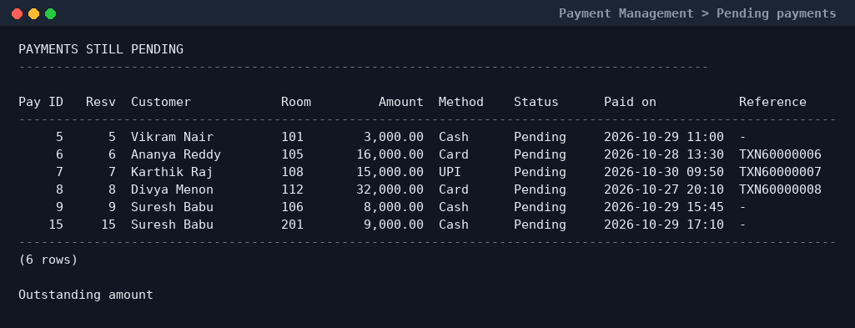
Figure 13.12 — Pending payments with the total outstanding amount.
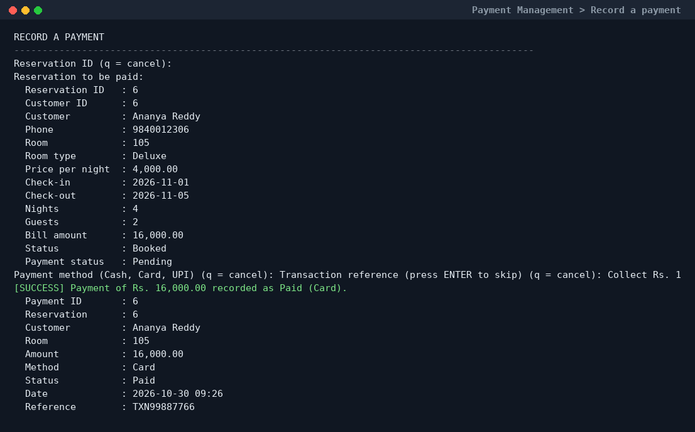
Figure 13.13 — Recording a card payment with a transaction reference.

13.7 Reports
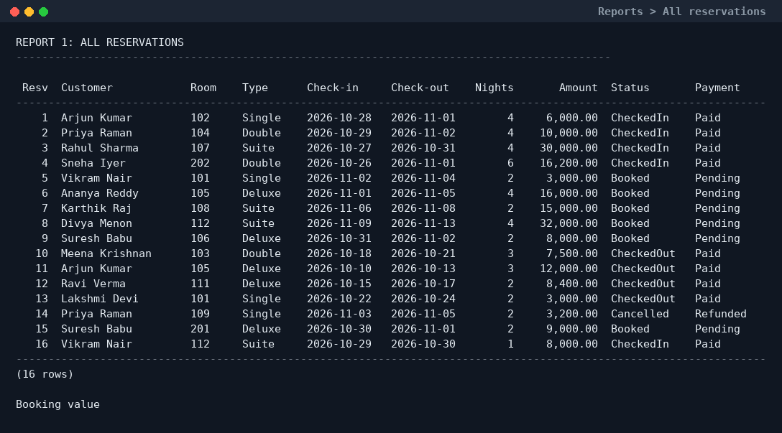
Figure 13.14 — Reservation report built from `vw_reservation_details`.
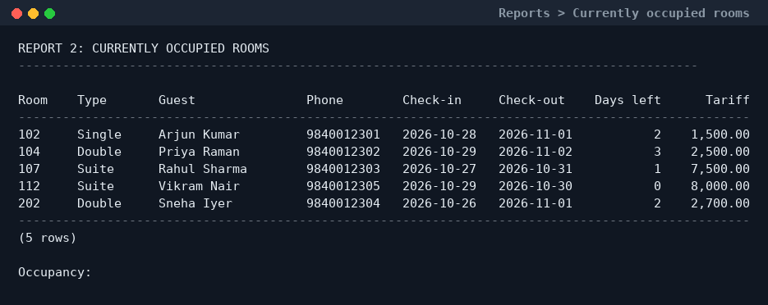
Figure 13.15 — Currently occupied rooms, guests and occupancy percentage.
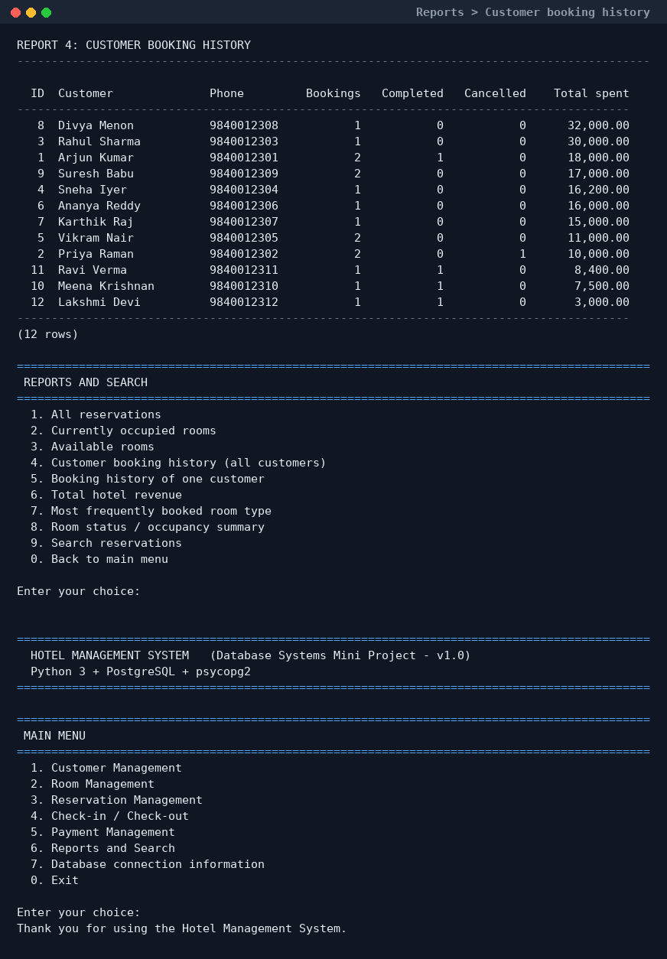
Figure 13.16 — Customer booking history (`LEFT JOIN` + `GROUP BY`).
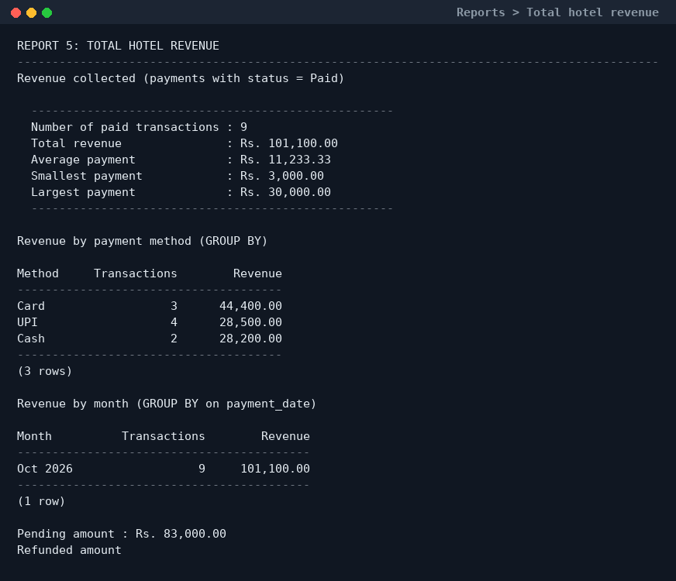
Figure 13.17 — Total revenue, revenue by payment method and by month.
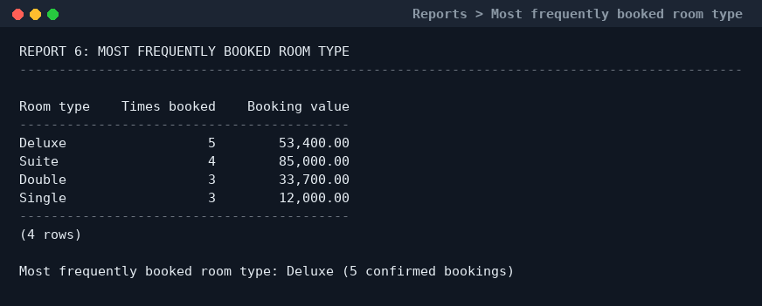
Figure 13.18 — Most frequently booked room type (Deluxe, 5 bookings).

13.8 SQL demonstration in `psql`
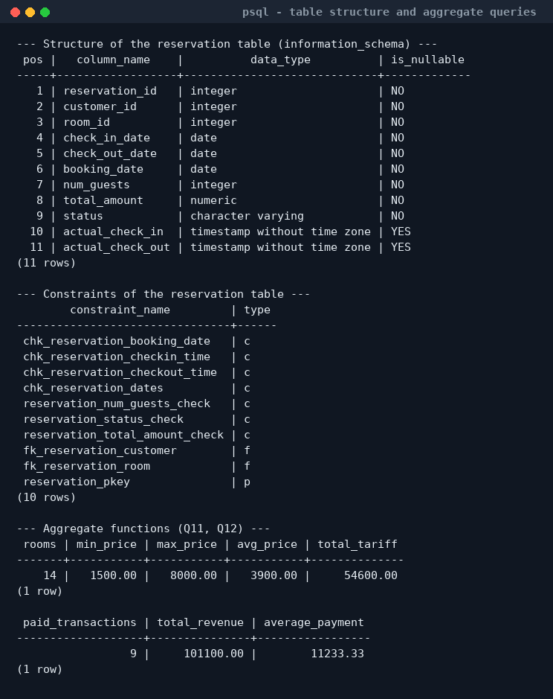
Figure 13.19 — Table structure and constraints, plus the five aggregate
functions.*
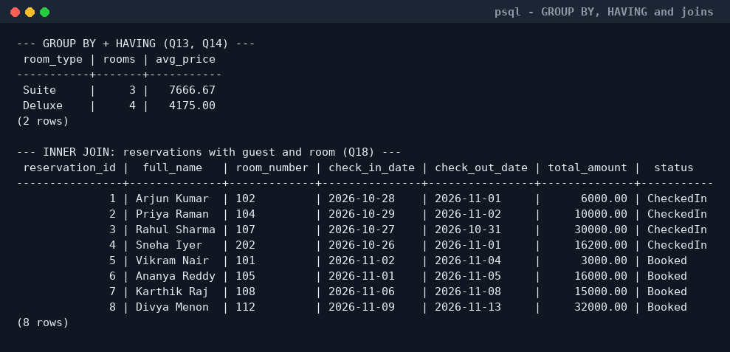
Figure 13.20 — `GROUP BY` with `HAVING` and an `INNER JOIN`.
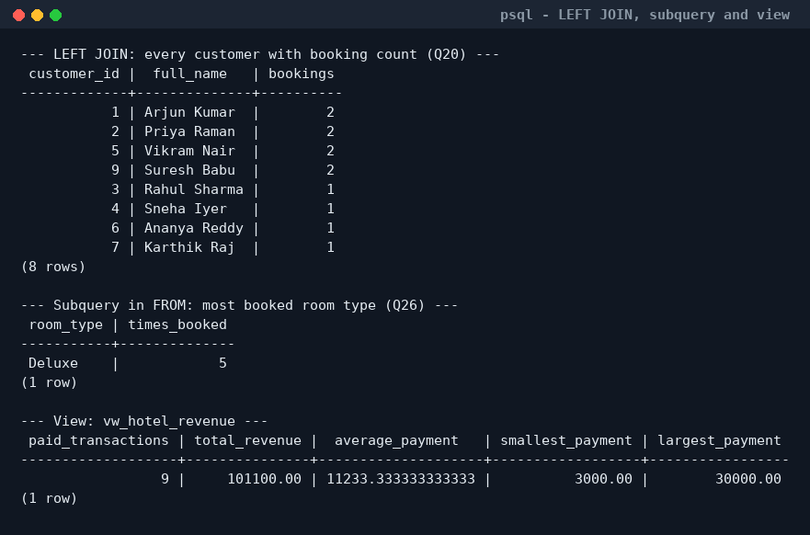
Figure 13.21 — `LEFT JOIN`, a subquery in `FROM` and a view.
A complete text transcript of one demo session is available in
docs/SAMPLE_RUN_OUTPUT.txt.

14. Results and observations

14.1 Results
- All four tables, five views, indexes and the helper function were created
successfully in PostgreSQL 16 (sql/01_schema.sql).
- The sample database contains **12 customers, 14 rooms (Single, Double,
Deluxe, Suite), 16 reservations (Booked, CheckedIn, CheckedOut, Cancelled)
and 16 payments (Cash, Card, UPI; Pending, Paid, Refunded)**.
- Total revenue in the sample data is ₹1,01,100.00 from 9 paid
transactions; pending amount ₹83,000 and refunded amount ₹3,200 are
reported separately.
- All 34 demonstration queries run without errors and produce the output
documented in section 11.
- Every module of the Python application was executed against the real
database: customer add/search/update/delete, room add/update, booking with
availability check and automatic billing, check-in, check-out, payment
recording, refund and all eight reports.
- Integrity rules were verified by deliberately trying to break them:
a duplicate e-mail, an invalid ID-proof type, a two-character name, a
check-out date before the check-in date, a room booked twice for the same
dates and deleting a customer who has reservations — each attempt was
rejected with a clear message.

14.2 Observations
1. Constraints are the real safety net. The application validates input,
but a UNIQUE or CHECK constraint also protects the data when somebody
edits the tables directly with psql or pgAdmin.
2. Availability must be date-based. Using only room.status would let a
room be booked twice for future dates; the NOT EXISTS overlap query is
the correct approach and is also fast because of
idx_reservation_dates.
3. Transactions matter. Check-in and check-out change two tables. Without
a transaction, a failure between the two UPDATEs would leave a guest in
a "free" room.
4. Views simplify the Python code. vw_reservation_details removed the
need to repeat a three-table join in six different screens.
5. Storing the bill amount is deliberate. reservation.total_amount is
kept even though it can be recalculated, because the tariff of a room can
change later and old bills must not change.
6. Small usability details matter: showing the bill before saving,
offering to collect payment at check-out, and printing the outstanding
amount in the pending-payments report make the program pleasant to use.

14.3 Limitations and future scope
- One payment per reservation (partial payments are not supported).
- No login/authentication — the menu is meant for a single front-desk
terminal.
- Availability is checked when the booking is saved, but there is no
database-level EXCLUDE constraint against two overlapping bookings
inserted at exactly the same moment (a single-user mini project does not
need it; it is mentioned as future work).
- Possible extensions: a Tkinter GUI, invoice printing/PDF, e-mail
confirmation, housekeeping module, GST calculation, and a
room_type master table with seasonal pricing.

15. Conclusion
A complete, working Hotel Management System was designed, implemented and
tested. The database is a normalized (3NF) PostgreSQL schema of four related
tables with primary keys, foreign keys, UNIQUE, NOT NULL and CHECK
constraints, five views and an availability query based on date overlap.
The Python application connects through psycopg2 and offers a simple
menu-driven interface for customers, rooms, reservations, check-in,
check-out, payments and reports, using parameterized SQL and transactions.
The ER diagram, the relational schema, the SQL scripts and the Python code
all describe the same four entities and the same relationships, and every
required SQL concept — from CREATE TABLE to GROUP BY … HAVING, joins,
subqueries and views — is demonstrated with realistic data and actual output.
The project therefore fulfils the objectives of the Database Systems mini
project: it shows database design, integrity enforcement, SQL skills and a
functional application that interacts with the database, while remaining
simple enough to be explained and extended in a viva.

Appendix A — How to create the database and run the project

Step 1 — Install the software
- Install PostgreSQL (remember the password you set for the postgres
user) and make sure the service is running.
- Install Python 3.10+ and the driver:
pip install psycopg2-binary

Step 2 — Create the database
From the hotel_management_system folder:
psql -U postgres -f sql/00_create_database.sql
This creates the database hotel_db and connects to it.

Step 3 — Create the tables and load the sample data
psql -U postgres -d hotel_db -f sql/01_schema.sql
psql -U postgres -d hotel_db -f sql/02_sample_data.sql
01_schema.sql can be re-run safely (it drops and recreates the objects).
02_sample_data.sql restarts the IDs and reloads the 12 + 14 + 16 + 16
sample rows.

Step 4 — Demonstrate the SQL queries (optional)
psql -U postgres -d hotel_db -f sql/03_queries.sql

Step 5 — Configure the connection
cp .env.example .env # Windows: copy .env.example .env
Edit .env and put your own PostgreSQL password.

Step 6 — Run the application
cd app
python main.py
The main menu appears. Type the number of a module and press ENTER.
> Note (Windows): if py is the Python launcher on your system use
> py main.py; if psql is not on PATH, use the full path such as
> "C:\Program Files\PostgreSQL\16\bin\psql.exe".

Appendix B — Demonstration sequence
Suggested order for the practical exam / viva (about 12 minutes):
Step | Action in the program | What to show
1 | Start python main.py | Connection status and row counts
2 | 1 → 1 add a customer | New customer ID returned by INSERT … RETURNING
3 | 1 → 3 search that customer | Search by ID / name / phone
4 | 2 → 2 view all rooms | 14 rooms, four categories, tariffs
5 | 2 → 4 tariff by type | GROUP BY result inside the application
6 | 3 → 2 check availability | Choose 2026-12-01 to 2026-12-03; note the free rooms
7 | 3 → 1 book a room | Guest → dates → room list → bill preview → confirmation; the amount = nights × tariff
8 | 3 → 1 again with the same dates and the same room | Room no longer appears in the available list (no double booking)
9 | 4 → 3 today's expected check-ins | Preparations for check-in
10 | 4 → 1 check-in | Reservation Booked → CheckedIn, room Available → Occupied
11 | 5 → 1 record the payment | Cash / Card / UPI, status becomes Paid
12 | 4 → 2 check-out | Reservation CheckedOut, room back to Available
13 | 3 → 4 view a reservation | Status and payment status together
14 | 6 → 2 occupied rooms, 6 → 6 revenue, 6 → 7 popular room type | The three main reports
15 | psql -d hotel_db then \d reservation, and run any query from sql/03_queries.sql | Table structure and SQL concepts
16 | psql -d hotel_db -f sql/03_queries.sql | All 34 queries in one go

Useful viva questions prepared by the design: *Why is total_amount stored
even though it can be calculated? (tariff history) · How is double booking
prevented? (overlap test with `NOT EXISTS`) · Which normal form and why?*
(3NF, no transitive dependency) · *What happens if a customer with bookings
is deleted? (`ON DELETE RESTRICT` protects the history) · Where is SQL
injection prevented?* (parameterized queries in db.py).

Appendix C — Project file structure
hotel_management_system/
├── README.md quick start guide
├── .env.example connection settings template
├── sql/
│ ├── 00_create_database.sql create database hotel_db
│ ├── 01_schema.sql tables, constraints, indexes, views
│ ├── 02_sample_data.sql 12 customers, 14 rooms, 16 reservations, 16 payments
│ └── 03_queries.sql 34 demonstration queries
├── app/
│ ├── main.py entry point and main menu
│ ├── config.py reads .env / environment variables
│ ├── db.py psycopg2 wrapper (queries, transactions, errors)
│ ├── ui.py tables, messages and validated input helpers
│ ├── customers.py module 1 - customer management
│ ├── rooms.py module 2 - room management
│ ├── reservations.py module 3 - reservation management
│ ├── frontdesk.py module 4 - check-in / check-out
│ ├── payments.py module 5 - payment management
│ └── reports.py module 6 - reports and search
└── docs/
├── PROJECT_REPORT.md this report
├── PROJECT_REPORT.docx the same report, ready to print
├── ER_DIAGRAM.png / .svg ER diagram
├── SAMPLE_RUN_OUTPUT.txt text transcript of a demo session
├── screenshots/ 21 screenshots used in this report
└── tools/
├── make_er_diagram.py generate the ER diagram
└── make_screenshots.py regenerate the screenshots

References
1. Elmasri R. and Navathe S. B., Fundamentals of Database Systems, 7th
edition, Pearson, 2016.
2. Silberschatz A., Korth H. F. and Sudarshan S., *Database System
Concepts*, 7th edition, McGraw-Hill, 2019.
3. PostgreSQL Global Development Group, PostgreSQL 16 Documentation,
<https://www.postgresql.org/docs/16/>.
4. Psycopg Development Team, Psycopg 2 Documentation,
<https://www.psycopg.org/docs/>.
5. Python Software Foundation, The Python Tutorial,
<https://docs.python.org/3/tutorial/>.

