M Vignesh
vigneshmtinku@gmail.com

UST_Assignment-1

1.Number Classification (if + function)
Write a shell script that uses a function to check whether a number is positive, negative, or zero using if.
Program:
number_check() {
if [ $1 -gt 0 ]; then
echo "the number is +ve"
elif [ $1 -lt 0 ]; then
echo "the number is -ve"
else
echo "the number is 0"
fi
}
read -p "enter your a number:" num
number_check $num

Output:

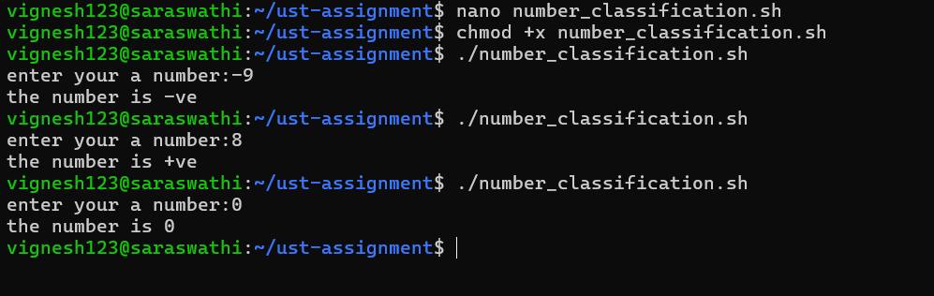
2. Factorial of a Number (while + function)
Write a shell script to calculate the factorial of a number using a while loop inside a function.
Program:
fact() {
num=$1
f=1
while [ $num -gt 1 ]; do
f=$((f * $num))
num=$((num - 1))
done
echo "the factorial of $1 is: $f"
}
read -p "enter a number to get factorial of the number" num
fact $num

Output
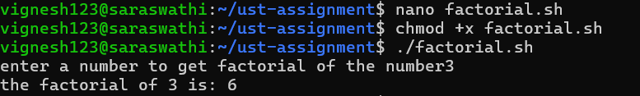

3.Sum of N Numbers (for + function)
Write a shell script to calculate the sum of numbers from 1 to N using a for loop inside a function.
Program:
sumofnum() {
n=$1
sum=0
for ((i=1; i<=n; i++))
do
sum=$((sum + i))
done
echo "Sum of number from 1 to $1 is : $sum"
}
read -p "Enter the number : " n
sumofnum $n

Output:
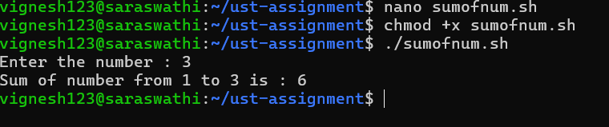

4.Prime Number Check (if + for + function)
Write a shell script that uses a function to check whether a given number is prime using if and for.
Program:
prime() {
n=$1
if [ $n -lt 2 ]; then
echo "$n is not a prime number"
return
fi
for ((i=2; i<=n/2; i++)); do
if [ $(( n % i )) -eq 0 ]; then
echo "$n is not a prime number."
return
fi
done
echo "$1 is a prime number"

}
read -p "enter number to check prime or not : " n
prime $n

Output
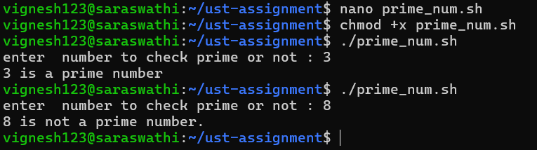

5.Reverse a Number (while + if)
Write a shell script to reverse a number using a while loop and if conditions where required.
Program :
read -p "enter a number : " n
rn=0

while [ $n -gt 0 ]; do
d=$((n%10))
rn=$((rn * 10 + d))
n=$((n/10))
done

echo "the reversed number is $rn"

Output:
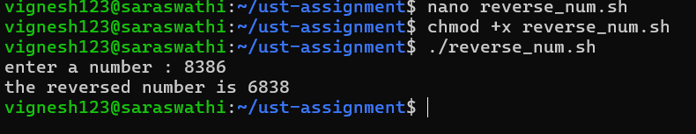

6.File Existence & Permission Check (if + function)
Write a shell script that uses a function to check if a file exists and whether it has read, write, and execute permissions.
Program:
file() {
if [ -e $1 ]; then
echo "$1 file exists"

if [ -r $1 ]; then
echo "$1 has read permission"
else
echo "$1 has no read permission"
fi

if [ -w $1 ]; then
echo "$1 has write permission"
else
echo "$1 has no write permission"
fi

if [ -x $1 ]; then
echo "$1 has excute permission"
else
echo "$1 has no excute permission"
fi
else
echo "$1 does not exists ,check the file name "
fi
}
read -p "enter the file name : " f
file $f

Output:
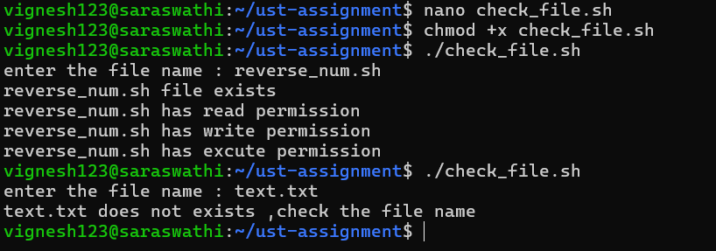

7.Menu-Driven Calculator (while + case + function)
Write a shell script that shows a menu in a while loop and performs add, subtract, multiply, divide using functions.
Program :
add() {
echo "result : $(( $1 + $2))"
}
sud() {
echo "result : $(( $1 - $2))"
}
mul() {
echo "result : $(( $1 * $2))"
}
div() {
if [ $2 -eq 0 ]; then
echo "division by 0 is not allowed"
else
echo "result : $(( $1 / $2))"
fi
}

while true ; do
echo "=========================="
echo "Menu"
echo "1.add"
echo "2.sub"
echo "3.mul"
echo "4.div"
echo "5.exits"
echo "=========================="
read -p "enter your choice : " c

case $c in
1)
read -p "enter two numbers : " n1 n2
add $n1 $n2
;;
2)
read -p "enter two numbers : " n1 n2
sud $n1 $n2
;;
3)
read -p "enter two numbers : " n1 n2
mul $n1 $n2
;;
4)
read -p "enter two numbers : " n1 n2
div $n1 $n2
;;
5)
echo "exited"
break
;;
*)
echo "invalid option. select correct option"
esac
done

Output:
