|  |  |  |  |
| --- | --- | --- | --- |
| Equity Risk Unadjusted |  |  |  |
| Returns | Daily | Weekly | Monthly |
| Mean(%) | 0.0398 | 0.2824 | 0.7983 |
| Max(%) | 5.8831 | 4.9434 | 9.5756 |
| Min(%) | -4.0742 | -4.009 | -6.1269 |
| Standard Deviation | 1.423899 | 2.431817 | 6.543596175 |

|  |  |  |  |
| --- | --- | --- | --- |
| Equity Risk adjusted |  |  |  |
| Returns | Daily | Weekly | Monthly |
| Mean(%) | 0.0058 | 0.248363 | 0.7640511 |
| Max(%) | 5.85 | 4.909308 | 9.5425677 |
| Min(%) | -4.1072 | -4.04387 | -6.1628855 |
| Standard Deviation | 1.423978 | 2.432046 | 5.981082956 |

|  |  |
| --- | --- |
| Sharpe Ratio For  Equity |  |
| Frequency | Sharpe Ratio |
| Daily | 0.004071647 |
| Weekly | 0.102120885 |
| Monthly | 0.127744603 |

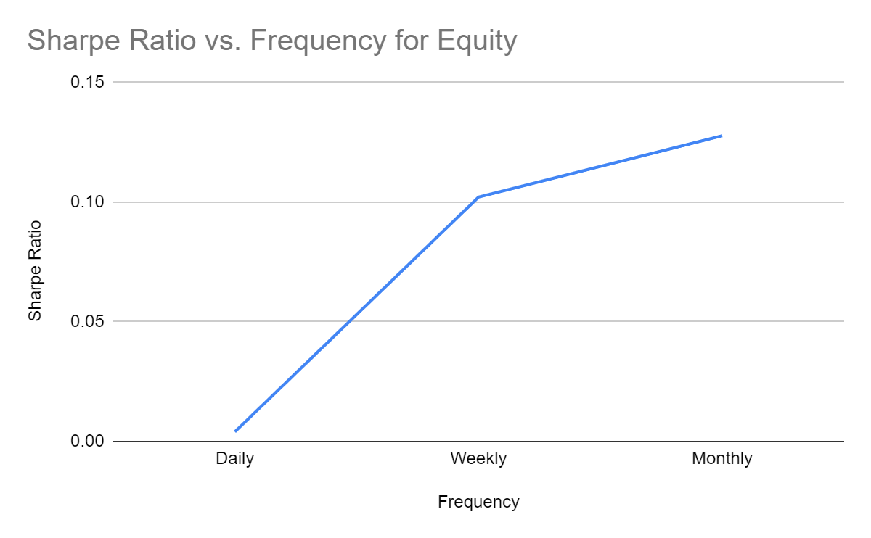

|  |  |  |  |
| --- | --- | --- | --- |
| Current Month Unadjusted |  |  |  |
| Returns | Daily | Weekly | Monthly |
| Mean(%) | 0.0341 | 0.2792 | 0.561 |
| Max(%) | 6.1415 | 4.996 | 9.172 |
| Min(%) | -4.0076 | -3.5653 | -6.5066 |
| Standard Deviation | 1.422048 | 2.334026 | 6.551276 |

|  |  |  |  |
| --- | --- | --- | --- |
| Next Month Unadjusted |  |  |  |
| Returns | Daily | Weekly | Monthly |
| Mean(%) | 0.0357 | 0.3093 | 0.5424 |
| Max(%) | 6.0377 | 4.9221 | 9.0268 |
| Min(%) | -4.0119 | -3.7897 | -6.6437 |
| Standard Deviation | 1.431974 | 2.372592 | 6.520358 |

|  |  |  |  |
| --- | --- | --- | --- |
| Far Month Unadjusted |  |  |  |
| Returns | Daily | Weekly | Monthly |
| Mean(%) | 0.0357 | 0.2796 | 0.561 |
| Max(%) | 6.4552 | 5.0998 | 9.172 |
| Min(%) | -4.103 | -4.0512 | -6.5066 |
| Standard Deviation | 1.414615 | 2.466004 | 6.551276 |

|  |  |  |  |
| --- | --- | --- | --- |
| Current month adjusted |  |  |  |
| Returns | Daily | Weekly | Monthly |
| Mean(%) | 0.000133 | 0.245177 | 0.526755 |
| Max(%) | 6.1084 | 4.9629 | 9.1389 |
| Min(%) | -4.0418 | -3.5997 | -6.5425 |
| Standard Deviation | 1.422129 | 2.334249 | 5.984432 |

|  |  |  |  |
| --- | --- | --- | --- |
| Next month adjusted |  |  |  |
| Returns | Daily | Weekly | Monthly |
| Mean(%) | 0.001666 | 0.27522 | 0.508119 |
| Max(%) | 6.0046 | 4.889 | 8.9937 |
| Min(%) | -4.0461 | -3.8241 | -6.6796 |
| Standard Deviation | 1.432052 | 2.372798 | 6.521076 |

|  |  |  |  |
| --- | --- | --- | --- |
| Fart month adjusted |  |  |  |
| Returns | Daily | Weekly | Monthly |
| Mean(%) | 0.001722 | 0.245551 | 0.526755 |
| Max(%) | 6.4221 | 5.0667 | 9.1389 |
| Min(%) | -4.136 | -4.0856 | -6.5425 |
| Standard Deviation | 1.419792 | 2.466217 | 5.984432 |

|  |  |
| --- | --- |
| Sharpe Ratio For  Current Month | |
| Frequency | Sharpe Ratio |
| Daily | 0.00009322 |
| Weekly | 0.105034747 |
| Monthly | 0.088020929 |

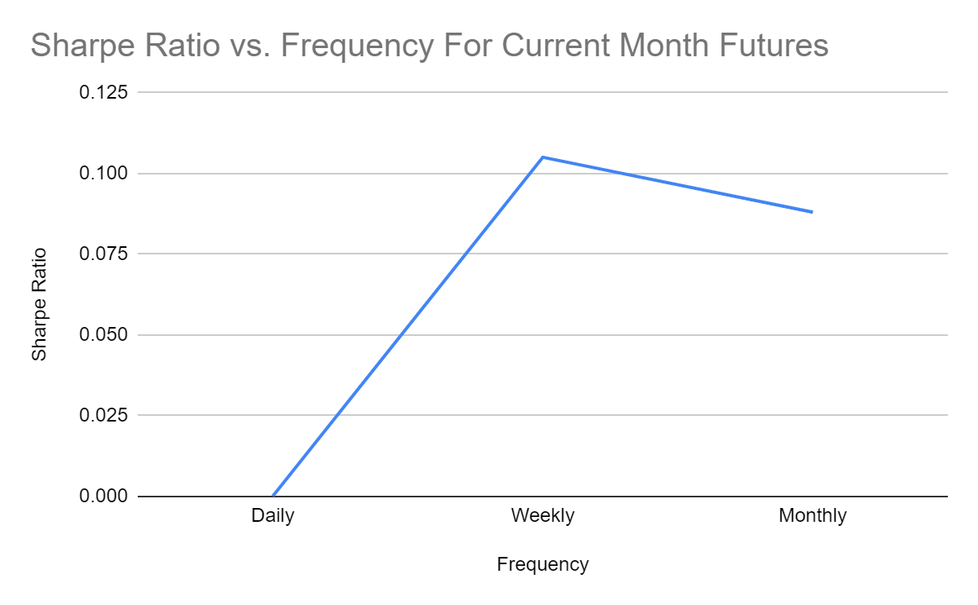

|  |  |
| --- | --- |
| Sharpe Ratio For  Next  Month | |
| Frequency | Sharpe Ratio |
| Daily | 0.0011634 |
| Weekly | 0.1159895 |
| Monthly | 0.0779195 |

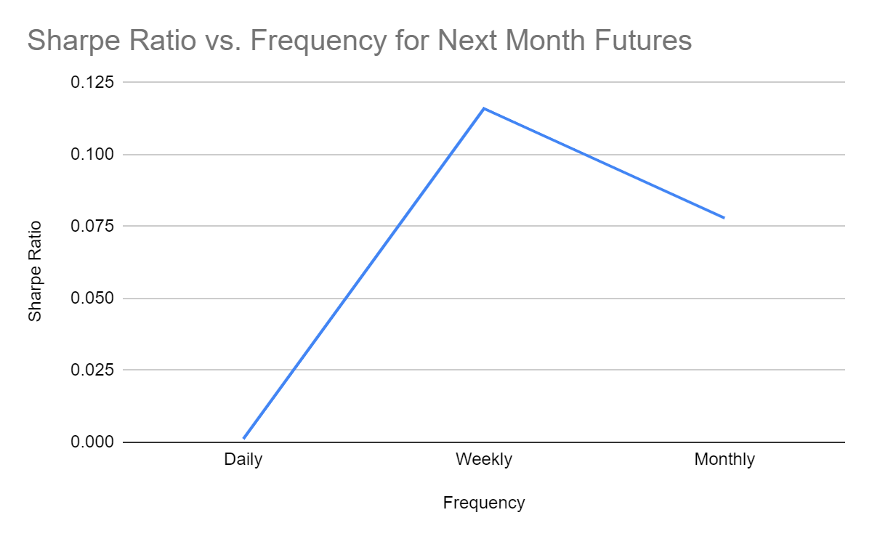

|  |  |
| --- | --- |
| Sharpe Ratio For  Far  Month | |
| Frequency | Sharpe Ratio |
| Daily | 0.001212914 |
| Weekly | 0.099565748 |
| Monthly | 0.088020929 |

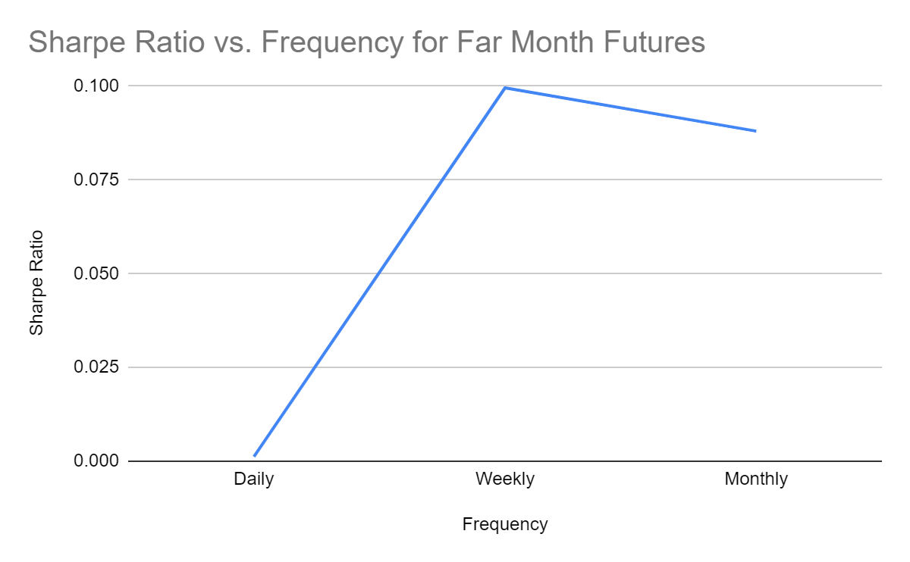

|  |  |  |  |  |  |  |  |  |
| --- | --- | --- | --- | --- | --- | --- | --- | --- |
| Comparison of Current, Next, and Far Monthly Risk Unadjusted Returns with underlying asset risk-adjusted returns  Comparisons |  | |  | |  | |  | |
|  |  | |  | |  | |  | |
| Risk unadjusted Daily Frequency | | |  | |  | |  | |
| Comparisons | |  | |  | |  | |  | |
|  | |  | |  | |  | |  | |
|  | |  | |  | |  | |  | |
| Risk Unadjusted Return | | Underlying asset | | Current | | Next | | Far Month | |
| Month | | Month | |
| Mean(%) | | 0.0398 | | 0.0341 | | 0.0357 | | 0.0357 | |
| Max(%) | | 5.8831 | | 6.1415 | | 6.0377 | | 6.4552 | |
| Min(%) | | -4.0742 | | -4.0076 | | -4.0119 | | -4.103 | |
| Standard Deviation | | 1.423898504 | | 1.422048 | | 1.431973738 | | 1.414615 | |

|  |  |  |  |  |
| --- | --- | --- | --- | --- |
| Risk unadjusted Weekly Frequency |  |  |  |  |
|  |  |  |  |  |
| Risk Unadjusted Return | Underlying asset | Current | Next | Far Month |
| Month | Month |
| Mean(%) | 0.2824 | 0.2792 | 0.3093 | 0.2796 |
| Max(%) | 4.9434 | 4.996 | 4.9221 | 5.0998 |
| Min(%) | -4.009 | -3.5653 | -3.7897 | -4.0512 |
| Standard Deviation | 2.431817393 | 2.334026 | 2.372592256 | 2.466004 |

|  |  |  |  |  |
| --- | --- | --- | --- | --- |
| Risk unadjusted Monthly Frequency |  |  |  |  |
|  |  |  |  |  |
| Risk Unadjusted Return | Underlying asset | Current | Next | Far Month |
| Month | Month |
| Mean(%) | 0.7983 | 0.561 | 0.5424 | 0.561 |
| Max(%) | 9.5756 | 9.172 | 9.0268 | 9.172 |
| Min(%) | -6.1269 | -6.5066 | -6.6437 | -6.5066 |
| Standard Deviation | 6.5435 | 6.551276 | 6.520358207 | 6.551276 |

|  |  |  |  |  |
| --- | --- | --- | --- | --- |
| Risk adjusted Daily Frequency |  |  |  |  |
| Risk Unadjusted Return | Underlying asset | Current | Next | Far Month |
| Month | Month |
| Mean(%) | 0.0058 | 0.000133 | 0.0016661 | 0.001722 |
| Max(%) | 5.85 | 6.1084 | 6.0046 | 6.4221 |
| Min(%) | -4.1072 | -4.0418 | -4.0461 | -4.136 |
| Standard Deviation | 1.423978491 | 1.422129 | 1.432052267 | 1.419792 |

|  |  |  |  |  |
| --- | --- | --- | --- | --- |
| Risk adjusted Weekly Frequency |  |  |  |  |
| Risk Unadjusted Return | Underlying asset | Current | Next | Far Month |
| Month | Month |
| Mean(%) | 0.2483627 | 0.245177 | 0.2752197 | 0.245551 |
| Max(%) | 4.9093078 | 4.9629 | 4.889 | 5.0667 |
| Min(%) | -4.0438676 | -3.5997 | -3.8241 | -4.0856 |
| Standard Deviation | 2.43204595 | 2.334249 | 2.372797962 | 2.466217 |

|  |  |  |  |  |
| --- | --- | --- | --- | --- |
| Risk adjusted Monthly Frequency | |  |  |  |
| Risk Unadjusted Return | Underlying asset | Current | Next | Far Month |
| Month | Month |
| Mean(%) | 0.7640511 | 0.526755 | 0.5081192 | 0.526755 |
| Max(%) | 9.5425677 | 9.1389 | 8.9937 | 9.1389 |
| Min(%) | -6.1628855 | -6.5425 | -6.6796 | -6.5425 |
| Standard Deviation | 5.981082956 | 5.984432 | 6.52107633 | 5.984432 |

Comparison of Current, Next, and Far Monthly Risk Unadjusted Returns with underlying asset risk-adjusted returns

|  |  |  |  |  |
| --- | --- | --- | --- | --- |
| Risk Unadjusted Return | Next Month | Far Month | Current Month | Underlying asset |
| Mean(%) | 0.5424 | 0.561 | 0.561 | 0.7983 |
| Max(%) | 9.0268 | 9.172 | 9.172 | 9.5756 |
| Min(%) | -6.6437 | -6.5066 | -6.5066 | -6.1269 |
| Standard Deviation | 6.520358207 | 6.551276306 | 6.551276306 | 6.543596175 |

Comparison of Next, Far, and Current Monthly Risk-Adjusted Returns with underlying asset risk-adjusted returns

|  |  |  |  |  |
| --- | --- | --- | --- | --- |
| Risk adjusted Return | Next Month | Far Month | Current Month | Underlying asset |
| Mean(%) | 0.5081192 | 0.5267553 | 0.5267553 | 0.7640511 |
| Max(%) | 8.9937 | 9.1389 | 9.1389 | 9.5425677 |
| Min(%) | -6.6796 | -6.5425 | -6.5425 | -6.1628855 |
| Standard Deviation | 6.52107633 | 5.984432277 | 5.984432277 | 5.981082956 |