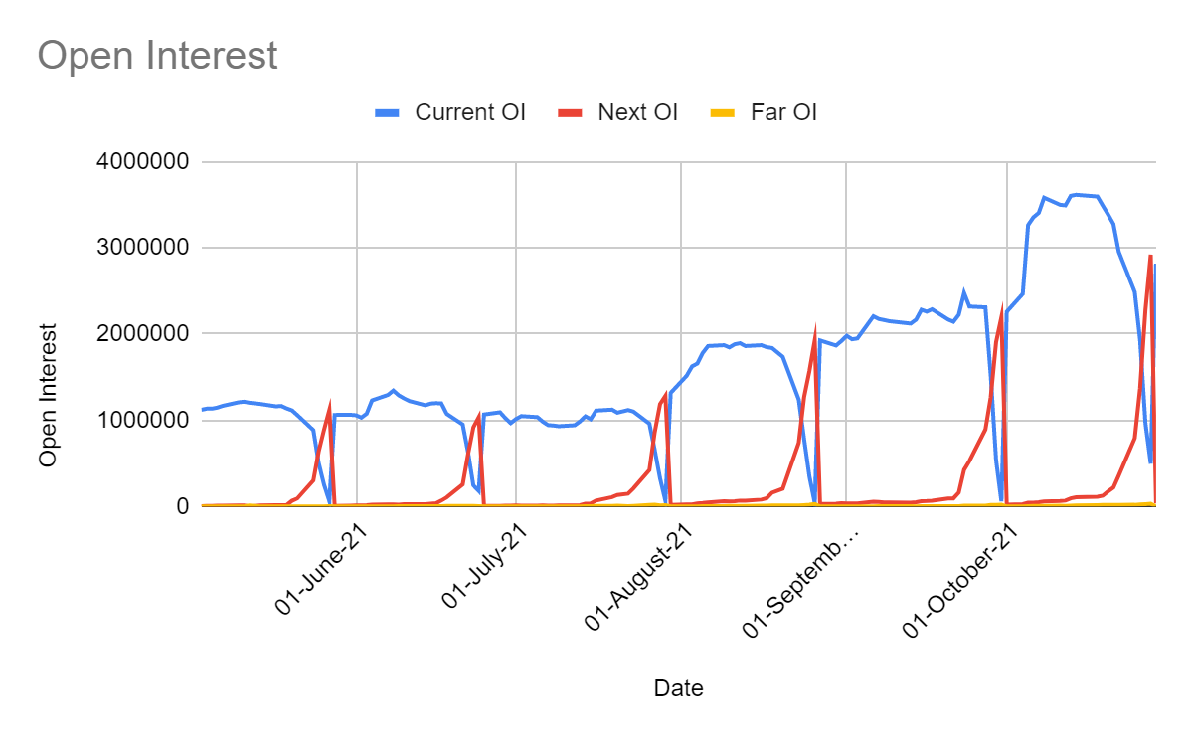

|  |  |  |
| --- | --- | --- |
| Contango and Backwardation |  |  |
| Type | No of Days in Contango | No of Days in Backwardation |
| Current Month | 93 | 32 |
| Next Month | 94 | 31 |
| Far Month | 95 | 30 |

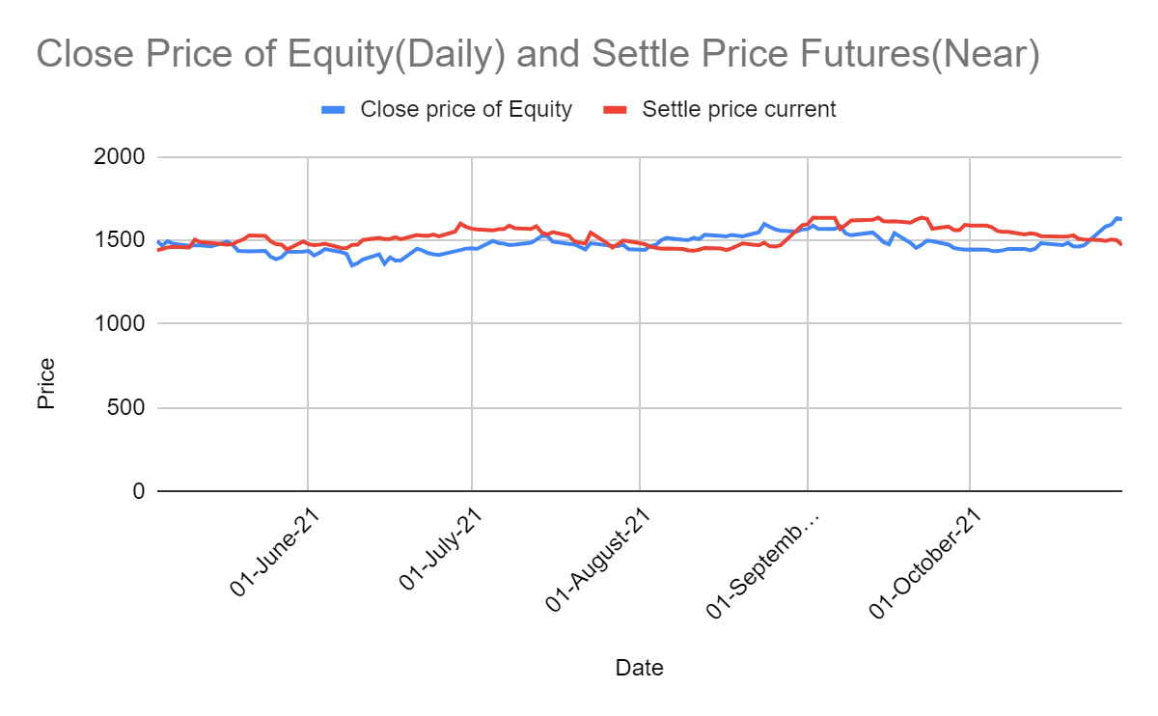

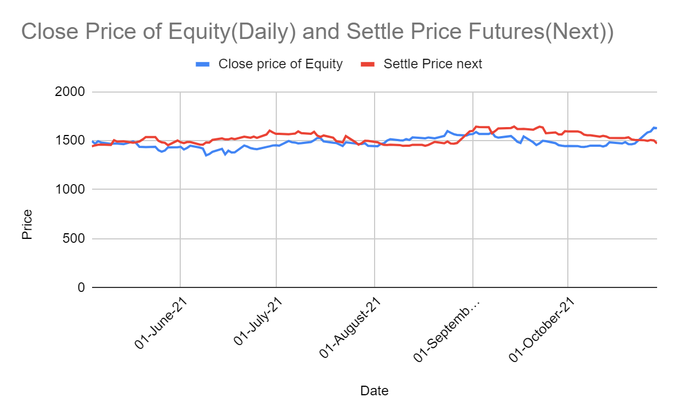

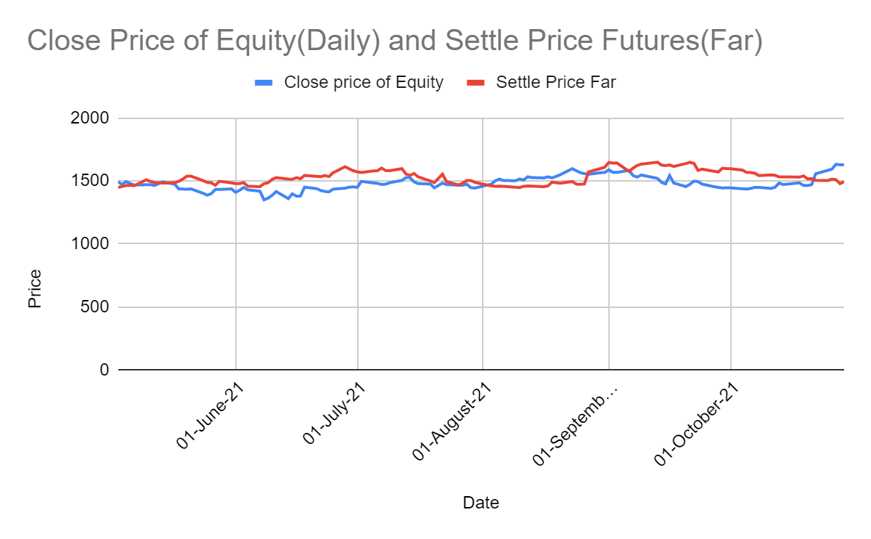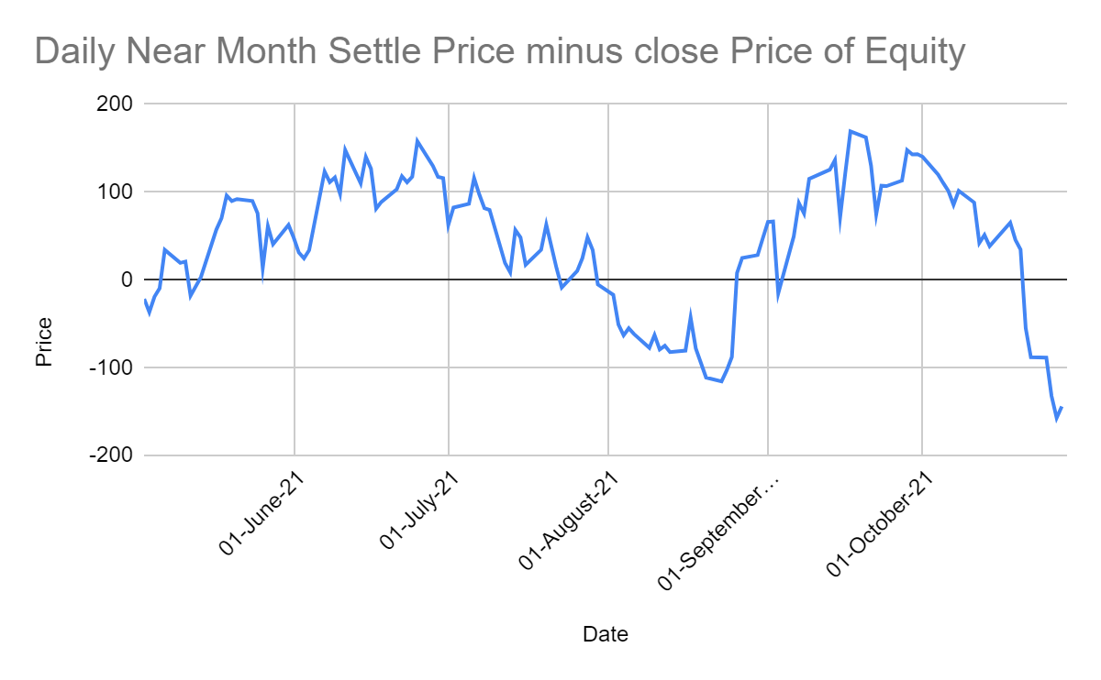

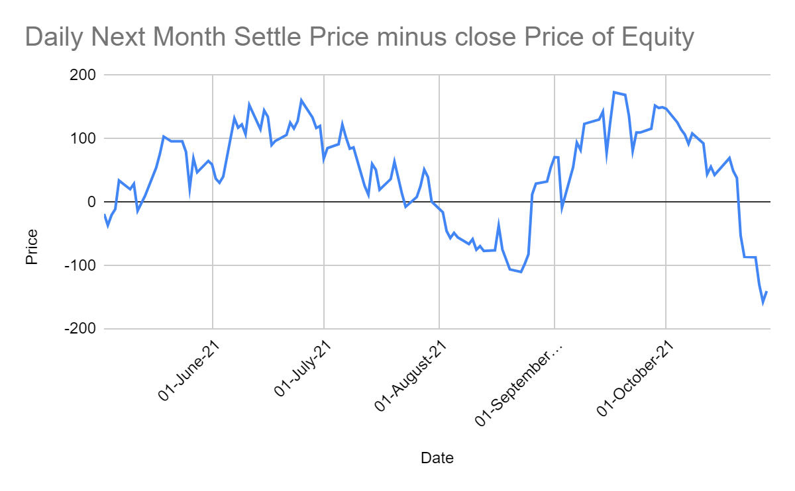

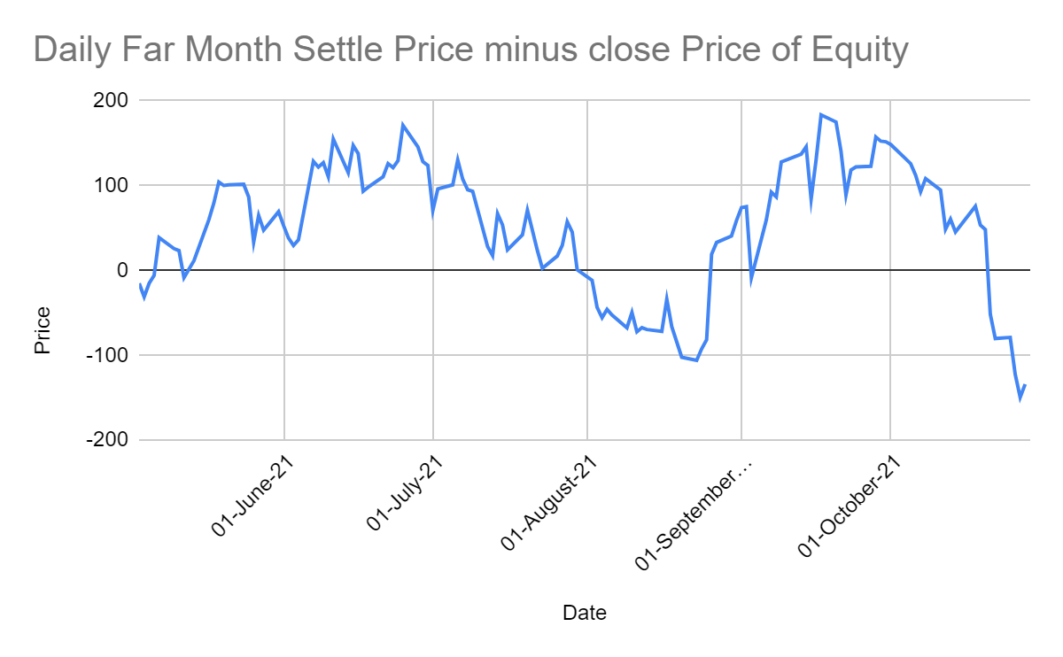

|  |  |  |  |
| --- | --- | --- | --- |
|  |  |  |  |
|  |  |  |  |
|  |  |  |  |
|  |  |  |  |

|  |  |  |  |
| --- | --- | --- | --- |
|  | Current Month | Next Month | Far Month |
| Avg no of contracts | 1650 | 451 | 5 |
| Avg OI | 1562082 | 279582 | 5862 |