WEEK 2: ADVANCED DATA VISUALIZATION
AND STORYTELLING WITH PYTHON
Titanic Dataset Analysis
Main Submission Report
Prepared from the completed Week 2 Python notebook

Dataset | Titanic Dataset
Records | 891 passenger records
Visualizations | 6 static visualizations + 1 interactive Plotly visualization
Primary Objective | Analyze factors associated with passenger survival

1. Introduction
Data visualization helps convert numerical and categorical information into patterns that can be understood by both technical and non-technical audiences. In this Week 2 project, the Titanic dataset is used to investigate passenger survival through a sequence of visual analyses.
The analysis focuses on survival outcomes in relation to gender, passenger class, age, and numerical variables. The visualizations are arranged as a narrative: first establishing the overall survival outcome, then examining individual factors, combining factors, and finally using correlation and interactive visualization to provide additional perspective.

2. Dataset Description
The report uses the cleaned Titanic dataset carried forward from the Week 1 analysis. The completed notebook loads the file as `titanic_cleaned.csv` and reports 891 passenger records across 11 columns.
Variable | Type / Role | Description
PassengerId | Numerical | Passenger identifier
Survived | Binary | 0 = did not survive; 1 = survived
Pclass | Categorical / ordinal | Passenger class: 1, 2, or 3
Name | Text | Passenger name
Sex | Categorical | Passenger gender
Age | Numerical | Passenger age
SibSp | Numerical | Siblings/spouses aboard
Parch | Numerical | Parents/children aboard
Ticket | Text | Ticket identifier
Fare | Numerical | Passenger fare
Embarked | Categorical | Port of embarkation
The notebook's structural check shows 891 non-null values for each of the 11 columns, and the missing-value check returns zero missing values for all columns in the cleaned dataset.

3. Project Objective
The main question guiding the visual narrative is:
“What factors are associated with passenger survival in the Titanic dataset?”
- Establish the overall survival outcome.
- Compare survival outcomes by gender.
- Compare survival outcomes by passenger class.
- Explore age distributions for survivors and non-survivors.
- Examine gender and passenger class together.
- Investigate relationships among numerical variables.
- Provide an interactive view of age, fare, class, gender, and survival.

4. Tools and Methodology
The completed notebook uses Python with Pandas, NumPy, Matplotlib, Seaborn, and Plotly. Pandas is used for loading and inspecting the dataset; Matplotlib and Seaborn are used for static visualizations; Plotly is used for the interactive visualization.
Stage | Work Completed
Dataset loading | Loaded the cleaned Titanic dataset with Pandas.
Data verification | Reviewed sample records and data structure.
Missing-value check | Verified zero missing values in the cleaned dataset.
Descriptive analysis | Generated numerical summary statistics.
Visualization | Created six static charts using Seaborn/Matplotlib.
Interactive analysis | Created a Plotly scatter visualization.
Storytelling | Connected the visual findings into an overall narrative.

5. Visualization 1 – Overall Passenger Survival

Objective
Compare the number of passengers who survived with the number who did not survive.

Visualization Choice
A count plot is appropriate because it gives a direct comparison of the two survival categories.
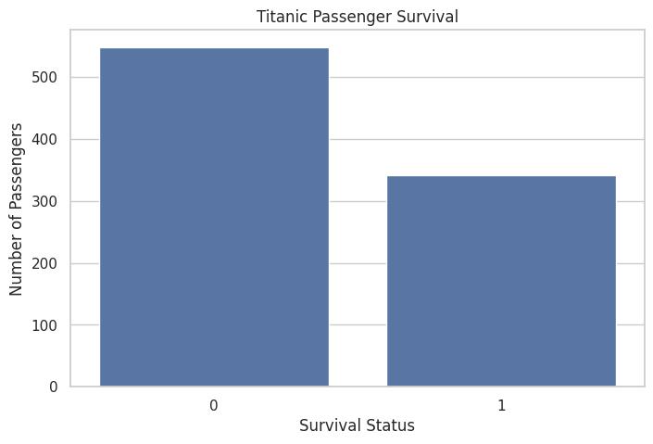
Figure 5. Visualization 1 – Overall Passenger Survival

Interpretation
The chart establishes the starting point of the story. In the analyzed dataset, 342 of 891 passengers survived (38.4%), while 549 did not survive (61.6%).

Contribution to the Data Story
This visualization provides the baseline outcome that the remaining charts attempt to explain. It moves the story from “what happened?” toward “which passenger characteristics were associated with the outcome?”

Implication
The overall result shows that non-survival was the more common outcome in this dataset, making it important to examine the passenger-level factors associated with the difference.

6. Visualization 2 – Survival by Gender

Objective
Examine whether survival outcomes differed between male and female passengers.

Visualization Choice
A grouped count plot makes it easy to compare survivors and non-survivors within each gender category.
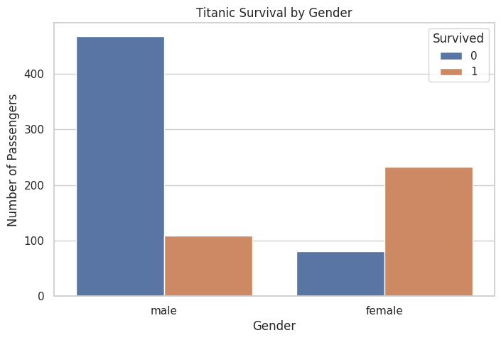
Figure 6. Visualization 2 – Survival by Gender

Interpretation
The gender comparison shows a substantial difference in survival outcomes. Among female passengers, 233 survived out of 314 (74.2%). Among male passengers, 109 survived out of 577 (18.9%).

Contribution to the Data Story
After establishing the overall outcome, this chart introduces the first major passenger-level factor. The strong difference between the two groups indicates that gender is an important dimension for the rest of the story.

Implication
Gender is strongly associated with survival in this dataset. This is an association observed in the historical data, not a causal conclusion.

7. Visualization 3 – Survival by Passenger Class

Objective
Examine the relationship between passenger class and survival.

Visualization Choice
A grouped count plot allows direct comparison of survival and non-survival across the three passenger classes.
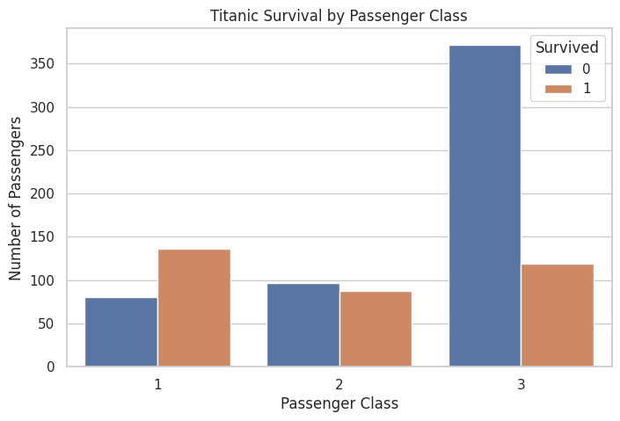
Figure 7. Visualization 3 – Survival by Passenger Class

Interpretation
Survival outcomes differ by passenger class. The dataset contains 216 first-class, 184 second-class, and 491 third-class passengers. The corresponding survival rates are approximately 63.0%, 47.3%, and 24.2%, respectively.

Contribution to the Data Story
The narrative now moves from gender to socioeconomic/structural position represented by passenger class. The differences in survival rates show why class should be considered alongside gender rather than treating all passengers as one group.

Implication
Passenger class is another important variable associated with survival. The result supports further analysis of class and gender together.

8. Visualization 4 – Age Distribution by Survival

Objective
Explore how passenger ages are distributed among survivors and non-survivors.

Visualization Choice
A histogram with density curves is useful for comparing distributions rather than only totals.
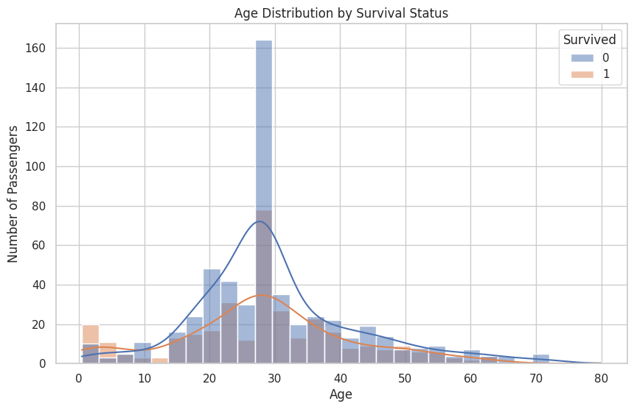
Figure 8. Visualization 4 – Age Distribution by Survival

Interpretation
The age distribution visualization provides a demographic perspective on the survival outcome. It allows the audience to see where survivor and non-survivor observations are concentrated and whether the distributions differ across age ranges.

Contribution to the Data Story
This chart adds a continuous variable to the narrative. Instead of asking only which category performed differently, the story now considers how passenger age is distributed across the outcome.

Implication
Age provides additional context for survival analysis. Any apparent age-group differences should be interpreted together with gender and passenger class rather than in isolation.

9. Visualization 5 – Survival Rate by Passenger Class and Gender

Objective
Examine two factors together: passenger class and gender.

Visualization Choice
A grouped bar chart using average survival rate makes comparisons across class and gender directly visible.
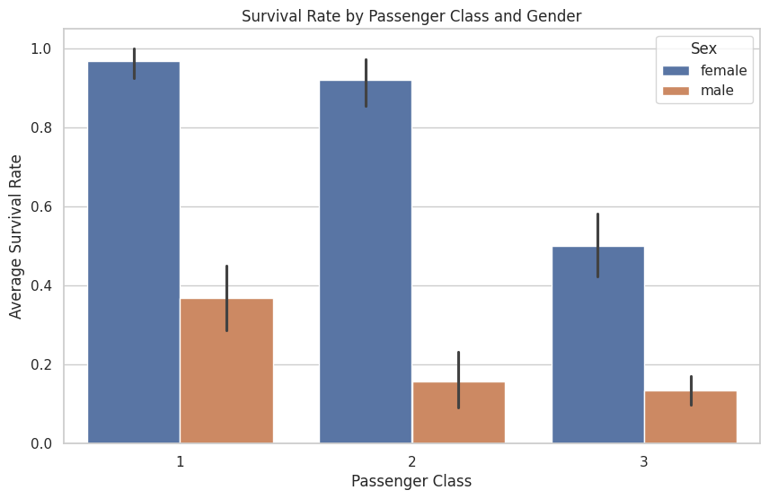
Figure 9. Visualization 5 – Survival Rate by Passenger Class and Gender

Interpretation
When gender and passenger class are considered together, the survival-rate differences become clearer. For example, the female survival rates by class are approximately 96.8% (1st class), 92.1% (2nd class), and 50.0% (3rd class). The corresponding male rates are approximately 36.9%, 15.7%, and 13.5%.

Contribution to the Data Story
This is the point where the narrative becomes multidimensional. The earlier charts identified gender and class separately; this chart demonstrates why combining variables can reveal a more detailed pattern.

Implication
The joint view suggests that survival cannot be adequately described by one variable alone. For future predictive analysis, interactions between passenger characteristics would be worth investigating.

10. Visualization 6 – Correlation Heatmap

Objective
Examine relationships among numerical variables including survival, passenger class, age, family-related counts, and fare.

Visualization Choice
A correlation heatmap provides a compact overview of the direction and strength of pairwise linear relationships.
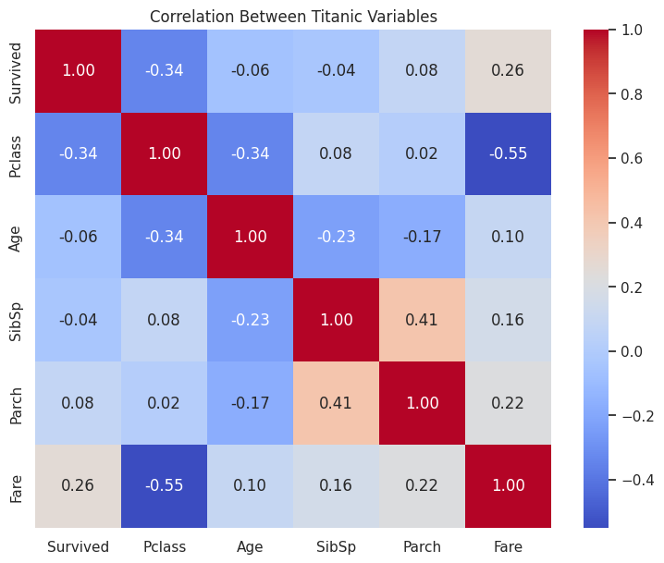
Figure 10. Visualization 6 – Correlation Heatmap

Interpretation
The heatmap provides a high-level numerical summary of relationships among the variables used in the notebook. It complements the categorical charts by showing how numerical variables relate to one another.

Contribution to the Data Story
The heatmap broadens the story from individual comparisons to relationships across multiple numerical measures. It can help identify variables that deserve closer investigation in future analysis.

Implication
Correlation is useful for identifying patterns, but it does not establish causation. The heatmap should therefore be treated as an exploratory tool rather than proof that one variable causes another.

11. Interactive Visualization – Plotly
The notebook also contains an interactive Plotly scatter plot titled “Titanic Passengers: Age, Fare and Survival.” It uses Age on the x-axis, Fare on the y-axis, Survived as the color encoding, Pclass as point size, and Sex/Pclass as hover information.
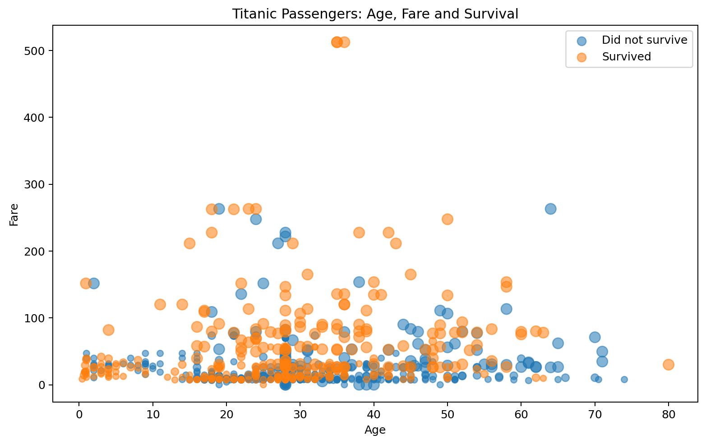
Figure 7. Static preview of the interactive Plotly visualization; the interactive version remains in the notebook.
The interactive view supports exploratory storytelling because the audience can inspect individual observations and compare multiple passenger attributes at the same time. The report includes a static preview for document compatibility; the full interactive version should be opened from the submitted notebook.

12. Overall Data Story
The analysis begins with the overall survival outcome and then progressively adds passenger characteristics. The first chart establishes that non-survival was more common than survival. The gender analysis then reveals a substantial difference in outcomes between male and female passengers. Passenger class introduces another strong dimension, with different survival rates across the three classes.
The age distribution adds demographic context, while the combined class-and-gender chart demonstrates that multiple variables should be considered together. Finally, the correlation heatmap and interactive Plotly visualization provide broader exploratory views of the relationships within the dataset.
Taken together, the visualizations form a coherent narrative: survival was not evenly distributed across the passenger population, and gender and passenger class show particularly clear associations with survival in this dataset.

13. Key Insights
- 342 of 891 passengers survived, giving an overall survival rate of 38.4%.
- Female passengers had a survival rate of 74.2%, compared with 18.9% for male passengers.
- Survival rates differed across passenger classes: 63.0% in first class, 47.3% in second class, and 24.2% in third class.
- Age distributions provide additional demographic context for the survival outcome.
- Combining gender and passenger class reveals more detailed survival patterns than either variable alone.
- The correlation heatmap provides a compact overview of numerical relationships, while the Plotly chart enables interactive exploration.

14. Scientific / Analytical Implications
Because the Titanic dataset is a historical observational dataset, scientific and analytical implications are more appropriate than direct modern business recommendations.
- Gender and passenger class are strong candidate features for further survival modeling.
- Future analysis could test interactions between gender, class, age, and family-related variables.
- The observed associations can guide hypothesis formation, but they should not be interpreted as causal effects.
- The visual workflow demonstrates how exploratory visualization can support feature selection and hypothesis generation before predictive modeling.
- The interactive visualization shows how combining several dimensions can improve exploratory understanding for non-technical audiences.

15. Limitations
- The analysis is based on the cleaned Titanic dataset used in the Week 2 notebook; preprocessing decisions from Week 1 are inherited.
- The dataset is historical and observational, so the findings describe associations within this sample rather than causal relationships.
- Visualization alone cannot establish why a survival difference occurred.
- The Plotly chart is interactive in the notebook; the DOCX contains a static preview because Word documents do not preserve notebook interactivity.

16. Conclusion
This Week 2 project demonstrates how advanced visualization can transform a structured dataset into a coherent data story. Using six static visualizations and one interactive Plotly visualization, the analysis examined overall survival, gender, passenger class, age, combined class-and-gender patterns, and numerical relationships.
Overall, the analysis shows clear differences in survival outcomes across gender and passenger class, while age and other numerical variables provide additional context. The project also demonstrates the value of selecting chart types according to the question being asked and explaining each visualization in terms that a non-technical audience can understand.

17. References / Project Sources
1. Cleaned Titanic dataset: titanic_cleaned.csv, carried forward from the Week 1 project.
2. Python analysis notebook: Week_2_Titanic_Data_Visualization (1).ipynb.
3. Python libraries used in the notebook: Pandas, NumPy, Matplotlib, Seaborn, and Plotly.

