WEEK 3
STATISTICAL ANALYSIS AND
HYPOTHESIS TESTING IN PYTHON
Wine Quality Dataset

Dataset | Wine Quality – Red and White Wine
Observations | 6,497 combined observations
Statistical Tests | Welch t-test, One-Way ANOVA, Tukey HSD, Chi-square
Significance Level | α = 0.05

1. Introduction
This Week 3 project applies statistical analysis and hypothesis testing to the Wine Quality dataset. The purpose is to move beyond visual observations and determine whether selected differences or associations in the data are statistically significant.
The analysis combines red and white wine observations and examines alcohol content, wine quality, and wine type. Three statistical questions are investigated using a Welch independent samples t-test, one-way ANOVA with Tukey HSD post-hoc analysis, and a chi-square test of independence.

2. Dataset Description
The project uses the Wine Quality dataset containing physicochemical measurements and a quality score for red and white wines. The red and white datasets were combined and a new `wine_type` variable was added to identify the two wine categories.
Variable group | Type | Description
Wine type | Categorical | Red or White
Alcohol | Numerical | Alcohol content
Quality | Ordinal / categorical score | Wine quality score
Physicochemical variables | Numerical | Acidity, sugar, chlorides, sulfur dioxide, density, pH, sulphates, and related measures

3. Research Questions and Hypotheses
The project investigates three statistical questions.

Hypothesis 1 – Welch Independent Samples t-test
H₀: There is no statistically significant difference in mean alcohol content between red and white wines.
H₁: There is a statistically significant difference in mean alcohol content between red and white wines.

Hypothesis 2 – One-Way ANOVA
H₀: Mean alcohol content is the same across all wine quality score groups.
H₁: At least one wine quality group has a different mean alcohol content.

Hypothesis 3 – Chi-Square Test
H₀: Wine type and the defined quality group are independent.
H₁: Wine type and the defined quality group are significantly associated.
A significance level of α = 0.05 is used for all hypothesis tests.

4. Statistical Methodology

Welch Independent Samples t-test
Used to compare mean alcohol content between the two independent groups: red wine and white wine. Welch's version does not require equal population variances.

One-Way ANOVA
Used to test whether mean alcohol content differs across multiple wine quality score groups.

Tukey HSD Post-Hoc Test
Applied after the significant ANOVA result to identify which specific quality-score pairs differ while accounting for multiple comparisons.

Chi-Square Test of Independence
Used to test whether wine type and the defined quality group are statistically associated.

Effect Sizes
Cohen's d is reported for the t-test, eta-squared for ANOVA, and Cramér's V for the chi-square test so that statistical significance can be considered alongside effect magnitude.

5. Data Preparation and Quality Checks
The red and white wine datasets were loaded, labeled by wine type, and combined into a single dataset containing 6,497 observations. The notebook checks data structure, descriptive statistics, missing values, and duplicate rows.
The duplicate check identified 1,177 duplicate rows. These observations were retained because identical physicochemical measurements can represent multiple wine samples; removing them without domain justification could change the dataset's distribution.

6. Exploratory Analysis and Visualizations
The exploratory visualizations provide context before formal hypothesis testing. They show the distribution of wine types, the alcohol distributions by wine type, and alcohol content across quality scores.

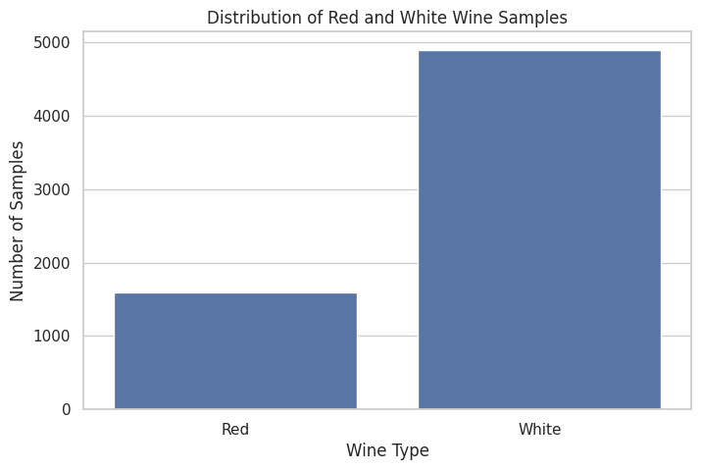
Figure 1. Exploratory visualization generated in the Week 3 notebook.

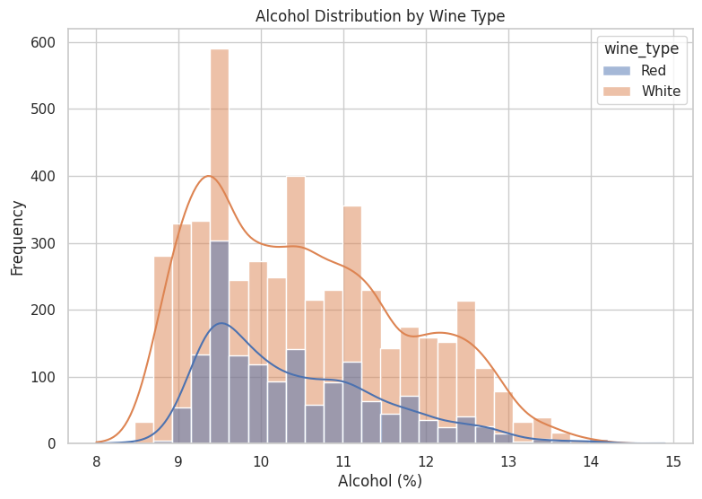
Figure 2. Exploratory visualization generated in the Week 3 notebook.

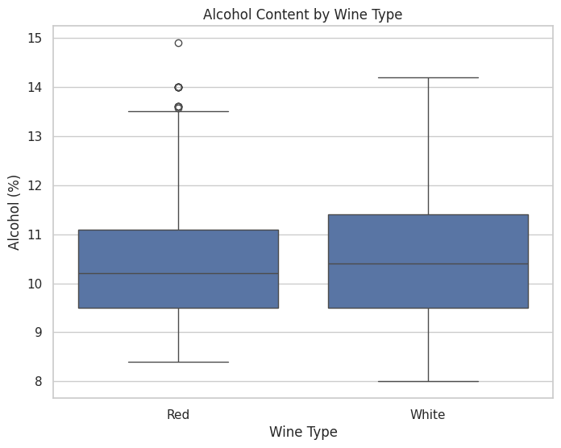
Figure 3. Exploratory visualization generated in the Week 3 notebook.

7. Statistical Assumptions
The t-test treats red and white wine observations as independent groups; Welch's method is used because it does not require equal variances. ANOVA assumes independent observations, approximately normal outcomes within groups, and reasonably similar variances; with the large sample size, the method is reasonably robust to moderate departures from normality. The chi-square test requires independent observations and sufficiently large expected cell frequencies.

8. Hypothesis Test 1 – Welch Independent Samples t-test
Mean alcohol content for red wine: 10.423
Mean alcohol content for white wine: 10.514
t-statistic: -2.859
p-value: 0.00428
Cohen's d: -0.0766

Interpretation
The p-value (0.00428) is below 0.05, so the null hypothesis is rejected. There is statistically significant evidence of a difference in mean alcohol content between red and white wines.
The estimated difference is small in standardized terms: Cohen's d is approximately -0.077. Thus, statistical significance should not be interpreted as a large practical difference.

9. Confidence Interval for the Mean Difference
The completed notebook calculates a 95% confidence interval for the red-minus-white mean alcohol difference of approximately [-0.154, -0.029]. The interval does not include zero, which is consistent with the statistically significant t-test result.

10. Hypothesis Test 2 – One-Way ANOVA
F-statistic: 320.593
p-value: < 0.001
Eta-squared: 0.2286

Interpretation
The ANOVA result is statistically significant (p < 0.001), so the null hypothesis is rejected. There is evidence that mean alcohol content is not the same across all wine quality score groups.
The eta-squared value is approximately 0.2286, indicating that about 22.9% of the total variation in alcohol content is associated with the quality-group factor in this analysis.

11. Tukey HSD Post-Hoc Analysis
Because the ANOVA test identified an overall significant difference, Tukey's HSD post-hoc procedure was used to identify specific quality-score pairs that differ while controlling the family-wise error rate.
The notebook's Tukey output contains multiple pairwise comparisons. Several quality-score pairs are statistically significant, while some pairs are not. Therefore, the ANOVA finding is refined by showing that differences are concentrated in particular quality-group comparisons.

12. Hypothesis Test 3 – Chi-Square Test of Independence
Chi-square statistic: 49.209
p-value: 4.278e-03
Cramér's V: 0.0870

Interpretation
The chi-square p-value (4.278e-03) is far below 0.05, so the null hypothesis is rejected. There is statistically significant evidence of an association between wine type and the defined quality group.
Cramér's V is approximately 0.0870, indicating that the association is relatively small in magnitude despite being statistically significant.

13. Statistical Result Visualizations
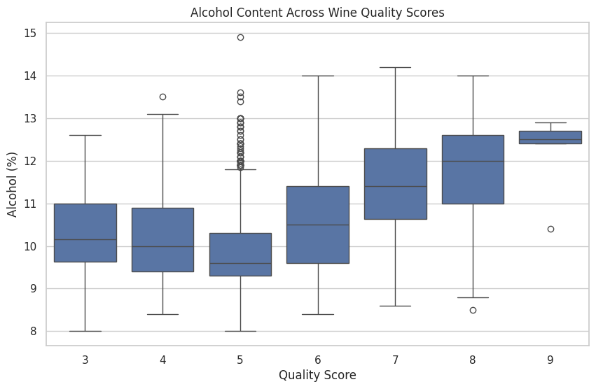
Figure 4. Statistical-analysis visualization from the completed notebook.
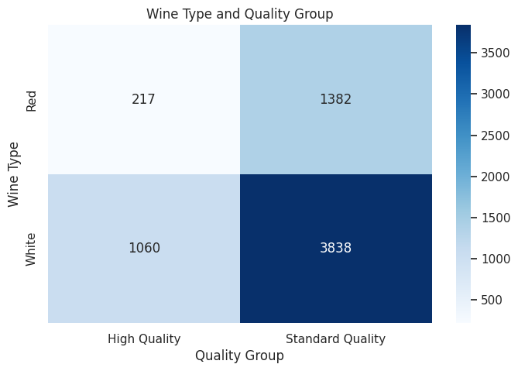
Figure 5. Statistical-analysis visualization from the completed notebook.

14. Statistical Test Summary
Test | Statistic | p-value | Effect size | Decision
Welch t-test | -2.859 | 0.00428 | Cohen's d = -0.0766 | Reject H₀
One-way ANOVA | 320.593 | < 0.001 | Eta² = 0.2286 | Reject H₀
Chi-square | 49.209 | 4.278e-03 | Cramér's V = 0.0870 | Reject H₀

15. Key Findings
- Mean alcohol content differs statistically between red and white wines, but the standardized difference is small.
- Mean alcohol content differs significantly across wine quality score groups.
- Tukey HSD shows that some quality-score pairs differ significantly while others do not.
- Wine type and the defined quality group are statistically associated.
- The chi-square effect size indicates a relatively small association.
- Statistical significance and practical effect magnitude are not the same; effect sizes provide additional context.

16. Analytical Implications
The results show how hypothesis testing can distinguish statistically detectable patterns from differences that may be small in practical terms. For future analysis, additional modeling could examine several physicochemical variables simultaneously and investigate whether their combined effects improve prediction of quality. Because this is observational data, the statistical associations should not be interpreted as causal relationships.

17. Limitations
- The dataset is observational, so statistical associations do not establish causation.
- Duplicate observations were retained and documented rather than removed without domain justification.
- ANOVA identifies an overall group difference; Tukey HSD is required to identify specific pairwise differences.
- The quality score is an ordered rating, and treating it as a grouping variable for ANOVA is an analytical simplification.
- Statistical significance can be influenced by the large sample size, so effect sizes are reported alongside p-values.

18. Conclusion
The Week 3 statistical analysis provides evidence against all three null hypotheses at the 0.05 significance level. The Welch t-test found a statistically significant difference in mean alcohol content between red and white wines. The ANOVA found statistically significant differences in mean alcohol content across quality score groups, and Tukey HSD identified specific pairwise differences. The chi-square test found a statistically significant association between wine type and the defined quality group.
Importantly, the effect-size results show that statistical significance does not automatically imply a large practical effect. The t-test and chi-square analyses have relatively small effect sizes, while the ANOVA explains a more substantial proportion of variation. Overall, the project demonstrates a complete statistical workflow from hypothesis formulation and exploratory visualization to formal testing, effect-size analysis, and evidence-based interpretation.

19. References
1. Wine Quality dataset used in the Week 3 notebook.
2. Completed Python notebook: Week_3_Wine_Statistical_Analysis (3).ipynb.
3. Python libraries used: Pandas, NumPy, Matplotlib, Seaborn, SciPy, and Statsmodels.

