WEEK 1 PROJECT
Data Acquisition, Cleaning and
Exploratory Data Analysis
Titanic Dataset

Python • Pandas • NumPy • Matplotlib • Seaborn • Google Colab

Prepared as the Week 1 Data Science Deliverable

1. Introduction
The objective of this project is to demonstrate the basic data preparation and exploratory data analysis process using the Titanic dataset. The project includes data acquisition, data cleaning, missing-value handling, duplicate checking, statistical analysis, visualization, and interpretation of results.

2. Dataset Description
The Titanic dataset contains information about passengers who travelled on the Titanic. The dataset includes variables such as passenger ID, survival status, passenger class, name, sex, age, family information, ticket, fare, cabin, and embarkation port.
The dataset contains 891 passenger records and 12 columns before cleaning.
Column | Type | Description
PassengerId | Integer | Unique passenger identifier
Survived | Integer | Survival outcome: 0 = did not survive, 1 = survived
Pclass | Integer | Passenger class
Name | Text | Passenger name
Sex | Categorical | Passenger sex
Age | Numeric | Passenger age
SibSp | Integer | Siblings/spouses aboard
Parch | Integer | Parents/children aboard
Ticket | Text | Ticket identifier
Fare | Numeric | Passenger fare
Cabin | Categorical/Text | Cabin information
Embarked | Categorical | Port of embarkation

3. Tools and Technologies
- Python
- Google Colab
- Pandas
- NumPy
- Matplotlib
- Seaborn

4. Data Acquisition
The dataset was acquired from a publicly available Titanic CSV file. The notebook loads the data directly into a Pandas DataFrame using the CSV URL.
url = "https://raw.githubusercontent.com/datasciencedojo/datasets/master/titanic.csv"
df = pd.read_csv(url)
The initial inspection confirmed that the dataset loaded successfully. The first rows were displayed using df.head(), and the dataset dimensions were checked using df.shape.
df.head()
df.shape
Initial dataset size: 891 rows × 12 columns.

5. Data Quality Assessment
Before cleaning, the dataset was examined for missing values, duplicate records, and data types. This step helps identify data-quality issues before analysis.

5.1 Missing Values
The initial missing-value check found 177 missing Age values, 687 missing Cabin values, and 2 missing Embarked values. The remaining columns had no missing values.
df.isnull().sum()
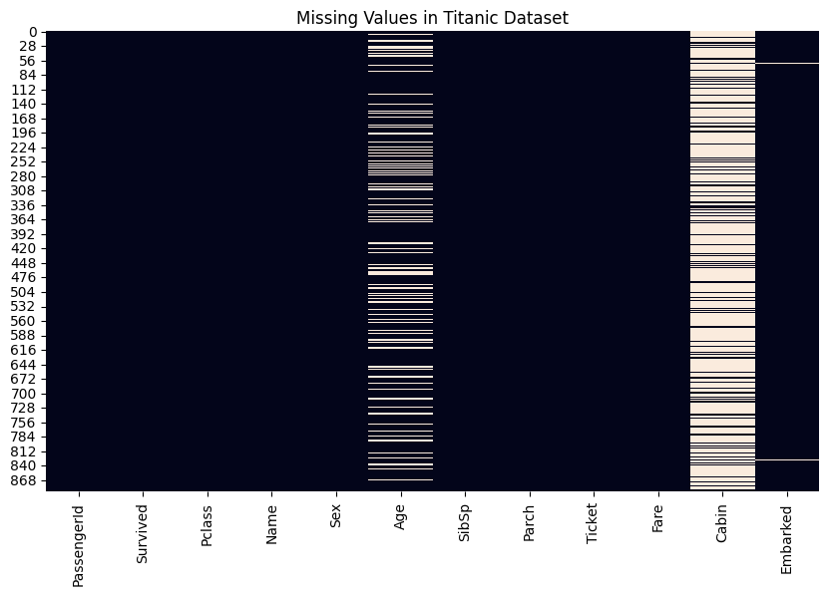
Figure 1 — Missing Values Heatmap
This heatmap visualizes missing observations before cleaning.

5.2 Duplicate Records
Duplicate rows were checked using Pandas. The result was 0, so no duplicate records were removed.
df.duplicated().sum()

5.3 Data Types
The notebook inspected the data types using df.dtypes and df.info(). Numerical variables such as Age and Fare were represented as floating-point values, while text/categorical variables were represented as object values in the original dataset.
df.dtypes
df.info()

6. Data Cleaning
The cleaning methods were selected according to the type of variable and the amount of missing information.

6.1 Age — Median Imputation
Missing Age values were replaced with the median Age. Age is numerical, and the median is less affected by extreme values than the mean.
df['Age'] = df['Age'].fillna(df['Age'].median())

6.2 Embarked — Mode Imputation
Missing Embarked values were replaced with the most frequent category. Embarked is categorical, so mode imputation is appropriate for the approach used in this project.
df['Embarked'] = df['Embarked'].fillna(df['Embarked'].mode()[0])

6.3 Cabin — Column Removal
The Cabin column was removed because it contained a large number of missing values, making reliable imputation difficult.
df = df.drop(columns=['Cabin'])

6.4 Cleaning Verification
After cleaning, the missing-value check showed 0 missing values in all remaining columns.
df.isnull().sum()

7. Exploratory Data Analysis
Exploratory Data Analysis was performed to understand passenger survival, gender, passenger class, age distribution, fare distribution, and relationships between numerical variables.

7.1 Summary Statistics
The descriptive statistics show that the cleaned dataset contains 891 observations. The mean survival value is approximately 0.384, which corresponds to an overall survival rate of approximately 38.38%. The median age is 28 years, while the median fare is 14.4542.
df.describe()

7.2 Survival Distribution
There were 549 passengers who did not survive and 342 passengers who survived. This corresponds to approximately 61.62% not surviving and 38.38% surviving.
df['Survived'].value_counts()
df['Survived'].value_counts(normalize=True) * 100
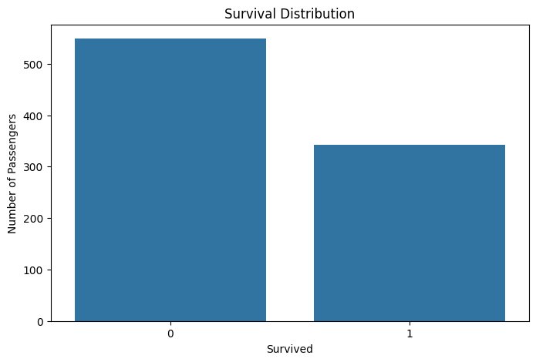
Figure 2 — Survival Distribution
The chart compares passengers who did not survive with passengers who survived.

7.3 Survival by Gender
The analysis shows a clear difference in survival rates between female and male passengers. Female passengers had a survival rate of approximately 74.20%, while male passengers had a survival rate of approximately 18.89%.
df.groupby('Sex')['Survived'].mean() * 100
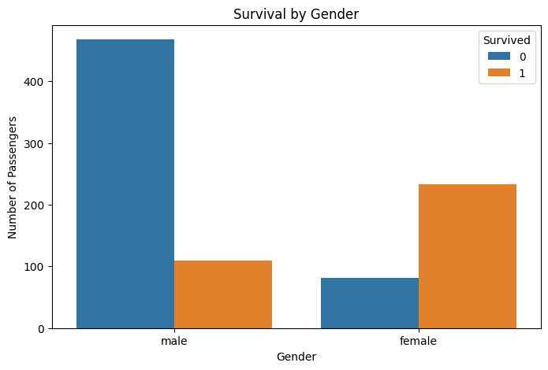
Figure 3 — Survival by Gender
The chart compares survival outcomes for female and male passengers.

7.4 Survival by Passenger Class
Survival rates differed across passenger classes. Class 1 had the highest survival rate at approximately 62.96%, followed by Class 2 at 47.28% and Class 3 at 24.24%.
df.groupby('Pclass')['Survived'].mean() * 100
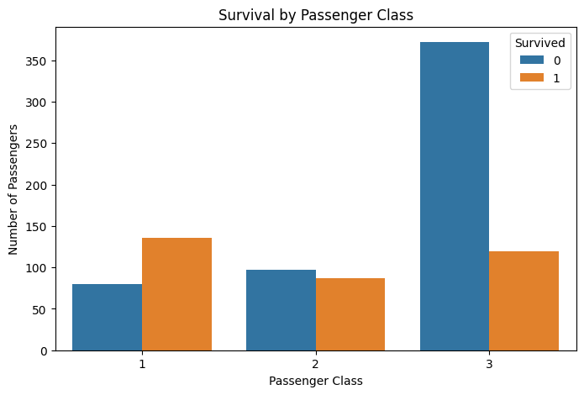
Figure 4 — Survival by Passenger Class
The chart compares survival outcomes across passenger classes.

7.5 Age Distribution
The age histogram shows the distribution of passenger ages. The dataset contains passengers from children to elderly people, with ages ranging from approximately 0.42 to 80 years in the descriptive statistics.
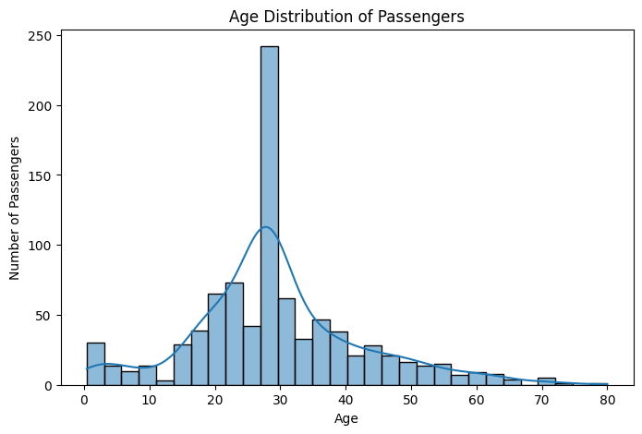
Figure 5 — Age Distribution
The histogram shows the distribution of passenger ages.

7.6 Age and Fare
The scatter plot explores the relationship between age and fare while distinguishing survival outcomes. It provides a visual way to inspect whether observations with different fares and ages show different survival patterns.
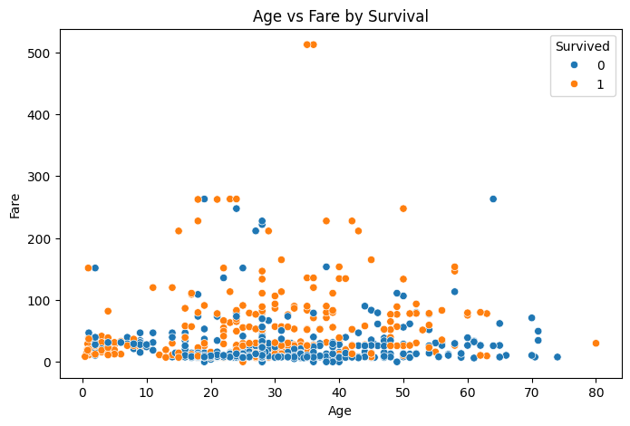
Figure 6 — Age vs Fare by Survival
The scatter plot explores the relationship between age and fare while distinguishing survival outcomes.

7.7 Correlation Analysis
A correlation matrix was calculated for numerical variables. The correlation heatmap helps identify the strength and direction of linear relationships among the numerical variables.
numeric_df = df.select_dtypes(include=np.number)
correlation = numeric_df.corr()
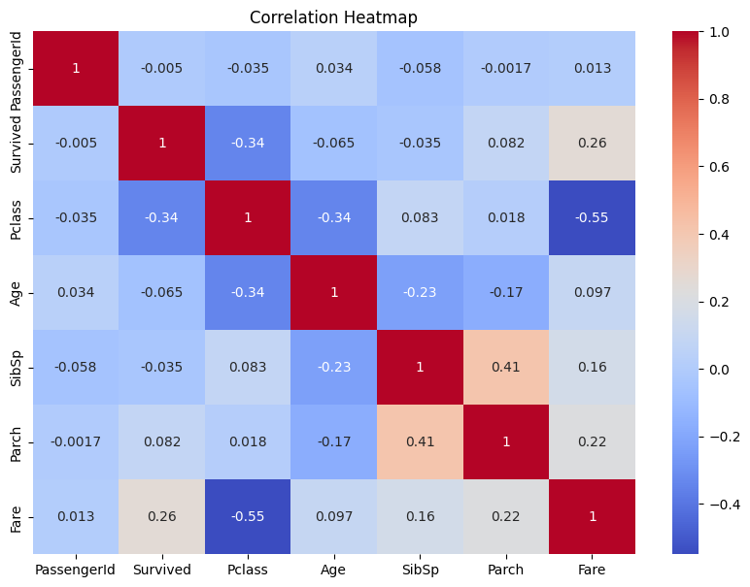
Figure 7 — Correlation Heatmap
The heatmap shows correlations among numerical variables.

7.8 Fare Outliers
The Fare box plot was used to examine the distribution and potential outliers. Unusually high fare values were retained rather than automatically removed because an unusual value is not necessarily an error.
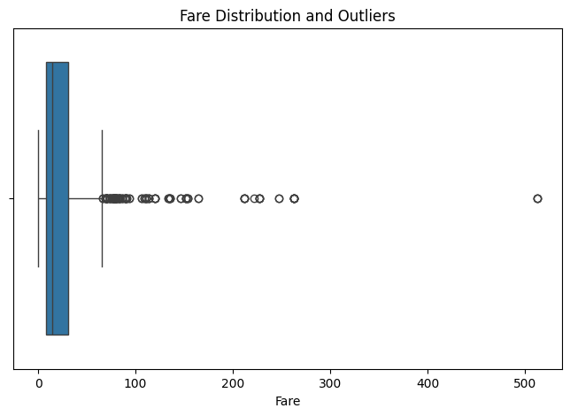
Figure 8 — Fare Distribution and Outliers
The box plot highlights the spread of fares and potential high-value observations.

7.9 Survival Rate by Class
The survival-rate bar chart provides a direct comparison of the percentage of passengers who survived within each passenger class.
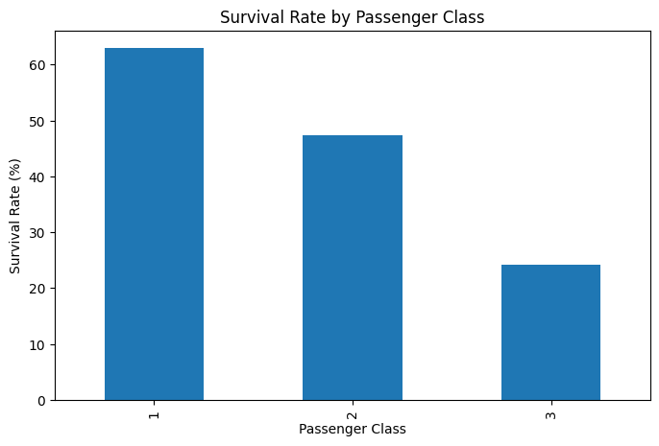
Figure 9 — Survival Rate by Passenger Class
The bar chart presents survival percentages by passenger class.

8. Key Insights
- Overall survival was 38.38%, while 61.62% of passengers did not survive.
- Female passengers had a substantially higher survival rate (approximately 74.20%) than male passengers (approximately 18.89%).
- Passenger class was associated with different survival rates: Class 1 was approximately 62.96%, Class 2 was 47.28%, and Class 3 was 24.24%.
- The dataset contains a wide range of passenger ages, from children to elderly passengers.
- Fare values showed considerable variation, including high-value observations identified by the box plot.
- Correlation analysis provided a way to examine relationships among numerical variables; correlation alone does not establish causation.

9. Methodology Summary
- Acquire the publicly available Titanic dataset.
- Load the CSV data into a Pandas DataFrame.
- Inspect rows, columns, data types, and dataset dimensions.
- Check missing values and duplicate records.
- Handle missing Age and Embarked values and remove Cabin.
- Verify that the cleaned dataset contains no missing values in the remaining columns.
- Calculate descriptive and survival statistics.
- Create visualizations to explore survival, gender, class, age, fare, and correlations.
- Interpret the observed patterns and summarize key insights.

10. Conclusion
This project demonstrated the basic data science workflow of acquiring, cleaning, and exploring a real-world dataset. Missing values were handled, duplicate records were checked, and the dataset was explored using summary statistics and multiple visualizations. The analysis highlighted clear differences in survival rates by gender and passenger class and demonstrated how visualization can support exploratory analysis and interpretation.

Appendix A — Main Code Snippets
Library imports and data acquisition:
import pandas as pd
import numpy as np
import matplotlib.pyplot as plt
import seaborn as sns
url = "https://raw.githubusercontent.com/datasciencedojo/datasets/master/titanic.csv"
df = pd.read_csv(url)
Cleaning:
df['Age'] = df['Age'].fillna(df['Age'].median())
df['Embarked'] = df['Embarked'].fillna(df['Embarked'].mode()[0])
df = df.drop(columns=['Cabin'])
EDA examples:
df.describe()
df['Survived'].value_counts(normalize=True) * 100
df.groupby('Sex')['Survived'].mean() * 100
df.groupby('Pclass')['Survived'].mean() * 100
The code and results in this report are based on the uploaded Week 1 Titanic analysis notebook.

