WEEK 4 TASK
Machine Learning Model Development and Evaluation
Using Logistic Regression

Dataset | Breast Cancer Wisconsin Dataset
Algorithm | Logistic Regression
Problem Type | Binary Classification
Environment | Python / Google Colab / Scikit-learn

Prepared for Week 4 Machine Learning Task

1. Introduction
Machine Learning is a branch of Artificial Intelligence that enables computers to learn patterns from data and make predictions without being explicitly programmed for every decision. This project demonstrates a complete machine learning classification workflow using Python and Scikit-learn.
The Breast Cancer Wisconsin dataset is used with Logistic Regression as the classification algorithm. The workflow covers data exploration, data cleaning, preprocessing, model training, prediction, evaluation, visualization, and critical discussion of model performance.

2. Project Objective
The objective is to develop and evaluate a basic binary classification model and document the complete model-development process.
- Explore and understand the dataset.
- Check for missing and duplicate values.
- Prepare the data for machine learning.
- Split the data into training and testing sets.
- Standardize the numerical features.
- Develop and train a Logistic Regression model.
- Generate predictions for unseen test data.
- Evaluate performance using classification metrics.
- Use a confusion matrix and ROC curve to visualize performance.
- Discuss possible errors, limitations, and improvements.

3. Dataset Description
The project uses the Breast Cancer Wisconsin dataset available through Scikit-learn. The notebook reports 569 observations and 30 numerical features. The target classes are malignant and benign.
The target distribution in the notebook contains 212 observations for class 0 (malignant) and 357 observations for class 1 (benign).
Dataset shape: 569 rows × 30 features.
Target classes: malignant and benign.

4. Data Preparation and Cleaning
The dataset was inspected before model development. The notebook checks the shape, first rows, target classes, target distribution, data types, and statistical summary.

4.1 Missing Values
The missing-value check found 0 total missing values across all 30 features. Therefore, no missing-value imputation was required.

4.2 Duplicate Values
The duplicate-row check found 0 duplicate rows in the feature data.

4.3 Target Distribution
The target distribution was inspected numerically and visualized with a class-distribution count plot. The classes are not identical in size, with more benign observations than malignant observations.

5. Data Preprocessing

5.1 Train-Test Split
The dataset was divided into training and testing sets using an 80:20 split. The notebook uses random_state=42 for reproducibility and stratify=y to preserve the class distribution.
Training samples: 455
Testing samples: 114
X_train, X_test, y_train, y_test = train_test_split(
X, y,
test_size=0.20,
random_state=42,
stratify=y
)

5.2 Feature Standardization
StandardScaler was used to standardize the numerical features. The scaler was fitted only on the training data and then applied to the test data. This avoids using information from the test set during preprocessing.
scaler = StandardScaler()
X_train_scaled = scaler.fit_transform(X_train)
X_test_scaled = scaler.transform(X_test)

6. Model Selection and Training

6.1 Why Logistic Regression?
Logistic Regression was selected because the project is a binary classification problem. It is a simple, efficient, and interpretable classification algorithm and provides a suitable baseline model for evaluating classification performance.

6.2 Model Configuration
model = LogisticRegression(
max_iter=1000,
random_state=42
)

6.3 Model Training
The model was trained using the standardized training data. During training, the model learns the relationship between the input features and the target classes.
model.fit(X_train_scaled, y_train)

7. Model Prediction
After training, the model generated class predictions for the unseen test set. Prediction probabilities were also generated so that ROC-AUC and the ROC curve could be calculated.
y_pred = model.predict(X_test_scaled)
y_prob = model.predict_proba(X_test_scaled)[:, 1]

8. Model Evaluation
The model was evaluated using accuracy, precision, recall, F1 Score, and ROC-AUC. The actual values below are taken from the executed notebook.
Metric | Score
Accuracy | 0.9825
Precision | 0.9861
Recall | 0.9861
F1 Score | 0.9861
ROC-AUC | 0.9954

8.1 Classification Report
The classification report shows strong performance for both target classes. For malignant, precision, recall, and F1-score are approximately 0.98. For benign, all three are approximately 0.99. The report covers all 114 test observations.

9. Confusion Matrix
The confusion matrix summarizes correct and incorrect classifications. From the executed results, the matrix corresponds to 41 true negatives, 1 false positive, 1 false negative, and 71 true positives when class 1 (benign) is treated as the positive class.
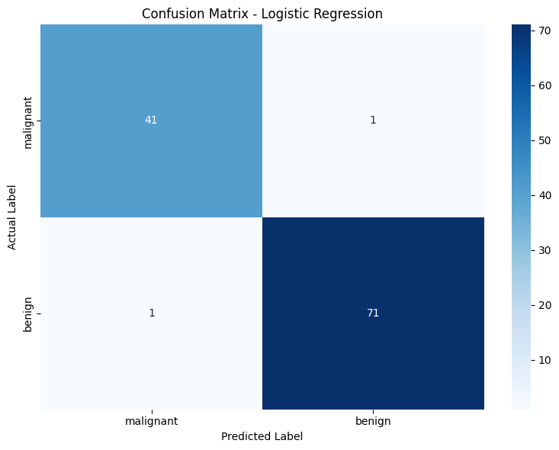
Figure 1. Confusion Matrix - Logistic Regression
The small number of false predictions indicates that the model performed strongly on the test set. However, a confusion matrix should always be interpreted together with the dataset context and the consequences of different error types.

10. ROC Curve
The ROC curve evaluates the relationship between the true positive rate and false positive rate across classification thresholds. The notebook reports an ROC-AUC of 0.9954, indicating very strong class discrimination on this test split.
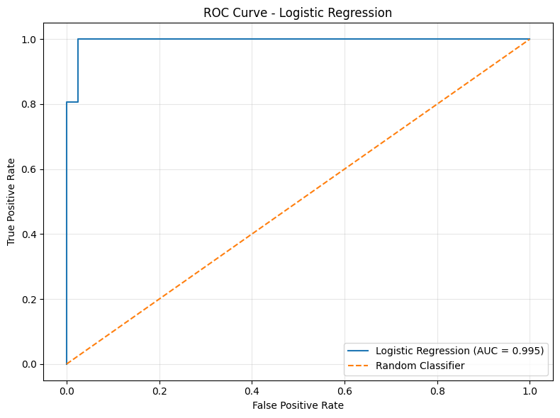
Figure 2. ROC Curve - Logistic Regression

11. Overfitting and Underfitting Analysis
The training accuracy was 0.9890, while the testing accuracy was 0.9825. The difference was 0.0066. The relatively small difference suggests that the model generalizes well on this particular train-test split and does not show a large training-to-testing performance gap. This does not prove that overfitting is impossible; cross-validation would provide a stronger assessment.

12. Sources of Error and Model Limitations
- False positive and false negative predictions can occur even when overall accuracy is high.
- The dataset has a finite size and may not represent every possible population or real-world setting.
- The model uses only the features available in the dataset; relevant factors not represented by those features cannot be learned.
- Logistic Regression may be less suitable when relationships between predictors and the target are highly complex or non-linear.
- The reported performance is based on one train-test split, so it should not be interpreted as a universal performance guarantee.

13. Possible Model Improvements
- Use cross-validation to obtain a more reliable estimate of generalization performance.
- Tune Logistic Regression hyperparameters using GridSearchCV or RandomizedSearchCV.
- Compare Logistic Regression with Decision Tree, Random Forest, Support Vector Machine, and K-Nearest Neighbors models.
- Evaluate feature selection or dimensionality-reduction approaches where appropriate.
- Use a larger and more diverse dataset when available.
- Compare multiple models using the same validation procedure and the same evaluation metrics.

14. Final Results
The executed notebook produced the following final test-set performance:
- Accuracy: 0.9825
- Precision: 0.9861
- Recall: 0.9861
- F1 Score: 0.9861
- ROC-AUC: 0.9954
Training accuracy was 0.9890 and testing accuracy was 0.9825, with a difference of 0.0066.

15. Conclusion
This project demonstrated the complete machine learning model development and evaluation process using the Breast Cancer Wisconsin dataset and Logistic Regression. The workflow included data exploration, data-quality checks, train-test splitting, feature standardization, model training, prediction, and quantitative and visual evaluation.
On the executed test split, the model achieved 0.9825 accuracy and a 0.9954 ROC-AUC. The small difference between training and testing accuracy also indicates good performance on this particular split. Further validation and comparison with alternative algorithms would be appropriate before drawing broader conclusions.

16. References
Scikit-learn documentation and the built-in Breast Cancer Wisconsin dataset were used through the Python/Scikit-learn environment in the Colab notebook.
Primary library: Scikit-learn (sklearn).
Dataset used: Breast Cancer Wisconsin dataset provided by Scikit-learn.

