WEEK 5
COMPREHENSIVE DATA SCIENCE PROJECT REPORT
Breast Cancer Classification Using Machine Learning
Comprehensive Data Analysis, Statistical Analysis, Machine Learning, Evaluation and Strategic Recommendations

Student Name | ____________________________
Internship / Program | ____________________________
Dataset | sklearn.datasets.load_breast_cancer
Date | August 2026

Executive Summary
This Week 5 project integrates exploratory data analysis, statistical hypothesis testing, machine-learning model development, model comparison, evaluation, and strategic recommendations using the Breast Cancer dataset available through scikit-learn. The dataset contains 569 observations and 30 numerical features describing measured characteristics of breast cancer samples. The target variable contains two classes: malignant and benign.
The analysis began with data understanding and quality checks. No missing values or duplicate rows were found. Exploratory analysis examined class distribution, feature distributions, mean radius differences, and correlations among numerical features. The dataset contained 357 benign observations and 212 malignant observations.
A Chi-square test was used to examine the association between a median-based mean-radius group and diagnosis. The test produced a chi-square statistic of 234.545 and a p-value of approximately 6.08 × 10⁻⁵³. At the 0.05 significance level, the null hypothesis was rejected, indicating statistically significant evidence of an association in this dataset.
Three classification algorithms were evaluated: Logistic Regression, Decision Tree, and Random Forest. Logistic Regression was the best-performing model based on F1 score, achieving 98.25% accuracy, 98.61% precision, 98.61% recall, and 98.61% F1 score on the held-out test set. The test set contained 114 observations.
Random Forest feature importance was separately used to identify influential predictive features. The leading features included worst perimeter, worst area, worst concave points, mean concave points, and worst radius. These are model-specific predictive importance measures and should not be interpreted as causal effects.
The strategic recommendations emphasize using machine learning as a research-support tool, evaluating multiple performance metrics, investigating influential features, validating models on independent datasets, and maintaining qualified human oversight. Because this is a benchmark dataset, the model should not be treated as a clinically validated diagnostic system.

1. Introduction

1.1 Background
Data science combines data preparation, statistical reasoning, visualization, and predictive modeling to support evidence-based decisions. This final-week project brings together the skills developed during the earlier internship tasks into one end-to-end workflow.

1.2 Problem Statement
The project investigates whether measured characteristics in the scikit-learn Breast Cancer dataset can be used to classify observations into malignant and benign categories using machine-learning methods.

1.3 Project Objectives
- Understand and prepare the Breast Cancer dataset.
- Explore distributions, class balance, and relationships among features.
- Perform a statistical hypothesis test related to diagnosis.
- Train and compare Logistic Regression, Decision Tree, and Random Forest classifiers.
- Evaluate models using accuracy, precision, recall, and F1 score.
- Identify influential features using Random Forest feature importance.
- Translate the analytical findings into strategic research recommendations.
- Document limitations and propose future improvements.

2. Dataset Description
The project uses the Breast Cancer dataset loaded with sklearn.datasets.load_breast_cancer. The source notebook converts the feature matrix into a pandas DataFrame, adds the original numeric target, and maps target values to readable diagnosis labels: 0 = malignant and 1 = benign.
Item | Value
Observations | 569
Numerical features | 30
Target classes | 2
Benign observations | 357
Malignant observations | 212
Missing values | 0
Duplicate rows | 0
Machine-learning test set | 114 observations (20%)

2.1 Feature Groups
The 30 features include mean measurements, standard-error measurements, and worst-case measurements for characteristics such as radius, texture, perimeter, area, smoothness, compactness, concavity, concave points, symmetry, and fractal dimension.

2.2 Data Quality
The notebook's data-quality checks found no missing values and no duplicate rows. The final DataFrame contains 32 columns because the original 30 numerical features are accompanied by the numeric target and the readable diagnosis label.

3. Methodology
The project follows the workflow below:
- Load the benchmark dataset using scikit-learn.
- Convert the feature matrix into a pandas DataFrame and create readable diagnosis labels.
- Inspect dimensions, data types, missing values, duplicates, and descriptive statistics.
- Perform exploratory visual analysis of class distribution, feature distributions, mean radius, and feature correlations.
- Create a median-based mean-radius group and conduct a Chi-square test of association with diagnosis.
- Split the data into training and test sets using an 80/20 split with stratification and random_state=42.
- Standardize training and test features for Logistic Regression.
- Train Logistic Regression, Decision Tree, and Random Forest classifiers.
- Compare accuracy, precision, recall, and F1 score and select the highest-F1 model.
- Evaluate the selected Logistic Regression model with a confusion matrix and classification report.
- Use Random Forest feature importance as a separate model-interpretation exercise.
- Translate the findings into recommendations, impact considerations, limitations, and future work.

3.1 Machine-Learning Setup
Component | Configuration
Train/test split | 80% training / 20% test
Random state | 42
Stratification | Yes
Scaling | StandardScaler for Logistic Regression
Logistic Regression | max_iter=10000, random_state=42
Decision Tree | random_state=42
Random Forest | 200 estimators, random_state=42

4. Exploratory Data Analysis

4.1 Class Distribution
The target distribution contains 357 benign observations and 212 malignant observations. This means the classes are not perfectly balanced, although both classes have substantial representation.
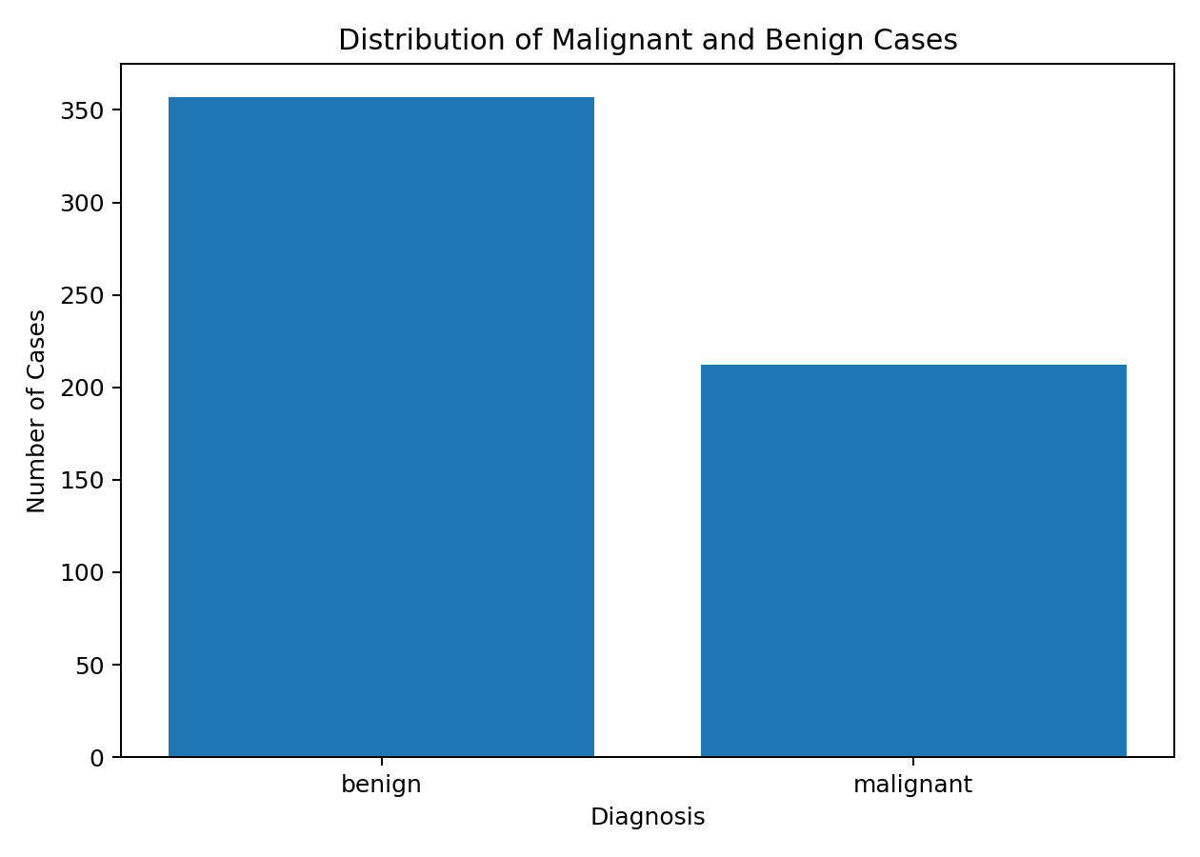
Figure 1. Distribution of malignant and benign cases.

4.2 Mean Radius Comparison
The boxplot compares mean radius between the two diagnosis groups. The visual separation supports the use of feature-level analysis and motivates the later statistical examination of a median-based radius grouping.
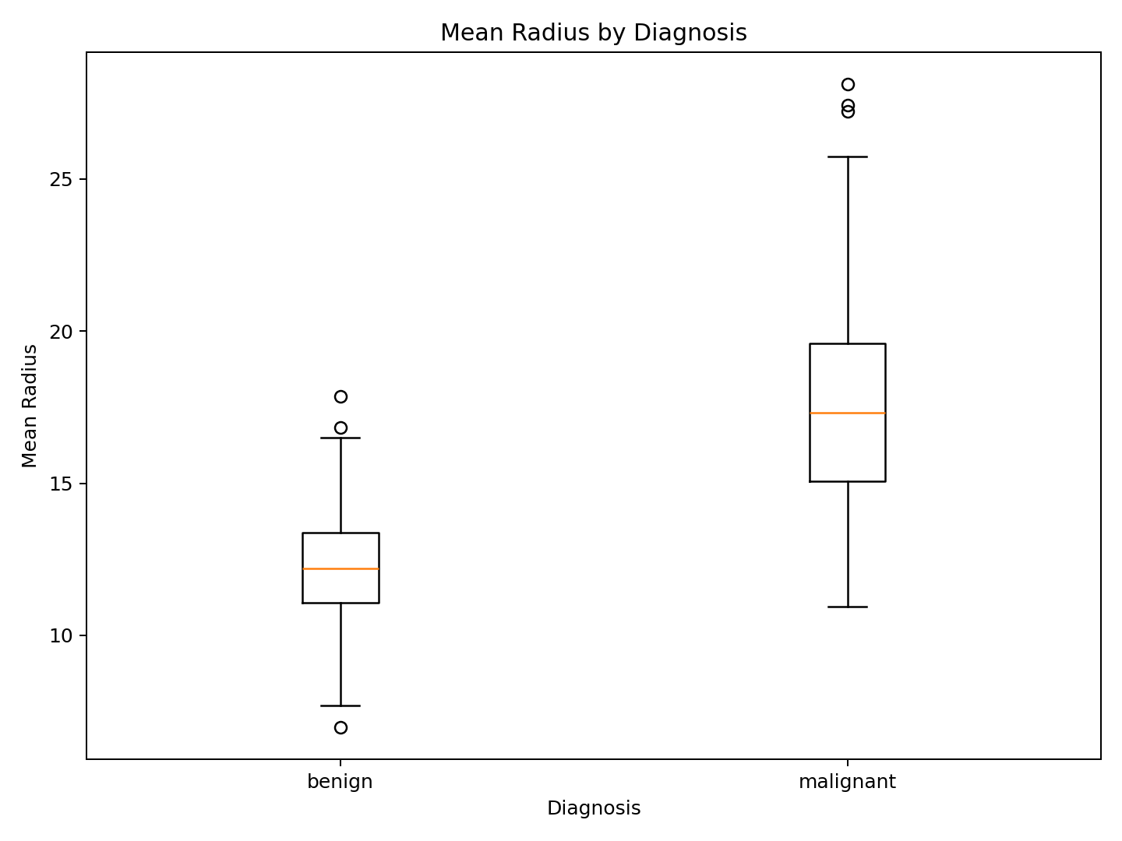
Figure 2. Mean radius by diagnosis.

4.3 Correlation Analysis
The correlation analysis identified strong relationships among several geometric measurements. The strongest absolute correlation reported in the notebook was approximately 0.998 between mean radius and mean perimeter. Other strong relationships included mean radius and mean area, and worst radius and worst perimeter.
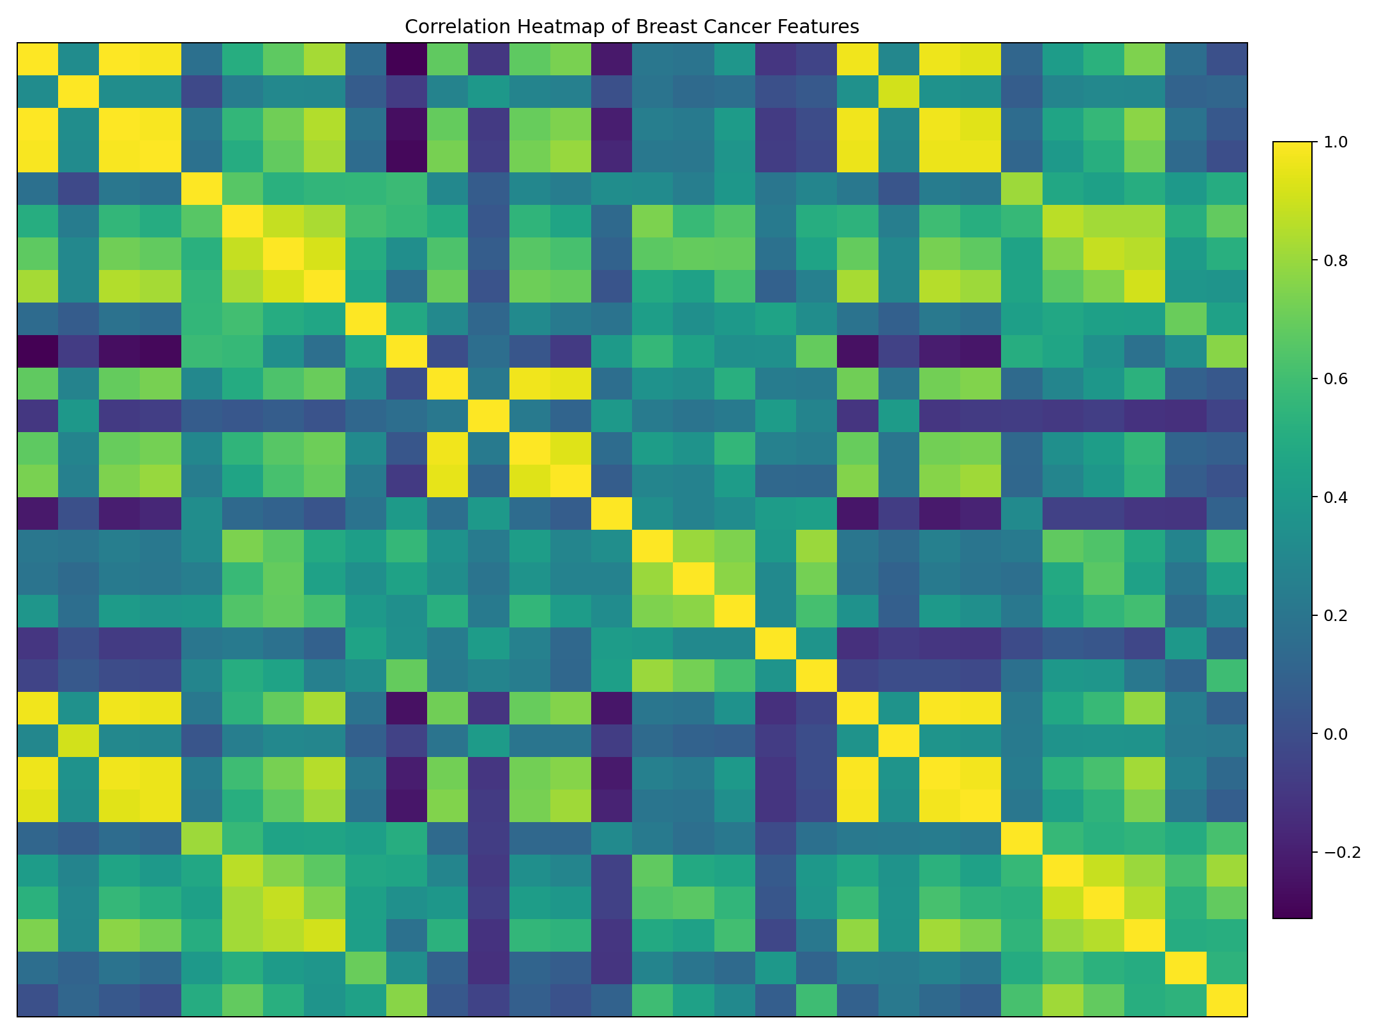
Figure 3. Correlation heatmap of the 30 numerical features.

5. Statistical Analysis and Hypothesis Testing

5.1 Hypotheses
Null hypothesis (H₀): There is no significant association between the mean-radius group and diagnosis.
Alternative hypothesis (H₁): There is a significant association between the mean-radius group and diagnosis.
A significance level of 0.05 was used.

5.2 Group Construction
The notebook divides mean radius into two groups using the dataset median. Observations at or above the median are labeled High Radius, while observations below the median are labeled Low Radius.
Mean-radius group | Benign | Malignant
High Radius | 90 | 195
Low Radius | 267 | 17

5.3 Chi-square Test Result
Statistic | Value
Chi-square statistic | 234.54477585836327
p-value | 6.084766364093077e-53
Significance level | 0.05
Decision | Reject H₀
Because the p-value is far below 0.05, the null hypothesis is rejected. The analysis therefore provides statistically significant evidence of an association between the median-based mean-radius group and diagnosis in this dataset.
This result describes association in the analyzed benchmark dataset. It does not by itself establish causation or clinical validity.

6. Machine Learning Model Development and Results

6.1 Model Comparison
Three classification algorithms were trained and evaluated: Logistic Regression, Decision Tree, and Random Forest. Accuracy, precision, recall, and F1 score were used to compare the models.
Model | Accuracy | Precision | Recall | F1 Score
Logistic Regression | 98.25% | 98.61% | 98.61% | 98.61%
Decision Tree | 91.23% | 95.59% | 90.28% | 92.86%
Random Forest | 95.61% | 95.89% | 97.22% | 96.55%
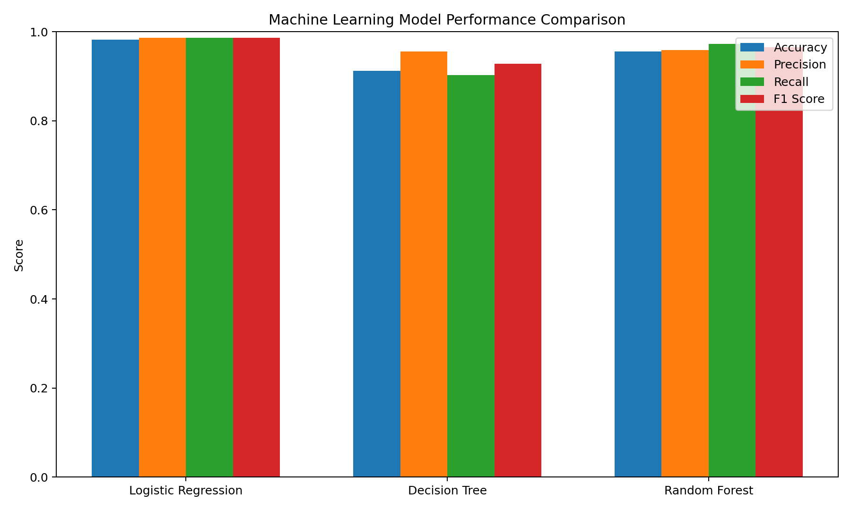
Figure 4. Comparison of model performance metrics.

6.2 Best Model
Logistic Regression was selected as the best-performing model because it achieved the highest F1 score (98.61%) and the highest accuracy (98.25%) among the three evaluated models.

6.3 Confusion Matrix
The Logistic Regression confusion matrix on the 114-observation test set contains 41 correctly classified malignant observations, 71 correctly classified benign observations, one malignant observation classified as benign, and one benign observation classified as malignant.
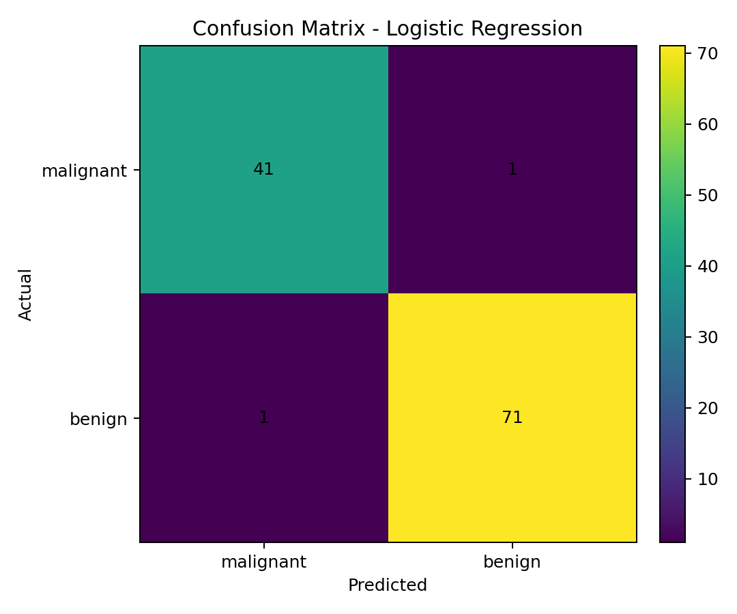
Figure 5. Confusion matrix for Logistic Regression.

6.4 Classification Report
Class | Precision | Recall | F1 Score | Support
Malignant | 0.98 | 0.98 | 0.98 | 42
Benign | 0.99 | 0.99 | 0.99 | 72
Overall accuracy | 0.98 | 0.98 | 0.98 | 114
The class-level report shows similarly strong performance for both diagnosis classes. The held-out test set contained 42 malignant and 72 benign observations.

6.5 Feature Importance
Random Forest feature importance was used as a separate interpretation exercise. It identified worst perimeter, worst area, worst concave points, mean concave points, and worst radius as the five highest-ranked features in the notebook.
Rank | Feature | Importance
1 | worst perimeter | 0.133100
2 | worst area | 0.128052
3 | worst concave points | 0.108107
4 | mean concave points | 0.094414
5 | worst radius | 0.090639
6 | mean radius | 0.058662
7 | mean perimeter | 0.055242
8 | mean area | 0.049938
9 | mean concavity | 0.046207
10 | worst concavity | 0.035357
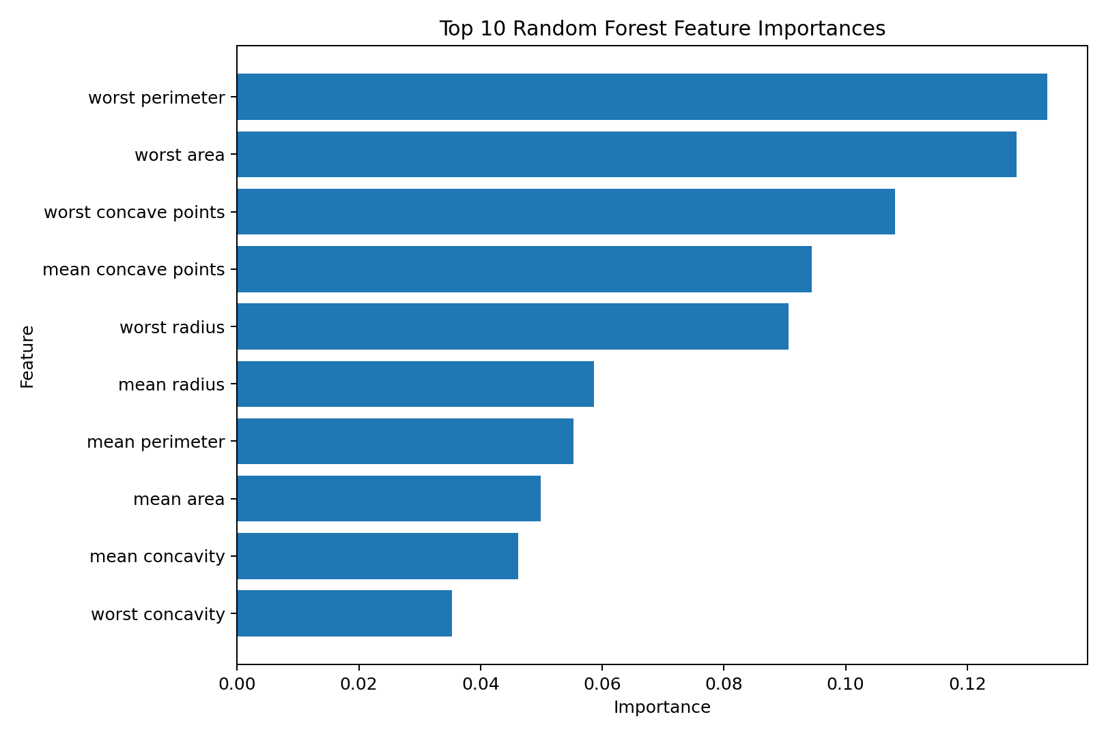
Figure 6. Top 10 Random Forest feature importances.
These importance values describe predictive contribution within the Random Forest model. They should not be interpreted as causal effects or as evidence that a feature independently determines diagnosis.

7. Strategic Recommendations

1. Use Machine Learning as a Research-Support Tool
The strong benchmark performance shows that machine-learning classifiers can identify patterns in structured observations. Such models can be explored as research or decision-support tools only after appropriate validation and expert oversight.

2. Investigate Influential Predictive Features
The Random Forest analysis highlights worst perimeter, worst area, worst concave points, mean concave points, and worst radius. Future analysis should examine these variables in more detail and test whether their predictive contribution remains stable across datasets.

3. Evaluate Multiple Performance Metrics
Model selection should not depend only on accuracy. Precision, recall, and F1 score should be reviewed together because they provide additional information about classification errors and class-specific performance.

4. Validate on Independent Data
Before any practical or clinical consideration, the selected model should be evaluated on independent datasets from different sources and populations to determine whether the observed performance generalizes.

5. Maintain Human and Expert Oversight
Machine-learning predictions should not be treated as independent medical diagnoses. Any real-world use would require qualified professionals, appropriate validation, ethical safeguards, and applicable regulatory consideration.

8. Potential Research Impact
This project demonstrates a complete data science workflow from raw structured data through exploratory analysis, hypothesis testing, predictive modeling, evaluation, and recommendation development. It shows how multiple analytical methods can be combined to answer a classification problem and communicate findings to stakeholders.
- Provides a reproducible benchmark workflow for comparing classification algorithms.
- Demonstrates the value of evaluating multiple metrics rather than accuracy alone.
- Shows how feature-importance analysis can support further research questions.
- Provides a foundation for future validation, explainability, and model-monitoring work.
The project should be interpreted as a research and educational exercise using a benchmark dataset, not as evidence of a deployable clinical system.

9. Limitations
- The analysis uses a benchmark dataset rather than newly collected real-world data.
- The dataset contains a limited number of observations compared with the diversity that may exist in real-world populations.
- Machine-learning performance depends on the features and observations contained in this dataset.
- The evaluation uses a single stratified 80/20 train-test split, so performance can vary with a different split.
- The Chi-square analysis converts continuous mean radius into a binary median-based group, which simplifies the underlying measurement.
- Random Forest feature importance reflects model-specific predictive contribution and should not be interpreted as causality.
- The model is not a clinically validated diagnostic system.

10. Future Improvements
- Collect and evaluate larger and more diverse datasets.
- Use k-fold cross-validation to obtain more robust performance estimates.
- Perform systematic hyperparameter tuning.
- Evaluate additional classification algorithms and calibrated probabilities.
- Test the final model on an independent external dataset.
- Use explainable-AI methods to investigate model predictions.
- Develop an interactive dashboard for presenting analytical results.
- Monitor model performance and data drift if a model is ever deployed.

11. Indicative Workload Plan
The Week 5 task specifies a prescribed workload of approximately 30–35 hours. The following is an indicative allocation for completing and documenting the project; it is a planning guide rather than a claim about time already spent.
Activity | Indicative hours
Project synthesis and review of Weeks 1–4 | 4
Data preparation and exploratory analysis | 6
Statistical analysis and interpretation | 4
Model development and evaluation | 7
Visualization and results interpretation | 3
Strategic recommendations and impact analysis | 3
Report writing, formatting, and quality review | 5
Total | 32

12. Conclusion
This project presented a comprehensive data science analysis of the Breast Cancer dataset available through scikit-learn. The workflow integrated data understanding, exploratory data analysis, statistical hypothesis testing, machine-learning development, model comparison, evaluation, and strategic recommendations.
The analysis evaluated Logistic Regression, Decision Tree, and Random Forest. Logistic Regression achieved the strongest test performance, with 98.25% accuracy and 98.61% for precision, recall, and F1 score. The statistical analysis also found a highly significant association between the median-based mean-radius group and diagnosis.
Random Forest feature importance separately highlighted several influential measurements, including worst perimeter, worst area, worst concave points, mean concave points, and worst radius. These findings can guide future research, but they should not be interpreted as causal relationships.
Overall, the project demonstrates how data science methods can be integrated into a coherent end-to-end analytical process. Further validation on independent and diverse datasets, together with expert oversight, would be required before any real-world or clinical application.

13. References
- Scikit-learn documentation – Breast Cancer Wisconsin dataset.
- Scikit-learn documentation – Classification algorithms and evaluation metrics.
- Python documentation – Python programming language.
- Pandas documentation – Data manipulation and analysis.
- Matplotlib documentation – Data visualization.
- Seaborn documentation – Statistical data visualization.
- SciPy documentation – Statistical analysis and hypothesis testing.

14. Appendix: Selected Code Snippets
The following excerpts represent key stages of the notebook. They are included to document the reproducible workflow without reproducing the entire notebook.

14.1 Dataset Loading
from sklearn.datasets import load_breast_cancer
data = load_breast_cancer()
df = pd.DataFrame(
data.data,
columns=data.feature_names
)
df["target"] = data.target
df["diagnosis"] = df["target"].map({
0: "malignant",
1: "benign"
})

14.2 Train/Test Split and Scaling
X_train, X_test, y_train, y_test = train_test_split(
X, y,
test_size=0.20,
random_state=42,
stratify=y
)
scaler = StandardScaler()
X_train_scaled = scaler.fit_transform(X_train)
X_test_scaled = scaler.transform(X_test)

14.3 Logistic Regression
logistic_model = LogisticRegression(
max_iter=10000,
random_state=42
)
logistic_model.fit(
X_train_scaled,
y_train
)
logistic_pred = logistic_model.predict(
X_test_scaled
)

14.4 Model Comparison
results = pd.DataFrame({
"Model": [
"Logistic Regression",
"Decision Tree",
"Random Forest"
],
"Accuracy": [
logistic_accuracy,
tree_accuracy,
rf_accuracy
],
"Precision": [
logistic_precision,
tree_precision,
rf_precision
],
"Recall": [
logistic_recall,
tree_recall,
rf_recall
],
"F1 Score": [
logistic_f1,
tree_f1,
rf_f1
]
})

14.5 Statistical Test
chi2, p_value, dof, expected = chi2_contingency(
contingency_table
)
print("Chi-square statistic:", chi2)
print("p-value:", p_value)

14.6 Confusion Matrix
ConfusionMatrixDisplay.from_predictions(
y_test,
logistic_pred,
display_labels=data.target_names
)
plt.title("Confusion Matrix - Logistic Regression")
plt.show()

14.7 Random Forest Feature Importance
feature_importance = pd.DataFrame({
"Feature": data.feature_names,
"Importance": rf_model.feature_importances_
}).sort_values(
by="Importance",
ascending=False
)

