Higher Technological Institute

Faculty of Engineering

Mechatronics Department

**Chassis Supervisory Control and Data Acquisition**

**Graduation Project Submitted By:**

**Omar Abdelghany Ahmed 20160603**

**Mohamed Yehia Shaaban 20160927**

**Donia Khaled Amer 20160368**

**Ahmed Ashraf Abdel-Aziz 20160036**

**Ali Tarek Abdel-hai El Hadidy 20160563**

**Omar Adel Ahmed Mohamed 20160601**

**Mohamed Mostafa Abdel-Mawgood 20160908**



**Under the supervision of**

**Dr. Amal Ibrahim**

**July 2021**

**ACKNOWLEDGEMENTS**

Praise to ALLAH, All Mighty, by whose grace this work has been done.

Our gratitude goes to our project supervisor Dr. Amal Ibrahim.

We would like to express our very great appreciation to Technician Reda and the Whole crew for Supporting our project and providing us with the technical information.

We would like to offer our special thanks to each and every person who assisted us by putting their work and guidance on the internet in an open-source format including: ResearchGate.net, Lucas Sangoi Mendonça.

We wish to acknowledge every entity that made the components for the project available for purchase or provided us with guidance from where to buy them: Kitchen Maker Space, RAM Electronics, Free Electronics.

We are extremely grateful to our parents and families for their continuous love, prayers, sacrifice, care and support. This whole project would not have been possible without them.

**ABSTRACT**

Electronic devices in automotive area have been used on large scale and a control unit is mandatory for greater engine efficiency. By performing the spark advance and injection timing correctly in internal-combustion engines, an engine control unit improves drivability and helps to reduce fuel consumption.

This paper presents hardware development, software coding using embedded C programming language for an ATmega128 - 8-bit AVR Microcontroller. The injection flow rates were measured and calibrated with the calculated fuel flow rates for different equivalence ratios of the engine.

**TABLE OF CONTENTS**

**ACKNOWLEDGEMENTS** I

**ABSTRACT** II

**TABLE OF CONTENTS** III

**TABLE OF FIGURES** VIII



## Introduction



### Chapter 1

Internal-combustion engines create power by burning fuel mixed with air, that is, chemical energy from air-fuel mixture is converted into kinetic energy providing torque. For many decades, carburetors has powered gasoline engines, however, considering their difficulty for precise fuel metering and environmental concerns, they have become obsolete.

Electronic devices in automotive area have been used on a large scale, and a control unit is mandatory for greater engine efficiency. Utilizing microcomputers, developed a universal control unit (UCU), a data acquisition unit (DAU) and an engine simulation unit (ESU) for an overall engine control development system.

An engine control unit or electronic control unit (ECU) is a system on which the timing of the injection, the amount of fuel that is injected and the spark advance (for gasoline engines) are calculated, and its development has been reported in literature.

Electronic components incorporated in cars help to reduce emission of pollutant, improve drivability and reduce fuel consumption, furthermore, with the embedded systems growth, powerful electronic control systems were applied for internal-combustion engines, considering that modern cars incorporate approximately one third of their parts in electronic components.

The ECU of an internal-combustion engine is a microprocessor that receives input signals from the engine and executes various tasks. the main output signals from ECU are the injection and ignition command. The signal for injection is a pulse-width signal with duty cycle related to injection timing according to injection map. The ignition system generates a very high voltage and sends it to each sparkplug which introduces energy into the chamber and produces a spark between the electrodes, initializing combustion.

The ECU receives the signals from the sensors, processes data and realizes calculations to generate output signals for the actuators. A software program is stored in ECU´s memory and is executed by a microcontroller that realizes tasks in order to improve efficiency.

This paper presents an automotive engine control unit development considering the architecture of tasks for spark advance and injection timing using embedded C programming language for an ATmega128 - 8-bit AVR Microcontroller.



### Chapter 2

**\**

**\**

## Hardware

# Mechanical

# Electrical

**\**

**2.1 Mechanical**

**2.1.1 Internal Combustion Engine**

An internal combustion engine (ICE) is a heat engine in which the combustion of a fuel occurs with an oxidizer (usually air) in a combustion chamber that is an integral part of the working fluid flow circuit. In an internal combustion engine, the expansion of the high-temperature and high-pressure gases produced by combustion applies direct force to some component of the engine. The force is applied typically to pistons, turbine blades, a rotor, or a nozzle.

**2.1.2 Engine Parts**

**2.1.2.1 Engine Block**

An engine block is the structure which contains the cylinders, and other parts, of an internal combustion engine. In an early automotive engine, the engine block consisted of just the cylinder block, to which a separate crankcase was attached.

Modern engine blocks typically have the crankcase integrated with the cylinder block as a single component. Engine blocks often also include elements such as coolant passages and oil galleries.

Figure 1 : Engine Block

**2.1.2.2 Valves**

Engine valves are mechanical components used in internal combustion engines to allow or restrict the flow of fluid or gas to and from the combustion chambers or cylinders during engine operation.

**2.1.2.3 Pistons and Connecting rod**

Figure 2 : Valves

It is the moving component that is contained by a cylinder and is made gas-tight by piston rings. In an engine, its purpose is to transfer force from expanding gas in the cylinder to the crankshaft via the connecting rod. The Piston ring is a metallic split ring that is attached to the outer diameter of a piston in an internal combustion engine.

Figure 3 : Piston, rings & connecting rod

Figure 4 : Piston, rings & connecting rod

The main functions of piston rings in engines are:

* Sealing the combustion chamber so that there is minimal loss of gases to the crank case.
* Improving heat transfer from the piston to the cylinder wall.
* Maintaining the proper quantity of the oil between the piston and the cylinder wall
* Regulating engine oil consumption by scraping oil from the cylinder walls back to the sump.

**2.1.2.4 Crankshaft**

A crankshaft is a rotating shaft which (in conjunction with the connecting rods) converts reciprocating motion of the pistons into rotational motion. Crankshafts are commonly used in internal combustion engines and consist of a series of cranks and crankpins to which the connecting rods are attached.

Figure 5: Crankshaft

**2.1.2.5 Camshaft**

A camshaft is a rotating object usually made of metal that contains pointed cams, which converts rotational motion to reciprocal motion. Camshafts are used in internal combustion engines (to operate the intake and exhaust valves)

Figure 6: Camshaft

**2.1.2.6 Cylinder Head and its Gasket**

In an internal combustion engine, the cylinder head contains the valves and sits above the cylinders on top of the cylinder block. It closes in the top of the cylinder, forming the combustion chamber. This joint is sealed by a head gasket that sits between the engine block and cylinder head(s) in an internal combustion engine. Its purpose is to seal the cylinders to ensure maximum compression and avoid leakage of coolant or engine oil into the cylinders.

Figure 7: Cylinder Head & its Gasket

**2.1.2.7 Timing Gears, Timing Belts and Chains**

* **A picture containing indoor, table, sitting, engine

  Description automatically generated**Timing gears: They are two, the first gear on the front of the crankshaft is in constant mesh with the second gear on the front of the camshaft.
* Timing Belts: In recent times, many engine manufacturers have reverted to timing belts. There are many advantages to using timing belts: they are quiet; manufacture and assembly are easier because they can sit 'outside' the engine, as oil is not needed for lubrication; and they can more easily be routed over multiple gears for engines with multiple camshafts. One disadvantage for the owner is the required replacement interval.

Figure 8: Timing Gears & Belts

* 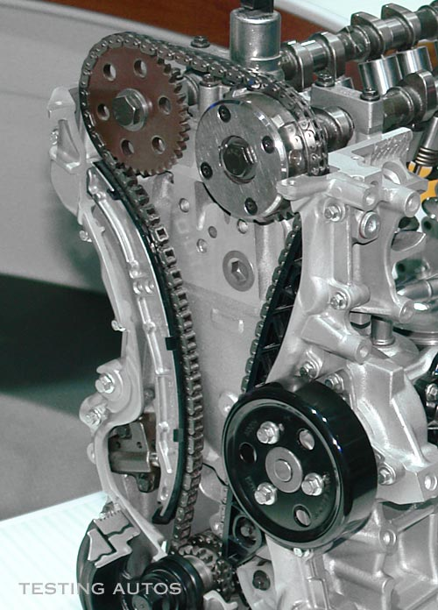Timing Chains: A timing chain is used when the spacing between the crankshaft and camshaft is too large to allow the gears to touch. A chain offers the advantages of being stronger, and not requiring regular replacement. One disadvantage is that a chain must run in oil, so it must be designed to sit inside the engine, which makes access more involved.

**2.1.2.8 Spark Plug & Fuel Injector**

Figure 9: Timing Chains

**Spark Plug** is a device for delivering electric current from an ignition system to the combustion chamber of a spark-ignition engine to ignite the compressed fuel/air mixture by an electric spark. While the **Fuel Injector** spray **fuel** into a **car's** engine using electronic controlled valves, capable of opening and closing many times a second.

Figure 10: Spark Plug & Fuel Injector

There are two types of injection:

**Indirect Injection** in an internal combustion engine is fuel injection where fuel is not directly injected into the combustion chamber.

**Direct injection** directly injects fuel into main combustion chamber which is gap between cylinder and piston where it penetrates into hot mass of compressed air.

Figure 11: Direct & Indirect Injection

**2.1.3 Four Stroke Engine**

A four-stroke (also four-cycle) engine is an internal combustion (IC) engine in which the piston completes four separate strokes while turning the crankshaft. A stroke refers to the full travel of the piston along the cylinder, in either direction. The four separate strokes are termed:

**2.1.3.1 Intake**

In this stroke the piston moves downward to the bottom, this increases the volume to allow a fuel-air mixture to enter the chamber.

**2.1.3.2 Compression**

In this stroke the intake valve is closed, and the piston moves up the chamber to the top. This compresses the fuel-air mixture. At the end of this stroke, a spark plug provides the compressed fuel with the activation energy required to begin combustion.

**2.1.3.3 Power**

In this stroke as the fuel reaches the end of its combustion, the heat released from combusting hydrocarbons increases the pressure which causes the gas to push down on the piston and create the power output.

**2.1.3.4 Exhaust**

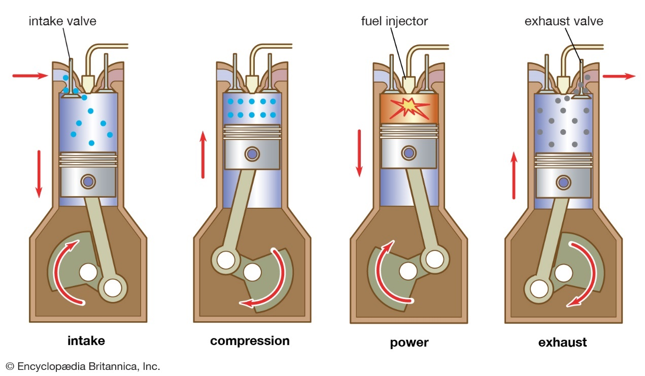In this stroke as the piston reaches the bottom, the exhaust valve opens. The remaining exhaust gas is pushed out by the piston as it moves back upwards.

Figure 12: Four-stroke Engine

**2.2 Electrical**