TASK 1
Zenmap is already installed in kali-linux.

TASK 2

PC address: 192.168.100.86

Subnet : 255.255.255.0

TASK 3

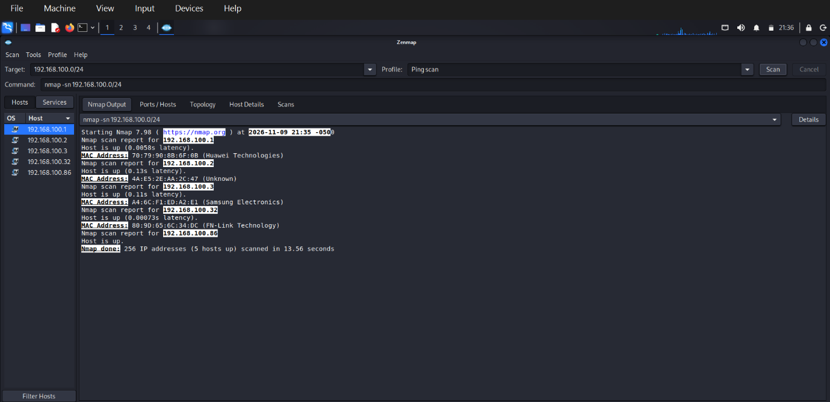

TASK 4

Live hosts : 5

TASK 5

IP Addresses of live hosts:
192.168.100.1
192.168.100.2
192.168.100.3
192.168.100.32
192.168.100.86
TASK 6

MAC Addresses of live hosts:
70:79:90:8B:6F:0B
4A:E5:2E:AA:2C:47
A4:6C:F1:ED:A2:EA
80:9D:65:6C:34:DC
08:00:27:05:02:cf

TASK 7


