**Project: The Pizza Shop**

**Documentation of Excel Dashboard**

**KPI**

We need to analyze key indicators for our pizza sales data to gain insights into our business performance. Specifically, we want to calculate the following metrics:

**1. Total Revenue:** The sum of the total price of all pizza orders.

**2. Average Order Value**: The average amount spent per order, calculated by dividing the ale total revenue by the total number of orders.

**3. Total Pizzas Sold:** The sum of the quantities of all pizzas sold.

**4. Total Orders:** The total number of orders placed.

**5. Average Pizzas Per Order:** The average number of pizzas sold per order, calculated by dividing the total number of pizzas sold by the total number of orders.

**CHARTS REQUIREMENT**

We would like to visualize various aspects of our pizza sales data to gain insights and understand key trends. We have identified the following requirements for creating charts:

**1.Daily Trend for Total Orders:** Create a bar chart that displays the daily trend of total orders over a specific time period. This chart will help us identify any patterns or fluctuations in order volumes on a daily basis.

**2.Hourly Trend for Total Orders:** Create a line chart that illustrates the hourly trend of total orders throughout the day. This chart will allow us to identify peak hours or periods of high order activity.

**3.Percentage of Sales by Pizza Category:** Create a pie chart that shows the distribution of sales across different pizza categories. This chart will provide insights into the popularity of various pizza categories and their contribution to overall sales.

**4.Percentage of Sales by Pizza Size:** Generate a pie chart that represents the percentage of sales attributed to different pizza sizes. This chart will help us understand customer preferences for pizza sizes and their impact on sales.

**5.Total Pizzas Sold by Pizza Category:** Create a funnel chart that presents the total number of pizzas sold for each pizza category. This chart will allow us to compare the sales performance of different pizza categories.

**6.Top 5 Best Sellers by Total Pizzas Sold:** Create a bar chart highlighting the top 5 best-selling pizzas based on the total number of pizzas sold. This chart will help us identily the most popular pizza options.

**7.Bottom 5 Worst Sellers by Total Pizzas Sold:** Create a bar chart showcasing the bottom 5 worst-selling pizzas based on the total number of pizzas sold. This chart will enable us to identify underperforming or less popular pizza options.

**PIZZA SALES SQL QUERIES**

**A. KPI’s**

**1. Total Revenue:**

SELECT SUM(total_price) AS Total_Revenue FROM pizza_sales;

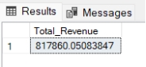

**2. Average Order Value**

SELECT (SUM(total_price) / COUNT(DISTINCT order_id)) AS Avg_order_Value FROM pizza_sales

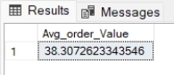

**3. Total Pizzas Sold**

SELECT SUM(quantity) AS Total_pizza_sold FROM pizza_sales

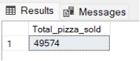

**4. Total Orders**

SELECT COUNT(DISTINCT order_id) AS Total_Orders FROM pizza_sales

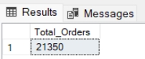

**5. Average Pizzas Per Order**

SELECT CAST(CAST(SUM(quantity) AS DECIMAL(10,2)) /

CAST(COUNT(DISTINCT order_id) AS DECIMAL(10,2)) AS DECIMAL(10,2))

AS Avg_Pizzas_per_order

FROM pizza_sales

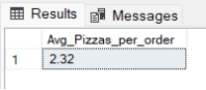

**B. Daily Trend for Total Orders**SELECT DATENAME(DW, order_date) AS order_day, COUNT(DISTINCT order_id) AS total_orders

FROM pizza_sales

GROUP BY DATENAME(DW, order_date)

***Output:***

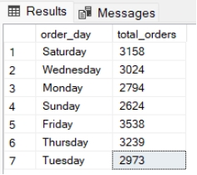

**C. Hourly Trend for Orders**

SELECT DATEPART(HOUR, order_time) as order_hours, COUNT(DISTINCT order_id) as total_orders

from pizza_sales

group by DATEPART(HOUR, order_time)

order by DATEPART(HOUR, order_time)

***Output***

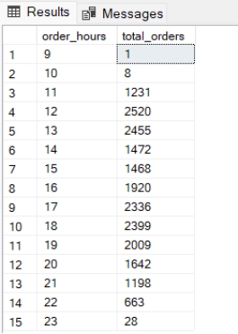

**D. % of Sales by Pizza Category**

SELECT pizza_category, CAST(SUM(total_price) AS DECIMAL(10,2)) as total_revenue,

CAST(SUM(total_price) * 100 / (SELECT SUM(total_price) from pizza_sales) AS DECIMAL(10,2)) AS PCT

FROM pizza_sales

GROUP BY pizza_category

***Output***

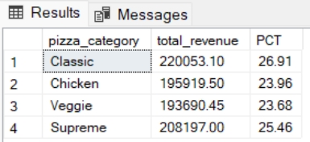

**E. % of Sales by Pizza Size**

SELECT pizza_size, CAST(SUM(total_price) AS DECIMAL(10,2)) as total_revenue,

CAST(SUM(total_price) * 100 / (SELECT SUM(total_price) from pizza_sales) AS DECIMAL(10,2)) AS PCT

FROM pizza_sales

GROUP BY pizza_size

ORDER BY pizza_size

***Output***

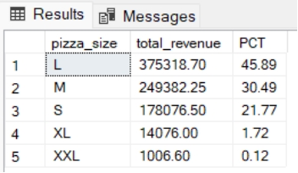

**F. Total Pizzas Sold by Pizza Category**

SELECT pizza_category, SUM(quantity) as Total_Quantity_Sold

FROM pizza_sales

WHERE MONTH(order_date) = 2

GROUP BY pizza_category

ORDER BY Total_Quantity_Sold DESC

***Output***

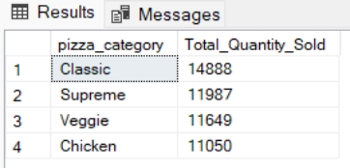

**G. Top 5 Best Sellers by Total Pizzas Sold**

SELECT Top 5 pizza_name, SUM(quantity) AS Total_Pizza_Sold

FROM pizza_sales

GROUP BY pizza_name

ORDER BY Total_Pizza_Sold DESC

***Output***

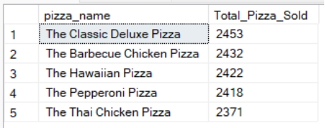

**H. Bottom 5 Best Sellers by Total Pizzas Sold**

SELECT TOP 5 pizza_name, SUM(quantity) AS Total_Pizza_Sold

FROM pizza_sales

GROUP BY pizza_name

ORDER BY Total_Pizza_Sold ASC

***Output***

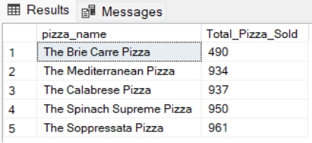

***NOTE***

If you want to apply the Month, Quarter, Week filters to the above queries you can use WHERE clause. Follow some of below examples

SELECT DATENAME(DW, order_date) AS order_day, COUNT(DISTINCT order_id) AS total_orders

FROM pizza_sales

WHERE MONTH(order_date) = 1

GROUP BY DATENAME(DW, order_date)

*\*Here MONTH(order_date) = 1 indicates that the output is for the month of January. MONTH(order_date) = 4 indicates output for Month of April.*

SELECT DATENAME(DW, order_date) AS order_day, COUNT(DISTINCT order_id) AS total_orders

FROM pizza_sales

WHERE DATEPART(QUARTER, order_date) = 1

GROUP BY DATENAME(DW, order_date)

*\*Here DATEPART(QUARTER, order_date) = 1 indicates that the output is for the Quarter 1. MONTH(order_date) = 3 indicates output for Quarter 3.*