LAB 2
Unit, Component & Integration Testing
Web Application | Mobile Application | DSA Semester Project
Submitted by | [Your Name]
Roll Number | [Roll Number]
Course | Software Testing (Semester 8)
Submitted to | [Instructor Name]
Date | 2026-09-26

Table of Contents
(If the table of contents is empty, right-click it in Word and choose "Update Field".)
Table of Contents 2
1. Introduction 4
1.1 Objective 4
1.2 Testing Levels 4
1.3 Test Environment 4
1.4 Method 4
2. Summary of Results 5
3. Web Application - ShopEase 7
3.1 System Under Test 7
3.2 Unit Testing 7
3.3 Component Testing 21
3.4 Integration Testing 30
3.5 System Behaviour Screenshots (running application) 39
4. Mobile Application - PostHub (Expo / React Native) 46
4.1 System Under Test 46
4.2 Unit Testing 46
4.3 Component Testing 58
4.4 Integration Testing 66
4.5 System Behaviour Screenshots (running application) 72
5. DSA Semester Project - DSA Toolkit (Python) 77
5.1 System Under Test 77
5.2 Unit Testing 77
5.3 Component Testing 89
5.4 Integration Testing 96
5.5 System Behaviour Screenshots (running program (CLI sessions)) 105
6. Defects Found and Recommendations 110
7. Conclusion 113

1. Introduction

1.1 Objective
Apply three levels of testing - Unit Testing, Component Testing and Integration Testing - to three software projects: a Web Application, a Mobile Application and a Data Structures & Algorithms semester project, and document the test cases, results, defects and screenshot evidence.

1.2 Testing Levels
- Unit testing: each function/method/class is tested in isolation; external dependencies (network, storage, database) are stubbed, mocked or reset.
- Component testing: related units are grouped into a module (e.g. Authentication, Notification, Tree Operations) and tested through the module interface or rendered screen.
- Integration testing: the interaction and data flow between modules is tested using Top-Down, Bottom-Up and Incremental integration strategies.

1.3 Test Environment
Item | Value
Operating system | Windows 11 Pro
Runtimes | Node.js v20.18.0, Python 3.13.7
Web app | Express 4, Jest 29.7, Supertest 7
Mobile app | Expo SDK 57, React Native 0.86, jest-expo, @testing-library/​react-​native 14, AsyncStorage Jest mock
DSA project | Python unittest (standard library)
Screenshots | Headless Microsoft Edge via Playwright; terminal output captured from the real test commands

1.4 Method
All test cases are automated and table-driven. While a test runs, its input, expected result, actual result and Pass/Fail status are written to a JSON file (test-results folder of each project); the tables in this report are generated from those files, so the "Actual Result" and "Status" columns are the real outputs of the execution. For every unit, component and integration group, the real test command was run again and its terminal output was captured as a screenshot together with the recorded inputs/outputs. Screenshots of the running applications show the same behaviour from the user's point of view.
Test case ID format: UT = unit, CT = component, IT = integration; W = web, M = mobile, D = DSA. For example UT-W01-03 is test case 3 of web unit 1.

2. Summary of Results
All tests were executed on 2026-09-26. A failing test case means the system did not behave as specified - every failure below is a genuine defect in the application code (not in the test) and is described in section 6.
Project | Testing Level | Items Tested | Test Cases | Passed | Failed | Pass Rate
Web App | Unit | 7 units | 44 | 43 | 1 | 97.7%
Web App | Component | 3 components | 19 | 18 | 1 | 94.7%
Web App | Integration | 3 scenarios | 15 | 14 | 1 | 93.3%
Mobile App | Unit | 6 units | 38 | 37 | 1 | 97.4%
Mobile App | Component | 3 components | 18 | 18 | 0 | 100.0%
Mobile App | Integration | 3 scenarios | 15 | 14 | 1 | 93.3%
DSA Project | Unit | 6 units | 41 | 41 | 0 | 100.0%
DSA Project | Component | 3 components | 17 | 15 | 2 | 88.2%
DSA Project | Integration | 3 scenarios | 20 | 18 | 2 | 90.0%
TOTAL |  |  | 227 | 218 | 9 | 96.0%

Requirement Coverage
Lab Requirement | Required | Web App | Mobile App | DSA Project
Units tested (Part I) | >= 5 per project | 7 | 6 | 6
Test cases per unit | >= 5 | 6 - 7 | 6 - 7 | 6 - 7
Components tested (Part II) | >= 3 per project | 3 | 3 | 3
Integration scenarios (Part III) | >= 3 per project | 3 | 3 | 3
Integration strategies applied | >= 1 | Top-Down, Bottom-Up, Incremental | Top-Down, Incremental, Bottom-Up | Bottom-Up, Incremental, Top-Down
Screenshots | Every scenario | Every unit/​component/​integra​tion group + 11 UI | Every group + 12 UI | Every group + 8 CLI sessions

Defects Found
Bug ID | Project | Found by Test Case | Severity | Title
BUG-W01 | Web | UT-W01-07 | Low | Email checker accepts consecutive dots in the domain
BUG-W02 | Web | CT-W02-07 | High | Stored XSS / HTML injection through product name
BUG-W03 | Web | IT-W03-05 | Critical | Card charged but order fails when the same product is in two cart lines
BUG-M01 | Mobile | UT-M05-06 | Medium | loadSession() crashes on corrupted session data
BUG-M02 | Mobile | IT-M03-05 | Low | Read notifications become unread after profile update
BUG-D01 | DSA | CT-D02-05 | Medium | BST height() fails with RecursionError on degenerate trees
BUG-D02 | DSA | CT-D03-07 | Medium | Graph dfs() fails with RecursionError on long paths
BUG-D03 | DSA | IT-D01-07 | Low | Malformed edge "A-B-C" is silently accepted
BUG-D04 | DSA | IT-D02-07 | Low | Bar chart is not scaled to terminal width

3. Web Application - ShopEase

3.1 System Under Test
ShopEase is a small e-commerce web application. The backend is Node.js + Express with an in-memory database; the frontend is HTML + vanilla JavaScript that talks to the REST API. Features: registration, login/logout with session tokens, product management (add/search/delete), cart, mock card-payment gateway and order history.
Testing tools: Jest 29 (test runner & assertions), Supertest (HTTP calls into Express), real HTTP server + fetch for frontend/backend tests, headless Microsoft Edge (Playwright) for UI screenshots.
How to run the tests: cd web-app -> npm install -> npm test (application: npm start, http://localhost:3000)
Overall: 78 test cases executed, 75 passed, 3 failed.
Use cases referenced by the test cases:
Use Case ID | Use Case | Description
UC-W01 | Register account | Visitor creates an account with name, email and strong password
UC-W02 | Login / Logout | User logs in with email + password, receives a session token, logs out
UC-W03 | Browse & manage products | View/​search product list; logged-in user adds or deletes products
UC-W04 | Checkout & pay | User adds items to cart and pays by card; stock is reduced and an order is created
UC-W05 | View my orders | User sees only his/​her own orders

3.2 Unit Testing
7 units were identified and tested independently (external dependencies such as fetch, storage or the database were stubbed or reset). Each unit has at least 5 test cases in the required template format.

3.2.1 UT-W01 - validateEmail() - Email format checker
Result: 7 test cases executed, 6 passed, 1 failed.
Test Case ID | Related Use Case ID | Test Case Title | Test Objective | Preconditions | Test Steps | Test Data | Expected Result | Actual Result | Status (Pass/​Fail) | Priority | Tested By | Test Date
UT-W01-01 | UC-W01 Register / UC-W02 Login | Valid email is accepted | Verify the email format checker accepts only well-formed email addresses | validators.js module loaded | 1. Call validateEmail(input) 2. Compare returned boolean with expected | ["ali@test.com"] | true | true | Pass | High | [Your Name] | 2026-09-26
UT-W01-02 | UC-W01 Register / UC-W02 Login | Email without @ is rejected | Verify the email format checker accepts only well-formed email addresses | validators.js module loaded | 1. Call validateEmail(input) 2. Compare returned boolean with expected | ["alitest.com"] | false | false | Pass | High | [Your Name] | 2026-09-26
UT-W01-03 | UC-W01 Register / UC-W02 Login | Email without top-level domain is rejected | Verify the email format checker accepts only well-formed email addresses | validators.js module loaded | 1. Call validateEmail(input) 2. Compare returned boolean with expected | ["ali@test"] | false | false | Pass | Medium | [Your Name] | 2026-09-26
UT-W01-04 | UC-W01 Register / UC-W02 Login | Email containing a space is rejected | Verify the email format checker accepts only well-formed email addresses | validators.js module loaded | 1. Call validateEmail(input) 2. Compare returned boolean with expected | ["ali @test.com"] | false | false | Pass | Medium | [Your Name] | 2026-09-26
UT-W01-05 | UC-W01 Register / UC-W02 Login | Non-string input (number) is rejected | Verify the email format checker accepts only well-formed email addresses | validators.js module loaded | 1. Call validateEmail(input) 2. Compare returned boolean with expected | [12345] | false | false | Pass | Low | [Your Name] | 2026-09-26
UT-W01-06 | UC-W01 Register / UC-W02 Login | Leading/​trailing spaces are trimmed | Verify the email format checker accepts only well-formed email addresses | validators.js module loaded | 1. Call validateEmail(input) 2. Compare returned boolean with expected | [" ALI@Test.COM "] | true | true | Pass | Medium | [Your Name] | 2026-09-26
UT-W01-07 | UC-W01 Register / UC-W02 Login | Domain with consecutive dots is rejected | Verify the email format checker accepts only well-formed email addresses | validators.js module loaded | 1. Call validateEmail(input) 2. Compare returned boolean with expected | ["ali@test..com"] | false | true | Fail | Medium | [Your Name] | 2026-09-26
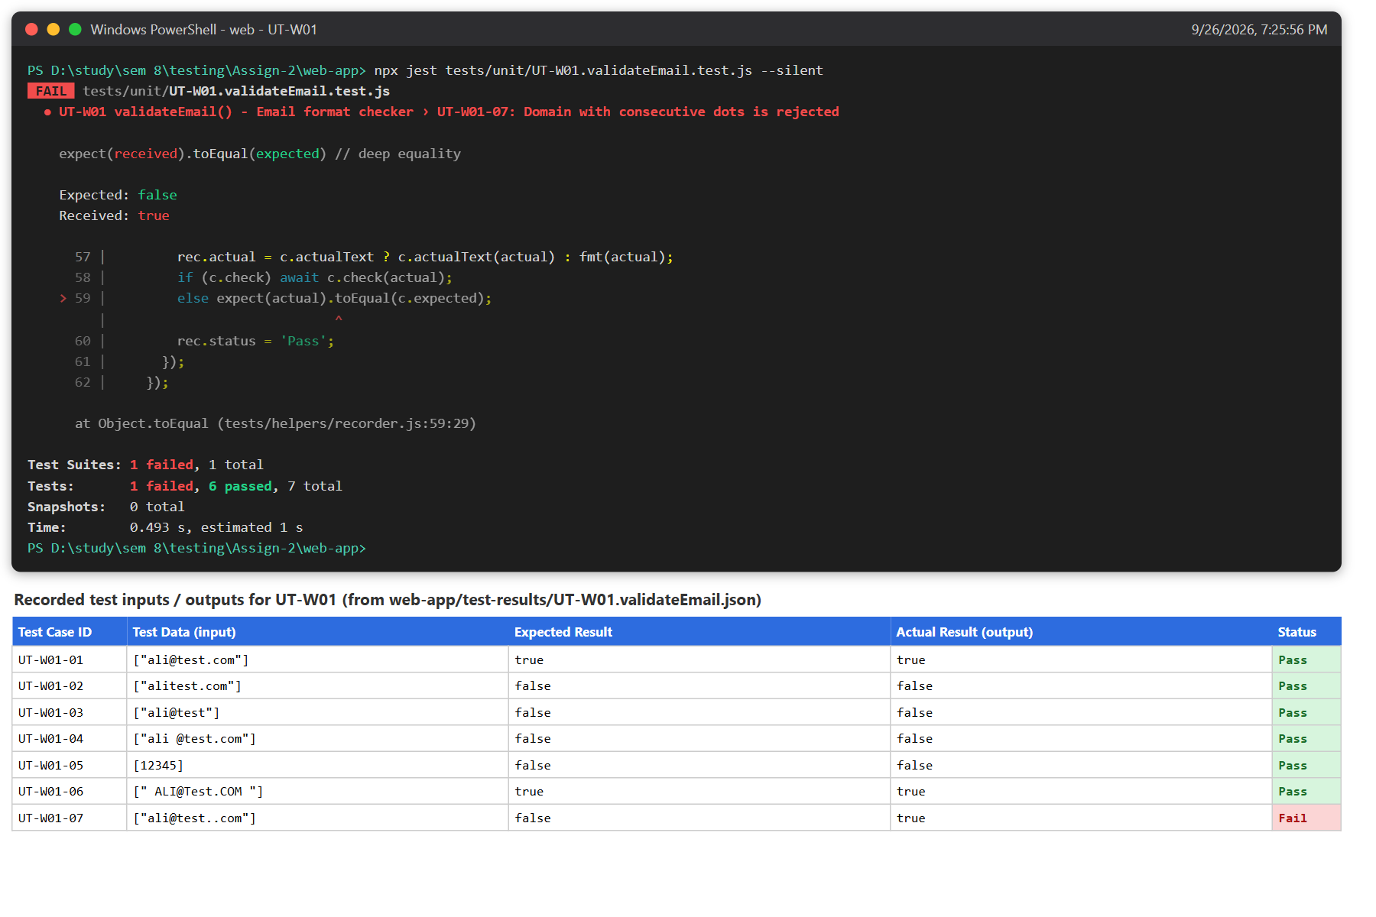
Figure 1: UT-W01 execution - "npx jest tests/unit/UT-W01.validateEmail.test.js --silent" (terminal output) with the recorded inputs/outputs of all 7 test cases (6 passed).

3.2.2 UT-W02 - validatePassword() - Password strength checker
Result: 6 test cases executed, 6 passed, 0 failed.
Test Case ID | Related Use Case ID | Test Case Title | Test Objective | Preconditions | Test Steps | Test Data | Expected Result | Actual Result | Status (Pass/​Fail) | Priority | Tested By | Test Date
UT-W02-01 | UC-W01 Register | Strong password is valid | Verify password rules: min 8 chars, 1 uppercase, 1 lowercase, 1 digit | validators.js module loaded | 1. Call validatePassword(input) 2. Compare {valid, errors} with expected | ["Secret123"] | {"valid":​true,​"errors"​:​[]} | {"valid":​true,​"errors"​:​[]} | Pass | High | [Your Name] | 2026-09-26
UT-W02-02 | UC-W01 Register | Password shorter than 8 chars is rejected | Verify password rules: min 8 chars, 1 uppercase, 1 lowercase, 1 digit | validators.js module loaded | 1. Call validatePassword(input) 2. Compare {valid, errors} with expected | ["Sec1a"] | {"valid":​false,​"errors​":​["Password must be at least 8 characters"]} | {"valid":​false,​"errors​":​["Password must be at least 8 characters"]} | Pass | High | [Your Name] | 2026-09-26
UT-W02-03 | UC-W01 Register | Password without uppercase is rejected | Verify password rules: min 8 chars, 1 uppercase, 1 lowercase, 1 digit | validators.js module loaded | 1. Call validatePassword(input) 2. Compare {valid, errors} with expected | ["secret123"] | {"valid":​false,​"errors​":​["Password must contain an uppercase letter"]} | {"valid":​false,​"errors​":​["Password must contain an uppercase letter"]} | Pass | Medium | [Your Name] | 2026-09-26
UT-W02-04 | UC-W01 Register | Password without lowercase is rejected | Verify password rules: min 8 chars, 1 uppercase, 1 lowercase, 1 digit | validators.js module loaded | 1. Call validatePassword(input) 2. Compare {valid, errors} with expected | ["SECRET123"] | {"valid":​false,​"errors​":​["Password must contain a lowercase letter"]} | {"valid":​false,​"errors​":​["Password must contain a lowercase letter"]} | Pass | Medium | [Your Name] | 2026-09-26
UT-W02-05 | UC-W01 Register | Password without digit is rejected | Verify password rules: min 8 chars, 1 uppercase, 1 lowercase, 1 digit | validators.js module loaded | 1. Call validatePassword(input) 2. Compare {valid, errors} with expected | ["SecretPass"] | {"valid":​false,​"errors​":​["Password must contain a digit"]} | {"valid":​false,​"errors​":​["Password must contain a digit"]} | Pass | Medium | [Your Name] | 2026-09-26
UT-W02-06 | UC-W01 Register | Empty password is rejected as required | Verify password rules: min 8 chars, 1 uppercase, 1 lowercase, 1 digit | validators.js module loaded | 1. Call validatePassword(input) 2. Compare {valid, errors} with expected | [""] | {"valid":​false,​"errors​":​["Password is required"]} | {"valid":​false,​"errors​":​["Password is required"]} | Pass | High | [Your Name] | 2026-09-26
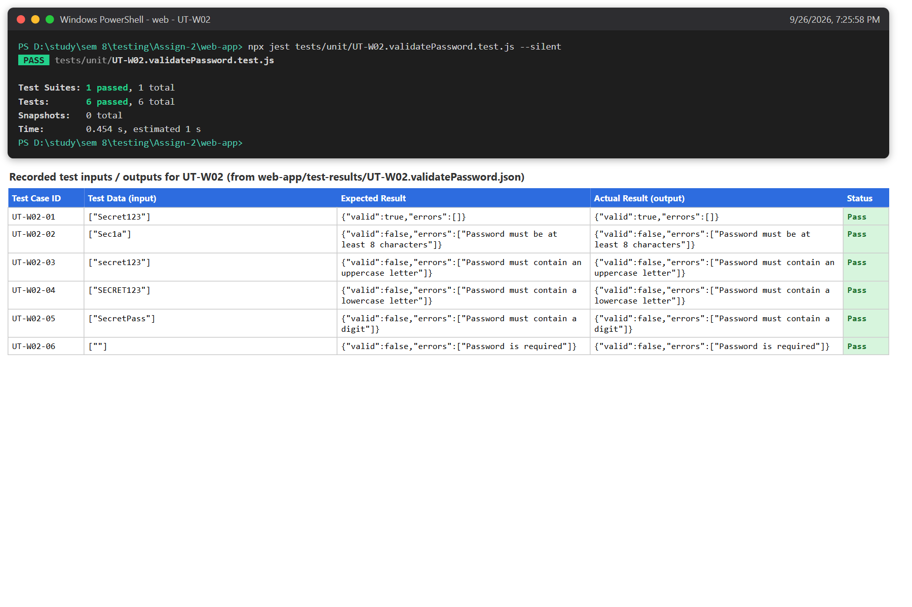
Figure 2: UT-W02 execution - "npx jest tests/unit/UT-W02.validatePassword.test.js --silent" (terminal output) with the recorded inputs/outputs of all 6 test cases (6 passed).

3.2.3 UT-W03 - hashPassword() / verifyPassword() - Password encryption
Result: 7 test cases executed, 7 passed, 0 failed.
Test Case ID | Related Use Case ID | Test Case Title | Test Objective | Preconditions | Test Steps | Test Data | Expected Result | Actual Result | Status (Pass/​Fail) | Priority | Tested By | Test Date
UT-W03-01 | UC-W01 Register / UC-W02 Login | Hash has format <32-hex salt>:​<64-hex hash> | Verify passwords are salted + hashed (PBKDF2-SHA256) and can be verified | crypto.js module loaded | 1. Call hashPassword / verifyPassword with test data 2. Inspect returned value | password=​"Secret123" | matches /​^[0-9a-f]{32}:​[0-9a-f​]{64}$/ | "1253adec4a3c19b239f1958​adf649daa:​1fc90dbf918cc​74ddaead2b4ca6bfd70db123​0f5bda7a4fdbceb0393183cb​ca4" | Pass | High | [Your Name] | 2026-09-26
UT-W03-02 | UC-W01 Register / UC-W02 Login | Same password hashed twice gives different hashes (random salt) | Verify passwords are salted + hashed (PBKDF2-SHA256) and can be verified | crypto.js module loaded | 1. Call hashPassword / verifyPassword with test data 2. Inspect returned value | password=​"Secret123" x2 | hash1 !=​= hash2 | hash1 !=​= hash2 | Pass | Medium | [Your Name] | 2026-09-26
UT-W03-03 | UC-W01 Register / UC-W02 Login | Same password + same salt is deterministic | Verify passwords are salted + hashed (PBKDF2-SHA256) and can be verified | crypto.js module loaded | 1. Call hashPassword / verifyPassword with test data 2. Inspect returned value | password=​"Secret123", salt=​"abc123" | hash1 =​=​= hash2 | hash1 =​=​= hash2 | Pass | Medium | [Your Name] | 2026-09-26
UT-W03-04 | UC-W01 Register / UC-W02 Login | verifyPassword returns true for correct password | Verify passwords are salted + hashed (PBKDF2-SHA256) and can be verified | crypto.js module loaded | 1. Call hashPassword / verifyPassword with test data 2. Inspect returned value | stored=​hash("Secret123"​), input=​"Secret123" | true | true | Pass | High | [Your Name] | 2026-09-26
UT-W03-05 | UC-W01 Register / UC-W02 Login | verifyPassword returns false for wrong password | Verify passwords are salted + hashed (PBKDF2-SHA256) and can be verified | crypto.js module loaded | 1. Call hashPassword / verifyPassword with test data 2. Inspect returned value | stored=​hash("Secret123"​), input=​"secret123" | false | false | Pass | High | [Your Name] | 2026-09-26
UT-W03-06 | UC-W01 Register / UC-W02 Login | Hashing an empty password throws an error | Verify passwords are salted + hashed (PBKDF2-SHA256) and can be verified | crypto.js module loaded | 1. Call hashPassword / verifyPassword with test data 2. Inspect returned value | password=​"" | "throws: Password must be a non-empty string" | "throws: Password must be a non-empty string" | Pass | Medium | [Your Name] | 2026-09-26
UT-W03-07 | UC-W01 Register / UC-W02 Login | verifyPassword with malformed stored hash returns false | Verify passwords are salted + hashed (PBKDF2-SHA256) and can be verified | crypto.js module loaded | 1. Call hashPassword / verifyPassword with test data 2. Inspect returned value | stored=​"nohashhere", input=​"Secret123" | false | false | Pass | Low | [Your Name] | 2026-09-26
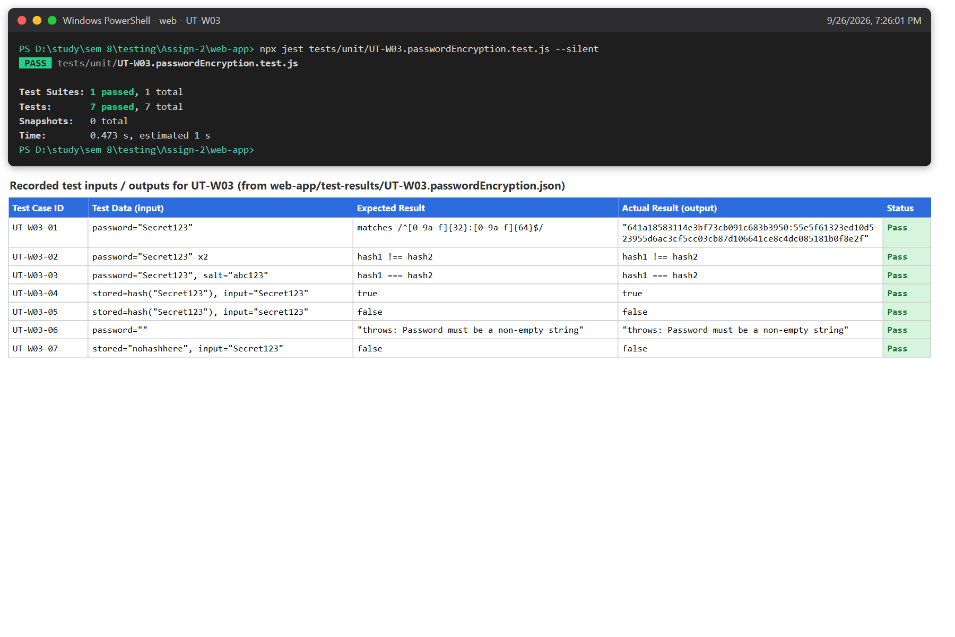
Figure 3: UT-W03 execution - "npx jest tests/unit/UT-W03.passwordEncryption.test.js --silent" (terminal output) with the recorded inputs/outputs of all 7 test cases (7 passed).

3.2.4 UT-W04 - validateLoginForm() - Login validation
Result: 6 test cases executed, 6 passed, 0 failed.
Test Case ID | Related Use Case ID | Test Case Title | Test Objective | Preconditions | Test Steps | Test Data | Expected Result | Actual Result | Status (Pass/​Fail) | Priority | Tested By | Test Date
UT-W04-01 | UC-W02 Login | Valid email and password pass validation | Verify login form validation reports the correct error messages | validators.js module loaded | 1. Call validateLoginForm({email​, password}) 2. Compare {valid, errors} with expected | [{"email":​"ali@test.com​",​"password":​"Secret12​3"}] | {"valid":​true,​"errors"​:​[]} | {"valid":​true,​"errors"​:​[]} | Pass | High | [Your Name] | 2026-09-26
UT-W04-02 | UC-W02 Login | Empty email reports "Email is required" | Verify login form validation reports the correct error messages | validators.js module loaded | 1. Call validateLoginForm({email​, password}) 2. Compare {valid, errors} with expected | [{"email":​"",​"password​":​"Secret123"}] | {"valid":​false,​"errors​":​["Email is required"]} | {"valid":​false,​"errors​":​["Email is required"]} | Pass | High | [Your Name] | 2026-09-26
UT-W04-03 | UC-W02 Login | Malformed email reports "Invalid email format" | Verify login form validation reports the correct error messages | validators.js module loaded | 1. Call validateLoginForm({email​, password}) 2. Compare {valid, errors} with expected | [{"email":​"ali@",​"pass​word":​"Secret123"}] | {"valid":​false,​"errors​":​["Invalid email format"]} | {"valid":​false,​"errors​":​["Invalid email format"]} | Pass | Medium | [Your Name] | 2026-09-26
UT-W04-04 | UC-W02 Login | Empty password reports "Password is required" | Verify login form validation reports the correct error messages | validators.js module loaded | 1. Call validateLoginForm({email​, password}) 2. Compare {valid, errors} with expected | [{"email":​"ali@test.com​",​"password":​""}] | {"valid":​false,​"errors​":​["Password is required"]} | {"valid":​false,​"errors​":​["Password is required"]} | Pass | High | [Your Name] | 2026-09-26
UT-W04-05 | UC-W02 Login | Both fields empty report both errors | Verify login form validation reports the correct error messages | validators.js module loaded | 1. Call validateLoginForm({email​, password}) 2. Compare {valid, errors} with expected | [{"email":​"",​"password​":​""}] | {"valid":​false,​"errors​":​["Email is required",​"Password is required"]} | {"valid":​false,​"errors​":​["Email is required",​"Password is required"]} | Pass | Medium | [Your Name] | 2026-09-26
UT-W04-06 | UC-W02 Login | Missing argument object is handled | Verify login form validation reports the correct error messages | validators.js module loaded | 1. Call validateLoginForm({email​, password}) 2. Compare {valid, errors} with expected | undefined | {"valid":​false,​"errors​":​["Email is required",​"Password is required"]} | {"valid":​false,​"errors​":​["Email is required",​"Password is required"]} | Pass | Low | [Your Name] | 2026-09-26
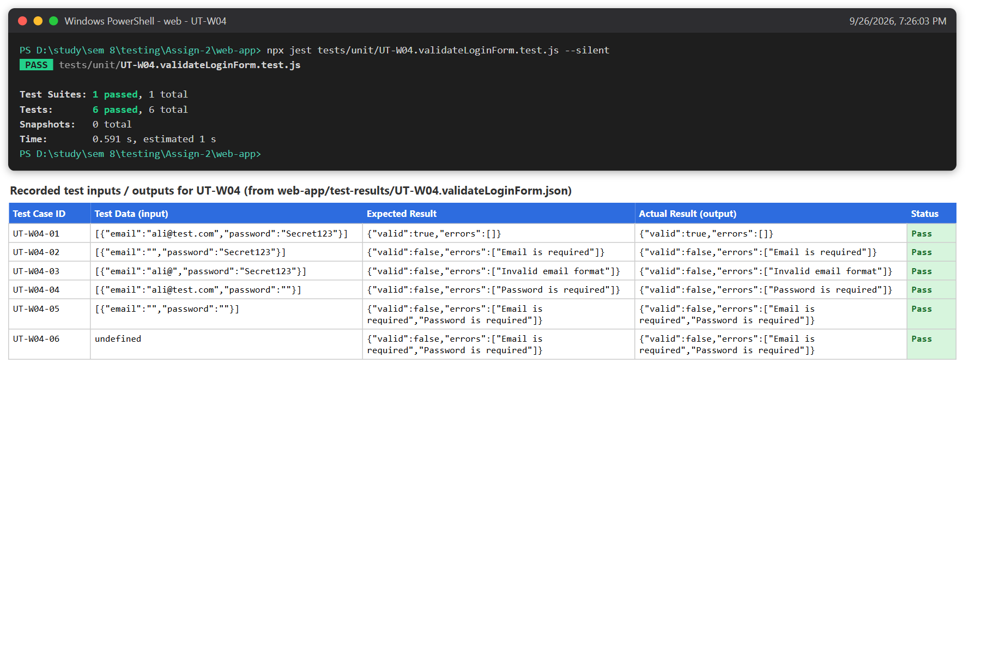
Figure 4: UT-W04 execution - "npx jest tests/unit/UT-W04.validateLoginForm.test.js --silent" (terminal output) with the recorded inputs/outputs of all 6 test cases (6 passed).

3.2.5 UT-W05 - apiRequest() - Frontend API request handler
Result: 6 test cases executed, 6 passed, 0 failed.
Test Case ID | Related Use Case ID | Test Case Title | Test Objective | Preconditions | Test Steps | Test Data | Expected Result | Actual Result | Status (Pass/​Fail) | Priority | Tested By | Test Date
UT-W05-01 | UC-W03 Browse Products / all API calls | GET request returns status + parsed JSON body | Verify the API request handler builds requests correctly and normalises responses/​errors | public/​api.js loaded; fetch replaced by a Jest stub (no server needed) | 1. Create stub fetch 2. Call apiRequest(url, options) 3. Inspect result and stub call arguments | GET /​api/​products; stub -> 200 {ok:​true, products:​[{id:​1}]} | {"status":​200,​"ok":​tr​ue,​"products":​[{"id":​​1}]} | {"status":​200,​"ok":​tr​ue,​"products":​[{"id":​​1}]} | Pass | High | [Your Name] | 2026-09-26
UT-W05-02 | UC-W03 Browse Products / all API calls | POST request sends JSON body and Content-Type header | Verify the API request handler builds requests correctly and normalises responses/​errors | public/​api.js loaded; fetch replaced by a Jest stub (no server needed) | 1. Create stub fetch 2. Call apiRequest(url, options) 3. Inspect result and stub call arguments | POST /​api/​login body=​{email:​"a@b.com"} | {"method":​"POST",​"body​":​"{\"email\":​\"a@b.co​m\"}",​"contentType":​"a​pplication/​json"} | {"method":​"POST",​"body​":​"{\"email\":​\"a@b.co​m\"}",​"contentType":​"a​pplication/​json"} | Pass | Medium | [Your Name] | 2026-09-26
UT-W05-03 | UC-W03 Browse Products / all API calls | Token is sent as Bearer Authorization header | Verify the API request handler builds requests correctly and normalises responses/​errors | public/​api.js loaded; fetch replaced by a Jest stub (no server needed) | 1. Create stub fetch 2. Call apiRequest(url, options) 3. Inspect result and stub call arguments | token=​"abc123" | "Bearer abc123" | "Bearer abc123" | Pass | High | [Your Name] | 2026-09-26
UT-W05-04 | UC-W03 Browse Products / all API calls | Non-JSON response is converted to an error object | Verify the API request handler builds requests correctly and normalises responses/​errors | public/​api.js loaded; fetch replaced by a Jest stub (no server needed) | 1. Create stub fetch 2. Call apiRequest(url, options) 3. Inspect result and stub call arguments | stub -> 500, body is HTML (json() throws) | {"status":​500,​"ok":​fa​lse,​"errors":​["Invalid JSON response"]} | {"status":​500,​"ok":​fa​lse,​"errors":​["Invalid JSON response"]} | Pass | Medium | [Your Name] | 2026-09-26
UT-W05-05 | UC-W03 Browse Products / all API calls | Network failure returns status 0 with message | Verify the API request handler builds requests correctly and normalises responses/​errors | public/​api.js loaded; fetch replaced by a Jest stub (no server needed) | 1. Create stub fetch 2. Call apiRequest(url, options) 3. Inspect result and stub call arguments | stub throws "Failed to fetch" | {"status":​0,​"ok":​fals​e,​"errors":​["Network error: Failed to fetch"]} | {"status":​0,​"ok":​fals​e,​"errors":​["Network error: Failed to fetch"]} | Pass | High | [Your Name] | 2026-09-26
UT-W05-06 | UC-W03 Browse Products / all API calls | No Authorization header when token is absent | Verify the API request handler builds requests correctly and normalises responses/​errors | public/​api.js loaded; fetch replaced by a Jest stub (no server needed) | 1. Create stub fetch 2. Call apiRequest(url, options) 3. Inspect result and stub call arguments | token=​undefined | undefined (header not set) | undefined | Pass | Low | [Your Name] | 2026-09-26
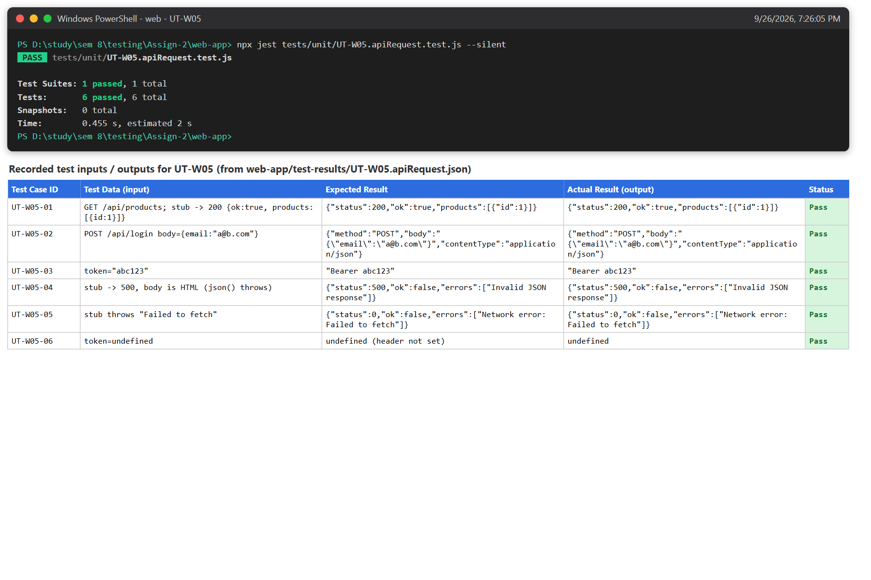
Figure 5: UT-W05 execution - "npx jest tests/unit/UT-W05.apiRequest.test.js --silent" (terminal output) with the recorded inputs/outputs of all 6 test cases (6 passed).

3.2.6 UT-W06 - validateCard() - Payment card validation (Luhn)
Result: 6 test cases executed, 6 passed, 0 failed.
Test Case ID | Related Use Case ID | Test Case Title | Test Objective | Preconditions | Test Steps | Test Data | Expected Result | Actual Result | Status (Pass/​Fail) | Priority | Tested By | Test Date
UT-W06-01 | UC-W04 Checkout & Pay | Valid Visa test card passes | Verify card number (Luhn), expiry (MM/​YY, not expired) and CVV validation | validators.js module loaded; system date 2026 | 1. Call validateCard({cardNumber​, expiry, cvv}) 2. Compare {valid, errors} with expected | [{"cardNumber":​"4242424​242424242",​"expiry":​"1​2/​30",​"cvv":​"123"}] | {"valid":​true,​"errors"​:​[]} | {"valid":​true,​"errors"​:​[]} | Pass | High | [Your Name] | 2026-09-26
UT-W06-02 | UC-W04 Checkout & Pay | Card number failing Luhn check is rejected | Verify card number (Luhn), expiry (MM/​YY, not expired) and CVV validation | validators.js module loaded; system date 2026 | 1. Call validateCard({cardNumber​, expiry, cvv}) 2. Compare {valid, errors} with expected | [{"cardNumber":​"4242424​242424241",​"expiry":​"1​2/​30",​"cvv":​"123"}] | {"valid":​false,​"errors​":​["Invalid card number"]} | {"valid":​false,​"errors​":​["Invalid card number"]} | Pass | High | [Your Name] | 2026-09-26
UT-W06-03 | UC-W04 Checkout & Pay | Expired card is rejected | Verify card number (Luhn), expiry (MM/​YY, not expired) and CVV validation | validators.js module loaded; system date 2026 | 1. Call validateCard({cardNumber​, expiry, cvv}) 2. Compare {valid, errors} with expected | [{"cardNumber":​"4242424​242424242",​"expiry":​"0​1/​20",​"cvv":​"123"}] | {"valid":​false,​"errors​":​["Card has expired"]} | {"valid":​false,​"errors​":​["Card has expired"]} | Pass | High | [Your Name] | 2026-09-26
UT-W06-04 | UC-W04 Checkout & Pay | Invalid expiry month (13) is rejected | Verify card number (Luhn), expiry (MM/​YY, not expired) and CVV validation | validators.js module loaded; system date 2026 | 1. Call validateCard({cardNumber​, expiry, cvv}) 2. Compare {valid, errors} with expected | [{"cardNumber":​"4242424​242424242",​"expiry":​"1​3/​30",​"cvv":​"123"}] | {"valid":​false,​"errors​":​["Expiry must be MM/​YY"]} | {"valid":​false,​"errors​":​["Expiry must be MM/​YY"]} | Pass | Medium | [Your Name] | 2026-09-26
UT-W06-05 | UC-W04 Checkout & Pay | Non-numeric CVV is rejected | Verify card number (Luhn), expiry (MM/​YY, not expired) and CVV validation | validators.js module loaded; system date 2026 | 1. Call validateCard({cardNumber​, expiry, cvv}) 2. Compare {valid, errors} with expected | [{"cardNumber":​"4242424​242424242",​"expiry":​"1​2/​30",​"cvv":​"ab1"}] | {"valid":​false,​"errors​":​["CVV must be 3 or 4 digits"]} | {"valid":​false,​"errors​":​["CVV must be 3 or 4 digits"]} | Pass | Medium | [Your Name] | 2026-09-26
UT-W06-06 | UC-W04 Checkout & Pay | Card number with spaces is accepted | Verify card number (Luhn), expiry (MM/​YY, not expired) and CVV validation | validators.js module loaded; system date 2026 | 1. Call validateCard({cardNumber​, expiry, cvv}) 2. Compare {valid, errors} with expected | [{"cardNumber":​"4242 4242 4242 4242",​"expiry":​"12/​30​",​"cvv":​"123"}] | {"valid":​true,​"errors"​:​[]} | {"valid":​true,​"errors"​:​[]} | Pass | Low | [Your Name] | 2026-09-26
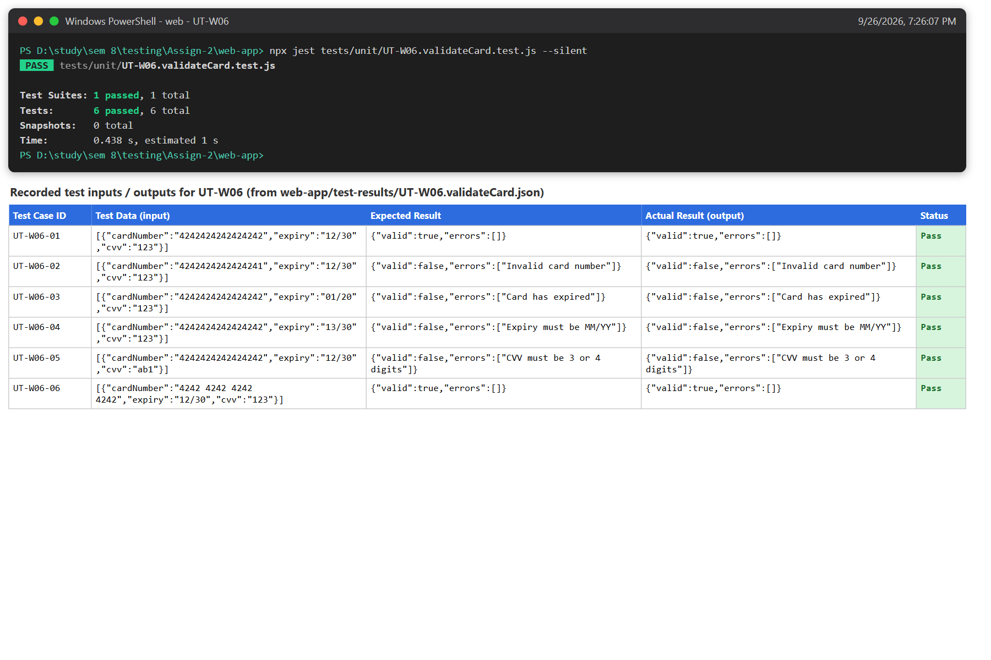
Figure 6: UT-W06 execution - "npx jest tests/unit/UT-W06.validateCard.test.js --silent" (terminal output) with the recorded inputs/outputs of all 6 test cases (6 passed).

3.2.7 UT-W07 - calculateTotal() - Cart total with discount
Result: 6 test cases executed, 6 passed, 0 failed.
Test Case ID | Related Use Case ID | Test Case Title | Test Objective | Preconditions | Test Steps | Test Data | Expected Result | Actual Result | Status (Pass/​Fail) | Priority | Tested By | Test Date
UT-W07-01 | UC-W04 Checkout & Pay | Empty cart total is 0 | Verify cart total = sum(price x qty), with 10% discount when subtotal > 10,​000 | orders.js module loaded | 1. Call calculateTotal(items) 2. Compare returned total with expected | [[]] | 0 | 0 | Pass | Medium | [Your Name] | 2026-09-26
UT-W07-02 | UC-W04 Checkout & Pay | Single line total is price x qty | Verify cart total = sum(price x qty), with 10% discount when subtotal > 10,​000 | orders.js module loaded | 1. Call calculateTotal(items) 2. Compare returned total with expected | [[{"price":​1500,​"qty":​​2}]] | 3000 | 3000 | Pass | High | [Your Name] | 2026-09-26
UT-W07-03 | UC-W04 Checkout & Pay | Subtotal exactly 10,​000 gets no discount (boundary) | Verify cart total = sum(price x qty), with 10% discount when subtotal > 10,​000 | orders.js module loaded | 1. Call calculateTotal(items) 2. Compare returned total with expected | [[{"price":​5000,​"qty":​​2}]] | 10000 | 10000 | Pass | High | [Your Name] | 2026-09-26
UT-W07-04 | UC-W04 Checkout & Pay | Subtotal above 10,​000 gets 10% discount | Verify cart total = sum(price x qty), with 10% discount when subtotal > 10,​000 | orders.js module loaded | 1. Call calculateTotal(items) 2. Compare returned total with expected | [[{"price":​6500,​"qty":​​2}]] | 11700 | 11700 | Pass | High | [Your Name] | 2026-09-26
UT-W07-05 | UC-W04 Checkout & Pay | Decimal prices are rounded to 2 places | Verify cart total = sum(price x qty), with 10% discount when subtotal > 10,​000 | orders.js module loaded | 1. Call calculateTotal(items) 2. Compare returned total with expected | [[{"price":​99.99,​"qty"​:​3}]] | 299.97 | 299.97 | Pass | Medium | [Your Name] | 2026-09-26
UT-W07-06 | UC-W04 Checkout & Pay | Invalid input (null) returns 0 | Verify cart total = sum(price x qty), with 10% discount when subtotal > 10,​000 | orders.js module loaded | 1. Call calculateTotal(items) 2. Compare returned total with expected | [null] | 0 | 0 | Pass | Low | [Your Name] | 2026-09-26
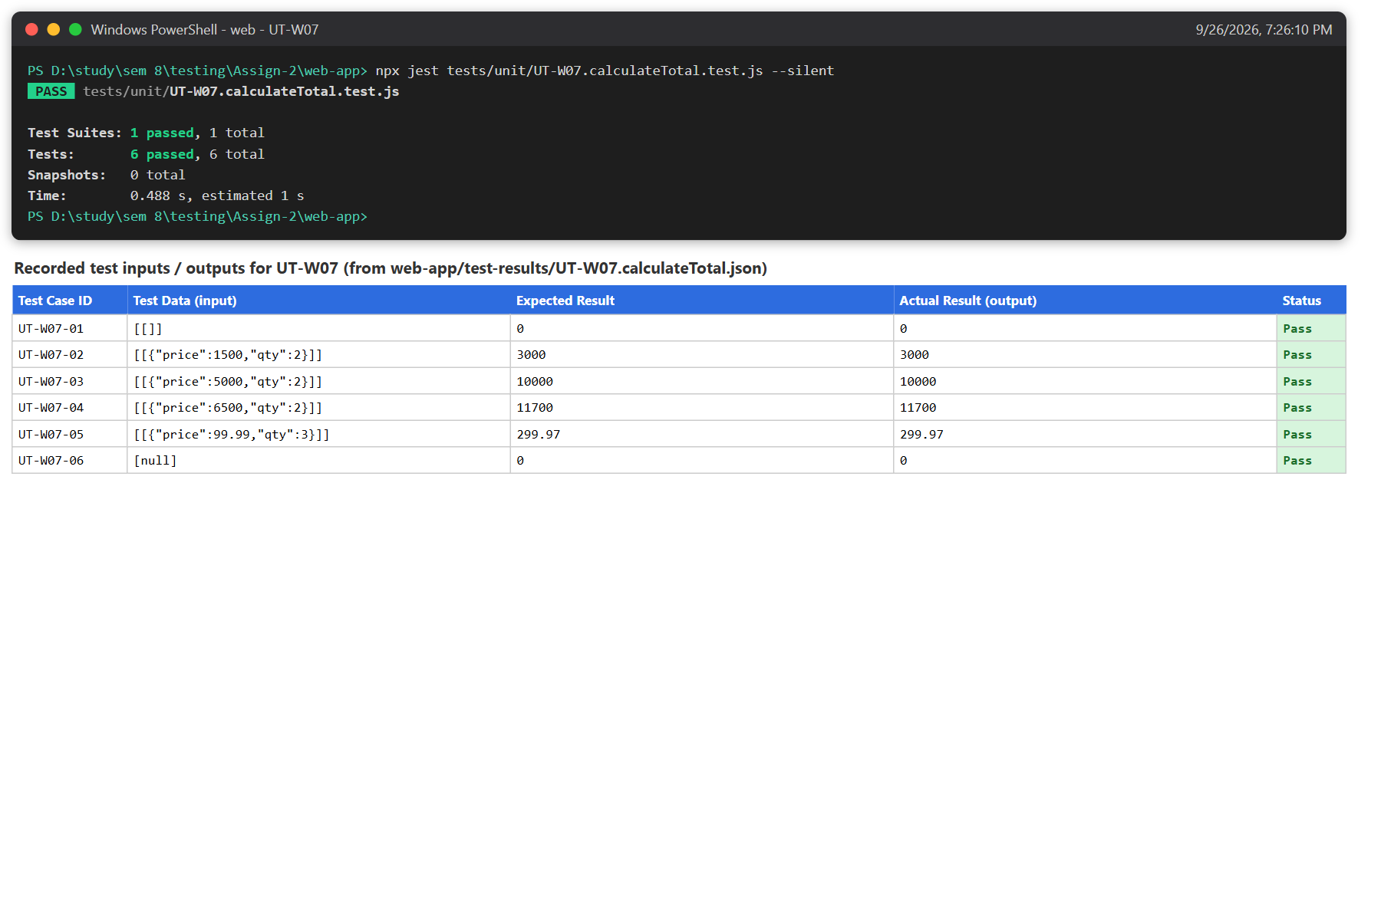
Figure 7: UT-W07 execution - "npx jest tests/unit/UT-W07.calculateTotal.test.js --silent" (terminal output) with the recorded inputs/outputs of all 6 test cases (6 passed).

3.3 Component Testing
Related units were grouped into components (modules) and tested together through the module's public functions or rendered screens.

3.3.1 CT-W01 - Authentication Module
Deliverable | Details
Component Name | Authentication Module (src/​modules/​auth.js)
Included Units | validateRegisterForm(), validateLoginForm(), hashPassword(), verifyPassword(), generateToken(), findUserByEmail() (DB check), getUserByToken()
Test Scenarios | CT-W01-01: Register a new valid user  CT-W01-02: Registering an already used email is rejected  CT-W01-03: Duplicate check is case-insensitive  CT-W01-04: Password is stored hashed, never in plain text  CT-W01-05: Login with correct credentials returns token and session  CT-W01-06: Login with wrong password is rejected  CT-W01-07: Logout invalidates the session token
Observed Behavior | 7 of 7 scenarios passed. Registration validates input, hashes the password (PBKDF2 + random salt) and stores the user; duplicate emails are blocked case-insensitively. Login issues a 48-character session token that resolves back to the user and logout removes it.
Bugs Found | None - all scenarios passed.

Test scenarios (executed):
Test Case ID | Related Use Case ID | Test Case Title | Test Objective | Preconditions | Test Steps | Test Data | Expected Result | Actual Result | Status (Pass/​Fail) | Priority | Tested By | Test Date
CT-W01-01 | UC-W01 Register / UC-W02 Login | Register a new valid user | Verify register + login + session handling work together inside the auth module | In-memory DB reset before each test | 1. Prepare state (see Preconditions) 2. Perform the actions listed in Test Data 3. Compare the output with Expected Result | {"name":​"Ali Khan",​"email":​"ali@tes​t.com",​"password":​"Sec​ret123"} | status 201, returned user has id/​name/​email and NO passwordHash | status 201, user=​{"id":​1,​"name":​​"Ali Khan",​"email":​"ali@tes​t.com"} | Pass | High | [Your Name] | 2026-09-26
CT-W01-02 | UC-W01 Register / UC-W02 Login | Registering an already used email is rejected | Verify register + login + session handling work together inside the auth module | In-memory DB reset before each test | 1. Prepare state (see Preconditions) 2. Perform the actions listed in Test Data 3. Compare the output with Expected Result | register ALI twice | {"ok":​false,​"status":​​409,​"errors":​["Email already registered"]} | {"ok":​false,​"status":​​409,​"errors":​["Email already registered"]} | Pass | High | [Your Name] | 2026-09-26
CT-W01-03 | UC-W01 Register / UC-W02 Login | Duplicate check is case-insensitive | Verify register + login + session handling work together inside the auth module | In-memory DB reset before each test | 1. Prepare state (see Preconditions) 2. Perform the actions listed in Test Data 3. Compare the output with Expected Result | register ali@test.com, then ALI@TEST.COM | {"ok":​false,​"status":​​409,​"errors":​["Email already registered"]} | {"ok":​false,​"status":​​409,​"errors":​["Email already registered"]} | Pass | Medium | [Your Name] | 2026-09-26
CT-W01-04 | UC-W01 Register / UC-W02 Login | Password is stored hashed, never in plain text | Verify register + login + session handling work together inside the auth module | In-memory DB reset before each test | 1. Prepare state (see Preconditions) 2. Perform the actions listed in Test Data 3. Compare the output with Expected Result | register ALI then read db.users[0] | passwordHash != "Secret123" and has salt:​hash format | passwordHash=​"682c06e41​678d44bfaf0..." (length 97) | Pass | High | [Your Name] | 2026-09-26
CT-W01-05 | UC-W01 Register / UC-W02 Login | Login with correct credentials returns token and session | Verify register + login + session handling work together inside the auth module | In-memory DB reset before each test | 1. Prepare state (see Preconditions) 2. Perform the actions listed in Test Data 3. Compare the output with Expected Result | register ALI, login ali@test.com / Secret123 | status 200, 48-char token, getUserByToken(token) returns Ali | status 200, token length 48, session user=​Ali Khan | Pass | High | [Your Name] | 2026-09-26
CT-W01-06 | UC-W01 Register / UC-W02 Login | Login with wrong password is rejected | Verify register + login + session handling work together inside the auth module | In-memory DB reset before each test | 1. Prepare state (see Preconditions) 2. Perform the actions listed in Test Data 3. Compare the output with Expected Result | login ali@test.com / Wrong1234 | {"ok":​false,​"status":​​401,​"errors":​["Invalid email or password"]} | {"ok":​false,​"status":​​401,​"errors":​["Invalid email or password"]} | Pass | High | [Your Name] | 2026-09-26
CT-W01-07 | UC-W01 Register / UC-W02 Login | Logout invalidates the session token | Verify register + login + session handling work together inside the auth module | In-memory DB reset before each test | 1. Prepare state (see Preconditions) 2. Perform the actions listed in Test Data 3. Compare the output with Expected Result | login, then logout(token), then getUserByToken(token) | {"loggedOut":​true,​"use​rAfter":​null} | {"loggedOut":​true,​"use​rAfter":​null} | Pass | Medium | [Your Name] | 2026-09-26
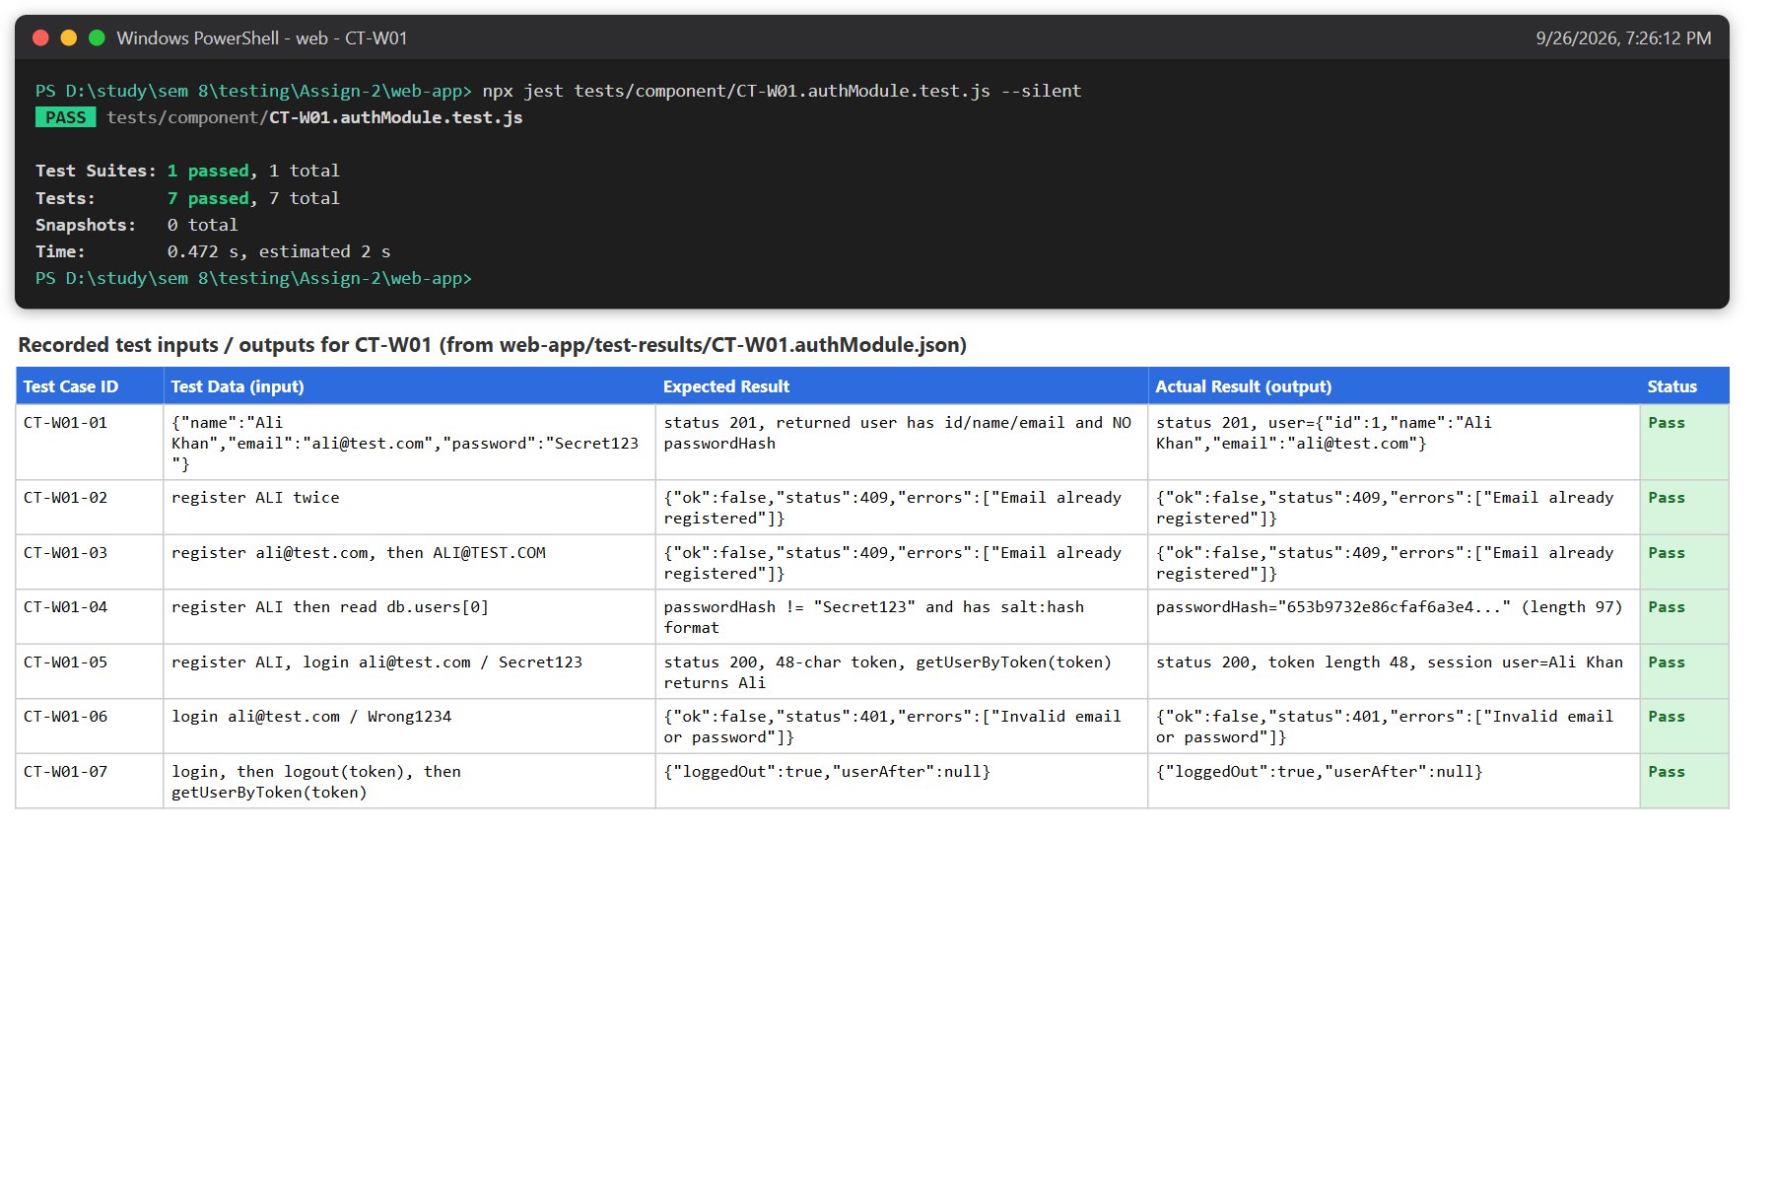
Figure 8: CT-W01 execution - "npx jest tests/component/CT-W01.authModule.test.js --silent" (terminal output) with the recorded inputs/outputs of all 7 test cases (7 passed).

3.3.2 CT-W02 - Product Module
Deliverable | Details
Component Name | Product Module (src/​modules/​products.​js)
Included Units | validateProductForm(), addProduct(), listProducts(), getProduct(), deleteProduct(), reduceStock()
Test Scenarios | CT-W02-01: Add a valid product  CT-W02-02: Add product with invalid price and stock is rejected  CT-W02-03: Search products by partial name (case-insensitive)  CT-W02-04: Delete existing product removes it  CT-W02-05: Delete non-existent product returns 404  CT-W02-06: Reducing stock beyond availability throws  CT-W02-07: Product name containing HTML/​script is rejected
Observed Behavior | 6 of 7 scenarios passed. Valid products get auto-increment IDs, invalid price/​stock are rejected with both messages, search is case-insensitive, deleting an unknown ID returns 404 and reduceStock() prevents overselling. However, a product name containing HTML markup was accepted (201).
Bugs Found | BUG-W02 (CT-W02-07): Stored XSS / HTML injection through product name

Test scenarios (executed):
Test Case ID | Related Use Case ID | Test Case Title | Test Objective | Preconditions | Test Steps | Test Data | Expected Result | Actual Result | Status (Pass/​Fail) | Priority | Tested By | Test Date
CT-W02-01 | UC-W03 Manage Products | Add a valid product | Verify add / view / search / delete / stock operations of the product module | DB seeded with 3 products (Mouse, Keyboard, Cable) before each test | 1. Prepare state (see Preconditions) 2. Perform the actions listed in Test Data 3. Compare the output with Expected Result | {name:​"Monitor", price:​30000, stock:​3} | {"ok":​true,​"status":​2​01,​"product":​{"id":​4,​​"name":​"Monitor",​"pri​ce":​30000,​"stock":​3}} | {"ok":​true,​"status":​2​01,​"product":​{"id":​4,​​"name":​"Monitor",​"pri​ce":​30000,​"stock":​3}} | Pass | High | [Your Name] | 2026-09-26
CT-W02-02 | UC-W03 Manage Products | Add product with invalid price and stock is rejected | Verify add / view / search / delete / stock operations of the product module | DB seeded with 3 products (Mouse, Keyboard, Cable) before each test | 1. Prepare state (see Preconditions) 2. Perform the actions listed in Test Data 3. Compare the output with Expected Result | {name:​"Bad", price:​-5, stock:​1.5} | {"ok":​false,​"status":​​400,​"errors":​["Price must be a positive number",​"Stock must be a non-negative integer"]} | {"ok":​false,​"status":​​400,​"errors":​["Price must be a positive number",​"Stock must be a non-negative integer"]} | Pass | Medium | [Your Name] | 2026-09-26
CT-W02-03 | UC-W03 Manage Products | Search products by partial name (case-insensitive) | Verify add / view / search / delete / stock operations of the product module | DB seeded with 3 products (Mouse, Keyboard, Cable) before each test | 1. Prepare state (see Preconditions) 2. Perform the actions listed in Test Data 3. Compare the output with Expected Result | search=​"KEY" | ["Mechanical Keyboard"] | ["Mechanical Keyboard"] | Pass | Medium | [Your Name] | 2026-09-26
CT-W02-04 | UC-W03 Manage Products | Delete existing product removes it | Verify add / view / search / delete / stock operations of the product module | DB seeded with 3 products (Mouse, Keyboard, Cable) before each test | 1. Prepare state (see Preconditions) 2. Perform the actions listed in Test Data 3. Compare the output with Expected Result | deleteProduct(2) then getProduct(2) | {"status":​200,​"deleted​":​"Mechanical Keyboard",​"after":​null​} | {"status":​200,​"deleted​":​"Mechanical Keyboard",​"after":​null​} | Pass | High | [Your Name] | 2026-09-26
CT-W02-05 | UC-W03 Manage Products | Delete non-existent product returns 404 | Verify add / view / search / delete / stock operations of the product module | DB seeded with 3 products (Mouse, Keyboard, Cable) before each test | 1. Prepare state (see Preconditions) 2. Perform the actions listed in Test Data 3. Compare the output with Expected Result | deleteProduct(99) | {"ok":​false,​"status":​​404,​"errors":​["Product not found"]} | {"ok":​false,​"status":​​404,​"errors":​["Product not found"]} | Pass | Medium | [Your Name] | 2026-09-26
CT-W02-06 | UC-W03 Manage Products | Reducing stock beyond availability throws | Verify add / view / search / delete / stock operations of the product module | DB seeded with 3 products (Mouse, Keyboard, Cable) before each test | 1. Prepare state (see Preconditions) 2. Perform the actions listed in Test Data 3. Compare the output with Expected Result | reduceStock(1, 11) (stock=​10) | "throws: Insufficient stock for Wireless Mouse" | "throws: Insufficient stock for Wireless Mouse" | Pass | Medium | [Your Name] | 2026-09-26
CT-W02-07 | UC-W03 Manage Products | Product name containing HTML/​script is rejected | Verify add / view / search / delete / stock operations of the product module | DB seeded with 3 products (Mouse, Keyboard, Cable) before each test | 1. Prepare state (see Preconditions) 2. Perform the actions listed in Test Data 3. Compare the output with Expected Result | {name:​"<img src=​x onerror=​alert(1)>", price:​10, stock:​1} | status 400 (markup rejected, prevents stored XSS in product table) | status 201, product stored with name "<img src=​x onerror=​alert(1)>" | Fail | High | [Your Name] | 2026-09-26
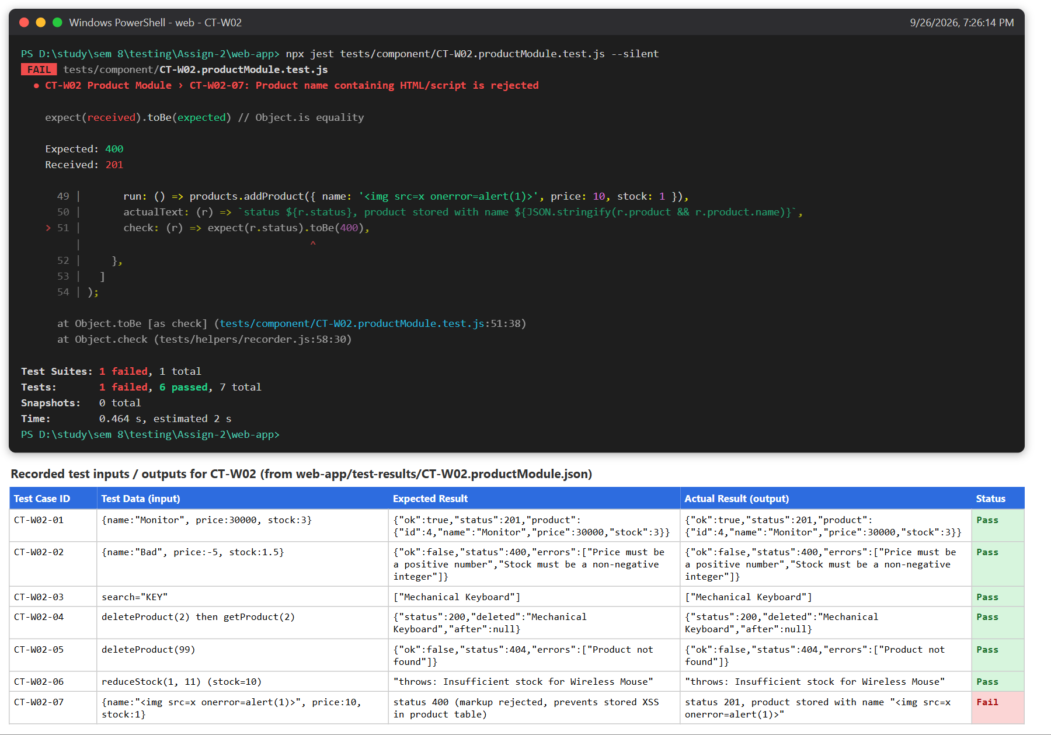
Figure 9: CT-W02 execution - "npx jest tests/component/CT-W02.productModule.test.js --silent" (terminal output) with the recorded inputs/outputs of all 7 test cases (6 passed).

3.3.3 CT-W03 - Payment Module
Deliverable | Details
Component Name | Payment Module (src/​modules/​payment.j​s)
Included Units | validateCard(), luhnCheck(), processPayment(), payments table (db.payments)
Test Scenarios | CT-W03-01: Valid card payment succeeds  CT-W03-02: Bank-declined card returns 402 and is recorded as DECLINED  CT-W03-03: Zero amount is rejected before contacting gateway  CT-W03-04: Expired card is rejected and nothing is recorded  CT-W03-05: Full card number is never stored (only last 4 digits)
Observed Behavior | 5 of 5 scenarios passed. The gateway validates the card before charging, records SUCCESS / DECLINED payments and stores only the last 4 digits of the card. Expired cards and zero amounts are rejected and nothing is recorded.
Bugs Found | None - all scenarios passed.

Test scenarios (executed):
Test Case ID | Related Use Case ID | Test Case Title | Test Objective | Preconditions | Test Steps | Test Data | Expected Result | Actual Result | Status (Pass/​Fail) | Priority | Tested By | Test Date
CT-W03-01 | UC-W04 Checkout & Pay | Valid card payment succeeds | Verify the mock payment gateway validates cards, charges, declines and records payments | In-memory DB reset before each test | 1. Prepare state (see Preconditions) 2. Perform the actions listed in Test Data 3. Compare the output with Expected Result | amount=​3000, card 4242...4242 | ok=​true, status 200, payment.status=​"SUCCESS​", last4=​"4242" | ok=​true, status 200, payment.status=​"SUCCESS​", last4=​"4242" | Pass | High | [Your Name] | 2026-09-26
CT-W03-02 | UC-W04 Checkout & Pay | Bank-declined card returns 402 and is recorded as DECLINED | Verify the mock payment gateway validates cards, charges, declines and records payments | In-memory DB reset before each test | 1. Prepare state (see Preconditions) 2. Perform the actions listed in Test Data 3. Compare the output with Expected Result | amount=​3000, card 4000000000000002 | status 402, "Payment declined by bank", db.payments[0].status=​"​DECLINED" | status 402, ["Payment declined by bank"], stored status=​"DECLINED" | Pass | High | [Your Name] | 2026-09-26
CT-W03-03 | UC-W04 Checkout & Pay | Zero amount is rejected before contacting gateway | Verify the mock payment gateway validates cards, charges, declines and records payments | In-memory DB reset before each test | 1. Prepare state (see Preconditions) 2. Perform the actions listed in Test Data 3. Compare the output with Expected Result | amount=​0 | {"ok":​false,​"status":​​400,​"errors":​["Amount must be a positive number"]} | {"ok":​false,​"status":​​400,​"errors":​["Amount must be a positive number"]} | Pass | Medium | [Your Name] | 2026-09-26
CT-W03-04 | UC-W04 Checkout & Pay | Expired card is rejected and nothing is recorded | Verify the mock payment gateway validates cards, charges, declines and records payments | In-memory DB reset before each test | 1. Prepare state (see Preconditions) 2. Perform the actions listed in Test Data 3. Compare the output with Expected Result | amount=​500, expiry=​"01/​21" | {"status":​400,​"errors"​:​["Card has expired"],​"paymentsStor​ed":​0} | {"status":​400,​"errors"​:​["Card has expired"],​"paymentsStor​ed":​0} | Pass | Medium | [Your Name] | 2026-09-26
CT-W03-05 | UC-W04 Checkout & Pay | Full card number is never stored (only last 4 digits) | Verify the mock payment gateway validates cards, charges, declines and records payments | In-memory DB reset before each test | 1. Prepare state (see Preconditions) 2. Perform the actions listed in Test Data 3. Compare the output with Expected Result | successful payment, inspect db.payments[0] | stored keys = id, amount, last4, status, createdAt (no cardNumber / cvv) | ["id",​"amount",​"last4"​,​"status",​"createdAt"] | Pass | High | [Your Name] | 2026-09-26
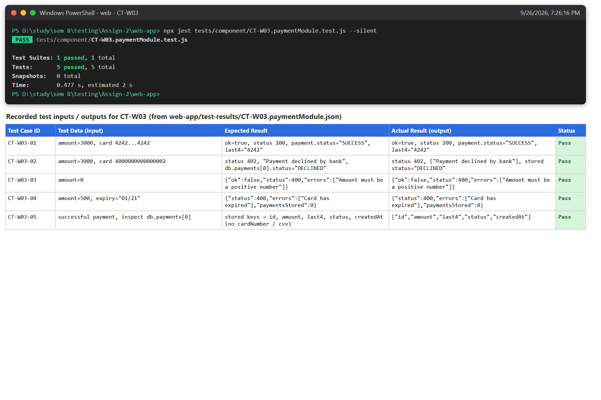
Figure 10: CT-W03 execution - "npx jest tests/component/CT-W03.paymentModule.test.js --silent" (terminal output) with the recorded inputs/outputs of all 5 test cases (5 passed).

3.4 Integration Testing
Interactions between modules were tested. Strategies used: Top-Down Integration, Bottom-Up Integration, Incremental Integration.

3.4.1 IT-W01 - Frontend (API handler) <-> Backend REST API
Deliverable | Details
Modules Integrated | public/​api.js (apiRequest) + public/​main.js <-> src/​app.js (Express routes) -> auth/​products modules
Integration Strategy Used | Top-Down Integration: the top layer (frontend API handler) is tested first against the real backend routes; the DB is replaced by the seeded in-memory store (stub).
Test Cases | IT-W01-01: Frontend loads product list from backend [Pass]  IT-W01-02: Register + login through frontend returns a session token [Pass]  IT-W01-03: Backend validation errors reach the frontend unchanged [Pass]  IT-W01-04: Protected endpoint without token is refused [Pass]  IT-W01-05: Product added via frontend appears in the list [Pass]
Data Passed Between Modules | HTTP JSON requests (method, JSON body, Bearer token) -> JSON responses {ok, status, products|​token|​user|​e​rrors}
Observed Behavior | 5 of 5 test cases passed. Real HTTP requests made by the frontend handler reached the Express routes; JSON responses, validation errors and 401 Unauthorized came back unchanged, and a product added through the API was immediately visible in search.
Errors / Failures Observed | None - all scenarios passed.

Integration test cases (executed):
Test Case ID | Related Use Case ID | Test Case Title | Test Objective | Preconditions | Test Steps | Test Data | Expected Result | Actual Result | Status (Pass/​Fail) | Priority | Tested By | Test Date
IT-W01-01 | UC-W01..UC-W03 | Frontend loads product list from backend | Verify the frontend request handler and the Express backend exchange data correctly over real HTTP | Express server started on random port; DB seeded with 3 products | 1. Prepare state (see Preconditions) 2. Perform the actions listed in Test Data 3. Compare the output with Expected Result | GET /​api/​products | status 200, 3 products (Wireless Mouse, Mechanical Keyboard, USB-C Cable) | status 200, 3 products (Wireless Mouse, Mechanical Keyboard, USB-C Cable) | Pass | High | [Your Name] | 2026-09-26
IT-W01-02 | UC-W01..UC-W03 | Register + login through frontend returns a session token | Verify the frontend request handler and the Express backend exchange data correctly over real HTTP | Express server started on random port; DB seeded with 3 products | 1. Prepare state (see Preconditions) 2. Perform the actions listed in Test Data 3. Compare the output with Expected Result | POST /​api/​register {Ali}, POST /​api/​login | register 201; login 200 with 48-char token and user.name=​"Ali Khan" | register 201; login 200, token length 48, user.name=​"Ali Khan" | Pass | High | [Your Name] | 2026-09-26
IT-W01-03 | UC-W01..UC-W03 | Backend validation errors reach the frontend unchanged | Verify the frontend request handler and the Express backend exchange data correctly over real HTTP | Express server started on random port; DB seeded with 3 products | 1. Prepare state (see Preconditions) 2. Perform the actions listed in Test Data 3. Compare the output with Expected Result | POST /​api/​register {email:​"bad", password:​"123"} | status 400 with name, email and password error messages | status 400, errors=​["Name must be at least 2 characters",​"Invalid email format",​"Password must be at least 8 characters",​"Password must contain an uppercase letter",​"Password must contain a lowercase letter"] | Pass | Medium | [Your Name] | 2026-09-26
IT-W01-04 | UC-W01..UC-W03 | Protected endpoint without token is refused | Verify the frontend request handler and the Express backend exchange data correctly over real HTTP | Express server started on random port; DB seeded with 3 products | 1. Prepare state (see Preconditions) 2. Perform the actions listed in Test Data 3. Compare the output with Expected Result | POST /​api/​products (no token) | {"status":​401,​"ok":​fa​lse,​"errors":​["Unautho​rized"]} | {"status":​401,​"ok":​fa​lse,​"errors":​["Unautho​rized"]} | Pass | High | [Your Name] | 2026-09-26
IT-W01-05 | UC-W01..UC-W03 | Product added via frontend appears in the list | Verify the frontend request handler and the Express backend exchange data correctly over real HTTP | Express server started on random port; DB seeded with 3 products | 1. Prepare state (see Preconditions) 2. Perform the actions listed in Test Data 3. Compare the output with Expected Result | login, POST /​api/​products {Monitor, 30000, 3}, GET /​api/​products?search=​​mon | POST 201, search returns [Monitor] | POST 201, search returns ["Monitor"] | Pass | Medium | [Your Name] | 2026-09-26
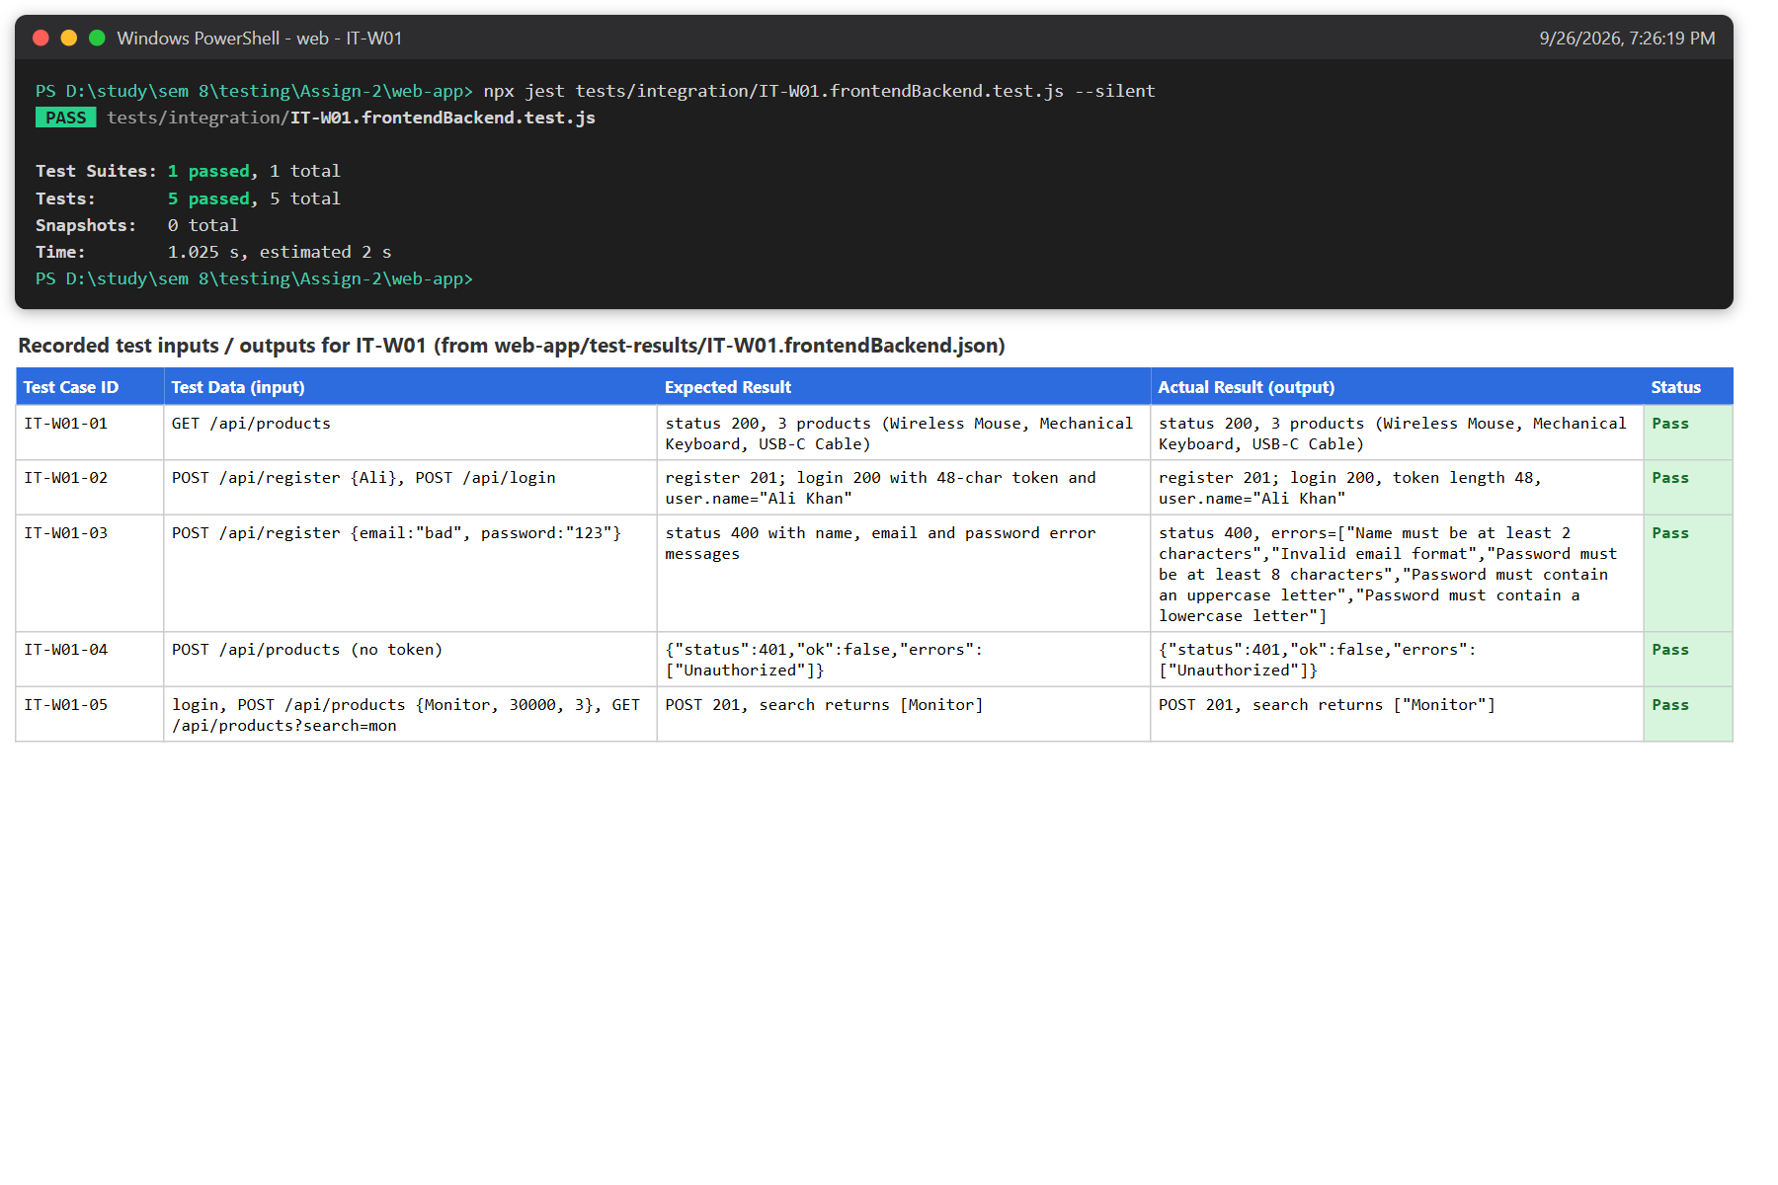
Figure 11: IT-W01 execution - "npx jest tests/integration/IT-W01.frontendBackend.test.js --silent" (terminal output) with the recorded inputs/outputs of all 5 test cases (5 passed).

3.4.2 IT-W02 - Backend API <-> Database
Deliverable | Details
Modules Integrated | src/​app.js (routes) -> auth / products / orders modules -> src/​db.js (users, sessions, products, orders tables)
Integration Strategy Used | Bottom-Up Integration: db.js and the modules were already verified (unit + component); now the Express routes are integrated on top and checked against the DB state.
Test Cases | IT-W02-01: POST /​api/​register persists a user row with hashed password [Pass]  IT-W02-02: Login creates a session row; logout deletes it [Pass]  IT-W02-03: DELETE /​api/​products/​:​id removes the DB row [Pass]  IT-W02-04: GET /​api/​orders returns only the logged-in user's orders [Pass]  IT-W02-05: Registering the same email twice keeps only one DB row [Pass]
Data Passed Between Modules | Route params/​JSON body -> module calls -> DB rows (users, sessions, products, orders); DB rows -> JSON responses
Observed Behavior | 5 of 5 test cases passed. Every API call produced the expected database change: users stored with hashed passwords, sessions created/​deleted on login/​logout, product rows deleted, duplicate users prevented and orders filtered per user.
Errors / Failures Observed | None - all scenarios passed.

Integration test cases (executed):
Test Case ID | Related Use Case ID | Test Case Title | Test Objective | Preconditions | Test Steps | Test Data | Expected Result | Actual Result | Status (Pass/​Fail) | Priority | Tested By | Test Date
IT-W02-01 | UC-W01..UC-W05 | POST /​api/​register persists a user row with hashed password | Verify that API calls read/​write the correct records in the database tables | DB seeded before each test; requests sent with supertest | 1. Prepare state (see Preconditions) 2. Perform the actions listed in Test Data 3. Compare the output with Expected Result | {name:​"Sara", email:​"sara@test.com", password:​"Secret123"} | db.users has 1 row, email "sara@test.com", passwordHash != plain password | db.users rows=​1, email=​"sara@test.com", passwordHash starts "45e5862d0ee4..." | Pass | High | [Your Name] | 2026-09-26
IT-W02-02 | UC-W01..UC-W05 | Login creates a session row; logout deletes it | Verify that API calls read/​write the correct records in the database tables | DB seeded before each test; requests sent with supertest | 1. Prepare state (see Preconditions) 2. Perform the actions listed in Test Data 3. Compare the output with Expected Result | login -> check db.sessions -> POST /​api/​logout -> check db.sessions | {"sessionsAfterLogin":​1​,​"sessionsAfterLogout":​​0} | {"sessionsAfterLogin":​1​,​"sessionsAfterLogout":​​0} | Pass | High | [Your Name] | 2026-09-26
IT-W02-03 | UC-W01..UC-W05 | DELETE /​api/​products/​:​id removes the DB row | Verify that API calls read/​write the correct records in the database tables | DB seeded before each test; requests sent with supertest | 1. Prepare state (see Preconditions) 2. Perform the actions listed in Test Data 3. Compare the output with Expected Result | DELETE /​api/​products/​2 then GET /​api/​products/​2 | {"deleteStatus":​200,​"r​owsLeft":​2,​"getStatus"​:​404} | {"deleteStatus":​200,​"r​owsLeft":​2,​"getStatus"​:​404} | Pass | Medium | [Your Name] | 2026-09-26
IT-W02-04 | UC-W01..UC-W05 | GET /​api/​orders returns only the logged-in user's orders | Verify that API calls read/​write the correct records in the database tables | DB seeded before each test; requests sent with supertest | 1. Prepare state (see Preconditions) 2. Perform the actions listed in Test Data 3. Compare the output with Expected Result | user A orders 1 mouse, user B orders 1 cable; each calls GET /​api/​orders | {"ordersInDb":​2,​"userA​":​["Wireless Mouse"],​"userB":​["USB-​C Cable"]} | {"ordersInDb":​2,​"userA​":​["Wireless Mouse"],​"userB":​["USB-​C Cable"]} | Pass | High | [Your Name] | 2026-09-26
IT-W02-05 | UC-W01..UC-W05 | Registering the same email twice keeps only one DB row | Verify that API calls read/​write the correct records in the database tables | DB seeded before each test; requests sent with supertest | 1. Prepare state (see Preconditions) 2. Perform the actions listed in Test Data 3. Compare the output with Expected Result | POST /​api/​register x2 with "dup@test.com" | {"secondStatus":​409,​"r​ows":​1} | {"secondStatus":​409,​"r​ows":​1} | Pass | Medium | [Your Name] | 2026-09-26
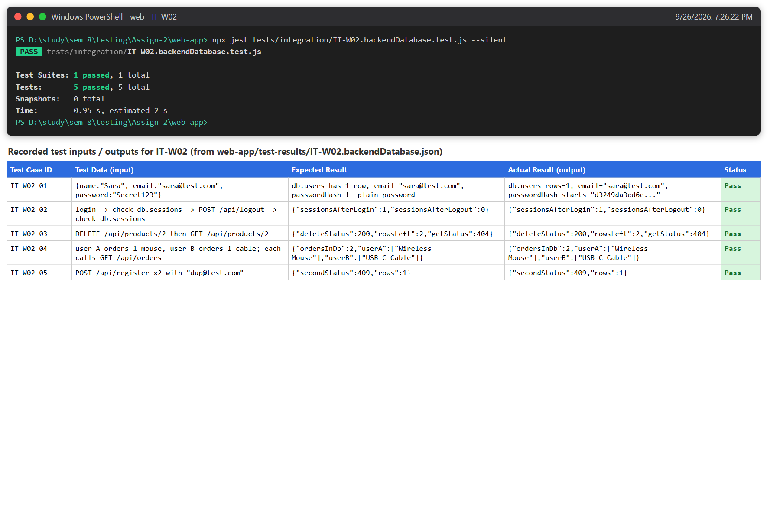
Figure 12: IT-W02 execution - "npx jest tests/integration/IT-W02.backendDatabase.test.js --silent" (terminal output) with the recorded inputs/outputs of all 5 test cases (5 passed).

3.4.3 IT-W03 - Payment Gateway <-> Order Module
Deliverable | Details
Modules Integrated | Order Module (orders.js: createOrder, calculateTotal) <-> Payment Module (payment.js: processPayment) <-> Product Module (reduceStock)
Integration Strategy Used | Incremental Integration: Product module + Order module were combined first, then the Payment gateway was added and the combined flow re-tested.
Test Cases | IT-W03-01: Successful payment creates PAID order and reduces stock [Pass]  IT-W03-02: Declined payment creates no order and keeps stock [Pass]  IT-W03-03: Discounted total (>10,​000) is what the gateway charges [Pass]  IT-W03-04: Insufficient stock is detected before charging the card [Pass]  IT-W03-05: Same product in two cart lines exceeding stock is refused without charging [Fail]
Data Passed Between Modules | Order -> Payment: {amount = calculated total, cardNumber, expiry, cvv}; Payment -> Order: {ok, payment.id, status}; Order -> Product: (productId, qty) for stock reduction
Observed Behavior | 4 of 5 test cases passed. Normal checkout, declined card, discount and insufficient-stock flows behaved correctly. When the same product appears in two cart lines whose total exceeds stock, each line passed the stock check, the card was charged and reduceStock() then threw, returning HTTP 500.
Errors / Failures Observed | BUG-W03 (IT-W03-05): Card charged but order fails when the same product is in two cart lines

Integration test cases (executed):
Test Case ID | Related Use Case ID | Test Case Title | Test Objective | Preconditions | Test Steps | Test Data | Expected Result | Actual Result | Status (Pass/​Fail) | Priority | Tested By | Test Date
IT-W03-01 | UC-W04 Checkout & Pay | Successful payment creates PAID order and reduces stock | Verify the order module charges through the payment gateway and only updates stock/​orders when payment succeeds | DB seeded (stock: Mouse=​10, Keyboard=​5, Cable=​50); user logged in | POST /​api/​orders with items + card | items=​[{productId:​1, qty:​2}], card 4242... | status 201, total 3000, order PAID, payment SUCCESS, Mouse stock 10 -> 8 | status 201, total 3000, order PAID, payments ["SUCCESS"], stock [8,​5,​50] | Pass | High | [Your Name] | 2026-09-26
IT-W03-02 | UC-W04 Checkout & Pay | Declined payment creates no order and keeps stock | Verify the order module charges through the payment gateway and only updates stock/​orders when payment succeeds | DB seeded (stock: Mouse=​10, Keyboard=​5, Cable=​50); user logged in | POST /​api/​orders with items + card | items=​[{productId:​1, qty:​2}], card 4000000000000002 | status 402, 0 orders, payment DECLINED, stock unchanged [10,​5,​50] | status 402, orders 0, payments ["DECLINED"], stock [10,​5,​50] | Pass | High | [Your Name] | 2026-09-26
IT-W03-03 | UC-W04 Checkout & Pay | Discounted total (>10,​000) is what the gateway charges | Verify the order module charges through the payment gateway and only updates stock/​orders when payment succeeds | DB seeded (stock: Mouse=​10, Keyboard=​5, Cable=​50); user logged in | POST /​api/​orders with items + card | items=​[{productId:​2, qty:​2}] (2 x 6500 = 13000) | order.total = 11700 and payment amount = 11700 | {"total":​11700,​"charge​d":​11700} | Pass | Medium | [Your Name] | 2026-09-26
IT-W03-04 | UC-W04 Checkout & Pay | Insufficient stock is detected before charging the card | Verify the order module charges through the payment gateway and only updates stock/​orders when payment succeeds | DB seeded (stock: Mouse=​10, Keyboard=​5, Cable=​50); user logged in | POST /​api/​orders with items + card | items=​[{productId:​2, qty:​6}] (stock 5) | status 409, no payment recorded, stock unchanged | status 409, ["Insufficient stock for Mechanical Keyboard"], payments [], stock [10,​5,​50] | Pass | Medium | [Your Name] | 2026-09-26
IT-W03-05 | UC-W04 Checkout & Pay | Same product in two cart lines exceeding stock is refused without charging | Verify the order module charges through the payment gateway and only updates stock/​orders when payment succeeds | DB seeded (stock: Mouse=​10, Keyboard=​5, Cable=​50); user logged in | POST /​api/​orders with items + card | items=​[{productId:​1, qty:​6},​{productId:​1, qty:​6}] (stock 10) | status 409 "Insufficient stock", no payment recorded, stock stays 10 | status 500, orders 0, payments ["SUCCESS"], Mouse stock 4 | Fail | High | [Your Name] | 2026-09-26
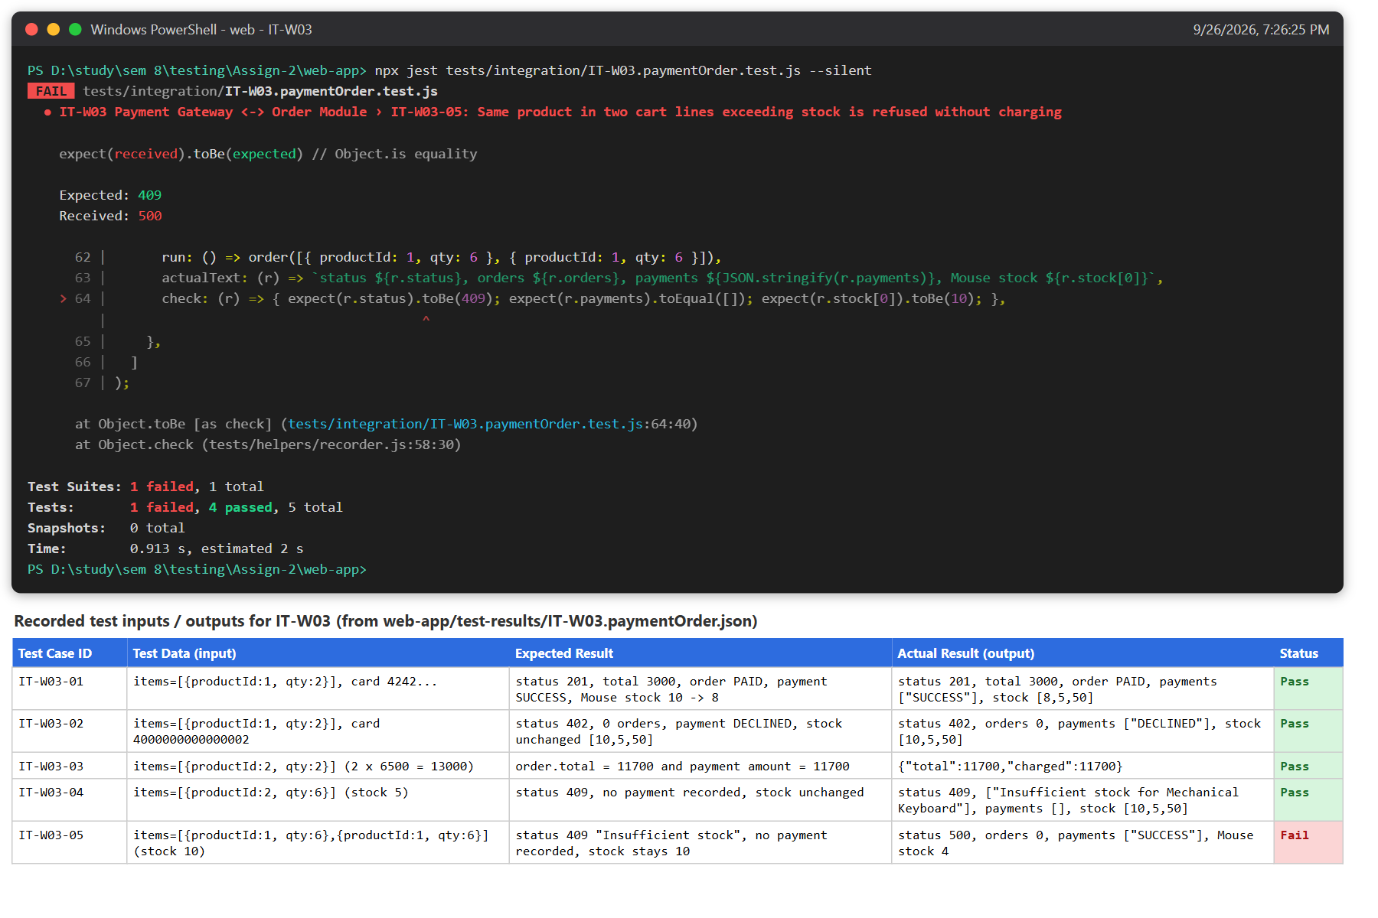
Figure 13: IT-W03 execution - "npx jest tests/integration/IT-W03.paymentOrder.test.js --silent" (terminal output) with the recorded inputs/outputs of all 5 test cases (4 passed).

3.5 System Behaviour Screenshots (running application)
The application was started with "npm start" and driven in Microsoft Edge. Each caption names the test cases it demonstrates.
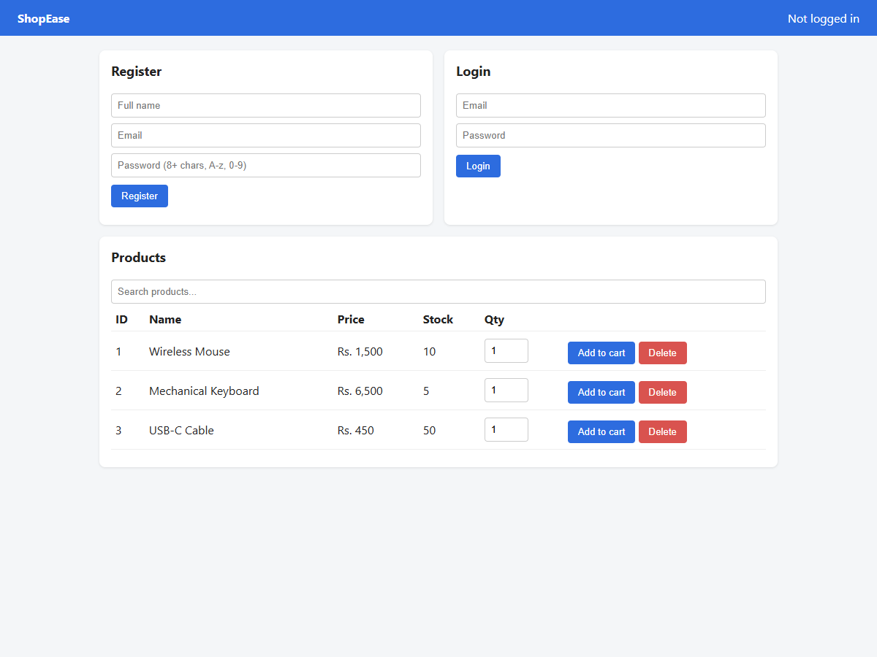  Figure 14: Home page: product list loaded from backend (GET /api/products) - IT-W01-01 | 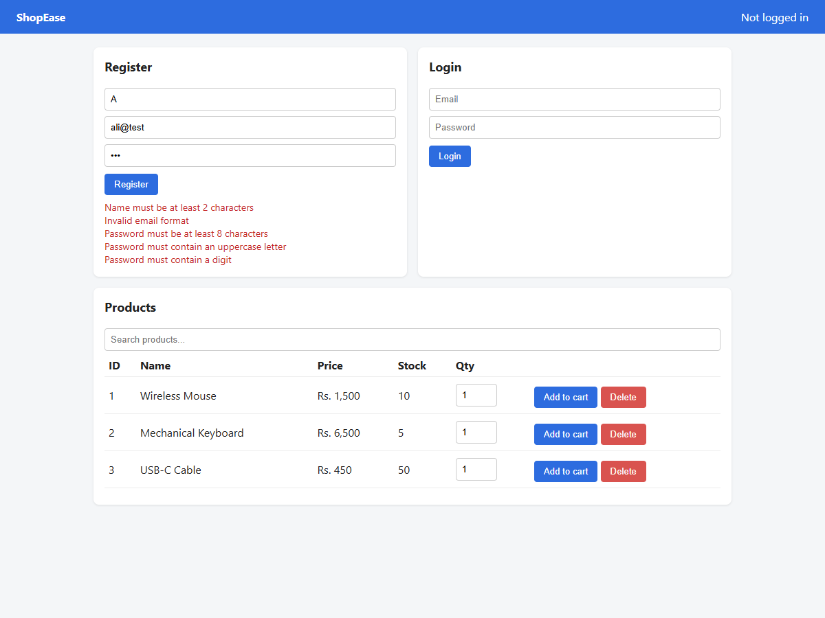  Figure 15: Register with invalid data: backend validation errors displayed in UI - IT-W01-03, UT-W01/UT-W02
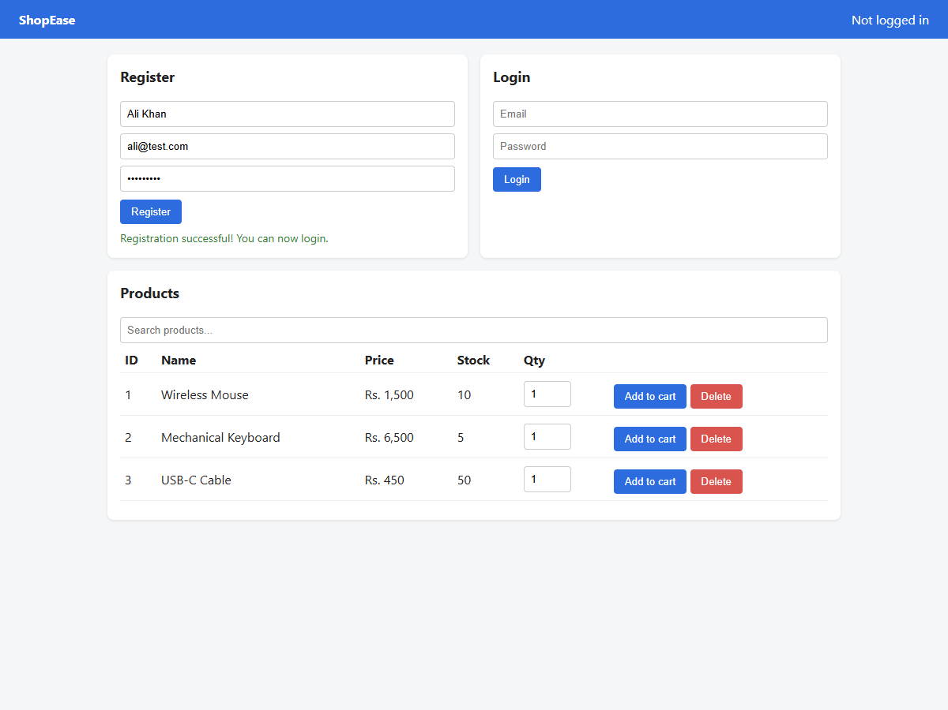  Figure 16: Successful registration (POST /api/register -> 201) - CT-W01-01, IT-W02-01 | 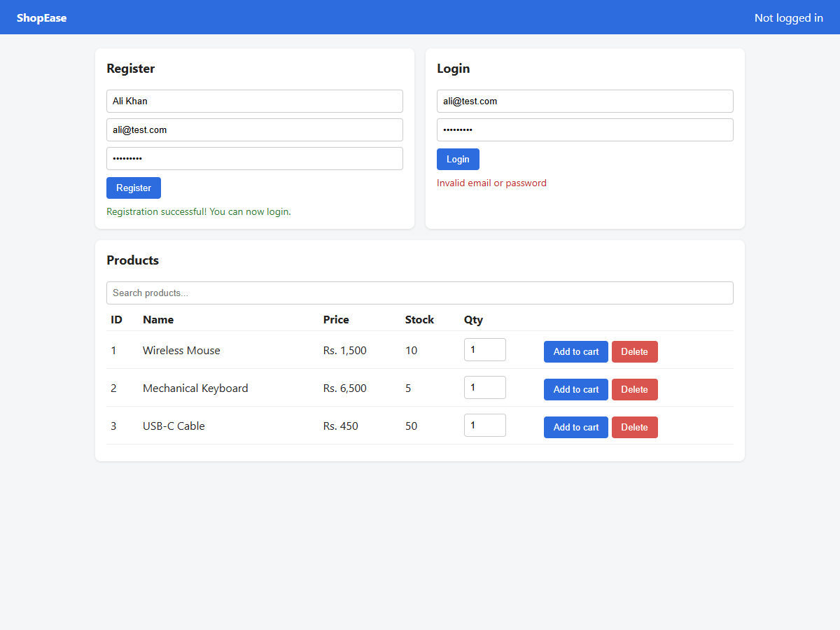  Figure 17: Login with wrong password rejected (401 "Invalid email or password") - CT-W01-06
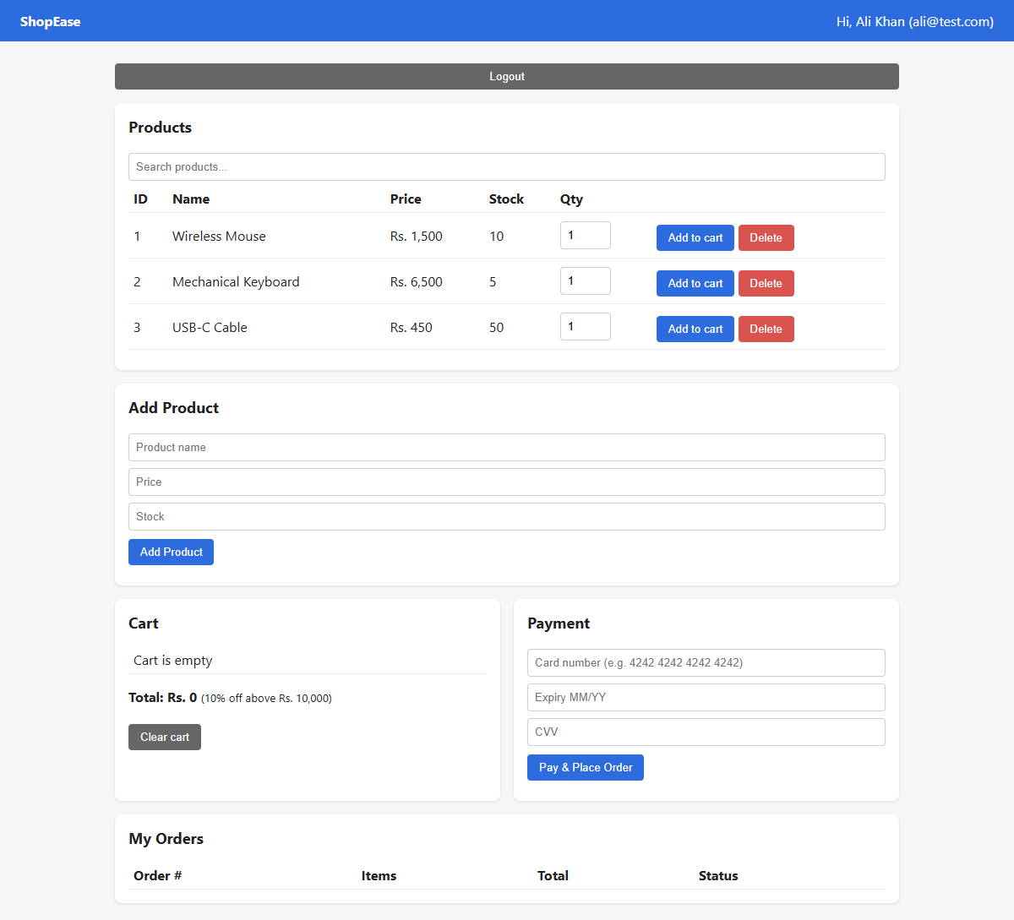  Figure 18: Login success: session token issued, header shows user, protected sections visible - IT-W01-02 | 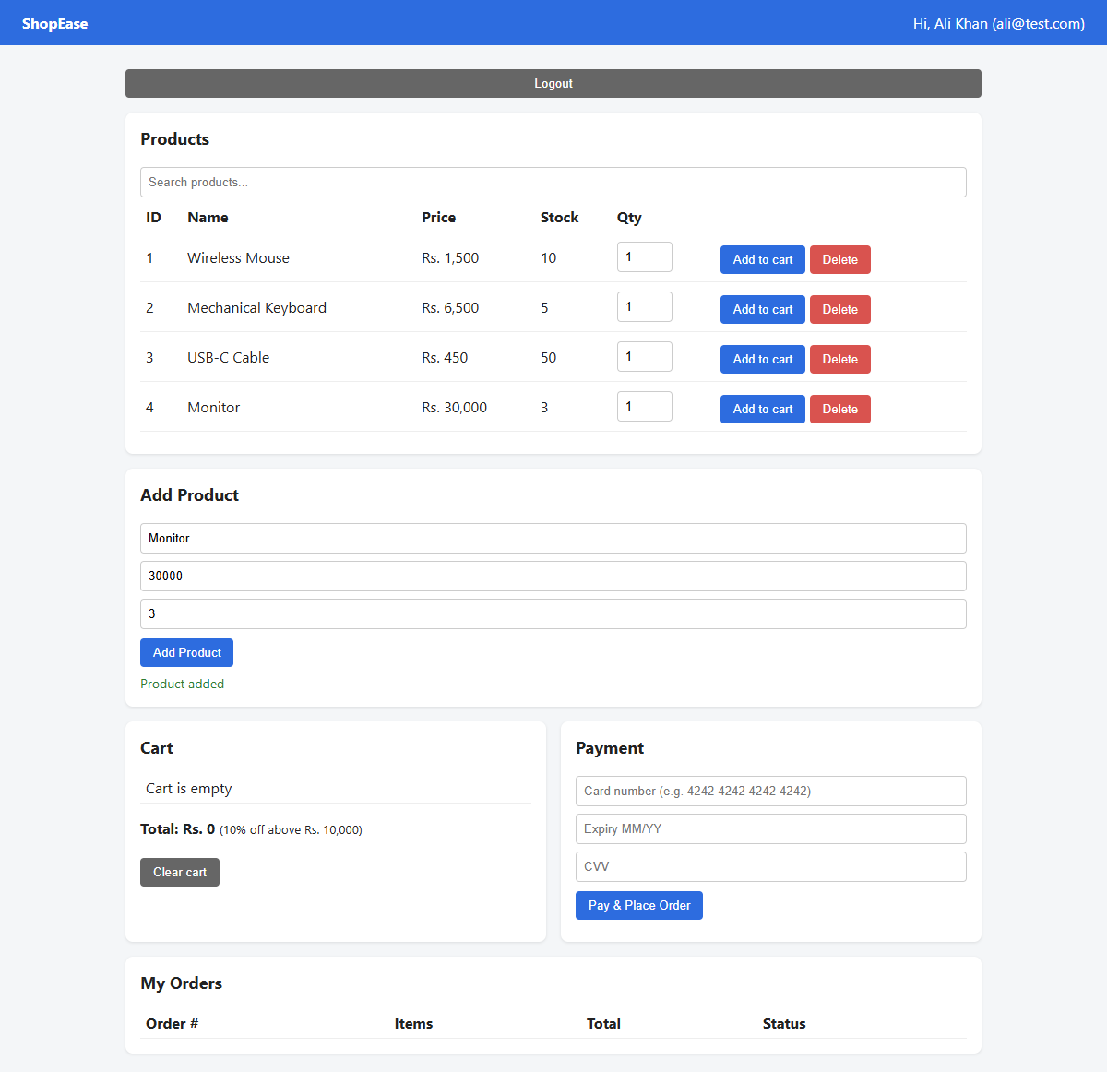  Figure 19: Product added through UI appears in product list - IT-W01-05, CT-W02-01
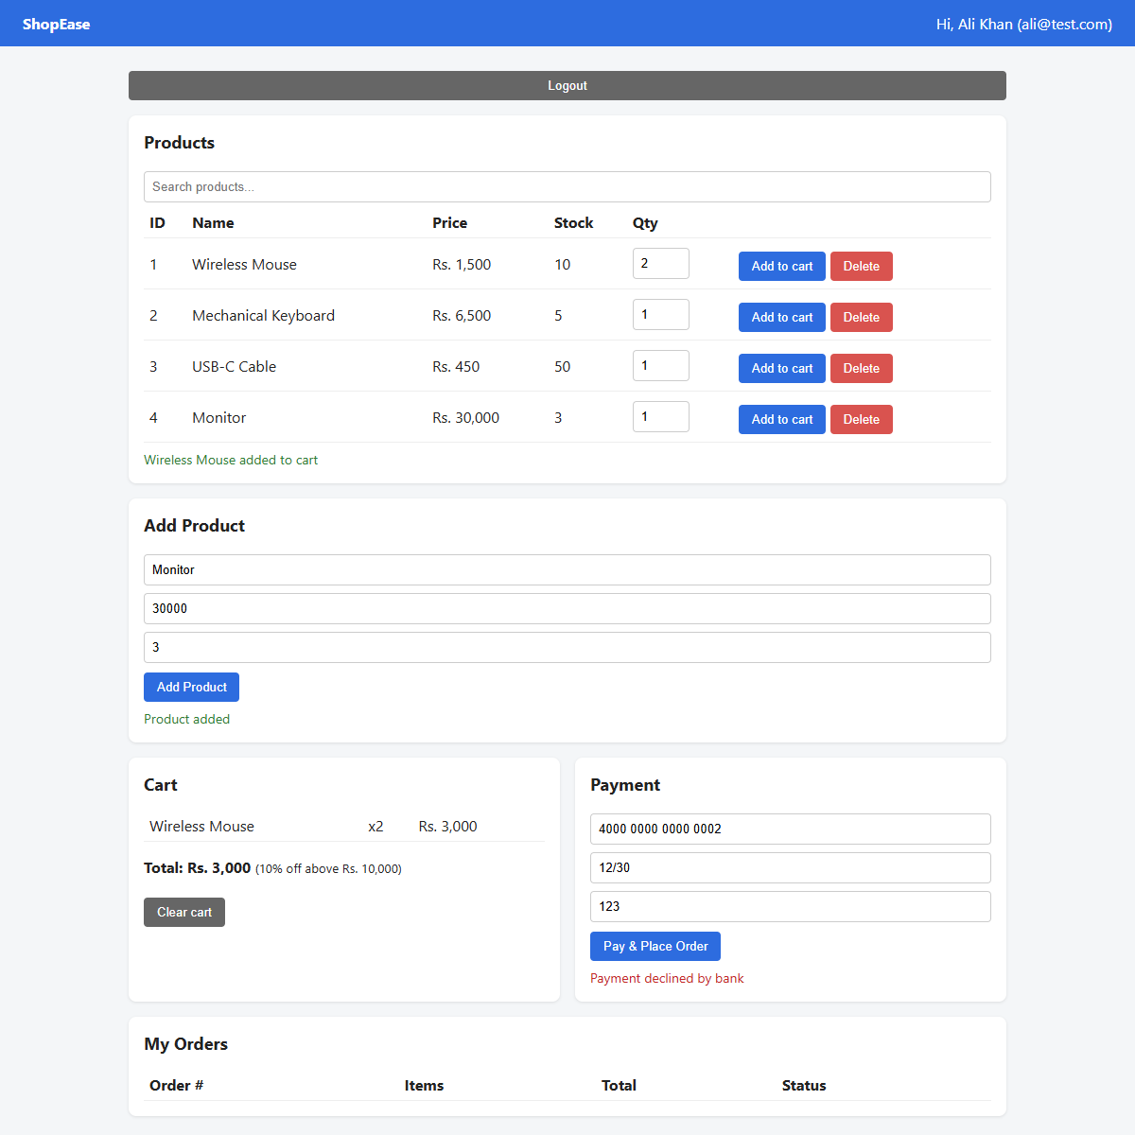  Figure 20: Checkout with declined card: "Payment declined by bank", no order created, stock unchanged - IT-W03-02 | 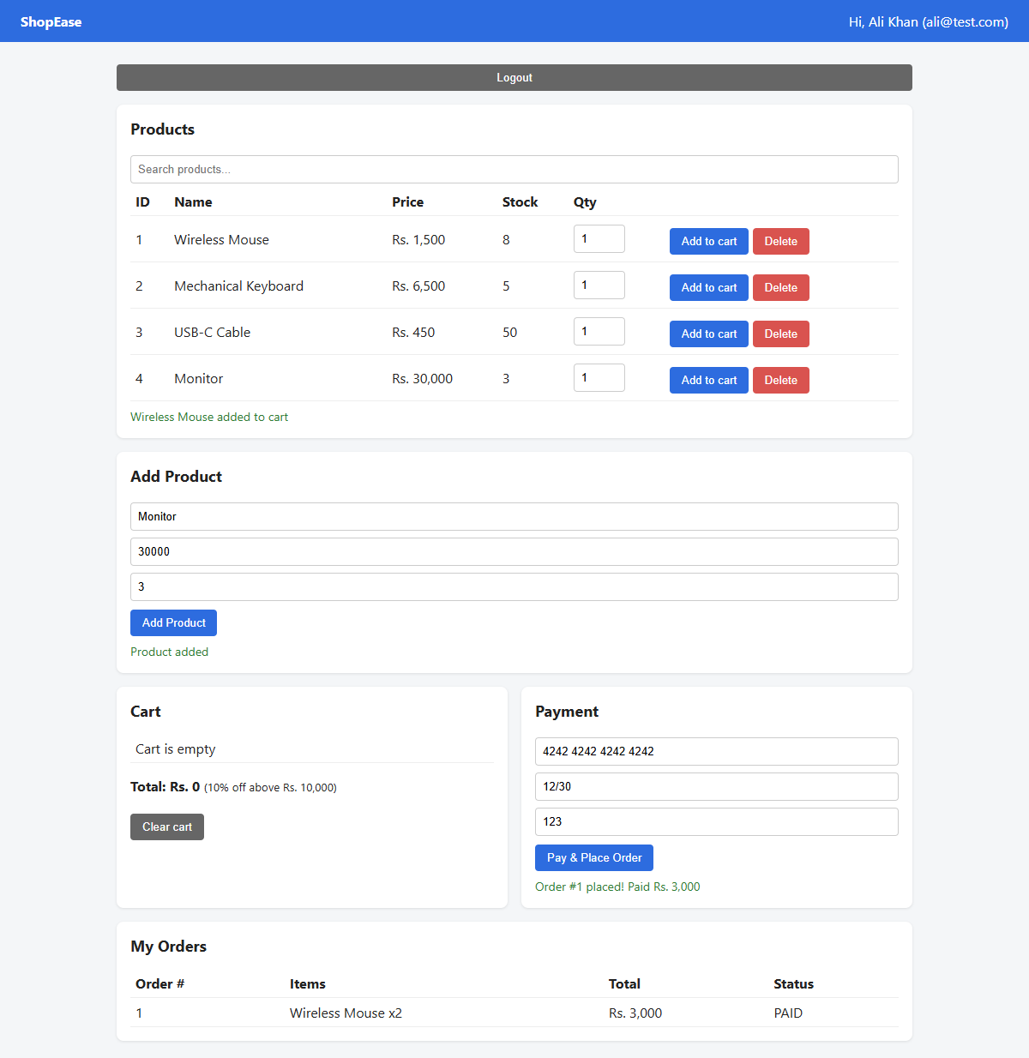  Figure 21: Checkout with valid card: order PAID, Mouse stock 10 -> 8, order listed in My Orders - IT-W03-01
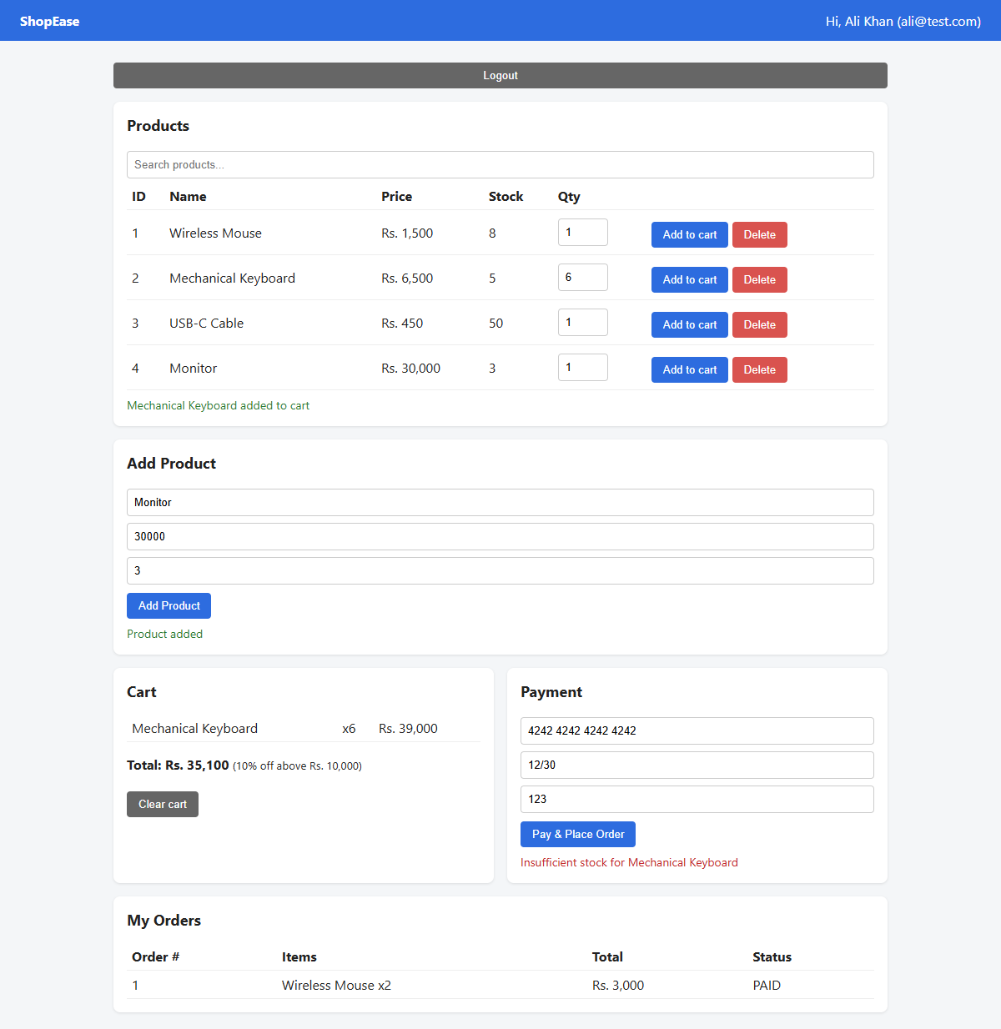  Figure 22: Ordering 6 keyboards (stock 5): "Insufficient stock" returned before charging - IT-W03-04 | 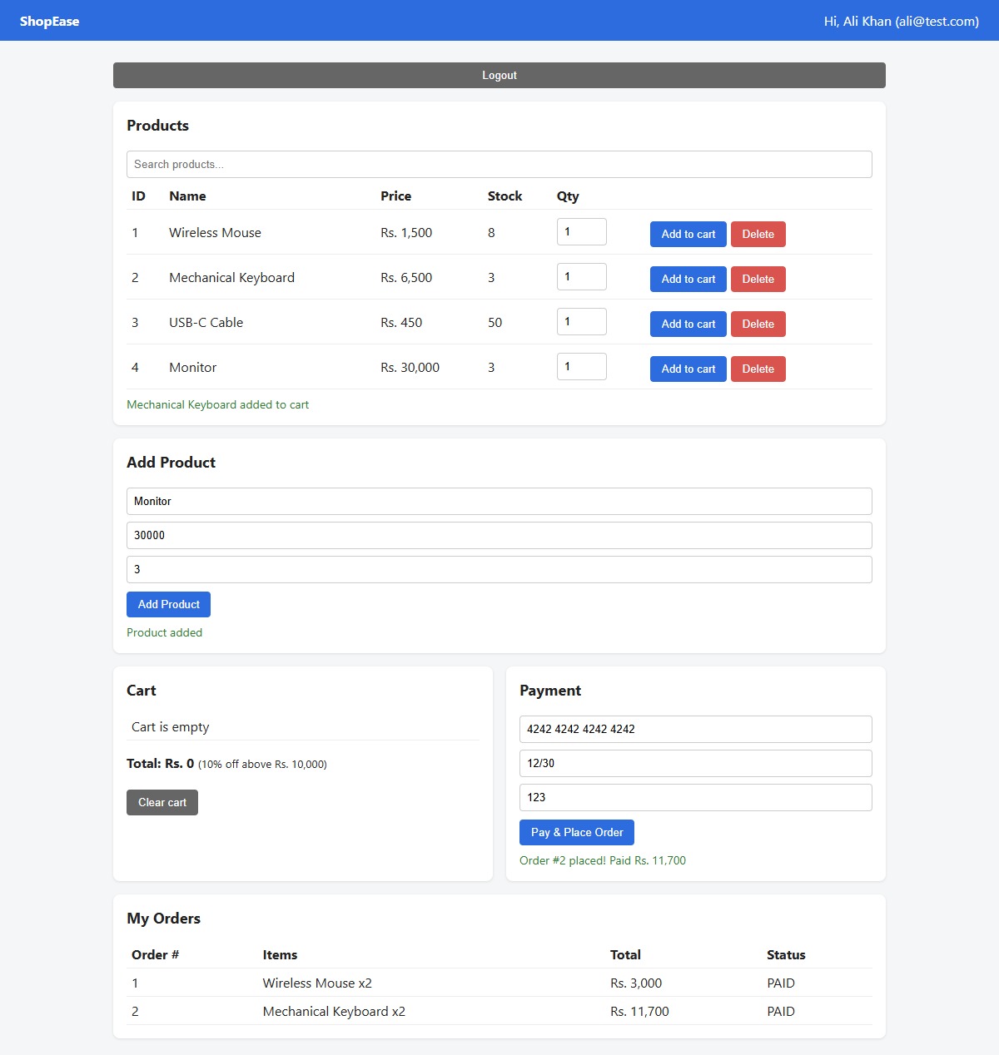  Figure 23: Order of 2 keyboards (13,000) charged 11,700 after 10% discount - IT-W03-03, UT-W07
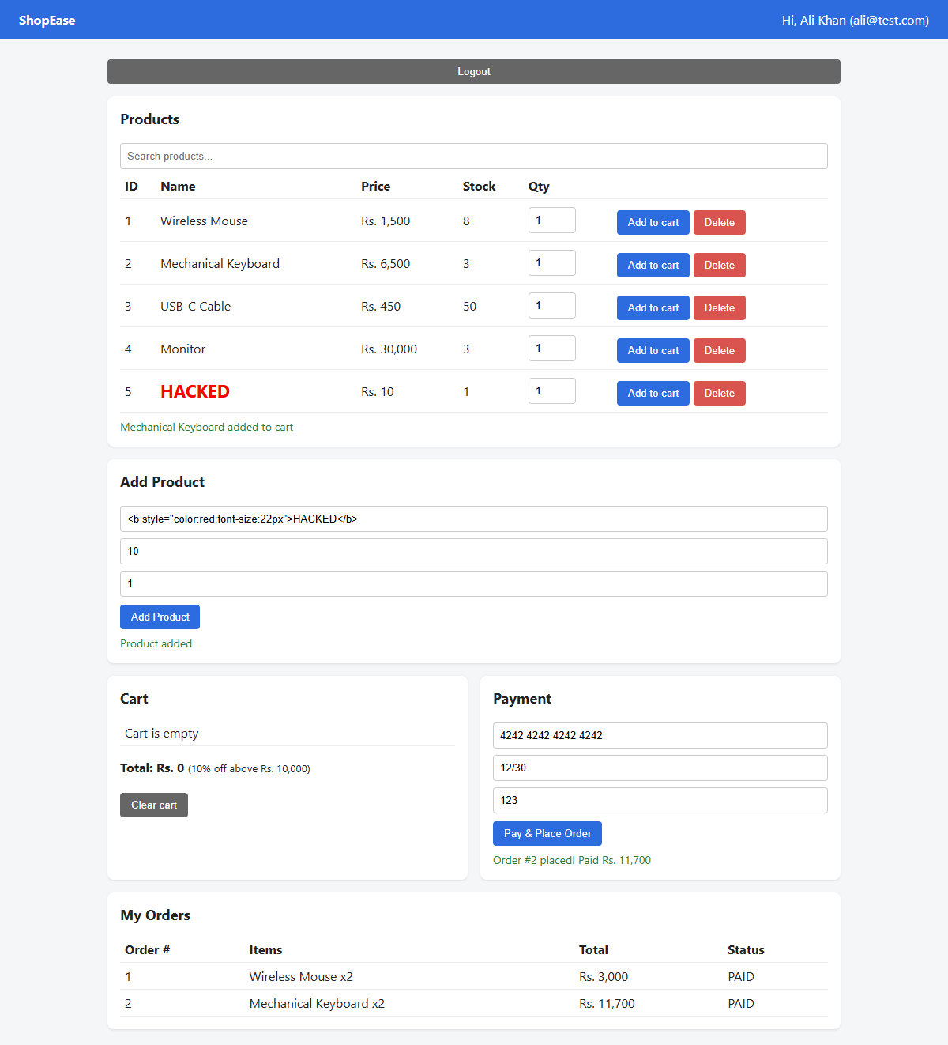
Figure 24: BUG (CT-W02-07): product name containing HTML is accepted and rendered as markup (red "HACKED") - stored XSS risk

4. Mobile Application - PostHub (Expo / React Native)

4.1 System Under Test
PostHub is an Expo (React Native, SDK 57) app. After logging in, the user sees a dashboard of posts fetched from the public REST API jsonplaceholder.typicode.com, can like posts and change how many are shown, edit a profile saved on the device (AsyncStorage) and read in-app notifications generated from his/her data.
Testing tools: Jest 29 with the jest-expo preset, React Native Testing Library 14 (renders real screens and fires presses/typing), official AsyncStorage Jest mock, stubbed fetch for the API server, Expo web export + headless Edge (390x844 phone viewport) for UI screenshots against the live API.
How to run the tests: cd mobile-app -> npm install -> npm test (application: npx expo start, scan QR with Expo Go)
Overall: 71 test cases executed, 69 passed, 2 failed.
Use cases referenced by the test cases:
Use Case ID | Use Case | Description
UC-M01 | Login | User logs in with demo credentials; session saved on device
UC-M02 | View dashboard | Posts of the user are loaded from the API server; like posts; change count; refresh
UC-M03 | Manage profile | User edits name/​age/​phone which is validated and saved to device storage
UC-M04 | View notifications | In-app alerts generated from user data; mark read / mark all read

4.2 Unit Testing
6 units were identified and tested independently (external dependencies such as fetch, storage or the database were stubbed or reset). Each unit has at least 5 test cases in the required template format.

4.2.1 UT-M01 - validateLogin() - Login input validation
Result: 6 test cases executed, 6 passed, 0 failed.
Test Case ID | Related Use Case ID | Test Case Title | Test Objective | Preconditions | Test Steps | Test Data | Expected Result | Actual Result | Status (Pass/​Fail) | Priority | Tested By | Test Date
UT-M01-01 | UC-M01 Login | Valid email and password pass | Verify login inputs are validated with field-specific error messages | validation.js module loaded | 1. Call validateLogin(email, password) 2. Compare {valid, errors} with expected | ["ali@test.com",​"ali123​"] | {"valid":​true,​"errors"​:​{}} | {"valid":​true,​"errors"​:​{}} | Pass | High | [Your Name] | 2026-09-26
UT-M01-02 | UC-M01 Login | Empty email reports "Email is required" | Verify login inputs are validated with field-specific error messages | validation.js module loaded | 1. Call validateLogin(email, password) 2. Compare {valid, errors} with expected | ["",​"ali123"] | {"valid":​false,​"errors​":​{"email":​"Email is required"}} | {"valid":​false,​"errors​":​{"email":​"Email is required"}} | Pass | High | [Your Name] | 2026-09-26
UT-M01-03 | UC-M01 Login | Whitespace-only email treated as empty | Verify login inputs are validated with field-specific error messages | validation.js module loaded | 1. Call validateLogin(email, password) 2. Compare {valid, errors} with expected | [" ",​"ali123"] | {"valid":​false,​"errors​":​{"email":​"Email is required"}} | {"valid":​false,​"errors​":​{"email":​"Email is required"}} | Pass | Medium | [Your Name] | 2026-09-26
UT-M01-04 | UC-M01 Login | Malformed email reports "Invalid email format" | Verify login inputs are validated with field-specific error messages | validation.js module loaded | 1. Call validateLogin(email, password) 2. Compare {valid, errors} with expected | ["ali.test.com",​"ali123​"] | {"valid":​false,​"errors​":​{"email":​"Invalid email format"}} | {"valid":​false,​"errors​":​{"email":​"Invalid email format"}} | Pass | Medium | [Your Name] | 2026-09-26
UT-M01-05 | UC-M01 Login | Password shorter than 6 chars is rejected | Verify login inputs are validated with field-specific error messages | validation.js module loaded | 1. Call validateLogin(email, password) 2. Compare {valid, errors} with expected | ["ali@test.com",​"123"] | {"valid":​false,​"errors​":​{"password":​"Passwor​d must be at least 6 characters"}} | {"valid":​false,​"errors​":​{"password":​"Passwor​d must be at least 6 characters"}} | Pass | High | [Your Name] | 2026-09-26
UT-M01-06 | UC-M01 Login | Both fields empty report both errors | Verify login inputs are validated with field-specific error messages | validation.js module loaded | 1. Call validateLogin(email, password) 2. Compare {valid, errors} with expected | ["",​""] | {"valid":​false,​"errors​":​{"email":​"Email is required",​"password":​"​Password is required"}} | {"valid":​false,​"errors​":​{"email":​"Email is required",​"password":​"​Password is required"}} | Pass | Medium | [Your Name] | 2026-09-26
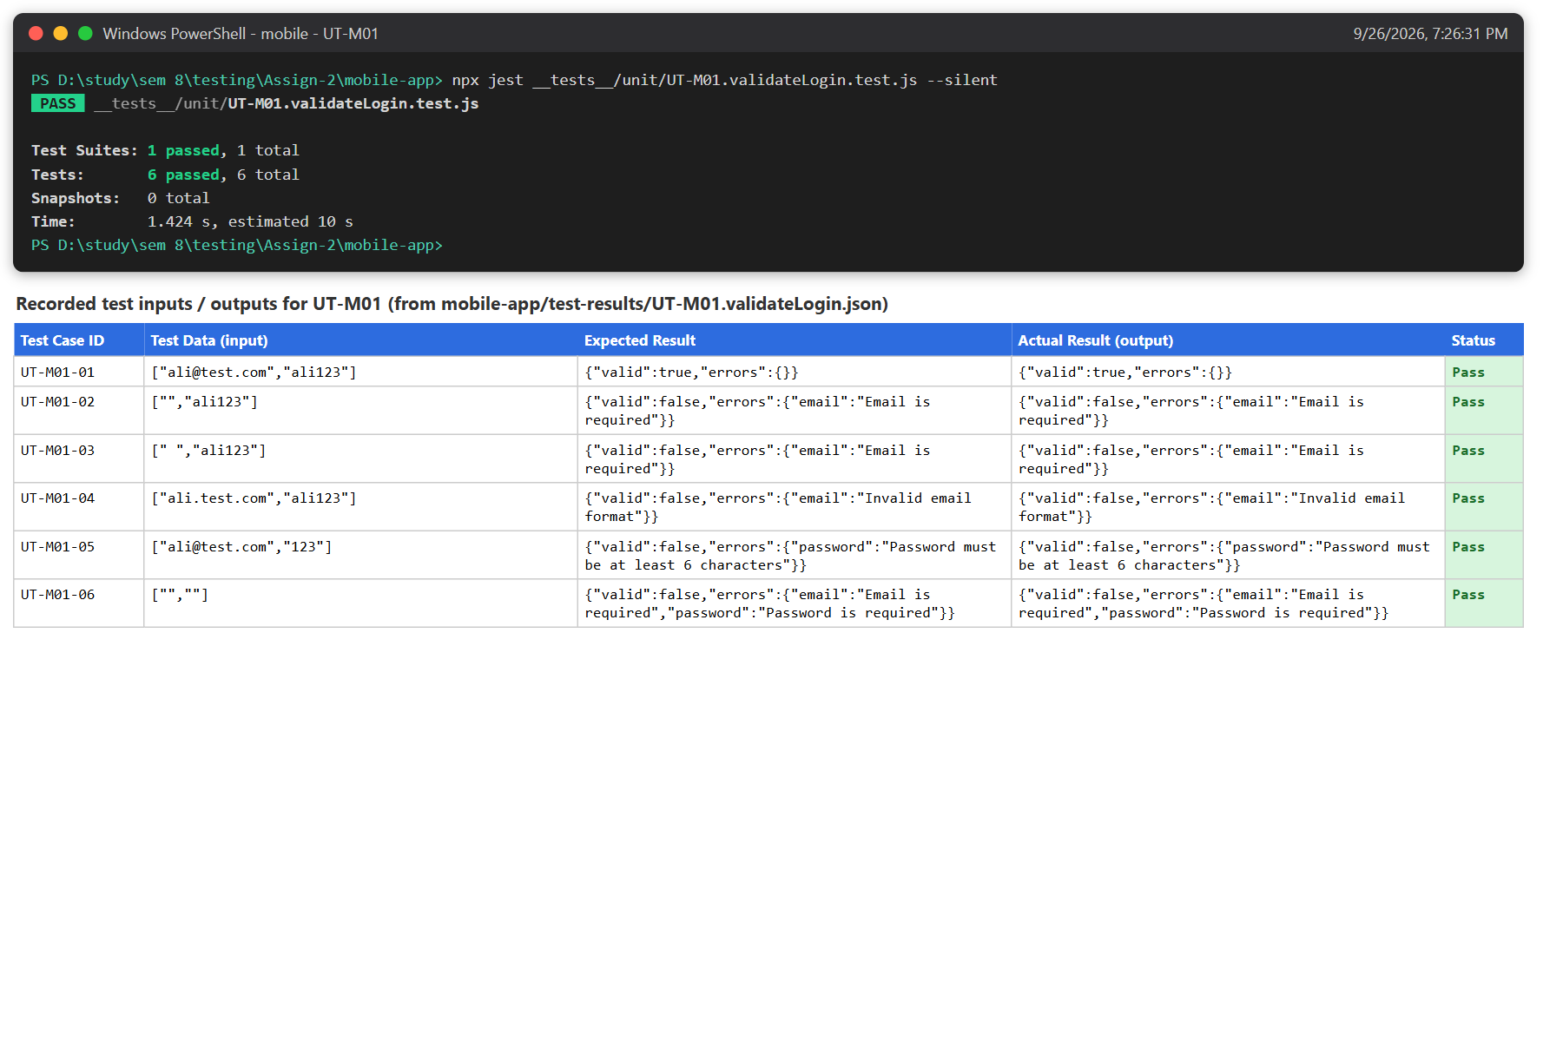
Figure 25: UT-M01 execution - "npx jest __tests__/unit/UT-M01.validateLogin.test.js --silent" (terminal output) with the recorded inputs/outputs of all 6 test cases (6 passed).

4.2.2 UT-M02 - validateProfile() - Profile form validation
Result: 7 test cases executed, 7 passed, 0 failed.
Test Case ID | Related Use Case ID | Test Case Title | Test Objective | Preconditions | Test Steps | Test Data | Expected Result | Actual Result | Status (Pass/​Fail) | Priority | Tested By | Test Date
UT-M02-01 | UC-M03 Manage Profile | Valid profile passes | Verify profile name, age (1-120 integer) and Pakistani phone format validation | validation.js module loaded | 1. Call validateProfile({name, age, phone}) 2. Compare {valid, errors} with expected | [{"name":​"Ali",​"age":​​"22",​"phone":​"03001234​567"}] | {"valid":​true,​"errors"​:​{}} | {"valid":​true,​"errors"​:​{}} | Pass | High | [Your Name] | 2026-09-26
UT-M02-02 | UC-M03 Manage Profile | One-letter name is rejected | Verify profile name, age (1-120 integer) and Pakistani phone format validation | validation.js module loaded | 1. Call validateProfile({name, age, phone}) 2. Compare {valid, errors} with expected | [{"name":​"A",​"age":​"2​2",​"phone":​"0300123456​7"}] | {"valid":​false,​"errors​":​{"name":​"Name must be at least 2 characters"}} | {"valid":​false,​"errors​":​{"name":​"Name must be at least 2 characters"}} | Pass | Medium | [Your Name] | 2026-09-26
UT-M02-03 | UC-M03 Manage Profile | Age above 120 is rejected (boundary) | Verify profile name, age (1-120 integer) and Pakistani phone format validation | validation.js module loaded | 1. Call validateProfile({name, age, phone}) 2. Compare {valid, errors} with expected | [{"name":​"Ali",​"age":​​"121",​"phone":​"0300123​4567"}] | {"valid":​false,​"errors​":​{"age":​"Age must be a whole number between 1 and 120"}} | {"valid":​false,​"errors​":​{"age":​"Age must be a whole number between 1 and 120"}} | Pass | High | [Your Name] | 2026-09-26
UT-M02-04 | UC-M03 Manage Profile | Decimal age is rejected | Verify profile name, age (1-120 integer) and Pakistani phone format validation | validation.js module loaded | 1. Call validateProfile({name, age, phone}) 2. Compare {valid, errors} with expected | [{"name":​"Ali",​"age":​​"22.5",​"phone":​"030012​34567"}] | {"valid":​false,​"errors​":​{"age":​"Age must be a whole number between 1 and 120"}} | {"valid":​false,​"errors​":​{"age":​"Age must be a whole number between 1 and 120"}} | Pass | Medium | [Your Name] | 2026-09-26
UT-M02-05 | UC-M03 Manage Profile | International format +92 phone is accepted | Verify profile name, age (1-120 integer) and Pakistani phone format validation | validation.js module loaded | 1. Call validateProfile({name, age, phone}) 2. Compare {valid, errors} with expected | [{"name":​"Ali",​"age":​​"22",​"phone":​"+9230012​34567"}] | {"valid":​true,​"errors"​:​{}} | {"valid":​true,​"errors"​:​{}} | Pass | Medium | [Your Name] | 2026-09-26
UT-M02-06 | UC-M03 Manage Profile | Phone with dashes is accepted | Verify profile name, age (1-120 integer) and Pakistani phone format validation | validation.js module loaded | 1. Call validateProfile({name, age, phone}) 2. Compare {valid, errors} with expected | [{"name":​"Ali",​"age":​​"22",​"phone":​"0300-123​4567"}] | {"valid":​true,​"errors"​:​{}} | {"valid":​true,​"errors"​:​{}} | Pass | Low | [Your Name] | 2026-09-26
UT-M02-07 | UC-M03 Manage Profile | Short phone number is rejected | Verify profile name, age (1-120 integer) and Pakistani phone format validation | validation.js module loaded | 1. Call validateProfile({name, age, phone}) 2. Compare {valid, errors} with expected | [{"name":​"Ali",​"age":​​"22",​"phone":​"12345"}] | {"valid":​false,​"errors​":​{"phone":​"Phone must be like 03001234567 or +923001234567"}} | {"valid":​false,​"errors​":​{"phone":​"Phone must be like 03001234567 or +923001234567"}} | Pass | High | [Your Name] | 2026-09-26
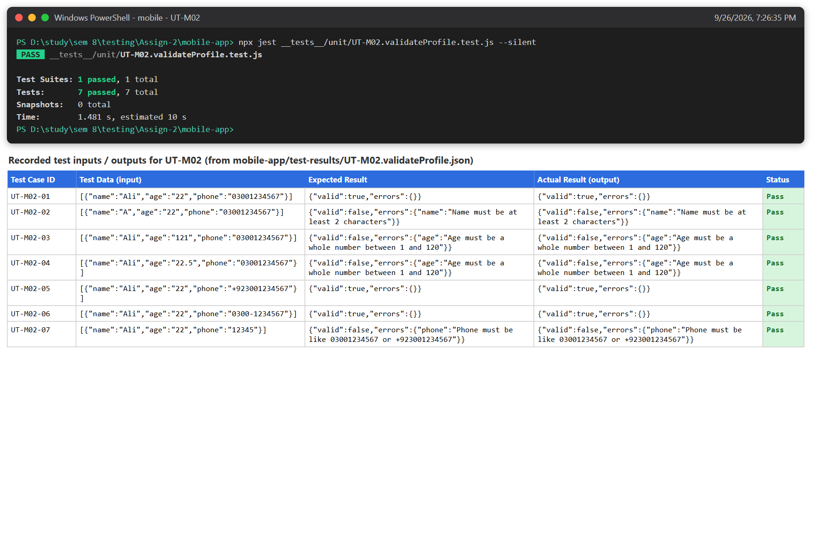
Figure 26: UT-M02 execution - "npx jest __tests__/unit/UT-M02.validateProfile.test.js --silent" (terminal output) with the recorded inputs/outputs of all 7 test cases (7 passed).

4.2.3 UT-M03 - toggleLike() / stepCounter() - Button click handlers
Result: 6 test cases executed, 6 passed, 0 failed.
Test Case ID | Related Use Case ID | Test Case Title | Test Objective | Preconditions | Test Steps | Test Data | Expected Result | Actual Result | Status (Pass/​Fail) | Priority | Tested By | Test Date
UT-M03-01 | UC-M02 View Dashboard | Like button adds post id to liked set | Verify the Like button and +/​- stepper handlers compute the correct next state | handlers.js module loaded | 1. Call handler with current state 2. Compare new state with expected | toggleLike(Set[], 1) | [1] | [1] | Pass | High | [Your Name] | 2026-09-26
UT-M03-02 | UC-M02 View Dashboard | Pressing Like again removes the like | Verify the Like button and +/​- stepper handlers compute the correct next state | handlers.js module loaded | 1. Call handler with current state 2. Compare new state with expected | toggleLike(Set[1], 1) | [] | [] | Pass | High | [Your Name] | 2026-09-26
UT-M03-03 | UC-M02 View Dashboard | Handler does not mutate previous state | Verify the Like button and +/​- stepper handlers compute the correct next state | handlers.js module loaded | 1. Call handler with current state 2. Compare new state with expected | prev=​Set[2]; toggleLike(prev, 3) | {"prev":​[2],​"next":​[2​,​3]} | {"prev":​[2],​"next":​[2​,​3]} | Pass | Medium | [Your Name] | 2026-09-26
UT-M03-04 | UC-M02 View Dashboard | "+" increases posts limit by 5 | Verify the Like button and +/​- stepper handlers compute the correct next state | handlers.js module loaded | 1. Call handler with current state 2. Compare new state with expected | stepCounter(5, +5) | 10 | 10 | Pass | High | [Your Name] | 2026-09-26
UT-M03-05 | UC-M02 View Dashboard | "+" at maximum stays at 20 (upper bound) | Verify the Like button and +/​- stepper handlers compute the correct next state | handlers.js module loaded | 1. Call handler with current state 2. Compare new state with expected | stepCounter(20, +5) | 20 | 20 | Pass | Medium | [Your Name] | 2026-09-26
UT-M03-06 | UC-M02 View Dashboard | "-" at minimum stays at 5 (lower bound) | Verify the Like button and +/​- stepper handlers compute the correct next state | handlers.js module loaded | 1. Call handler with current state 2. Compare new state with expected | stepCounter(5, -5) | 5 | 5 | Pass | Medium | [Your Name] | 2026-09-26
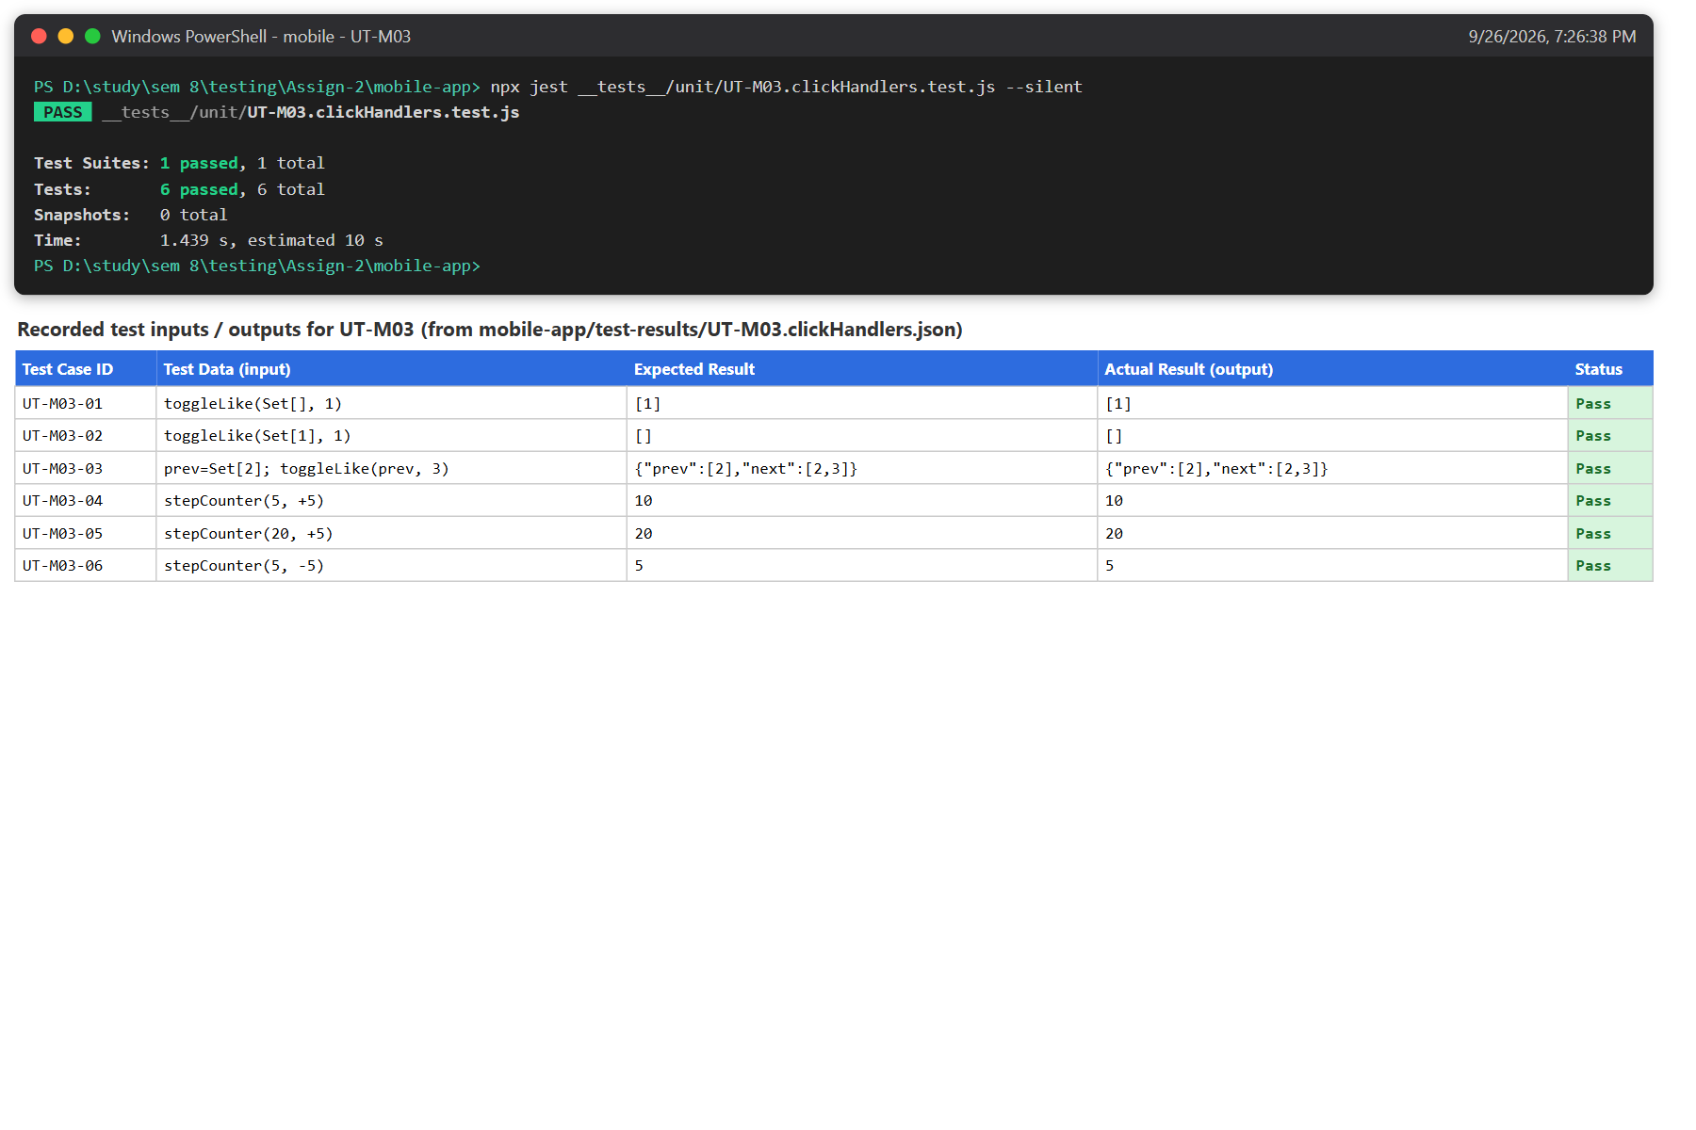
Figure 27: UT-M03 execution - "npx jest __tests__/unit/UT-M03.clickHandlers.test.js --silent" (terminal output) with the recorded inputs/outputs of all 6 test cases (6 passed).

4.2.4 UT-M04 - parsePost() / parsePosts() / parseUser() - Data parsing
Result: 7 test cases executed, 7 passed, 0 failed.
Test Case ID | Related Use Case ID | Test Case Title | Test Objective | Preconditions | Test Steps | Test Data | Expected Result | Actual Result | Status (Pass/​Fail) | Priority | Tested By | Test Date
UT-M04-01 | UC-M02 View Dashboard / UC-M03 Profile | Post title is capitalised and preview created | Verify raw API JSON is converted into clean app models and bad data is handled | parser.js module loaded | 1. Call parser with raw JSON 2. Compare model with expected | {id:​1, userId:​1, title:​"hello world", body:​"line one\nline two"} | {"id":​1,​"userId":​1,​"​title":​"Hello world",​"body":​"line one\nline two",​"preview":​"line one line two"} | {"id":​1,​"userId":​1,​"​title":​"Hello world",​"body":​"line one\nline two",​"preview":​"line one line two"} | Pass | High | [Your Name] | 2026-09-26
UT-M04-02 | UC-M02 View Dashboard / UC-M03 Profile | Missing title becomes "(untitled)" | Verify raw API JSON is converted into clean app models and bad data is handled | parser.js module loaded | 1. Call parser with raw JSON 2. Compare model with expected | {id:​2, title:​"", body:​"x"} | "(untitled)" | "(untitled)" | Pass | Medium | [Your Name] | 2026-09-26
UT-M04-03 | UC-M02 View Dashboard / UC-M03 Profile | Preview is limited to 60 characters | Verify raw API JSON is converted into clean app models and bad data is handled | parser.js module loaded | 1. Call parser with raw JSON 2. Compare model with expected | body = "a" x 100 | 60 | 60 | Pass | Medium | [Your Name] | 2026-09-26
UT-M04-04 | UC-M02 View Dashboard / UC-M03 Profile | Null post throws "Invalid post data" | Verify raw API JSON is converted into clean app models and bad data is handled | parser.js module loaded | 1. Call parser with raw JSON 2. Compare model with expected | null | "throws: Invalid post data" | "throws: Invalid post data" | Pass | High | [Your Name] | 2026-09-26
UT-M04-05 | UC-M02 View Dashboard / UC-M03 Profile | parsePosts skips entries without id | Verify raw API JSON is converted into clean app models and bad data is handled | parser.js module loaded | 1. Call parser with raw JSON 2. Compare model with expected | [{id:​1,​title:​"a"}, {title:​"no id"}, null] | [1] | [1] | Pass | Medium | [Your Name] | 2026-09-26
UT-M04-06 | UC-M02 View Dashboard / UC-M03 Profile | parsePosts rejects non-array input | Verify raw API JSON is converted into clean app models and bad data is handled | parser.js module loaded | 1. Call parser with raw JSON 2. Compare model with expected | {"error":​"x"} | "throws: Expected an array of posts" | "throws: Expected an array of posts" | Pass | Medium | [Your Name] | 2026-09-26
UT-M04-07 | UC-M02 View Dashboard / UC-M03 Profile | parseUser fills missing nested fields with N/​A | Verify raw API JSON is converted into clean app models and bad data is handled | parser.js module loaded | 1. Call parser with raw JSON 2. Compare model with expected | {id:​5, name:​"Sara"} | {"id":​5,​"name":​"Sara"​,​"email":​"",​"city":​"​N/​A",​"company":​"N/​A"​} | {"id":​5,​"name":​"Sara"​,​"email":​"",​"city":​"​N/​A",​"company":​"N/​A"​} | Pass | Medium | [Your Name] | 2026-09-26
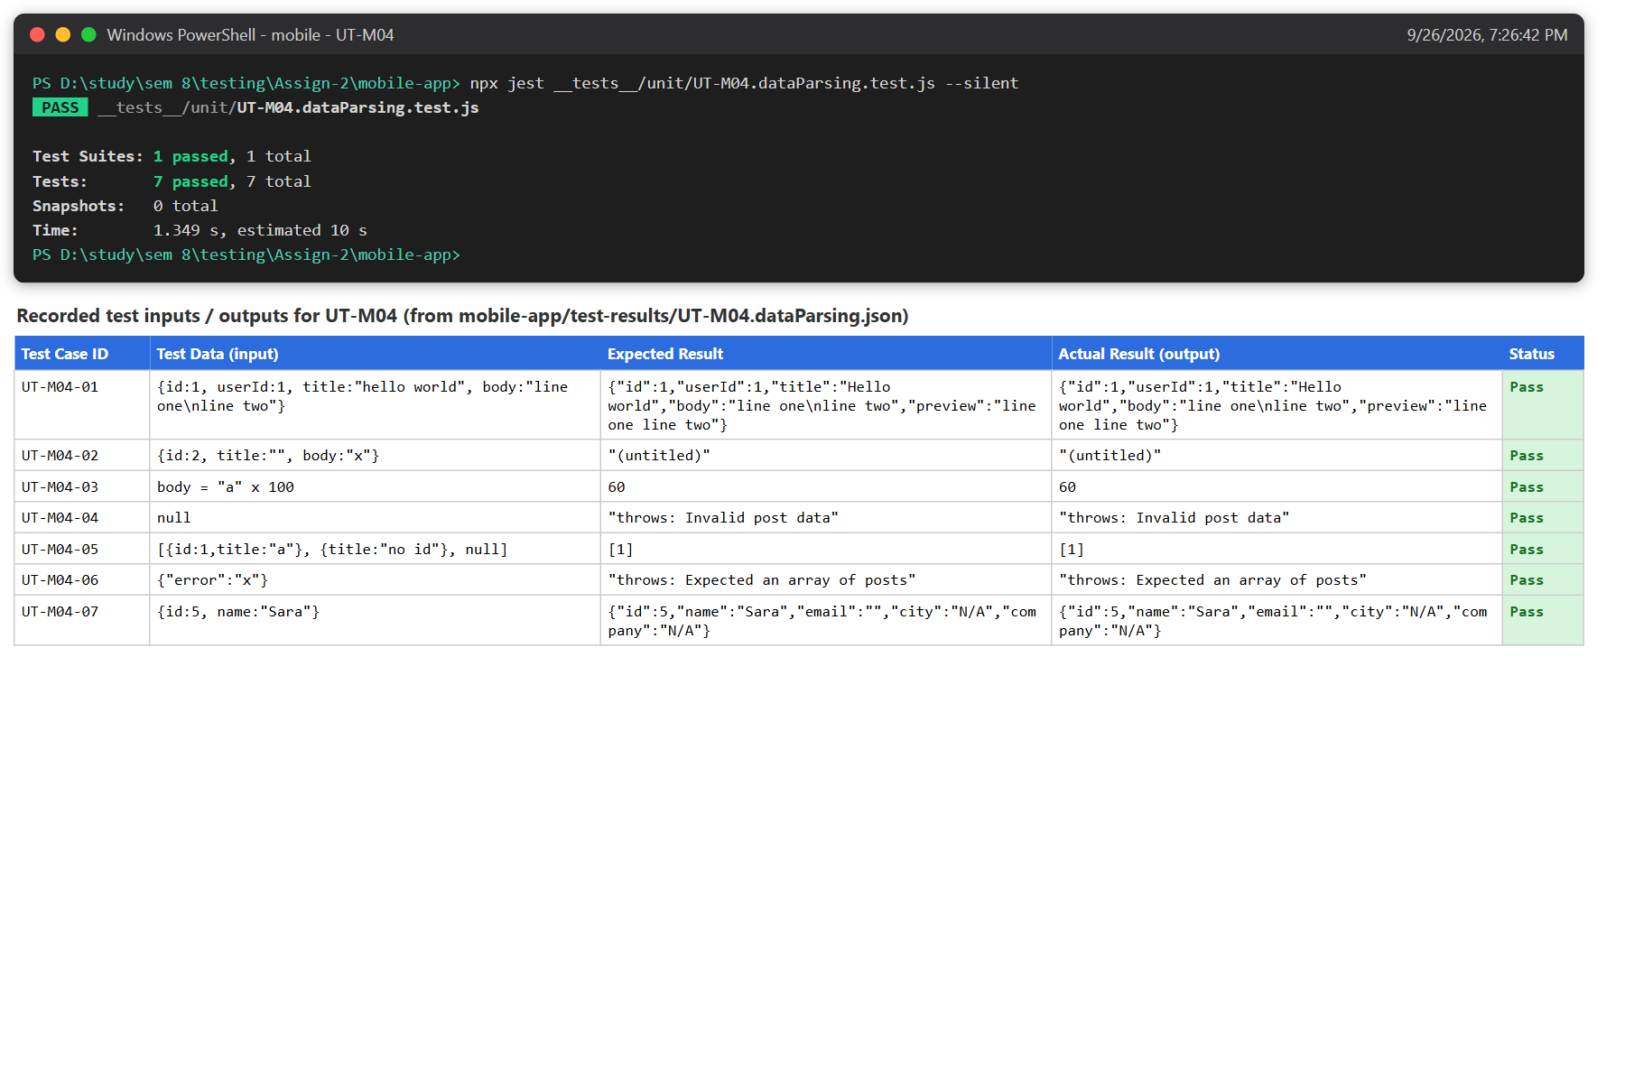
Figure 28: UT-M04 execution - "npx jest __tests__/unit/UT-M04.dataParsing.test.js --silent" (terminal output) with the recorded inputs/outputs of all 7 test cases (7 passed).

4.2.5 UT-M05 - saveProfile() / loadProfile() / clearProfile() / loadSession() - Local storage
Result: 6 test cases executed, 5 passed, 1 failed.
Test Case ID | Related Use Case ID | Test Case Title | Test Objective | Preconditions | Test Steps | Test Data | Expected Result | Actual Result | Status (Pass/​Fail) | Priority | Tested By | Test Date
UT-M05-01 | UC-M03 Manage Profile | Saved profile can be loaded back | Verify profile/​session data is saved to and read from device storage (AsyncStorage) correctly | AsyncStorage replaced by official in-memory Jest mock, cleared before each test | 1. Call storage function(s) 2. Read back value 3. Compare with expected | saveProfile(1, {Ali, 22, 03001234567}); loadProfile(1) | {"name":​"Ali",​"age":​2​2,​"phone":​"03001234567​"} | {"name":​"Ali",​"age":​2​2,​"phone":​"03001234567​"} | Pass | High | [Your Name] | 2026-09-26
UT-M05-02 | UC-M03 Manage Profile | Loading profile of unknown user returns null | Verify profile/​session data is saved to and read from device storage (AsyncStorage) correctly | AsyncStorage replaced by official in-memory Jest mock, cleared before each test | 1. Call storage function(s) 2. Read back value 3. Compare with expected | loadProfile(99) | null | null | Pass | Medium | [Your Name] | 2026-09-26
UT-M05-03 | UC-M03 Manage Profile | Corrupted profile JSON returns null instead of crashing | Verify profile/​session data is saved to and read from device storage (AsyncStorage) correctly | AsyncStorage replaced by official in-memory Jest mock, cleared before each test | 1. Call storage function(s) 2. Read back value 3. Compare with expected | AsyncStorage["profile:​1​"] = "{bad json" | null | null | Pass | Medium | [Your Name] | 2026-09-26
UT-M05-04 | UC-M03 Manage Profile | clearProfile removes the saved profile | Verify profile/​session data is saved to and read from device storage (AsyncStorage) correctly | AsyncStorage replaced by official in-memory Jest mock, cleared before each test | 1. Call storage function(s) 2. Read back value 3. Compare with expected | saveProfile(1, ...); clearProfile(1); loadProfile(1) | null | null | Pass | Medium | [Your Name] | 2026-09-26
UT-M05-05 | UC-M03 Manage Profile | Saving without userId throws | Verify profile/​session data is saved to and read from device storage (AsyncStorage) correctly | AsyncStorage replaced by official in-memory Jest mock, cleared before each test | 1. Call storage function(s) 2. Read back value 3. Compare with expected | saveProfile(undefined, profile) | "throws: userId is required" | "throws: userId is required" | Pass | Low | [Your Name] | 2026-09-26
UT-M05-06 | UC-M03 Manage Profile | Corrupted session JSON returns null instead of crashing | Verify profile/​session data is saved to and read from device storage (AsyncStorage) correctly | AsyncStorage replaced by official in-memory Jest mock, cleared before each test | 1. Call storage function(s) 2. Read back value 3. Compare with expected | AsyncStorage["session"] = "{bad json" | null | Threw error: Expected property name or '}' in JSON at position 1 | Fail | High | [Your Name] | 2026-09-26
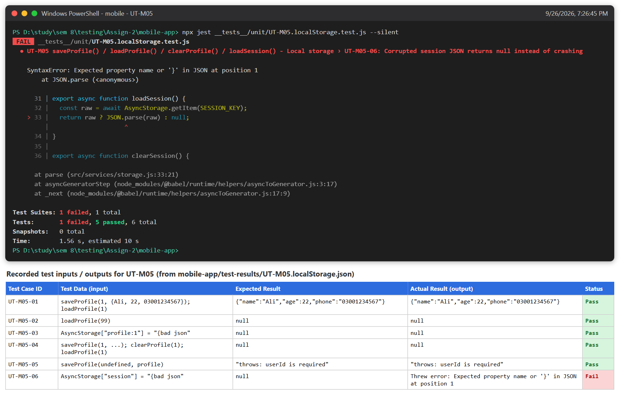
Figure 29: UT-M05 execution - "npx jest __tests__/unit/UT-M05.localStorage.test.js --silent" (terminal output) with the recorded inputs/outputs of all 6 test cases (5 passed).

4.2.6 UT-M06 - handleApiResponse() - API response handler
Result: 6 test cases executed, 6 passed, 0 failed.
Test Case ID | Related Use Case ID | Test Case Title | Test Objective | Preconditions | Test Steps | Test Data | Expected Result | Actual Result | Status (Pass/​Fail) | Priority | Tested By | Test Date
UT-M06-01 | UC-M02 View Dashboard | 200 OK returns parsed JSON | Verify HTTP responses are turned into data or meaningful error messages | api.js module loaded; fake Response objects | 1. Build fake response 2. Call handleApiResponse(respon​se) 3. Compare result/​error | status 200, body [{id:​1}] | [{"id":​1}] | [{"id":​1}] | Pass | High | [Your Name] | 2026-09-26
UT-M06-02 | UC-M02 View Dashboard | 404 gives "Resource not found (404)" | Verify HTTP responses are turned into data or meaningful error messages | api.js module loaded; fake Response objects | 1. Build fake response 2. Call handleApiResponse(respon​se) 3. Compare result/​error | status 404 | "throws: Resource not found (404)" | "throws: Resource not found (404)" | Pass | Medium | [Your Name] | 2026-09-26
UT-M06-03 | UC-M02 View Dashboard | 500 gives "Server error (500)" | Verify HTTP responses are turned into data or meaningful error messages | api.js module loaded; fake Response objects | 1. Build fake response 2. Call handleApiResponse(respon​se) 3. Compare result/​error | status 500 | "throws: Server error (500)" | "throws: Server error (500)" | Pass | High | [Your Name] | 2026-09-26
UT-M06-04 | UC-M02 View Dashboard | Other 4xx gives generic "Request failed" | Verify HTTP responses are turned into data or meaningful error messages | api.js module loaded; fake Response objects | 1. Build fake response 2. Call handleApiResponse(respon​se) 3. Compare result/​error | status 401 | "throws: Request failed (401)" | "throws: Request failed (401)" | Pass | Medium | [Your Name] | 2026-09-26
UT-M06-05 | UC-M02 View Dashboard | Invalid JSON body is reported | Verify HTTP responses are turned into data or meaningful error messages | api.js module loaded; fake Response objects | 1. Build fake response 2. Call handleApiResponse(respon​se) 3. Compare result/​error | status 200, body "<html>" | "throws: Invalid JSON in response" | "throws: Invalid JSON in response" | Pass | Medium | [Your Name] | 2026-09-26
UT-M06-06 | UC-M02 View Dashboard | Missing response is reported | Verify HTTP responses are turned into data or meaningful error messages | api.js module loaded; fake Response objects | 1. Build fake response 2. Call handleApiResponse(respon​se) 3. Compare result/​error | undefined | "throws: No response from server" | "throws: No response from server" | Pass | Low | [Your Name] | 2026-09-26
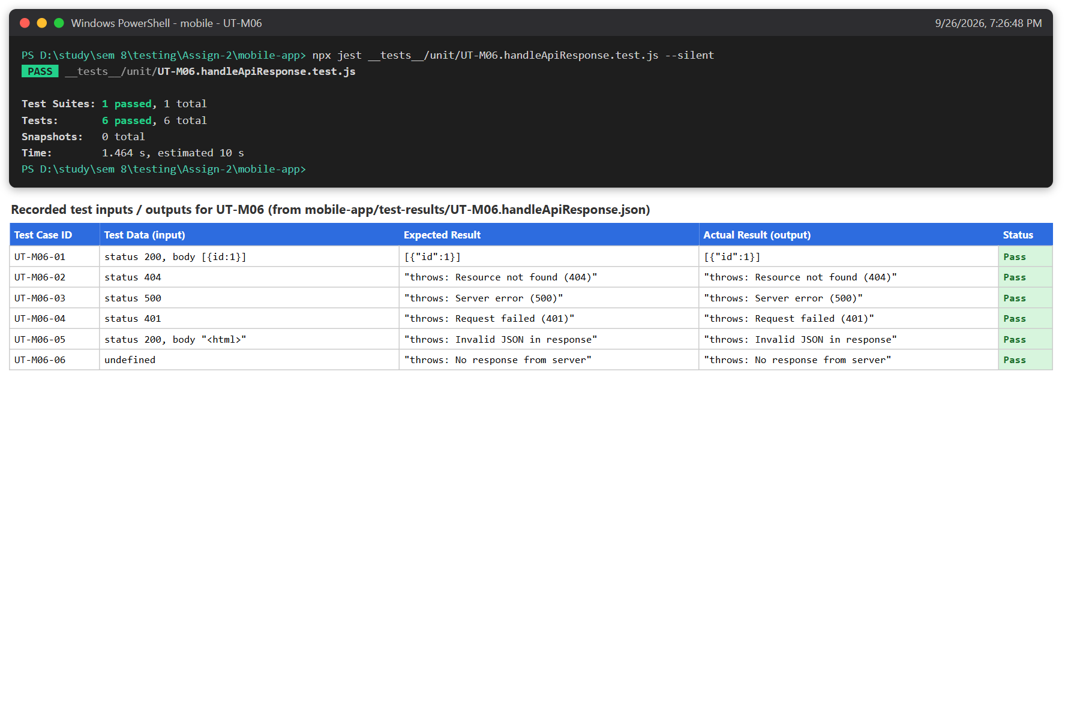
Figure 30: UT-M06 execution - "npx jest __tests__/unit/UT-M06.handleApiResponse.test.js --silent" (terminal output) with the recorded inputs/outputs of all 6 test cases (6 passed).

4.3 Component Testing
Related units were grouped into components (modules) and tested together through the module's public functions or rendered screens.

4.3.1 CT-M01 - User Profile Module
Deliverable | Details
Component Name | User Profile Module (ProfileScreen.js + validation.js + storage callbacks)
Included Units | ProfileScreen (UI), validateProfile(), handleSave() click handler, onSave -> saveProfile(), onClear -> clearProfile()
Test Scenarios | CT-M01-01: Screen pre-fills name from logged-in user  CT-M01-02: Server data from API user is displayed  CT-M01-03: Invalid age shows error and does not save  CT-M01-04: Valid data is saved and success message shown  CT-M01-05: Clear button clears profile and confirms  CT-M01-06: Saved profile values are shown when screen opens
Observed Behavior | 6 of 6 scenarios passed. The screen pre-fills the user name and shows API server data, blocks an invalid age with an inline error, saves valid data (age converted to a number) and confirms save/​clear actions.
Bugs Found | None - all scenarios passed.

Test scenarios (executed):
Test Case ID | Related Use Case ID | Test Case Title | Test Objective | Preconditions | Test Steps | Test Data | Expected Result | Actual Result | Status (Pass/​Fail) | Priority | Tested By | Test Date
CT-M01-01 | UC-M03 Manage Profile | Screen pre-fills name from logged-in user | Verify the profile screen, its validation and save/​clear actions work together | ProfileScreen rendered with user Ali Khan; onSave/​onClear are Jest spies | Render screen, type into inputs, press buttons | user.name=​"Ali Khan", profile=​null | "Ali Khan" | "Ali Khan" | Pass | Medium | [Your Name] | 2026-09-26
CT-M01-02 | UC-M03 Manage Profile | Server data from API user is displayed | Verify the profile screen, its validation and save/​clear actions work together | ProfileScreen rendered with user Ali Khan; onSave/​onClear are Jest spies | Render screen, type into inputs, press buttons | apiUser.city=​"Gwenborou​gh", company=​"Romaguera-Cron​a" | "Server data: Gwenborough · Romaguera-Crona" | "Server data: Gwenborough · Romaguera-Crona" | Pass | Medium | [Your Name] | 2026-09-26
CT-M01-03 | UC-M03 Manage Profile | Invalid age shows error and does not save | Verify the profile screen, its validation and save/​clear actions work together | ProfileScreen rendered with user Ali Khan; onSave/​onClear are Jest spies | Render screen, type into inputs, press buttons | name=​"Ali", age=​"abc", phone=​"03001234567" -> press Save | error "Age must be a whole number between 1 and 120" shown; onSave not called | {"errorShown":​true,​"sa​veCalls":​0} | Pass | High | [Your Name] | 2026-09-26
CT-M01-04 | UC-M03 Manage Profile | Valid data is saved and success message shown | Verify the profile screen, its validation and save/​clear actions work together | ProfileScreen rendered with user Ali Khan; onSave/​onClear are Jest spies | Render screen, type into inputs, press buttons | name=​"Ali Raza", age=​"23", phone=​"03211234567" -> press Save | onSave({name:​"Ali Raza", age:​23, phone:​"03211234567"}); message "Profile saved to device storage" | {"savedWith":​{"name":​"​Ali Raza",​"age":​23,​"phone​":​"03211234567"},​"mess​age":​"Profile saved to device storage"} | Pass | High | [Your Name] | 2026-09-26
CT-M01-05 | UC-M03 Manage Profile | Clear button clears profile and confirms | Verify the profile screen, its validation and save/​clear actions work together | ProfileScreen rendered with user Ali Khan; onSave/​onClear are Jest spies | Render screen, type into inputs, press buttons | press "Clear Saved Profile" | {"clearCalls":​1,​"messa​ge":​"Profile cleared"} | {"clearCalls":​1,​"messa​ge":​"Profile cleared"} | Pass | Medium | [Your Name] | 2026-09-26
CT-M01-06 | UC-M03 Manage Profile | Saved profile values are shown when screen opens | Verify the profile screen, its validation and save/​clear actions work together | ProfileScreen rendered with user Ali Khan; onSave/​onClear are Jest spies | Render screen, type into inputs, press buttons | profile=​{name:​"Ali", age:​22, phone:​"03001234567"} | {"name":​"Ali",​"age":​"​22",​"phone":​"030012345​67"} | {"name":​"Ali",​"age":​"​22",​"phone":​"030012345​67"} | Pass | Medium | [Your Name] | 2026-09-26
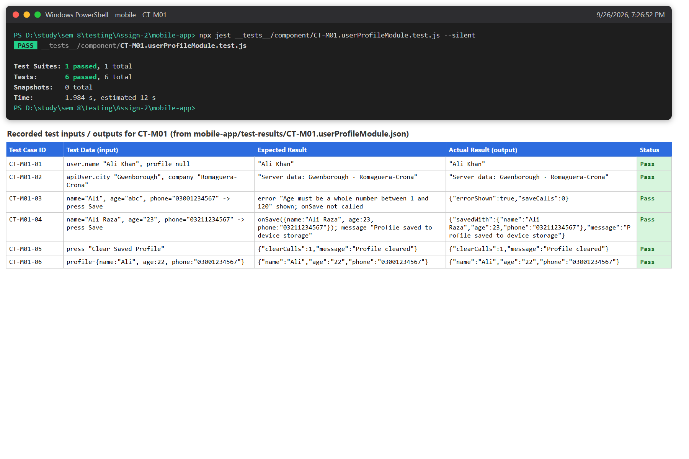
Figure 31: CT-M01 execution - "npx jest __tests__/component/CT-M01.userProfileModule.test.js --silent" (terminal output) with the recorded inputs/outputs of all 6 test cases (6 passed).

4.3.2 CT-M02 - API Communication Module
Deliverable | Details
Component Name | API Communication Module (src/​services/​api.js)
Included Units | fetchPosts(), fetchUser(), handleApiResponse(), parsePosts() / parseUser()
Test Scenarios | CT-M02-01: fetchPosts calls the correct URL  CT-M02-02: fetchPosts limits and parses results  CT-M02-03: fetchUser returns parsed user model  CT-M02-04: Server error is propagated as readable message  CT-M02-05: Network failure is propagated  CT-M02-06: Malformed items in server list are skipped
Observed Behavior | 6 of 6 scenarios passed. Requests go to the correct jsonplaceholder URLs, results are parsed and limited, malformed items are skipped, and HTTP 500 / network failures surface as readable error messages.
Bugs Found | None - all scenarios passed.

Test scenarios (executed):
Test Case ID | Related Use Case ID | Test Case Title | Test Objective | Preconditions | Test Steps | Test Data | Expected Result | Actual Result | Status (Pass/​Fail) | Priority | Tested By | Test Date
CT-M02-01 | UC-M02 View Dashboard | fetchPosts calls the correct URL | Verify fetchPosts/​fetchUser build correct requests and return parsed models or errors | fetch replaced with Jest stub returning jsonplaceholder-shaped data | Call fetchPosts/​fetchUser with stub fetch | fetchPosts(userId=​1) | "https:​/​/​jsonplacehol​der.typicode.com/​posts?​userId=​1" | "https:​/​/​jsonplacehol​der.typicode.com/​posts?​userId=​1" | Pass | High | [Your Name] | 2026-09-26
CT-M02-02 | UC-M02 View Dashboard | fetchPosts limits and parses results | Verify fetchPosts/​fetchUser build correct requests and return parsed models or errors | fetch replaced with Jest stub returning jsonplaceholder-shaped data | Call fetchPosts/​fetchUser with stub fetch | server returns 10 posts, limit=​5 | 5 posts, first title "Post 1" | 5 posts, first title "Post 1" | Pass | High | [Your Name] | 2026-09-26
CT-M02-03 | UC-M02 View Dashboard | fetchUser returns parsed user model | Verify fetchPosts/​fetchUser build correct requests and return parsed models or errors | fetch replaced with Jest stub returning jsonplaceholder-shaped data | Call fetchPosts/​fetchUser with stub fetch | server returns {id:​1, name:​"Leanne Graham", address:​{city:​"Gwenbor​ough"}, company:​{name:​"Romague​ra-Crona"}} | {"id":​1,​"name":​"Leann​e Graham",​"email":​"Since​re@april.biz",​"city":​"​Gwenborough",​"company":​​"Romaguera-Crona"} | {"id":​1,​"name":​"Leann​e Graham",​"email":​"Since​re@april.biz",​"city":​"​Gwenborough",​"company":​​"Romaguera-Crona"} | Pass | Medium | [Your Name] | 2026-09-26
CT-M02-04 | UC-M02 View Dashboard | Server error is propagated as readable message | Verify fetchPosts/​fetchUser build correct requests and return parsed models or errors | fetch replaced with Jest stub returning jsonplaceholder-shaped data | Call fetchPosts/​fetchUser with stub fetch | server returns 500 | "throws: Server error (500)" | "throws: Server error (500)" | Pass | High | [Your Name] | 2026-09-26
CT-M02-05 | UC-M02 View Dashboard | Network failure is propagated | Verify fetchPosts/​fetchUser build correct requests and return parsed models or errors | fetch replaced with Jest stub returning jsonplaceholder-shaped data | Call fetchPosts/​fetchUser with stub fetch | fetch rejects "Network request failed" | "throws: Network request failed" | "throws: Network request failed" | Pass | Medium | [Your Name] | 2026-09-26
CT-M02-06 | UC-M02 View Dashboard | Malformed items in server list are skipped | Verify fetchPosts/​fetchUser build correct requests and return parsed models or errors | fetch replaced with Jest stub returning jsonplaceholder-shaped data | Call fetchPosts/​fetchUser with stub fetch | server returns [{id:​1}, {title:​"broken"}, {id:​3}] | [1,​3] | [1,​3] | Pass | Medium | [Your Name] | 2026-09-26
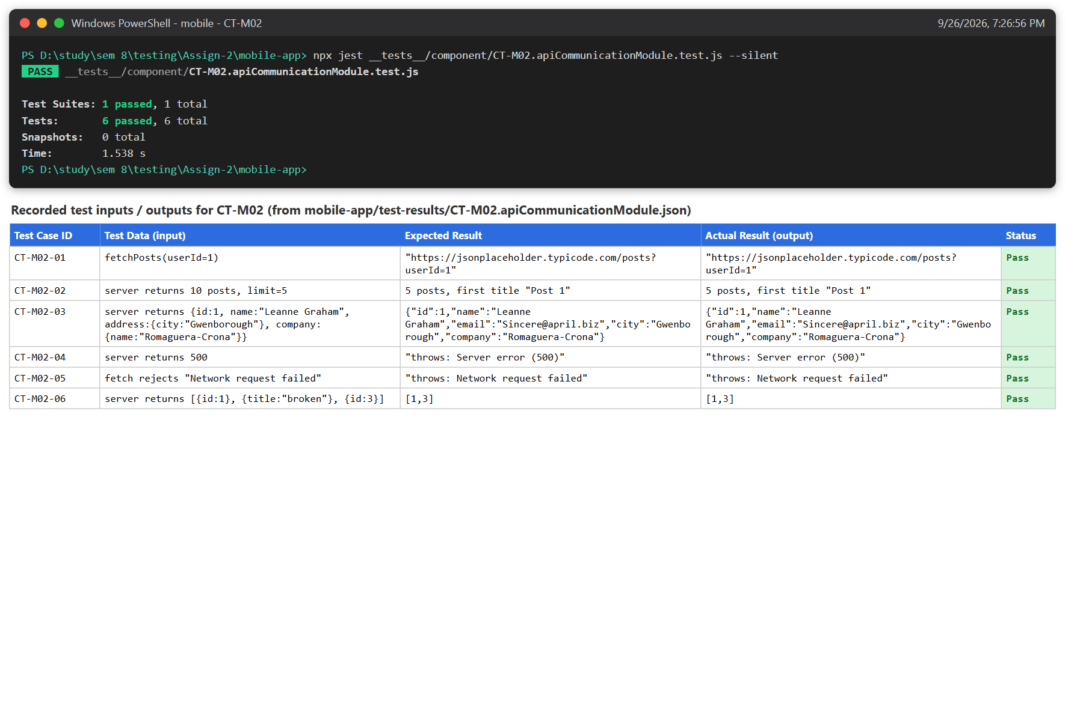
Figure 32: CT-M02 execution - "npx jest __tests__/component/CT-M02.apiCommunicationModule.test.js --silent" (terminal output) with the recorded inputs/outputs of all 6 test cases (6 passed).

4.3.3 CT-M03 - Notification Module
Deliverable | Details
Component Name | Notification Module (notifications.js + NotificationsScreen.js)
Included Units | generateNotifications(), markAsRead(), markAllAsRead(), unreadCount(), NotificationsScreen (UI)
Test Scenarios | CT-M03-01: No user means no notifications  CT-M03-02: User without profile gets welcome, complete-profile and posts notifications  CT-M03-03: Under-18 profile gets restriction notice  CT-M03-04: markAsRead reduces unread count by 1  CT-M03-05: markAllAsRead sets unread count to 0  CT-M03-06: Tapping a notification in the UI calls onRead with its id
Observed Behavior | 6 of 6 scenarios passed. Notifications are derived from user, posts and profile (including the under-18 notice); unread counts update correctly and tapping an item in the UI calls onRead with its id.
Bugs Found | None - all scenarios passed.

Test scenarios (executed):
Test Case ID | Related Use Case ID | Test Case Title | Test Objective | Preconditions | Test Steps | Test Data | Expected Result | Actual Result | Status (Pass/​Fail) | Priority | Tested By | Test Date
CT-M03-01 | UC-M04 View Notifications | No user means no notifications | Verify notifications are generated from user data and read-state is tracked | notifications.js loaded; user Ali Khan with 2 posts | Generate notifications and apply read actions | generateNotifications(nu​ll) | [] | [] | Pass | Medium | [Your Name] | 2026-09-26
CT-M03-02 | UC-M04 View Notifications | User without profile gets welcome, complete-profile and posts notifications | Verify notifications are generated from user data and read-state is tracked | notifications.js loaded; user Ali Khan with 2 posts | Generate notifications and apply read actions | user=​Ali, posts=​2, profile=​null | ["welcome",​"profile",​"​posts"] | ["welcome",​"profile",​"​posts"] | Pass | High | [Your Name] | 2026-09-26
CT-M03-03 | UC-M04 View Notifications | Under-18 profile gets restriction notice | Verify notifications are generated from user data and read-state is tracked | notifications.js loaded; user Ali Khan with 2 posts | Generate notifications and apply read actions | profile.age=​16 | ["welcome",​"posts",​"mi​nor"] | ["welcome",​"posts",​"mi​nor"] | Pass | Medium | [Your Name] | 2026-09-26
CT-M03-04 | UC-M04 View Notifications | markAsRead reduces unread count by 1 | Verify notifications are generated from user data and read-state is tracked | notifications.js loaded; user Ali Khan with 2 posts | Generate notifications and apply read actions | 3 unread, markAsRead("welcome") | {"before":​3,​"after":​2​} | {"before":​3,​"after":​2​} | Pass | High | [Your Name] | 2026-09-26
CT-M03-05 | UC-M04 View Notifications | markAllAsRead sets unread count to 0 | Verify notifications are generated from user data and read-state is tracked | notifications.js loaded; user Ali Khan with 2 posts | Generate notifications and apply read actions | 3 unread, markAllAsRead() | 0 | 0 | Pass | Medium | [Your Name] | 2026-09-26
CT-M03-06 | UC-M04 View Notifications | Tapping a notification in the UI calls onRead with its id | Verify notifications are generated from user data and read-state is tracked | notifications.js loaded; user Ali Khan with 2 posts | Generate notifications and apply read actions | render NotificationsScreen, press item "profile" | ["profile"] | ["profile"] | Pass | High | [Your Name] | 2026-09-26
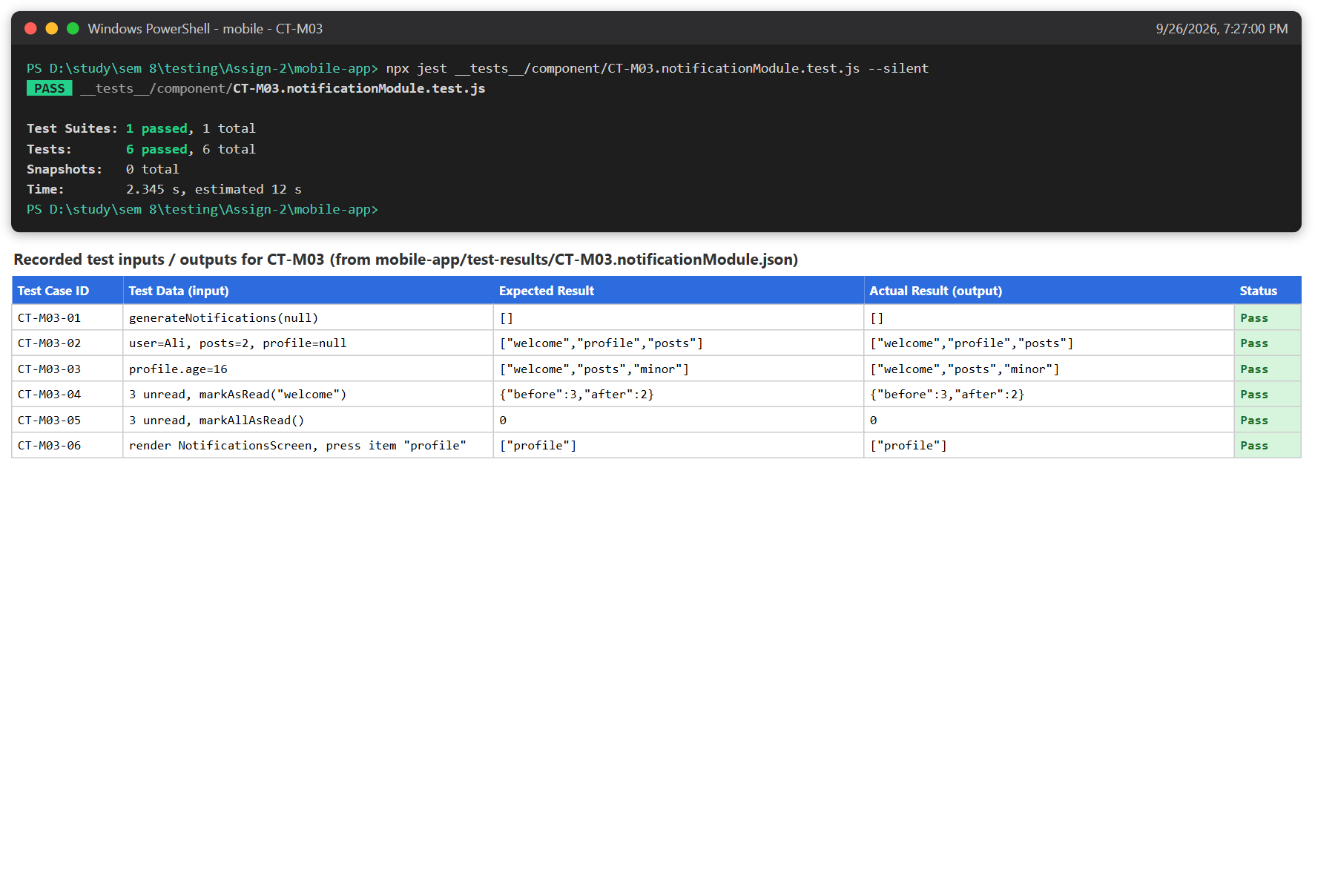
Figure 33: CT-M03 execution - "npx jest __tests__/component/CT-M03.notificationModule.test.js --silent" (terminal output) with the recorded inputs/outputs of all 6 test cases (6 passed).

4.4 Integration Testing
Interactions between modules were tested. Strategies used: Top-Down Integration, Incremental Integration, Bottom-Up Integration.

4.4.1 IT-M01 - App UI <-> API Server
Deliverable | Details
Modules Integrated | App.js + DashboardScreen (UI) <-> api.js (fetchPosts/​fetchUser) <-> API server (jsonplaceholder, stubbed)
Integration Strategy Used | Top-Down Integration: the top-level App/​Dashboard UI is integrated with the real API module; the remote server is replaced by a stub returning jsonplaceholder-shaped data.
Test Cases | IT-M01-01: After login dashboard shows first 5 posts from server [Pass]  IT-M01-02: Pressing "+" re-requests and shows 10 posts [Pass]  IT-M01-03: Server error is shown on the dashboard [Pass]  IT-M01-04: Refresh button calls the API again [Pass]  IT-M01-05: Logged-in user id is sent to the server [Pass]
Data Passed Between Modules | UI -> API: userId, limit (GET /​posts?userId=​1, GET /​users/​1); API -> UI: JSON posts[] / user{} parsed into models, or error message
Observed Behavior | 5 of 5 test cases passed. After login the Dashboard requested posts with the logged-in user id and rendered them; "+" and Refresh re-requested data; a 500 from the server was displayed as an error message.
Errors / Failures Observed | None - all scenarios passed.

Integration test cases (executed):
Test Case ID | Related Use Case ID | Test Case Title | Test Objective | Preconditions | Test Steps | Test Data | Expected Result | Actual Result | Status (Pass/​Fail) | Priority | Tested By | Test Date
IT-M01-01 | UC-M02 View Dashboard | After login dashboard shows first 5 posts from server | Verify the Dashboard UI requests data from the API server and displays / handles the responses | Storage cleared; global fetch replaced by a fake jsonplaceholder server | Render <App/​>, log in, interact with Dashboard | login ali@test.com/​ali123; server returns 10 posts | 5 post cards rendered (post-101..post-105) | 5 post cards rendered (post-101..post-105) | Pass | High | [Your Name] | 2026-09-26
IT-M01-02 | UC-M02 View Dashboard | Pressing "+" re-requests and shows 10 posts | Verify the Dashboard UI requests data from the API server and displays / handles the responses | Storage cleared; global fetch replaced by a fake jsonplaceholder server | Render <App/​>, log in, interact with Dashboard | press limit-plus once | 10 post cards rendered, /​posts requested again | 10 post cards rendered, /​posts requested 2 times | Pass | Medium | [Your Name] | 2026-09-26
IT-M01-03 | UC-M02 View Dashboard | Server error is shown on the dashboard | Verify the Dashboard UI requests data from the API server and displays / handles the responses | Storage cleared; global fetch replaced by a fake jsonplaceholder server | Render <App/​>, log in, interact with Dashboard | server responds 500 to every request | "Server error (500)" | "Server error (500)" | Pass | High | [Your Name] | 2026-09-26
IT-M01-04 | UC-M02 View Dashboard | Refresh button calls the API again | Verify the Dashboard UI requests data from the API server and displays / handles the responses | Storage cleared; global fetch replaced by a fake jsonplaceholder server | Render <App/​>, log in, interact with Dashboard | press refresh-button | /​posts requested 2 times | /​posts requested 2 times | Pass | Medium | [Your Name] | 2026-09-26
IT-M01-05 | UC-M02 View Dashboard | Logged-in user id is sent to the server | Verify the Dashboard UI requests data from the API server and displays / handles the responses | Storage cleared; global fetch replaced by a fake jsonplaceholder server | Render <App/​>, log in, interact with Dashboard | login sara@test.com/​sara123 (userId 2) | request URL contains userId=​2 and cards are post-201.. | {"url":​"https:​/​/​json​placeholder.typicode.com​/​posts?userId=​2",​"fir​st":​"post-201"} | Pass | High | [Your Name] | 2026-09-26
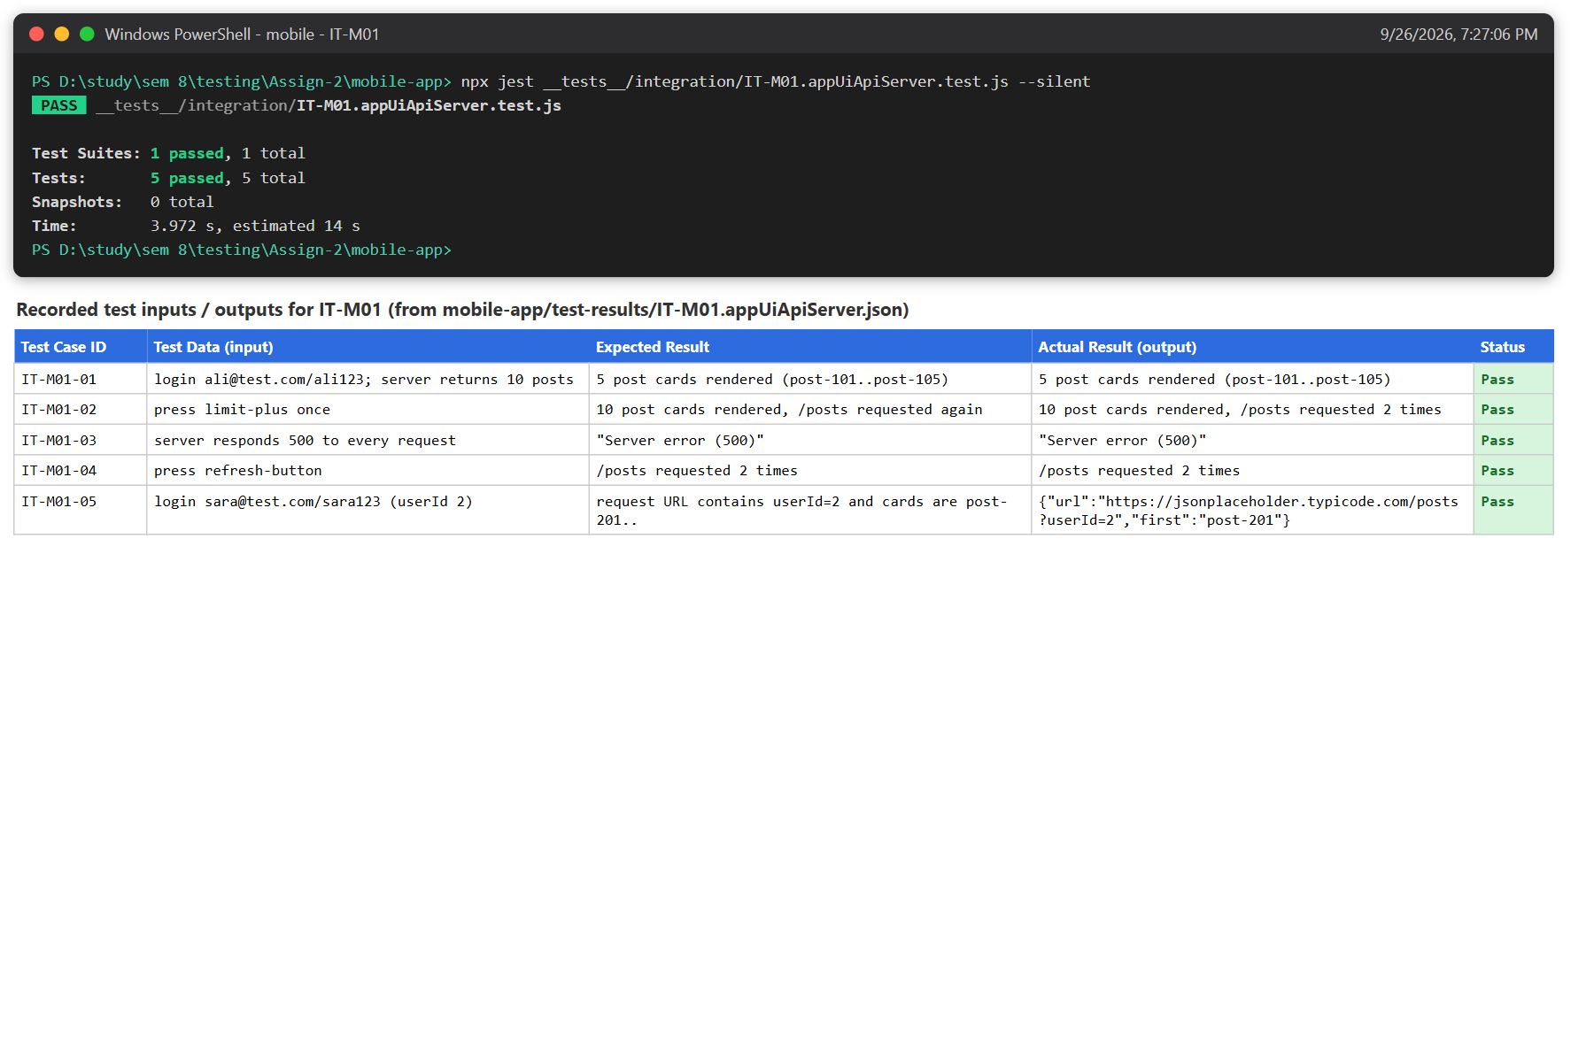
Figure 34: IT-M01 execution - "npx jest __tests__/integration/IT-M01.appUiApiServer.test.js --silent" (terminal output) with the recorded inputs/outputs of all 5 test cases (5 passed).

4.4.2 IT-M02 - Login Module <-> Dashboard
Deliverable | Details
Modules Integrated | LoginScreen + auth.js (login) -> App.js (session state + storage.saveSession) -> DashboardScreen / ProfileScreen (logout)
Integration Strategy Used | Incremental Integration: Login module was integrated with App state first, then Dashboard, then session storage and logout were added one at a time, re-testing after each addition.
Test Cases | IT-M02-01: Wrong password keeps user on Login screen [Pass]  IT-M02-02: Valid login opens Dashboard with user name [Pass]  IT-M02-03: Login stores the session on the device [Pass]  IT-M02-04: Logout returns to Login screen and clears session [Pass]  IT-M02-05: Re-opening the app with a saved session skips Login [Pass]
Data Passed Between Modules | Login -> App: user {userId, email, name}; App -> Storage: "session" JSON; App -> Dashboard: user prop (name shown in greeting)
Observed Behavior | 5 of 5 test cases passed. Wrong credentials kept the user on Login; a valid login passed the user to the Dashboard and saved the session; logout cleared it; re-opening the app with a saved session skipped Login.
Errors / Failures Observed | None - all scenarios passed.

Integration test cases (executed):
Test Case ID | Related Use Case ID | Test Case Title | Test Objective | Preconditions | Test Steps | Test Data | Expected Result | Actual Result | Status (Pass/​Fail) | Priority | Tested By | Test Date
IT-M02-01 | UC-M01 Login / UC-M02 Dashboard | Wrong password keeps user on Login screen | Verify successful login hands the user/​session to the Dashboard and logout returns to Login | Storage cleared; fake API server installed | Render <App/​>, perform login/​logout flows | ali@test.com / wrong99 | {"error":​"Invalid email or password",​"dashboardVis​ible":​false} | {"error":​"Invalid email or password",​"dashboardVis​ible":​false} | Pass | High | [Your Name] | 2026-09-26
IT-M02-02 | UC-M01 Login / UC-M02 Dashboard | Valid login opens Dashboard with user name | Verify successful login hands the user/​session to the Dashboard and logout returns to Login | Storage cleared; fake API server installed | Render <App/​>, perform login/​logout flows | ali@test.com / ali123 | "Hello, Ali Khan" | "Hello, Ali Khan" | Pass | High | [Your Name] | 2026-09-26
IT-M02-03 | UC-M01 Login / UC-M02 Dashboard | Login stores the session on the device | Verify successful login hands the user/​session to the Dashboard and logout returns to Login | Storage cleared; fake API server installed | Render <App/​>, perform login/​logout flows | login ali, read AsyncStorage["session"] | {"userId":​1,​"email":​"​ali@test.com",​"name":​"​Ali Khan"} | {"userId":​1,​"email":​"​ali@test.com",​"name":​"​Ali Khan"} | Pass | Medium | [Your Name] | 2026-09-26
IT-M02-04 | UC-M01 Login / UC-M02 Dashboard | Logout returns to Login screen and clears session | Verify successful login hands the user/​session to the Dashboard and logout returns to Login | Storage cleared; fake API server installed | Render <App/​>, perform login/​logout flows | login -> Profile tab -> Logout | {"loginVisible":​true,​"​session":​null} | {"loginVisible":​true,​"​session":​null} | Pass | High | [Your Name] | 2026-09-26
IT-M02-05 | UC-M01 Login / UC-M02 Dashboard | Re-opening the app with a saved session skips Login | Verify successful login hands the user/​session to the Dashboard and logout returns to Login | Storage cleared; fake API server installed | Render <App/​>, perform login/​logout flows | AsyncStorage["session"] = Sara; render App | "Hello, Sara Ahmed" | "Hello, Sara Ahmed" | Pass | Medium | [Your Name] | 2026-09-26
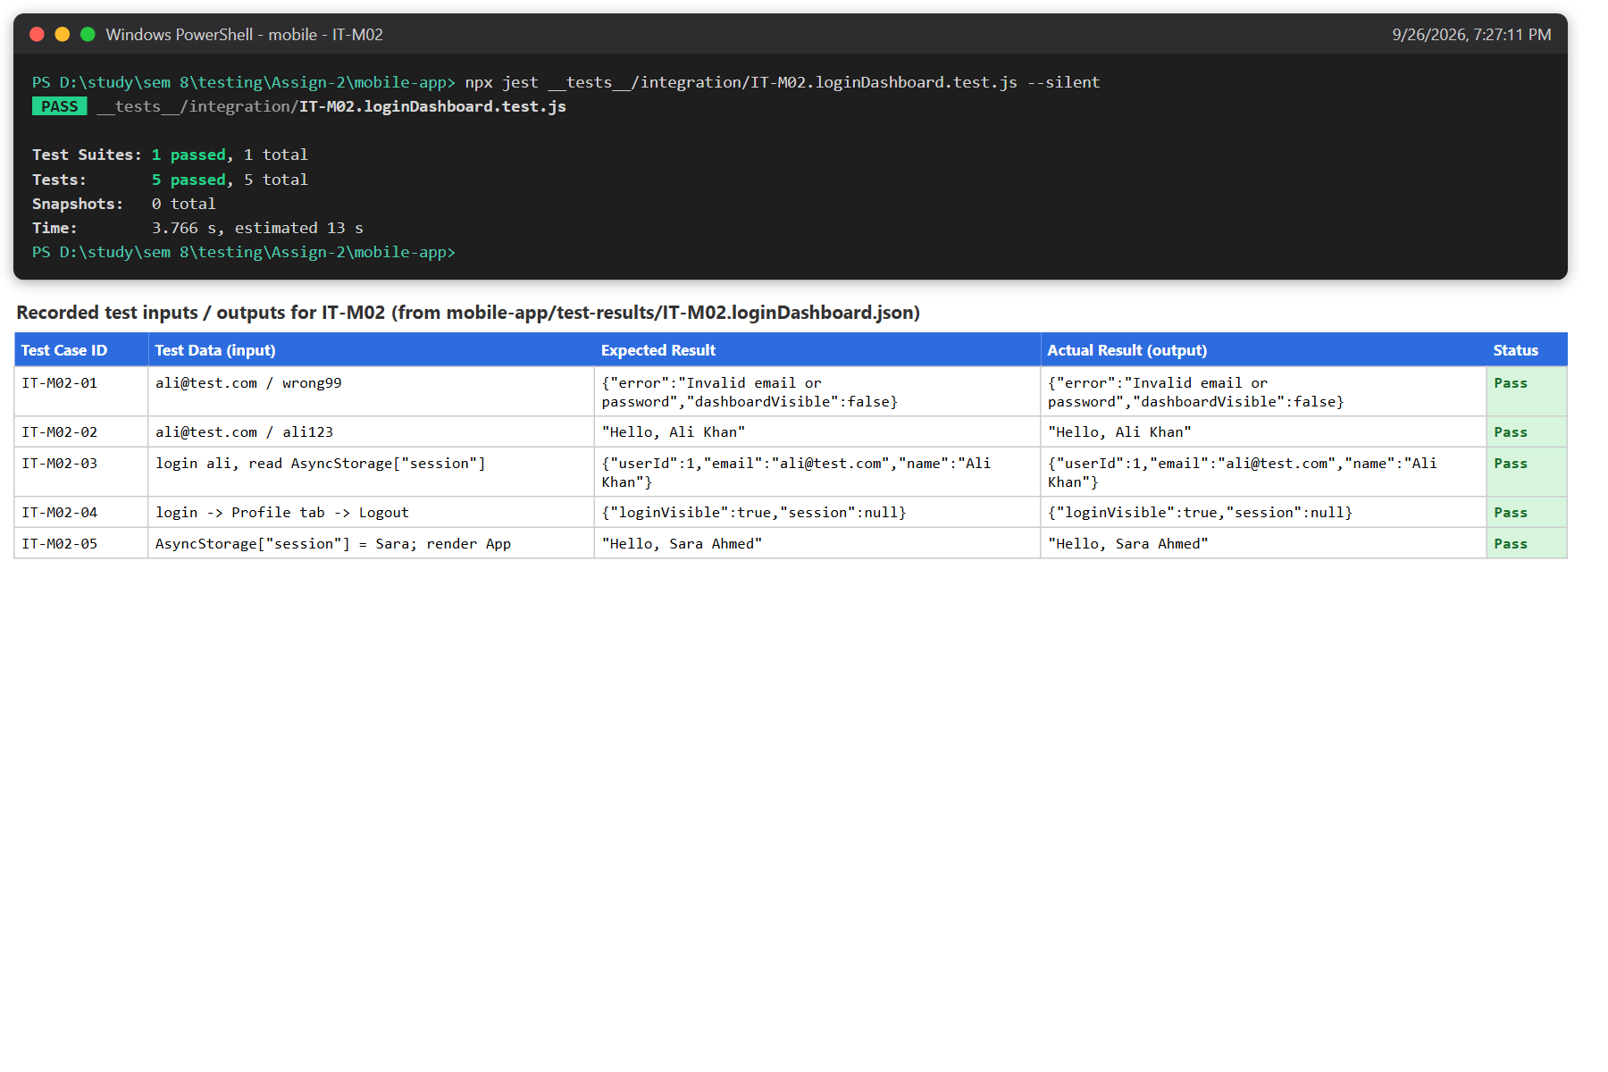
Figure 35: IT-M02 execution - "npx jest __tests__/integration/IT-M02.loginDashboard.test.js --silent" (terminal output) with the recorded inputs/outputs of all 5 test cases (5 passed).

4.4.3 IT-M03 - Notification Service <-> User Data
Deliverable | Details
Modules Integrated | storage.js (profile) + api.js (posts) -> notifications.js (generateNotifications) -> App.js tab badge + NotificationsScreen
Integration Strategy Used | Bottom-Up Integration: storage and notification units (already tested) are combined first, then driven through App.js and the Notifications/​Profile screens.
Test Cases | IT-M03-01: New user without profile sees 3 unread alerts [Pass]  IT-M03-02: Saving an under-18 profile updates notifications [Pass]  IT-M03-03: Profile already in storage is used at login [Pass]  IT-M03-04: Tapping a notification lowers the unread badge [Pass]  IT-M03-05: Read notifications stay read after profile update [Fail]
Data Passed Between Modules | User {name}, posts[] (count, latest title), profile {age} -> notification list [{id, text, read}] -> unread badge count
Observed Behavior | 4 of 5 test cases passed. Notifications reacted to stored profile and posts (badge 3 -> 2, under-18 notice). However, after "Mark all read" and saving the profile, already-read notifications were regenerated as unread ("Alerts (2)").
Errors / Failures Observed | BUG-M02 (IT-M03-05): Read notifications become unread after profile update

Integration test cases (executed):
Test Case ID | Related Use Case ID | Test Case Title | Test Objective | Preconditions | Test Steps | Test Data | Expected Result | Actual Result | Status (Pass/​Fail) | Priority | Tested By | Test Date
IT-M03-01 | UC-M03 Profile / UC-M04 Notifications | New user without profile sees 3 unread alerts | Verify notifications react to the user's stored profile and posts data | Storage cleared; fake API server installed; user Ali logs in | Render <App/​>, log in, change profile, open Alerts tab | login ali, no saved profile | "Alerts (3)" | "Alerts (3)" | Pass | High | [Your Name] | 2026-09-26
IT-M03-02 | UC-M03 Profile / UC-M04 Notifications | Saving an under-18 profile updates notifications | Verify notifications react to the user's stored profile and posts data | Storage cleared; fake API server installed; user Ali logs in | Render <App/​>, log in, change profile, open Alerts tab | save profile {Ali, 16, 03001234567}, open Alerts | {"underageNotice":​true,​​"completeProfileNotice"​:​false} | {"underageNotice":​true,​​"completeProfileNotice"​:​false} | Pass | High | [Your Name] | 2026-09-26
IT-M03-03 | UC-M03 Profile / UC-M04 Notifications | Profile already in storage is used at login | Verify notifications react to the user's stored profile and posts data | Storage cleared; fake API server installed; user Ali logs in | Render <App/​>, log in, change profile, open Alerts tab | AsyncStorage["profile:​1​"] = {Ali, 25, ...}; login | "Alerts (2)" | "Alerts (2)" | Pass | Medium | [Your Name] | 2026-09-26
IT-M03-04 | UC-M03 Profile / UC-M04 Notifications | Tapping a notification lowers the unread badge | Verify notifications react to the user's stored profile and posts data | Storage cleared; fake API server installed; user Ali logs in | Render <App/​>, log in, change profile, open Alerts tab | open Alerts, tap "welcome" | "Alerts (2)" | "Alerts (2)" | Pass | Medium | [Your Name] | 2026-09-26
IT-M03-05 | UC-M03 Profile / UC-M04 Notifications | Read notifications stay read after profile update | Verify notifications react to the user's stored profile and posts data | Storage cleared; fake API server installed; user Ali logs in | Render <App/​>, log in, change profile, open Alerts tab | Mark all read -> save profile {Ali, 25, 03001234567} | "Alerts" (0 unread: welcome/​posts were already read, no new notices for age 25) | "Alerts (2)" | Fail | Medium | [Your Name] | 2026-09-26
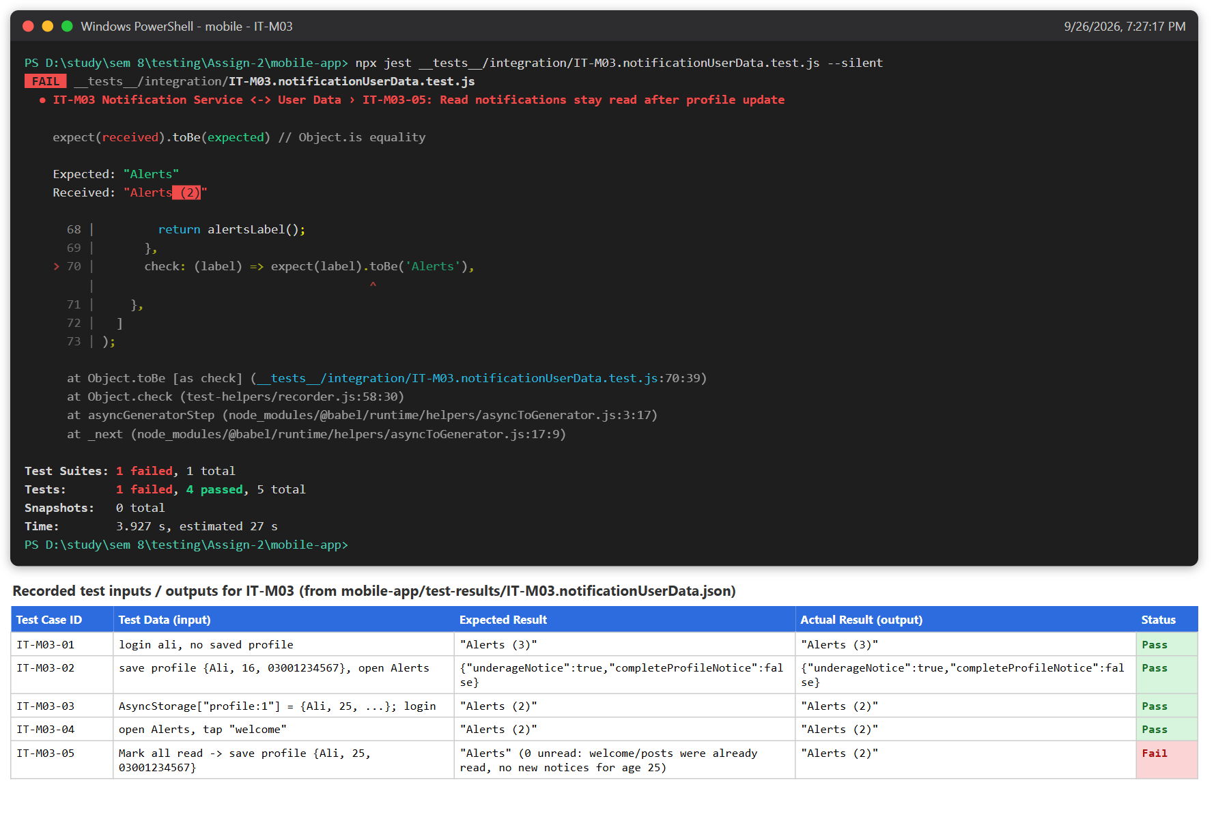
Figure 36: IT-M03 execution - "npx jest __tests__/integration/IT-M03.notificationUserData.test.js --silent" (terminal output) with the recorded inputs/outputs of all 5 test cases (4 passed).

4.5 System Behaviour Screenshots (running application)
The Expo app was exported for web and driven in a 390x844 phone viewport. Posts and user data in these screenshots come from the live jsonplaceholder API server. Each caption names the test cases it demonstrates.
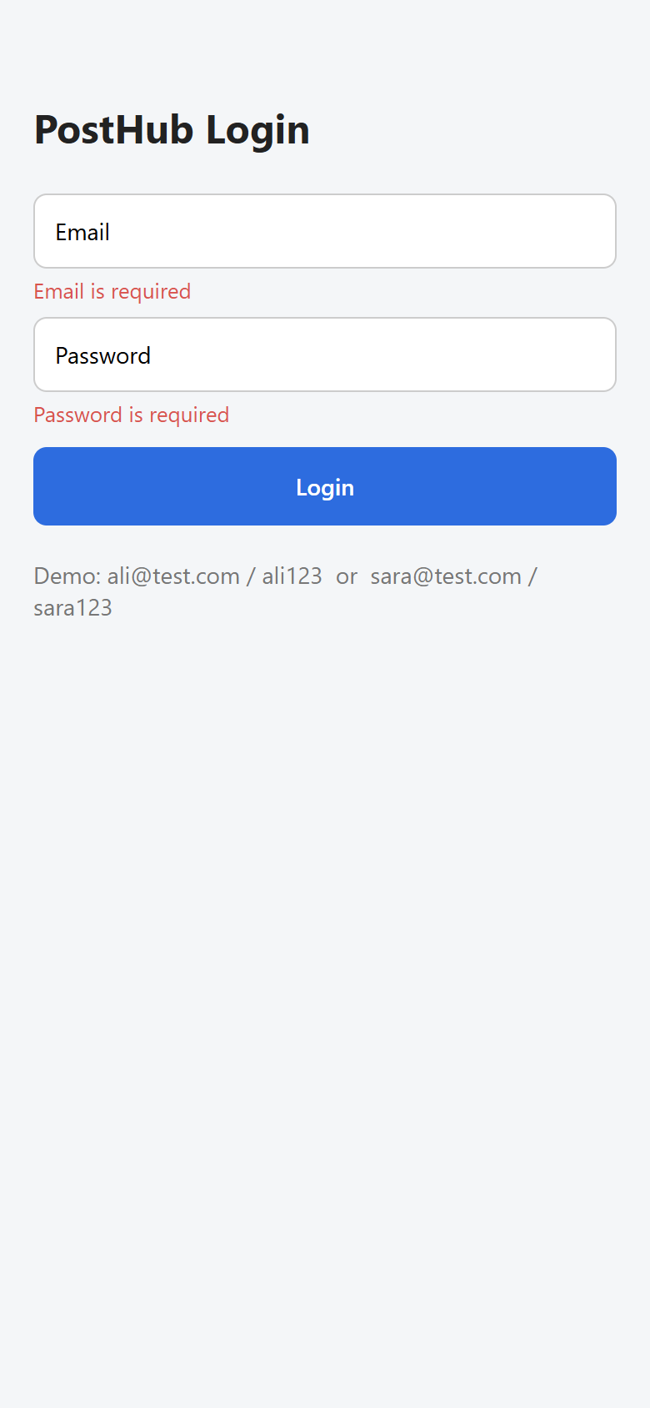  Figure 37: Login pressed with empty fields: input validation errors shown - UT-M01-06 | 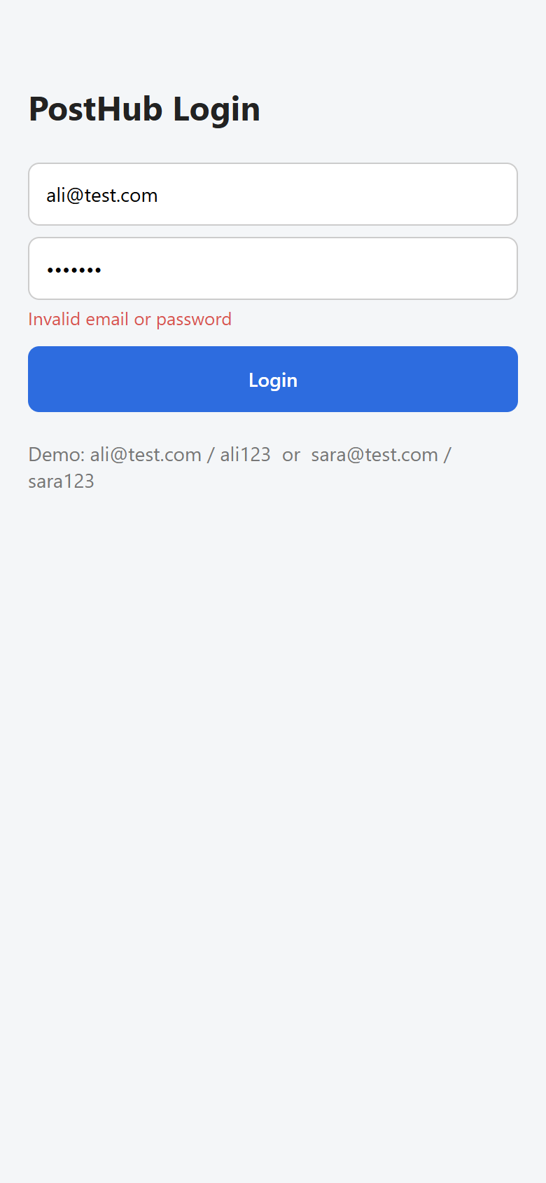  Figure 38: Wrong password: stays on Login with "Invalid email or password" - IT-M02-01 | 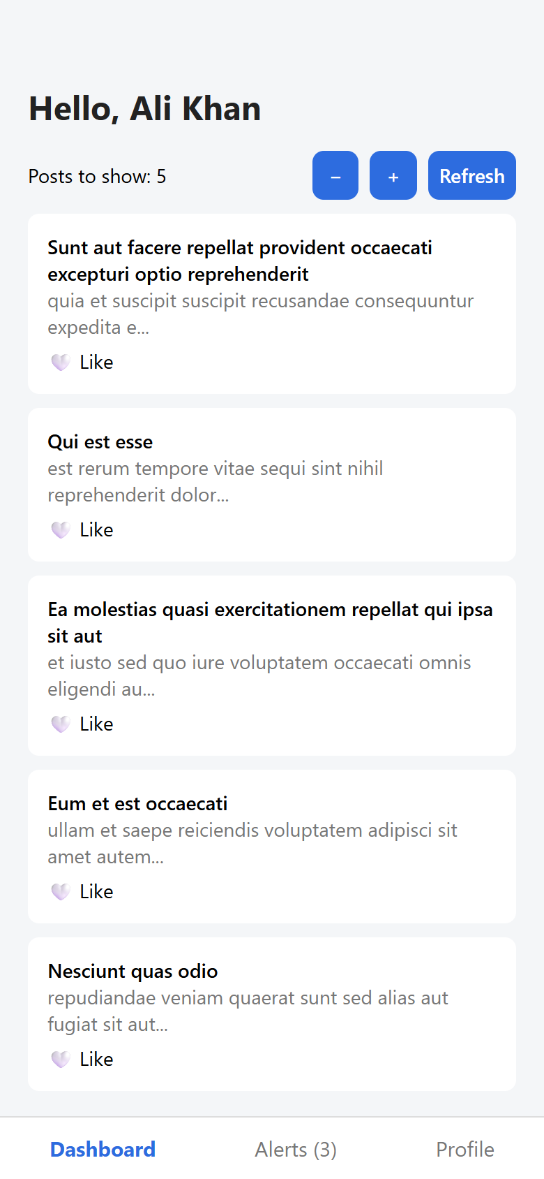  Figure 39: Login success -> Dashboard "Hello, Ali Khan" with 5 posts fetched live from jsonplaceholder API - IT-M02-02, IT-M01-01
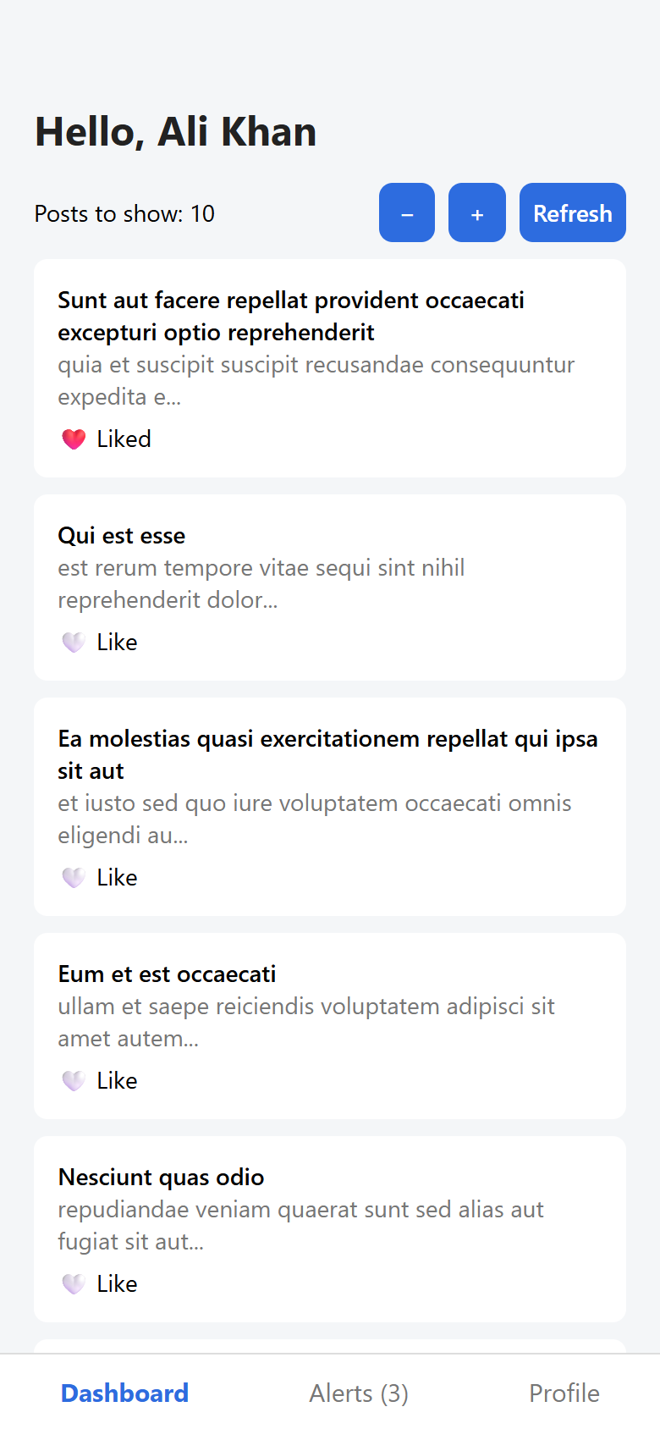  Figure 40: Pressing "+" re-requests the API and shows 10 posts; first post Liked (button click handler) - IT-M01-02, UT-M03 | 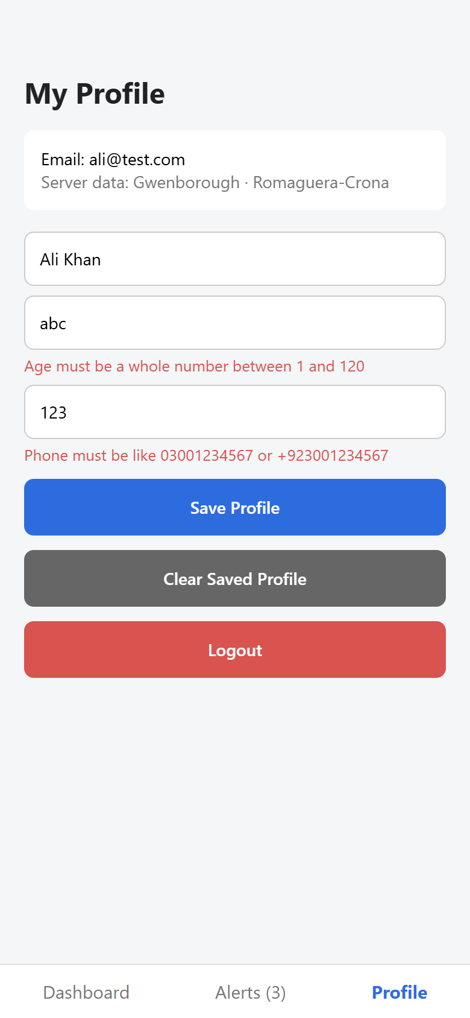  Figure 41: Profile save with invalid age/phone: validation errors shown - CT-M01-03, UT-M02 | 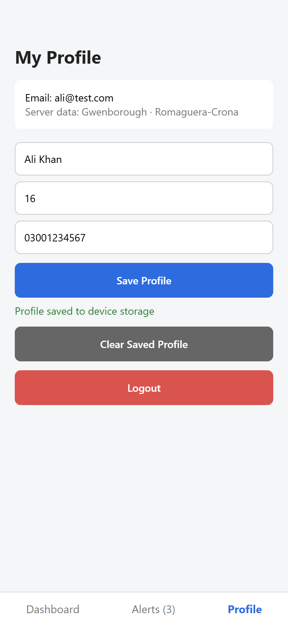  Figure 42: Valid profile saved to device storage; server data (city/company) from API shown - CT-M01-04, UT-M05
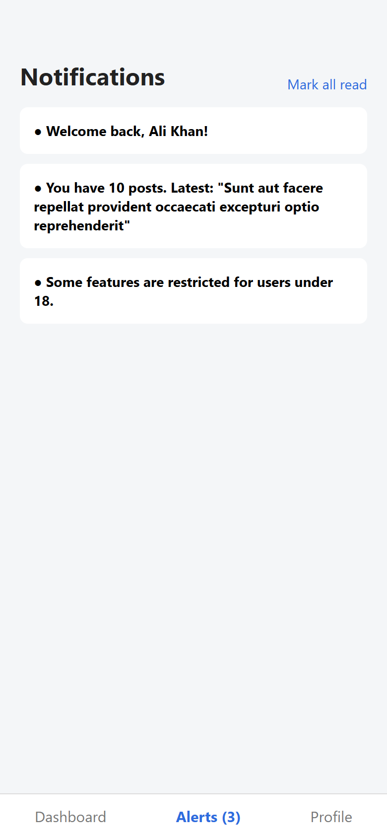  Figure 43: Alerts after saving age 16: under-18 notice generated from user data - IT-M03-02 | 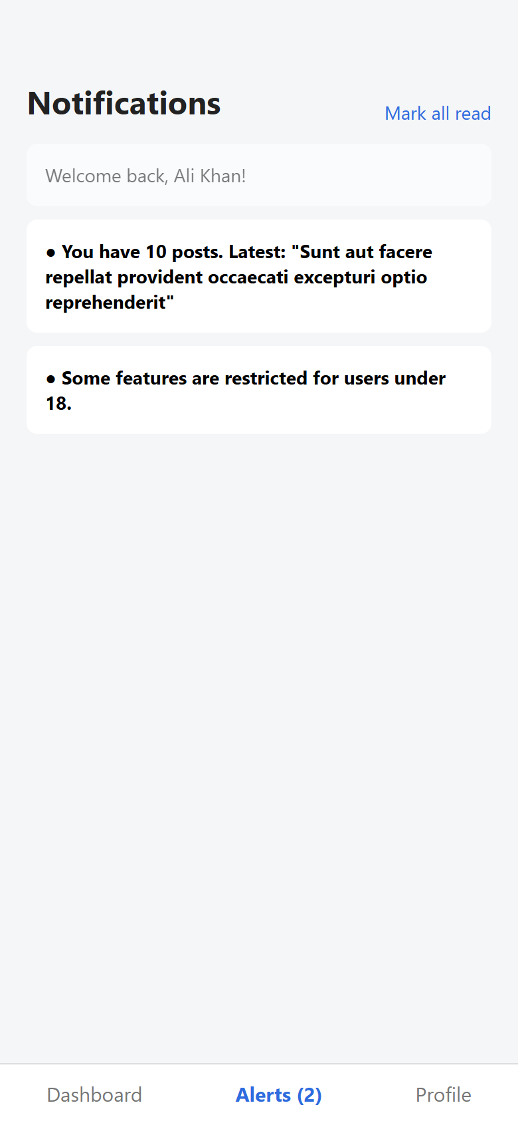  Figure 44: Tapping a notification marks it read; unread badge decreases - IT-M03-04, CT-M03-04 | 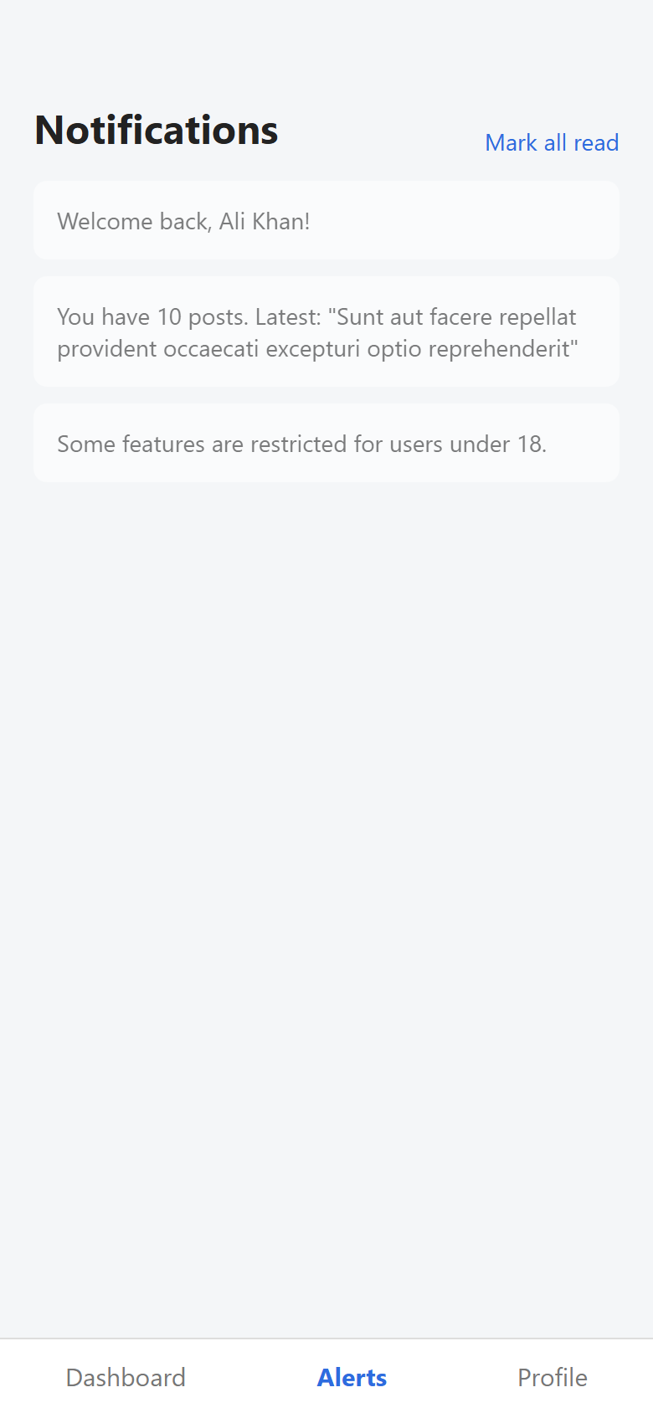  Figure 45: Mark all read: badge shows "Alerts" with no count - CT-M03-05
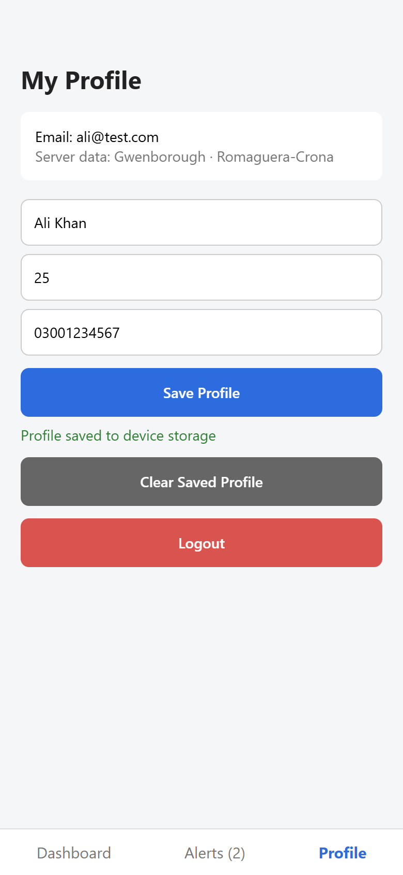  Figure 46: BUG (IT-M03-05): after saving the profile, already-read notifications become unread again (badge back to a count) | 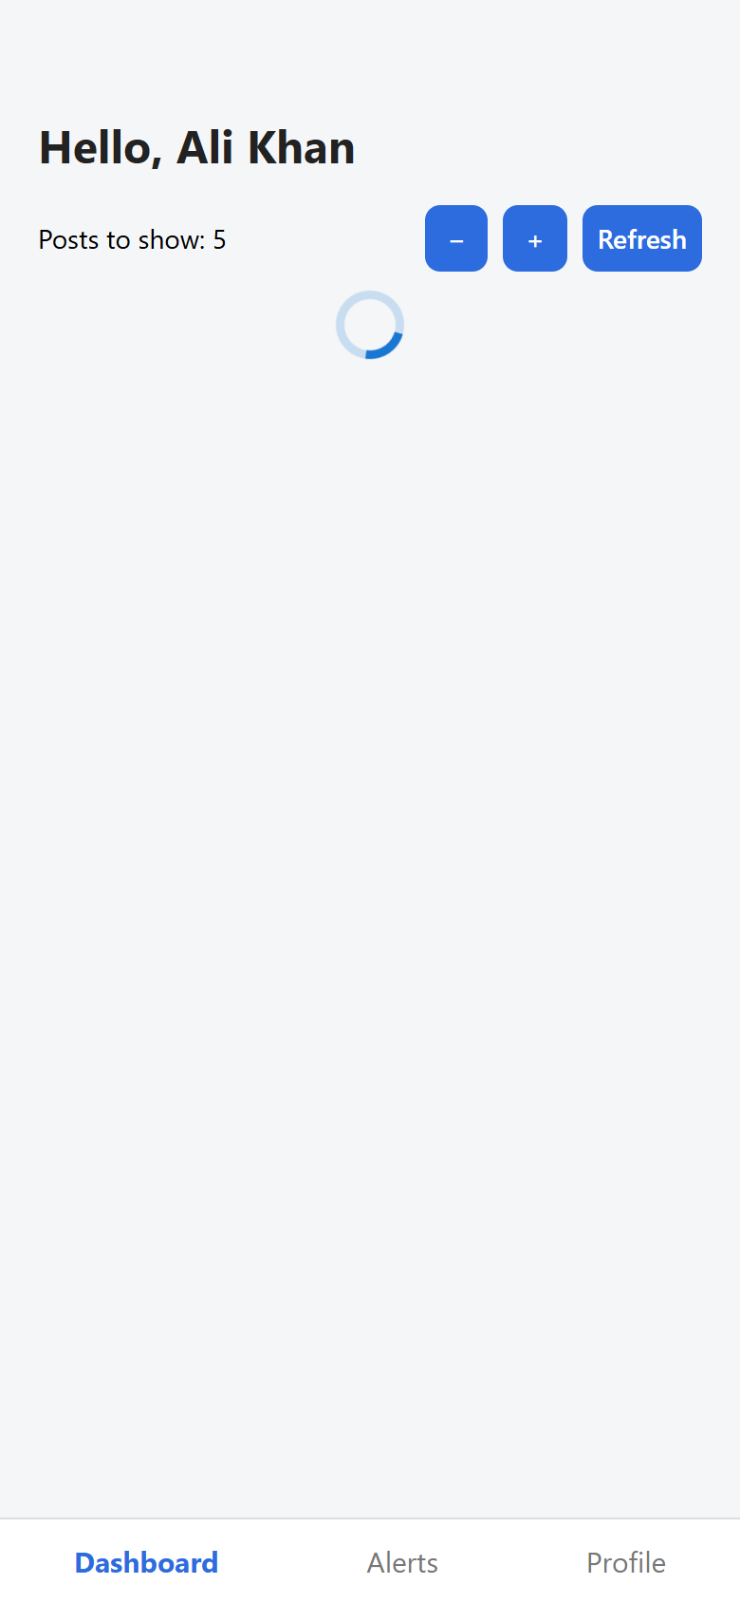  Figure 47: App reopened (page reload): saved session restores Dashboard without login - IT-M02-05 | 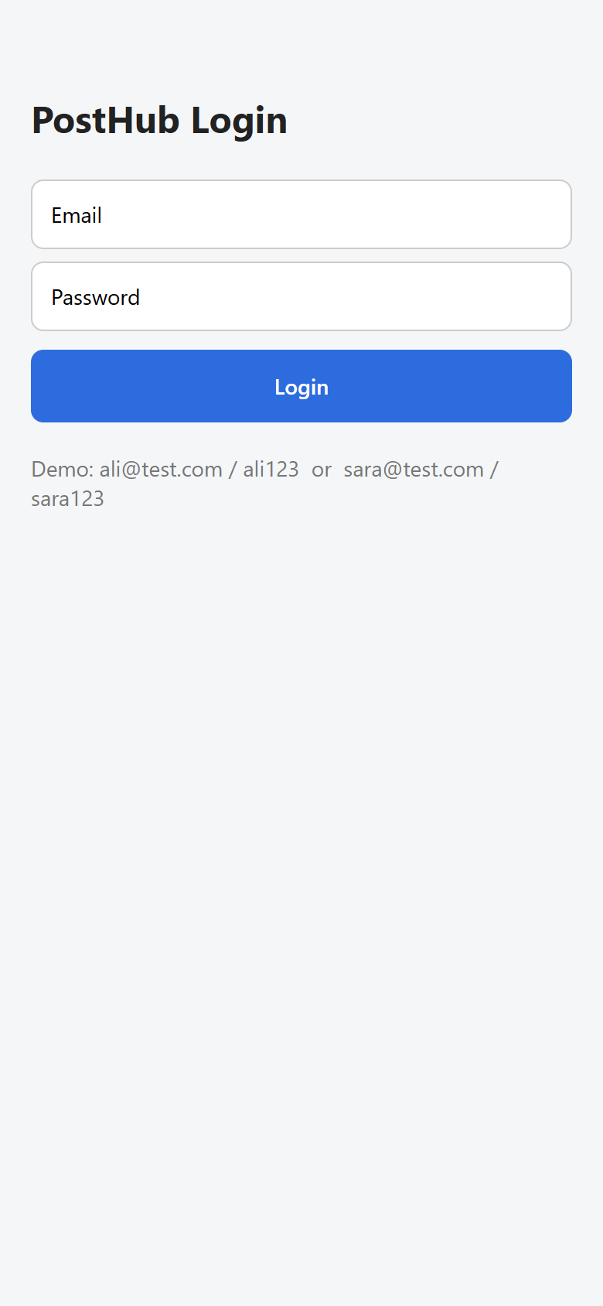  Figure 48: Logout returns to Login screen and clears session - IT-M02-04

5. DSA Semester Project - DSA Toolkit (Python)

5.1 System Under Test
DSA Toolkit is a Python 3 command-line program implementing a singly linked list, a binary search tree, a stack and a circular queue, four sorting algorithms with linear/binary search and a weighted graph (BFS, DFS, Dijkstra). A data-input module parses user text, a processing module builds the structures and a visualization module renders them as text.
Testing tools: Python unittest (standard library), subprocess for end-to-end CLI tests, headless Edge for terminal screenshots.
How to run the tests: cd dsa-project -> python -m unittest discover -s tests -t . -v (application: python main.py)
Overall: 78 test cases executed, 74 passed, 4 failed.
Use cases referenced by the test cases:
Use Case ID | Use Case | Description
UC-D01 | Manage linked list | Insert at head/​tail/​index, delete, search, reverse
UC-D02 | Tree operations | Build BST, search, delete, traversals, height/​min/​max
UC-D03 | Stack & queue | Push/​pop/​peek, enqueue/​dequeue, bracket checking
UC-D04 | Sort & search | Sort a list with bubble/​insertion/​merge​/​quick sort; linear & binary search
UC-D05 | Graph processing | Build weighted graph from edge list; BFS, DFS, Dijkstra shortest path

5.2 Unit Testing
6 units were identified and tested independently (external dependencies such as fetch, storage or the database were stubbed or reset). Each unit has at least 5 test cases in the required template format.

5.2.1 UT-D01 - LinkedList insert functions (insert_at_head / insert_at_tail / insert_at)
Result: 7 test cases executed, 7 passed, 0 failed.
Test Case ID | Related Use Case ID | Test Case Title | Test Objective | Preconditions | Test Steps | Test Data | Expected Result | Actual Result | Status (Pass/​Fail) | Priority | Tested By | Test Date
UT-D01-01 | UC-D01 Manage Linked List | Insert at tail of empty list | Verify nodes are inserted at the correct position and size is updated | linked_list.py imported; new LinkedList created per test | 1. Build list from test data 2. Call insert function 3. Compare to_list() with expected | [] + insert_at_tail(5) | [5] | [5] | Pass | High | [Your Name] | 2026-09-26
UT-D01-02 | UC-D01 Manage Linked List | Insert at tail keeps order | Verify nodes are inserted at the correct position and size is updated | linked_list.py imported; new LinkedList created per test | 1. Build list from test data 2. Call insert function 3. Compare to_list() with expected | [1,​2] + insert_at_tail(3) | [1, 2, 3] | [1, 2, 3] | Pass | High | [Your Name] | 2026-09-26
UT-D01-03 | UC-D01 Manage Linked List | Insert at head becomes first element | Verify nodes are inserted at the correct position and size is updated | linked_list.py imported; new LinkedList created per test | 1. Build list from test data 2. Call insert function 3. Compare to_list() with expected | [1,​2] + insert_at_head(0) | [0, 1, 2] | [0, 1, 2] | Pass | High | [Your Name] | 2026-09-26
UT-D01-04 | UC-D01 Manage Linked List | Insert at middle index | Verify nodes are inserted at the correct position and size is updated | linked_list.py imported; new LinkedList created per test | 1. Build list from test data 2. Call insert function 3. Compare to_list() with expected | [1,​2] + insert_at(1, 9) | [1, 9, 2] | [1, 9, 2] | Pass | Medium | [Your Name] | 2026-09-26
UT-D01-05 | UC-D01 Manage Linked List | Insert at index =​= size appends | Verify nodes are inserted at the correct position and size is updated | linked_list.py imported; new LinkedList created per test | 1. Build list from test data 2. Call insert function 3. Compare to_list() with expected | [1,​2] + insert_at(2, 9) | [1, 2, 9] | [1, 2, 9] | Pass | Medium | [Your Name] | 2026-09-26
UT-D01-06 | UC-D01 Manage Linked List | Insert at invalid index raises IndexError | Verify nodes are inserted at the correct position and size is updated | linked_list.py imported; new LinkedList created per test | 1. Build list from test data 2. Call insert function 3. Compare to_list() with expected | [1,​2] + insert_at(5, 9) | "throws IndexError: Index out of range" | "throws IndexError: Index out of range" | Pass | Medium | [Your Name] | 2026-09-26
UT-D01-07 | UC-D01 Manage Linked List | Size is updated after inserts | Verify nodes are inserted at the correct position and size is updated | linked_list.py imported; new LinkedList created per test | 1. Build list from test data 2. Call insert function 3. Compare to_list() with expected | insert_at_tail x3 | 3 | 3 | Pass | Low | [Your Name] | 2026-09-26
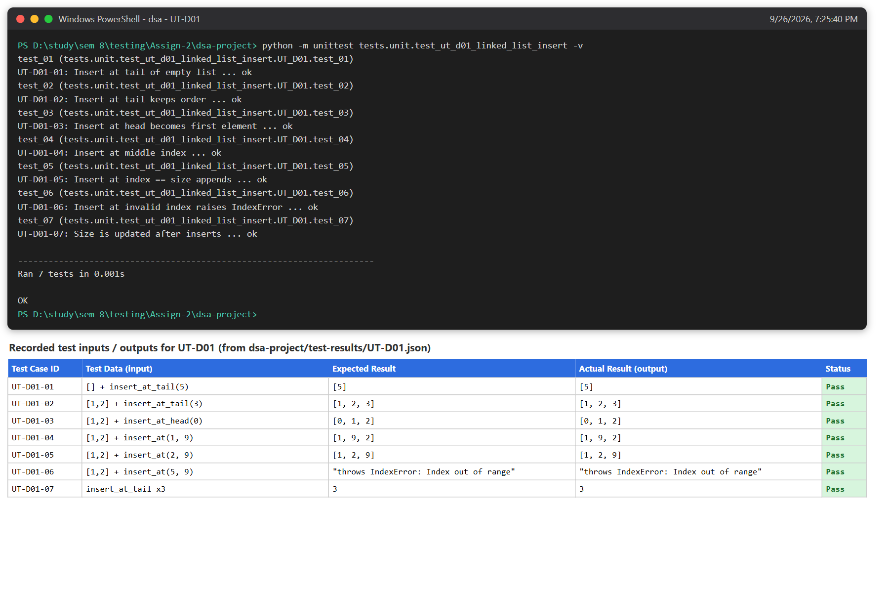
Figure 49: UT-D01 execution - "python -m unittest tests.unit.test_ut_d01_linked_list_insert -v" (terminal output) with the recorded inputs/outputs of all 7 test cases (7 passed).

5.2.2 UT-D02 - LinkedList delete / search functions
Result: 7 test cases executed, 7 passed, 0 failed.
Test Case ID | Related Use Case ID | Test Case Title | Test Objective | Preconditions | Test Steps | Test Data | Expected Result | Actual Result | Status (Pass/​Fail) | Priority | Tested By | Test Date
UT-D02-01 | UC-D01 Manage Linked List | Delete head node | Verify delete removes the right node and search returns the correct index | linked_list.py imported; list built from test data | 1. Build list 2. Call delete(value)/​delete_at​(i)/​search(value) 3. Compare result and list contents | [1,​2,​3] delete(1) | {"deleted": true, "list": [2, 3], "size": 2} | {"deleted": true, "list": [2, 3], "size": 2} | Pass | High | [Your Name] | 2026-09-26
UT-D02-02 | UC-D01 Manage Linked List | Delete middle node | Verify delete removes the right node and search returns the correct index | linked_list.py imported; list built from test data | 1. Build list 2. Call delete(value)/​delete_at​(i)/​search(value) 3. Compare result and list contents | [1,​2,​3] delete(2) | {"deleted": true, "list": [1, 3], "size": 2} | {"deleted": true, "list": [1, 3], "size": 2} | Pass | High | [Your Name] | 2026-09-26
UT-D02-03 | UC-D01 Manage Linked List | Delete value not present leaves list unchanged | Verify delete removes the right node and search returns the correct index | linked_list.py imported; list built from test data | 1. Build list 2. Call delete(value)/​delete_at​(i)/​search(value) 3. Compare result and list contents | [1,​2,​3] delete(7) | {"deleted": false, "list": [1, 2, 3], "size": 3} | {"deleted": false, "list": [1, 2, 3], "size": 3} | Pass | Medium | [Your Name] | 2026-09-26
UT-D02-04 | UC-D01 Manage Linked List | Delete removes only first duplicate | Verify delete removes the right node and search returns the correct index | linked_list.py imported; list built from test data | 1. Build list 2. Call delete(value)/​delete_at​(i)/​search(value) 3. Compare result and list contents | [4,​5,​4] delete(4) | {"deleted": true, "list": [5, 4], "size": 2} | {"deleted": true, "list": [5, 4], "size": 2} | Pass | Medium | [Your Name] | 2026-09-26
UT-D02-05 | UC-D01 Manage Linked List | delete_at on empty list raises IndexError | Verify delete removes the right node and search returns the correct index | linked_list.py imported; list built from test data | 1. Build list 2. Call delete(value)/​delete_at​(i)/​search(value) 3. Compare result and list contents | [] delete_at(0) | "throws IndexError: Index out of range" | "throws IndexError: Index out of range" | Pass | Medium | [Your Name] | 2026-09-26
UT-D02-06 | UC-D01 Manage Linked List | Search returns index of existing value | Verify delete removes the right node and search returns the correct index | linked_list.py imported; list built from test data | 1. Build list 2. Call delete(value)/​delete_at​(i)/​search(value) 3. Compare result and list contents | [10,​20,​30] search(30) | 2 | 2 | Pass | High | [Your Name] | 2026-09-26
UT-D02-07 | UC-D01 Manage Linked List | Search for missing value returns -1 | Verify delete removes the right node and search returns the correct index | linked_list.py imported; list built from test data | 1. Build list 2. Call delete(value)/​delete_at​(i)/​search(value) 3. Compare result and list contents | [10,​20,​30] search(99) | -1 | -1 | Pass | Medium | [Your Name] | 2026-09-26
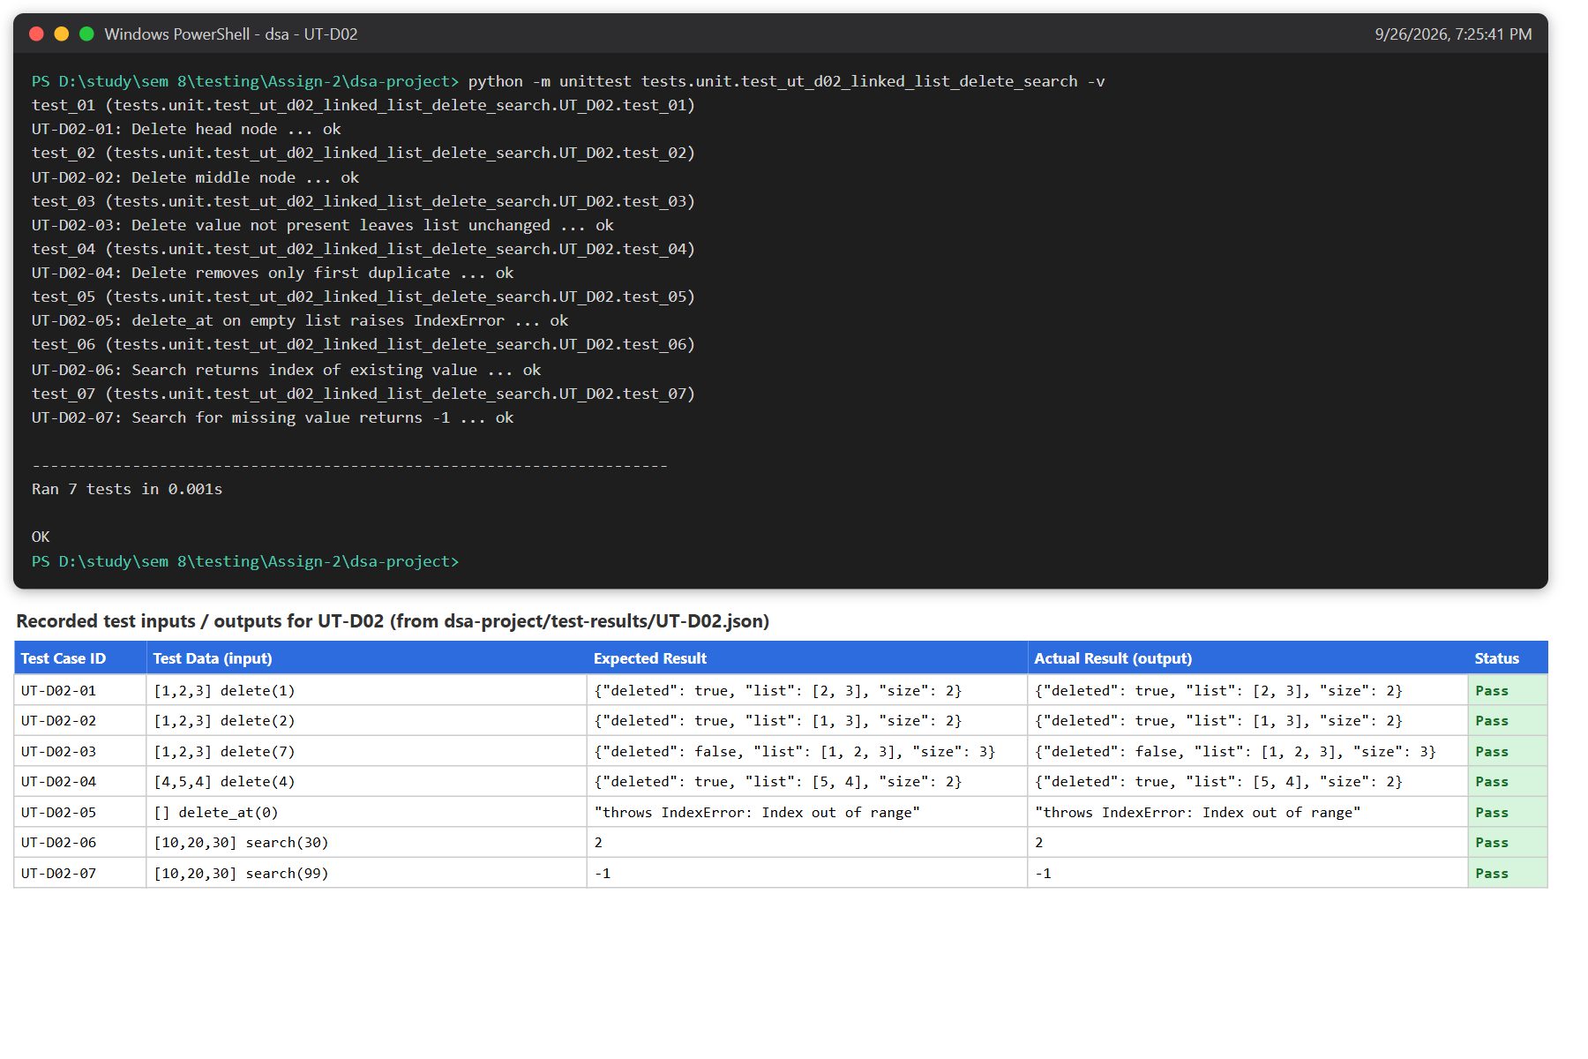
Figure 50: UT-D02 execution - "python -m unittest tests.unit.test_ut_d02_linked_list_delete_search -v" (terminal output) with the recorded inputs/outputs of all 7 test cases (7 passed).

5.2.3 UT-D03 - BST insert / search / delete functions
Result: 7 test cases executed, 7 passed, 0 failed.
Test Case ID | Related Use Case ID | Test Case Title | Test Objective | Preconditions | Test Steps | Test Data | Expected Result | Actual Result | Status (Pass/​Fail) | Priority | Tested By | Test Date
UT-D03-01 | UC-D02 Tree Operations | Insert keeps inorder traversal sorted | Verify BST insertion ordering, search, and all three delete cases | bst.py imported; tree built from test data | 1. Build BST 2. Call insert/​search/​delete 3. Compare result / inorder traversal | insert 50,​30,​70,​20,​40 | [20, 30, 40, 50, 70] | [20, 30, 40, 50, 70] | Pass | High | [Your Name] | 2026-09-26
UT-D03-02 | UC-D02 Tree Operations | Duplicate insert is ignored | Verify BST insertion ordering, search, and all three delete cases | bst.py imported; tree built from test data | 1. Build BST 2. Call insert/​search/​delete 3. Compare result / inorder traversal | insert 50,​30 then insert(30) | {"inserted": false, "size": 2} | {"inserted": false, "size": 2} | Pass | Medium | [Your Name] | 2026-09-26
UT-D03-03 | UC-D02 Tree Operations | Search finds existing and rejects missing key | Verify BST insertion ordering, search, and all three delete cases | bst.py imported; tree built from test data | 1. Build BST 2. Call insert/​search/​delete 3. Compare result / inorder traversal | tree 50,​30,​70; search(70), search(65) | [true, false] | [true, false] | Pass | High | [Your Name] | 2026-09-26
UT-D03-04 | UC-D02 Tree Operations | Delete leaf node | Verify BST insertion ordering, search, and all three delete cases | bst.py imported; tree built from test data | 1. Build BST 2. Call insert/​search/​delete 3. Compare result / inorder traversal | tree 50,​30,​70,​20; delete(20) | {"deleted": true, "inorder": [30, 50, 70], "root": 50} | {"deleted": true, "inorder": [30, 50, 70], "root": 50} | Pass | Medium | [Your Name] | 2026-09-26
UT-D03-05 | UC-D02 Tree Operations | Delete node with one child | Verify BST insertion ordering, search, and all three delete cases | bst.py imported; tree built from test data | 1. Build BST 2. Call insert/​search/​delete 3. Compare result / inorder traversal | tree 50,​30,​20; delete(30) | {"deleted": true, "inorder": [20, 50], "root": 50} | {"deleted": true, "inorder": [20, 50], "root": 50} | Pass | Medium | [Your Name] | 2026-09-26
UT-D03-06 | UC-D02 Tree Operations | Delete root with two children uses inorder successor | Verify BST insertion ordering, search, and all three delete cases | bst.py imported; tree built from test data | 1. Build BST 2. Call insert/​search/​delete 3. Compare result / inorder traversal | tree 50,​30,​70,​60,​80; delete(50) | {"deleted": true, "inorder": [30, 60, 70, 80], "root": 60} | {"deleted": true, "inorder": [30, 60, 70, 80], "root": 60} | Pass | High | [Your Name] | 2026-09-26
UT-D03-07 | UC-D02 Tree Operations | Delete missing key returns False | Verify BST insertion ordering, search, and all three delete cases | bst.py imported; tree built from test data | 1. Build BST 2. Call insert/​search/​delete 3. Compare result / inorder traversal | tree 50,​30; delete(99) | {"deleted": false, "inorder": [30, 50], "root": 50} | {"deleted": false, "inorder": [30, 50], "root": 50} | Pass | Medium | [Your Name] | 2026-09-26
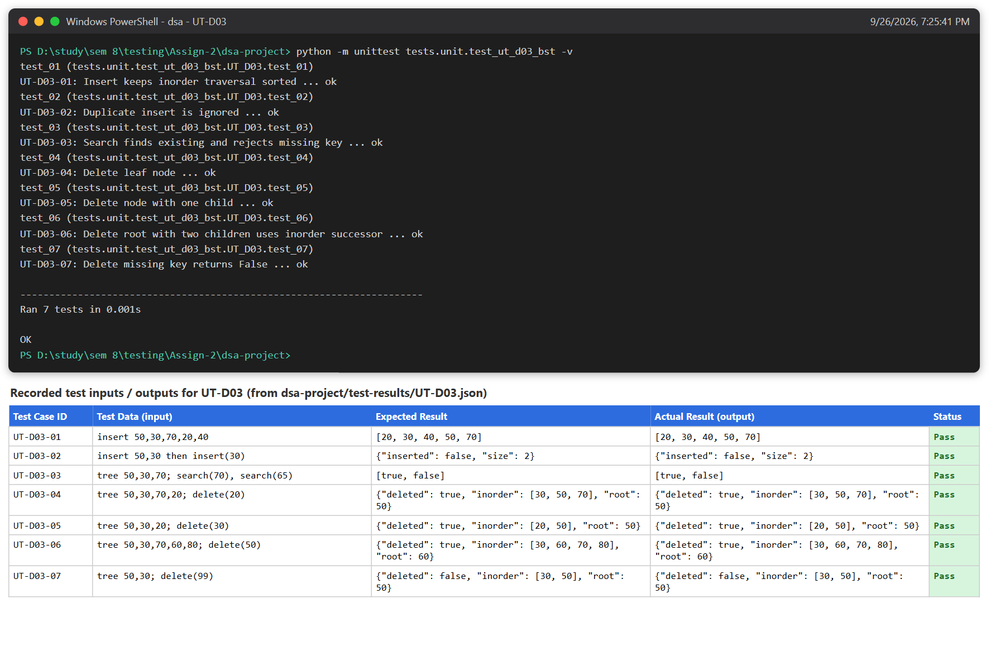
Figure 51: UT-D03 execution - "python -m unittest tests.unit.test_ut_d03_bst -v" (terminal output) with the recorded inputs/outputs of all 7 test cases (7 passed).

5.2.4 UT-D04 - Sorting functions (bubble / insertion / merge / quick)
Result: 7 test cases executed, 7 passed, 0 failed.
Test Case ID | Related Use Case ID | Test Case Title | Test Objective | Preconditions | Test Steps | Test Data | Expected Result | Actual Result | Status (Pass/​Fail) | Priority | Tested By | Test Date
UT-D04-01 | UC-D04 Sort & Search | Merge sort on random list | Verify each sorting algorithm returns a correctly ordered new list | sorting.py imported | 1. Call sort function with input list 2. Compare returned list with expected | [38, 27, 43, 3, 9, 82, 10] | [3, 9, 10, 27, 38, 43, 82] | [3, 9, 10, 27, 38, 43, 82] | Pass | High | [Your Name] | 2026-09-26
UT-D04-02 | UC-D04 Sort & Search | Quick sort handles duplicates | Verify each sorting algorithm returns a correctly ordered new list | sorting.py imported | 1. Call sort function with input list 2. Compare returned list with expected | [5,​1,​5,​3,​1] | [1, 1, 3, 5, 5] | [1, 1, 3, 5, 5] | Pass | High | [Your Name] | 2026-09-26
UT-D04-03 | UC-D04 Sort & Search | Bubble sort on already sorted list | Verify each sorting algorithm returns a correctly ordered new list | sorting.py imported | 1. Call sort function with input list 2. Compare returned list with expected | [1,​2,​3,​4] | [1, 2, 3, 4] | [1, 2, 3, 4] | Pass | Medium | [Your Name] | 2026-09-26
UT-D04-04 | UC-D04 Sort & Search | Insertion sort on reverse-sorted list | Verify each sorting algorithm returns a correctly ordered new list | sorting.py imported | 1. Call sort function with input list 2. Compare returned list with expected | [5,​4,​3,​2,​1] | [1, 2, 3, 4, 5] | [1, 2, 3, 4, 5] | Pass | Medium | [Your Name] | 2026-09-26
UT-D04-05 | UC-D04 Sort & Search | Empty and single-element lists | Verify each sorting algorithm returns a correctly ordered new list | sorting.py imported | 1. Call sort function with input list 2. Compare returned list with expected | [], [7] (all 4 algorithms) | [[], [7]] | [[], [7]] | Pass | Low | [Your Name] | 2026-09-26
UT-D04-06 | UC-D04 Sort & Search | Negative numbers and floats | Verify each sorting algorithm returns a correctly ordered new list | sorting.py imported | 1. Call sort function with input list 2. Compare returned list with expected | [2.5,​-1,​0,​-3.5,​2] | [-3.5, -1, 0, 2, 2.5] | [-3.5, -1, 0, 2, 2.5] | Pass | Medium | [Your Name] | 2026-09-26
UT-D04-07 | UC-D04 Sort & Search | Input list is not modified | Verify each sorting algorithm returns a correctly ordered new list | sorting.py imported | 1. Call sort function with input list 2. Compare returned list with expected | original=​[3,​1,​2] passed to all sorts | [3, 1, 2] | [3, 1, 2] | Pass | High | [Your Name] | 2026-09-26
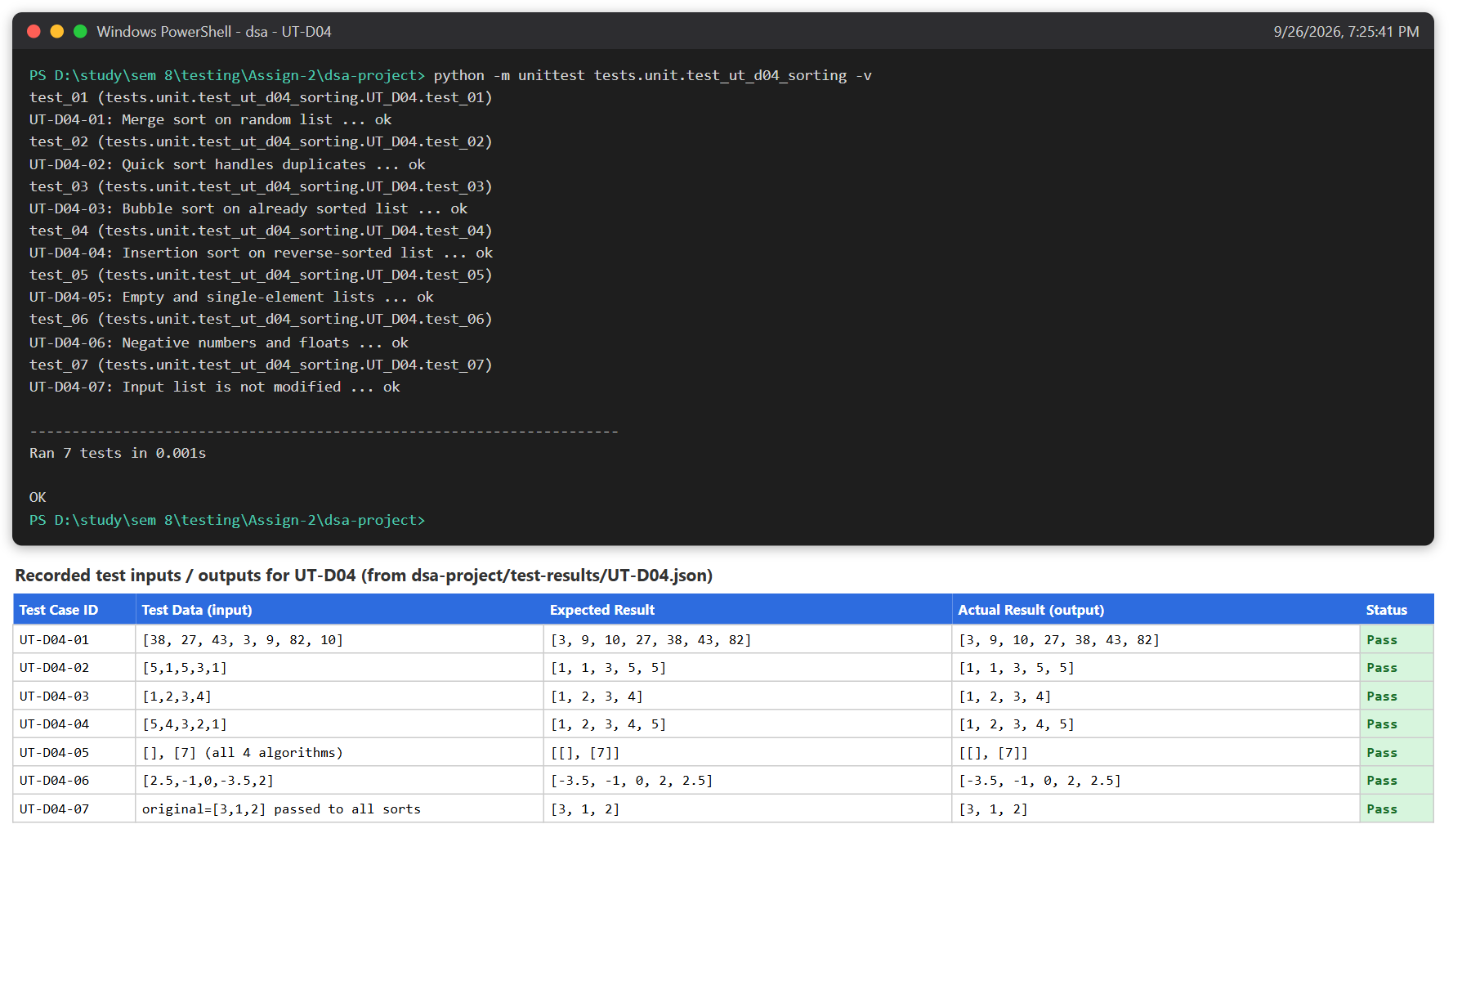
Figure 52: UT-D04 execution - "python -m unittest tests.unit.test_ut_d04_sorting -v" (terminal output) with the recorded inputs/outputs of all 7 test cases (7 passed).

5.2.5 UT-D05 - Search functions (binary_search / linear_search)
Result: 6 test cases executed, 6 passed, 0 failed.
Test Case ID | Related Use Case ID | Test Case Title | Test Objective | Preconditions | Test Steps | Test Data | Expected Result | Actual Result | Status (Pass/​Fail) | Priority | Tested By | Test Date
UT-D05-01 | UC-D04 Sort & Search | Binary search finds middle element | Verify search returns the correct index or -1 | sorting.py imported; sorted array [2, 5, 8, 12, 16, 23, 38, 56, 72, 91] | 1. Call search(arr, target) 2. Compare index with expected | target=​23 | 5 | 5 | Pass | High | [Your Name] | 2026-09-26
UT-D05-02 | UC-D04 Sort & Search | Binary search finds first and last elements | Verify search returns the correct index or -1 | sorting.py imported; sorted array [2, 5, 8, 12, 16, 23, 38, 56, 72, 91] | 1. Call search(arr, target) 2. Compare index with expected | target=​2, target=​91 | [0, 9] | [0, 9] | Pass | High | [Your Name] | 2026-09-26
UT-D05-03 | UC-D04 Sort & Search | Binary search returns -1 for missing value | Verify search returns the correct index or -1 | sorting.py imported; sorted array [2, 5, 8, 12, 16, 23, 38, 56, 72, 91] | 1. Call search(arr, target) 2. Compare index with expected | target=​50 | -1 | -1 | Pass | Medium | [Your Name] | 2026-09-26
UT-D05-04 | UC-D04 Sort & Search | Binary search on empty list returns -1 | Verify search returns the correct index or -1 | sorting.py imported; sorted array [2, 5, 8, 12, 16, 23, 38, 56, 72, 91] | 1. Call search(arr, target) 2. Compare index with expected | arr=​[], target=​1 | -1 | -1 | Pass | Medium | [Your Name] | 2026-09-26
UT-D05-05 | UC-D04 Sort & Search | Linear search returns first occurrence | Verify search returns the correct index or -1 | sorting.py imported; sorted array [2, 5, 8, 12, 16, 23, 38, 56, 72, 91] | 1. Call search(arr, target) 2. Compare index with expected | arr=​[4,​7,​7,​1], target=​7 | 1 | 1 | Pass | Medium | [Your Name] | 2026-09-26
UT-D05-06 | UC-D04 Sort & Search | Linear search works on unsorted list | Verify search returns the correct index or -1 | sorting.py imported; sorted array [2, 5, 8, 12, 16, 23, 38, 56, 72, 91] | 1. Call search(arr, target) 2. Compare index with expected | arr=​[9,​3,​6], target=​6 / 5 | [2, -1] | [2, -1] | Pass | Low | [Your Name] | 2026-09-26
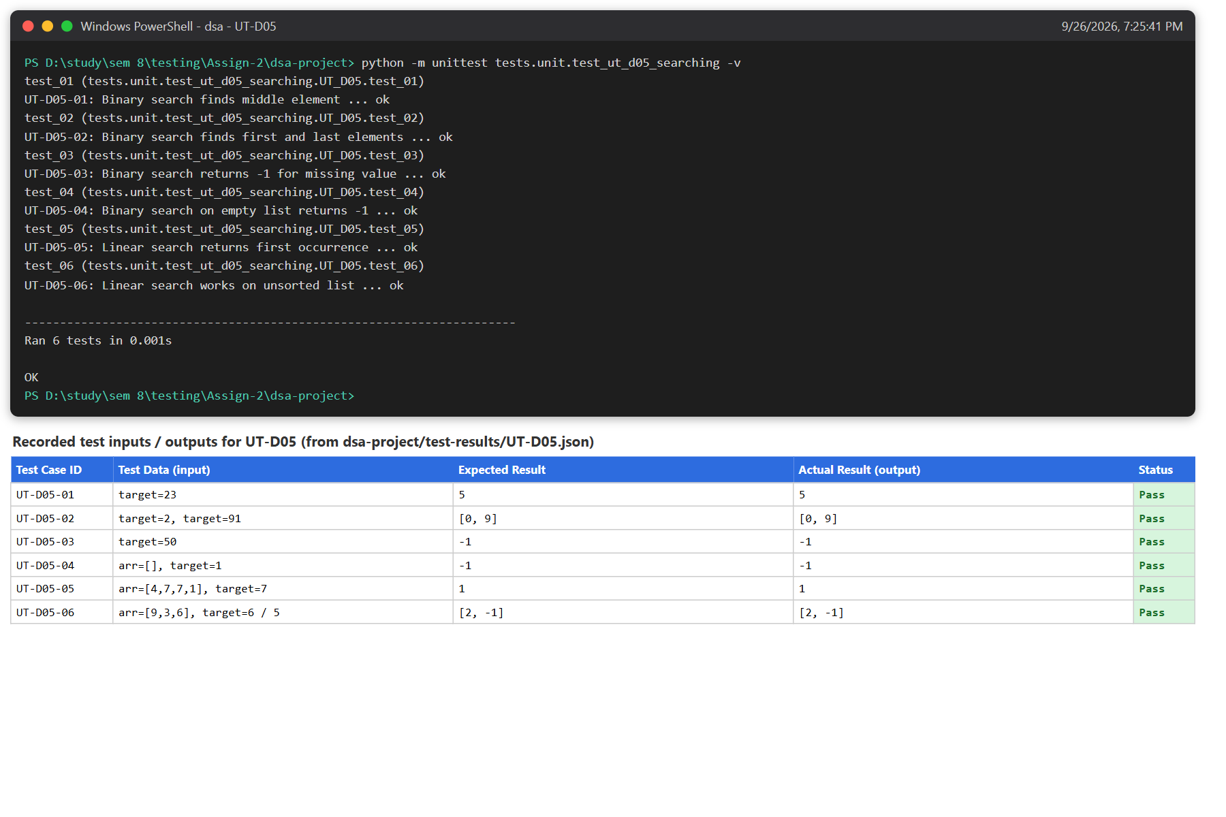
Figure 53: UT-D05 execution - "python -m unittest tests.unit.test_ut_d05_searching -v" (terminal output) with the recorded inputs/outputs of all 6 test cases (6 passed).

5.2.6 UT-D06 - Stack / Queue operations (push, pop, peek, enqueue, dequeue)
Result: 7 test cases executed, 7 passed, 0 failed.
Test Case ID | Related Use Case ID | Test Case Title | Test Objective | Preconditions | Test Steps | Test Data | Expected Result | Actual Result | Status (Pass/​Fail) | Priority | Tested By | Test Date
UT-D06-01 | UC-D03 Stack & Queue | Stack pops in LIFO order | Verify LIFO/​FIFO behaviour, bounds errors and circular queue wrap-around | stack_queue.py imported | 1. Perform operation sequence 2. Compare returned values with expected | push 1,​2,​3; pop; pop; peek; size | [3, 2, 1, 1] | [3, 2, 1, 1] | Pass | High | [Your Name] | 2026-09-26
UT-D06-02 | UC-D03 Stack & Queue | Pop on empty stack raises underflow | Verify LIFO/​FIFO behaviour, bounds errors and circular queue wrap-around | stack_queue.py imported | 1. Perform operation sequence 2. Compare returned values with expected | Stack(); pop() | "throws IndexError: Stack underflow" | "throws IndexError: Stack underflow" | Pass | High | [Your Name] | 2026-09-26
UT-D06-03 | UC-D03 Stack & Queue | Push beyond capacity raises overflow | Verify LIFO/​FIFO behaviour, bounds errors and circular queue wrap-around | stack_queue.py imported | 1. Perform operation sequence 2. Compare returned values with expected | Stack(capacity=​2); push 1,​2,​3 | "throws OverflowError: Stack overflow" | "throws OverflowError: Stack overflow" | Pass | Medium | [Your Name] | 2026-09-26
UT-D06-04 | UC-D03 Stack & Queue | Queue dequeues in FIFO order | Verify LIFO/​FIFO behaviour, bounds errors and circular queue wrap-around | stack_queue.py imported | 1. Perform operation sequence 2. Compare returned values with expected | enqueue A,​B,​C; dequeue; front; size | ["A", "B", 2] | ["A", "B", 2] | Pass | High | [Your Name] | 2026-09-26
UT-D06-05 | UC-D03 Stack & Queue | Circular queue wraps around correctly | Verify LIFO/​FIFO behaviour, bounds errors and circular queue wrap-around | stack_queue.py imported | 1. Perform operation sequence 2. Compare returned values with expected | Queue(3): enqueue 1,​2,​3; dequeue; enqueue 4 | [2, 3, 4] | [2, 3, 4] | Pass | Medium | [Your Name] | 2026-09-26
UT-D06-06 | UC-D03 Stack & Queue | Dequeue on empty queue raises error | Verify LIFO/​FIFO behaviour, bounds errors and circular queue wrap-around | stack_queue.py imported | 1. Perform operation sequence 2. Compare returned values with expected | Queue(3); dequeue() | "throws IndexError: Queue is empty" | "throws IndexError: Queue is empty" | Pass | Medium | [Your Name] | 2026-09-26
UT-D06-07 | UC-D03 Stack & Queue | Stack application: balanced brackets | Verify LIFO/​FIFO behaviour, bounds errors and circular queue wrap-around | stack_queue.py imported | 1. Perform operation sequence 2. Compare returned values with expected | '{[()]}', '(]', '((' | [true, false, false] | [true, false, false] | Pass | Low | [Your Name] | 2026-09-26
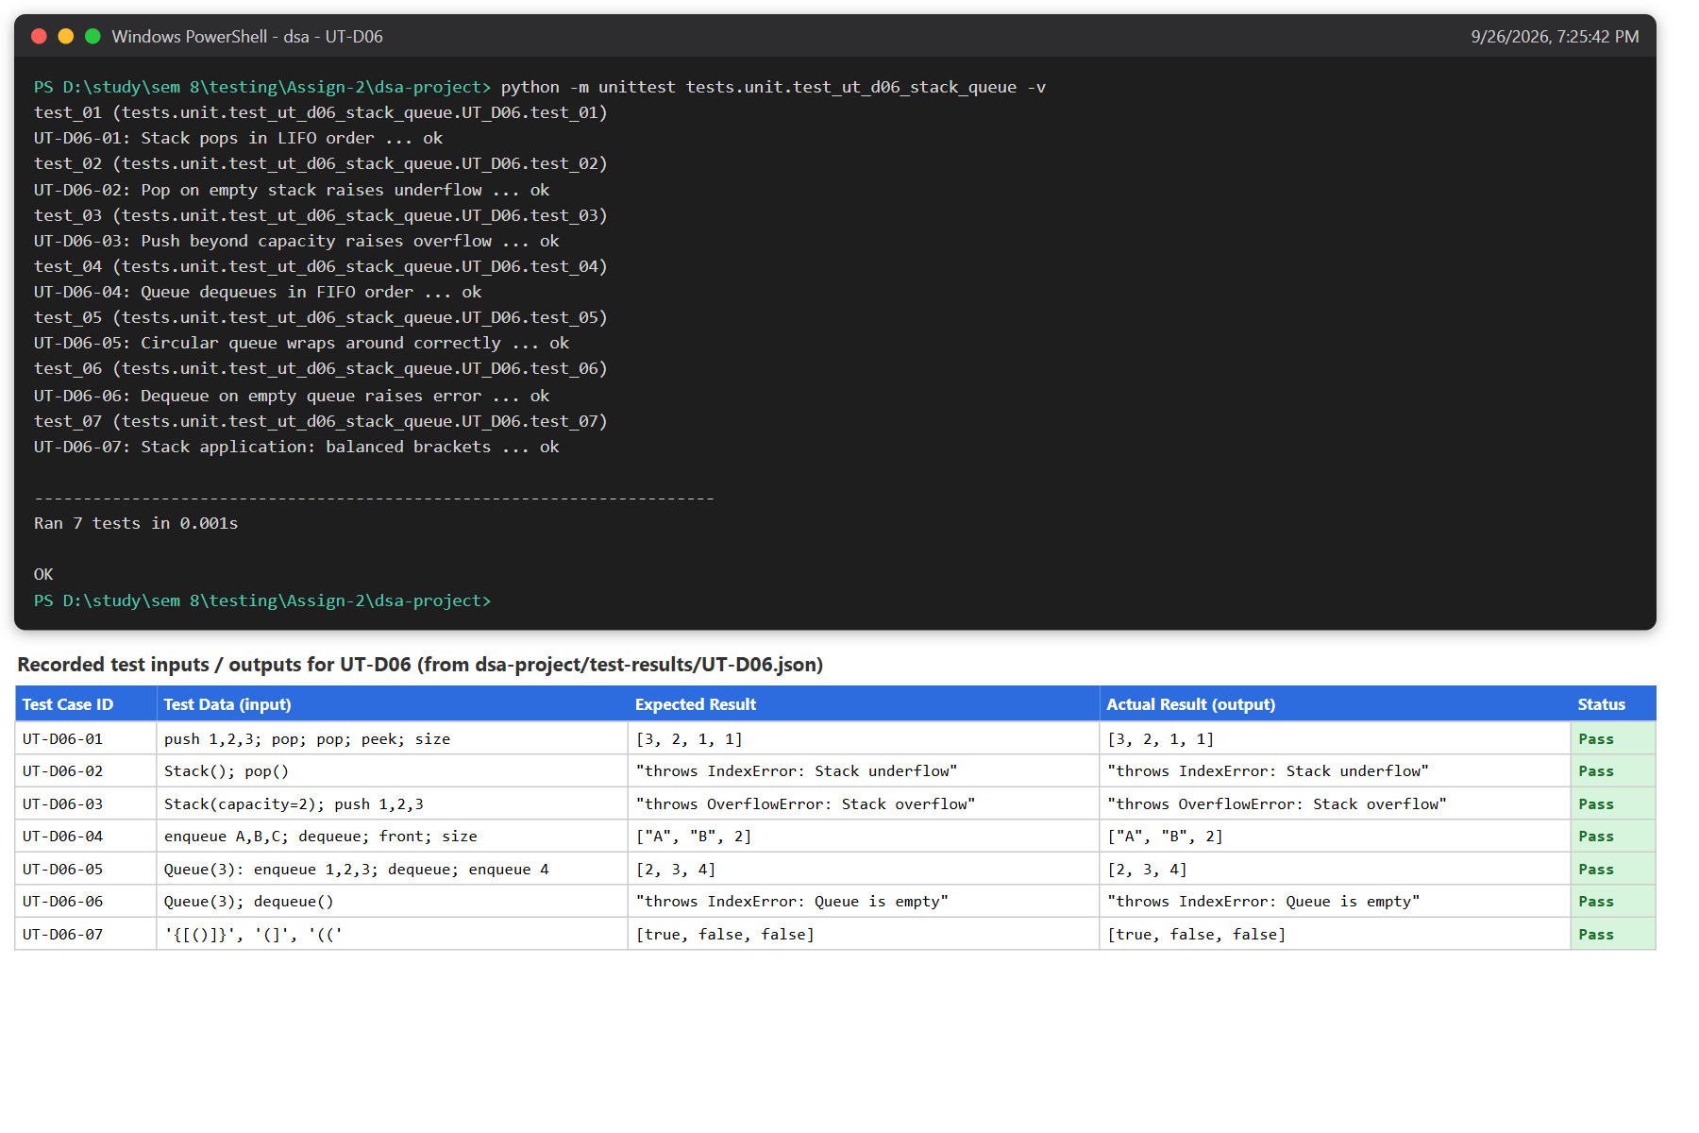
Figure 54: UT-D06 execution - "python -m unittest tests.unit.test_ut_d06_stack_queue -v" (terminal output) with the recorded inputs/outputs of all 7 test cases (7 passed).

5.3 Component Testing
Related units were grouped into components (modules) and tested together through the module's public functions or rendered screens.

5.3.1 CT-D01 - Complete Linked List Module
Deliverable | Details
Component Name | Linked List Module (dsa/​linked_list.py)
Included Units | Node, insert_at_head(), insert_at_tail(), insert_at(), delete(), delete_at(), search(), reverse(), to_list(), __len__()
Test Scenarios | CT-D01-01: Mixed insert/​delete/​search sequence  CT-D01-02: Reverse then search uses new positions  CT-D01-03: Reverse on empty and single-node lists  CT-D01-04: Bulk 1000 inserts + 500 deletes keeps size consistent  CT-D01-05: List can be emptied and reused
Observed Behavior | 5 of 5 scenarios passed. All linked-list operations kept the head pointer and size consistent, including 1000 inserts + 500 deletes, reversing empty/​single-node lists and re-using a list after emptying it.
Bugs Found | None - all scenarios passed.

Test scenarios (executed):
Test Case ID | Related Use Case ID | Test Case Title | Test Objective | Preconditions | Test Steps | Test Data | Expected Result | Actual Result | Status (Pass/​Fail) | Priority | Tested By | Test Date
CT-D01-01 | UC-D01 Manage Linked List | Mixed insert/​delete/​search sequence | Verify all linked-list operations work together and keep size/​links consistent | linked_list.py imported | Execute the operation sequence given in Test Data | tail 10,​20,​30; head 5; insert_at(2,​15); delete(20); search(30) | {"list": [5, 10, 15, 30], "size": 4, "index_of_30": 3} | {"list": [5, 10, 15, 30], "size": 4, "index_of_30": 3} | Pass | High | [Your Name] | 2026-09-26
CT-D01-02 | UC-D01 Manage Linked List | Reverse then search uses new positions | Verify all linked-list operations work together and keep size/​links consistent | linked_list.py imported | Execute the operation sequence given in Test Data | [1,​2,​3,​4] reverse(); search(1) | {"list": [4, 3, 2, 1], "index_of_1": 3} | {"list": [4, 3, 2, 1], "index_of_1": 3} | Pass | Medium | [Your Name] | 2026-09-26
CT-D01-03 | UC-D01 Manage Linked List | Reverse on empty and single-node lists | Verify all linked-list operations work together and keep size/​links consistent | linked_list.py imported | Execute the operation sequence given in Test Data | [] reverse, [7] reverse | [[], [7]] | [[], [7]] | Pass | Medium | [Your Name] | 2026-09-26
CT-D01-04 | UC-D01 Manage Linked List | Bulk 1000 inserts + 500 deletes keeps size consistent | Verify all linked-list operations work together and keep size/​links consistent | linked_list.py imported | Execute the operation sequence given in Test Data | insert 0..999, delete even numbers | {"size": 500, "to_list_len": 500, "first": 1, "last": 999} | {"size": 500, "to_list_len": 500, "first": 1, "last": 999} | Pass | High | [Your Name] | 2026-09-26
CT-D01-05 | UC-D01 Manage Linked List | List can be emptied and reused | Verify all linked-list operations work together and keep size/​links consistent | linked_list.py imported | Execute the operation sequence given in Test Data | [1,​2,​3] delete all, then insert 9 | [[], true, [9]] | [[], true, [9]] | Pass | Medium | [Your Name] | 2026-09-26
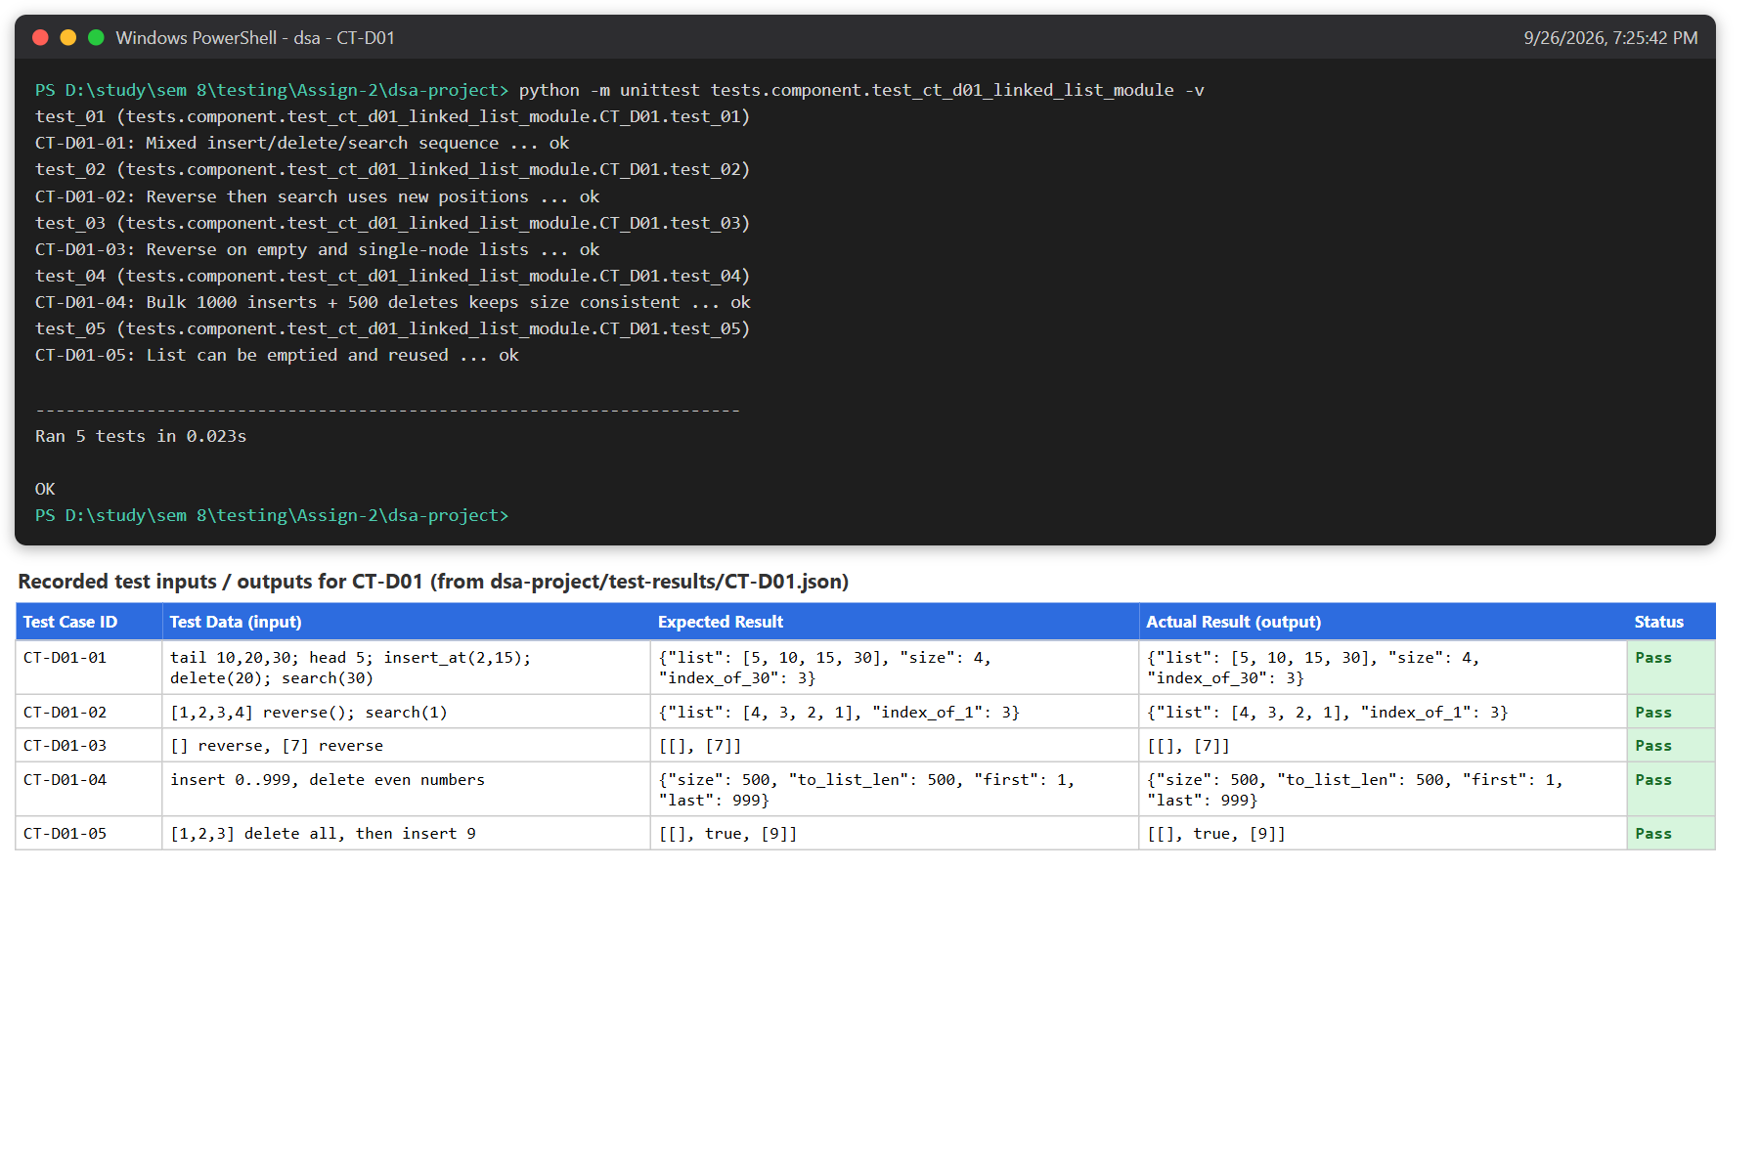
Figure 55: CT-D01 execution - "python -m unittest tests.component.test_ct_d01_linked_list_module -v" (terminal output) with the recorded inputs/outputs of all 5 test cases (5 passed).

5.3.2 CT-D02 - Tree Operations Module
Deliverable | Details
Component Name | Tree Operations Module (dsa/​bst.py)
Included Units | TreeNode, insert(), search(), delete()/​_delete(), inorder(), preorder(), postorder(), height(), min(), max()
Test Scenarios | CT-D02-01: All three traversals of a balanced tree  CT-D02-02: Height, min, max and size  CT-D02-03: Random deletes keep BST property  CT-D02-04: Empty tree edge cases  CT-D02-05: Height of degenerate tree built from sorted input
Observed Behavior | 4 of 5 scenarios passed. Traversals, height/​min/​max, random deletes and empty-tree cases were correct. With 1500 keys inserted in sorted order the tree degenerates into a chain and the recursive height() raised RecursionError.
Bugs Found | BUG-D01 (CT-D02-05): BST height() fails with RecursionError on degenerate trees

Test scenarios (executed):
Test Case ID | Related Use Case ID | Test Case Title | Test Objective | Preconditions | Test Steps | Test Data | Expected Result | Actual Result | Status (Pass/​Fail) | Priority | Tested By | Test Date
CT-D02-01 | UC-D02 Tree Operations | All three traversals of a balanced tree | Verify BST operations work together (build, traverse, measure, delete) for normal and edge inputs | bst.py imported | Build tree from Test Data and run the listed operations | [50, 30, 70, 20, 40, 60, 80] | {"inorder": [20, 30, 40, 50, 60, 70, 80], "preorder": [50, 30, 20, 40, 70, 60, 80], "postorder": [20, 40, 30, 60, 80, 70, 50]} | {"inorder": [20, 30, 40, 50, 60, 70, 80], "preorder": [50, 30, 20, 40, 70, 60, 80], "postorder": [20, 40, 30, 60, 80, 70, 50]} | Pass | High | [Your Name] | 2026-09-26
CT-D02-02 | UC-D02 Tree Operations | Height, min, max and size | Verify BST operations work together (build, traverse, measure, delete) for normal and edge inputs | bst.py imported | Build tree from Test Data and run the listed operations | [50, 30, 70, 20, 40, 60, 80] | {"height": 2, "min": 20, "max": 80, "size": 7} | {"height": 2, "min": 20, "max": 80, "size": 7} | Pass | Medium | [Your Name] | 2026-09-26
CT-D02-03 | UC-D02 Tree Operations | Random deletes keep BST property | Verify BST operations work together (build, traverse, measure, delete) for normal and edge inputs | bst.py imported | Build tree from Test Data and run the listed operations | 60 random keys (seed 1), delete every 3rd | {"sorted": true, "size": 40, "expected_size": 40} | {"sorted": true, "size": 40, "expected_size": 40} | Pass | High | [Your Name] | 2026-09-26
CT-D02-04 | UC-D02 Tree Operations | Empty tree edge cases | Verify BST operations work together (build, traverse, measure, delete) for normal and edge inputs | bst.py imported | Build tree from Test Data and run the listed operations | BST() -> height, inorder, min | [-1, [], "throws ValueError: Tree is empty"] | [-1, [], "throws ValueError: Tree is empty"] | Pass | Medium | [Your Name] | 2026-09-26
CT-D02-05 | UC-D02 Tree Operations | Height of degenerate tree built from sorted input | Verify BST operations work together (build, traverse, measure, delete) for normal and edge inputs | bst.py imported | Build tree from Test Data and run the listed operations | insert 1..1500 in ascending order, call height() | 1499 | Threw error: RecursionError: maximum recursion depth exceeded | Fail | High | [Your Name] | 2026-09-26
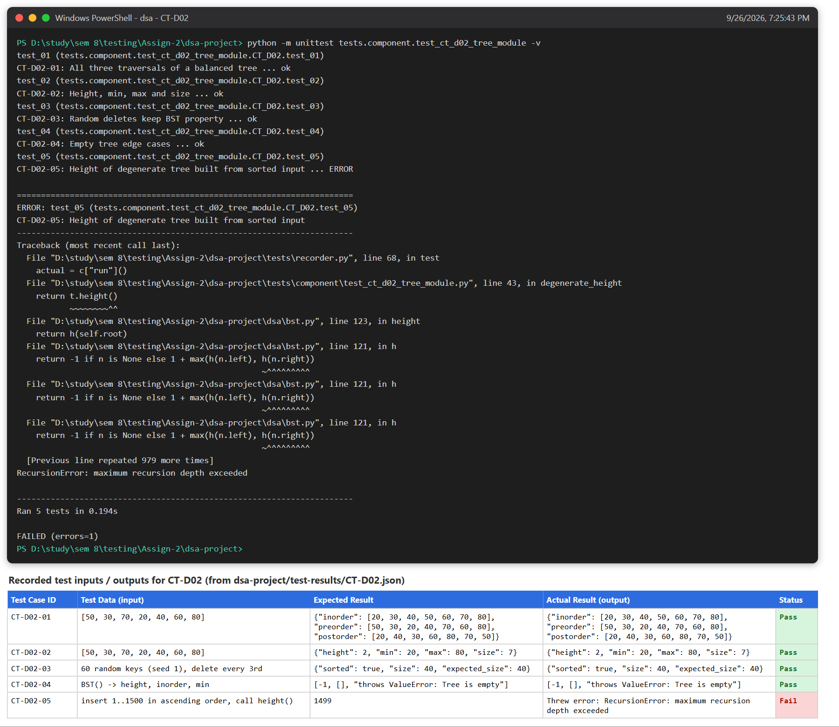
Figure 56: CT-D02 execution - "python -m unittest tests.component.test_ct_d02_tree_module -v" (terminal output) with the recorded inputs/outputs of all 5 test cases (4 passed).

5.3.3 CT-D03 - Graph Processing Module
Deliverable | Details
Component Name | Graph Processing Module (dsa/​graph.py)
Included Units | add_vertex(), add_edge(), remove_edge(), neighbors(), bfs(), dfs(), has_path(), dijkstra()
Test Scenarios | CT-D03-01: BFS visits level by level  CT-D03-02: DFS goes deep first  CT-D03-03: Dijkstra finds shortest weighted path  CT-D03-04: Unreachable vertex returns inf and empty path  CT-D03-05: Removing an edge changes the shortest path  CT-D03-06: Negative weight is rejected  CT-D03-07: DFS on a long path graph (1501 vertices)
Observed Behavior | 6 of 7 scenarios passed. BFS/​DFS orders, Dijkstra (A->C->B->D = 8), unreachable vertices, edge removal and negative-weight rejection were correct. The recursive dfs() raised RecursionError on a 1501-vertex path graph.
Bugs Found | BUG-D02 (CT-D03-07): Graph dfs() fails with RecursionError on long paths

Test scenarios (executed):
Test Case ID | Related Use Case ID | Test Case Title | Test Objective | Preconditions | Test Steps | Test Data | Expected Result | Actual Result | Status (Pass/​Fail) | Priority | Tested By | Test Date
CT-D03-01 | UC-D05 Graph Processing | BFS visits level by level | Verify graph building, traversals and shortest path work together | graph.py imported; sample graph A-B:​4, A-C:​1, C-B:​2, B-D:​5, C-E:​8, D-E:​3 | Build graph, run the listed algorithm | bfs('A') | ["A", "B", "C", "D", "E"] | ["A", "B", "C", "D", "E"] | Pass | High | [Your Name] | 2026-09-26
CT-D03-02 | UC-D05 Graph Processing | DFS goes deep first | Verify graph building, traversals and shortest path work together | graph.py imported; sample graph A-B:​4, A-C:​1, C-B:​2, B-D:​5, C-E:​8, D-E:​3 | Build graph, run the listed algorithm | dfs('A') | ["A", "B", "C", "E", "D"] | ["A", "B", "C", "E", "D"] | Pass | Medium | [Your Name] | 2026-09-26
CT-D03-03 | UC-D05 Graph Processing | Dijkstra finds shortest weighted path | Verify graph building, traversals and shortest path work together | graph.py imported; sample graph A-B:​4, A-C:​1, C-B:​2, B-D:​5, C-E:​8, D-E:​3 | Build graph, run the listed algorithm | dijkstra('A',​'D') | [8, ["A", "C", "B", "D"]] | [8, ["A", "C", "B", "D"]] | Pass | High | [Your Name] | 2026-09-26
CT-D03-04 | UC-D05 Graph Processing | Unreachable vertex returns inf and empty path | Verify graph building, traversals and shortest path work together | graph.py imported; sample graph A-B:​4, A-C:​1, C-B:​2, B-D:​5, C-E:​8, D-E:​3 | Build graph, run the listed algorithm | add X-Y; dijkstra('A',​'X'); has_path('A',​'Y') | ["inf", [], false] | ["inf", [], false] | Pass | Medium | [Your Name] | 2026-09-26
CT-D03-05 | UC-D05 Graph Processing | Removing an edge changes the shortest path | Verify graph building, traversals and shortest path work together | graph.py imported; sample graph A-B:​4, A-C:​1, C-B:​2, B-D:​5, C-E:​8, D-E:​3 | Build graph, run the listed algorithm | remove_edge('C',​'B') then dijkstra('A',​'D') | {"before": [8, ["A", "C", "B", "D"]], "after": [9, ["A", "B", "D"]]} | {"before": [8, ["A", "C", "B", "D"]], "after": [9, ["A", "B", "D"]]} | Pass | Medium | [Your Name] | 2026-09-26
CT-D03-06 | UC-D05 Graph Processing | Negative weight is rejected | Verify graph building, traversals and shortest path work together | graph.py imported; sample graph A-B:​4, A-C:​1, C-B:​2, B-D:​5, C-E:​8, D-E:​3 | Build graph, run the listed algorithm | add_edge('A',​'Z',​-2) | "throws ValueError: Negative weights are not supported" | "throws ValueError: Negative weights are not supported" | Pass | Medium | [Your Name] | 2026-09-26
CT-D03-07 | UC-D05 Graph Processing | DFS on a long path graph (1501 vertices) | Verify graph building, traversals and shortest path work together | graph.py imported; sample graph A-B:​4, A-C:​1, C-B:​2, B-D:​5, C-E:​8, D-E:​3 | Build graph, run the listed algorithm | path 0-1-2-...-1500, dfs(0) | 1501 | Threw error: RecursionError: maximum recursion depth exceeded | Fail | High | [Your Name] | 2026-09-26
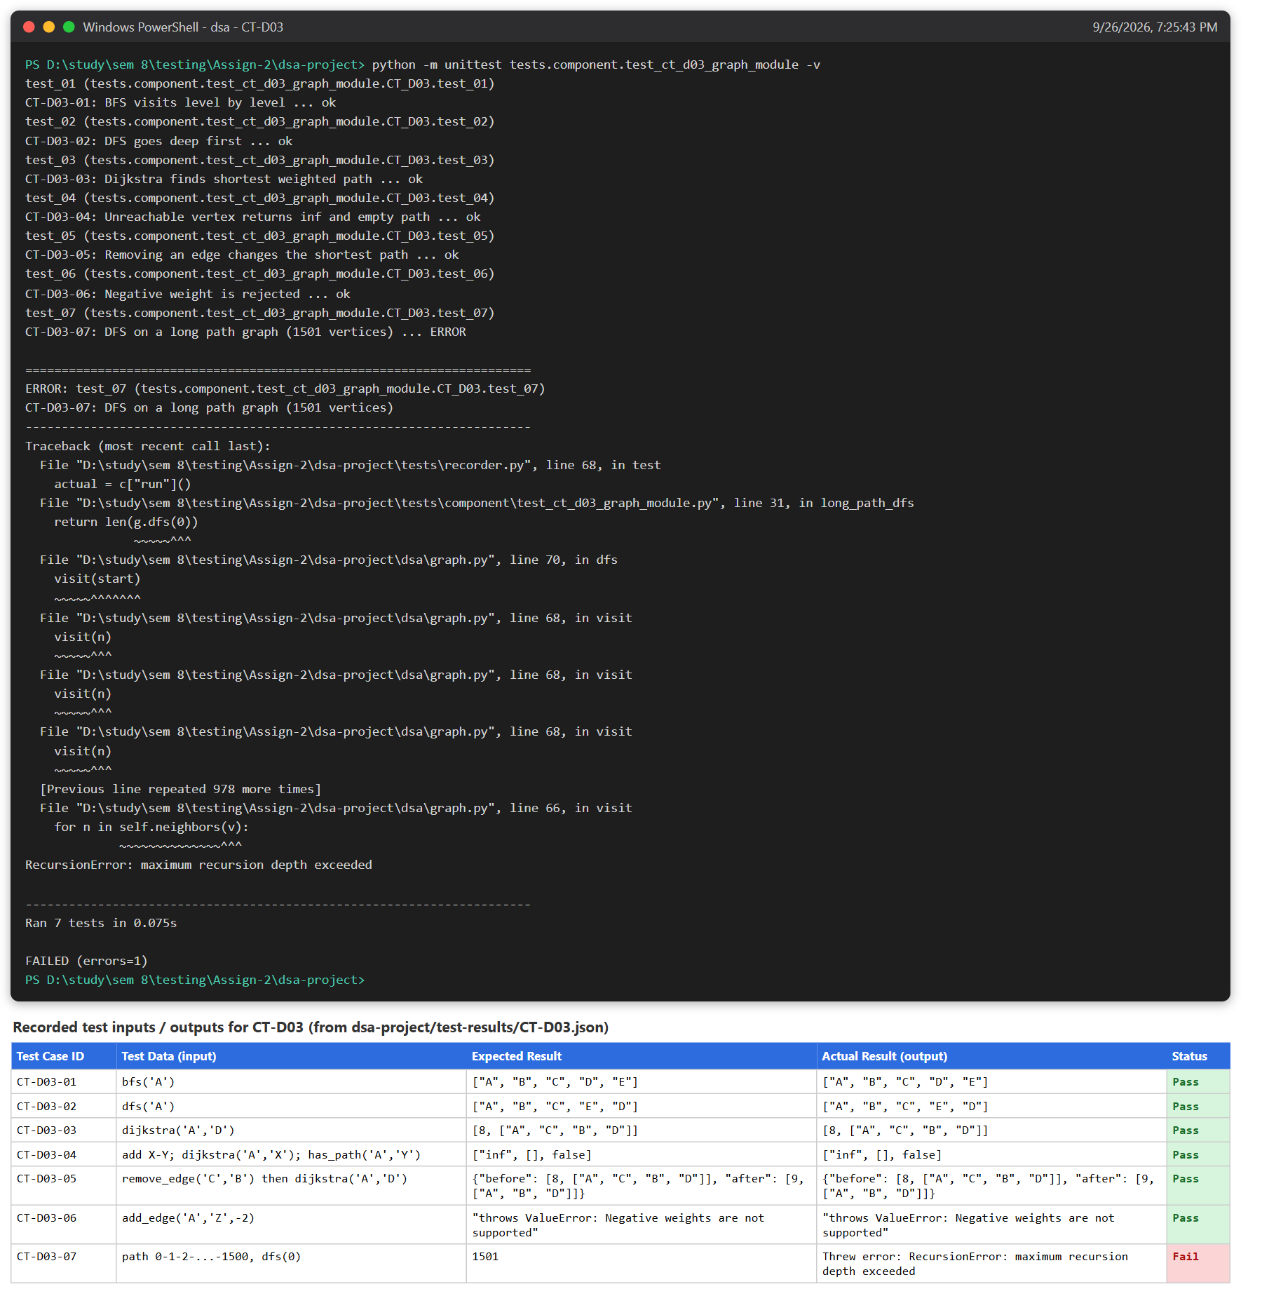
Figure 57: CT-D03 execution - "python -m unittest tests.component.test_ct_d03_graph_module -v" (terminal output) with the recorded inputs/outputs of all 7 test cases (6 passed).

5.4 Integration Testing
Interactions between modules were tested. Strategies used: Bottom-Up Integration, Incremental Integration, Top-Down Integration.

5.4.1 IT-D01 - Data Input Module <-> Processing Module
Deliverable | Details
Modules Integrated | input_module.py (parse_numbers, parse_edges) -> processing.py (build_linked_list, build_bst, build_graph, sort_and_search) -> linked_list / bst / graph / sorting
Integration Strategy Used | Bottom-Up Integration: the data-structure modules (already unit/​component tested) are driven by processing.py, and then by the input parser on top.
Test Cases | IT-D01-01: Comma/​space separated numbers build a BST [Pass]  IT-D01-02: Parsed numbers build a linked list in order [Pass]  IT-D01-03: Invalid token is rejected before processing [Pass]  IT-D01-04: Edge list input builds weighted graph [Pass]  IT-D01-05: Sort + binary search pipeline [Pass]  IT-D01-06: Negative edge weight is stopped by graph module [Pass]  IT-D01-07: Malformed edge with extra vertex is rejected [Fail]
Data Passed Between Modules | Raw string "50, 30, 70" -> list[int] [50,​30,​70] -> BST/​LinkedList; "A-B:​4, ..." -> list[(u, v, w)] -> Graph adjacency dict
Observed Behavior | 6 of 7 test cases passed. Parsed numbers and edge lists were handed correctly to the builders; invalid tokens and negative weights were stopped. A malformed edge "A-B-C:​2" was silently accepted, creating a vertex named "B-C".
Errors / Failures Observed | BUG-D03 (IT-D01-07): Malformed edge "A-B-C" is silently accepted

Integration test cases (executed):
Test Case ID | Related Use Case ID | Test Case Title | Test Objective | Preconditions | Test Steps | Test Data | Expected Result | Actual Result | Status (Pass/​Fail) | Priority | Tested By | Test Date
IT-D01-01 | UC-D01..UC-D05 | Comma/​space separated numbers build a BST | Verify raw text input is parsed and correctly handed to the data-structure builders | input_module.py and processing.py imported | 1. Parse raw text 2. Pass parsed data to processing function 3. Check built structure | "50, 30 70,​20" | [20, 30, 50, 70] | [20, 30, 50, 70] | Pass | High | [Your Name] | 2026-09-26
IT-D01-02 | UC-D01..UC-D05 | Parsed numbers build a linked list in order | Verify raw text input is parsed and correctly handed to the data-structure builders | input_module.py and processing.py imported | 1. Parse raw text 2. Pass parsed data to processing function 3. Check built structure | "3 1 2" | [3, 1, 2] | [3, 1, 2] | Pass | Medium | [Your Name] | 2026-09-26
IT-D01-03 | UC-D01..UC-D05 | Invalid token is rejected before processing | Verify raw text input is parsed and correctly handed to the data-structure builders | input_module.py and processing.py imported | 1. Parse raw text 2. Pass parsed data to processing function 3. Check built structure | "5, x, 3" | "throws ValueError: Invalid number: 'x'" | "throws ValueError: Invalid number: 'x'" | Pass | High | [Your Name] | 2026-09-26
IT-D01-04 | UC-D01..UC-D05 | Edge list input builds weighted graph | Verify raw text input is parsed and correctly handed to the data-structure builders | input_module.py and processing.py imported | 1. Parse raw text 2. Pass parsed data to processing function 3. Check built structure | "A-B:​4, A-C:​1, C-D" | {"vertices": ["A", "B", "C", "D"], "edges": 3, "weight_A_B": 4} | {"vertices": ["A", "B", "C", "D"], "edges": 3, "weight_A_B": 4} | Pass | Medium | [Your Name] | 2026-09-26
IT-D01-05 | UC-D01..UC-D05 | Sort + binary search pipeline | Verify raw text input is parsed and correctly handed to the data-structure builders | input_module.py and processing.py imported | 1. Parse raw text 2. Pass parsed data to processing function 3. Check built structure | "9 3 7 1", target 7, quick sort | [[1, 3, 7, 9], 2] | [[1, 3, 7, 9], 2] | Pass | High | [Your Name] | 2026-09-26
IT-D01-06 | UC-D01..UC-D05 | Negative edge weight is stopped by graph module | Verify raw text input is parsed and correctly handed to the data-structure builders | input_module.py and processing.py imported | 1. Parse raw text 2. Pass parsed data to processing function 3. Check built structure | "A-B:​-3" | "throws ValueError: Negative weights are not supported" | "throws ValueError: Negative weights are not supported" | Pass | Medium | [Your Name] | 2026-09-26
IT-D01-07 | UC-D01..UC-D05 | Malformed edge with extra vertex is rejected | Verify raw text input is parsed and correctly handed to the data-structure builders | input_module.py and processing.py imported | 1. Parse raw text 2. Pass parsed data to processing function 3. Check built structure | "A-B-C:​2" | "throws ValueError: Invalid edge: 'A-B-C'" | {"no_error": true, "value": {"vertices": ["A", "B", "B-C"], "edges": 2, "weight_A_B": 1}} | Fail | Medium | [Your Name] | 2026-09-26
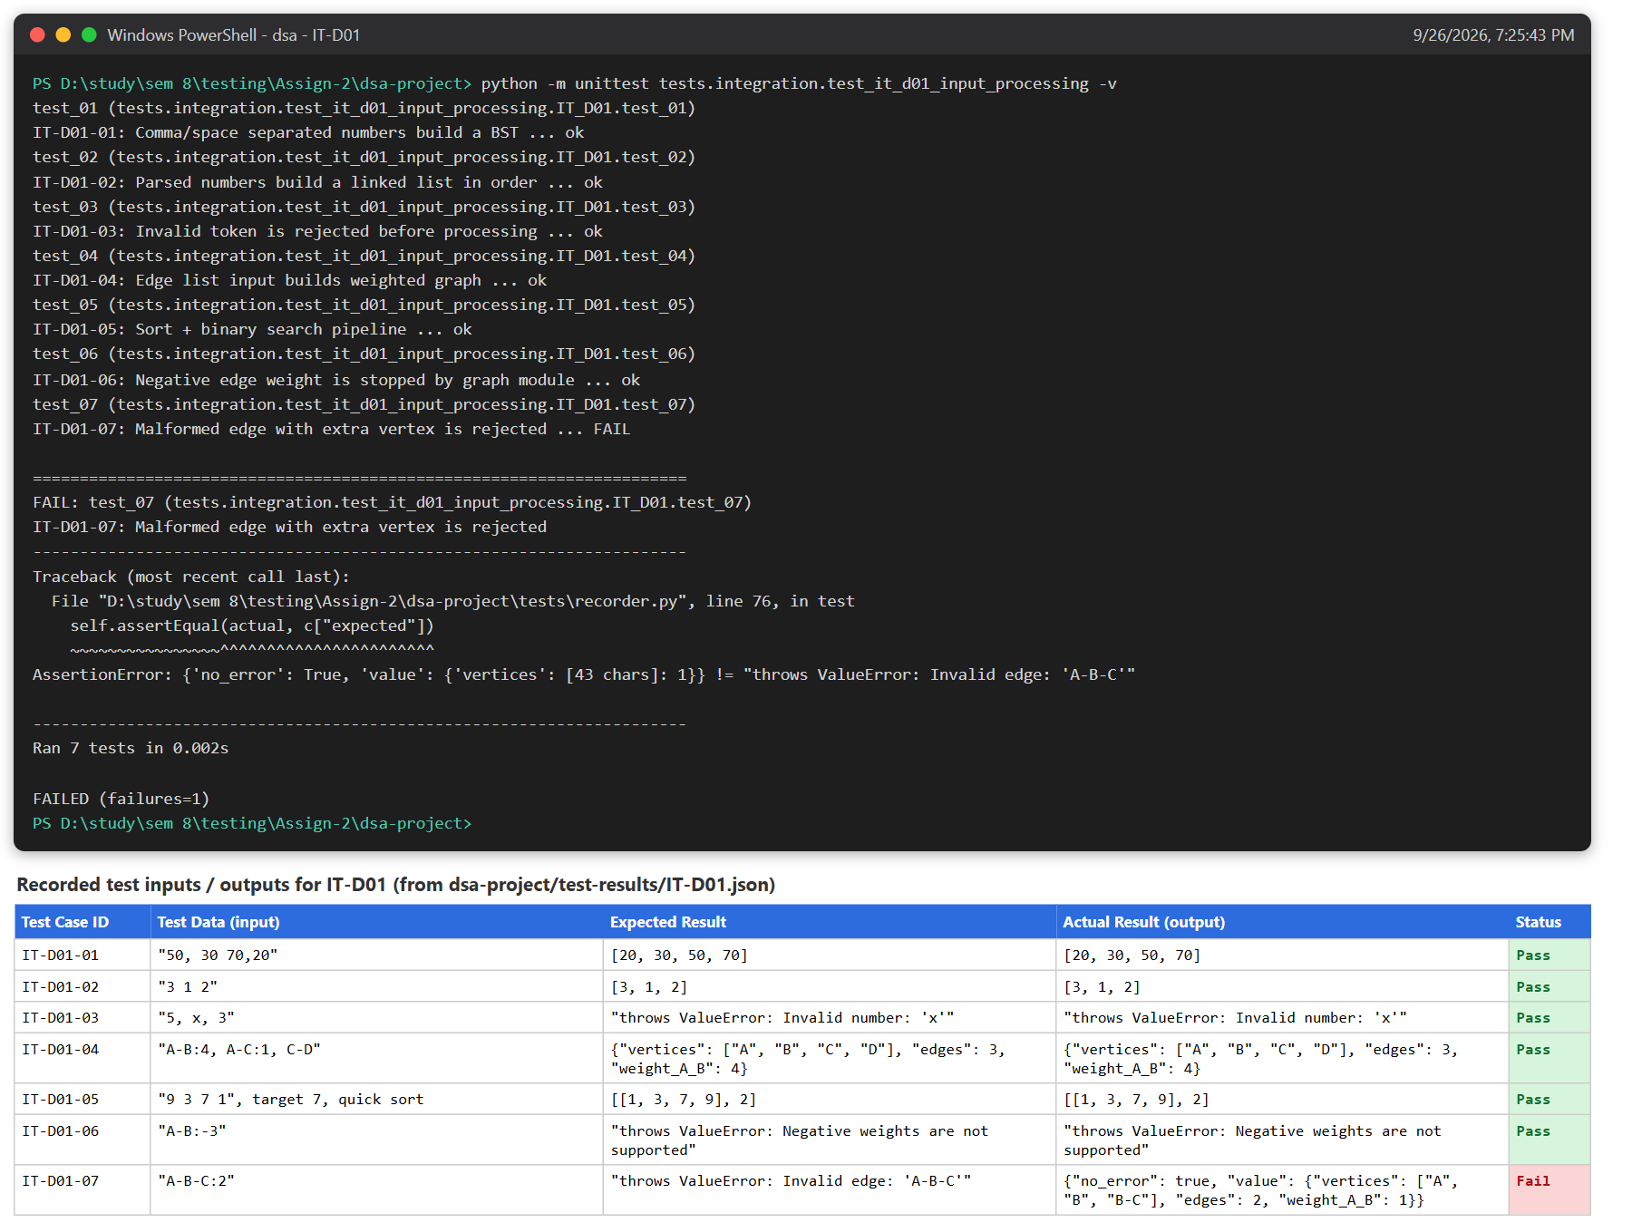
Figure 58: IT-D01 execution - "python -m unittest tests.integration.test_it_d01_input_processing -v" (terminal output) with the recorded inputs/outputs of all 7 test cases (6 passed).

5.4.2 IT-D02 - Algorithm Module <-> Output Visualization
Deliverable | Details
Modules Integrated | linked_list / bst / graph / sorting (via processing.py) -> visualizer.py (render_linked_list, render_tree, render_graph, render_path, render_bars)
Integration Strategy Used | Incremental Integration: each algorithm module was connected to its renderer one at a time (list, tree, graph, path, bars) and re-tested after each addition.
Test Cases | IT-D02-01: Linked list rendered with arrows [Pass]  IT-D02-02: BST rendered sideways [Pass]  IT-D02-03: Graph rendered as adjacency list [Pass]  IT-D02-04: Dijkstra result rendered as path [Pass]  IT-D02-05: Sorted array rendered as bar chart [Pass]  IT-D02-06: Empty structures show placeholder text [Pass]  IT-D02-07: Large values fit the terminal width (<= 80 cols) [Fail]
Data Passed Between Modules | LinkedList / BST / Graph objects, (distance, path) tuples and sorted lists -> multi-line text strings
Observed Behavior | 6 of 7 test cases passed. Every structure was rendered correctly (list arrows, sideways tree, adjacency list, path, bars, empty placeholders). Bars are not scaled: a value of 1000 produced a 1008-character line.
Errors / Failures Observed | BUG-D04 (IT-D02-07): Bar chart is not scaled to terminal width

Integration test cases (executed):
Test Case ID | Related Use Case ID | Test Case Title | Test Objective | Preconditions | Test Steps | Test Data | Expected Result | Actual Result | Status (Pass/​Fail) | Priority | Tested By | Test Date
IT-D02-01 | UC-D01..UC-D05 | Linked list rendered with arrows | Verify algorithm/​data-structur​e outputs are rendered correctly by the visualizer | processing.py and visualizer.py imported | 1. Run algorithm on Test Data 2. Pass result to visualizer 3. Compare rendered text | [1,​2,​3] | "HEAD -> 1 -> 2 -> 3 -> None" | "HEAD -> 1 -> 2 -> 3 -> None" | Pass | High | [Your Name] | 2026-09-26
IT-D02-02 | UC-D01..UC-D05 | BST rendered sideways | Verify algorithm/​data-structur​e outputs are rendered correctly by the visualizer | processing.py and visualizer.py imported | 1. Run algorithm on Test Data 2. Pass result to visualizer 3. Compare rendered text | [50,​30,​70] | " 70\n50\n 30" | " 70\n50\n 30" | Pass | Medium | [Your Name] | 2026-09-26
IT-D02-03 | UC-D01..UC-D05 | Graph rendered as adjacency list | Verify algorithm/​data-structur​e outputs are rendered correctly by the visualizer | processing.py and visualizer.py imported | 1. Run algorithm on Test Data 2. Pass result to visualizer 3. Compare rendered text | A-B:​4, A-C:​1, C-B:​2, B-D:​5 | "A: B(4), C(1)\nB: A(4), C(2), D(5)\nC: A(1), B(2)\nD: B(5)" | "A: B(4), C(1)\nB: A(4), C(2), D(5)\nC: A(1), B(2)\nD: B(5)" | Pass | High | [Your Name] | 2026-09-26
IT-D02-04 | UC-D01..UC-D05 | Dijkstra result rendered as path | Verify algorithm/​data-structur​e outputs are rendered correctly by the visualizer | processing.py and visualizer.py imported | 1. Run algorithm on Test Data 2. Pass result to visualizer 3. Compare rendered text | dijkstra('A',​'D') on graph above | "A -> C -> B -> D (total distance: 8)" | "A -> C -> B -> D (total distance: 8)" | Pass | High | [Your Name] | 2026-09-26
IT-D02-05 | UC-D01..UC-D05 | Sorted array rendered as bar chart | Verify algorithm/​data-structur​e outputs are rendered correctly by the visualizer | processing.py and visualizer.py imported | 1. Run algorithm on Test Data 2. Pass result to visualizer 3. Compare rendered text | merge sort [3,​1,​2] | " 1 | #\n 2 | ##\n 3 | ###" | " 1 | #\n 2 | ##\n 3 | ###" | Pass | Medium | [Your Name] | 2026-09-26
IT-D02-06 | UC-D01..UC-D05 | Empty structures show placeholder text | Verify algorithm/​data-structur​e outputs are rendered correctly by the visualizer | processing.py and visualizer.py imported | 1. Run algorithm on Test Data 2. Pass result to visualizer 3. Compare rendered text | empty list, empty tree, empty graph | ["HEAD -> None", "(empty tree)", "(empty graph)"] | ["HEAD -> None", "(empty tree)", "(empty graph)"] | Pass | Low | [Your Name] | 2026-09-26
IT-D02-07 | UC-D01..UC-D05 | Large values fit the terminal width (<= 80 cols) | Verify algorithm/​data-structur​e outputs are rendered correctly by the visualizer | processing.py and visualizer.py imported | 1. Run algorithm on Test Data 2. Pass result to visualizer 3. Compare rendered text | render_bars([5, 1000]) | every line <= 80 characters (bars scaled) | longest line = 1008 characters | Fail | Medium | [Your Name] | 2026-09-26
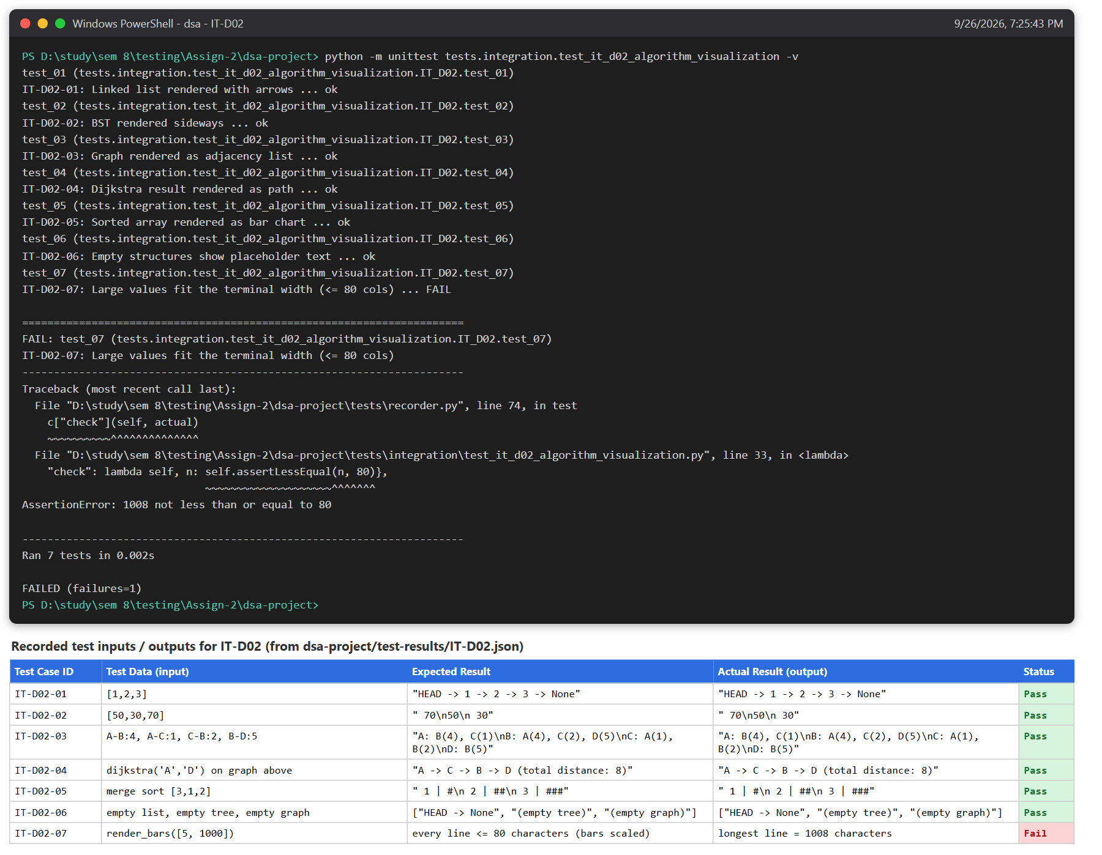
Figure 59: IT-D02 execution - "python -m unittest tests.integration.test_it_d02_algorithm_visualization -v" (terminal output) with the recorded inputs/outputs of all 7 test cases (6 passed).

5.4.3 IT-D03 - CLI Menu (main.py) <-> Input <-> Processing <-> Visualization
Deliverable | Details
Modules Integrated | main.py (menu) -> input_module.py -> processing.py -> linked_list / bst / stack_queue / sorting / graph -> visualizer.py
Integration Strategy Used | Top-Down Integration: the top-level menu (main.py) is tested end-to-end through all lower modules using real keyboard input (stdin).
Test Cases | IT-D03-01: Sorting menu: quick sort + binary search [Pass]  IT-D03-02: Graph menu: BFS, DFS and Dijkstra [Pass]  IT-D03-03: Linked list menu: insert, delete, search [Pass]  IT-D03-04: BST menu: delete node and show traversals [Pass]  IT-D03-05: Invalid numeric input shows error, program keeps running [Pass]  IT-D03-06: Invalid menu choice is handled [Pass]
Data Passed Between Modules | stdin keystrokes -> menu choice + raw text -> parsed values -> data structures/​algorithms -> rendered text on stdout
Observed Behavior | 6 of 6 test cases passed. Keystrokes sent to main.py flowed through menu -> parser -> processing -> visualizer; all end-to-end scenarios printed the expected output and invalid input never crashed the program.
Errors / Failures Observed | None - all scenarios passed.

Integration test cases (executed):
Test Case ID | Related Use Case ID | Test Case Title | Test Objective | Preconditions | Test Steps | Test Data | Expected Result | Actual Result | Status (Pass/​Fail) | Priority | Tested By | Test Date
IT-D03-01 | UC-D01..UC-D05 | Sorting menu: quick sort + binary search | Verify the complete program: user keystrokes flow through every module and the right output is printed | Python 3 installed; run from project root | 1. Start `python main.py` 2. Send keystrokes from Test Data 3. Check printed output | 4 / 9 3 7 1 / quick / 7 / 0 | output contains "After (quick sort)" and "Binary search: found at index 2" | After (quick sort): | Search for a value (blank to skip): Binary search: found at index 2 | Pass | High | [Your Name] | 2026-09-26
IT-D03-02 | UC-D01..UC-D05 | Graph menu: BFS, DFS and Dijkstra | Verify the complete program: user keystrokes flow through every module and the right output is printed | Python 3 installed; run from project root | 1. Start `python main.py` 2. Send keystrokes from Test Data 3. Check printed output | 5 / A-B:​4, A-C:​1, C-B:​2, B-D:​5 / A / D / 0 | BFS: ['A', 'B', 'C', 'D'] and Dijkstra: A -> C -> B -> D (total distance: 8) | BFS: ['A', 'B', 'C', 'D'] | Dijkstra: A -> C -> B -> D (total distance: 8) | Pass | High | [Your Name] | 2026-09-26
IT-D03-03 | UC-D01..UC-D05 | Linked list menu: insert, delete, search | Verify the complete program: user keystrokes flow through every module and the right output is printed | Python 3 installed; run from project root | 1. Start `python main.py` 2. Send keystrokes from Test Data 3. Check printed output | 1 / 5 3 8 / i / 10 / d / 3 / s / 10 / b / 0 | shows "HEAD -> 5 -> 8 -> 10 -> None" and "Found at index 2" | HEAD -> 5 -> 8 -> 10 -> None (size=​3) | Found at index 2 | Pass | Medium | [Your Name] | 2026-09-26
IT-D03-04 | UC-D01..UC-D05 | BST menu: delete node and show traversals | Verify the complete program: user keystrokes flow through every module and the right output is printed | Python 3 installed; run from project root | 1. Start `python main.py` 2. Send keystrokes from Test Data 3. Check printed output | 2 / 50 30 70 20 / d / 30 / t / b / 0 | Inorder: [20, 50, 70] after deleting 30 | [i]nsert [d]elete [s]earch [t]raversals [b]ack: Inorder: [20, 50, 70] | Height: 1 | Min: 20 | Max: 70 | Pass | Medium | [Your Name] | 2026-09-26
IT-D03-05 | UC-D01..UC-D05 | Invalid numeric input shows error, program keeps running | Verify the complete program: user keystrokes flow through every module and the right output is printed | Python 3 installed; run from project root | 1. Start `python main.py` 2. Send keystrokes from Test Data 3. Check printed output | 4 / 5, abc / 0 | Error: Invalid number: 'abc' then Goodbye! (no crash) | Enter numbers: Error: Invalid number: 'abc' | Choose: Goodbye! | Pass | High | [Your Name] | 2026-09-26
IT-D03-06 | UC-D01..UC-D05 | Invalid menu choice is handled | Verify the complete program: user keystrokes flow through every module and the right output is printed | Python 3 installed; run from project root | 1. Start `python main.py` 2. Send keystrokes from Test Data 3. Check printed output | 9 / 0 | prints "Invalid choice" then exits normally | Invalid choice | Goodbye! | Pass | Low | [Your Name] | 2026-09-26
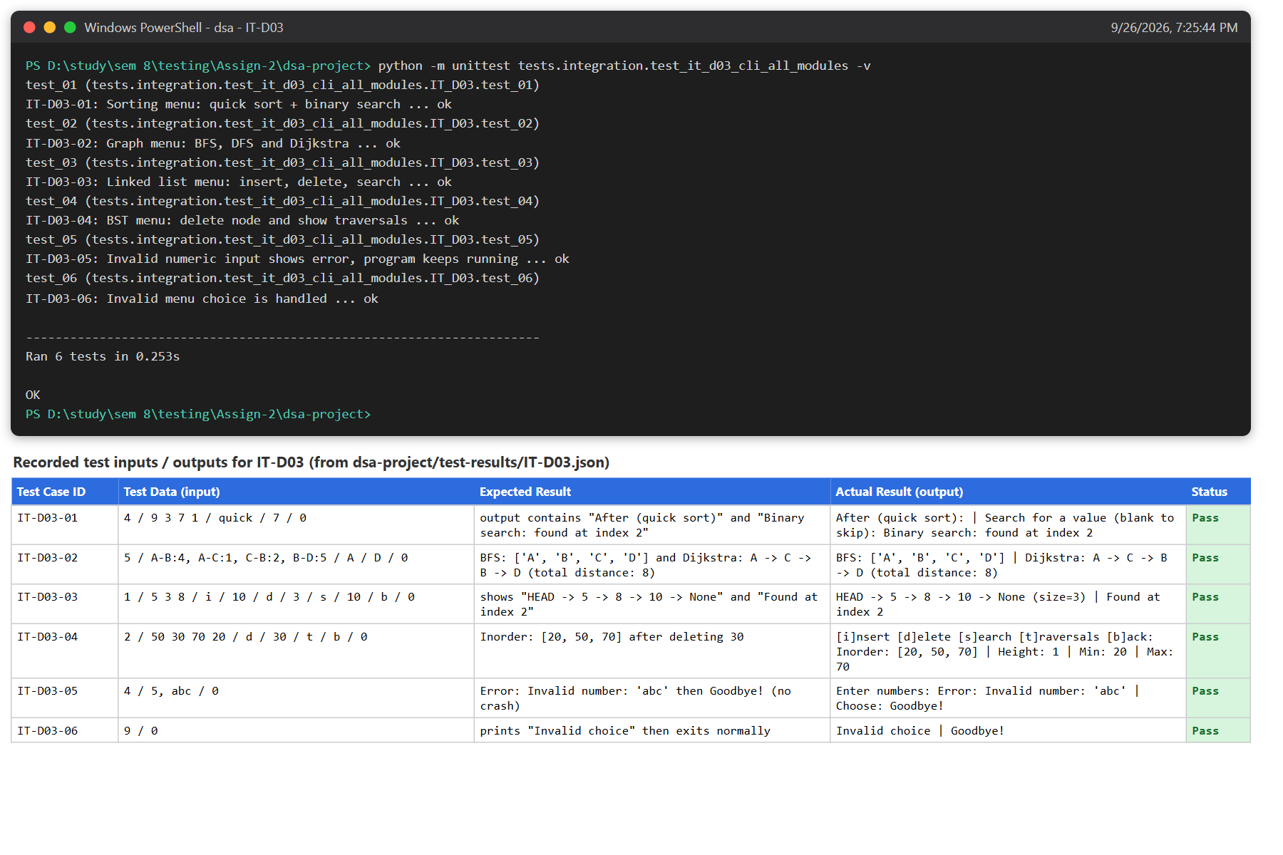
Figure 60: IT-D03 execution - "python -m unittest tests.integration.test_it_d03_cli_all_modules -v" (terminal output) with the recorded inputs/outputs of all 6 test cases (6 passed).

5.5 System Behaviour Screenshots (running program (CLI sessions))
main.py was run with the keystrokes shown after each prompt. Each caption names the test cases it demonstrates.
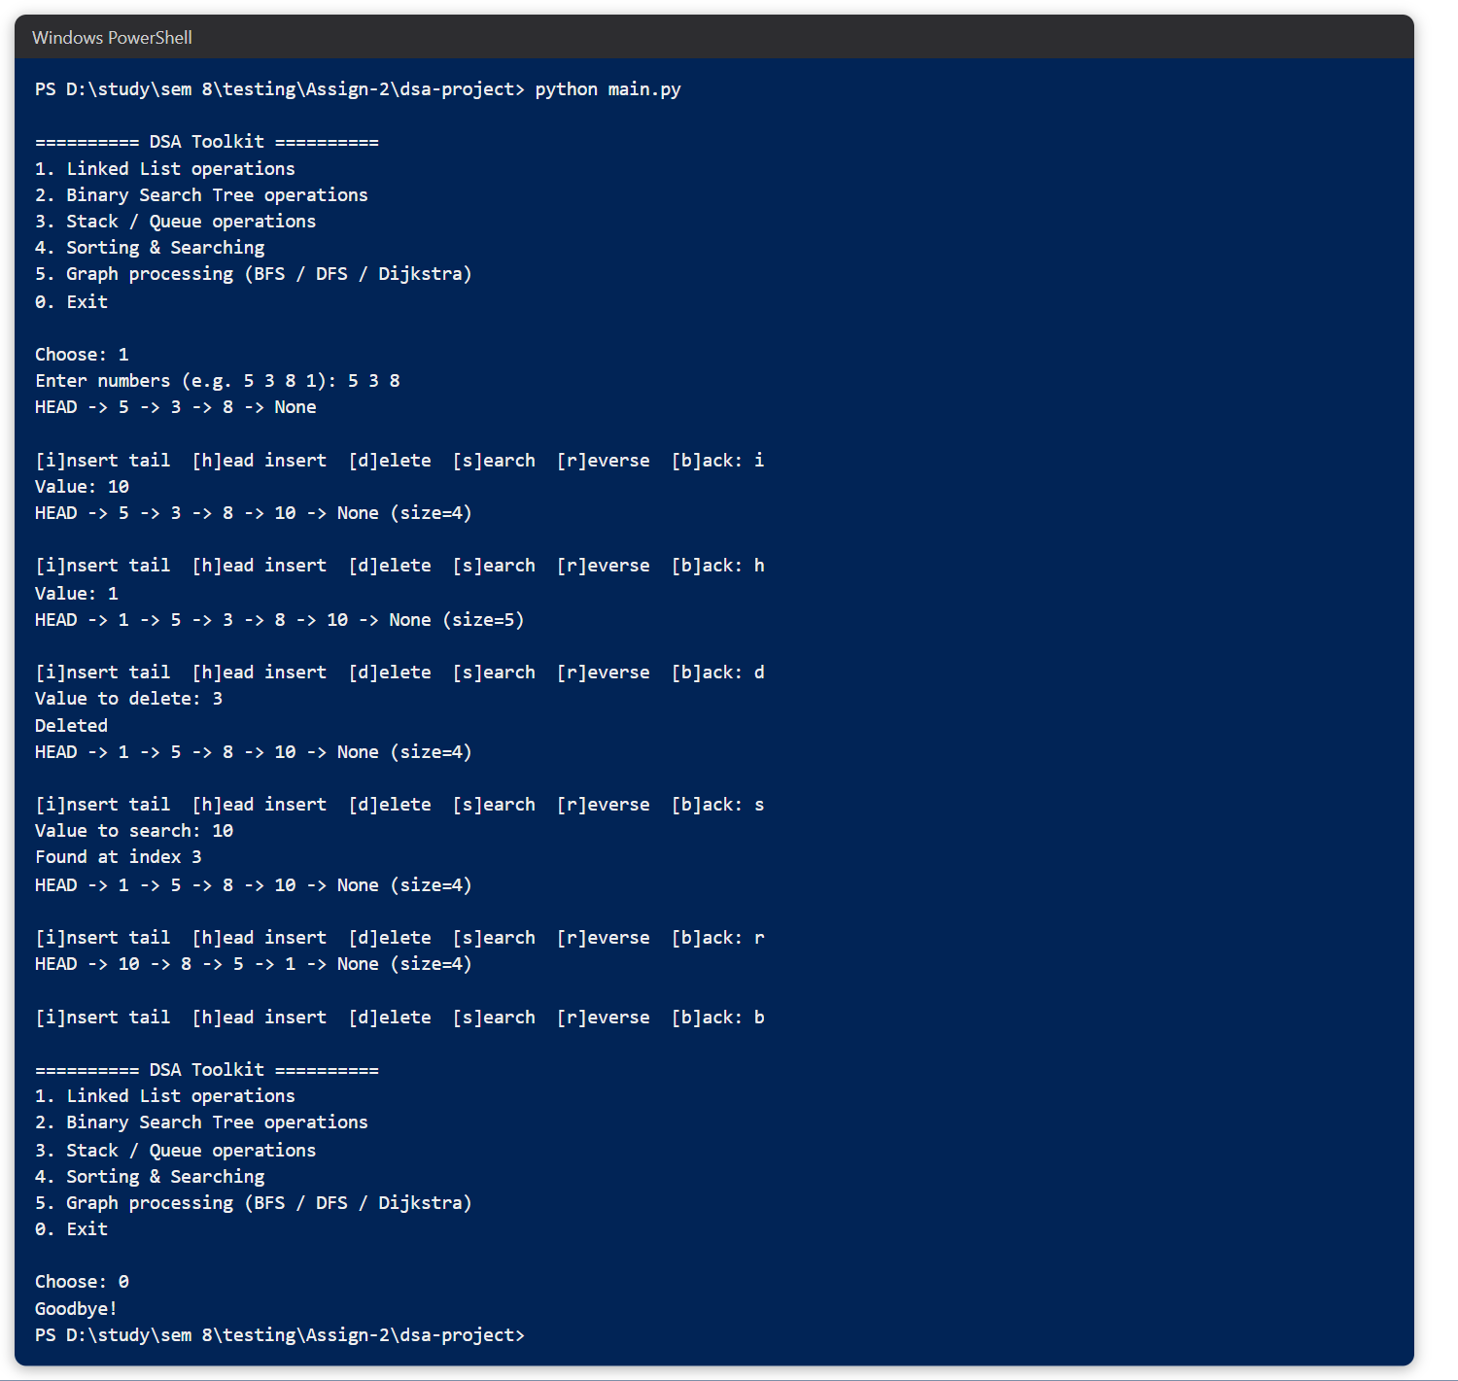  Figure 61: Linked List menu: insert tail/head, delete, search, reverse - UT-D01, UT-D02, CT-D01, IT-D03-03 | 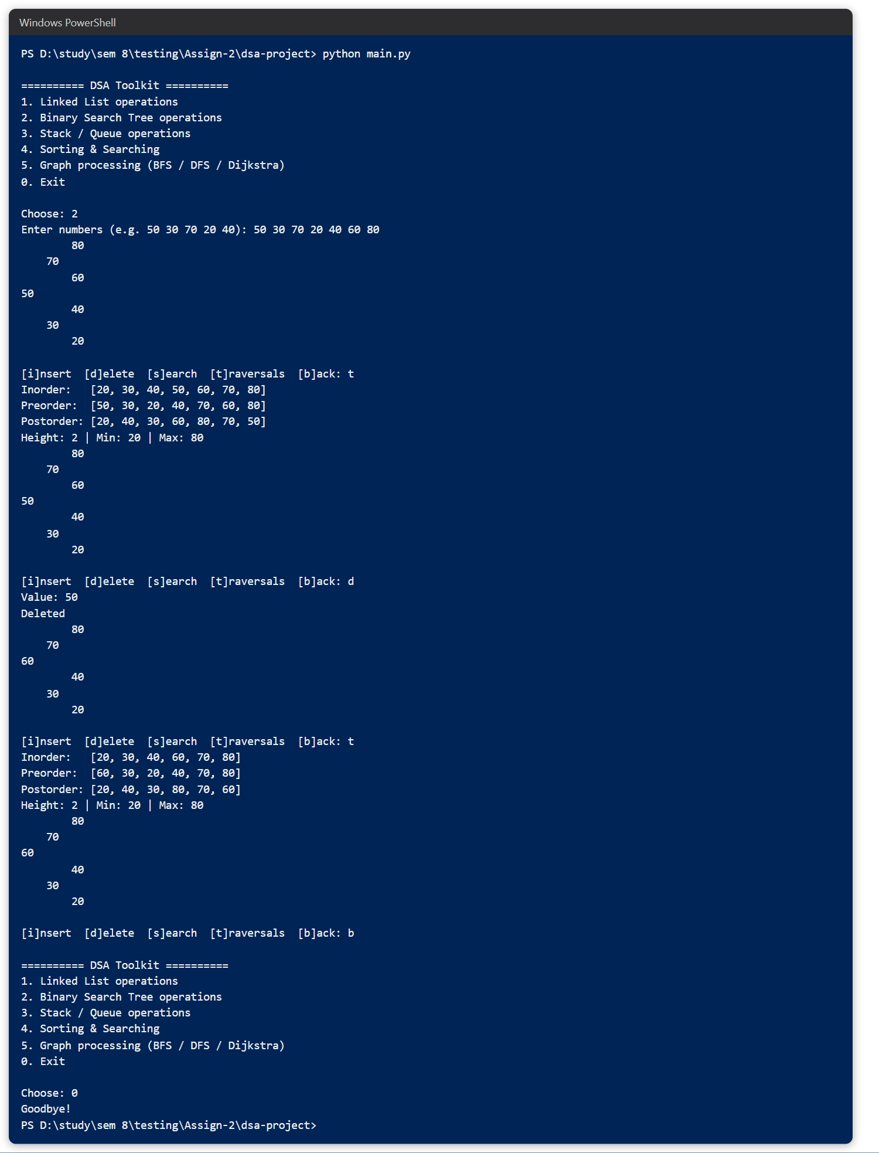  Figure 62: BST menu: build tree, traversals, delete root (successor 60 replaces it) - UT-D03, CT-D02
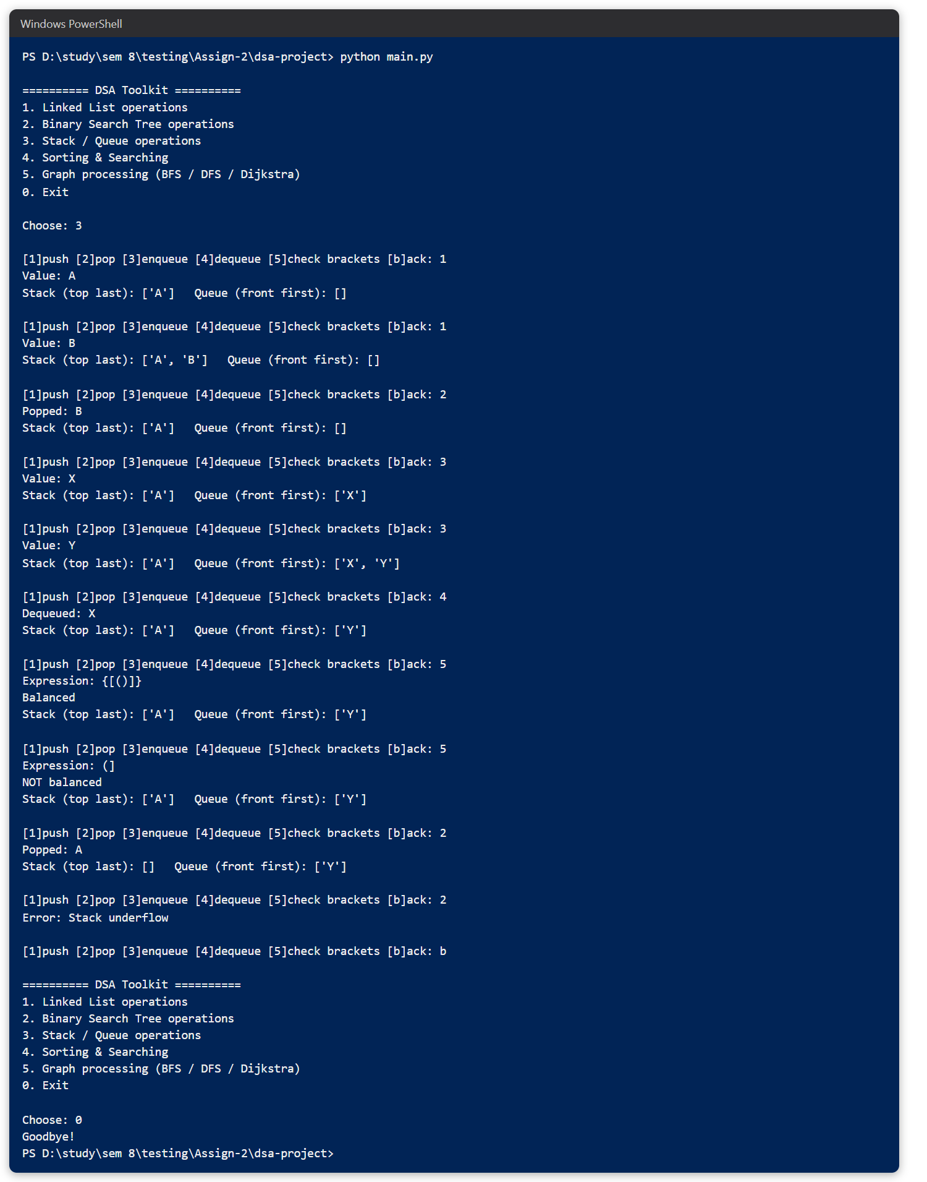  Figure 63: Stack/Queue menu: push/pop (LIFO), enqueue/dequeue (FIFO), bracket check, underflow error - UT-D06 | 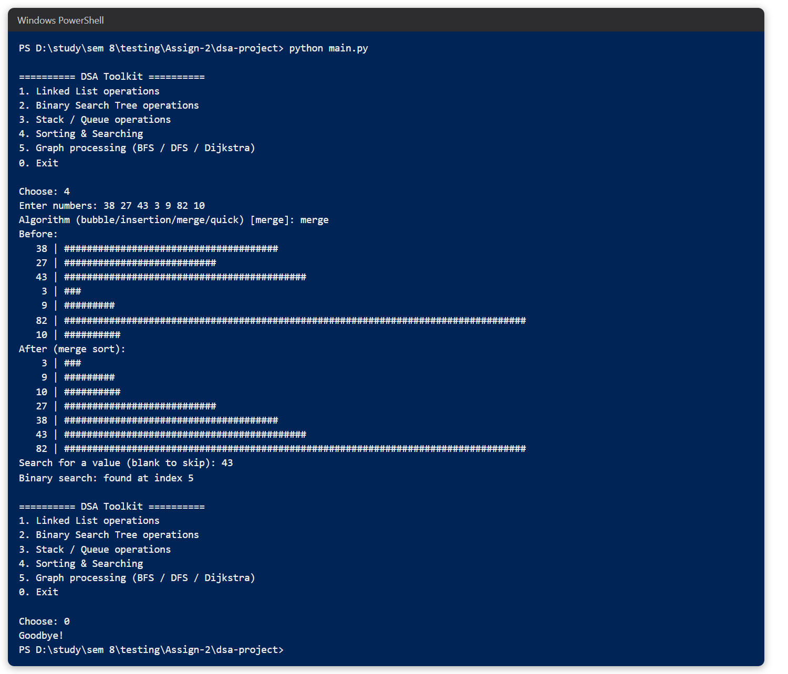  Figure 64: Sorting menu: merge sort shown as bars before/after, binary search - UT-D04, UT-D05, IT-D03-01
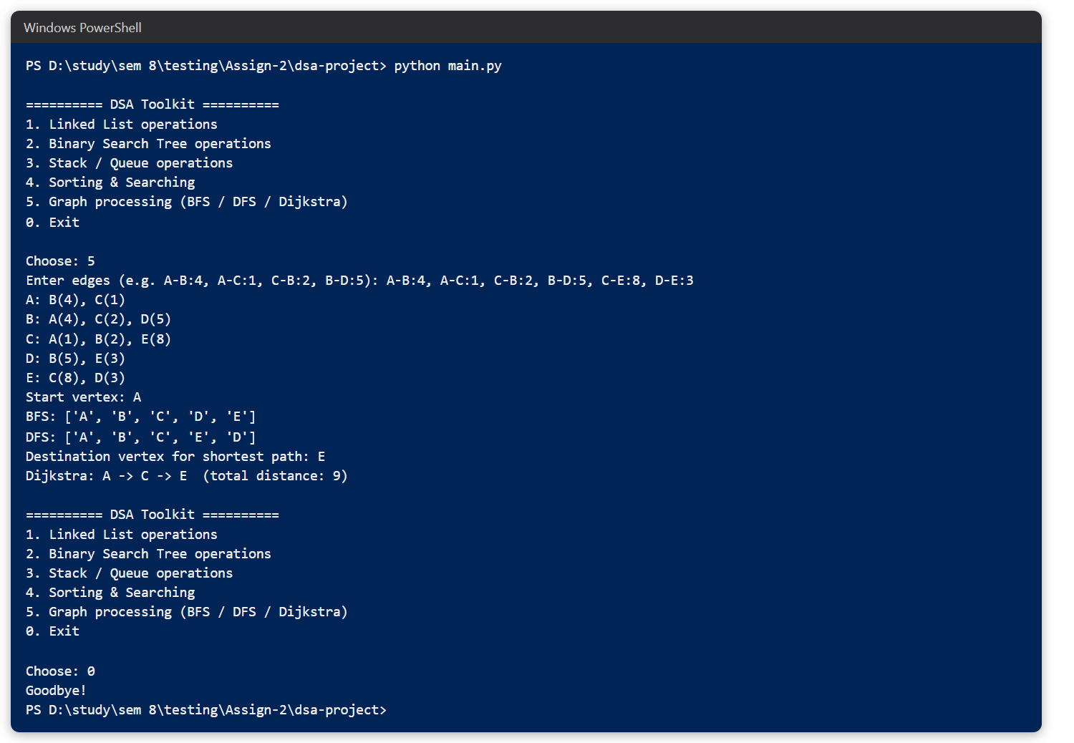  Figure 65: Graph menu: adjacency list, BFS, DFS, Dijkstra shortest path - CT-D03, IT-D02, IT-D03-02 | 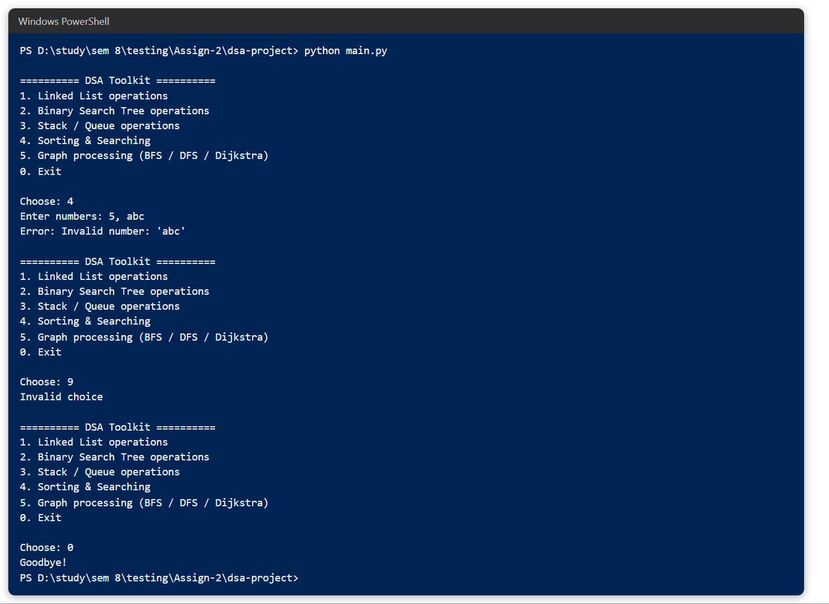  Figure 66: Invalid numeric input and invalid menu choice are reported without crashing - IT-D03-05, IT-D03-06
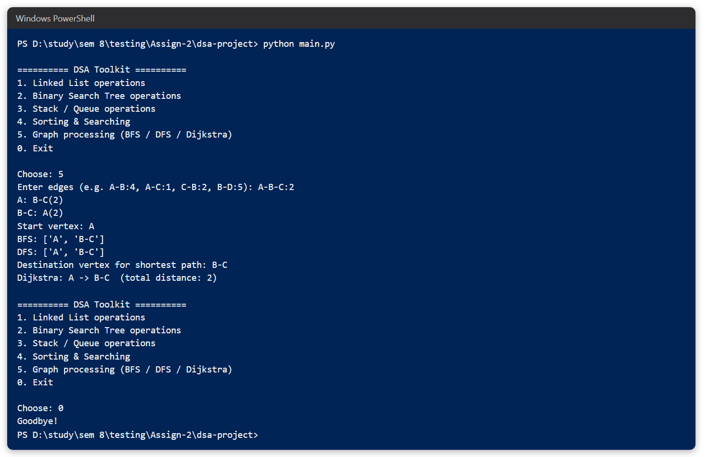  Figure 67: BUG (IT-D01-07): malformed edge "A-B-C:2" is accepted and creates a vertex named "B-C" | 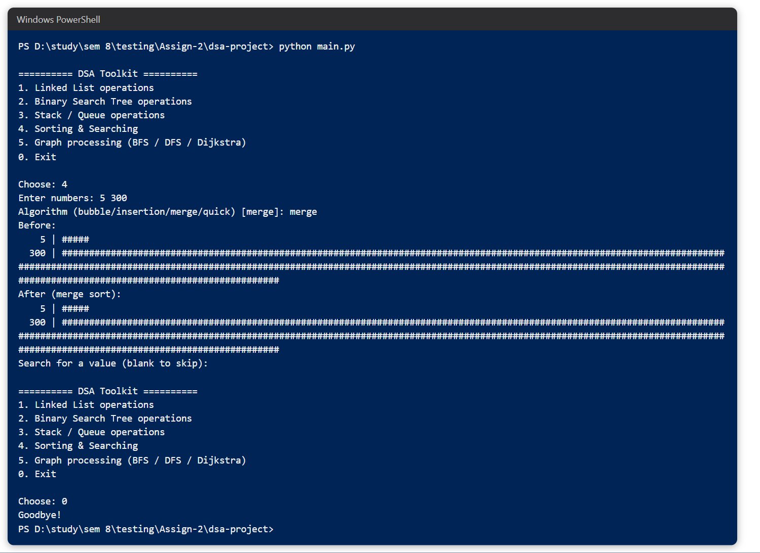  Figure 68: BUG (IT-D02-07): bar chart is not scaled - value 300 prints 300 "#" characters and overflows the terminal

6. Defects Found and Recommendations
The following defects were revealed by failing test cases. They were left unfixed so the report reflects the real test outcome; the recommended fix is listed for each.

BUG-W01 - Email checker accepts consecutive dots in the domain
Field | Details
Project / Test Case | Web - UT-W01-07
Severity | Low
Description | validateEmail("ali@test.​.com") returns true, so malformed addresses can be registered.
Recommended Fix | Use a stricter pattern that forbids empty domain labels, e.g. /​^[^\s@]+@([^\s@.]+\.)+​[^\s@.]{2,​}$/​.
Status | Open

BUG-W02 - Stored XSS / HTML injection through product name
Field | Details
Project / Test Case | Web - CT-W02-07
Severity | High
Description | addProduct() accepts names such as <img src=​x onerror=​alert(1)> and the frontend inserts names with innerHTML, so the markup is executed for every visitor (see screenshot web-ui/​11).
Recommended Fix | Reject or escape "<" and ">" in validateProductForm() and render names with textContent instead of innerHTML.
Status | Open

BUG-W03 - Card charged but order fails when the same product is in two cart lines
Field | Details
Project / Test Case | Web - IT-W03-05
Severity | Critical
Description | items [{productId:​1, qty:​6}, {productId:​1, qty:​6}] with stock 10: each line passes the stock check, the payment succeeds, then reduceStock() throws -> HTTP 500, no order is created, a SUCCESS payment is recorded and stock is left at 4.
Recommended Fix | Aggregate quantities per product before the stock check, reserve stock before charging, and roll back / refund if any later step fails.
Status | Open

BUG-M01 - loadSession() crashes on corrupted session data
Field | Details
Project / Test Case | Mobile - UT-M05-06
Severity | Medium
Description | If the saved "session" value is not valid JSON, loadSession() throws SyntaxError, while loadProfile() handles the same situation by returning null.
Recommended Fix | Wrap JSON.parse in try/​catch, remove the corrupted key and return null.
Status | Open

BUG-M02 - Read notifications become unread after profile update
Field | Details
Project / Test Case | Mobile - IT-M03-05
Severity | Low
Description | App.js regenerates the whole notification list with read:​false whenever the profile is saved, so the badge shows "Alerts (2)" again although the user already read them (see screenshot mobile-ui/​10).
Recommended Fix | When regenerating, copy the read flag from the previous list for notifications with the same id.
Status | Open

BUG-D01 - BST height() fails with RecursionError on degenerate trees
Field | Details
Project / Test Case | DSA - CT-D02-05
Severity | Medium
Description | Inserting 1500 sorted keys creates a chain of depth 1500; the recursive height() (and the recursive traversals) exceed Python's default recursion limit of 1000.
Recommended Fix | Implement height/​traversals iteratively (explicit stack/​queue) or use a self-balancing tree (AVL / Red-Black).
Status | Open

BUG-D02 - Graph dfs() fails with RecursionError on long paths
Field | Details
Project / Test Case | DSA - CT-D03-07
Severity | Medium
Description | dfs() is recursive, so a path graph with 1501 vertices raises RecursionError instead of returning the visit order.
Recommended Fix | Rewrite dfs() with an explicit stack.
Status | Open

BUG-D03 - Malformed edge "A-B-C" is silently accepted
Field | Details
Project / Test Case | DSA - IT-D01-07
Severity | Low
Description | parse_edges() splits only on the first "-", so "A-B-C:​2" becomes edge A -> "B-C" and a bogus vertex appears in the graph (see screenshot dsa-ui/​07).
Recommended Fix | Split on "-" and require exactly two non-empty vertex names, otherwise raise ValueError.
Status | Open

BUG-D04 - Bar chart is not scaled to terminal width
Field | Details
Project / Test Case | DSA - IT-D02-07
Severity | Low
Description | render_bars([5, 1000]) prints a 1008-character line, which wraps and makes the visualization unreadable (see screenshot dsa-ui/​08).
Recommended Fix | Scale bars relative to the maximum value (e.g. max 50 characters) and print the value next to the bar.
Status | Open

7. Conclusion
A total of 227 automated test cases were designed and executed across the three projects (218 passed, 9 failed). Unit tests verified individual functions in isolation, component tests verified complete modules, and integration tests verified the data flow between modules using Top-Down, Bottom-Up and Incremental strategies.
Each level found different kinds of defects: unit testing found a validation gap (email format), component testing found a security issue (HTML injection) and scalability limits (recursion depth), and integration testing found defects that only appear when modules interact - most importantly a checkout path where the customer is charged without an order being created. This shows why all three levels of testing are needed.

