ReStep Footwear — Business Plan (Pakistan)
Social-commerce thrifted footwear for Pakistan’s youth
Prepared by: ReStep Footwear (Partnership — Lahore)
Date: January 2026

Table of Contents
1. Executive Summary
2. Business Description
3. Product/Service and Value Additions
4. Industry Analysis (Size, Trends, Porter’s Five Forces)
5. Macro Environment (PESTLE — Pakistan)
6. Market Segmentation & Target Market
7. Competitor Analysis
8. Customer Details & Relationship Management
9. Marketing Strategy (4Ps + Sales Cycle)
10. Operations & Logistics
11. Management Team, Governance, and Mentor
12. Product/Service Development Plan
13. Financial Projections (Assumptions, Break-even, 6-Month Models, Ratios)
14. Risks, Contingency Plan, Exit Strategy
15. Visual Exhibits
16. Data Appendix & Pakistan Statistics
17. Compliance Notes (GST, Import, Courier)

1) Executive Summary
Lahore-based partnership selling authentic, cleaned, graded thrifted shoes via Instagram/TikTok with COD nationwide.
Ownership & profit/loss: Partner A 60%, Partner B 25%, Partner C 15%.
Value: Affordable branded footwear; hygiene assurance; transparent grading (A/B/C); 3‑day exchange for trust (youth 16–35).
Traction & capacity: ~100 customers/month; 2–3 purchases/year; ROAS 3x–5x; CPA PKR 300–500; capacity 200 pairs/month.
12–18 month goals: PKR 600k+ monthly revenue; >3 repeats/year; CPA 250–350; 24–48h delivery in top cities.
Funding: PKR 700,000 self-funded — inventory, marketing, packaging/hygiene, storage/utilities, working capital.
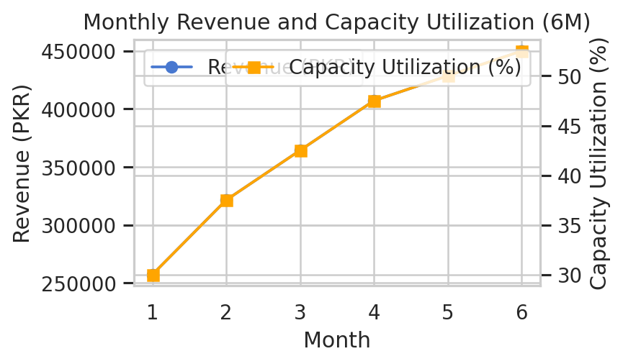
Figure ES-1: Monthly revenue and capacity utilization (6M)
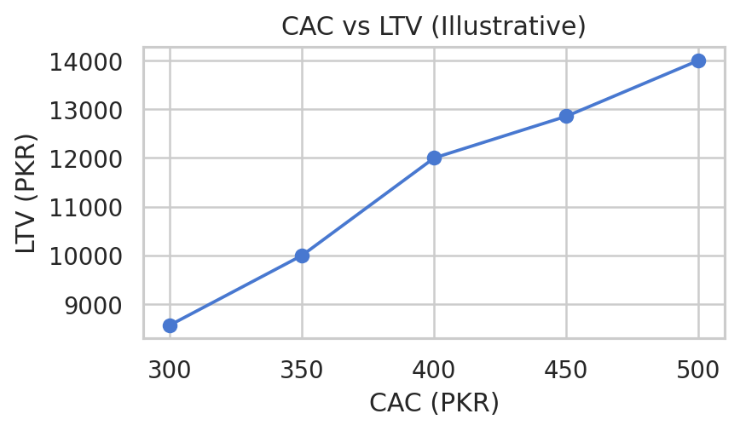
Figure ES-2: CAC vs LTV (illustrative)

2) Business Description
Legal: Partnership (AOP), Lahore. Ownership ratios aligned to profit/loss 60%/25%/15%.
Mission: Reliable, hygienically processed branded thrifted shoes at accessible prices, mobile-first social commerce, fast COD.

3) Product/Service and Value Additions
Product: Sneakers/trainers, casual, lifestyle footwear.
Features: Authenticity checks; cleaning/deodorization; detailed photos & sizing; 3‑day exchange.
Value: Hygiene workflow; transparent grading; DM sizing support; trust signals; 1–3 day sales cycle; COD via TCS/Leopards.

4) Industry Analysis (Pakistan)
Market: ~USD 5.8–5.89B (2025); ~600M pairs/year; 99% non-luxury; thrift <5–10% by volume (informal).
Trends: Youth-driven demand; mobile-first shopping; social commerce; COD; improving logistics.
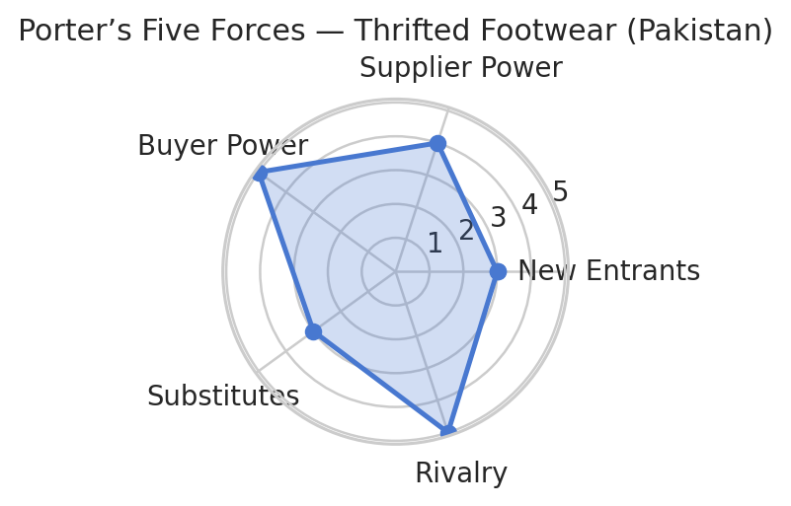
Figure 4-1: Porter’s Five Forces — thrifted footwear in Pakistan

5) Macro Environment (PESTLE — Pakistan)
Political: Stabilization; IMF constraints; import policy for used goods may shift.
Economic: CPI ~5.6% (Dec 2025); SBP policy rate ~10.5%; USD/PKR ~280.
Social: Youth (15–35 ~35–40%); urbanization ~34–35%.
Technological: Social commerce; wallets rising; strong couriers.
Legal: GST 18% on goods; provincial services tax 13–16%; Chapter 64 customs; IPO oversight for secondhand.
Environmental: Energy costs/load-shedding; efficient operations needed.

6) Market Segmentation & Target Market
Demographic: 16–35 youth; students; early professionals.
Geographic: Lahore; Karachi/Islamabad/Faisalabad/Multan/Peshawar; urban/peri-urban.
Psychographic: Trend-driven; value-conscious; sustainability-aware.
Behavioral: 2–3 purchases/year; drops/limited editions; high DM engagement.
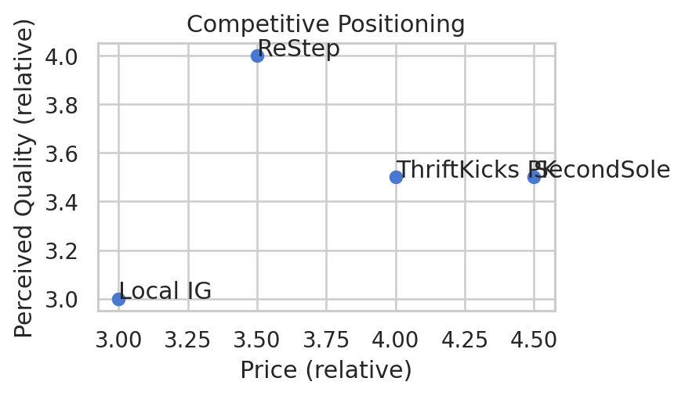
Figure 6-1: Positioning map — price vs quality

7) Competitor Analysis
- ThriftKicks PK (Started: 2021), Annual sales est.: PKR 3–5 million; Channels: Instagram, WhatsApp; Pricing: PKR 3,000–6,000; Coverage: Lahore core; nationwide COD.
- SecondSole (Started: 2022), Annual sales est.: PKR 3–5 million; Channels: Instagram, WhatsApp; Pricing: PKR 3,000–6,000; Coverage: Lahore core; nationwide COD.
- Local IG Sellers (Started: 2020–2024), Annual sales est.: PKR 2–4 million; Channels: Instagram, WhatsApp; Pricing: PKR 2,500–5,500; Coverage: Various; nationwide COD.

8) Customer Details & Relationship Management
Customers: ~100/month; students/young professionals; purchase frequency 2–3/year; budget share ~5–10% of fashion spend.
CRM: DMs + WhatsApp; post-purchase check-ins; loyalty discounts; early access; UGC reposts.

9) Marketing Strategy
Product: Cleaned, graded, authenticity checks; 3‑day exchange; fast COD; DM support; reviews.
Pricing by grade: A: PKR 5500, B: PKR 4000, C: PKR 2800; Mix A/B/C: 35%/45%/20%; Blended ASP ≈ PKR 4285.
Placement: IG/TikTok; WhatsApp; Daraz (commission ~9% + payment fee ~2%).
Promotion: PKR 30k/month; ROAS 3x–5x; CPA PKR 300–500; creatives: cleaning transitions; unboxing; sizing guides; UGC/influencers.
Sales cycle: 1–3 days; DM→Order 15–25%; 6‑month repeat >30%.
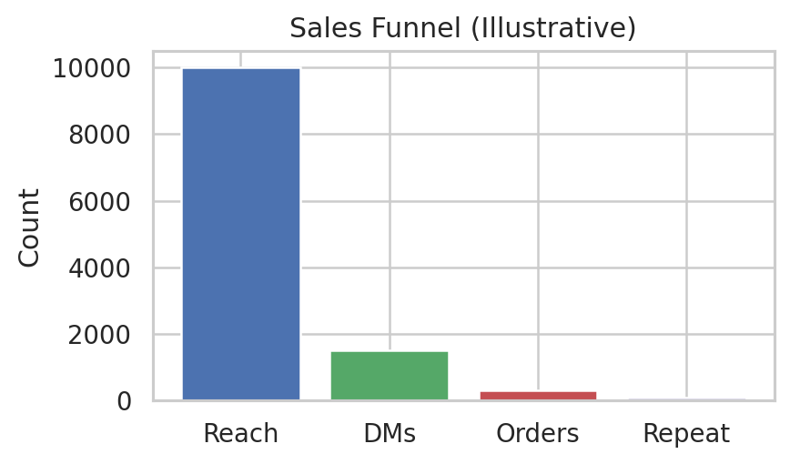
Figure 9-1: Sales funnel (illustrative)

10) Operations & Logistics
Vendors: Karachi wholesalers; Terms: Cash on pickup; 50% advance for premium bales; Lead time: 5–7 days Karachi→Lahore.
Yield (saleable): 85% with grade split A/B/C: 35%/45%/20%; Waste ~7%.
Capacity: ~200 pairs/month; home-based storage; cleaning; photography.
Courier: TCS & Leopards; Packaging per pair: PKR 110; Utilities+storage monthly: PKR 20000.
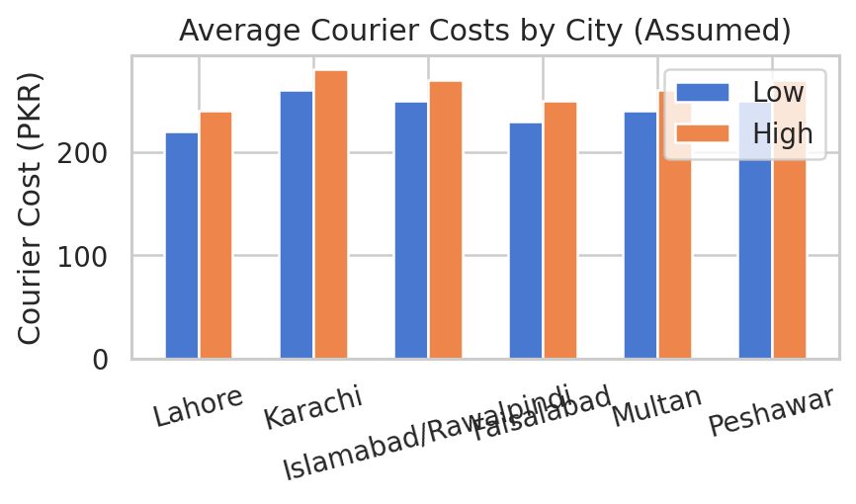
Figure 10-1: Average courier costs by city (assumed)

11) Management Team, Governance, and Mentor
Org: Partners (Strategy/Finance/Compliance); Operations; Marketing; Fulfillment.
Board: Partner A & Partner B; Advisors: to be filled (retail/logistics; legal/tax).
Mentor: University SME mentor (contact to be added).

12) Product/Service Development Plan
Weekly: Bale sorting/grading; Cleaning/sanitization; Photography/listings. Monthly: Packaging stock; Influencer collabs.

13) Financial Projections
Assumptions: COGS ~60%; Opex ~15%; returns 7%; blended ASP ≈ PKR 4285.
Break-even: Contribution per pair ≈ PKR 1714; Fixed monthly ≈ PKR 55000; Break-even ≈ 32 pairs/month.
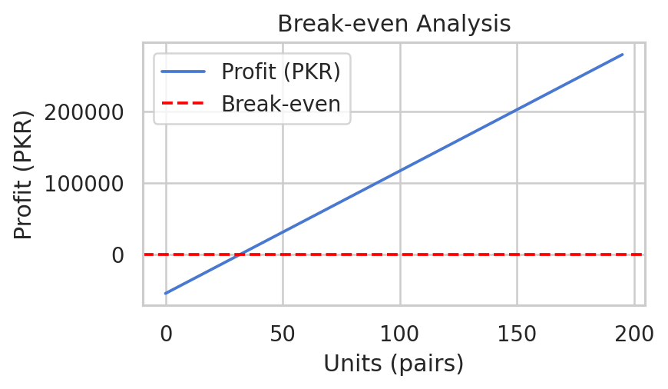
Figure 13-1: Break-even chart
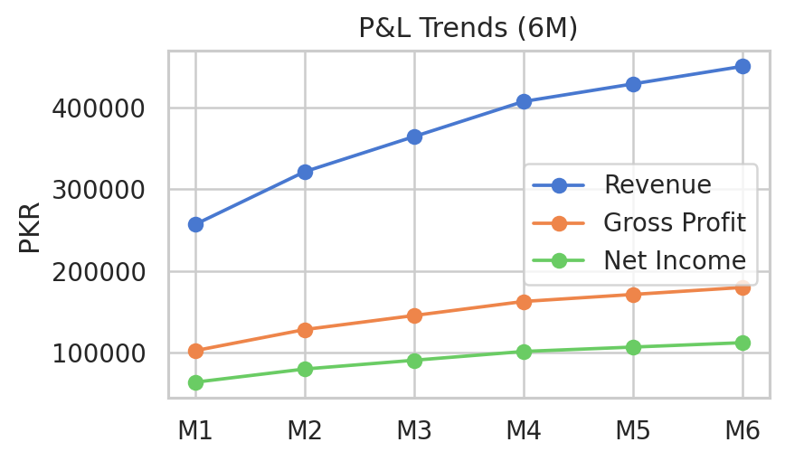
Figure 13-2: P&L trends (6M)
Ratios (Month 6; illustrative): Current ratio > 10; Debt-to-equity = 0; ROE ~39%; Gross margin ~40%; Net margin ~25%.

14) Risks, Contingency Plan, Exit Strategy
Risks: Supply quality/consistency; customer trust; platform dependency.
Contingency: Multi-wholesaler sourcing; transparency & 3‑day exchange; diversify TikTok/WhatsApp; build Daraz; campus pop-ups.
Exit: Management buyout; strategic sale; orderly wind-down.

15) Visual Exhibits (selection)
Exhibit: Fig Revenue Capacity
Exhibit: Fig Cac Ltv
Exhibit: Fig Porter
Exhibit: Fig Courier Costs
Exhibit: Fig Funnel
Exhibit: Fig Pnl
Exhibit: Fig Break Even
Exhibit: Fig Positioning

16) Data Appendix & Pakistan Statistics (2025–2026)
Youth & Urbanization: Youth (15–35) ~35–40%; >60% under 30; Urbanization ~34–35%.
E-commerce & Social: ~$10.4B (2025); mobile-first; COD ~75%; social commerce up to ~35% by 2026.
Macro: CPI ~5.6% (Dec 2025); SBP policy rate ~10.5%; USD/PKR ~280.

17) Compliance Notes (GST, Import, Courier)
GST: Standard 18% on goods; provincial services tax ~13–16%; potential e-commerce collection (e.g., 2% online).
Importing Used Footwear: Documentation, inspections, hygiene compliance; Chapter 64 PCT; IPO oversight.
Courier: TCS/Leopards nationwide; COD; tracking; TCS often for critical shipments; Leopards strong Tier‑II/III.

