GymOptix
A Camera-Based AI Fitness Coaching System for Real-Time Exercise Recognition, Repetition Counting, and Form Assessment

Chapter 1
Introduction

1.1 Overview
The rapid growth of at-home and gym-based fitness culture has been accompanied by a parallel rise in AI-driven tools that aim to guide users through their workouts. Most of these tools, however, stop at recognizing which exercise a user is performing and how many repetitions they have completed. GymOptix is a graduation project that goes a step further: it is a camera-based AI fitness coaching system designed to analyze exercise form in real time, count repetitions accurately, and identify specific technical errors as they occur — all without requiring any wearable sensors or specialized hardware.
The system relies on a standard RGB camera, whether a personal smartphone camera used by an individual at home, or a fixed camera already installed within a gym, to capture a user's movement. This video stream is processed through a human pose-estimation pipeline that extracts body landmarks, derives joint angles, and feeds them into a sequence of machine learning models responsible for exercise classification, repetition counting, and form-quality assessment. The result is delivered to the user not as a raw repetition count, but as structured, explainable coaching feedback: which repetitions were performed correctly, which were not, and precisely what needs to be corrected.
GymOptix is designed to serve three connected groups of users: individual users training independently with a personal device, gym members training on-site with gym-provided cameras and QR-based check-in, and gym managers and platform administrators who oversee accounts, usage, and analytics across the platform.
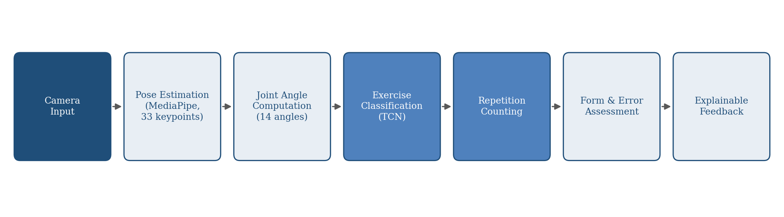
Figure 1.1: Conceptual end-to-end pipeline of GymOptix, from camera input to explainable coaching feedback

1.2 Problem Statement
Current AI-assisted fitness systems can broadly be grouped into two categories. The first relies on wearable devices such as smartwatches, inertial measurement units (IMUs), and accelerometers to track motion. While functional, this approach requires the user to purchase and consistently wear additional hardware, which is often impractical and unappealing in a gym setting where users move between machines and free weights. The second category relies on dedicated, purpose-built hardware, such as depth cameras and specialized sensor rigs used by commercial systems like Tempo and Tonal. These systems can achieve high measurement accuracy but come at a substantial cost that limits their accessibility for most gyms and individual users. Given that many gyms already operate networks of standard surveillance and security cameras, a natural question arises: why not build a fitness-coaching system around the cameras that already exist, rather than requiring new, dedicated hardware?
A closer look at recent camera-based research reveals a second, more fundamental gap. Systems that rely purely on standard RGB video, such as the reference thesis that inspired the technical direction of this project, successfully address two questions: what exercise is the user performing (a classification problem), and how many repetitions have been completed (a counting problem). However, these systems implicitly assume that every counted repetition was performed correctly. This assumption does not hold in practice. A user who performs four repetitions of a squat with poor form — for example, with the knees collapsing inward on every repetition — would still be reported as having completed "4 reps," even though a qualified human trainer observing the same session would say that not a single repetition was performed correctly.
This is a meaningful gap, particularly for beginners, who are the most likely to exhibit technical errors such as knees caving inward during a squat, a rounded lower back during a deadlift, excessive elbow flare during a bench press, poor neck alignment, or an insufficient range of motion. Left uncorrected, these errors can lead to joint overload, long-term injury risk, reduced training effectiveness, and repetitions that should not have been counted as valid training volume in the first place. A real trainer does not merely count; a real trainer watches each repetition, flags the ones performed incorrectly, and explains why: "Repetition 2, incorrect, knee valgus," not simply "four reps completed."
GymOptix is built around reframing the guiding question of camera-based fitness systems. Instead of asking only "What exercise is the user performing?", the system is designed to also ask "Is the exercise being performed correctly, and if not, why?" This shift is, in effect, a shift from Fitness Tracking to AI Fitness Coaching.

1.3 Background and Motivation

1.3.1 The Prevalence and Cost of Poor Exercise Form
Poor exercise technique is not a marginal concern; it is one of the leading contributors to gym-related injury. Industry-compiled injury reports estimate that roughly 2.5 million gym-related injuries occur annually in the United States alone, with improper technique cited as one of the most frequent underlying causes [1]. Independent survey-based research on weight-training participants similarly found that close to a quarter of respondents had experienced a training-related injury within a six-month period [2]. A separate cross-sectional study of gym-goers found that the shoulder, knee, and lower back together account for roughly two-thirds of all reported injury sites [3], a distribution illustrated in Figure 1.2. Form breakdown during specific lifts has also been tied to specific injury patterns: one aggregated analysis attributes a substantial share of barbell-related lower back strains among novice lifters directly to improper squat form [4]. These figures reinforce the central premise of this project: counting repetitions without evaluating their quality overlooks the very issue that most directly puts users at risk.
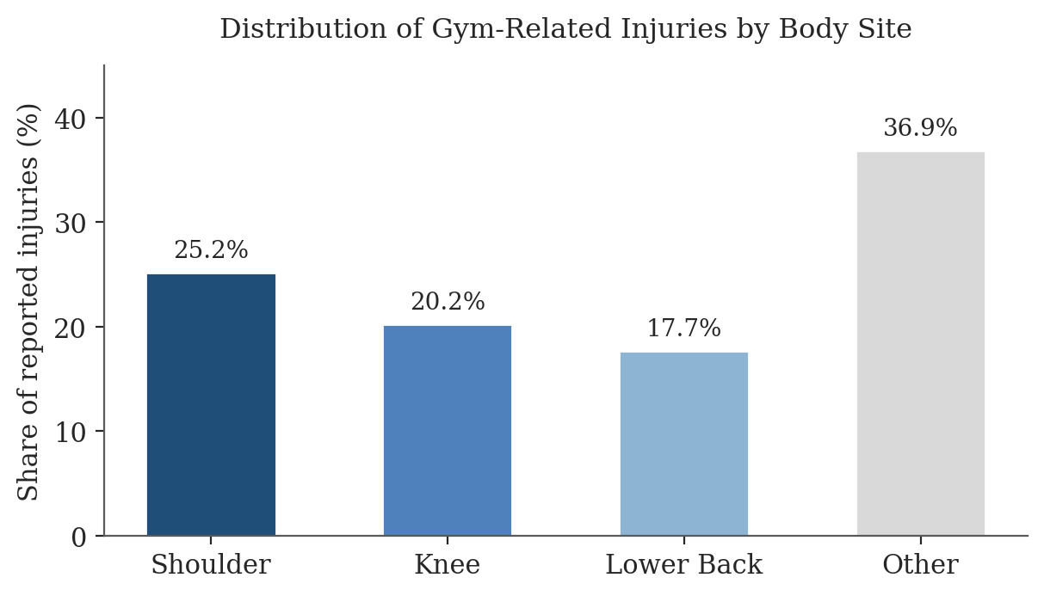
Figure 1.2: Distribution of gym-related injuries by body site, aggregated from a cross-sectional study of gym-goers

1.3.2 Limitations of Existing Solutions
As outlined in the problem statement, existing solutions fall short in two opposite directions. Wearable-based systems are inexpensive individually but require the user to own and wear additional hardware, and the signals they capture (acceleration, orientation) are a proxy for movement rather than a direct measurement of body posture, making fine-grained form errors difficult to detect. Dedicated-hardware systems, on the other hand, can capture posture directly and with high fidelity, but their cost places them out of reach for most independent gyms and individual users. A gap therefore exists for a solution that uses infrastructure that is already widely available, ordinary cameras, to deliver posture-aware, form-sensitive feedback.

1.3.3 Growing Market for AI-Driven Fitness Coaching
This gap is opening at a time of significant commercial and technological momentum. Market analyses place the global AI-in-fitness sector at roughly $10.7 billion in 2025, projected to grow at a compound annual rate of around 19% through 2035 [5], a trajectory shown in Figure 1.3, with computer-vision-based form correction repeatedly identified as one of the primary drivers of this growth [6]. Recent commercial platforms increasingly use a smartphone or tablet camera to track joint angles and range of motion frame by frame, flagging issues such as a rounded back or uneven weight distribution in real time [6]. This growing convergence between computer vision and fitness coaching confirms both the technical feasibility and the market relevance of the direction this project pursues.
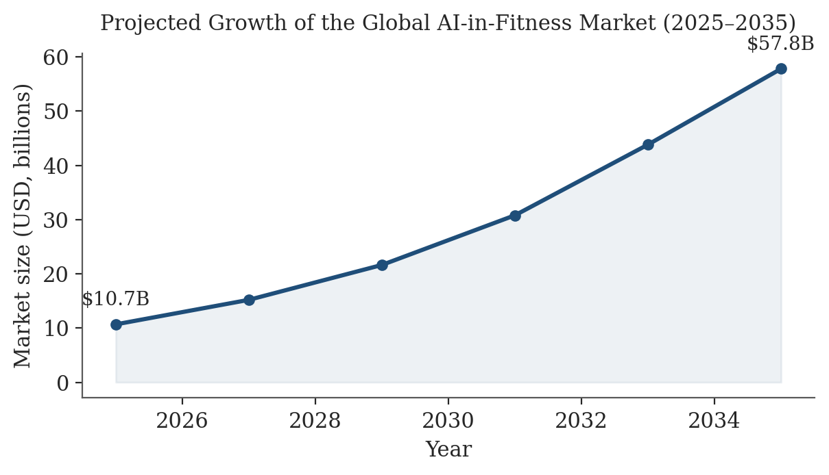
Figure 1.3: Projected growth of the global AI-in-fitness market, 2025–2035, at an estimated 19.3% CAGR

1.3.4 Why This Project Matters
GymOptix sits at the intersection of these observations: exercise-form errors are a leading, well-documented cause of gym injury; existing camera-based academic systems stop short of evaluating form; existing commercial alternatives are either hardware-dependent or prohibitively expensive; and the broader market is actively moving toward computer-vision-based coaching. By using infrastructure that already exists, standard cameras, and extending the state of the art from repetition counting to repetition quality assessment, this project aims to make trustworthy, explainable, real-time coaching accessible to a much wider range of users and gyms.

1.4 Project Limitations
- Data Availability for Form Errors: Publicly available datasets that label specific exercise repetitions with the type of technical error committed (e.g., knee valgus, back rounding) are scarce compared to datasets for exercise classification alone. Building or curating an adequately labeled dataset is expected to be one of the most significant challenges of this project (see Section 1.7).
- Camera Angle and Occlusion Sensitivity: Pose-estimation accuracy, and therefore the reliability of the derived joint angles, depends on the user being reasonably visible to the camera. Poor lighting, unusual camera angles, or occlusion by gym equipment can degrade detection quality.
- Real-Time Processing Constraints: Delivering feedback during, rather than only after, a set requires the pipeline to run within tight per-frame latency budgets, which constrains the complexity of the models that can be used, particularly on modest consumer hardware.
- Scope of Supported Exercises: Achieving reliable, fine-grained form assessment for every possible gym exercise within the timeframe of a graduation project is not feasible; the system is expected to prioritize depth of analysis on a smaller, well-defined set of core exercises rather than shallow coverage of many.
- Generalization Across Users: Differences in body proportions, clothing, and camera setups across users and gyms may affect how well a model trained on a given population generalizes to new users.
- Network Dependency in Gym Mode: The gym-based flow, in which data may be processed via a connected service rather than purely on-device, depends on the availability of adequate gym network infrastructure.

1.5 Project Expected Output
The completed system is expected to deliver the following outputs, organized around four core contributions: exercise recognition, repetition counting, form assessment, and explainable feedback.
- Real-Time Exercise Recognition: Identification of the exercise being performed from live camera input, with the system prompting the user to disambiguate when multiple exercises are plausible rather than guessing.
- Valid Repetition Counting: A repetition counter that reports the number of repetitions performed, distinguishing between correctly and incorrectly executed repetitions rather than treating every completed movement cycle as equally valid.
- Form and Error Assessment: Detection and naming of specific technical errors (e.g., knee valgus, rounded back, excessive elbow flare) for each repetition, rather than a binary correct/incorrect judgment alone.
- Explainable Feedback: Human-readable coaching output that names the error and how to correct it, delivered as concise on-screen messages (e.g., form score and error list) rather than complex visual overlays.
- Per-Session Coaching Report: A summary generated at the end of each exercise session, including total repetitions, correct versus incorrect repetitions, the most common error, an average form score, and a corrective recommendation.
- Supporting Application Layer: A mobile application for individual and gym users (authentication, workout library, camera-based sessions, history, and analytics), a web portal for gym managers (user and exercise management, QR-based check-in, analytics), and administrative tooling for platform-wide oversight.

1.6 Project Scope

1.6.1 Scope Overview
This project focuses on building a camera-based pipeline that classifies exercises, counts valid repetitions, assesses exercise form, and produces explainable feedback, wrapped in a supporting application layer that serves individual users, gym members, and gym administrators. The initial release targets a curated set of core exercises evaluated in depth, with breadth across a larger exercise catalog treated as a direction for future work.

1.6.2 In-Scope
- Pose extraction from standard RGB camera input using MediaPipe Pose, followed by conversion to camera-distance-invariant joint angle features.
- Exercise classification and repetition counting for a core set of exercises using a sliding-window temporal model.
- Form and technical-error assessment for the same core set of exercises, including named, common errors.
- Explainable, text-based feedback and a per-session coaching report.
- A credit-based access model for individual users, and a QR-code-based check-in and per-exercise verification flow for gym users.
- A gym manager web portal for user management and usage analytics, and a super-administrator layer for platform-wide oversight.

1.6.3 Out of Scope
- Integration with wearable sensors (smartwatches, IMUs, accelerometers) as a data source.
- Use of depth cameras or other specialized, non-standard hardware.
- Automated calorie and diet/nutrition planning (identified as future work).
- Facial recognition for security-camera identification (identified as future work).
- Comprehensive, form-level coverage of the full range of gym exercises in the initial release.

1.6.4 Assumptions
- The user is reasonably visible to the camera for the duration of a tracked set, without prolonged occlusion by equipment or other people.
- Users training under the gym plan have access to the gym's camera and network infrastructure, or fall back to personal mobile data when it is unavailable.
- A representative, if limited, set of labeled data for the targeted core exercises and their common form errors can be obtained or constructed.

1.6.5 Constraints
- The pipeline must operate under real-time or near-real-time latency budgets on modest, non-specialized hardware.
- The scarcity of publicly labeled, form-error-annotated exercise data constrains both model choice and achievable accuracy for the form-assessment component.
- Gym network access points have a practical concurrent-user capacity (approximately 30–50 users each), which bounds how the in-gym data flow can be designed.
- Processing of camera data, particularly within a gym setting, must account for user privacy expectations around video-based monitoring.

1.7 Related Datasets and Data Sources
A preliminary survey of publicly available datasets was carried out to assess what data already exists for the three underlying tasks of GymOptix: exercise classification, repetition counting, and form/error assessment. Table 1.1 summarizes the datasets identified so far. As the table shows, datasets for exercise classification and repetition counting are relatively plentiful, but datasets that explicitly label the correctness of individual repetitions, or name the specific technical error committed, remain scarce. This confirms the limitation noted in Section 1.4 and motivates treating dataset construction as a first-class task of the project rather than an afterthought.
Dataset | Size | Primary Labels | Relevance to GymOptix
CoT-AFA | 3,392 videos / 364,812 frames, 28 workout types, 141 action categories | Standard vs. non-standard execution, multi-view, Chain-of-Thought text explanations of errors and corrections | Most directly relevant source found so far: the only surveyed dataset that explicitly labels whether a repetition is performed correctly and explains why, closely matching the form-assessment and explainable-feedback goals of this project
Sana Exercise Pose Landmark Dataset | 330 original videos (117,658 frames), 16 exercise categories, plus an augmented variant | Exercise category only (14 joint angles + visibility, no form/error labels) | Close match in format (pose/angle features) and exercise vocabulary to the pipeline this project is extending, but offers no form-correctness labels
Kaggle Workout/Fitness Video Dataset | 652 videos, 22 exercise categories | Exercise category only | Usable as supplementary classification data for categories involving free weights or bodyweight movements
Fitness-AQA | Action-quality videos across 3 exercise classes | Form/quality assessment labels | Directly relevant to form assessment, but narrow exercise coverage (3 classes) limits standalone use
RepCount / Countix | RepCount: large-scale, purpose-built; Countix: in-the-wild video collection | Repetition counts (class-agnostic) | Useful for benchmarking the repetition-counting component; no form or classification labels
MM-Fit | Multimodal (video + wearable sensor) workout dataset | Exercise category, repetition counts | Reference point for viewpoint-invariant counting approaches; multimodal nature is outside this project's camera-only scope
InfiniteRep | Synthetic, 3D-animated avatar dataset | Exercise category, repetition counts | Illustrates a synthetic-data approach to augmenting scarce real footage, at the cost of a sim-to-real gap
Table 1.1: Preliminary survey of datasets relevant to exercise classification, repetition counting, and form assessment
CoT-AFA (standing for Chain-of-Thought Action Form Assessment) is, at the time of writing, the closest publicly available match to the form-assessment and explainable-feedback goals of GymOptix, since it already pairs standard/non-standard execution labels with step-by-step textual explanations of what was done wrong and how to correct it. It will be examined in detail as part of the Related Work chapter to determine whether it can be adopted directly, adapted to the project's target exercises, or used only as a methodological reference for how to structure correctness and explanation labels in a dataset collected for GymOptix itself.

References
[1] ZipDo Education Reports, "Gym Injuries Statistics: Statistics 2025," 2025. Accessed: 2026-09-14.
[2] Prevalence and Pattern of Injuries Across the Weight-Training Sports, National Center for Biotechnology Information (PMC10689975), 2023. Accessed: 2026-09-14.
[3] Prevalence and Types of Overuse Injuries in Gym Centers: A Cross-Sectional Study in Saudi Arabia, National Center for Biotechnology Information (PMC11245209), 2024. Accessed: 2026-10-06.
[4] Gitnux, "Must-Know Gym Injuries Statistics," 2026. Accessed: 2026-09-14.
[5] InsightAce Analytic / Glofox (ABC Fitness), "AI in Fitness and Wellness Market" and "30+ AI in Fitness Statistics (2026)," 2026. Accessed: 2026-09-14.
[6] WellnessLiving, "How an AI Personal Trainer Can Transform Your Business in 2026," 2025. Accessed: 2026-09-14.
[7] Qi, M., Wu, Y., Yun, W., Zhang, X., & Ma, H., "Explainable Action Form Assessment by Exploiting Multimodal Chain-of-Thoughts Reasoning," arXiv:2512.15153, 2025. (CoT-AFA dataset)
[8] Cridlig, N. I., "Real-Time Exercise Recognition and Repetition Counting from Monocular Gym Video," Master's Thesis, University of Bologna, 2025-2026. (Sana dataset)
[9] Abdillah, H., "Workout/Fitness Video," Kaggle, 2023.

