

CS 262L- Database Systems

Lab Manual 11

**Instructor:**

Nazeef- ul Haq

Database System



**Name:** Muhammad Ahmad

**Registration Number:** 2022-CS-144

**Section:** C

Department of Computer Science

**University of Engineering and Technology Lahore Pakistan**

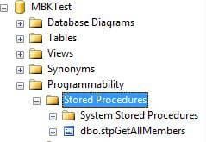

# Execute stored procedures in SQL Server

In below UI, right click on the SP name and select Execute Stored Procedure... to execute a SP. From here, you can also modify an existing SP.

Alternatively, you can also execute a SP from the Query window.

To run stored procedure in SQL Server Management Studio, switch to Query window or CTRL +N to open an new query window and type the following command.

* Syntax - EXEC <stored procedure name>
* Example - EXEC stpGetAllMembers

Now, we run our stored procedure called stpGetAllMembers. The output looks like the following:

# OUTPUT

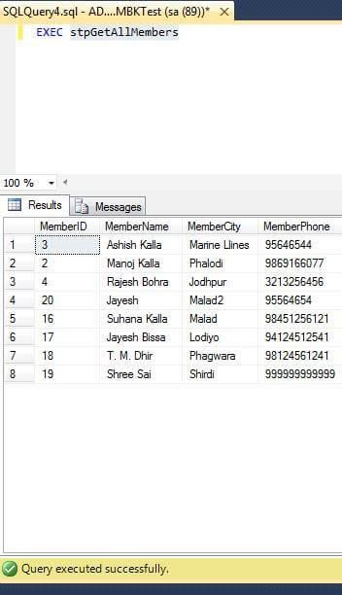

**What are parameters in stored procedures?**

Parameters in SPs are used to pass input values and return output values. There are two types of parameters:

1. Input parameters - Pass values to a stored procedure.
2. Output parameters - Return values from a stored procedure.

# How to create a SELECT query SP with parameters?

In the previous steps, we created a simple SP that returned all rows from a table. Now, let's create a new SP that will take a city name as an inpurt parameter and will return all rows where city name matches the input parameter value.

Here is the updated SP with a parameter @CityName.

|  |
| --- |
| 1. **SET** ANSI_NULLS **ON** |
| 2. GO |
| 3. **SET** QUOTED_IDENTIFIER **ON** |
| 4. GO |
| 5. -- ============================================= |
| 6. -- Author: Muhammad Ahmad |
| 7. -- Create date: 21-Nov-2024 |
| 8. -- Description: Delete a Member by Member ID |
| 9. -- ============================================= |
| 10. **CREATE PROCEDURE** stpGetMembersByCityName |
| 11. -- Add the parameters for the stored procedure here |
| 12. @CityName nvarchar(30) |
| 13. |
| 14. **AS** |
| 15. **BEGIN** |
| 16. -- SET NOCOUNT ON added to prevent extra result sets from |
| 17. -- interfering with SELECT statements. |
| 18. **SET** NOCOUNT **ON**; |
| 19. |
| 20. **Select** * **From** tblMembers |
| 21. **where** MemberCity like '%'+@CityName+'%' |
| 22. |
| 23. **END** |
| 24. GO |

Execute it.

To run this SP, type the following command in SQL query tool:

*EXEC GetMemberByCityName @CityName = 'mal'*

OR from the UI, run the SP and provide the following input.

The code to execute looks like the following:

1. USE [MBKTest] 3.

5.

7.

@CityName = N'mal'

9. **SELECT** 'Return Value' = @return_value

11. GO

10.

8.

6. **EXEC** @return_value = [dbo].[GetMemberByCityName]

4. **DECLARE** @return_value **int**

2. GO

# OUTPUT

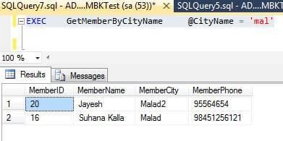

**How to create a INSERT query based stored procedure?**

We can use an INSERT INTO SQL query to insert data into a table. The following SQL statement creates an INSERT SP with three parameters.

1. **SET** ANSI_NULLS **ON**
2. GO
3. **SET** QUOTED_IDENTIFIER **ON**
4. GO

5. -- =============================================

|  |
| --- |
| 6. -- Author: Muhammad Ahmad |
| 7. -- Create date: 21-Nov-2024 |
| 8. -- Description: Delete a Member by Member ID |

1. **CREATE PROCEDURE** stpInsertMember
2. @MemberName **varchar**(50),
3. @MemberCity **varchar**(25),
4. @MemberPhone **varchar**(15) 14.
5. **AS**
6. **BEGIN**
7. -- SET NOCOUNT ON added to prevent extra result sets from
8. -- interfering with SELECT statements.
9. **SET** NOCOUNT **ON**; 20.
10. **Insert into** tblMembers (MemberName,MemberCity,MemberPhone)
11. **Values** (@MemberName,@MemberCity, @MemberPhone) 23.
12. **END**
13. GO

Right click on stored procedure in Object Explorer and select Refresh.

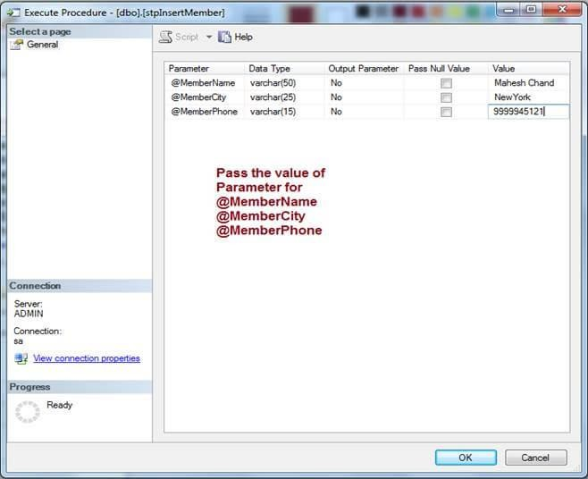

The following code can be used to execute this SP in SSMS.

1. USE [MBKTest] 3.

5.

7.

@MemberName = N'Mahesh Chand',

9.

@MemberPhone = N'9999945121'

11. GO

10. **SELECT** 'Return Value' = @return_value

@MemberCity = N'NewYork',

8.

6. **EXEC** @return_value = [dbo].[stpInsertMember]

4. **DECLARE** @return_value **int**

2. GO

# OUTPUT

In the query window, you can check if a new record for Member Name 'Mahesh Chand' is added to the table.

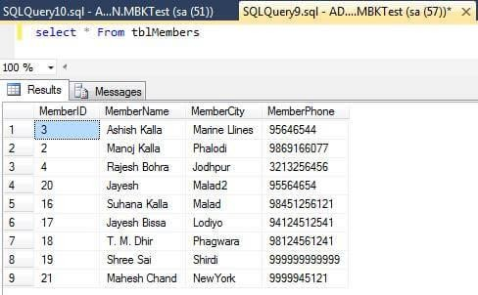

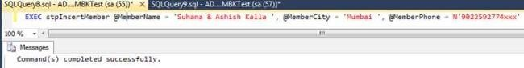

# OUTPUT

You can check “Suhana & Ashish Kalla” record is added successfully.

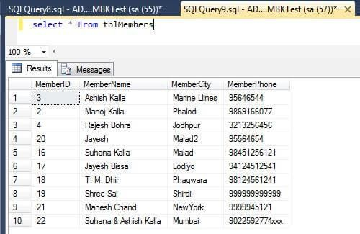

# How to create an UPDATE quert based stored procedure?

Let's create a new SP that will update a table records based on the Member ID column. The ID is passed as an input parameter. Here is the new SP that uses an UPDATE..SET..WHERE command.

1. **SET** ANSI_NULLS **ON**
2. GO
3. **SET** QUOTED_IDENTIFIER **ON**
4. GO

5. -- =============================================

1. -- Author: Manoj Kalla
2. -- Create date: 20-Nov-2017
3. -- Description: Update a member detail by ID

9. -- =============================================

1. **CREATE PROCEDURE** stpUpdateMemberByID
2. @MemberID **int**,
3. @MemberName **varchar**(50),
4. @MemberCity **varchar**(25),
5. @MemberPhone **varchar**(15) 15.
6. **AS**
7. **BEGIN**
8. -- SET NOCOUNT ON added to prevent extra result sets from
9. -- interfering with SELECT statements.
10. **SET** NOCOUNT **ON**; 21.
11. **UPDATE** tblMembers
12. **Set** MemberName = @MemberName,

|  |
| --- |
| 24. MemberCity = @MemberCity, |
| 25. MemberPhone = @MemberPhone |
| 26. **Where** MemberID = @MemberID |
| 27. **END** |
| 28. GO |

Right click on stored procedure in the Object Explorer and select Refresh. You will see the SP is created.

Now, Right click on SP name and select Execute stored procedure…. Provide the input values and execute.

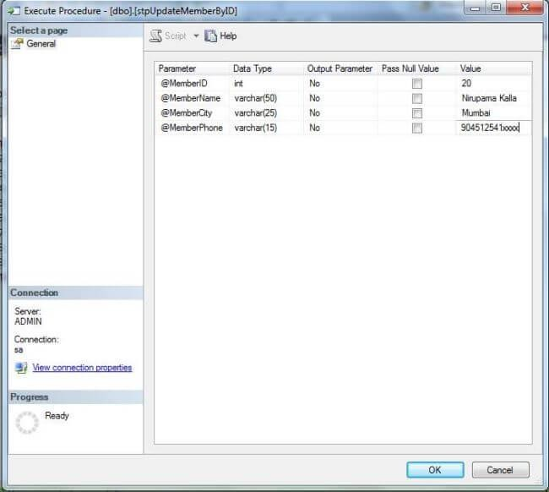

5. -- =============================================

|  |
| --- |
| 6. -- Author: Muhammad Ahmad |
| 7. -- Create date: 21-Nov-2024 |
| 8. -- Description: Delete a Member by Member ID |
| 9. -- ============================================= |
| 10. **CREATE PROCEDURE** stpDeleteMemberByMemberID |
| 11. @MemberID **int** |
| 12. **AS** |
| 13. **BEGIN** |
| 14. -- SET NOCOUNT ON added to prevent extra result sets from |
| 15. -- interfering with SELECT statements. |
| 16. **SET** NOCOUNT **ON**; |
| 17. |
| 18. **Delete from** tblMembers |
| 19. **where** MemberId = @MemberID |
| 20. |
| 21. **END** |
| 22. GO |

Execute it.

Right click on Stored Procedures in the Object Explorer and select Refresh.

# RUN stored procedure BY UI

Now again right click on stored procedure and select Execute stored procedure…

As you can see in the image, I passed @MemberID parameter value = 4.

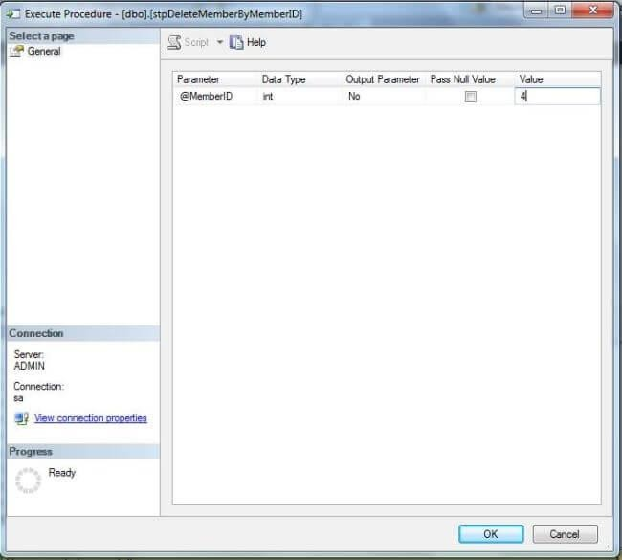

# RUN DELETE stored procedure BY MANUALLY (CODING)

*EXEC stpDeleteMemberByMemberID 2*

# OUTPUT

You can see in image MemberID = 4 record has been deleted successfully.

