Robust Voltage Control of Two-Phase Interleaved Boost Converter for Fuel Cell Systems

|  |  |  |  |
| --- | --- | --- | --- |
| Melisa Miranda  *Electronics and communication engineering.*  *PES University* Bangalore, India [melisamiranda@pes.edu](mailto:melisamiranda@pes.edu) | M Chetan  *Electronics and communication engineering.* *PES University*  Bangalore, India  [chetanmarukumbi1@gmail.com](mailto:chetanmarukumbi1@gmail.com) | Nichol Samarth Dsouza    *Electronics and communication engineering.*  *PES University*  Bangalore, India  [dsouzanichol@gmail.com](mailto:dsouzanichol@gmail.com) | N P Chetan   *Electronics and communication engineering.*  *PES University*  Bangalore, India  [npchetan@pesu.pes.edu](mailto:npchetan@pesu.pes.edu) |

***Abstract* — *The paper proposes the design and simulation of a Two-phase interleaved boost converter employing a PID controller. The main objective of the proposed DC-DC boost converter is to maintain a constant output voltage despite variations in source voltage and input current. The DC-DC boost converter has been modeled and simulated using MATLAB Simulink. The PID controller has been discussed in brief and steady-state analysis is carried out. The output voltage control of two-phase interleaved boost converter using PID controller is modeled and simulated using MATLAB Simulink***

***Keywords — Two-phase interleaved boost converter, PID control, DC-DC converter, Fuel Cell (FC) systems, steady-state analysis***

# Introduction

Non-renewable energy resources such as coal and petroleum are causing a major threat to the environment (Global warming) due to the release of harmful gases such as SO2 and Nitrogen Oxides in vehicles [1]. Therefore, it is important to look for alternative sources of energy in order to combat global warming and reduce our dependence on fossil fuels.

Renewable energy sources represented by solar panels, wind turbines, and fuel cells get more and more attention. Large industries are investing hugely in various sectors such as electronics, power vehicles, cell phones, space vehicles where usage of renewable energy is currently being implemented. Fuel cells attract industries as they generate portable electrical energy, static electric power, and weak harmful gas emission [2].

A fuel cell uses the chemical energy of hydrogen or another fuel to produce electrical energy from an electrochemical reaction with an oxidant (air or oxygen). The byproducts are water, heat, and depending on the fuel source, very small amounts of nitrogen dioxide. Fuel cells are similar to batteries since they both produce a DC voltage by using an electrochemical process [3], but differ as fuel cells require continuous addition of fuel and oxidants.

The fuel cell efficiency is normally low. But when the heat released is taken in a cogeneration scheme [4], the efficiency is improved rapidly.

But due to its slow dynamic and low output voltage [6] fuel cells are yet to be commercialized. To overcome these constraints, several cells should be connected in series and the output voltage should be passed to DC/DC boost converter to boost the voltage. An interleaved boost converter is considered to be one of the best solutions for voltage conversion in fuel cell systems as its efficiency is high [5]. Its main advantages and key features are as follows.

1. Fewer ripples at output current.
2. Current Improvement/smoothing.
3. Advanced current synthesizer for superior efficiency, accurate current sensing, and high power factor.
4. Applicable at high initial torque if required.
5. Stress reduction on MOSFET operation.

In the converters, the MOSFETs are subjected to continuous and fast switching operations so as to provide a high output voltage. Due to this operation, non-linearity arises in the system, and steady-state error increases. The efficiency, performance, and stability of the overall system gradually decreases, so as to overcome this issue a control scheme has to be designed. To design a good control scheme the following control goals should be considered.

1. Constant converter output voltage.
2. Equal current sharing between modules.
3. Avoid overloading of the resistive loads.
4. To reduce the non-linear characteristics of the overall system.

In the research conducted over the years, many control schemes based on Direct Pole Placement [7], current-mode control [7], voltage mode control, PI control, PID control have been proposed. Similarly, in recent years MPC (Model Predictive Control) algorithm is being studied by researchers for its robustness. Several optimization techniques such as Genetic Algorithm [8], PSO (Particle Swarm Optimization) [9] have also been studied.

In this paper, the output voltage of the proposed DC-DC boost converter has been controlled using PID Controller. The PID control algorithm is a robust and simple algorithm that is widely used in the industry. The algorithm has sufficient flexibility to yield excellent results in a wide variety of applications and has been one of the main reasons for the continued use over the years. The PID controller has been dominant among other control techniques due to its fast warm-up time, accurate set point temperature control, and fast reaction to disturbances. It’s basically a combination of proportional, integral, and derivative control strategies. It manipulates variables like speed, pressure, and temperature. PID controller has to be tuned in several ways for application in the real-time industrial process [10].

**A**

# IBC Working and Modeling

## Working of 2-phase IBC

An interleaved boost converter is basically a set of conventional boost converters connected in parallel where 2-phase implies that there are two boost converters connected in parallel with a single input and single load as shown in Fig. 1. Both these phases have switches (*S1* and *S2*) which take care of charging and discharging of each phase. These two switches are turned on and off alternatively in order to charge each phase alternatively and discharge the other simultaneously through 180o phase-shifted PWM signals *u1* and *u2*. This process makes sure that there is a constant voltage across the load. Finally, the capacitor helps to filter out the AC components or voltage ripples and helps to maintain a constant DC current across the load. For this paper, the converter is operating in continuous conduction mode (CCM), which means that the current in both the inductors is always positive.

* 1. *Modes of Operation*

There are basically four modes of operation for a 2-phase IBC, in which only two modes (mode2 and mode3) are significant as these are the ones that contribute to the step-up property of 2-phase IBC.

Mode1: in this mode both S1 and S2 are off, which implies that both control signals u1 and u2 are 0. This means that both the phase are discharging and currents in both the inductors are decreasing

Mode2: in this mode switch *S1*is on and *S2* is off which means control signals *u1* and *u2* are 1 and 0 respectively. In this state, phase one is charging and phase two is discharging, which means that phase two is contributing to the voltage across the load. Diode *D1*is reverse biased and diode *D2* is forward biased. Current in inductor *L1* is increasing linearly while current in inductor *L2* is decreasing linearly.

Mode3: in this mode switch *S1* is off and *S2* is on which means control signals *u1*and *u2*are 0 and 1 respectively. In this state, phase two is charging and phase one is discharging, which means that phase one is contributing to the voltage across the load. Diode *D2* is reverse biased and diode *D1* is forward biased. Current in inductor *L2* is increasing linearly while that in inductor *L1* is decreasing linearly.

Mode4: in this mode both *S1* and *S2* are on, which implies that both control signals *u1* and *u2* are 1. This means that both the phases are charging and currents in both the inductors are increasing.

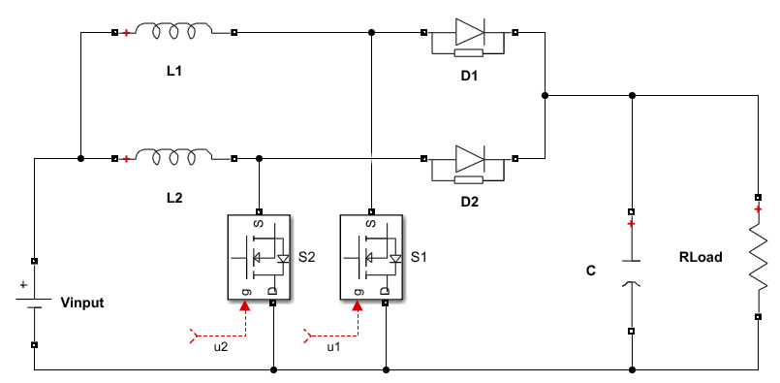

A

1. 2-phase Interleaved Boost Converter(IBC)

The equations for characteristics of inductor currents in any mode can be obtained by substituting the values for control signals (*u1* and *u2*) in (1) and (2) for the respective modes.

## Mathematical Modeling of 2-Phase IBC

By applying Kirchoff’s voltage law across the 2-phases, the following differential equations are obtained

(1)

(2)

*u1* and *u2* are the control signals given to the switches(MOSFETs) which can take either value ‘1’or ‘0’.When they 1, the last term *VLoad* becomes zero, and when they are 0, *VLoad*included in the equation.

By applying Kirchoff’s current law at node A, the following differential equations are obtained

$C\frac{{dV}_{Load}}{dt}=(1-u_{1})i_{L1}+(1-u_{2})i_{L2}-\frac{V_{Load}}{R_{Load}}$ (3)

A detailed derivation of (1), (2), and (3) is given in [11]

* 1. *2-Phase IBC Without Controller*

A graph that compares input voltage and output voltage for 2-phase IBC without a controller, with parameters in table I is given in Fig. 2. It can be observed from Fig. 2 that even though the voltage is stepped up, the overshoot of the output voltage is very high and there are also some ripples in the output voltage. These drawbacks can be overcome by using a controller for the converter.

|  |  |  |
| --- | --- | --- |
| **S. no** | **Parameters for an IBC** | **Values** |
| 1. | Input Voltage | 150 V |
| 2. | Output Voltage | 300 V |
| 3. | Load Resistance | 40 ohms |
| 4. | Capacitance | 1100 micro farad |
| 5. | Inductance of L1 & L2 | 757 micro henry |
| 6. | Switching Frequency | 20 kHz |
| 7. | Duty ratio | 0.50 |
| 8. | Phase Shift | 1800 |

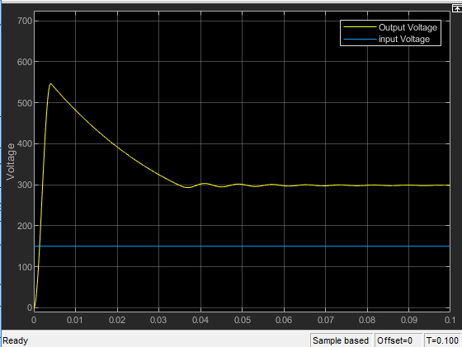

1. Input and output voltage

# PID Controller

* 1. *Overview of PID Controller*

PID control is one of the simplest and most widely used control algorithms. The popularity of PID controllers is due to its robust performance in a wide range of operating conditions and its functional simplicity. PID stands for proportional (P), integral (I), and derivative (D) controller. Fig. 3 shows the block diagram of a classical PID controller, where *R(t)* is the Reference signal or in this case reference voltage, *Vo(t)* is the output of the closed-loop system, *e(t)* is the error signal, *u(t)* is the control signals given to the plant(converter). The time-domain representation of the signal *u(t)* which is the output of the PID controller and the transfer function of the closed-loop system (in Laplace domain) are shown below

$u\left(t\right)=K_{p}e\left(t\right)+K_{i}\int{e\left(t\right)dt}+K_{d}\frac{de(t)}{dt}$ (4)

$L\left(s\right)=K_{p} + \frac{K_{i}}{s }+K_{d}s$ (5)

Where *Kp* is Proportional gain, *Ki* is integral gain, *Kd* is derivative gain, *e(t)* is error signal, *u(t)* is Output signal of PID controller and, *t* is instantaneous time.

Applications of PID controller based control system in industries include smoke machines, industrial ovens, improved performance of AVR ( Automatic Voltage Regulator)[14], speed controlling of DC motors [14] and power system stability, etc.

## Components of PID Controller

There are three components of the PID controller

* Proportional Response
* Integral Response
* Derivative Response

The proportional component, $K_{p}e\left(t\right)$ depends only on the error term i.e. difference between the set point (desired output) and process variable (current stage output). In general increasing, the proportional gain will increase the speed of the control system response up to a certain limit and the system becomes unstable and starts to oscillate if the limit is crossed.

1. Classical PID controller schematic

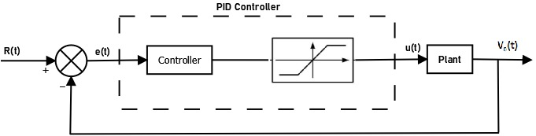

The task of the integral component $K_{i}\int{e\left(t\right)dt}$ is to calculate the sum of errors over time. The integral component increases continuously even when there is a small error term until the steady-state error is driven to zero.

Steady-state error is the difference between the set point and the process variable.

The derivative component $K_{d}\frac{de(t)}{dt}$ causes the output to decrease if the process variable is increasing rapidly. The derivative component is proportional to the rate of change of process variable increasing which causes the control system to react more strongly to the changes in the error term and hence will increase the speed of the overall control system response. If the control system response rate is too slow or noisy, the derivative response can make the control system unstable.

In literature, many of the controllers have been proposed based only on Proportional Integral [12] and Proportional Derivative [13]. In the case of a derivative controller, the steady-state error persists, and in the case of an integral controller, the stability problem is common. If we want a fast response, small overshoot, and no steady-state error neither PI nor PD will suffice. So the PID controller takes into account the above-specified problems and produces an output which is the combination of the outputs of proportional integral and derivative controller.

Effect of proportional, integral and derivative control on closed loop system is summarized in the table II.

|  |  |  |  |  |
| --- | --- | --- | --- | --- |
|  | Rise Time | Over shoot | Settling Time | Steady State Error |
| Proportional | Decrease | Increase | Small Change | Decrease |
| Integral | Decrease | Increase | Increase | Decrease/ Eliminate |
| Derivative | Small Change | Decrease | Decrease | Small Change |

References

1. Yao Baojun, Liu Yanxia, Cheng Jun and Xu Jing, "Air quality and environmental pollution analysis in Qinhuangdao city," *World Automation Congress 2012*, Puerto Vallarta, Mexico, 2012, pp. 1-3.
2. C. Raga *et al*., "Black-Box Model, Identification Technique and Frequency Analysis for PEM Fuel Cell With Overshooted Transient Response," in *IEEE Transactions on Power Electronics*, vol. 29, no. 10, pp. 5334-5346, Oct. 2014, doi: 10.1109/TPEL.2013.2292599
3. Ayad, M.Y., Becherif, M. and Henni, A., 2011. Vehicle hybridization with fuel cell, supercapacitors and batteries by sliding mode control. *Renewable Energy*, *36*(10), pp.2627-2634.
4. Guaitolini, Stefani Vanussi Melo, Imene Yahyaoui, Jussara Farias Fardin, Lucas Frizera Encarnação, and Fernando Tadeo. "A review of fuel cell and energy cogeneration technologies." In *2018 9th International renewable energy congress (IREC)*, pp. 1-6. IEEE, 2018.
5. El Fadil, Hassan, Fouad Giri, J. M. Guerrero, M. Haloua, and A. Abouloifa. "Advanced control of interleaved boost converter for fuel cell energy generation system." *IFAC Proceedings Volumes* 44, no. 1 (2011): 2803-2808.
6. Saadi, R., Bahri, M., Ayad, M.Y., Becherif, M., Kraa, O. and Aboubou, A., 2014, November. Implementation and dual loop control of two phases interleaved boost converter for fuel cell applications. In *3rd International Symposium on Environmental Friendly Energies and Applications (EFEA)* (pp. 1-7). IEEE.
7. N. Bajoria, P. Sahu, R. K. Nema and S. Nema, "Overview of different control schemes used for controlling of DC-DC converters," *2016 International Conference on Electrical Power and Energy Systems (ICEPES)*, Bhopal, 2016, pp. 75-82, doi: 10.1109/ICEPES.2016.7915909
8. K. F. Man, K. S. Tang and S. Kwong, "Genetic algorithms: concepts and applications [in engineering design]," in *IEEE Transactions on Industrial Electronics*, vol. 43, no. 5, pp. 519-534, Oct. 1996, doi: 10.1109/41.538609.
9. Mei-Ping Song and Guo-Chang Gu, "Research on particle swarm optimization: a review," *Proceedings of 2004 International Conference on Machine Learning and Cybernetics (IEEE Cat. No.04EX826)*, Shanghai, China, 2004, pp. 2236-2241 vol.4, doi: 10.1109/ICMLC.2004.1382171.
10. Rajkumar, SM Giri, Atal A. Kumar, and N. Anantharaman. "Application of Genetic Algorithm for Tuning of a PID Controller for a Real Time Industrial Process." *Sensors & Transducers* 121, no. 10 (2010): 56.
11. Phyo, Yin Yin, and Tun Lin Naing. "Modeling and Simulation of Two-Phase Interleaved Boost Converter Using Open-Source Software Scilab/Xcos." *International Journal of Electrical and Computer Engineering* 12, no. 10 (2018): 766-771.
12. Dogruer, T. and Tan, N., 2018. Design of PI controller using optimization method in fractional order control systems. *IFAC-PapersOnLine*, *51*(4), pp.841-846.
13. Salem, Farhan A., and Ayman A. Aly. "PD Controller Structures: Comparison and Selection for an Electromechanical System." *International Journal of Intelligent Systems and Applications* 7, no. 2 (2015): 1.
14. Nouman, K., Asim, Z. and Qasim, K., 2018, May. Comprehensive Study on Performance of PID Controller and its Applications. In *2018 2nd IEEE Advanced Information Management, Communicates, Electronic and Automation Control Conference (IMCEC)* (pp. 1574-1579). IEEE.

**IEEE conference templates contain guidance text for composing and formatting conference papers. Please ensure that all template text is removed from your conference paper prior to submission to the conference. Failure to remove template text from your paper may result in your paper not being published.**