Robust Voltage Control of Two-Phase Interleaved Boost Converter for fuel cell Systems

|  |  |  |  |
| --- | --- | --- | --- |
| Melisa Miranda  *Electronics and communication engineering.*  *PES University* Bangalore, India [melisamiranda@pes.edu](mailto:melisamiranda@pes.edu) | M Chetan  *Electronics and communication engineering.*  *PES University*  Bangalore, India  [chetanmarukumbi1@gmail.com](mailto:chetanmarukumbi1@gmail.com) | Nichol Samarth Dsouza  *Electronics and communication engineering.*  *PES University*  Bangalore, India  [dsouzanichol@gmail.com](mailto:dsouzanichol@gmail.com) | N P Chetan *Electronics and communication engineering.*  *PES University*  Bangalore, India  [npchetan@pesu.pes.edu](mailto:npchetan@pesu.pes.edu) |

***Abstract* — This paper proposes the planning and simulation of a two-phase Interleaved Boost convertor (IBC) using a PID controller for a fuel cell system. The most objective of the planned DC-DC boost converter is to take care of a constant output voltage despite variations in supply (fuel cell system) voltage and input current. The two-phase IBC has been modeled and simulated using MATLAB Simulink. The PID controller has been discussed in brief and the system's stability analysis is carried out through the method of root locus. Using the PID controller, the output voltage of the two-phase interleaved boost converter is controlled and the waveforms are analyzed.**

***Keywords—Two-phase interleaved boost converter, PID control, DC-DC converter, Fuel Cell (FC) systems, stability analysis, root locus.***

# Introduction

Non-renewable energy resources such as coal and petroleum are causing a major threat to the environment (Global warming) due to the release of harmful gases such as SO2 and Nitrogen Oxides from vehicles [1]. It is therefore important to look for alternative energy sources. To combat global warming and decrease our reliance on fossil fuels,

Renewable energy sources represented by solar panels, wind turbines, and fuel cells get more and more attention. Large industries are investing hugely in various sectors such as electronics, power vehicles, cell phones, space vehicles where usage of renewable energy is currently being implemented. Fuel cells attract industries as they generate portable electrical energy, static electric power, and weak harmful gas emission [2].

The chemical energy of hydrogen or another fuel is used by a fuel cell to produce electrical energy from an electrochemical reaction. The by-products are water, heat, and very small amounts of nitrogen dioxide, depending on the fuel source. Fuel cells are similar to batteries because, using an electrochemical [3] process, they both generate a DC voltage, but differ because fuel cells require continuous addition of fuel and oxidants.

The fuel cell efficiency is normally low. But when the heat released is taken in a cogeneration scheme [4], the efficiency is improved rapidly.

But due to its slow dynamic and low output voltage [6] fuel cells are yet to be commercialized. To overcome these constraints, several cells should be connected in series and the output voltage should be passed to a DC/DC boost converter in order to increase the voltage. An interleaved boost converter is considered to be one of the best solutions for voltage conversion in fuel cell systems as its efficiency is high [5]. Its main advantages and key features are as follows.

1. Fewer ripples at output current.
2. Current improvement/smoothing.
3. Advanced current synthesizer for superior efficiency, precise current sensing, and high power factor.
4. Applicable at high initial torque if required.
5. Stress reduction on MOSFET operation.

In the converters, the MOSFETs are subjected to continuous and fast switching operations so as to provide a high output voltage. Due to this operation, non-linearity arises in the system, and steady-state error increases. The efficiency, performance, and stability of the overall system gradually decreases, so as to overcome this issue a control scheme has to be designed. To design a good control scheme the following control goals should be considered.

1. Output voltage of the converter is constant.
2. Current shared between the modules is equal.
3. Avoid overloading of the resistive loads.
4. To reduce the non-linear characteristics of the overall system.

In the research conducted over the years, many control schemes based on Direct Pole Placement [7], current-mode control [7], voltage mode control, PI control, PID control have been proposed. Similarly, in recent years MPC (Model Predictive Control) algorithm is being studied by researchers for its robustness. Several optimization techniques such as Genetic Algorithm [8], PSO (Particle Swarm Optimization) [9] have also been studied.

In this paper, the power source is considered to be a fuel cell. Usually the output voltage of a fuel cell is in the range of 0.6 and 0.7V, but any voltage can be achieved when a stack of fuel cells is used[16]. The output voltage of the proposed DC-DC boost converter has been controlled using PID Controller. The PID control algorithm is a robust, simple algorithm that is widely used in the industry. The algorithm has sufficient flexibility to deliver excellent results in a wide range of applications and has been one of the main reasons for continued use over the years. Among other control techniques, the PID controller is dominant due to its rapid warm-up time, accurate set temperature control point and rapid reaction to disturbances. It’s basically a combination of proportional, integral, and derivative control strategies. It manipulates variables like speed, pressure, and temperature. PID controller has to be tuned in several ways for application in the real-time industrial process [10].

**A**

# IBC Working and Modeling

## Working of Two-Phase IBC

An interleaved boost converter is a set of conventional boost converters connected in parallel where two-phase implies that there are two boost converters connected in parallel with a single input and single load as shown in Fig. 1. Both these phases have switches (*S1* and *S2*) which take care of the charging and discharging of each phase. These two switches are turned on and off alternatively in order to charge each phase alternatively and discharge the other simultaneously through 180o phase-shifted PWM signals *u1* and *u2*. This process ensures that there is a constant voltage across the load. Finally, the capacitor helps to filter out the AC components or voltage ripples and helps to maintain a constant DC current across the load. For this paper, the converter operates in continuous conduction mode (CCM), which means that the current in both the inductors is always positive.

## Modes of Operation

There are basically four modes of operation for a two-phase IBC, in which only two modes (mode2 and mode3) are significant as these are the ones that contribute to the step-up property of two-phase IBC.

Mode1: In this mode both *S1* and *S2* are off, which implies that both control signals u1 and *u2* are 0. This means that both the phases are discharging and currents in both the inductors is decreasing.

Mode2: In this mode switch *S1*is on and *S2* is off which means control signals *u1* and *u2* are 1 and 0 respectively. In this state, phase one is charging and phase two is discharging, which means that phase two is contributing to the voltage across the load. Diode *D1* is reverse biased and diode *D2* is forward biased. Current in inductor *L1* is increasing linearly while current in inductor *L2* is decreasing linearly.

Mode3: In this mode switch *S1* is off and *S2* is on which means control signals *u1* and *u2*are 0 and 1 respectively. In this state, phase two is charging and phase one is discharging, which means that phase one is contributing to the voltage across the load. Diode *D2* is reverse biased and diode *D1* is forward biased. Current in inductor *L2* is increasing linearly while that in inductor *L1* is decreasing linearly.

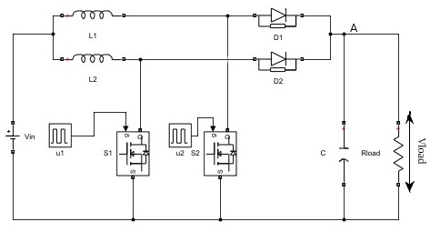

1. Two-Phase Interleaved Boost Converter(IBC)

Mode4: In this mode, both *S1* and *S2* are on, which implies that both control signals *u1* and *u2* are 1. This means that both the phases are charging and currents in both the inductors is increasing.

The equations for characteristics of inductor currents in any mode can be obtained by substituting the values for control signals (*u1* and *u2*) in (1) and (2) for the respective modes.

## Mathematical Modeling of Two-Phase IBC

By using Kirchhoff’s voltage law across the two-phases, the following differential equations are obtained.

$L1\frac{di_{L1}}{dt}=Vin−\left(1−u1\right)V_{C}$ (1)

$L2\frac{di_{L2}}{dt}=Vin−\left(1−u2\right)V_{C}$ (2)

*u1* and *u2* are the control signals given to the switches(MOSFETs) which can take either value ‘1’or ‘0’.When they are 1, the last term VC becomes zero, and when they are 0, VC is included in the equation. As the capacitor and the load resistor are connected in parallel, it can be said that VC=Vload.

By applying Kirchhoff’s current law at node A, the following differential equations are obtained.

$C\frac{{dV}_{C}}{dt}=\left(1−u1\right)i_{L1}+\left(1−u2\right)i_{L2}−\frac{V_{C}}{Rload}$ (3)

The detailed derivation of (1), (2), and (3) is given in [11]

## Transfer Function of Two-Phase IBC

The transfer function for two-phase IBC is given below; for the derivation of the transfer function, refer [15]. The values of *L1* and *L2* are considered equal and denoted by *L* and *D* is the duty cycle of the *u1* and *u2* control signals.

$\frac{Vload\left(s\right)}{Vin\left(s\right)}=\frac{1+s.Rload.C}{\left(1−D\right)\left[1+s\frac{L}{Rload{\left(1−D\right)}^{2}}+s^{2}\frac{LC}{{\left(1−D\right)}^{2}}\right]}$ (4)

## Two-Phase IBC without Controller

A graph that compares input voltage and output voltage for two-phase IBC without a controller, with parameters in Table I is given in Fig. 2. It can be observed from Fig. 2 that even though the voltage is stepped up, the overshoot of the output voltage is very high and there are also some ripples in the output voltage. These drawbacks can be overcome by using a controller for the converter. In

this paper, a PID controller is used to control the converter.

1. SIMULATION PARAMETERS FOR THE CONVERTER

|  |  |  |
| --- | --- | --- |
| **Sl. no** | **Parameters for an IBC** | **Values** |
| 1. | Input Voltage | 10 V |
| 2. | Output Voltage | 20 V |
| 3. | Load Resistance | 40 Ω |
| 4. | Capacitance | 1100 µF |
| 5. | Inductance of L1 & L2 | 757µH |
| 6. | Switching Frequency | 20 kHz |
| 7. | Duty ratio | 0.50 |
| 8. | Phase Shift | 1800 |

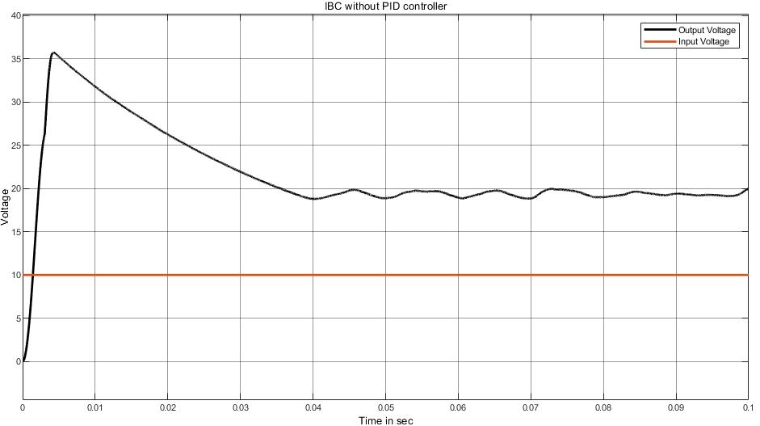

1. Input and output voltage waveform of two-phase IBC for Vin=10V

# PID Controller

## Description of PID Controller

The block diagram of a classic PID controller is shown in Fig. 3, where *R(t)* is the Reference signal or in this case reference voltage, *Vo(t)* is the output of the closed-loop system, *e(t)* is the error signal, *u(t)* is the control signals given to the plant (converter).The time-domain representation of the signal *u(t)* which is the output of the PID controller and the transfer function of the closed-loop system (in Laplace domain) are shown below

$u\left(t\right)=K_{p}e\left(t\right)+K_{i}\int{e\left(t\right)}dt+K_{d}\frac{de\left(t\right)}{dt}$ (5)

$L\left(s\right)=K_{p}+\frac{K_{i}}{s}+K_{d}s$ (6)

-----------------------------------------------------------

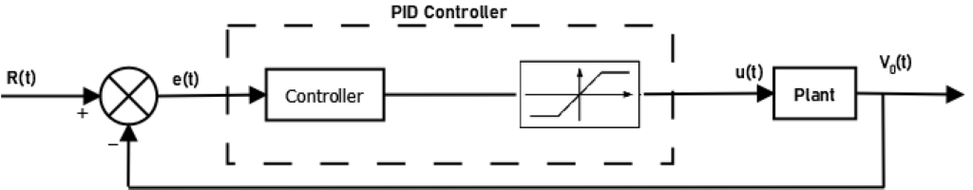

1. Schematic of classical PID controller

Applications of PID controller based control systems in industries include smoke machines, industrial ovens, improved performance of AVR (Automatic Voltage Regulator) [14], speed controlling of DC motors [14] and power system stability, etc.

## Components of PID Controller

There are three components of the PID controller

* Proportional Response
* Integral Response
* Derivative Response

The proportional component, $K_{p}e\left(t\right)$ depends only on the error term i.e. difference between the set point (desired output) and process variable (current stage output). In general, increasing the proportional gain will increase the speed of response of the control system up to a certain limit and the system becomes unstable and begins to oscillate if the limit is crossed.

The task of the integral component $K_{i}\int{e\left(t\right)}dt$ is to calculate the sum of errors over time. The integral component increases continuously even when there is a small error term until the steady-state error is driven to zero. Steady-state error is the difference between the set point and the process variable.

The derivative component $K_{d}\frac{de\left(t\right)}{dt}$ causes output to decrease if the process variable is increasing rapidly. The derivative component is proportional to the rate of change of the process variable, increasing which causes the control system to react more strongly to the changes in the error term and therefore increases the speed of the overall control system response. If the response rate of the control system is too slow or too noisy, the derivative response may make the control system unstable.

Many of the controllers have been proposed based only on Proportional Integral [12] and Proportional Derivative [13]. In the case of a derivative controller, the steady-state error persists, and in the case of an integral controller, the stability problem is common. If we want a fast response, small overshoot, and no steady-state error neither PI nor PD will suffice. So the PID controller takes into account the above-specified problems and produces an output which is the combination of proportional integral and derivative controller outputs.

Table II summarizes the effect of proportional, integral, and derivative controls on the closed-loop system.

1. EFFECT OF PID ON CLOSED-LOOP SYSTEM

|  |  |  |  |  |
| --- | --- | --- | --- | --- |
|  | **Rise Time** | **Over**  **shoot** | **Settling Time** | **Steady State Error** |
| **Proportional** | Decrease | Increase | Small Change | Decrease |
| **Integral** | Decrease | Increase | Increase | Decrease/ Eliminate |
| **Derivative** | Small Change | Decrease | Decrease | Small Change |

## Two- Phase IBC with PID Controller

Fig.4 shows the circuit of closed loop PID control of two-phase IBC in simulink. The steady state error decreases when the PID controller is integrated with the DC-DC converter . Hence, the system performance increases. As the proportional gain factor ki increases, the steady-state error decreases and nearly equals zero. The overshoot is reduced when the derivative gain factor kd is increased. Considering the effects of PID on the closed-loop system as mentioned in Table II, the gain values Kp, Ki, and Kd were found using the tuning feature available in MATLAB. The optimum value for the gains Kp, Ki, and Kd are shown in Table III.

1. PID GAIN VALUES

|  |  |
| --- | --- |
| **Parameter** | **Value** |
| *Kp* | 8.00 |
| *Ki* | 894.72 |
| *Kd* | 0.015 |

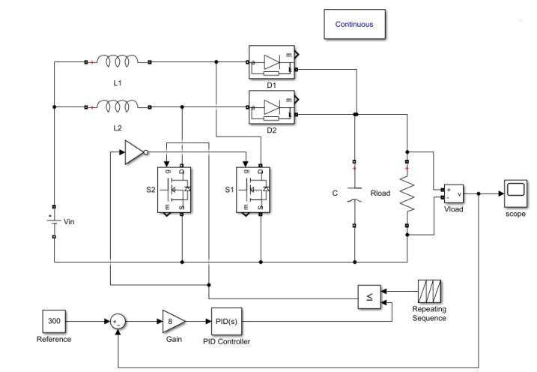

1. Simulink model of two-phase IBC with PID Controller

# STABILITY ANALYSIS

## Stability Analysis of Two- Phase IBC

In this paper, the stability of a two-phase IBC is tested using the root locus stability criterion. It’s a graphical technique where the poles and zeros of a closed loop system are plotted and stability is found out. The root locus plot of the proposed two-phase IBC is shown in Fig.5, it can be concluded that the proposed converter is stable as the poles and zeros lie on the left half of the s-plane.

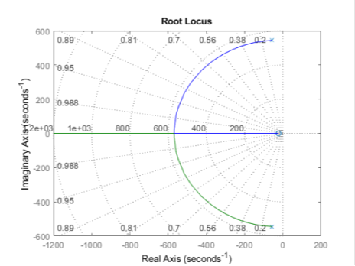

1. Root locus plot of two-phase IBC without PID controller

## Stability analysis of 2-Phase IBC with PID controller

Fig.6shows the root locus of the proposed converter with PID controller with valuesin Table Iand Table III for converter and controller respectively**.** From Fig.6, it can be concluded that the two-phase IBC with the PID controller is stable as the poles and zeros lie on the left half of the s-plane. The root locus plot has an equal number of poles and zeros, which are on the real axis.

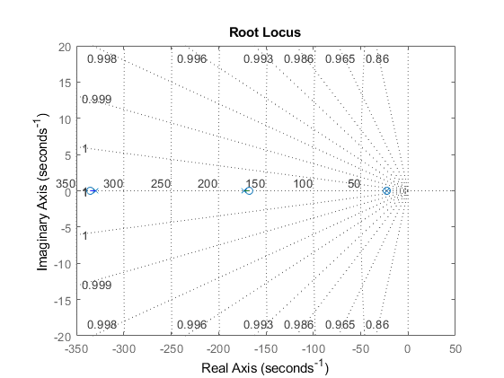

1. Root locus plot of two-phase IBC with PID controller

# SIMULATION RESULTS

Fig 7, 8, and 9 show the output voltage waveform of two-phase IBC without PID control for input voltages 5V, 10V, and 15V respectively. Fig 10, 11, 12 show the output voltage waveform of two-phase IBC with PID controller for input voltages 5V, 10V, and 15V respectively. Table IV shows the comparison of percentage overshoot and settling time of the two-phase IBC output waveform with and without the PID controller.

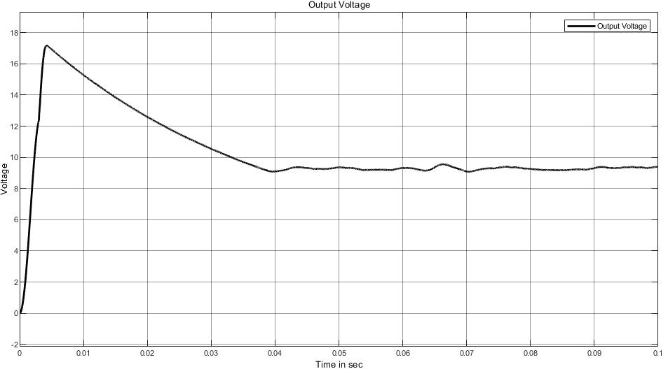

1. Output voltage without PID controller for Vin=5V

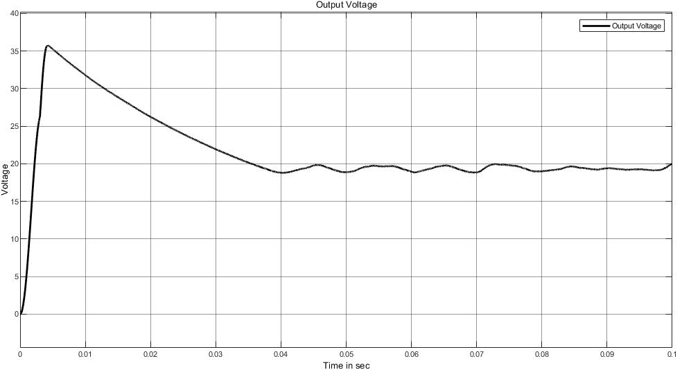

1. Output voltage without PID controller for Vin=10V

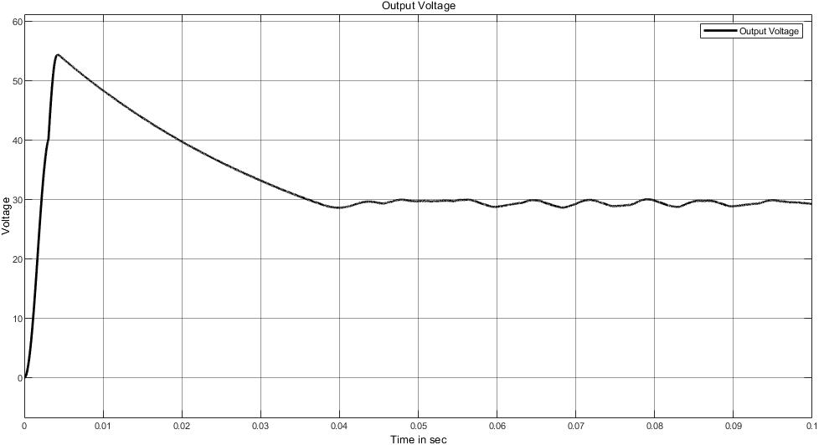

1. Output voltage without PID controller for Vin=15V

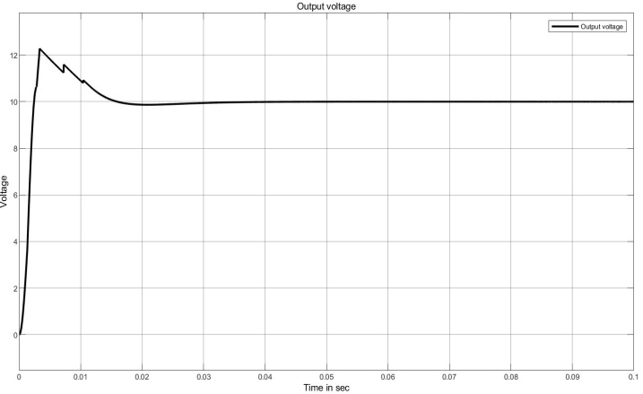

1. Output voltage with PID controller for Vin=5V

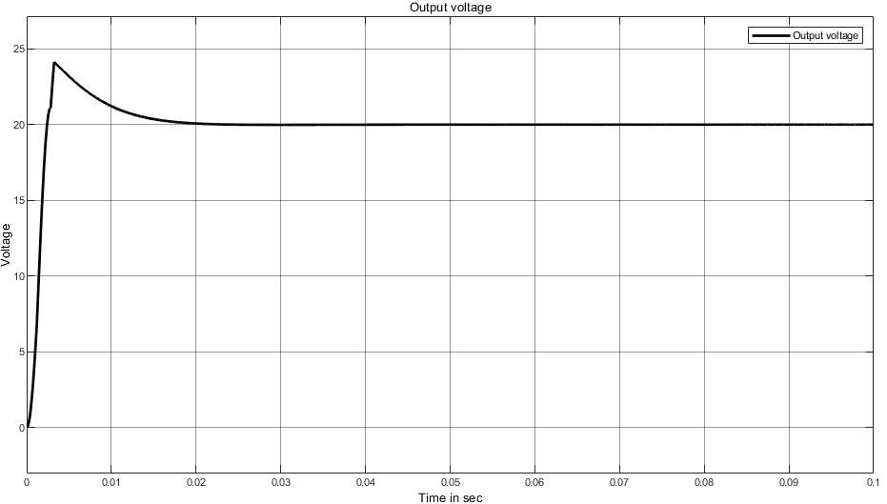

1. Output voltage with PID controller for Vin=10V

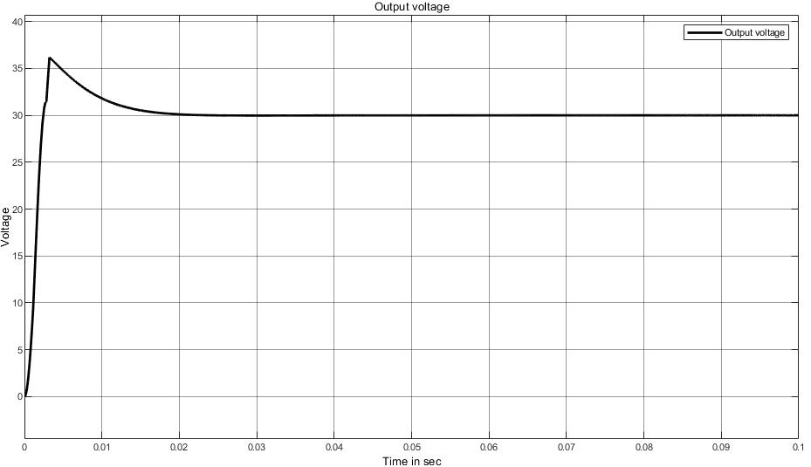

1. Output voltage with PID controller for Vin=15V
2. OBSERVATIONS

|  |  |  |  |  |  |
| --- | --- | --- | --- | --- | --- |
| **Input Voltage** | **Output Voltage** | **Percentage Overshoot(in %)** | | **Settling Time(in Seconds)** | |
|  |  | ***Without PID*** | ***With PID*** | ***Without PID*** | ***With PID*** |
| 5 V | 10 V | 84.26 | 22.84 | ∞ | 0.012 |
| 10 V | 20 V | 87.73 | 21.34 | ∞ | 0.014 |
| 15 V | 30 V | 84.26 | 21.34 | ∞ | 0.014 |

It can be observed that the maximum overshoot, settling time and ripples have been reduced satisfactorily when the PID controller is implanted in a closed loop.

# CONCLUSION

In this paper, closed loop control of a two-phase interleaved boost converter for fuel cell systems is presented. The system is first analyzed and the output voltage is found out. The output voltage has been controlled using a PID controller. The proposed model is simulated using numerous input voltage values and the corresponding output voltage waveforms are shown. The stability of the system is verified using root locus method. Simulation results illustrate that the output voltage’s overshoot and settling time has been reduced for a wide range of input voltages.

##### References

1. Yao Baojun, Liu Yanxia, Cheng Jun and Xu Jing, "Air quality and environmental pollution analysis in Qinhuangdao city," *World Automation Congress 2012*, Puerto Vallarta, Mexico, 2012, pp. 1-3.
2. C. Raga *et al*., "Black-Box Model, Identification Technique and Frequency Analysis for PEM Fuel Cell With Overshooted Transient Response," in *IEEE Transactions on Power Electronics*, vol. 29, no. 10, pp. 5334-5346, Oct. 2014, doi: 10.1109/TPEL.2013.2292599
3. Ayad, M.Y., Becherif, M. and Henni, A., 2011. Vehicle hybridization with fuel cell, supercapacitors and batteries by sliding mode control. *Renewable Energy*, *36*(10), pp.2627-2634.
4. Guaitolini, Stefani Vanussi Melo, Imene Yahyaoui, Jussara Farias Fardin, Lucas Frizera Encarnação, and Fernando Tadeo. "A review of fuel cell and energy cogeneration technologies." In *2018 9th International renewable energy congress (IREC)*, pp. 1-6. IEEE, 2018.
5. El Fadil, Hassan, Fouad Giri, J. M. Guerrero, M. Haloua, and A. Abouloifa. "Advanced control of interleaved boost converter for fuel cell energy generation system." *IFAC Proceedings Volumes* 44, no. 1 (2011): 2803-2808.
6. Saadi, R., Bahri, M., Ayad, M.Y., Becherif, M., Kraa, O. and Aboubou, A., 2014, November. Implementation and dual loop control of two phases interleaved boost converter for fuel cell applications. In *3rd International Symposium on Environmental Friendly Energies and Applications (EFEA)* (pp. 1-7). IEEE.
7. N. Bajoria, P. Sahu, R. K. Nema and S. Nema, "Overview of different control schemes used for controlling of DC-DC converters," *2016 International Conference on Electrical Power and Energy Systems (ICEPES)*, Bhopal, 2016, pp. 75-82, doi: 10.1109/ICEPES.2016.7915909
8. K. F. Man, K. S. Tang and S. Kwong, "Genetic algorithms: concepts and applications [in engineering design]," in *IEEE Transactions on Industrial Electronics*, vol. 43, no. 5, pp. 519-534, Oct. 1996, doi: 10.1109/41.538609.
9. Mei-Ping Song and Guo-Chang Gu, "Research on particle swarm optimization: a review," *Proceedings of 2004 International Conference on Machine Learning and Cybernetics (IEEE Cat. No.04EX826)*, Shanghai, China, 2004, pp. 2236-2241 vol.4, doi: 10.1109/ICMLC.2004.1382171.
10. Rajkumar, SM Giri, Atal A. Kumar, and N. Anantharaman. "Application of Genetic Algorithm for Tuning of a PID Controller for a Real Time Industrial Process." *Sensors & Transducers* 121, no. 10 (2010): 56.
11. Phyo, Yin Yin, and Tun Lin Naing. "Modeling and Simulation of Two-Phase Interleaved Boost Converter Using Open-Source Software Scilab/Xcos." *International Journal of Electrical and Computer Engineering* 12, no. 10 (2018): 766-771.
12. Dogruer, T. and Tan, N., 2018. Design of PI controller using optimization method in fractional order control systems. *IFAC-PapersOnLine*, *51*(4), pp.841-846.
13. Salem, Farhan A., and Ayman A. Aly. "PD Controller Structures: Comparison and Selection for an Electromechanical System." *International Journal of Intelligent Systems and Applications* 7, no. 2 (2015): 1.
14. Nouman, K., Asim, Z. and Qasim, K., 2018, May. Comprehensive Study on Performance of PID Controller and its Applications. In *2018 2nd IEEE Advanced Information Management, Communicates, Electronic and Automation Control Conference (IMCEC)* (pp. 1574-1579). IEEE.
15. Shenoy, K. Latha, C. Gurudas Nayak, and Rajashekar P. Mandi. "Design and implementation of interleaved boost converter." *International Journal of Engineering and Technology (IJET)* 9, no. 3S (2017).
16. Y. Huangfu, S. Zhuo, F. Chen, S. Pang, D. Zhao and F. Gao, "Robust Voltage Control of Floating Interleaved Boost Converter for Fuel Cell Systems," in IEEE Transactions on Industry Applications, vol. 54, no. 1, pp. 665-674, Jan.-Feb. 2018, doi: 10.1109/TIA.2017.2752686.