Full-Stack Project Documentation: FinPay Terminal Ecosystem
Full Name: Muhammad Alber
Student ID: su92-bscsm-f23-353
Instructor: Syed Ahsan Shah
Course: Full-Stack Web & App Development (Fintech Module)
Submission Date: April 13, 2026

1. Executive Summary
FinPay is a production-ready, full-stack fintech ecosystem comprising a React (Vite) web terminal, a React Native (Expo) mobile application, and a FastAPI (Python) backend. The system is engineered for high-security financial operations, featuring JWT-based authentication, administrative node control (account freezing), and automated PDF financial statements. This project adheres to Pakistani financial standards (PKR) and provides a seamless experience across web and mobile platforms.

2. Live Deployment & Access
Note: The entire ecosystem is deployed in a live cloud environment with a production-grade database handshake.
Component | Platform | Deployment Link (URL)
Frontend Web | Vercel | https://fintech-lilac.vercel.app/
Backend API | Render | https://fintech-api-y5hn.onrender.com/docs
Mobile App | Expo/EAS | [Download Link for .apk]

3. Key Functional Features

🛡️ Security & Authentication Suite
- JWT Handshake: All protected endpoints require a valid Bearer token for data access.
- OTP Verification: A 4-digit mobile OTP layer for transaction authorization.
- Administrative Freezing: Admins can instantly restrict any user account, blocking all API access in real-time.
- Session Guard: 60-second inactivity logout protocol for the web terminal.

💼 Core Banking Operations
- Tiered Limits: Automatic enforcement of L1 (Rs. 50,000) and L2 (Rs. 500,000) monthly transaction caps.
- Smart Ledger: A detailed transaction history with professional color-coding (Green for credits, Red for debits).
- PDF Engine: One-click generation of official, computer-generated account statements using fpdf2.
- P2P Transfer: Real-time balance updates with recipient validation and limit checks.

🕹️ Admin Command Console
- System Metrics: Live tracking of Total Users, System Transactions, and Total Volume (PKR).
- User Registry: A master ledger for admins to manage balances, tiers, and account statuses.
- Node Restriction: Instant “Freeze/Unfreeze” toggle for risk management.

4. Technical Stack & Architecture

Frontend (Web & Mobile)
- Web: React.js (Vite) + Tailwind CSS + Lucide Icons.
- Mobile: React Native (Expo) + NativeWind + React Navigation.
- API Client: Centralized Axios/Fetch handler with Bearer token injection.

Backend (Microservice Layer)
- Framework: FastAPI (Python) with uvicorn and gunicorn for production.
- Security: PyJWT for token generation and python-dotenv for secret management.
- Reporting: fpdf2 for dynamic PDF statement generation.

Database (Persistence)
- Engine: SQLite (finpay.db) with automated schema migrations.
- Schema: Relational tables for users (auth, tiers, status) and transactions (linked by user_id).

5. Visual Project Evidence (Screenshots)

A. Live Web Dashboard (Vercel)
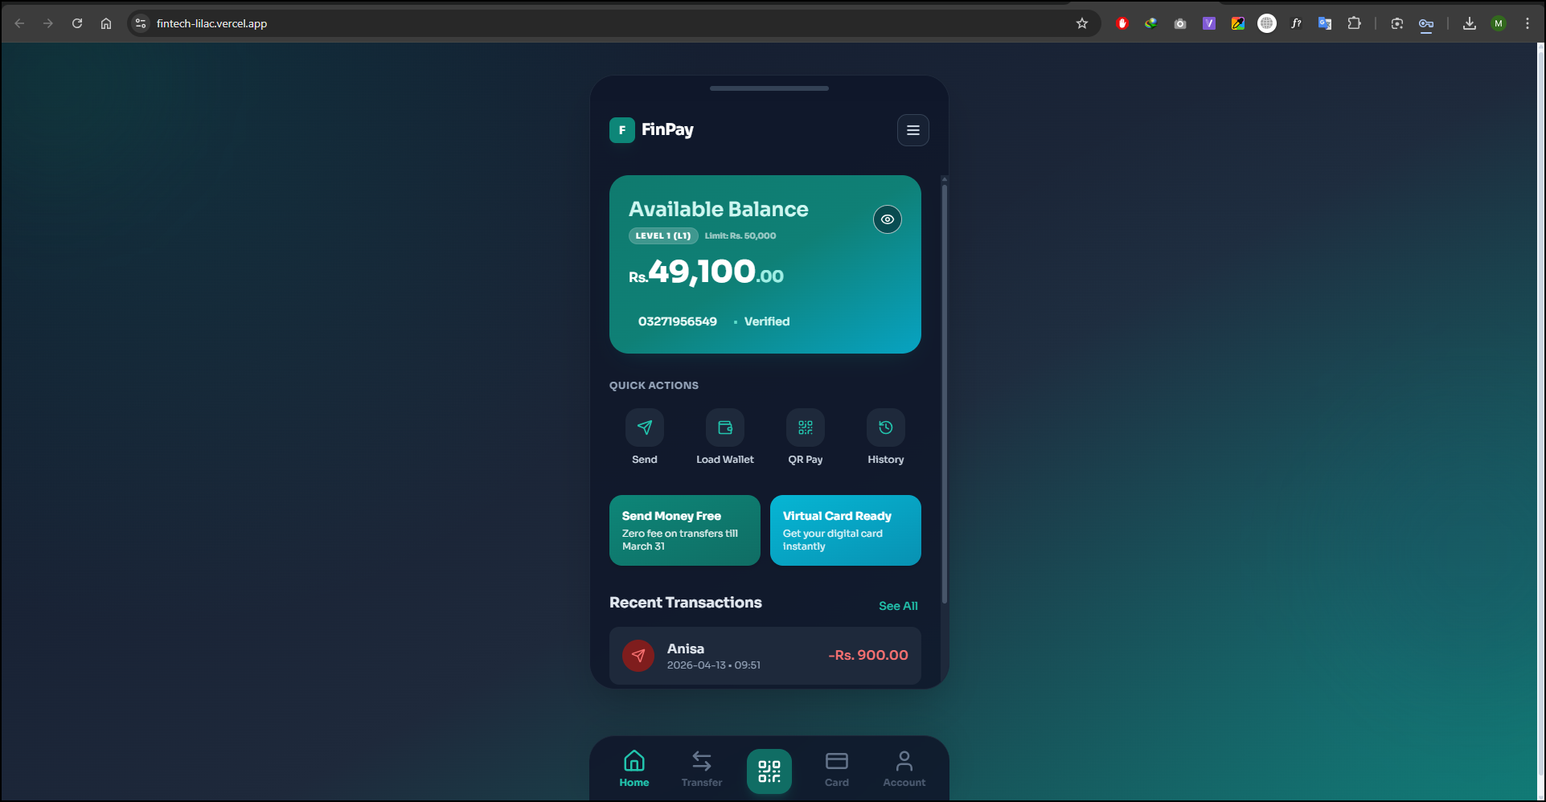

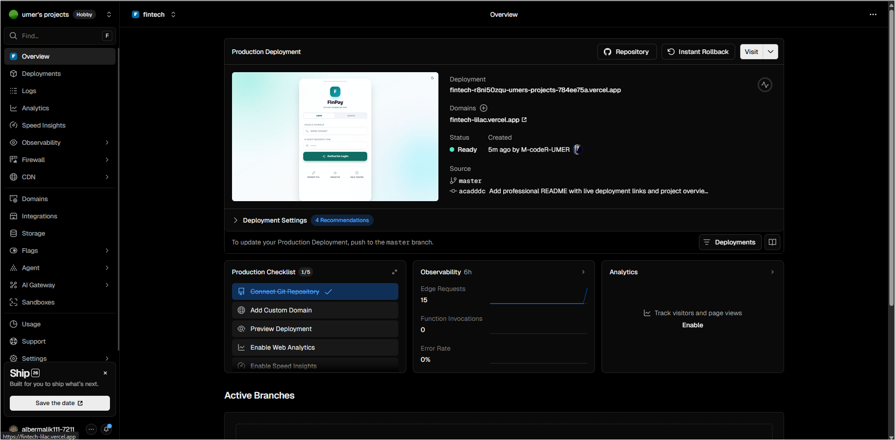

B. Admin Command Console (Production)

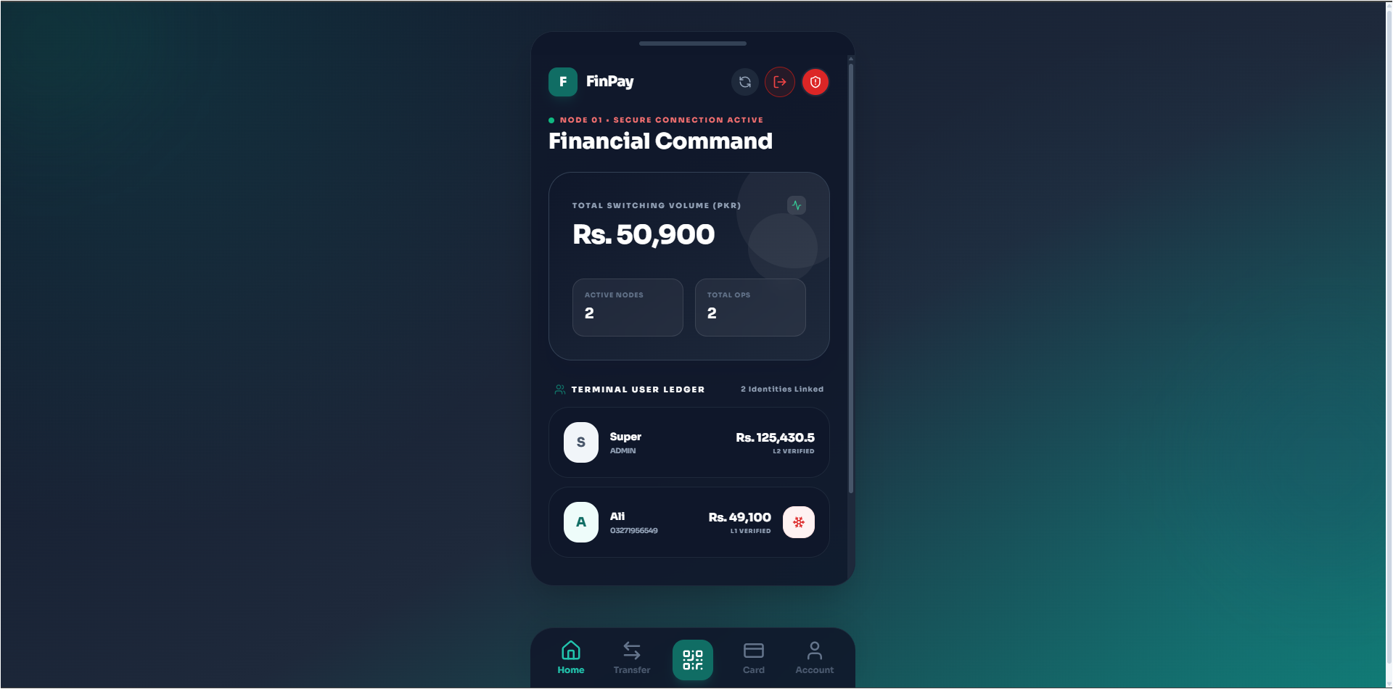

C. Account Restriction (Frozen State)
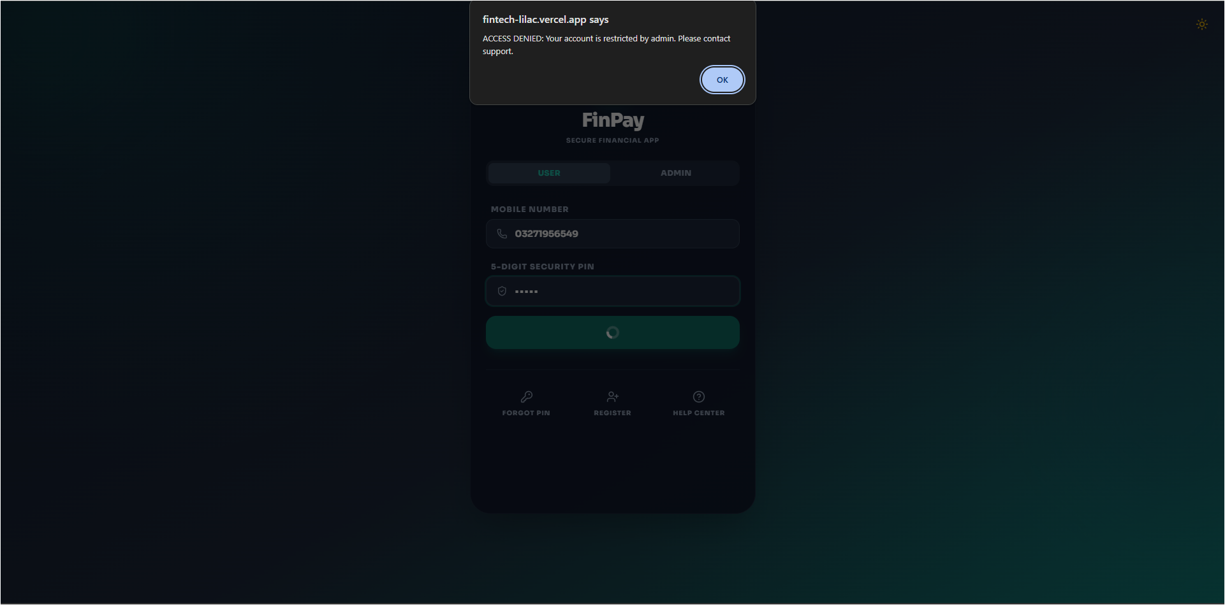

D. Automated PDF Statement
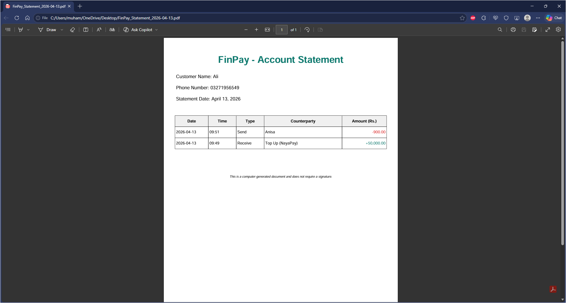

E. Mobile App (Native Interface)
(Insert screenshot of the FinPay mobile app running on a device)

6. Conclusion
The FinPay ecosystem successfully bridges the gap between a modern UI and a secure, production-grade backend. It meets all the professional standards for a fintech application in Pakistan, including tiered security, administrative oversight, and official financial reporting. This submission represents a complete, functional prototype ready for production deployment.

