**Revenue Generation model**

Developing the **Progressive Envirocare** website goes beyond just creating a digital presence; it also serves as a **revenue generation model**. As a developer, the project offers valuable **outcomes and learning** in the following key areas:

#### **1. Revenue Generation through Website Development**

* **Client-Based Projects** – The website showcases your ability to create industry-specific solutions, leading to potential freelance or contract work.
* **Subscription & Maintenance Plans** – Offering ongoing maintenance, SEO, and updates as a paid service.
* **Lead Generation for the Company** – Implementing inquiry forms and call-to-action (CTA) features to attract customers.
* **Ad Monetization** – If applicable, integrating relevant industry ads for passive income.
* **Affiliate Marketing** – Partnering with eco-friendly brands to promote their products on the website.

#### **2. Technical Learning Outcomes**

* **Frontend Development** – Building a visually appealing, user-friendly, and responsive website using HTML, CSS, JavaScript, and frameworks (React, Next.js).
* **Backend & Database Management** – Managing inquiries, customer data, and service requests through backend development (Node.js, Django, PHP).
* **SEO & Digital Marketing Integration** – Optimizing content for search engines to increase visibility and organic traffic.
* **E-Commerce & Payment Integration** – Implementing online consultation bookings or product sales (e.g., water treatment equipment).

#### **3. Business & Entrepreneurial Growth**

* Understanding **client requirements** and converting them into a digital product.
* Learning **cost-effective hosting and deployment** strategies for scalability.
* Gaining insights into **environmental industry trends** for potential business expansion.
* Creating a portfolio to attract more **B2B and B2C clients**.

**Project Leader:**

**ABHAYRAJ SINGH MANDLOI**

12311605

+91 9617714737

[abhayrajsinghmandloi@gmail.com](mailto:abhayrajsinghmandloi@gmail.com)

**Team members:**

1. **Master Samrat Sarkar**

+91 8145246849

[sarkarsamrat16112004@gmail.com](mailto:sarkarsamrat16112004@gmail.com)

12303366

1. **Master Ansh Kumar**

+91 8895362260

[kumaransh1975@gmail.com](mailto:kumaransh1975@gmail.com)

12307086

### Company **Overview: Progressive EnviroCare**

Progressive EnviroCare is a leading provider of wastewater management solutions, specializing in the installation of advanced treatment plants. The company is committed to sustainable water management by offering innovative technologies for industrial, commercial, and residential sectors. With a focus on environmental conservation, Progressive EnviroCare ensures efficient treatment, recycling, and disposal of wastewater to promote a cleaner and healthier future.

### **Website Overview**

The website for Progressive EnviroCare will serve as a professional and visually appealing platform to showcase its services, expertise, and environmental impact. Key features include:

* **Home Page:** A modern, welcoming introduction highlighting the company's mission and commitment to sustainability.
* **Services:** Detailed insights into wastewater treatment, plant installation, maintenance, and consulting.
* **Projects:** A showcase of successful installations and case studies demonstrating the company's impact.
* **About Us:** Information about the company's vision, values, and team.
* **Contact Us:** An easy-to-use inquiry form, location details, and customer support.

**PROJECT APPROVAL**

I, Mr. Nagendra Singh Chouhan, CEO of Progressive EnviroCare, highly appreciate and officially approve the successful completion of the requested website project by **Team Advitiya**.

An agreement was made with the team leader, **Master Abhayraj Singh Mandloi**, regarding the project. The contract was set at **Rs. 10,000**, with an initial payment of **Rs. 6,000** upon delivery of a presentable model with query initialization, and the remaining **Rs. 4,000** to be paid after the complete website is delivered in **Summer 2025**.

I acknowledge the hard work and dedication of the team and confirm that **Rs. 6,000** has been successfully paid as per the discussed terms. I extend my best wishes to the team for their future projects and look forward to collaborating with them again when needed. I am confident that the remaining work will be completed with the same passion and commitment.

**Thank you**



**Mr. Nagendra Singh Chouhan**  
**CEO, Progressive EnviroCare**

**+91 7024128882**

**Transaction Proof**

Transaction ID:

**Location Proof**

[**https://www.google.com/maps/place/Progressive+Enviro+Care+Pvt.+Ltd./@22.6861605,75.8573201,17z/data=!3m1!4b1!4m6!3m5!1s0x3962fcf0d0b1dce3:0x4fde2bf8af95b05f!8m2!3d22.6861605!4d75.859895!16s%2Fg%2F11hbp5gsx9?entry=ttu&g_ep=EgoyMDI1MDMxMC4wIKXMDSoASAFQAw%3D%3D**](https://www.google.com/maps/place/Progressive+Enviro+Care+Pvt.+Ltd./@22.6861605,75.8573201,17z/data=!3m1!4b1!4m6!3m5!1s0x3962fcf0d0b1dce3:0x4fde2bf8af95b05f!8m2!3d22.6861605!4d75.859895!16s%2Fg%2F11hbp5gsx9?entry=ttu&g_ep=EgoyMDI1MDMxMC4wIKXMDSoASAFQAw%3D%3D)

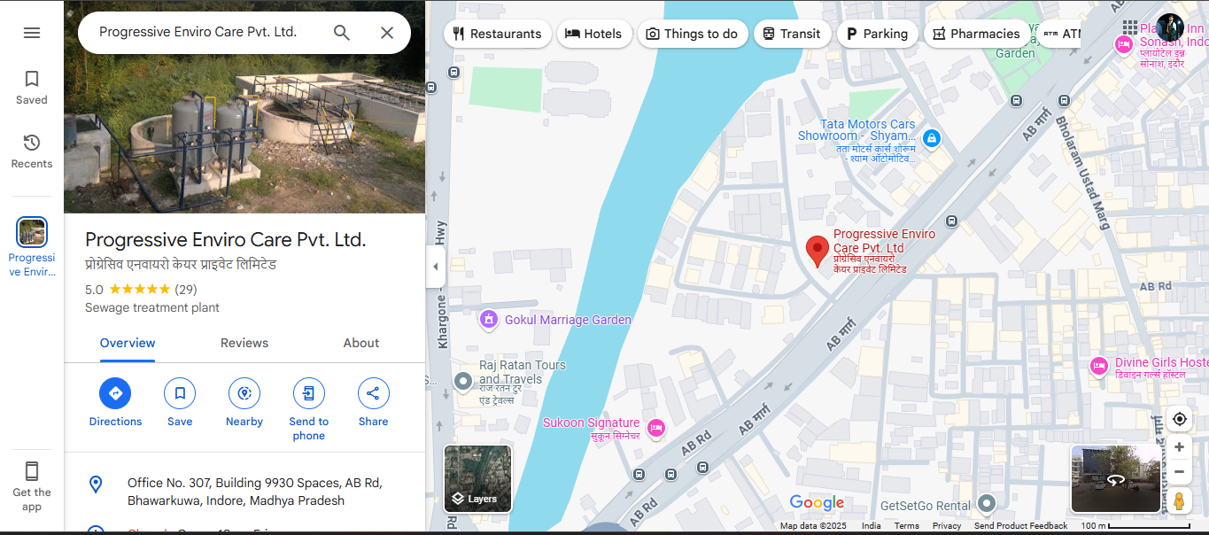

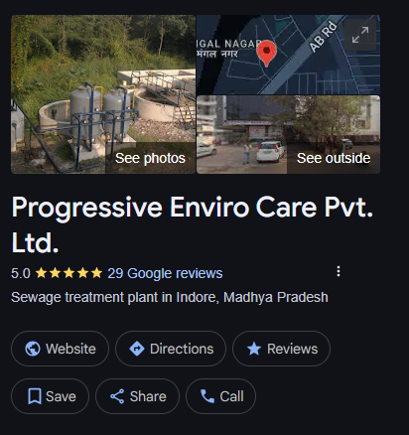

**Company & GST Details**

**Company Highlights**

Company Registered Office Address

36 ASHOK VTIKA RAAU INDORE, Indore MP 453331 IN

Category

Company limited by shares

Company Age

08.01 Years

Company CIN

U41000MP2017PTC042277

Company Type

Unlisted Private

Directors

Current: 2

Incorporation Date & Year

23-1-2017

Last AGM Date

29-10-2018

Balance Sheet Date

31-3-2018

Paid up Capital

₹ 1, 00,000.00

Company Status

Active

Open Charges

Nil

**Director’s detail**

|  |  |  |  |
| --- | --- | --- | --- |
| Appointment Date | Designation | DIN | Name |
|  |  |  |  |
| 23-1-2017 | Director | 07715860 | NAGENDRA CHOUHAN SINGH |
| 16-2-2017 | Director | 07738881 | KIRTI CHOUHAN |

Nature of Business

Service Provider and Others

Legal Status of Firm

Limited Company

Annual Turnover

40 L - 1.5 Cr

GST Registration Date

01-07-2017

Total Number of Employees

Upto 10 People

GST Number

23AAJCP1087G1ZH

**Company Proof**

**Email Proof**