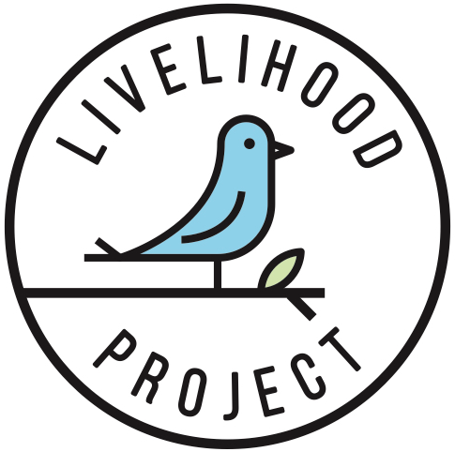

**VISION**

Our vision is a world where everyone has an opportunity to work as per both their abilities and aspirations, in order to make a sustainable livelihood while contributing to the overall society.

**MISSION**

Our mission is to help those facing barriers to suitable and sustainable employment to build a resilient career path.

**VALUES**

*Dignity*

Human dignity is inviolable. To respect and to protect it is the duty of every one of us and the institutions we are part of. Most of us spend the majority of our conscious lives engaged in work. So work is fundamental to our sense of self-worth.

*Solidarity*

The most effective solutions will not be crafted by a powerful few, but by our voices and participation in a cohesive and collaborative community, with those most affected by injustice at the center.

*Resilience*

We will bounce back in face of failures in our journey of hope to a better life. It takes time, effort and social engagement to overcome adversity and adapt to change, and we are ready for it.

*Diversity*

Each one of us is unique and have something to offer to the world. We are open to listening, learning, and innovating through inclusion of others who look different, think different, and act different.

*Responsibility*

We are responsible for our actions – all of them. We are responsible for our thoughts and behaviour, whether deliberate or unintentional. We make mistakes, but when we do, we take responsibility and make it right.

*Story*

We are committed to honor the stories behind the statistics. In doing so, we elevate the courage and resilience of those facing unspeakable challenges, and unleash the human capacity for empathy that has the power to change history.