Level 1 – Basics (Variables & Echo)

- Variable Practice –
Create a variable called name and store your name in it. Print: Hello, !
Welcome to Shell Scripting.

Code :--
#!/bin/bash
name="Neha"
echo "Hello, $name ! “
echo “Welcome to Shell Scripting."

Output:
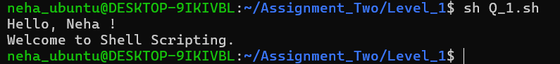

2) Arithmetic Operations –
Take two variables a=10 and b=5. Print their sum, difference, product,and division using echo.

#!/bin/bash
echo "Arithmetic Operations..."
a=10
b=5
sum=$((a + b))
difference=$((a - b))
product=$((a * b))
division=$((a / b))
echo "The sum is : $sum"
echo "The difference is : $difference"
echo "The product is : $product"
echo "The division is : $division"
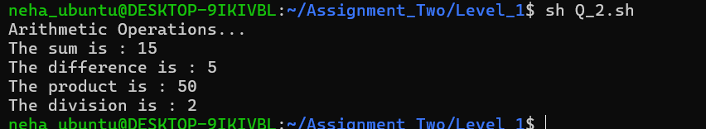
3) User Input –
Ask the user to enter their favorite programming language. Display a message:
Your favorite programming language is.

#!/bin/bash
echo "Enter your favorite programming language"
read programming_language
echo "Your favorite programming language is $programming_language ."

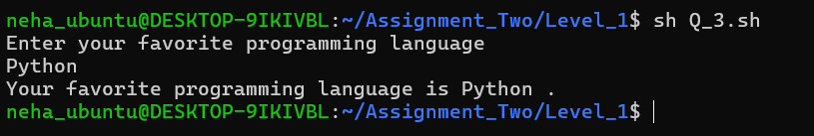

Level 2 – Conditional Statements (if-else)
- Check Even or Odd
– Take a number as input. Use if-else to check whether the number is even or odd.
#!/bin/bash

echo "check if a number is even or odd"
read -p "Enter a number : " number
echo "THe number is $number"
if (( $number % 2 == 0 )); then
echo "the number $number is even"
else
echo "the number $number is odd"
Fi
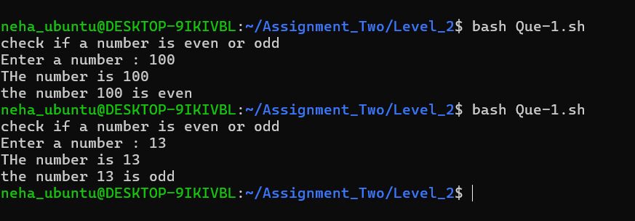

2)
2)
Compare Two Numbers
Ask user to input two numbers. Display which number is greater or if they are equal.

#!/bin/bash
echo "Compare two numbers"
read -p "Enter first number:- " num1
read -p "Enter second number:- " num2
echo " first no is $num1 and second no is $num2 "
if [ $num1 -gt $num2 ]; then
echo "first number $num1 is greater than the second one $num2"
elif [ $num1 -eq $num2 ]; then
echo "both numbers $num1 and $num2 are equal"
else
echo "second number $num2 is greater than the first one $num1"
fi
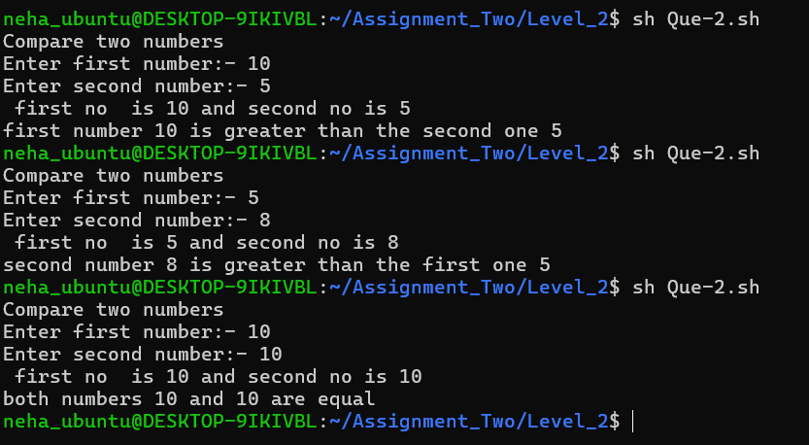

3) String Comparison
Store two strings in variables. Compare them and print whether they are same or different.

#!/bin/bash
echo "String comparison"
read -p "Enter first string value : " string_1
read -p "Enter second string value : " string_2
echo "first string value is $string_1 and second string value is $string_2"

if [ "$string_1" = "$string_2" ]; then
echo "both strings are same"
else
echo "both strings are different"
fi
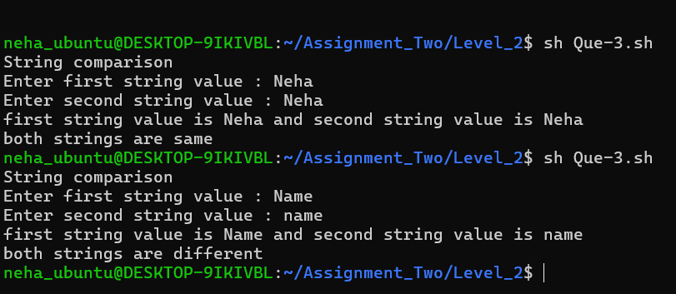

4)
Login Simulation
Store a username and password inside the script. Ask user to input username and password. If both match, print 'Login Successful', otherwise 'Access Denied'.

#!/bin/bash
echo "Login Simulation"
username="neha"
password="1234neha"
read -p "Enter username: " user
read -p "Enter password: " passw
echo "username and password given by user = $user and $passw"

if [ "$username" = "$user" ] && [ "$password" = "$passw" ]; then
echo "Login Successful !!"
else
echo "Access Denied !!"
fi

# with [[ condition1 && condition2 ]]
#echo " also check other brackets"
if [[ "$username" = "$user" && "$password" = "$passw" ]]; then
echo "same"
else
echo "different"
fi
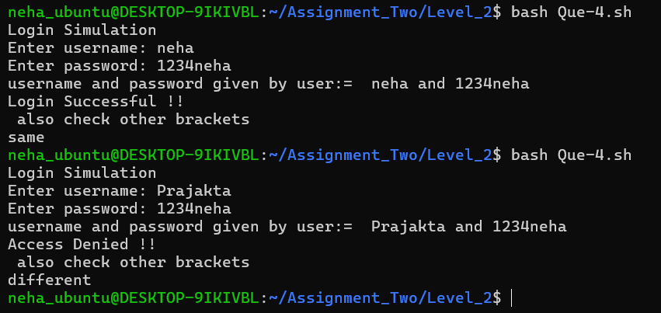

■ Level 3 – Loops (for loop, while loop)
- Print Numbers 1 to 10
Use a for loop to print numbers from 1 to 10.

#!/bin/bash
echo "Print numbers 1 to 10 "
for number in {1..10}
do
echo "number is- $number"
done
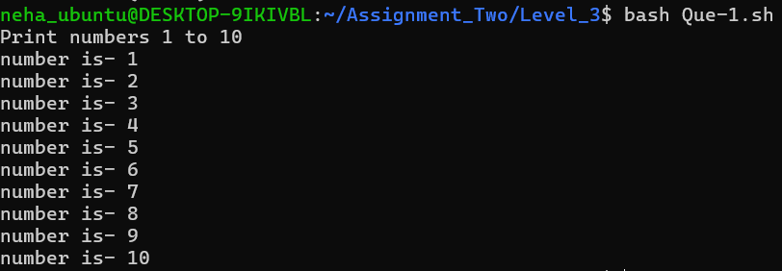

- Sum of First 10 Numbers
Use a for loop to calculate and print the sum of numbers from 1 to 10.

#!/bin/bash
echo "calculate sum of first 10 numbers"
sum=0
for i in {1..10}
do
sum=$((sum+i))
done
echo " "
echo "The sum of first 10 numbers is- $sum"

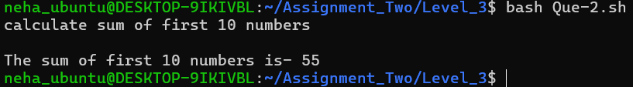

- Factorial Finder
Take a number as input. Use a for loop to calculate its factorial.

#!/bin/bash
echo "find factorial of a number"
read -p "Enter a number to calculate its factorial: " number
echo $number
fact=1
for (( i=1; i<=$number; i++ ))
do
fact=$((fact * i))
done
echo "factorial is $fact"

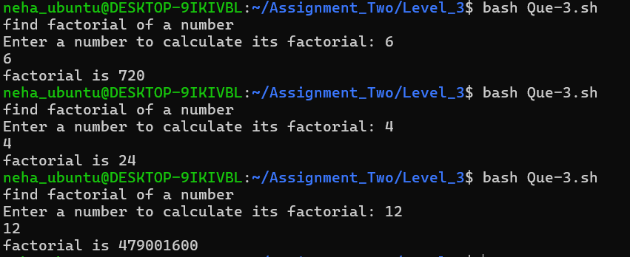

- Countdown
Use a while loop to print numbers from 10 to 1.

#!/bin/bash
echo "While loop to print numbers"
count=10
while [ $count -ge 1 ];
do
echo "Number is: $count"
count=$((count-1))
done
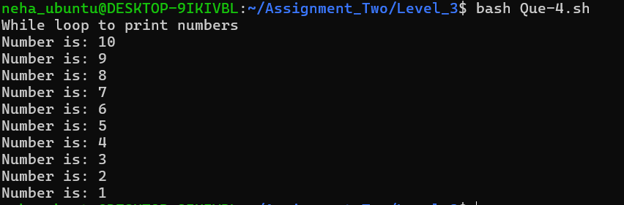

- Print Multiplication Table
Take a number as input. Print its multiplication table (e.g., for 5 →5x1=5 ... 5x10=50).

#!/bin/bash
echo "Print Multiplication table"
read -p "Enter a number:" number
echo "Multiplication table of $number is "
for (( i=1; i<=10; i++ ))
do
echo $((number*i))
done

