Install Mysql 8.4 version on an aws EC2 ubuntu instance .
1 ) First create an EC2 instance
2 ) Connect to the instance .
more /etc/os-release (it will show os version )
3 ) Go to mysql.com .
- Click on Downloads
  - 
- Click on MySQL Community Downloads
- Click on Mysql Community server

https://dev.mysql.com/downloads/mysql/

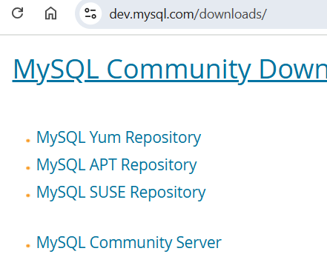

- Fill the details as per our requirements
  - Mysql community server 8.4.7 LTS
  - Select version- 8.4.7
  - Select operating system- Ubuntu Linux
  - Select OS version – Ubuntu Linux 24.04

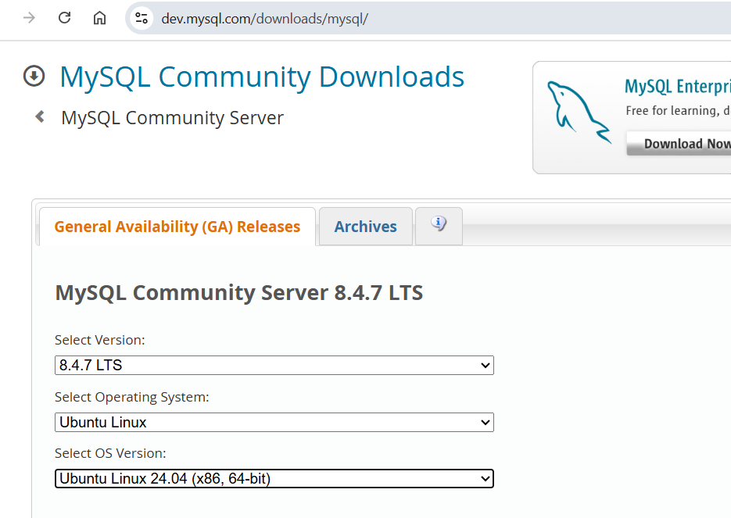

- Then scroll down after filling above information and download DEB bundle.. Click on Download
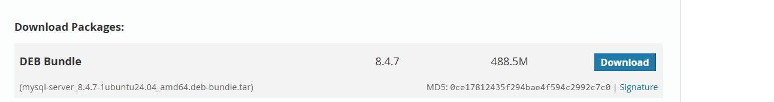

- Right click on No thanks, just start my download
Then click on copy link address
https://dev.mysql.com/get/Downloads/MySQL-8.4/mysql-server_8.4.7-1ubuntu24.04_amd64.deb-bundle.tar

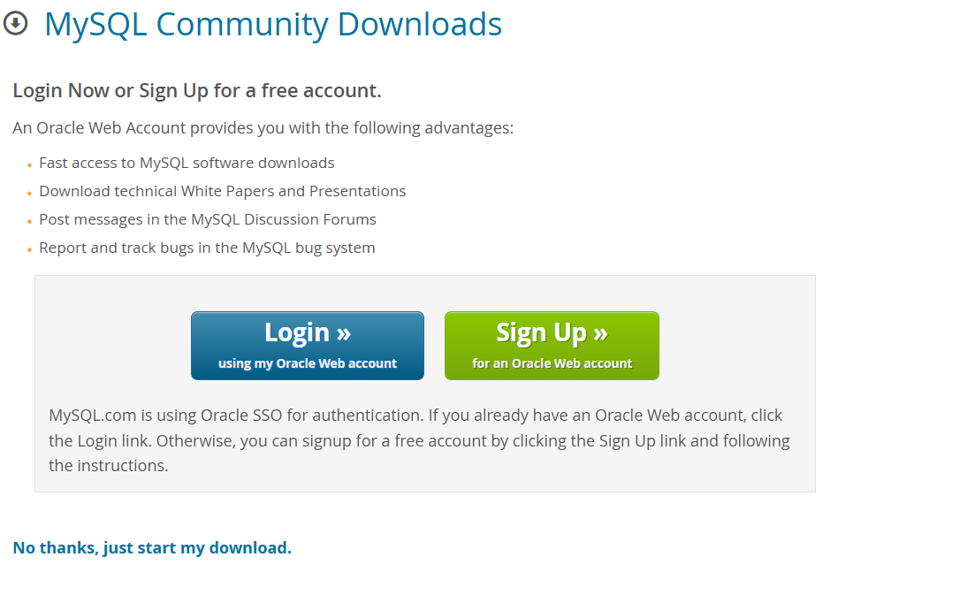
- Now we run following commands on ec2 instance to install mysql 8.4 server.

Sudo apt update
- wget https://dev.mysql.com/get/Downloads/MySQL-8.4/ mysql-server_8.4.7-1ubuntu24.04_amd64.deb-bundle.tar
- ls ( to check if tar file is downloaded or not)
- tar -xf mysql-server_8.4.7-1ubuntu24.04_amd64.deb-bundle.tar
  - it will unpack all deb files
- sudo apt-get install libaio-dev mecab-ipadic-utf8
  - this will install dependency libraries
- now we need to install deb packages
sudo dpkg - i *.deb
- here you are asked – Enter root password:
  - Configuring mysql-community-server
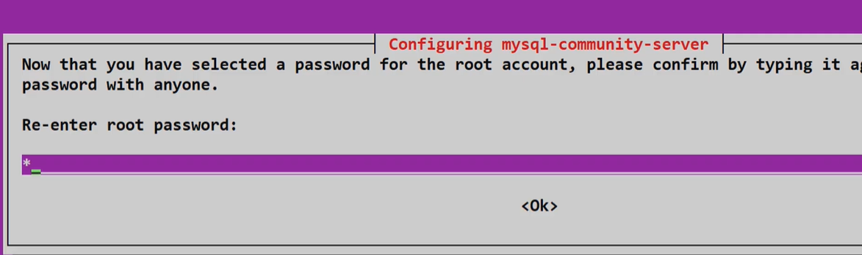

- Select below
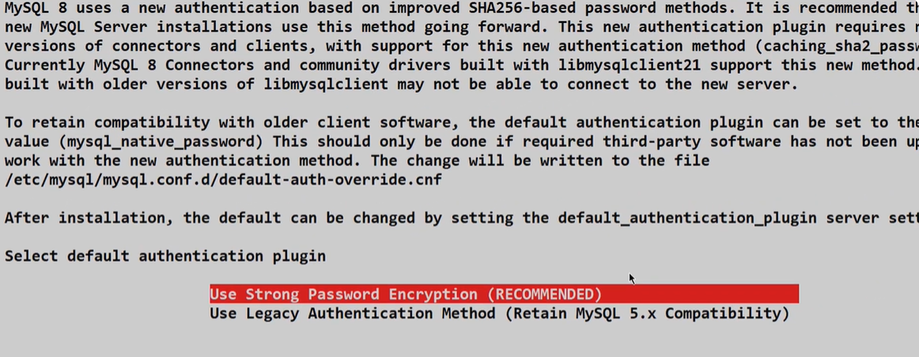

- After this check status if mysql is installed or not using below command
  - sudo systemctl status mysql.service
  - sudo systemctl start mysql
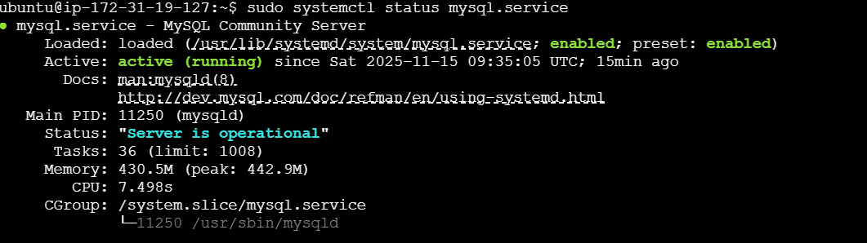
- now connect to mysql once we get the Active status.
  - sudo mysql -u root -p (if password is set)
  - sudo mysql -u root (if not set)
  - sudo mysql -u username (if we have created any user)
  - it will ask for password….
  - Then you connect to mysql .. see below image
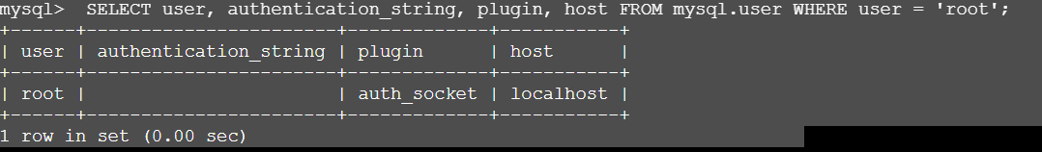
Above no password is set.
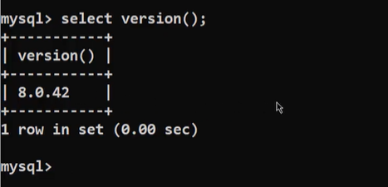

- How to create a user ‘neham’

CREATE USER 'neham'@'%' IDENTIFIED BY 'StrongPassword123!';
GRANT ALL PRIVILEGES ON *.* TO 'neham'@'%' WITH GRANT OPTION;
FLUSH PRIVILEGES;
Now, login into mysql using neham user using below command
sudo mysql -u neham -p

PART 2 –
How to connect mysql installed on Ec2 instance to DBeaver
- Allow MySQL in EC2 Security Group
  - Go to AWS Console → EC2 → Security Groups → YourInstance-SG
Add inbound rule:
Type | Port | Source
MySQL/Aurora | 3306 | Your IP (recommended)/32

👉 Don’t open 3306 to 0.0.0.0/0 unless temporary for testing.
To find your IP: Google “my ip”.
On google .. https://whatismyipaddress.com/
IPv4: - “your-ip-address”

- Open DBeaver → Database-> New Database Connection → MySQL
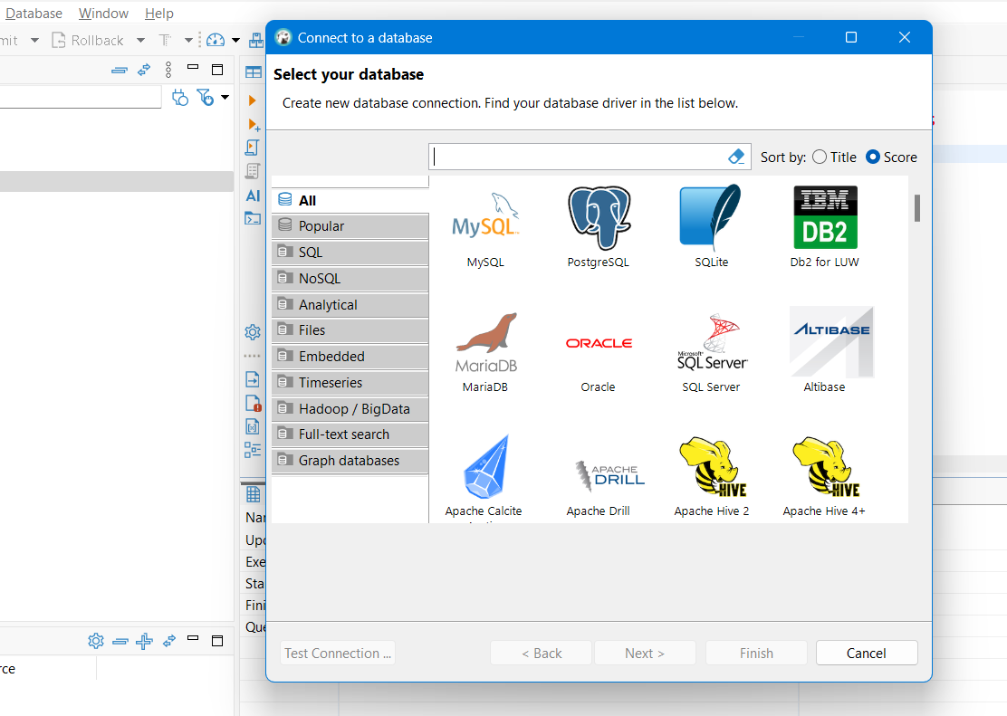
- Here, select your database…MYSQL
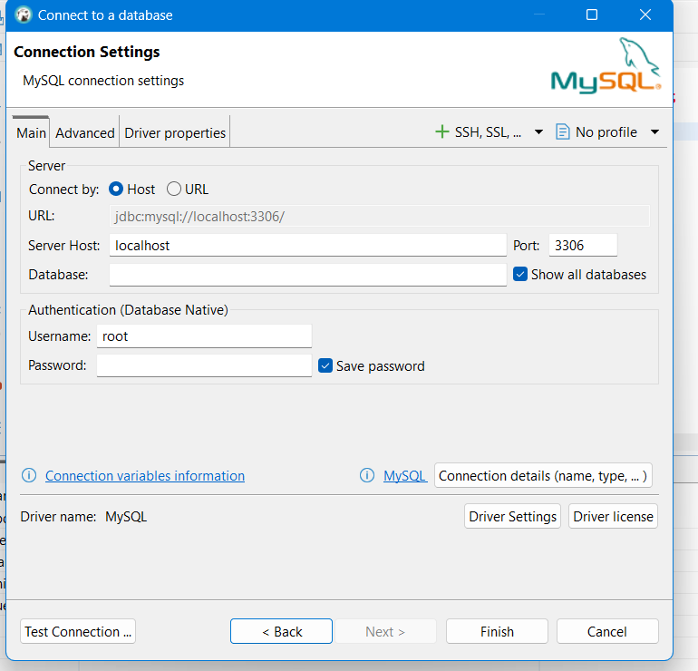
  - Host: EC2 public IP Port: 3306
  - Username: neham Password: ‘your-password’
  - Database: leave empty (optional)
  - Click Test Connection → Should turn green.
  - Then click Finish.
IF we get an error -
“ If error Public Key Retrieval is not allowed “
It is a MySQL 8 authentication issue, NOT a connection or server issue.
Solution :-
  - Open DBeaver
  - Go to Database → Connection → Edit Connection
  - Select Driver Properties tab
  - Find property:
    - set: useSSL = false
allowPublicKeyRetrieval TRUE

  - Click Test Connection → OK
As shown in below image, we can access mysql database.
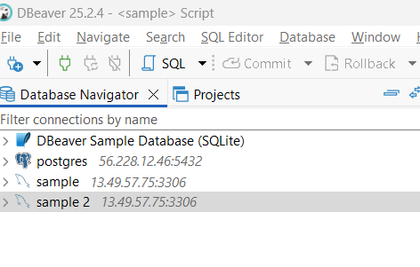

Postgress version to install on ec2 ubuntu 24.04

Refer official documentation of Postgress
https://www.postgresql.org/download/linux/ubuntu/

Run below commands once you connect to the EC2 instance…
sudo apt update
sudo apt upgrade -y
-Automated repository configuration:
sudo apt install -y postgresql-common
sudo /usr/share/postgresql-common/pgdg/apt.postgresql.org.sh

-To manually configure the Apt repository, follow these steps:
sudo apt install curl ca-certificates
sudo install -d /usr/share/postgresql-common/pgdg
sudo curl -o /usr/share/postgresql-common/pgdg/apt.postgresql.org.asc --fail https://www.postgresql.org/media/keys/ACCC4CF8.asc
cat /etc/os-release
sudo sh -c "echo 'deb [signed-by=/usr/share/postgresql-common/pgdg/apt.postgresql.org.asc] https://apt.postgresql.org/pub/repos/apt $VERSION_CODENAME-pgdg main' > /etc/apt/sources.list.d/pgdg.list"
sudo apt update
sudo apt install postgresql-17
you can give any version you want
sudo systemctl status postgresql
psql –version
sudo -u postgres psql
------------------------- Create a user----------------------------
CREATE USER ‘user-name’ WITH ENCRYPTED PASSWORD password;
GRANT ALL PRIVILEGES ON DATABASE ‘database_name’ TO ‘user-name’;
sudo systemctl restart postgresql
login using created-user
psql -U ‘username’ -h localhost -d ‘databasename’


PART 2 –
To connect postgress to Dbeaver..
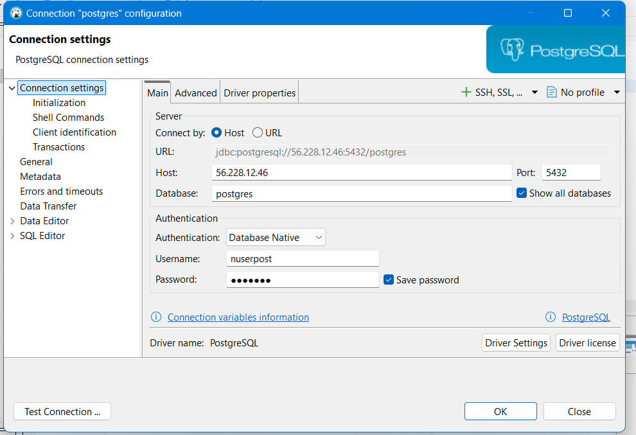
If connection does not happen
Refer chatgpt
https://chatgpt.com/share/6919cb64-4094-8003-9f4c-122e6520142b
Then run below command
sudo ss -tlnp | grep 5432
if listen_addresses = localhost
then change it in below file
sudo vim /etc/postgresql/17/main/postgresql.conf
to listen_addresses = 0.0.0.0
then again run sudo ss -tlnp | grep 5432
if then we get error
FATAL: no pg_hba.conf entry for host
IT means PostgreSQL received your connection, BUT your IP is NOT allowed in pg_hba.conf
change security group
You can set your laptop public ip instead of 0.0.0.0
we can check our laptop’s public ip using
curl https://checkip.amazonaws.com on command terminal
now, SSH into EC2 and edit pg_hba.conf
sudo vim /etc/postgresql/17/main/pg_hba.conf
Add this line at the very bottom, replacing YOUR_IP:
host all all 223.233.81.191/32 md5
then restart
sudo systemctl restart postgresql
And again try to connect DBeaver – Postgress connection

