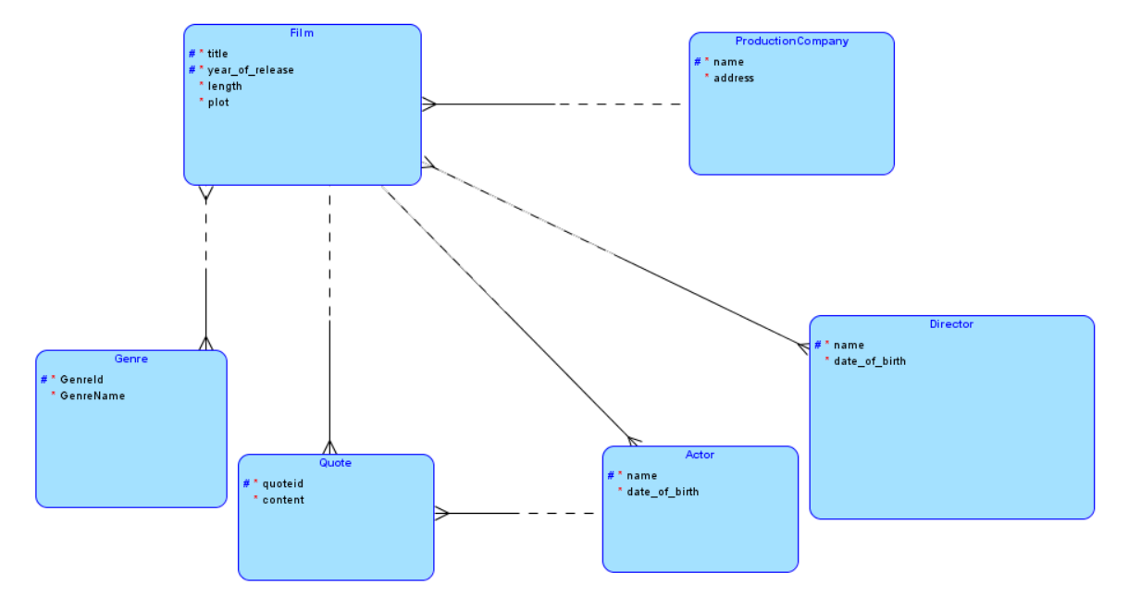

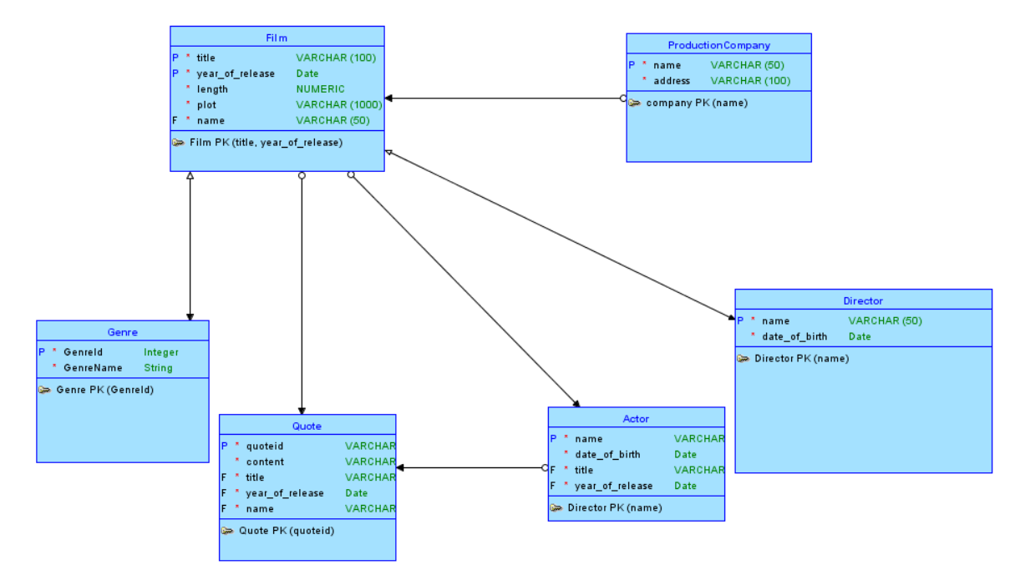

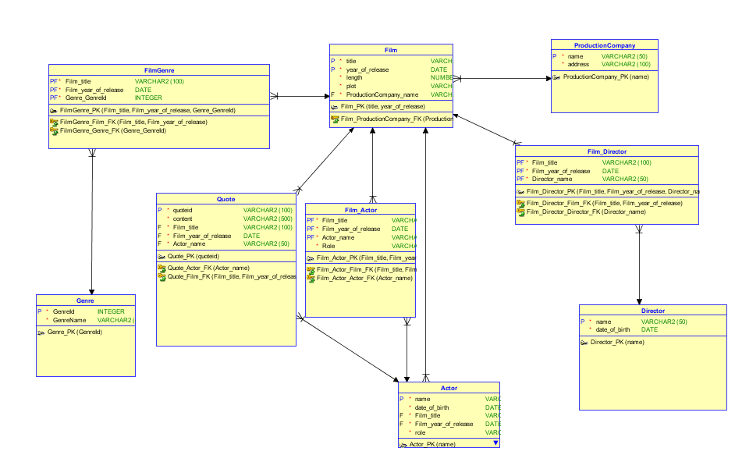

**CREATE** **TABLE** actor (

**name** **VARCHAR2**(50) **NOT** **NULL**,

date_of_birth **DATE** **NOT** **NULL**,

film_title **VARCHAR2**(100) **NOT** **NULL**,

film_year_of_release **DATE** **NOT** **NULL**,

**role** **VARCHAR2**(50) **NOT** **NULL**

);

**ALTER** **TABLE** actor **ADD** **CONSTRAINT** actor_pk **PRIMARY** **KEY** ( **name** );

**CREATE** **TABLE** director (

**name** **VARCHAR2**(50) **NOT** **NULL**,

date_of_birth **DATE** **NOT** **NULL**

);

**ALTER** **TABLE** director **ADD** **CONSTRAINT** director_pk **PRIMARY** **KEY** ( **name** );

**CREATE** **TABLE** film (

title **VARCHAR2**(100) **NOT** **NULL**,

year_of_release **DATE** **NOT** **NULL**,

length **NUMBER** **NOT** **NULL**,

plot **VARCHAR2**(1000) **NOT** **NULL**,

productioncompany_name **VARCHAR2**(50) **NOT** **NULL**

);

**ALTER** **TABLE** film **ADD** **CONSTRAINT** film_pk **PRIMARY** **KEY** ( title,year_of_release );

**CREATE** **TABLE** film_actor (

film_title **VARCHAR2**(100) **NOT** **NULL**,

film_year_of_release **DATE** **NOT** **NULL**,

actor_name **VARCHAR2**(50) **NOT** **NULL**,

**role** **VARCHAR2**(50) **NOT** **NULL**

);

**ALTER** **TABLE** film_actor

**ADD** **CONSTRAINT** film_actor_pk **PRIMARY** **KEY** ( film_title,film_year_of_release,actor_name );

**CREATE** **TABLE** film_director (

film_title **VARCHAR2**(100) **NOT** **NULL**,

film_year_of_release **DATE** **NOT** **NULL**,

director_name **VARCHAR2**(50) **NOT** **NULL**

);

**ALTER** **TABLE** film_director

**ADD** **CONSTRAINT** film_director_pk **PRIMARY** **KEY** ( film_title,film_year_of_release,director_name );

**CREATE** **TABLE** filmgenre (

film_title **VARCHAR2**(100) **NOT** **NULL**,

film_year_of_release **DATE** **NOT** **NULL**,

genre_genreid **INTEGER** **NOT** **NULL**

);

**ALTER** **TABLE** filmgenre

**ADD** **CONSTRAINT** filmgenre_pk **PRIMARY** **KEY** ( film_title,film_year_of_release,genre_genreid );

**CREATE** **TABLE** genre (

genreid **INTEGER** **NOT** **NULL**,

genrename **VARCHAR2**(4000) **NOT** **NULL**

);

**ALTER** **TABLE** genre **ADD** **CONSTRAINT** genre_pk **PRIMARY** **KEY** ( genreid );

**CREATE** **TABLE** productioncompany (

**name** **VARCHAR2**(50) **NOT** **NULL**,

address **VARCHAR2**(100) **NOT** **NULL**

);

**ALTER** **TABLE** productioncompany **ADD** **CONSTRAINT** productioncompany_pk **PRIMARY** **KEY** ( **name** );

**CREATE** **TABLE** **quote** (

quoteid **VARCHAR2**(100) **NOT** **NULL**,

**content** **VARCHAR2**(500) **NOT** **NULL**,

film_title **VARCHAR2**(100) **NOT** **NULL**,

film_year_of_release **DATE** **NOT** **NULL**,

actor_name **VARCHAR2**(50) **NOT** **NULL**

);

**ALTER** **TABLE** **quote** **ADD** **CONSTRAINT** quote_pk **PRIMARY** **KEY** ( quoteid );

**ALTER** **TABLE** actor

**ADD** **CONSTRAINT** actor_film_fk **FOREIGN** **KEY** ( film_title,film_year_of_release )

**REFERENCES** film ( title,year_of_release );

**ALTER** **TABLE** film_actor

**ADD** **CONSTRAINT** film_actor_actor_fk **FOREIGN** **KEY** ( actor_name )

**REFERENCES** actor ( **name** );

**ALTER** **TABLE** film_actor

**ADD** **CONSTRAINT** film_actor_film_fk **FOREIGN** **KEY** ( film_title,film_year_of_release )

**REFERENCES** film ( title,year_of_release );

**ALTER** **TABLE** film_director

**ADD** **CONSTRAINT** film_director_director_fk **FOREIGN** **KEY** ( director_name )

**REFERENCES** director ( **name** );

**ALTER** **TABLE** film_director

**ADD** **CONSTRAINT** film_director_film_fk **FOREIGN** **KEY** ( film_title,film_year_of_release )

**REFERENCES** film ( title,year_of_release );

**ALTER** **TABLE** film

**ADD** **CONSTRAINT** film_productioncompany_fk **FOREIGN** **KEY** ( productioncompany_name )

**REFERENCES** productioncompany ( **name** );

**ALTER** **TABLE** filmgenre

**ADD** **CONSTRAINT** filmgenre_film_fk **FOREIGN** **KEY** ( film_title,film_year_of_release )

**REFERENCES** film ( title,year_of_release );

**ALTER** **TABLE** filmgenre

**ADD** **CONSTRAINT** filmgenre_genre_fk **FOREIGN** **KEY** ( genre_genreid )

**REFERENCES** genre ( genreid );

**ALTER** **TABLE** **quote**

**ADD** **CONSTRAINT** quote_actor_fk **FOREIGN** **KEY** ( actor_name )

**REFERENCES** actor ( **name** );

**ALTER** **TABLE** **quote**

**ADD** **CONSTRAINT** quote_film_fk **FOREIGN** **KEY** ( film_title,film_year_of_release )

**REFERENCES** film ( title,year_of_release );