实验二报告
37220222203612 洪伟鑫
1 列出每个部门的编号和该部门的员工个数，并按照部门编号升序排列。(注意从哪里查询全部的部门信息)
select dept.deptno,count(emp.empno)
from s3612.dept left outer join s3612.emp
on dept.deptno = emp.deptno
group by dept.deptno
order by dept.deptno asc;
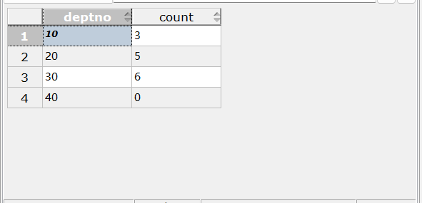
2 列出每个经理的雇员编号和该经理所直接领导的员工个数。
select mgr,count(empno)
from s3612.emp
where mgr is not NULL
group by mgr
order by mgr;
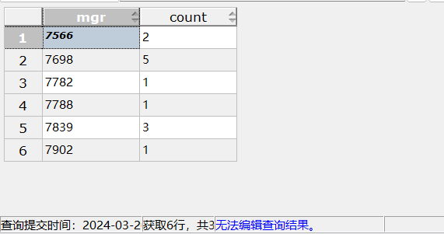
以经理的雇员编号升序，对每个经理分组，统计组内领导员工的个数
3 列出工龄最大的员工的雇员编号和他的工龄（已经工作多少年）。
select empno,extract(year from age(now(),hiredate)) as hireyear
from s3612.emp
where hiredate = (
select min(hiredate)
from s3612.emp
);
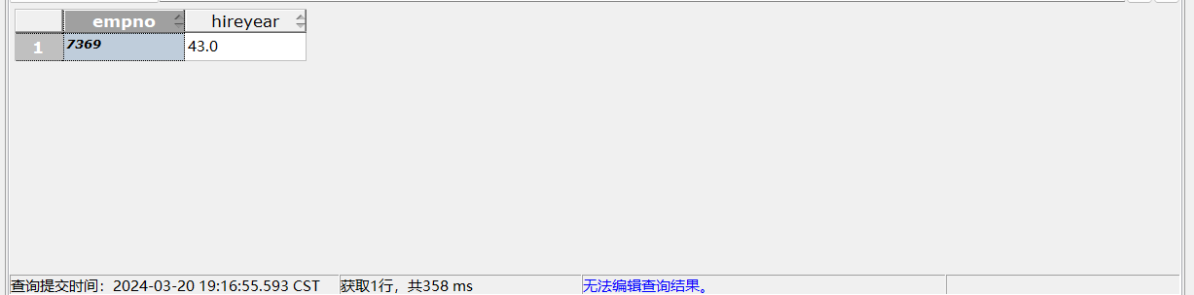
4 列出平均工资大于2000的部门编号及它的平均工资。
select deptno,avg(emp.sal)
from s3612.emp
group by deptno
having avg(sal)>2000;
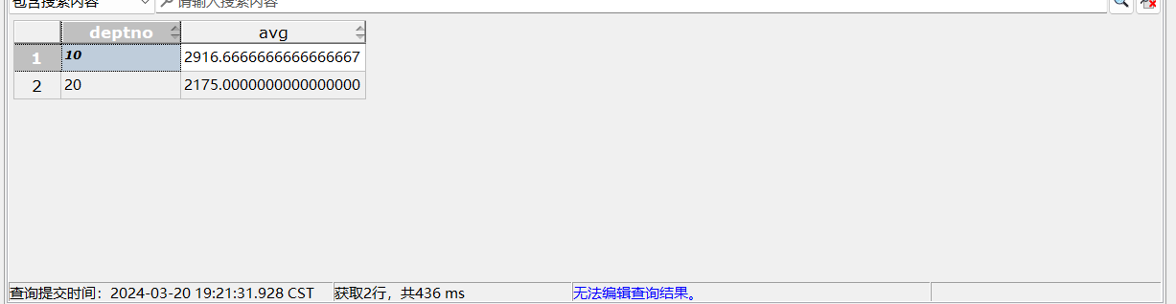
5 列出每个部门中每种职位的最低工资，并按照部门升序，职位降序排列。
select deptno,job,min(sal)
from s3612.emp
group by deptno,job
order by deptno asc,job desc;
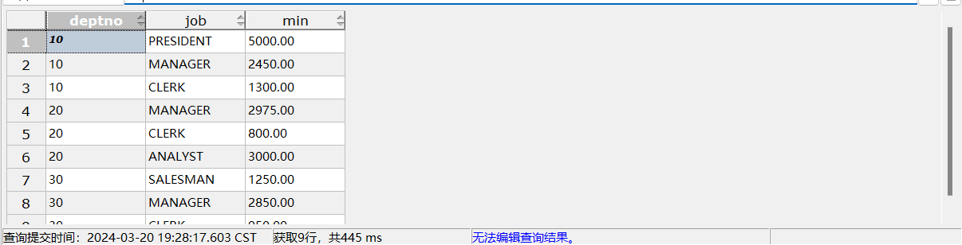
group by deptno,job ；以唯一的deptno、job作组合，求组合内的min(sal)
6 找出姓名以S开头或者以S结尾的员工编号和姓名。
select empno,ename
from s3612.emp
where ename like 'S%' OR
ename like '%S';
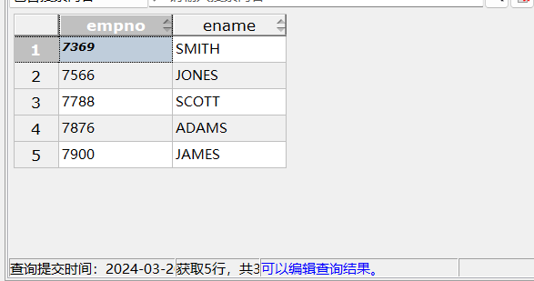
7 对于每个部门，找出工资最高的员工编号，姓名，并按照部门编号和员工编号升序排列。
select deptno,empno,ename,sal
from s3612.emp
where sal in (
select max(sal)
from s3612.emp
group by deptno
)
order by deptno asc,empno asc;
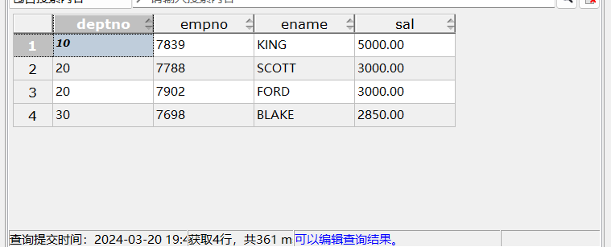
最高工资可能不止一个，用 where sal in 组内最高工资的元组集合
8 列出工资等级为4的员工信息。
select *
from s3612.emp
where emp.sal>=(
select losal
from s3612.salgrade
where s3612.salgrade.grade = 4
)
and emp.sal<=(
select hisal
from s3612.salgrade
where s3612.salgrade.grade = 4
);
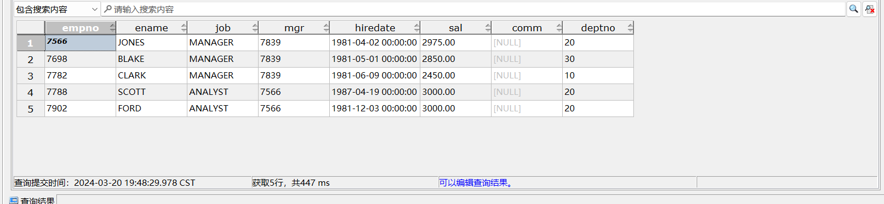
9 查询和SMITH部门相同且工作职位相同的其他员工信息(连接，嵌套)。
嵌套
select *
from emp
where deptno = (
select deptno
from s3612.emp
where ename = 'SMITH'
)
and job = (
select job
from s3612.emp
where ename = 'SMITH'

)
and ename != 'SMITH';
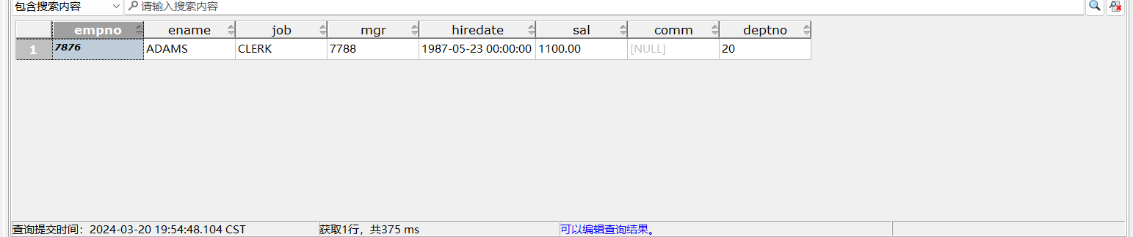
连接
select s1.*
from emp s1,emp s2
where s1.ename != 'SMITH'
and s2.deptno = s1.deptno
and s2.job = s1.job
and s2.ename = 'SMITH';
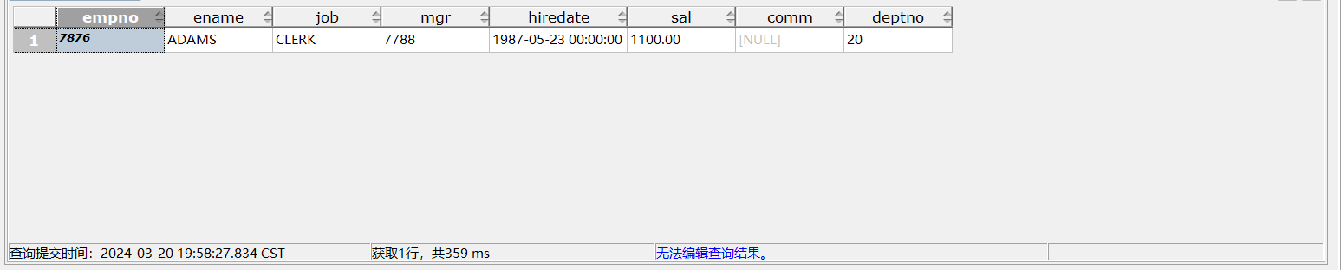
10 查询在纽约工作的员工平均工资，四舍五入保留两位小数(连接，嵌套)。
连接
select round(avg(sal),2) as avgsal
from emp,dept
where dept.loc = 'NEW YORK'
and dept.deptno =emp.deptno;
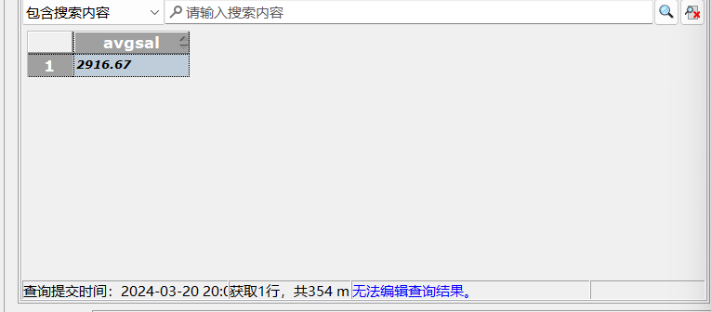
嵌套
select round(avg(sal),2) as avgsal
from s3612.emp
where emp.deptno in (
select deptno
from s3612.dept
where dept.loc = 'NEW YORK'
);
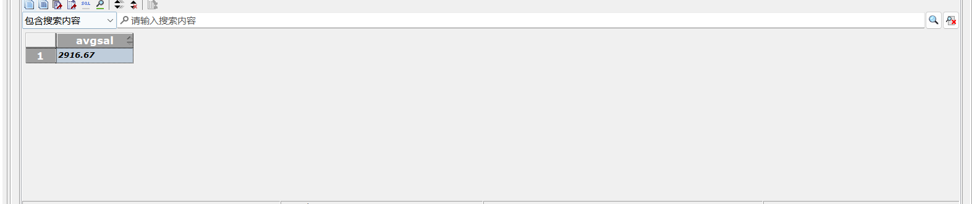
11 列出工资大于该部门平均工资的员工信息。
select s.*
FROM emp s
where s.sal>(
select avg(sal)
from emp p
where p.deptno = s.deptno
);
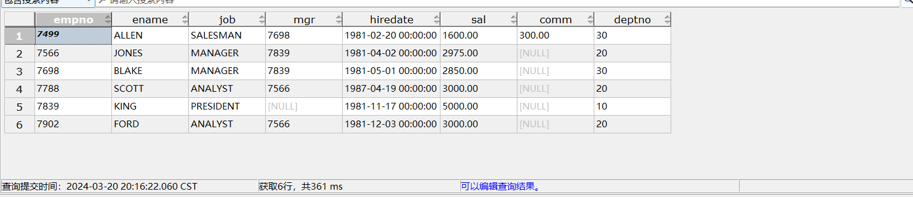
12 列出各个工资等级以及对应等级的员工数。(注意从哪里查询全部的工资等级)
SELECT s3612.salgrade.grade, COUNT(emp.empno)
FROM s3612.salgrade LEFT OUTER JOIN emp
ON emp.sal BETWEEN s3612.salgrade.losal AND s3612.salgrade.hisal
GROUP BY s3612.salgrade.grade
ORDER BY s3612.salgrade.grade;
