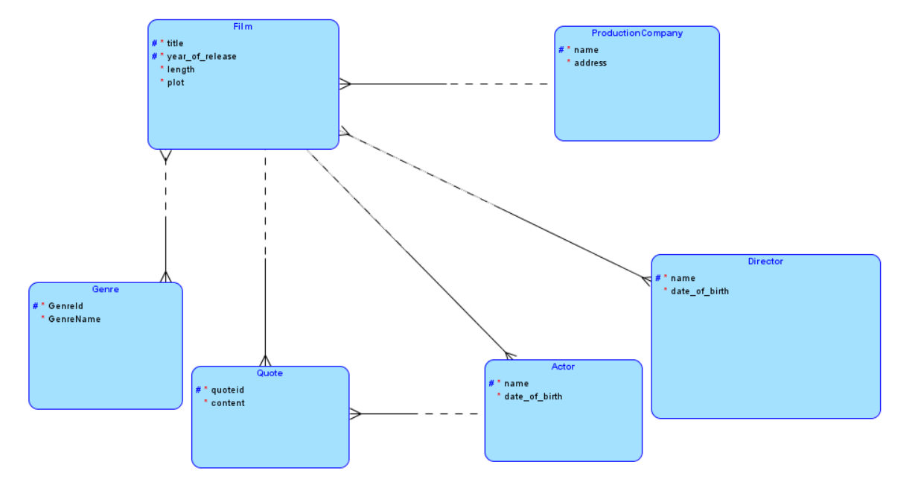
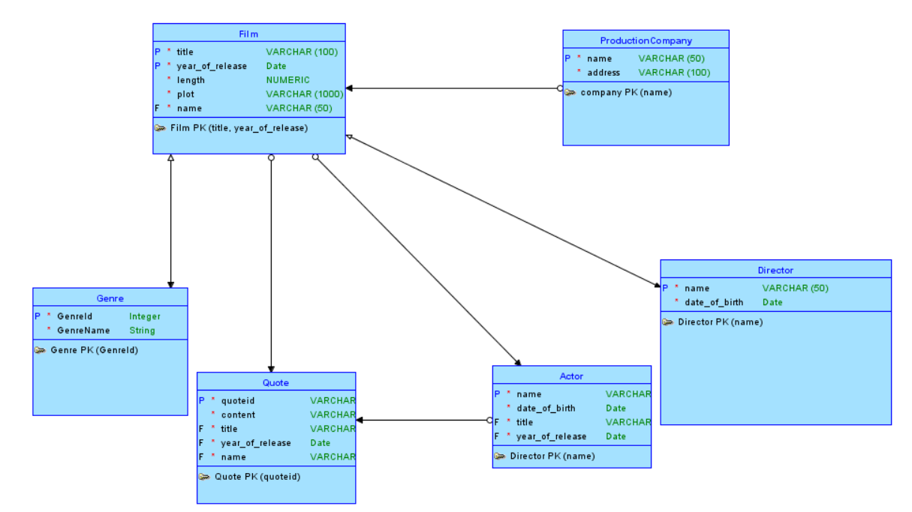
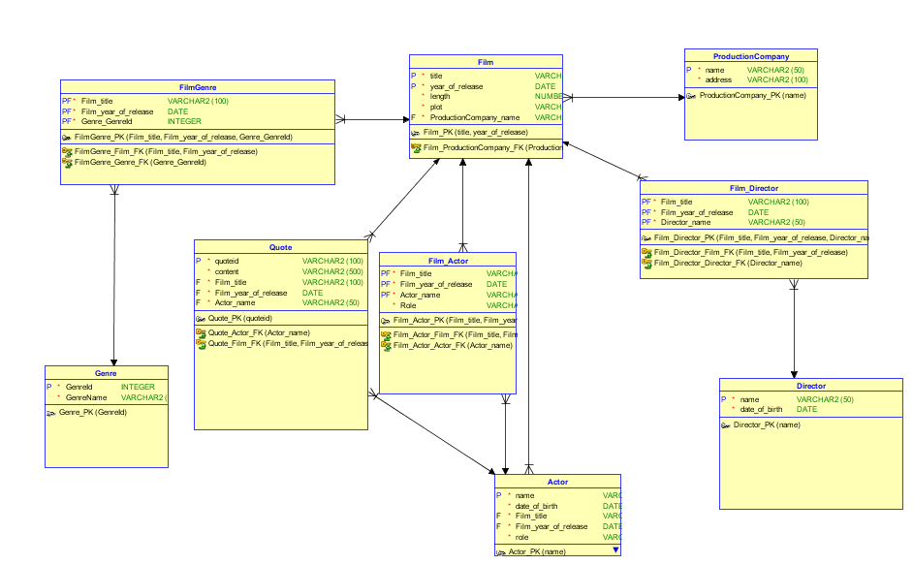

CREATE TABLE actor (
name VARCHAR2(50) NOT NULL,
date_of_birth DATE NOT NULL,
film_title VARCHAR2(100) NOT NULL,
film_year_of_release DATE NOT NULL,
role VARCHAR2(50) NOT NULL
);

ALTER TABLE actor ADD CONSTRAINT actor_pk PRIMARY KEY ( name );

CREATE TABLE director (
name VARCHAR2(50) NOT NULL,
date_of_birth DATE NOT NULL
);

ALTER TABLE director ADD CONSTRAINT director_pk PRIMARY KEY ( name );

CREATE TABLE film (
title VARCHAR2(100) NOT NULL,
year_of_release DATE NOT NULL,
length NUMBER NOT NULL,
plot VARCHAR2(1000) NOT NULL,
productioncompany_name VARCHAR2(50) NOT NULL
);

ALTER TABLE film ADD CONSTRAINT film_pk PRIMARY KEY ( title,year_of_release );

CREATE TABLE film_actor (
film_title VARCHAR2(100) NOT NULL,
film_year_of_release DATE NOT NULL,
actor_name VARCHAR2(50) NOT NULL,
role VARCHAR2(50) NOT NULL
);

ALTER TABLE film_actor
ADD CONSTRAINT film_actor_pk PRIMARY KEY ( film_title,film_year_of_release,actor_name );

CREATE TABLE film_director (
film_title VARCHAR2(100) NOT NULL,
film_year_of_release DATE NOT NULL,
director_name VARCHAR2(50) NOT NULL
);

ALTER TABLE film_director
ADD CONSTRAINT film_director_pk PRIMARY KEY ( film_title,film_year_of_release,director_name );

CREATE TABLE filmgenre (
film_title VARCHAR2(100) NOT NULL,
film_year_of_release DATE NOT NULL,
genre_genreid INTEGER NOT NULL
);

ALTER TABLE filmgenre
ADD CONSTRAINT filmgenre_pk PRIMARY KEY ( film_title,film_year_of_release,genre_genreid );

CREATE TABLE genre (
genreid INTEGER NOT NULL,
genrename VARCHAR2(4000) NOT NULL
);

ALTER TABLE genre ADD CONSTRAINT genre_pk PRIMARY KEY ( genreid );

CREATE TABLE productioncompany (
name VARCHAR2(50) NOT NULL,
address VARCHAR2(100) NOT NULL
);

ALTER TABLE productioncompany ADD CONSTRAINT productioncompany_pk PRIMARY KEY ( name );

CREATE TABLE quote (
quoteid VARCHAR2(100) NOT NULL,
content VARCHAR2(500) NOT NULL,
film_title VARCHAR2(100) NOT NULL,
film_year_of_release DATE NOT NULL,
actor_name VARCHAR2(50) NOT NULL
);

ALTER TABLE quote ADD CONSTRAINT quote_pk PRIMARY KEY ( quoteid );

ALTER TABLE actor
ADD CONSTRAINT actor_film_fk FOREIGN KEY ( film_title,film_year_of_release )
REFERENCES film ( title,year_of_release );

ALTER TABLE film_actor
ADD CONSTRAINT film_actor_actor_fk FOREIGN KEY ( actor_name )
REFERENCES actor ( name );

ALTER TABLE film_actor
ADD CONSTRAINT film_actor_film_fk FOREIGN KEY ( film_title,film_year_of_release )
REFERENCES film ( title,year_of_release );

ALTER TABLE film_director
ADD CONSTRAINT film_director_director_fk FOREIGN KEY ( director_name )
REFERENCES director ( name );

ALTER TABLE film_director
ADD CONSTRAINT film_director_film_fk FOREIGN KEY ( film_title,film_year_of_release )
REFERENCES film ( title,year_of_release );

ALTER TABLE film
ADD CONSTRAINT film_productioncompany_fk FOREIGN KEY ( productioncompany_name )
REFERENCES productioncompany ( name );

ALTER TABLE filmgenre
ADD CONSTRAINT filmgenre_film_fk FOREIGN KEY ( film_title,film_year_of_release )
REFERENCES film ( title,year_of_release );

ALTER TABLE filmgenre
ADD CONSTRAINT filmgenre_genre_fk FOREIGN KEY ( genre_genreid )
REFERENCES genre ( genreid );

ALTER TABLE quote
ADD CONSTRAINT quote_actor_fk FOREIGN KEY ( actor_name )
REFERENCES actor ( name );

ALTER TABLE quote
ADD CONSTRAINT quote_film_fk FOREIGN KEY ( film_title,film_year_of_release )
REFERENCES film ( title,year_of_release );

