VSC:

import React, { useCallback, useEffect, useState } from 'react';
import {
ActivityIndicator,
FlatList,
RefreshControl,
StyleSheet,
Text,
Pressable,
View,
} from 'react-native';
import type { ApiPost } from '../data/ApiPost';

const API_URL = 'https://jsonplaceholder.typicode.com/posts';

export default function ApiPostsScreen() {
const [posts, setPosts] = useState<ApiPost[]>([]);
const [loading, setLoading] = useState(true);
const [refreshing, setRefreshing] = useState(false);
const [error, setError] = useState<string | null>(null);
const loadPosts = useCallback(async () => {
setError(null);
setLoading(true);
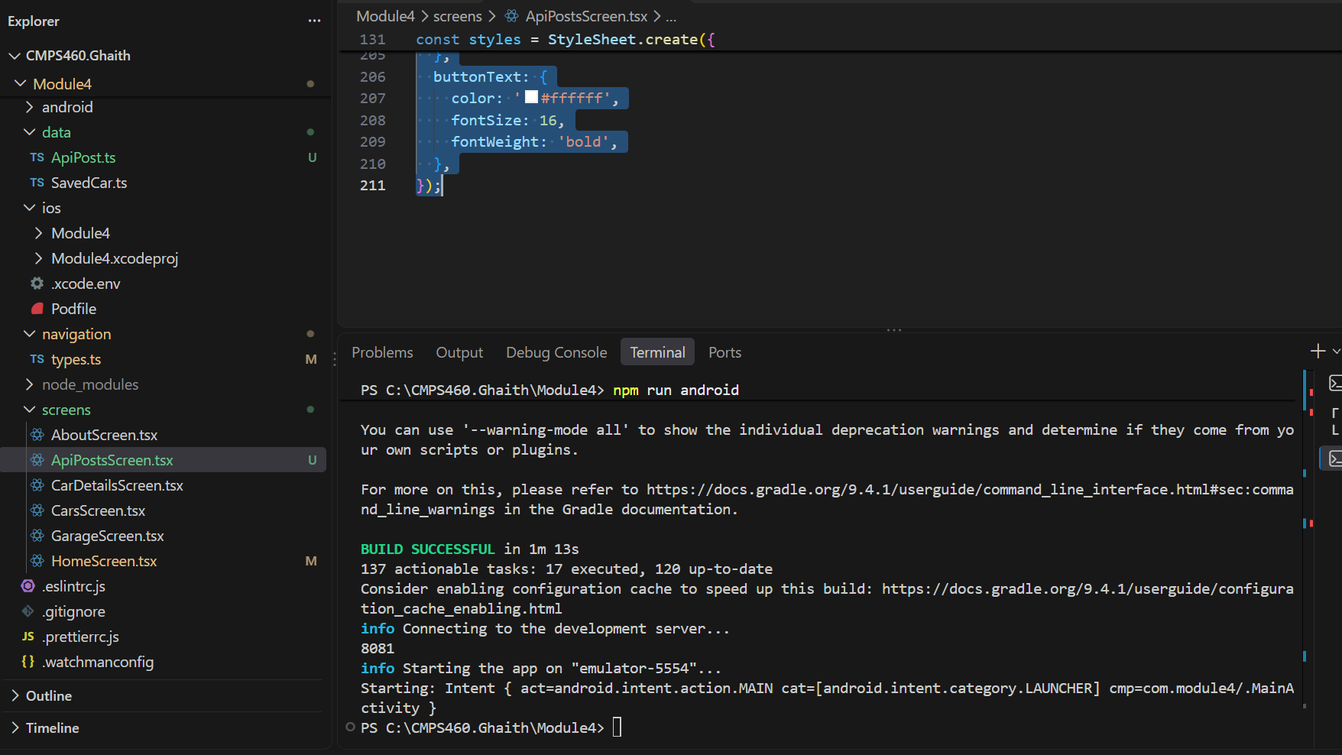

Live Android:

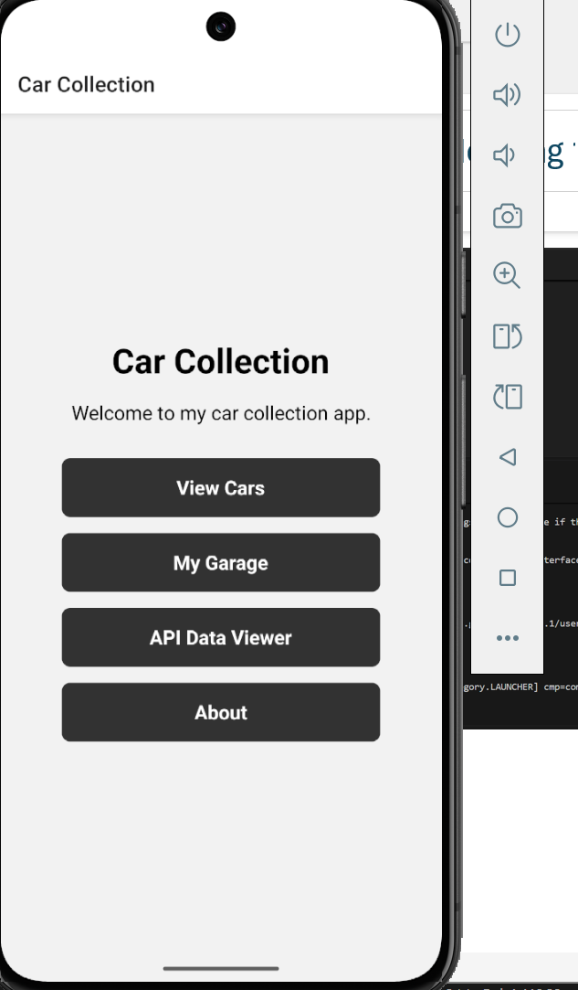
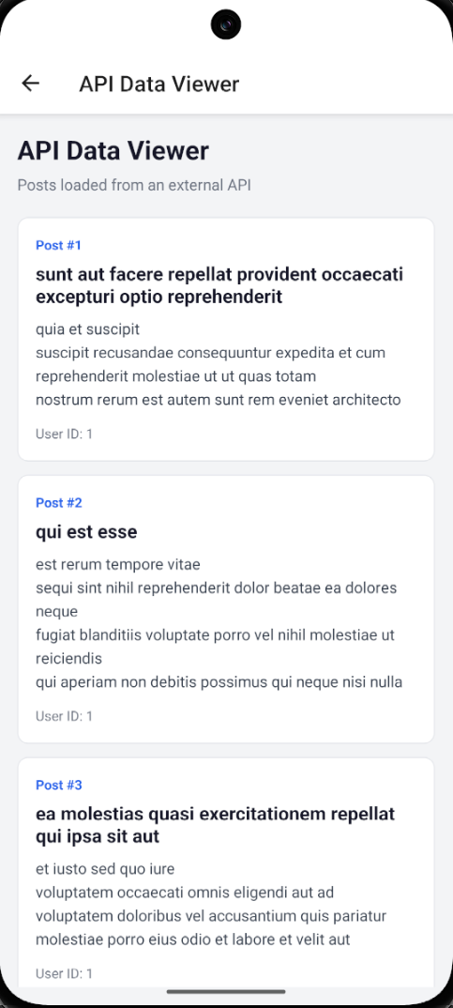
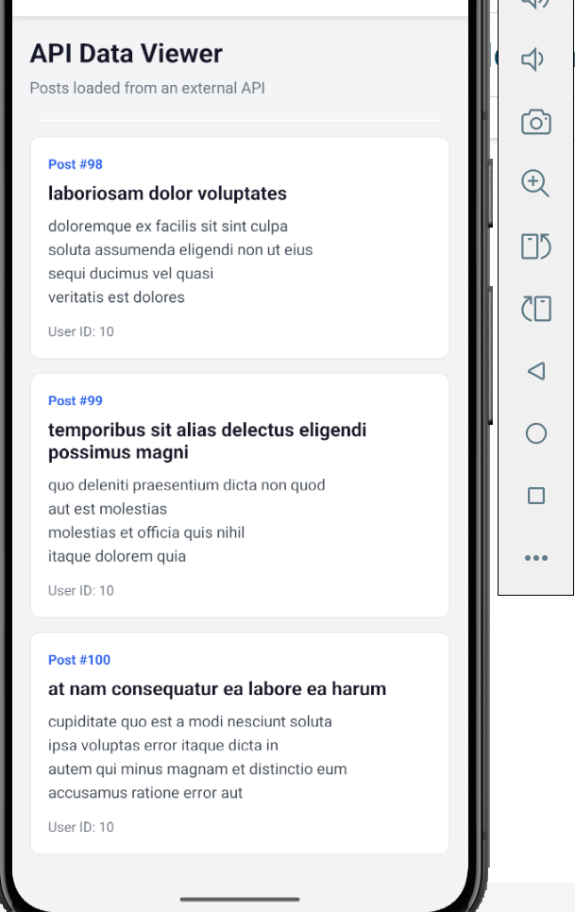

The ERROR page :
