**ASSIGNMENT-4**

**MAJOR PROJECT DOCUMENTATION**

**TO-DO-LIST**

**CODE:**

**Html file:**

<!DOCTYPE html>

<html>

<head>

<title>To-Do-List</title>

<link rel="stylesheet" href="styles.css"> </head>

<body>

    <style>

        body{

        background-color: aliceblue;

        }

        h1{

            color: rgb(33, 33, 31);

            text-align: center;

        }

    </style>

  <h1>To-Do List</h1>

  <input type="text" id="new-task" placeholder="Add a new task">

  <button onclick="addTask()">Add Task</button>

  <ul id="task-list"></ul>

  <script src="script.js"></script> </body>

</html>

**Css file:**

body {

    font-family: sans-serif;

  }

  ul {

    list-style-type: none;

    padding: 0;

  }

  li {

    margin-bottom: 10px;

  }

  button {

    margin-left: 10px;

  }

**Java script file:**

const newTaskInput = document.getElementById("new-task");

const taskList = document.getElementById("task-list");

function addTask() {

  const newTask = newTaskInput.value.trim();

  if (newTask) {

    const li = document.createElement("li");

    li.textContent = newTask;

    const removeButton = document.createElement("button");

    removeButton.textContent = "Remove";

    removeButton.addEventListener("click", () => {

      taskList.removeChild(li);

    });

    li.appendChild(removeButton);

    taskList.appendChild(li);

    newTaskInput.value = "";

  }

}

**OUTPUT :**

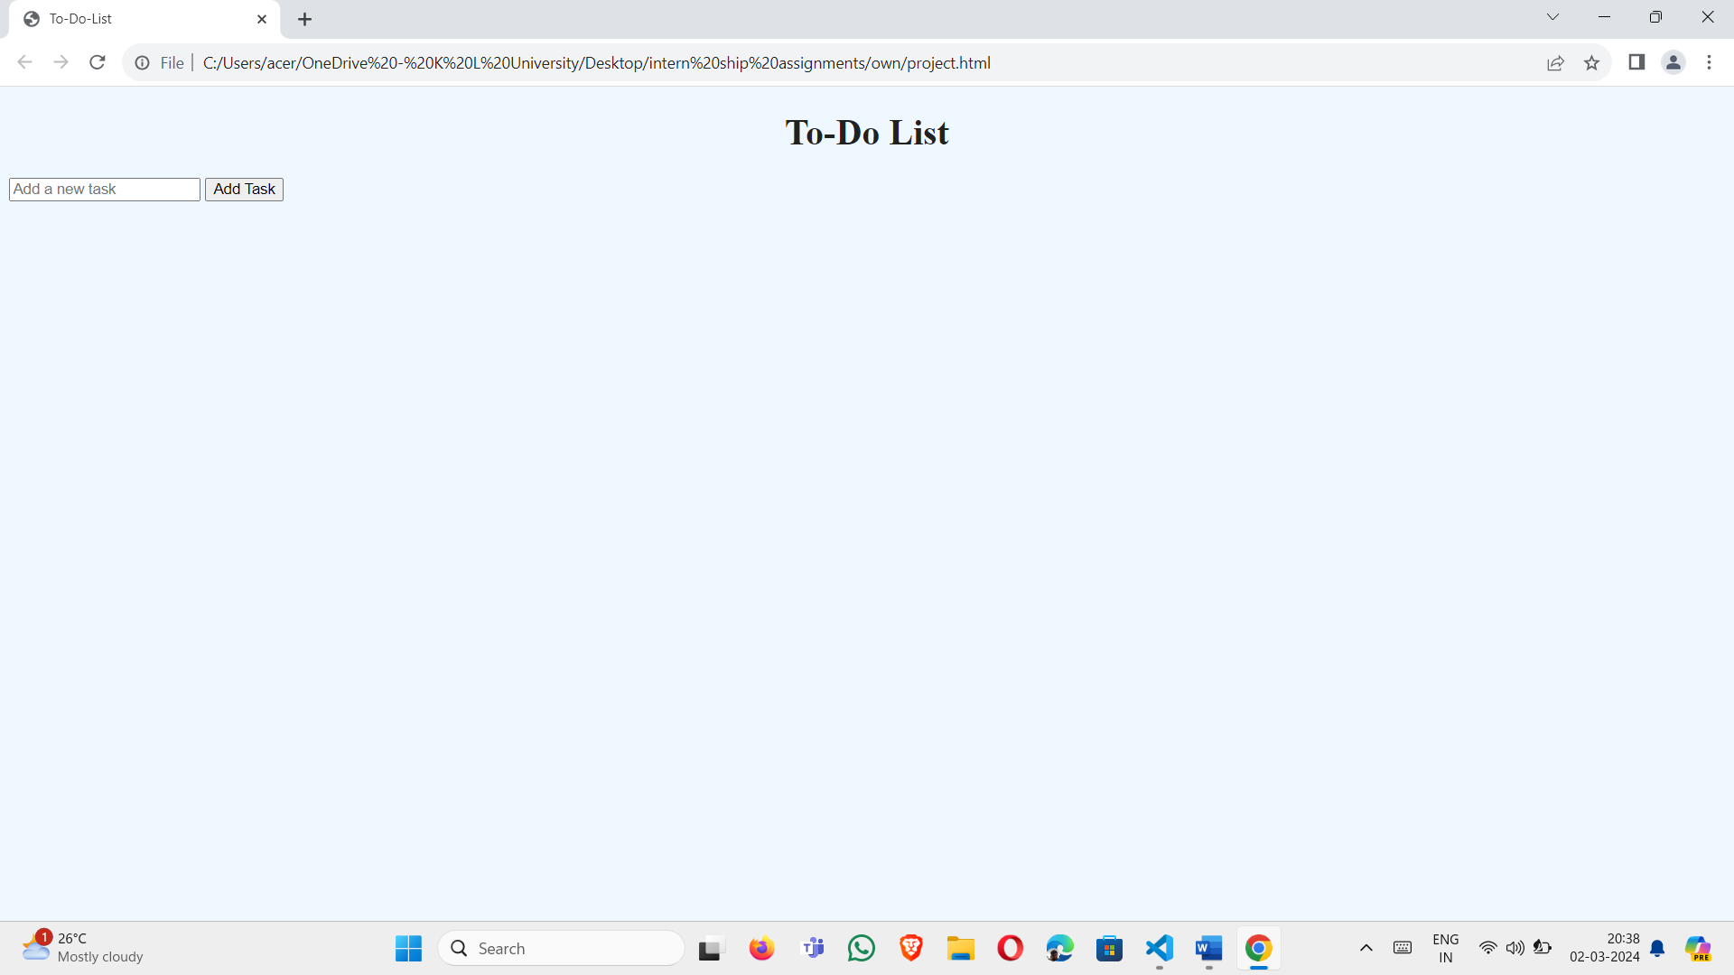

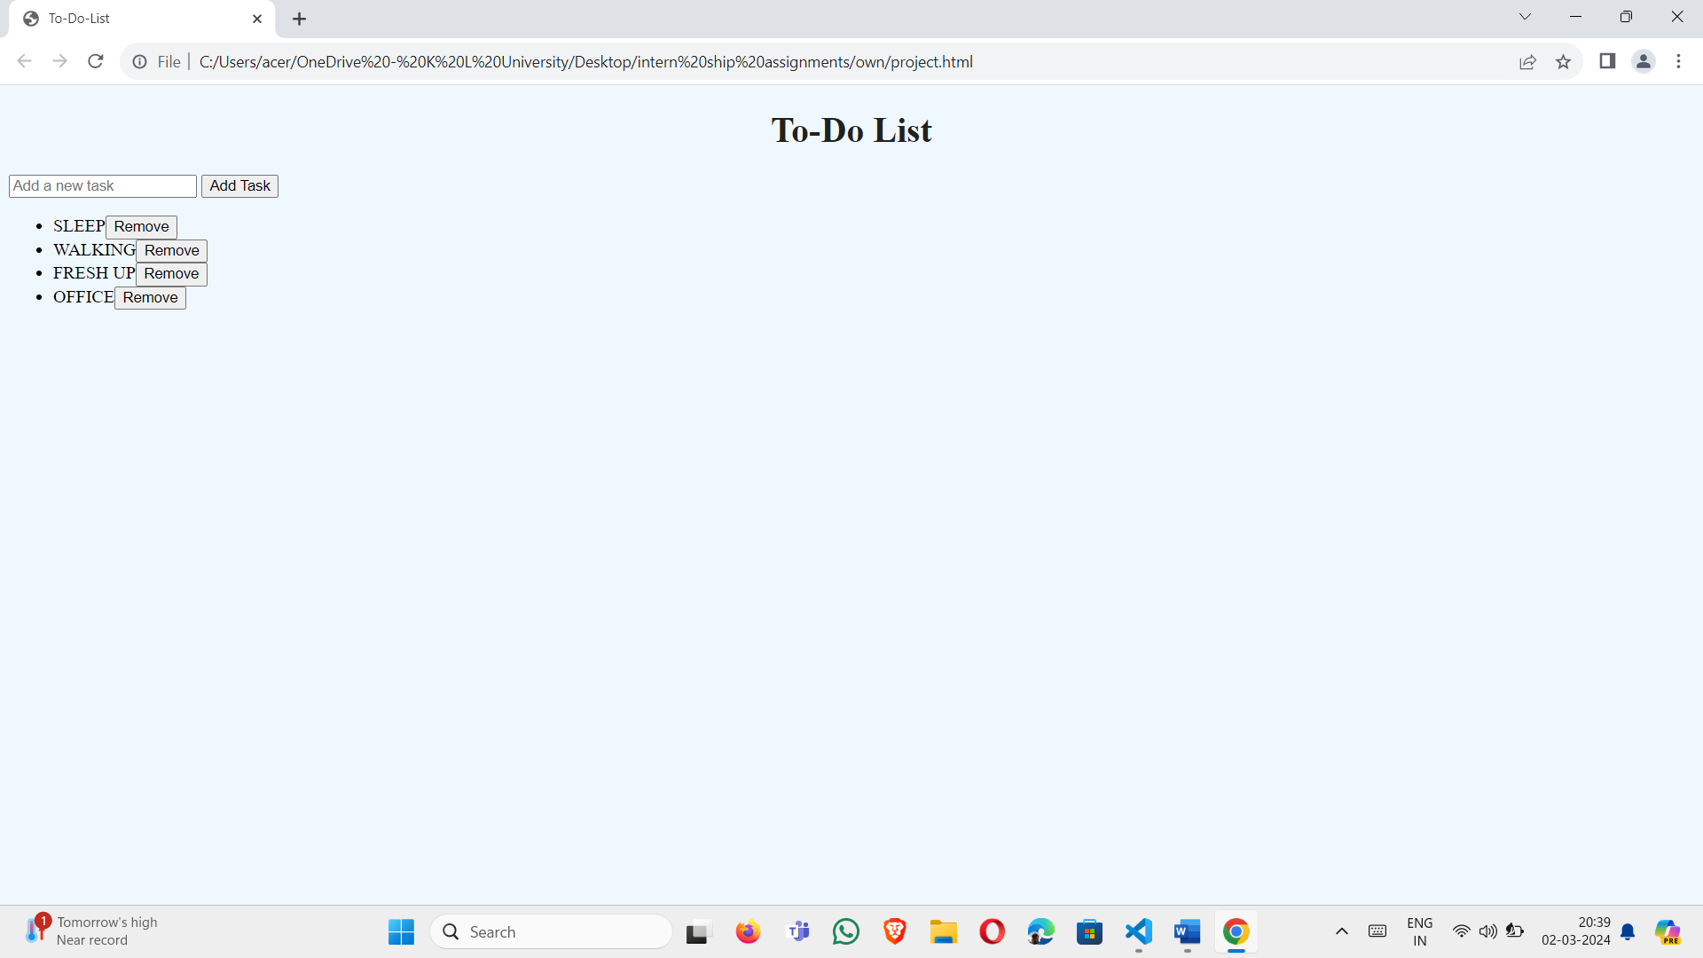

**INTRODUCTION:**

Conquer Your Day with a Simple To-Do List App

This is a basic to-do list application built using three fundamental web development languages: HTML, CSS, and JavaScript. It provides a user-friendly interface to manage your daily tasks and stay organized.

Key Features:

* **Add Tasks:** Enter your tasks in a designated input field.
* **View Tasks:** All entered tasks are displayed in a list format.
* **Mark Tasks as Done:** As you complete tasks, check them off to mark them as done. This can be done visually through UI elements or by interacting with the list items.

**WORKING :**

You can enter new tasks in the designated input field and click the "Add" button to add them to the list. Each task is displayed as a list item, and you can visually mark them as completed by checking the corresponding checkbox. While this example showcases the basic functionalities, the app can be further enhanced to:

* **Mark tasks as completed:** Implement functionality where checking a task visually marks it as completed, such as striking through the text or changing its color.
* **Delete tasks:** Allow users to remove completed or unwanted tasks from the list using a delete button.
* **Persist data:** Store the to-do list data in local storage, ensuring it remains even after refreshing the page.

**USES:**

* **Task Management:** Create and manage all your daily tasks in one convenient location, preventing them from getting lost or forgotten.
* **Improved Organization:** Organize your tasks into different categories (work, personal, errands) for better clarity and focus. Prioritize tasks based on their urgency and importance.
* **Enhanced Productivity:** Visualize your tasks and stay focused on completing them efficiently, leading to a sense of accomplishment as you check off completed items.
* **Reduced Stress:** Alleviate the mental load of remembering numerous tasks by having them listed and organized, leading to a calmer and more focused mindset.
* **Goal Setting:** Break down large goals into smaller, manageable tasks, making them easier to achieve and track progress.

**ADVANTAGES & DIS ADVANTAGES:**

* **Improved Organization:** Keeps all your tasks in one place, preventing them from getting lost or forgotten. Allows for categorization and prioritization of tasks for better focus.
* **Increased Productivity:** Helps visualize tasks and stay focused on completing them efficiently, leading to a sense of accomplishment as you check them off.
* **Reduced Stress:** Alleviates the mental burden of remembering numerous tasks, leading to a calmer and more focused mindset.
* **Boosted Motivation:** Seeing completed tasks can be motivating and encourage further progress.
* **Goal Achievement:** Breaks down large goals into smaller, manageable steps, making them easier to achieve and track progress.

**DIS ADVANTAGES:**

* **Over-reliance:** Overdependence on the app can make it difficult to remember tasks without it.
* **Excessive Focus:** Can lead to focusing solely on completing tasks on the list, neglecting other important aspects of life.
* **Stress from Incompletion:** Seeing a long list of uncompleted tasks can be overwhelming and contribute to stress.
* **Technical Dependence:** Reliant on technology and electricity, making it unusable in case of power outages or device malfunctions.
* **Potential for Procrastination:** May lead to procrastination by constantly adding tasks to the list without actually completing them.
* **Security Concerns:** Some apps may require storing data online, raising concerns about data privacy and security.

**FUTURE SCOPE:**

The basic to-do list app can be further developed to embrace emerging technologies and cater to evolving user needs, offering a more comprehensive and personalized experience. Here are some potential advancements:

**Integration with AI and Machine Learning:**

* **Smart task suggestions:** Based on user behavior and past entries, the app could recommend relevant tasks or suggest breaking down larger tasks into smaller, more manageable ones.
* **Context-aware prioritization:** The app could utilize AI to understand user context (location, time, existing commitments) and prioritize tasks accordingly, suggesting the most relevant tasks to focus on at a specific time.