EmiratesAIWeather
Website Update Log & Function Rationale
By M-Quantum-Tech | 26 August 2026 - 10 October 2026
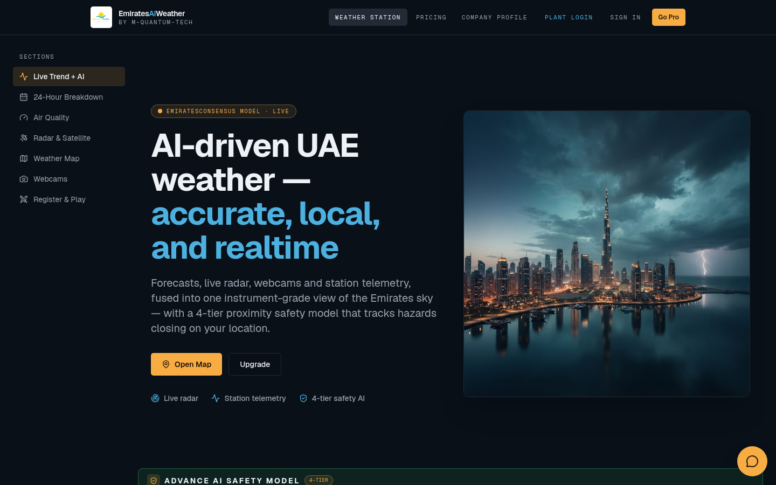
Figure: EmiratesAIWeather homepage
Purpose: This document lists every update to the EmiratesAIWeather website in date order. For each update it says what the function does and why it was built. Screenshots of the live site are included next to the related updates.
Date | Milestone | Updates
26 August 2026 | Project launch and NCM-style weather map | 12
27 August 2026 | Live alert and measuring map | 3
29 August 2026 | Units consistency | 1
22 September 2026 | Safety model, admin portal and AI trend | 23
23 September 2026 | Admin console, escalation rules and NCM wind streamlines | 12
24 September 2026 | Engineering console, AWS stations and Wind Event Monitor | 18
25 September 2026 | Reliable admin login, tier simulator and data resilience | 19
26 September 2026 | Chart redesign and simulator drills | 10
27 September 2026 | Plant IAM | 1
9 October 2026 | Auto buzzer, Ghaith feeds and IAM controls | 13
10 October 2026 | Live buzzer inputs and Push to mirror | 9
 | Total | 121

26 August 2026
Project launch and NCM-style weather map
The site was created from v0 and the first live weather map layers were built, then deployed to Vercel with SEO files and authentication settings.
# | Update | What the function does | Reason
1 | Initial project and CI workflow | Created the Next.js project and a GitHub Actions workflow. | Gives the site a codebase and automatic checks on every push.
2 | Wind layer with live wind data | Map layer that fetches live wind speed and direction. | Wind is the main hazard the plant has to track.
3 | Warnings layer for UAE emirates | Shows live weather warnings per emirate. | Lets operators see official warnings by region at a glance.
4 | Windy-style animated wind forecast | Turned the wind layer into an animated forecast field. | Movement makes wind direction and strength easier to read than static arrows.
5 | NCM-style radar and wind palettes | Matched radar and wind colours to the National Center of Meteorology. | Operators already know NCM colours, so readings stay consistent.
6 | NCM map visuals and layering | Adjusted the order and opacity of map layers. | Stops layers from hiding each other.
7 | Hourly forecast warnings with timeline | Warnings follow the real hourly forecast, with a play timeline. | Shows when a warning starts and ends, not only that it exists.
8 | vercel.json routing fixes | Added Vercel config, then simplified it so Next.js handles routing. | Fixed 404 errors on the deployed site.
9 | sitemap.xml and robots.txt | Added SEO files pointing to the production domain. | Helps search engines index the site.
10 | Better Auth environment setup | Added .env.example and the BETTER_AUTH_SECRET redeploys. | Sign-in needs a secret key to work in production.
11 | Hero section and landing UI | New landing hero and better homepage layout. | Gives visitors a clear first impression and entry point.
12 | Deep-dive map weather codes | Weather-code icons and visual updates on the detail map. | Makes conditions recognisable without reading numbers.

Figure: Homepage hero: AI-driven UAE weather landing section

27 August 2026
Live alert and measuring map
The wind-field demo was merged and the homepage gained a live alert and a larger measuring map.
# | Update | What the function does | Reason
1 | Merge demo/wind-field | Auto-deployed the wind-field demo branch. | Brought the animated wind field into the main site.
2 | Marketing hero and live alert | Placed a live alert banner beside the hero. | Urgent conditions show immediately when the page opens.
3 | Measure map with axes | Doubled the canvas size and added axes to the measuring map. | Distances and bearings can be read more accurately.

29 August 2026
Units consistency
A small fix so the NCM sources panel uses the same units everywhere.
# | Update | What the function does | Reason
1 | Units reference in NCM sources | Shared one units setting across the sources panel. | Stops mixed units such as m/s and km/h showing side by side.

22 September 2026
Safety model, admin portal and AI trend
A major build day. The 4-tier proximity safety model, admin portal, pricing, solar DNI forecast and the Live Trend + AI projection panel were added. Several earlier forecast panels were merged into one clearer view.
# | Update | What the function does | Reason
1 | Canvas image editor (added, later removed) | Interactive editor for images. | Tried out for annotating imagery, then removed the same day to keep the site focused.
2 | Green/Yellow/Orange/Red threat labels | Unified threat names; refresh every 3 minutes; added DNI solar forecast. | Matches plant colour codes; faster refresh; DNI matters for solar output.
3 | 14-day DNI (Pro), English basemap, clearer wind arrows | Pro gating, hero fix and radar-merged clouds. | Separates the paid feature and makes the map readable for English users.
4 | Admin portal, dynamic pricing, 4-tier proximity safety model | Admin area, editable plan prices and a distance-based hazard model. | Owners can manage the business, and hazards are graded by how close they are.
5 | Stripe checkout guard | Checkout only starts when the Stripe key is present. | Prevents a crash when payments are not configured.
6 | TypeScript fixes | Fixed type errors in the chat route, local ads and panels. | Keeps production builds passing.
7 | Hero redesign with storm and Dubai skyline images | Full-bleed storm photo, then a contained Dubai skyline. | A local, relevant visual that does not crowd the text.
8 | 24-hour forecast breakdown | Hourly detail driven by the selected day. | Operators plan shifts hour by hour.
9 | DNI day selection linked to 24-hour view | Picking a DNI day updates the hourly breakdown. | One click shows that day's hourly solar detail.
10 | Free 14-day solar trend with scrub cursor | Unlocked the 14-day trend and added a hover cursor. | Gives free users value and allows precise reading.
11 | Merged DNI and 24-hour blocks | Combined two panels into one. | Less scrolling and no duplicated information.
12 | 14-day multi-model outlook | Replaced the 7-day meteogram with a synced 14-day comparison. | A longer horizon, plus agreement between models.
13 | Trendable AI Prediction (24H / 14-day) | Replaced the old strips with one AI prediction chart. | Puts forecast and trend in a single view.
14 | DNI folded into AI Prediction | Added predictive timing, measures and a Solar DNI tab. | Shows when to act and what to do.
15 | AI Briefing with timed advisories | Added a top briefing in place of the 14-day outlook. | Gives a written summary of what is coming.
16 | Removed Live Observation and Monitoring panels | Cleaned up the station dashboard. | These panels repeated data shown elsewhere.
17 | Briefing comments as live trend header | AI comments shown above the prediction chart. | Explanation and data sit together.
18 | Normalized live trend + AI projection | Re-added the trend with a band for predictive comments. | Puts different metrics on one comparable scale.
19 | Upcoming-peak highlight | Marks the next peak on the trend band. | Draws attention to the next critical moment.
20 | Larger Live Trend + AI projection panel | Merged the prediction into one bigger panel; removed the briefing. | Makes the main chart easier to read.
21 | Single safety model with refresh counter | One safety visual plus on-site and far-site gusts. | One place to check safety status.
22 | Bigger proximity radar | Thicker rings and bigger markers. | Readable from a distance in the control room.
23 | 1-minute refresh, synced clock, wind-front arrival | Faster updates and an estimated arrival time for wind fronts. | Gives operators time to prepare before a front arrives.

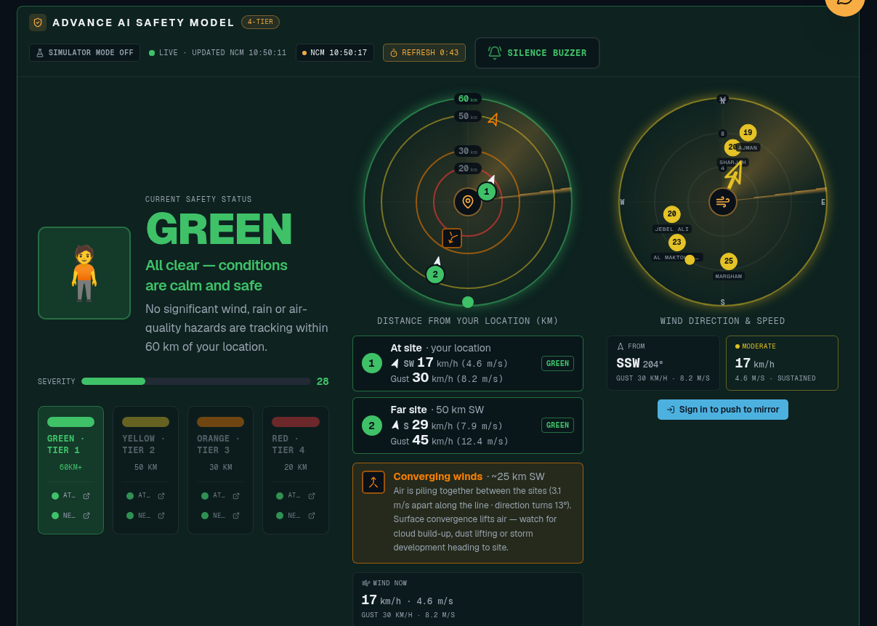
Figure: Advance AI Safety Model with proximity radar and wind direction radar

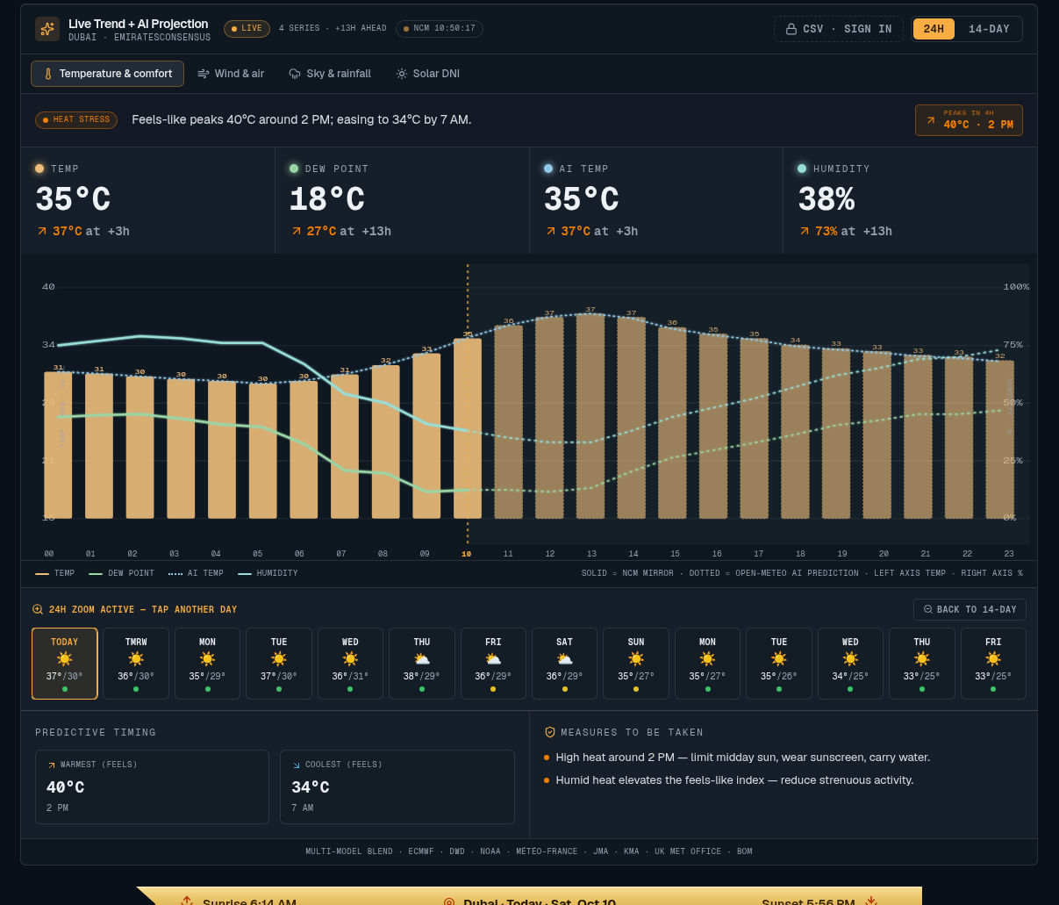
Figure: Live Trend + AI Projection panel

23 September 2026
Admin console, escalation rules and NCM wind streamlines
Access control and the admin console arrived. Escalation rules replaced the simple legend, the buzzer and acknowledgement were added, and the wind field was rendered like NCM COSMO-UAE.
# | Update | What the function does | Reason
1 | Clean warnings map, more NCM sources, deeper zoom | Refined the alert tiers and map detail. | Makes the map clearer and the sources more complete.
2 | Admin console with access control | Admin-only console, admin login and a wind legend. | Protects sensitive settings from the public.
3 | Escalation rules + live prediction tables | Replaced the tier legend; refreshed the Dubai hero. | Operators see exactly why each tier triggers.
4 | L3 Orange rule: satellite convection < 20 km | Updated the Orange criteria. | Matches the plant's commissioned safety procedure.
5 | Radar scope redesign with m/s readout | Radar shows speed in m/s, the AI front call and a solar-optics trend scrub. | Puts exact numbers next to the visual.
6 | 14-day hourly trends, cloud bars, AI DNI, NCM clock | Hourly curves for each of the 14 days with cloud-cover bars. | Cloud cover drives solar output and alarm timing.
7 | Level-synced acknowledgement buzzer | Buzzer sounds per tier and can be acknowledged; AI arrival nowcast. | Gives an audible alarm that operators confirm.
8 | Unified 1-minute refresh + 15 s buzzer | One refresh cycle across the site. | All panels show data from the same moment.
9 | Per-day zoom into 24H | Zoom from the 14-day view into one day's hours; control placed under the chart. | Detail is available when needed.
10 | Bigger, always-clickable buzzer button | Enlarged the alarm button. | Makes it quick to silence during an incident.
11 | NCM COSMO-UAE particle streamlines | Animated wind particles over the wider Gulf domain. | Matches the official NCM wind product.
12 | Removed map popup; measure map optional | Simplified interaction on the NCM panel. | Stops accidental popups covering the map.

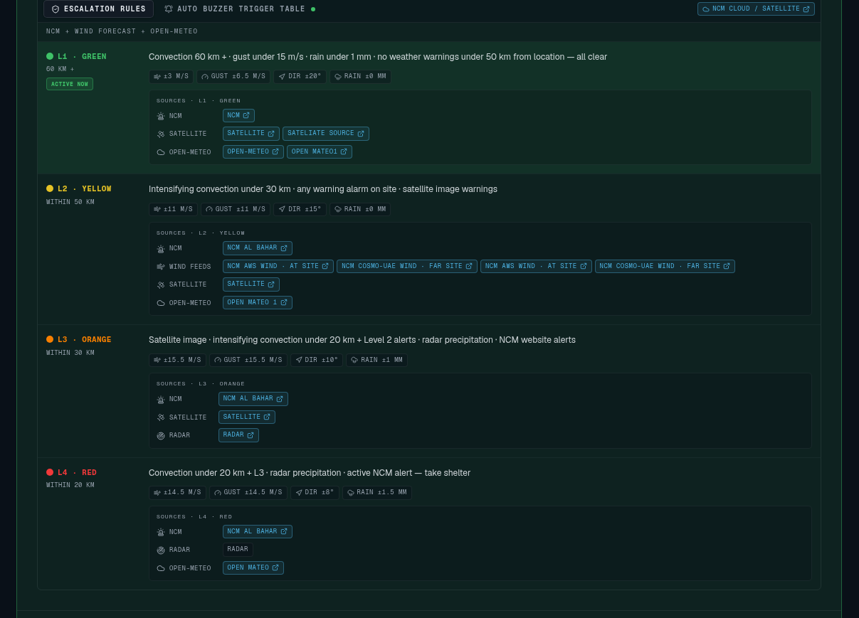
Figure: Escalation rules L1 - L4 with At-site / Far-site criteria

24 September 2026
Engineering console, AWS stations and Wind Event Monitor
The Engineering Console made the escalation rules editable. 41 more AWS stations were added. Wind speeds were standardised to km/h with m/s, and the Wind Event Monitor became the escalation ladder.
# | Update | What the function does | Reason
1 | Engineering Console | Editable escalation rules and a buzzer test for each level. | Engineers can tune thresholds without code changes.
2 | Boosted radar/cloud imagery; Google-Maps-style basemap | Stronger imagery and a coloured basemap. | Easier to tell land, sea and clouds apart.
3 | Total Clouds tab, trajectory tool, cached field route | New cloud tab and path measuring; field data is cached. | Cloud tracking with fewer API calls.
4 | Denser wind field; removed Clouds/IR tab | Improved the streamlines and removed a duplicate tab. | Clearer wind with less clutter.
5 | AWS wind / solar-DNI station overlay | Ground-station readings plotted on the map. | Real measurements complement the model forecast.
6 | Live / 7-day wind toggle, 0.5x playback | Switch between live and forecast wind; slower playback. | Live for now, forecast for planning.
7 | Better Auth secret env and auth origin fixes | Trusted serving origins, cross-site cookies and a hardened baseURL. | Fixed sign-in failures on the deployed site.
8 | Linked data sources + Wind Event Monitor | Escalation now uses the live wind monitor. | Tiers follow real readings.
9 | Wind-direction radar; rearranged parameter grid | New radar showing wind direction. | Direction tells whether a front is heading for the site.
10 | Dual-unit wind monitor; auto-scaled chart | km/h with m/s everywhere on the dashboard. | Matches both NCM (km/h) and plant (m/s) conventions.
11 | Blinking station status lamps | Green / yellow / orange / red lamps. | Status is visible at a glance across the room.
12 | 41 more UAE AWS sites | Expanded the station network. | Better coverage near every plant location.
13 | Configurable NCM COSMO-UAE wind source | Speed and gust readouts tied to the selected source. | Engineers choose the most reliable feed.
14 | Radar connected to COSMO-UAE with nearby stations | Bigger arrow; measure map removed. | Simpler and more accurate radar.
15 | Removed AI front call, arrival nowcast and prediction panels | Cleaned up the speculative panels. | Keeps the dashboard to trusted, actionable data.
16 | Wind Event Monitor as escalation ladder | Rows and columns ladder replacing the Approach Tracker. | Shows the current tier and how far it is from the next.
17 | Consistent radar readout boxes; slimmer Live Trend | Visual alignment and a better humidity colour. | Neater, more readable layout.
18 | Next.js type import updates | Maintenance for framework types. | Keeps the build compatible with the Next.js version.

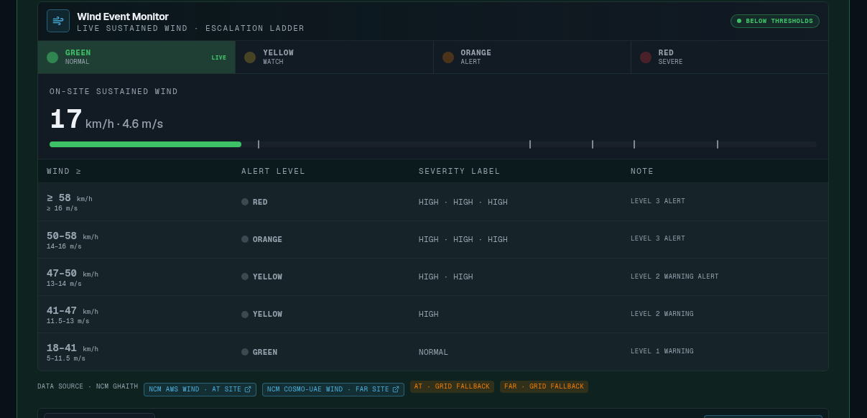
Figure: Wind Event Monitor escalation ladder (km/h and m/s)

25 September 2026
Reliable admin login, tier simulator and data resilience
Admin sign-in was made reliable, the tier simulator and per-tier At-site / Far-site panels were added, NCM fog warnings were integrated, and fallbacks were added so the UI never goes blank.
# | Update | What the function does | Reason
1 | Per-panel trend sources in console | Engineers choose the data source for each trend. | Control over which provider feeds each chart.
2 | Guaranteed Better Auth secret | A non-default secret is always set. | Production sign-in no longer returns 500 errors.
3 | Webcams callout added then removed; more air quality detail | Expanded NCM air quality. | Air quality matters more to operators than the callout did.
4 | Self-healing admin + engineering consoles | Consoles set themselves up on each deploy. | No manual setup after a redeploy.
5 | Dedicated admin sign-in and user portal | Separate admin login, redirect fix and owner seeding. | Admin login always works.
6 | Admin owner renamed to M-Quantum-Tech007 | Updated the owner account. | Matches the company account.
7 | Cloud source in console | Choose the cloud data source. | Pick the most accurate cloud feed.
8 | Dead-band hysteresis on tier changes | A tier only changes once readings pass a margin. | Stops alarms flickering on and off near a threshold.
9 | Per-tier At Site / Far Site panels | Each tier has on-site and distant criteria, linked to the ladder buttons. | A distant hazard gives early warning before it reaches the site.
10 | Weather provider for live site readings | Live per-site values. | Tiers use real readings.
11 | Monitor drives alert blink / horn | Wind Event Monitor triggers the visual and audible alarm. | One source of truth for alarms.
12 | Tier simulator with ON/OFF status | Simulate readings to test tiers. | Alarm drills without waiting for real weather.
13 | AI prediction multi-source panel | Compares several forecast sources. | Agreement between models raises confidence.
14 | Fog as yellow NCM warning from visibility | Fog warnings from live visibility. | Fog affects safety and matches NCM alerts.
15 | Official NCM warnings + Open-Meteo timeline | Merged official and model warnings; fixed card overlap and added auto-scroll. | Complete and readable warnings.
16 | NCM-mirror solid + dotted AI prediction with dew point | Observed vs predicted lines on the 24h trend. | Makes clear what happened and what is expected.
17 | Stale-cache resilience and NCM climatology fallback | Fewer API calls and fallback data. | The UI no longer goes blank when the API quota runs out.
18 | Live Trend / 24-hour detailed trend reskin | Enlarged, restyled to match the reference board, rain vs cloud colours. | Matches the plant's reference board for familiarity.
19 | Solar DNI with cloud cover and rain | Cloud area and precipitation bars on dual axes. | Explains why DNI drops.

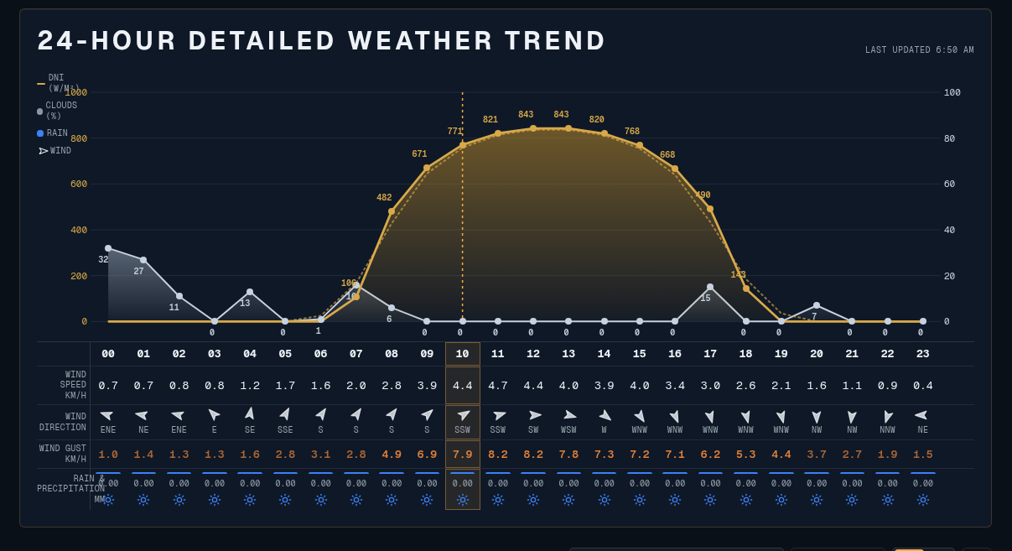
Figure: 24-Hour Detailed Weather Trend

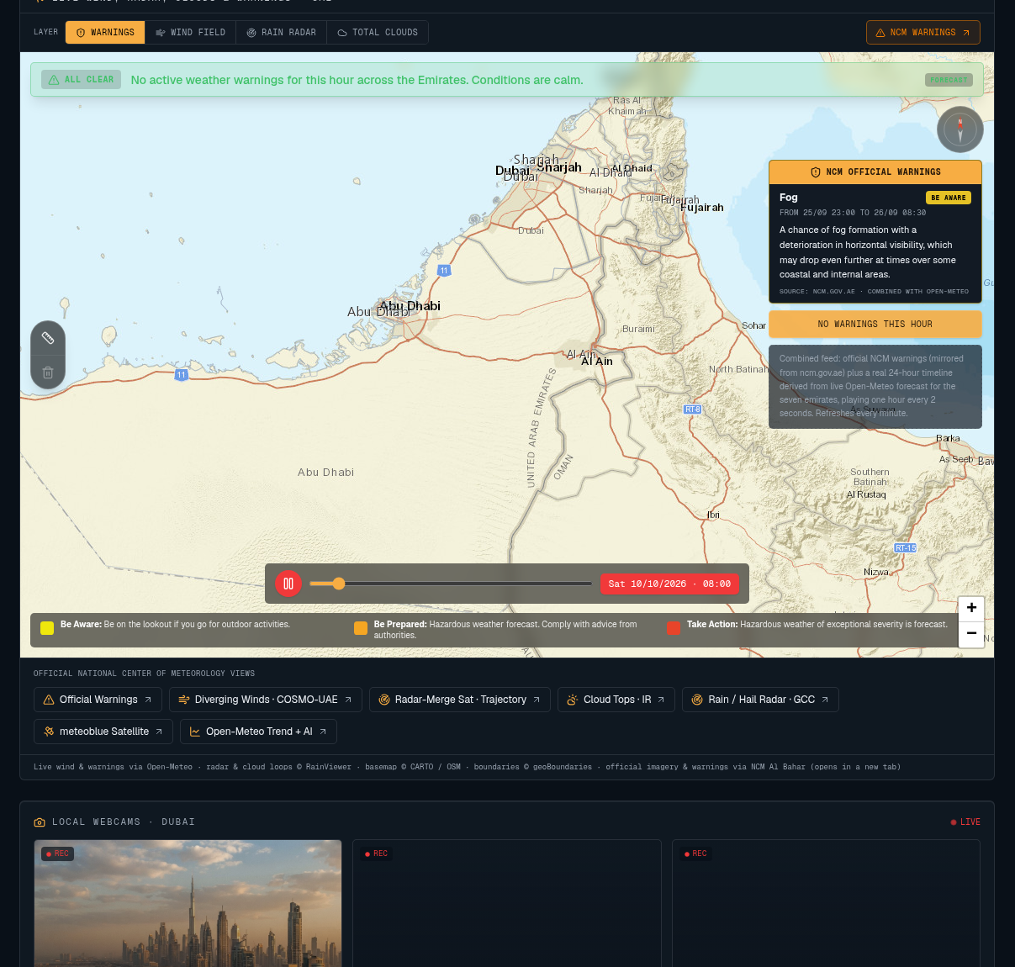
Figure: Weather map with official NCM warnings and timeline

26 September 2026
Chart redesign and simulator drills
The Solar DNI and trend tabs were redesigned for readability. The simulator gained per-site test values that drive the buzzer, and NCM warnings became editable in the database.
# | Update | What the function does | Reason
1 | Layered Solar DNI chart with toggles | Visibility toggles, axis titles and event callouts. | Users choose which layers to see.
2 | Temperature columns, cloud bars, golden DNI | Bar and column styling across the tabs. | Hourly values are easier to compare.
3 | All 24 hour labels and per-bar DNI values | Every hour labelled; solid filled bars. | No guessing which hour a bar belongs to.
4 | Enlarged 24-hour detailed trend | Bigger chart. | Readable on control-room screens.
5 | Simulator mode on safety panel | Shows when a drill is active; fixed the console crash. | Prevents a drill being mistaken for a real alarm.
6 | Per-site simulator values to buzzer | Drill readings flow into the indicators and buzzer and reset to green below the limits. | Drills behave exactly like a real event.
7 | Simulator isolated from live readings | Live data cannot override a drill. | Gives clean, predictable drill results.
8 | Continuous alarm for all tiers | Entry thresholds for each tier. | Every tier can be tested.
9 | Commissioned ranges as defaults | DEFAULT_SITE_CONFIG uses the commissioned values. | A new deploy starts with the correct thresholds.
10 | DB-backed NCM warnings with admin editor | Admins edit warnings stored in the database. | Warnings can be corrected quickly when the feed is wrong.

27 September 2026
Plant IAM
Plant Identity & Access Management was added: role-based dashboards, deep trends and user management.
# | Update | What the function does | Reason
1 | Plant IAM with role-based dashboard | Logins for roles such as PGM, Supervisor and CRO, each seeing its assigned controls. | Each person only sees and changes what their role allows.

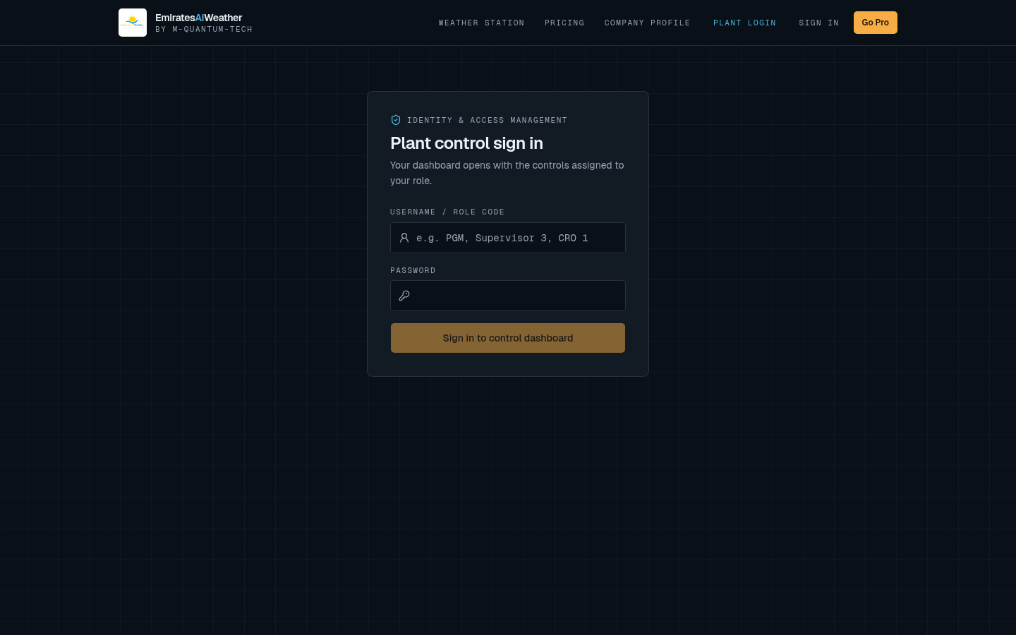
Figure: Plant control sign in (Identity & Access Management)

9 October 2026
Auto buzzer, Ghaith feeds and IAM controls
The auto buzzer now follows the escalation ranges. NCM Ghaith wind feeds became the primary source, and the safety model, radar and IAM management were refined.
# | Update | What the function does | Reason
1 | Auto buzzer from tier ranges + CSV export | Buzzer driven by ranges with a dead band; trend CSV download. | Alarms follow the rules, and data can be exported for reports.
2 | Intensive cloud cover as trigger | Cloud added as a buzzer trigger with a per-tier dead band. | Heavy cloud is a hazard in its own right.
3 | Green tier and buzzer trigger table | Editable, then read-only and aligned to tier top bands, OR across four metrics. | Any one metric can raise the alarm.
4 | NCM Ghaith aws-wind and cosmo-uae-wind feeds | Escalation and monitor wired to Ghaith. | Ghaith is NCM's official observation source.
5 | Ghaith mirror as primary source | Mirrored Ghaith values are used first. | Ghaith has no public API, so values are mirrored.
6 | Alarm details panel (added, simplified, removed) | Distance verdict and OK/causing checks. | Tried for explanation; removed to reduce clutter.
7 | Safety levels re-wire (reverted) | Change reverted. | Kept the commissioned behaviour.
8 | Safety Model tier from Live Wind Monitor, labelled 1-4 | One tier source. | The banner and monitor always agree.
9 | Forecast-to-site panel and radar legend | Shows when the forecast reaches the site. | Gives advance planning time.
10 | Ghaith-style readouts, diverging-wind marker | Removed the gust strip. | Highlights wind shifts that signal a front.
11 | NCM 24h clock and minute-synced refresh | Clock in the banner; data refreshes on the NCM minute. | Times match NCM bulletins exactly.
12 | IAM edit / delete confirm, Save staging | Changes only apply after Save; CSV export; read-only roster. | Avoids accidental user changes.
13 | Per-login CSV export permission | Admins allow or block CSV export per user. | Controls who can take data out.

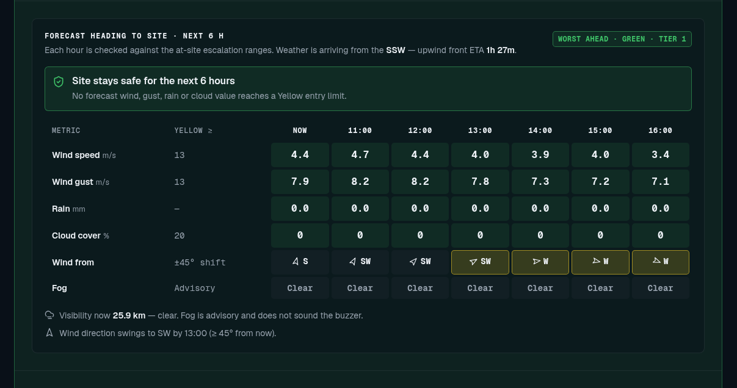
Figure: Forecast heading to site table

10 October 2026
Live buzzer inputs and Push to mirror
Every hazard input now feeds the live buzzer. The trigger table and escalation rules share one tabbed panel, and station users with IAM permission can push Ghaith values to the mirror.
# | Update | What the function does | Reason
1 | Gust, rain, cloud, far-site, NCM / Al Bahar warnings in buzzer; Red at 14 m/s | All inputs drive the alarm. | No hazard is missed.
2 | Live alarm Test and Reset | Added, then moved into the Wind Event Monitor; wind test removed. | Operators can test the horn where they watch the wind.
3 | Buzzer trigger table on station, grouped links | Station shows the trigger table. | Operators see why the horn sounds.
4 | Simulator state shared via database | All screens see the same drill; faster console refresh. | Every control-room screen stays in sync.
5 | Escalation rules + trigger table as tabs | Combined into one panel. | Saves space; related rules sit together.
6 | AWS and COSMO wind feed buttons | Buttons under the wind radar, styled like Push to mirror. | Quick access to the source feeds.
7 | Station Push to mirror | Push Ghaith wind values from the station page. | Keeps data live even though Ghaith blocks server requests.
8 | Require sign-in for Push to mirror | Guests cannot push. | Stops the public from tampering with safety data.
9 | Plant IAM "Push to mirror" permission | Admins allow or block each user, default Not allowed. | Simple per-user control over who can update the mirror.

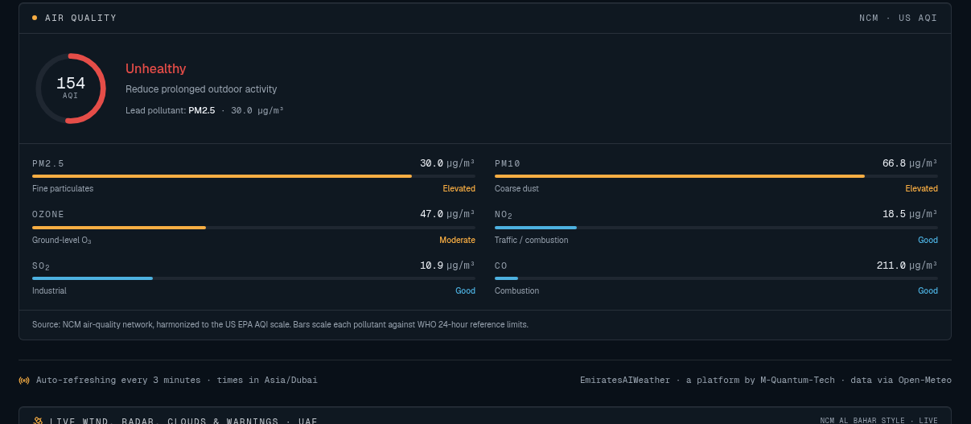
Figure: Air quality detail (NCM)


Figure: Pricing page: Company Pro and Personal Pro

Full dashboard overview
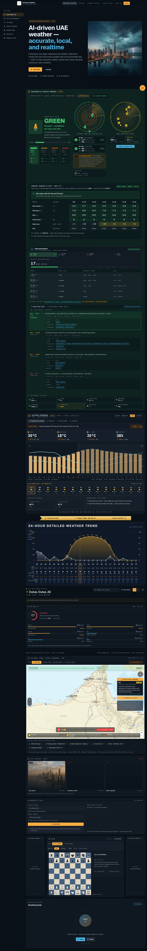
Figure: Complete station dashboard as of 10 October 2026

