APEXPLANET INTERNSHIP — TASK 3
Deep-Dive Analysis & Interactive Dashboard
Sales Performance Intelligence Dashboard

1. Objective
The objective of Task 3 is to perform a deep-dive analysis of the supplied sales dataset, define meaningful business KPIs, identify sales and customer patterns, and present the findings through an interactive Power BI dashboard.

2. Dataset & Preparation
The cleaned ApexPlanet Data Analytics dataset was used. It contains customer, order, product, demographic and sales fields such as Customer_ID, Customer_Name, Gender, Age, City, Order_Date, Order_ID, Product, Category, Quantity, Unit_Price and Total_Sales.
A data-quality check showed repeated Order_ID values across records. Therefore, the dashboard uses the number of dataset rows for the transaction KPI and DISTINCTCOUNT(Customer_ID) for unique customers.

3. Core KPIs
KPI | Value | Business Meaning
Total Sales | 139.40M | Total revenue represented in the dataset.
Total Transactions | 1,000 | Number of sales records analyzed.
Unique Customers | 947 | Distinct customers represented.
Average Transaction Value | 139.40K | Average sales value per transaction.
Total Units Sold | 5,435 | Total quantity sold.

4. Deep-Dive Analysis
Monthly Sales Trend: Tracks sales over time and helps identify high- and low-performing periods.
Category Analysis: Electronics is the leading category in the displayed dashboard.
Product Analysis: Laptop and Mobile are among the strongest products by sales.
City Analysis: Patna leads the displayed city-level sales comparison.
Age Group Analysis: Compares sales across the five customer age groups.
Gender Analysis: Shows a near-even sales split; the displayed dashboard shows Female at 51.98% and Male at 48.02%.
Interactive Filtering: City, Category, Gender and Age Group slicers allow focused segment analysis.

5. Final Interactive Dashboard
The completed Power BI dashboard contains five KPI cards, a monthly sales trend, category and product charts, city and age-group analysis, gender analysis, and interactive slicers.
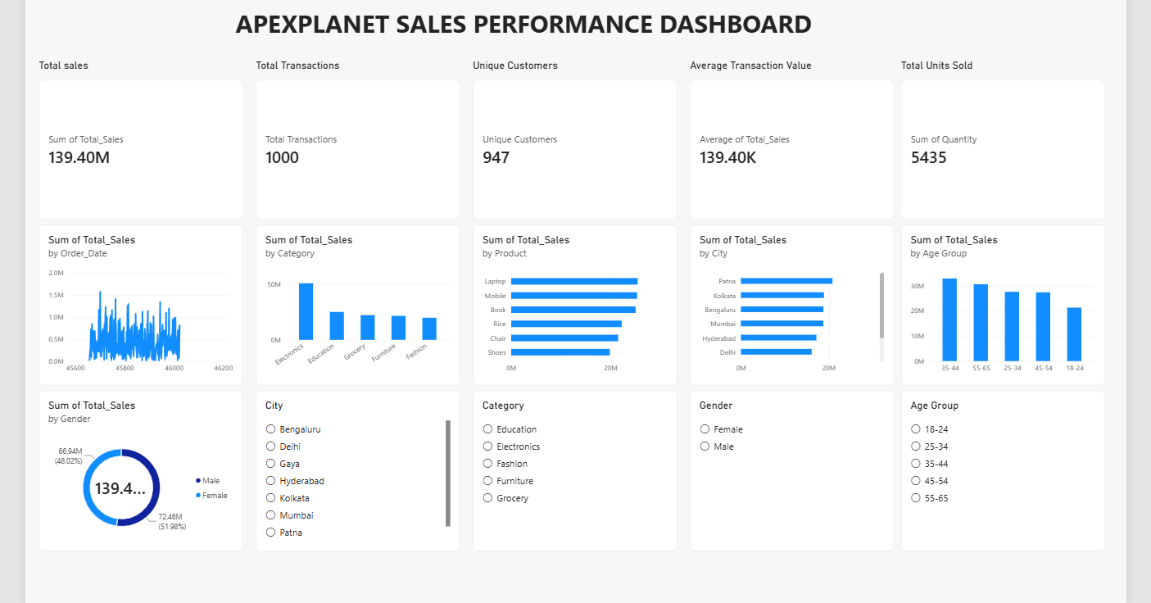
Figure 1. Final ApexPlanet Task 3 Power BI Dashboard

6. Key Business Findings
- Total sales are 139.40M across 1,000 sales records.
- 947 distinct customers are represented.
- Average transaction value is 139.40K and total units sold are 5,435.
- Electronics is the strongest category in the displayed analysis.
- Patna is the leading city in the displayed city comparison.
- Female customers contribute 51.98% of sales and Male customers 48.02% in the displayed dashboard.
- Interactive filters allow the overall sales view to be narrowed to specific customer segments.

7. Business Recommendations
- Prioritize inventory and promotional campaigns for high-performing categories and products.
- Investigate weaker months for seasonal, pricing or promotional factors.
- Use age, gender and city segmentation for targeted marketing.
- Develop loyalty and retention campaigns to increase repeat purchases.
- Monitor city-level performance to optimize regional marketing and inventory.
- Validate transaction identifiers before calculating operational KPIs.

8. Tools & Technologies
Microsoft Power BI Desktop • Microsoft Excel • Power Query • DAX

9. Submission Checklist
☐ 3–5 core KPIs defined and displayed.
☐ Deep-dive analysis completed.
☐ Interactive Power BI dashboard completed.
☐ Dashboard screenshot included in this report.
☐ 5–7 minute walkthrough video can be recorded from the completed dashboard.
☐ Power BI/report files can be uploaded to GitHub.
☐ GitHub and dashboard/demo links can be included in the LinkedIn post.

10. Conclusion
The project transforms the cleaned sales dataset into an interactive business intelligence dashboard. It combines KPI reporting, trend analysis, product and category performance, customer segmentation and interactive filtering to support data-driven business decisions.

