ONLINE LEARNING WEBSITE
SOFTWARE REQUIERMENTS SPECIFICATION
1 Overview
Requirement definition is the most important stage of a project because it defines what needs to be done and how. The only way to ensure the completion of a project successfully, with achievement of the defined objectives in an effective and organized manner, is by the process of requirement definition.
Some essential requirements to be considered during the design and development of the online learning website project are:
• Website Structuring: Informed design and organization of the website to ensure quick and easy access to a variety of courses and other resources.
• User Interface: Provide an intuitive and user-friendly interface to enable students and instructors to easily navigate the site, move around, and engage in the content seamlessly.
•Content Management: Ensure accurate and up-to-date information about courses or any other
Content is ready and updated.
• User Experience: Progress monitoring, customized recommendations, and engaging features like quizzes can enhance the experience of users.
• Accessibility and Inclusivity: Make sure that the website is as accessible as possible to all its future users, this content thereof strives towards being as inclusive and representative of as wide a variety of diverse audiences as possible.
By addressing these requirements, the online learning website will be able to provide a robust platform for educational engagement, facilitating a positive and productive learning environment for all users.
2. Feasibility study:
Overview:
The study was conducted to determine the feasibility of “LEARNERS GUIDE” website and whether it can operate as envisioned or not.

2.1 Operational Feasibility
Operational feasibility assesses the effectiveness of the proposed online learning website in meeting the educational needs of users in a straightforward and efficient manner. To evaluate this, a survey was conducted targeting potential users of the platform.

A total of 53 responses were collected through this survey, which aimed to gauge the acceptance and anticipated success of the website. The survey included the following key question to measure user acceptance:
By looking at Figure.1 we can see that 47.2% said that it is very likely that they would use
a online learning website to learn something new.
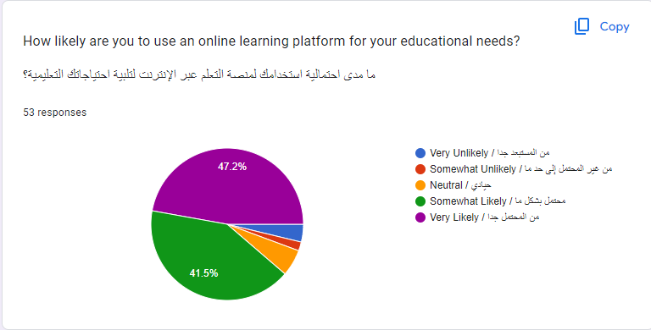
Figure .1

In figure.2 we can see what type of content people want in the online learning website
And that 66% want the website to have skill-based workshops (e.g... Coding …ETC)
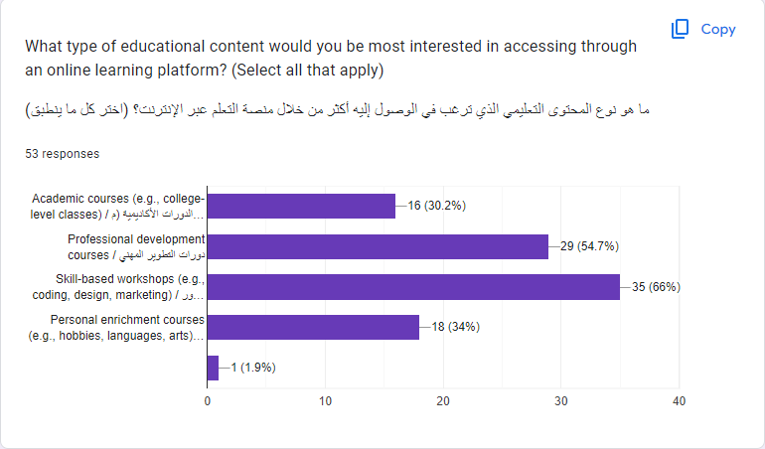
Figure.2

In figure.3 we can see the reason that would make you consider to use an online learning
website and by 30.2% selected all of the above
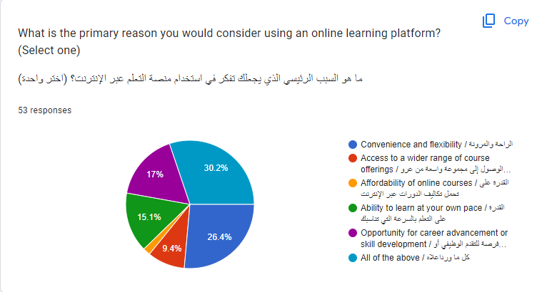
Figure.3

In figure.4 it helps us understand what challenges face people in learning the traditional way
and 56.6% said that it was because of scheduling conflicts.
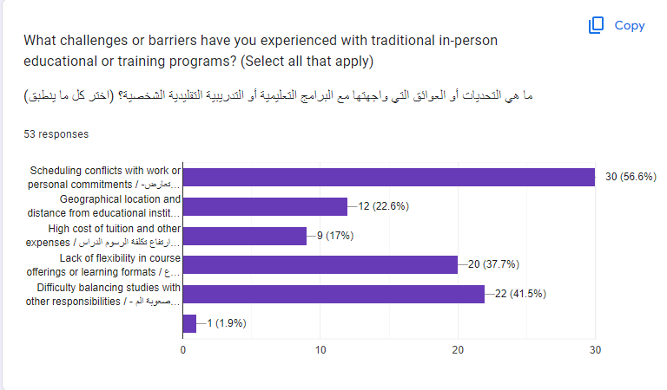
Figure.4

2.2 Legal feasibility study
A legal feasibility study assesses the legal viability of the online learning website, ensuring compliance with all relevant laws and regulations.
The website must:
- Comply with Data Protection Laws: Adhere to local data protection regulations, including obtaining user consent and securing user data.
- Respect Intellectual Property: Use properly licensed or owned educational materials and establish clear policies for user-generated content.
- Ensure Accessibility: Follow WCAG (Web Content Accessibility Guidelines) guidelines to make the platform accessible to users with disabilities.
- Provide Clear Terms: Develop comprehensive Terms of Service and Privacy Policy documents, requiring user agreement before use.
- Meet Educational Standards: Ensure courses meet accreditation standards and regularly update content.
2.3Technical Feasibility Study
An online learning website requires the implementation of suitable and widely accepted languages and technologies in programming. There may exist various technologies to be used in serving the objectives of the site. Hence, the duty calls for constructing a website with established technologies so that it becomes user-friendly, scalable, and efficient.
2.4 Source of Requirements
2.4.1 Expected Users
The anticipated users of an online learning website are individuals and organizations with a need for educational resources and courses. These users may include:
- Students: Individuals seeking to enhance their knowledge or skills through online courses, including high school students, college students, and lifelong learners.
- Professionals: Workers looking to acquire new skills or certifications for career advancement or to stay updated with industry trends.
- Educators: Teachers and instructors who want to offer their courses online, share resources, and interact with a wider audience.
- Organizations: Companies and institutions that require online training programs for employee development and continuous learning initiatives.
Online education websites have different types of users which include individuals and organizations so that their educational needs and goals may differ greatly. As a result, the website should be designed in such a way that it meets all these peoples’ requirements so that it could become a user-friendly, absorbing and seamless-for-everyone experience.
2.4.2 Similar Products
There are numerous online learning platforms available in the market. Examples include:
2.4.2.1 Coursera: An online learning platform offering courses, specializations, and degrees from universities and companies worldwide. It provides a wide range of subjects and interactive elements such as quizzes and forums.
2.4.2.2 Udemy: A global marketplace for learning and teaching online, where students can access thousands of courses on various topics, and instructors can create and sell their courses.
2.4.2.3 Khan Academy: A non-profit educational organization offering free online courses, lessons, and practice exercises in various subjects, aimed at learners of all ages.
2.4.2.4 LinkedIn Learning: An educational platform that offers video courses taught by industry experts in software, creative, and business skills. It integrates with LinkedIn profiles to help professionals develop and showcase their skills.

2.5 Requirement Elicitation Techniques
2.5.1 Survey
One of the most efficient ways to collect data super effectively is by surveys that’s why in this
Project, I used it and got a lot of good feedback from it.

2.6 System Scenario
- Traditional classroom learning can be cumbersome and inflexible; thus, an online learning website is needed to address various issues during the learning process. The user’s perspective of e-learning system can be outlined as follows:
- User Registration and Login: The user visits the online learning website and registers for an account using their email and a secure password. Once registered, the user logs in to access the platform.
- Course Browsing: The user navigates to the course catalog page, where they can browse or search for courses by looking into the many different courses available.
- Course Enrollment: After selecting a course of interest, the user enrolls in the course.
- Accessing Course Content: Once enrolled, the user can access course materials, including videos, readings The user can progress through the course at their own pace.
The online learning system allows users to access educational content easily and flexibly, facilitating a more efficient and enjoyable learning experience.

From the administrative perspective, the online learning system is as follows:
- Admin Login: The administrator logs into the online learning system using their username and password.
- Access to Dashboard: After logging in, the administrator accesses their dashboard, where they can manage content, users and instructor accounts
- Content Management: The administrator can create new content.
- User Management: The administrator can manage user accounts, including enrolling users in courses, monitoring user activity, and addressing any issues or inquiries.
- Analytics and Reporting: The administrator can review reports on user engagement, course performance, and other metrics to improve the website and make data-driven decisions.
The administrator can rely on the online learning system to effectively manage educational content, users, and interactions, improving the overall efficiency and effectiveness of the learning platform.

2.7 use case diagram :
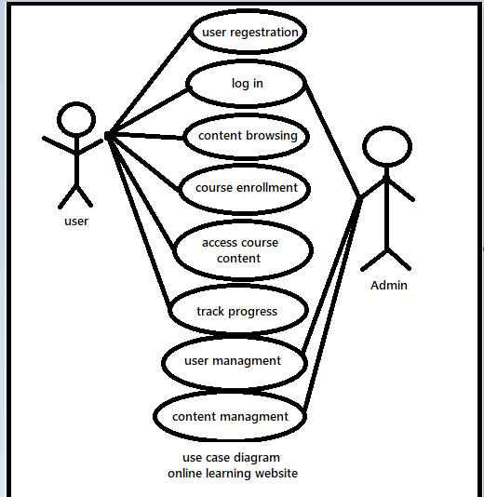

2.8 use cases
Table 2.8.1: Represent the User Registration Use Case
UC Name | User Registration
UC ID | UC_1
Actor | User
Description | The user wants to register an account on the website.
Pre-condition | - The device has to be connected to the internet. The user should not already have an account.
Main scenario | - The system shows a registration page with input fields for personal information and account details. The user fills in the required fields and submits the registration form.
Alternative scenario | None
Exceptional Scenario | - The user enters invalid or incomplete information; the system shows error messages indicating the issues.
Success post condition | The user successfully registers and can log in to the website.
Priority (1 the highest) | 1

Table 2.8.2: Represent the User Login Use Case

UC Name | User Login
UC ID | UC_2
Actor | User
Description | The user wants to log in to the website.
Pre-condition | - The device has to be connected to the internet. The user must have an existing account.
Main scenario | - The system shows a login page with input fields for username and password. The user enters their credentials and submits them.
Alternative scenario | None
Exceptional Scenario | - The user enters incorrect credentials; the system shows an error message. The user forgets to fill in one of the fields, the system shows a "required field" error message.
Success post condition | The user successfully logs in and accesses their dashboard.
Priority (1 the highest) | 1
2.8.3: Represent the Course Browsing Use Case
UC Name | Course Browsing
UC ID | UC_3
Actor | User
Description | The user wants to browse available courses.
Pre-condition | - The device has to be connected to the internet. The user should be logged in.
Main scenario | - The user navigates to the course catalog page. The user can browse courses by category, popularity, or keyword.
Alternative scenario | None
Exceptional Scenario | - If there are no courses available, the system displays a message indicating this.
Success post condition | The user can view and select courses of interest.
Priority (1 the highest) | 2

2.8.4: Represent the Course Enrollment Use Case
UC Name | Course Enrollment
UC ID | UC_4
Actor | User
Description | The user wants to enroll in a course.
Pre-condition | - The device has to be connected to the internet. The user should be logged in. The user should have selected a course.
Main scenario | - The user clicks on the "Enroll" button for a selected course.  The content of the course pops up
Alternative scenario | None
Exceptional Scenario | - If the enrollment fails due to technical issues, the system shows an error message and prompts the user to try again.
Success post condition | The user is successfully enrolled in the course and can access course materials.
Priority (1 the highest) | 1

2.8.5: Represent the Access Course Content Use Case
UC Name | Access Course Content
UC ID | UC_5
Actor | User
Description | The user wants to access course materials.
Pre-condition | - The device has to be connected to the internet. The user should be logged in. The user should be enrolled in the course.
Main scenario | - The user navigates to the course page. The user can view and interact with course videos, readings, quizzes, and assignments.
Alternative scenario | None
Exceptional Scenario | - If the course content fails to load, the system shows an error message.
Success post condition | The user successfully accesses and interacts with course materials.
Priority (1 the highest) | 1

2.8.6: Represent the Course Management Use Case
UC Name | Course Management
UC ID | UC_7
Actor | Instructor
Description | The instructor wants to manage courses.
Pre-condition | - The device has to be connected to the internet. The instructor must be logged in.
Main scenario | - The instructor can create, update, and delete courses.
Alternative scenario | None
Exceptional Scenario | - None
Success post condition | The instructor successfully manages the courses.
Priority (1 the highest) | 1

2.8.7: Represent the User Management Use Case
UC Name | User Management
UC ID | UC_8
Actor | Admin
Description | The admin wants to manage user accounts.
Pre-condition | - The device has to be connected to the internet. The admin must be logged in.
Main scenario | - The admin can delete user and instructor Accounts
Alternative scenario | None
Exceptional Scenario | - None
Success post condition | The admin successfully manages user accounts.
Priority (1 the highest) | 1

2.8.8: Represent the Content Moderation Use Case
UC Name | Content Moderation
UC ID | UC_9
Actor | Admin
Description | The instructor wants to moderate user-uploaded files.
Pre-condition | - The device has to be connected to the internet. The instructor must be logged in.
Main scenario | - The instructor reviews and moderates files posted by users in discussion forums and other interactive areas.
Alternative scenario | None
Exceptional Scenario | - None
Success post condition | The instructor successfully moderates user-generated content.
Priority (1 the highest) | 2

Requirements
Functional requirements

- User Registration and Login:
  - The system shall provide a registration page where users can create an account by entering their email, username, and password.
  - The system shall verify the email address by sending a confirmation link.
- Content Management:
  - The system shall allow administrators to create, update, and delete various types of content such as articles, videos, podcasts, and courses.
  - The system shall enable content creators to upload materials such as videos, documents, and audio files.
- Content Access:
  - The system shall provide access to various content types only to users with appropriate permissions.
  - The system shall allow users to download content where applicable.

4. Report Feature:
- The system shall provide a report button for users to submit feedback, including their name and a description of the issue or suggestion
- Users can easily access the report feature from any page to enhance user experience and address concerns effectively.
- The system shall ensure that all reports are reviewed and addressed promptly, fostering a supportive learning environment.
Non-Functional Requirements

- Performance Requirements:
  - The system shall support at least 500 concurrent users without performance degradation.
  - The system shall load any page within 2 seconds under normal load conditions.
- Security Requirements:
  - The system shall use HTTPS for all communications to protect data in transit.
  - The system shall securely store all user passwords using encryption techniques.
- Usability Requirements:
  - The system shall have a consistent and intuitive user interface.
  - The system shall provide accessibility features to support users with disabilities.
- Reliability Requirements:
  - The system shall have an uptime of 99.9% excluding scheduled maintenance.
  - The system shall automatically back up all data daily.
- Scalability Requirements:
  - The system shall be able to scale to support up to 10,000 active users.
- Maintainability Requirements:
  - The system shall be modular to enable easy updates and maintenance.
  - The system shall provide comprehensive error logging and reporting.

