**Department of Computing**

**Professional Software Projects**

**(55-508208-AF-20245)**

**Software Requirement Specification**  

**Project:**  Skills Enablement Game

**Team ID: IBM1**

**Team Members:**

|  |  |
| --- | --- |
| Name | ID |
| Owajigbana Blessing Uloyok | C2017806 |
| Elekir Moyuwen | C3028707 |
| Emmanuel Atiso | C3002944 |
| Niven Nishanthan | C3075853 |
| Saeed Abdilahi | C3009953 |

**Table of Contents**

**Introduction 3**

Project Overview 3

Problem Statement 3

Project Objectives 3

**System Requirements 4**

Functional Requirements 4

Non-Functional Requirements 4

User Roles 4

Personas 5

User Stories 6

**System Architecture 7**

Use Case Diagram: 7

C4 Context Diagram (level 1): 7

C4 Container Diagram (level 2): 7

ER Diagram: 7

**Appendix 1: Tasks Completed 8**

**Appendix 2: GitHub Repository 9**

**References 10**

# Introduction

## Project Overview

The Skills Enablement Digital Collectible Card Game (DCCG) project seeks to create, develop, and deploy an entertaining, competitive online card game that blends strategy, creativity, dynamic gameplay, and learning materials from IBM SkillBuild courses. This project will establish a comprehensive digital ecosystem in which gamers can collect, trade, and battle unique cards by answering questions based on course material.

The core objectives include:

* **Interactive Gameplay:** Players will construct custom decks and compete in turn-based matches emphasizing strategy and skill.
* **Card Collection System:** The game will feature collectible cards with varying rarities, attributes, and abilities, each balanced to ensure fair competition.
* **Progression and Rewards:** Players will earn rewards through victories, achievements(completing a badge), and daily challenges (completing a module quiz), enabling progression through ranks and collection enhancement.
* **Platform Compatibility:** The game will be optimized for desktop and possibly mobile platforms but desktop will be the main focus, accessibility and cross-platform play could also be a possibility as well.

The project will prioritise high-quality graphics and an intuitive UI to deliver an immersive and competitive experience for players of all ability levels. We intend to incorporate player feedback and industry best practices into an iterative development process to get a polished and enjoyable outcome.

## Problem Statement

There are a few potential challenges to using IBM SkillsBuild for e-learning, these include: technical issues with internet connectivity and system downtime, lack of learner engagement is passive as the learning formats is relaxed, poorly managing time with self-paced learning, potential distractions from the online environment, and ensuring learners have the necessary foundational skills to access more advanced courses; all while navigating the platform's design and features to optimise the learning.

**Key challenges:**

**Technical Barriers:**

* Poor internet connection impacting video quality and loading times.
* Device compatibility issues with older hardware or operating systems.
* Platform glitches or unexpected technical errors.

**Learner Engagement:**

* Passive learning experience from solely reading text-based content.
* Difficulty maintaining motivation and focus in a self-paced environment.
* Lack of interactive elements or real-world application scenarios.

**Time Management:**

* Balancing learning with other commitments due to flexible scheduling.
* Difficulty estimating the time required to complete courses.
* Procrastination and inconsistent study habits.

**Access and Prior Knowledge:**

* Learners with limited prior technical knowledge struggling with advanced concepts.
* Need for foundational skills to progress through the curriculum effectively.

**Assessment and Certification:**

* Ensuring the assessment accurately reflects acquired skills and knowledge.
* Maintaining the value and credibility of earned digital credentials.

## Project Objectives

The Skills Enablement Digital Collectible Card Game (DCCG) project is designed to encourage users of the IBM SkillBuild to complete courses offered by IBM in their commitment to skilling 30 million people globally by 2030 while delivering a high-quality, immersive gaming experience. The key objectives of the project are as follows:

1. **Design an Engaging Gameplay System:**
   * Create a turn-based strategic card game that focuses on player skill, deck building innovation, and dynamic decision-making.
   * Ensure mechanics are intuitive for new players while offering depth for competitive and experienced gamers.
2. **Develop a Comprehensive Card Collection System:**
   * Introduce a diverse library of cards featuring unique abilities, attributes, and artwork.
   * Implement a fair progression system for acquiring new cards through gameplay, rewards, and events.
3. **Foster Community Interaction:**
   * Build robust player-to-player features, such as card trading, tournaments, leaderboards, and chat tools.
   * Create a supportive ecosystem for esports and competitive events to encourage long-term player retention.
4. **Prioritize Fairness and Accessibility:**
   * Balance all cards to ensure fairness, avoiding pay-to-win mechanics.
   * Competitive ecosystems with meaningful opportunities for all players to progress.
5. **Deliver a Rich, Immersive Experience:**
   * Incorporate high-quality graphics, animations, sound effects, and storytelling to create a captivating game world.
   * Use live updates and seasonal content to keep the experience fresh and engaging.
6. **Achieve Technical Excellence:**
   * Build a scalable, secure backend to support matchmaking, multiplayer gameplay, and player data.
   * Ensure seamless performance and minimal downtime across all platforms.

By achieving these objectives, the Skills Enablement DCCG project will deliver a cutting-edge, community-driven card game that appeals to casual and competitive players alike whilst helping learners retain information and complete their courses with confidence.

# System Requirements

## Functional Requirements

**Gameplay Mechanics**

*Table 1.1 : Functional Requirements - Gameplay Mechanics*

|  |  |  |  |
| --- | --- | --- | --- |
| ID | Theme | Description | Priority (MoSCoW) |
| MFR01 | Mechanics | **Card Management**: Ability for players to view, organize, and manage their card collection | Must |
| MFR02 | Mechanics | **Card Management**: Functions to add, remove, or upgrade cards in a deck | Should |
| MFR03 | Mechanics | **Deck Building**: Players can create and save custom decks with specific rules (e.g., card limits, rarity restrictions) | Could |
| MFR04 | Mechanics | **Deck Building**: Validation to ensure decks comply with game rules | Should |
| MFR05 | Mechanics | **Game Rules Engine**: Implement the logic for turns, phases (e.g., draw, play, attack), and card interactions | Must |
| MFR06 | Mechanics | **Game Rules Engine**: Automatic enforcement of rules, including win/loss conditions | Must |
| MFR07 | Mechanics | **Card Abilities:** Cards must have specific attributes (e.g., attack, defense, mana cost, special abilities). | Must |
| MFR08 | Mechanics | **Card Abilities:** Implement dynamic effects such as buffs, debuffs, and triggered abilities | Should |

## 

**User Interface**

*Table 1.2 : Functional Requirements - User Interface*

|  |  |  |  |
| --- | --- | --- | --- |
| ID | Theme | Description | Priority (MoSCoW) |
| UIFR01 | Interface | **Card Display**: Interactive, visually appealing card design with stats, abilities, and artwork visible | Could |
| UIFR02 | Interface | **Card Display**: Filters and search functions to easily find specific cards | Should |
| UIFR03 | Interface | **Game Board**: A clear, responsive board layout for playing cards, tracking health/mana, and other resources | Must |
| UIFR04 | Interface | **Game Board**: Indicators for turns, card effects, and remaining time | Must |
| UIFR05 | Interface | **Player Profile**: Display rank, statistics (e.g., win/loss ratio), and rewards | Should |
| UIFR06 | Interface | **Player Profile**: Ability to customize avatars or in-game appearance | Could |

**Progression System**

*Table 1.3 : Functional Requirements - Progression System*

|  |  |  |  |
| --- | --- | --- | --- |
| ID | Theme | Description | Priority (MoSCoW) |
| PSFR01 | Progression | **Reward System**: Players earn rewards such as new cards, in-game currency, or cosmetic items through gameplay. | Must |
| PSFR02 | Progression | **Reward System**: Daily/weekly missions or achievements to encourage engagement | Should |
| PSFR03 | Progression | **Ranking and Leaderboards**: Implement an ELO-based ranking system or tier progression (e.g., bronze to diamond) | Could |
| PSFR04 | Progression | **Ranking and Leaderboards**: Global and friend-based leaderboards to track performance | Won’t/Would |

**Card Acquisition**

*Table 1.4 : Functional Requirements - Card Acquisition*

|  |  |  |  |
| --- | --- | --- | --- |
| ID | Theme | Description | Priority (MoSCoW) |
| CAFR01 | Acquisition | **Card Packs**: Players can purchase or earn randomized card packs | Could |
| CAFR02 | Acquisition | **Card Packs**: Implement mechanics for card trading or crafting duplicates into new cards | Won’t/Would |
| CAFR03 | Acquisition | **In-Game Store**: A store for purchasing card packs, single cards, or cosmetic items using real or in-game currency | Won’t/Would |
| CAFR04 | Acquisition | **Economy System**: In-game currency for earning rewards through gameplay | Must |
| CAFR05 | Acquisition | **Economy System**: System for purchasing cards, packs, or premium content | Won’t/Would |

**Backend Systems**

*Table 1.5 : Functional Requirements - Backend Systems*

|  |  |  |  |
| --- | --- | --- | --- |
| ID | Theme | Description | Priority (MoSCoW) |
| BSFR01 | System | **Account Management**: Support for account creation, login, and progression saving | Must |
| BSFR02 | System | **Account Management**: Synchronization for player data | Must |
| BSFR03 | System | **Anti-Cheating Measures**: Systems to detect and prevent cheating, exploits, or unfair play | Must |
| BSFR04 | System | **Anti-Cheating Measures**: Real-time monitoring of matches for suspicious behavior | Must |
| BSFR05 | System | **Scalability**: Backend capable of supporting thousands of concurrent players | Won’t/Would |
| BSFR06 | System | **Scalability**: Low-latency servers to ensure seamless gameplay | Won’t/Would |

**Community Features**

*Table 1.6 : Functional Requirements - Community Features*

|  |  |  |  |
| --- | --- | --- | --- |
| ID | Theme | Description | Priority (MoSCoW) |
| CFFR01 | Community | **Social Interaction**: Friends list, chat system, and private match invitations | Could |
| CFFR02 | Community | **Social Interaction**: Emotes or pre-set chat options for in-game communication | Should |
| CFFR03 | Community | **Tournaments and Events**: Regular in-game events and tournaments with unique rewards (card upgrades or acquire rare card) | Won’t/Would |
| CFFR04 | Community | **Tournaments and Events**: Bracket systems for competitive matches | Won’t/Would |
| CFFR05 | Community | **Spectator Mode**: Allow players to watch live matches or replays of high-ranking games | Won’t/Would |
| CFFR06 | Community | **Spectator Mode**: Overlay for detailed information on board state and cards played | Won’t/Would |

**Testing and Analytics**

*Table 1.7 : Functional Requirements - Testing and Analytics*

|  |  |  |  |
| --- | --- | --- | --- |
| ID | Theme | Description | Priority (MoSCoW) |
| TAFR01 | Analytics | **Analytics and Feedback**: Tools for tracking player behavior, game balance, and card usage | Must |
| TAFR02 | Analytics | **Analytics and Feedback**: Options for players to report bugs or suggest improvements | Must |
| TAFR03 | Testing | **Testing Environment**: Mode for players to test decks or practice against AI | Could |
| TAFR04 | Testing | **Testing Environment**: Tools for testing card interactions and game rules | Could |

**Tutorial and Help**

*Table 1.8 : Functional Requirements - Tutorial and Help*

|  |  |  |  |
| --- | --- | --- | --- |
| ID | Theme | Description | Priority (MoSCoW) |
| THFR01 | Tutorial | A comprehensive tutorial to help new players understand the game mechanics and rules | Must |
| THFR02 | Help | Easily accessible help and support options for players facing issues | Should |

## Non-Functional Requirements

|  |  |  |  |
| --- | --- | --- | --- |
| ID | Theme | Description | Priority (MoSCoW) |
| NFR01 | Security | User authentication must be handled via a secure method and must support two-factor authentication (2FA) for sensitive operations. | Must |
| NFR02 | Usability | The game’s user interface must be intuitive, allowing a first-time user to understand gameplay mechanics fairly quickly. | Should |
| NFR03 | Data Privacy | The system must comply with data protection regulations (e.g., GDPR, CCPA), ensuring users can opt out of data collection and request deletion. | Must |
| NFR04 | Scalability | The system should support multiple concurrent users without performance degradation. | Could |
| NFR05 | Testing | The game should be validated through iterative user testing to ensure usability and engagement. | Must |
| NFR06 | Performance | The game must respond to user interactions almost immediately under normal operating conditions. | Must |

## User Roles

|  |  |
| --- | --- |
| Role | Description |
| Player | Engages with the game, answers questions, and earns cards based on IBM Skills Build credentials. |
| Guest User | Can explore the game but has limited access to features like card collection. |
| Game Content Creator | Creates and curates quiz questions from IBM Skills Build credentials (AI, Cybersecurity, Cloud, Data Science). |

## Personas

|  |  |
| --- | --- |
| **James Carter** | |
| · **Age**: 22  · **Occupation**: Computer Science Student  · **Location**: London, UK  · **Gaming Experience**: Casual gamer, enjoys strategic and educational games.  · **Preferred Learning Style**: Interactive and hands-on learning.  **Quote:** "I want to learn new tech skills in an engaging way, rather than just reading through course material." | |
| **Background** | James is a university student with a keen interest in AI, cybersecurity, and cloud computing. While he understands the importance of certifications and learning new skills, he often finds traditional learning methods boring and difficult to stay motivated with. He enjoys gaming in his free time, especially card-based strategy games like *Hearthstone* and *Star Trek Adversaries*. |
| **Goals** | · Learn IBM Skills Build content in a fun and interactive way.  · Progress through the game while reinforcing his knowledge.  · Challenge friends and compare progress. |
| **Frustrations** | · Finds standard learning experiences too passive and repetitive.  · Wants a way to apply his knowledge in a competitive environment. |
| **Technology** | · Devices: Laptop, Smartphone.  · Gaming Preferences: Prefers browser-based games over heavy downloads. |
| **Scenario** | James logs into the Skills Enablement Game, selects a category (AI), and begins playing. He is asked a question from an IBM Skills Build credential, and after answering correctly, he unlocks a new card with an AI-related ability. As he progresses, he faces challenges from other players, reinforcing his learning while making the experience enjoyable. |

|  |  |
| --- | --- |
| Emily Rodriguez | |
| * **Age**: 19 * **Occupation**: First-Year University Student (Cybersecurity Major) * **Location**: Manchester, UK * **Gaming Experience**: Occasional mobile and browser gamer * **Preferred Learning Style**: Visual and interactive learning   **Quote:** "I love learning new tech concepts, but I struggle to stay engaged with long reading materials. A game-based approach sounds like a perfect way to reinforce my skills." | |
| **Background** | Emily is a first-year university student studying cybersecurity. She’s eager to gain hands-on experience but finds traditional learning materials overwhelming. She prefers interactive learning methods such as simulations and quizzes. Although she’s not a hardcore gamer, she enjoys mobile and browser-based puzzle games. |
| **Goals** | · Gain a strong understanding of cybersecurity topics in a fun way.  · Prepare for industry certifications through engaging practice.  · Play and learn at her own pace, without feeling pressured. |
| **Frustrations** | · Finds textbook-based learning dry and uninspiring.  · Has difficulty remembering concepts without interactive application. |
| **Technology** | · Devices: Laptop, Smartphone, Tablet  · Gaming Preferences: Prefers browser-based and mobile-friendly games |
| **Scenario** | Emily logs into the game and chooses the **Cybersecurity** category. She answers a series of questions about encryption and phishing attacks, unlocking a “Firewall Shield” card. Later, she plays a mini-game where she has to stop a simulated cyberattack by applying what she learned. |

|  |  |
| --- | --- |
| Daniel Kim | |
| * **Age: 28** * **Occupation: IT Support Engineer** * **Location: Birmingham, UK** * **Gaming Experience: Experienced strategy and RPG gamer** * **Preferred Learning Style: Problem-solving and challenge-based learning**   **Quote:** "I already work in IT, but I want to level up my skills in AI and cloud computing. If I can do that while playing a game, that’s a win-win." | |
| **Background** | Daniel has been working in IT support for several years but wants to expand his knowledge into AI and cloud computing. He doesn’t have the time for full-time courses, so he’s looking for an interactive way to upskill. He enjoys games that require strategy, critical thinking, and decision-making, such as *Hearthstone* and *Star Trek Adversaries*. |
| **Goals** | · Improve his AI and cloud computing knowledge for career growth.  · Learn through competition and strategic gameplay.  · Play in short, focused sessions due to his busy work schedule. |
| **Frustrations** | · Finds it hard to stay motivated in traditional online courses.  · Wants more **hands-on** and **real-world applications** rather than just reading theory. |
| **Technology** | * Devices: PC, Smartphone, Cloud-based gaming platforms * Gaming Preferences: Enjoys competitive strategy games with progression-based mechanics |
| **Scenario** | Daniel starts a **Cloud Computing** challenge and faces another player in a battle. Each move is determined by answering cloud-related questions correctly. He wins a match by correctly selecting the best cloud deployment model for a given business scenario, earning a rare “Cloud Architect” card. |

|  |  |
| --- | --- |
| Priya Patel | |
| · **Age: 35**  · **Occupation: Career Changer (Marketing → Data Science)**  · **Location: Edinburgh, Scotland**  · **Gaming Experience: Minimal gaming experience, mostly educational apps**  · **Preferred Learning Style: Structured yet interactive learning**  **Quote:** "I’m transitioning into data science and need a structured yet engaging way to test my knowledge. This game could be a fun way to reinforce what I learn." | |
| **Background** | Priya has worked in marketing for over 10 years but recently decided to switch careers to data science. She has been taking online courses but often struggles to retain technical concepts. She is not a big gamer but enjoys **educational apps and productivity-focused games**. |
| **Goals** | · Reinforce data science knowledge through game-based testing.  · Track progress over time to see measurable improvement.  · Stay engaged with the learning process while transitioning careers. |
| **Frustrations** | -Struggles with self-discipline when learning independently.  -Wants a way to apply her learning without needing a coding-heavy environment. |
| **Technology** | · Devices: Laptop, Tablet  · Gaming Preferences: Prefers simple, browser-based educational games |
| **Scenario** | Priya selects the **Data Science** category and plays a **quiz-style challenge** focused on statistics and machine learning. She answers correctly on data visualization techniques, unlocking a “Data Analyst” card. The game tracks her progress, showing improvement over time. |

|  |  |
| --- | --- |
| Alex Thompson | |
| * **Age: 40** * **Occupation: IT Lecturer & Mentor** * **Location: Bristol, UK** * **Gaming Experience: Limited, prefers simulations and learning-based tools** * **Preferred Learning Style: Teaching by example and discussion**   **Quote: "**I want to use this game as a learning tool for my students. If it’s engaging and educational, it could be a game-changer for how we teach technology." | |
| **Background** | Alex is an IT lecturer who is always looking for new ways to engage his students. He believes that **game-based learning** can be an effective way to reinforce concepts outside the classroom. He’s interested in testing the game to see how well it aligns with **IBM Skills Build credentials** and whether it can be used as a supplementary teaching tool. |
| **Goals** | · Evaluate the game for **educational effectiveness**.  · Recommend it to students as an **interactive study aid**.  · Provide **feedback to developers** to improve learning impact. |
| **Frustrations** | · Many educational games lack **depth and real-world application**.  · Hard to find games that align directly with **industry certifications**. |
| **Technology** | · **Devices**: Laptop, Tablet, Interactive Whiteboard  · **Gaming Preferences**: Prefers structured educational games and interactive simulations |
| **Scenario** | Alex plays through different categories in the game to assess the quality of questions. He provides feedback on areas that could better match industry standards. He later introduces the game to his students, encouraging them to use it to reinforce IBM Skills Build content. |

## User Stories

|  |  |  |
| --- | --- | --- |
| **Title**: Answer Questions to Earn Cards | **Priority**: Must | **Estimate:** 5 points |
| **As a Player**, I want to answer questions correctly to unlock new cards, so that I can build a stronger deck and progress in the game. | | |
| **Acceptance Criteria**   * **Given** I am in a game session, * **When** I answer a question correctly, * **Then** the system should:   + Reward me with a new card based on the category of the question (AI, Cybersecurity, etc.).   + Display feedback explaining why the answer was correct or incorrect.   + Update my card collection to reflect the newly acquired card.   + Provide an option to retry the question if answered incorrectly. | | |

|  |  |  |
| --- | --- | --- |
| **Title**: Media Search | **Priority**: Must | **Estimate:** 5 points |
| **As a user,** I want to search for media by title, author, or genre, so that I can easily find the media I am looking for. | | |
| **Acceptance Criteria**  **Given** I am on the search page,  **When** I enter search criteria such as title, author, or genre,  **Then** the system should:  · Offer autocomplete support,  · Query the database for media that matches my search criteria,  · Display the list of matching results with relevant details (availability, location, format),  · Allow me to filter the search results based on additional options like publication year or media type.  · Allow me to sort the search results based on media name, author, or publication year. | | |

|  |  |  |
| --- | --- | --- |
| **Title**: Reporting Inappropriate Behavior | **Priority**: Must | **Estimate:** 6 points |
| **As a Moderator**, I want to review player reports of cheating or abuse, so that I can maintain a fair and positive game environment. | | |
| **Acceptance Criteria**   * **Given** I am on the moderation panel, * **When** a player submits a report, * **Then** the system should:   + Store the report with the necessary details (reported user, reason, timestamp).   + Allow moderators to review and take action (warn, mute, ban).   + Notify the reporter once action has been taken.   + Prevent false reports from impacting gameplay. | | |

|  |  |  |
| --- | --- | --- |
| **Title**: Adding New Questions to the Game | **Priority**: Must | **Estimate:** 7 points |
| **As a Game Content Creator**, I want to add and update quiz questions, so that players always have fresh and relevant content to learn from. | | |
| **Acceptance Criteria**   * **Given** I am on the content management page, * **When** I create or edit a question, * **Then** the system should:   + Allow me to input the question text and answer choices.   + Tag the question with a relevant category (AI, Cloud, etc.).   + Validate the question format before saving.   + Store new questions in the database and make them available in the game. | | |

|  |  |  |
| --- | --- | --- |
| **Title**: Intuitive and Accessible Game Interface | **Priority**: should | **Estimate:** 5 points |
| **As a UI Designer**, I want to ensure the game interface is user-friendly and visually appealing, so that players can easily navigate and enjoy the experience. | | |
| **Acceptance Criteria**   * **Given** I am designing the interface, * **When** a player interacts with the game, * **Then** the system should:   + Provide clear visual indicators for actions (buttons, progress bars).   + Ensure accessibility features like screen reader support and high-contrast mode.   + Maintain consistent UI elements across different screens. | | |

# System Architecture

## Use Case Diagram: [Use Case Diagram.png](https://drive.google.com/file/d/1KoCxd0AZWNosxCpQkAkuRuT65sHJh1sX/view)

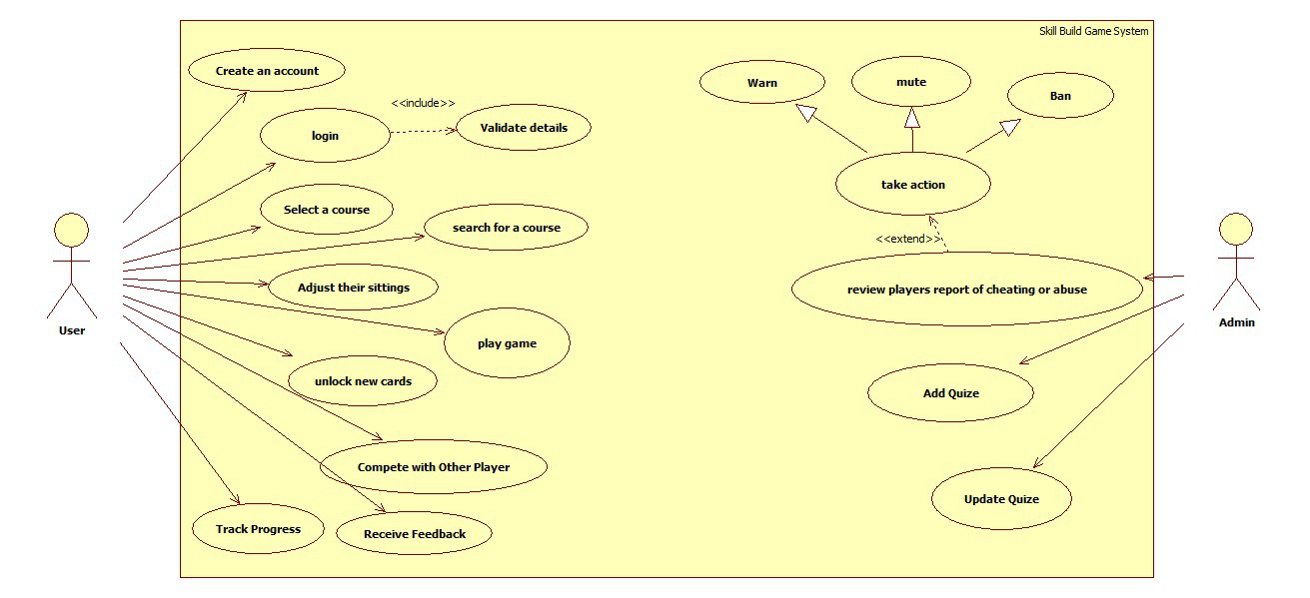

## Sequence Diagram: [SQ Diagram.png](https://drive.google.com/file/d/1vmKGWB8QGRwjrioyU0zDIN5Q8v_90w9y/view)

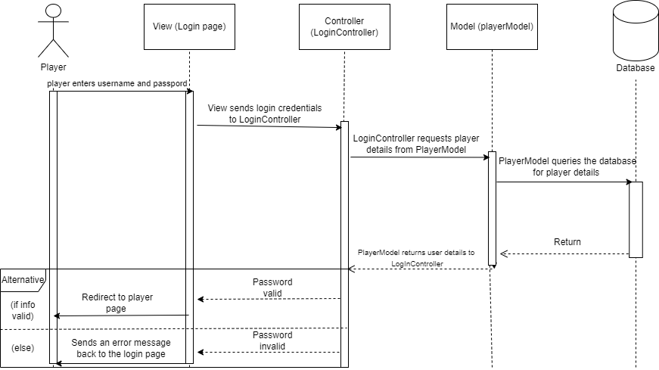

## 

## C4 Context Diagram (level 1): [ContextDiagram.png](https://drive.google.com/file/d/1lqlEOZ0nUloQBkZY51Yfov0csK8lqQkR/view)

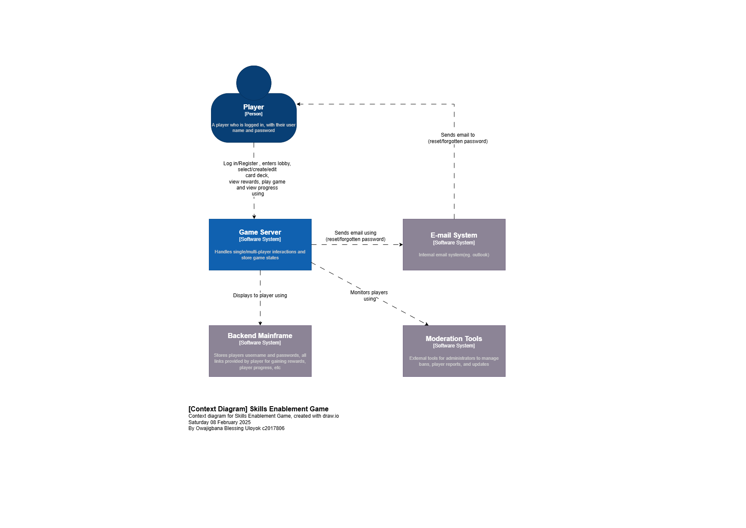

## C4 Container Diagram (level 2): [ContainerDiagram (2).png](https://drive.google.com/file/d/1i6Ppv0P9avZQicceIDfM-Uitiwtj8faG/view)

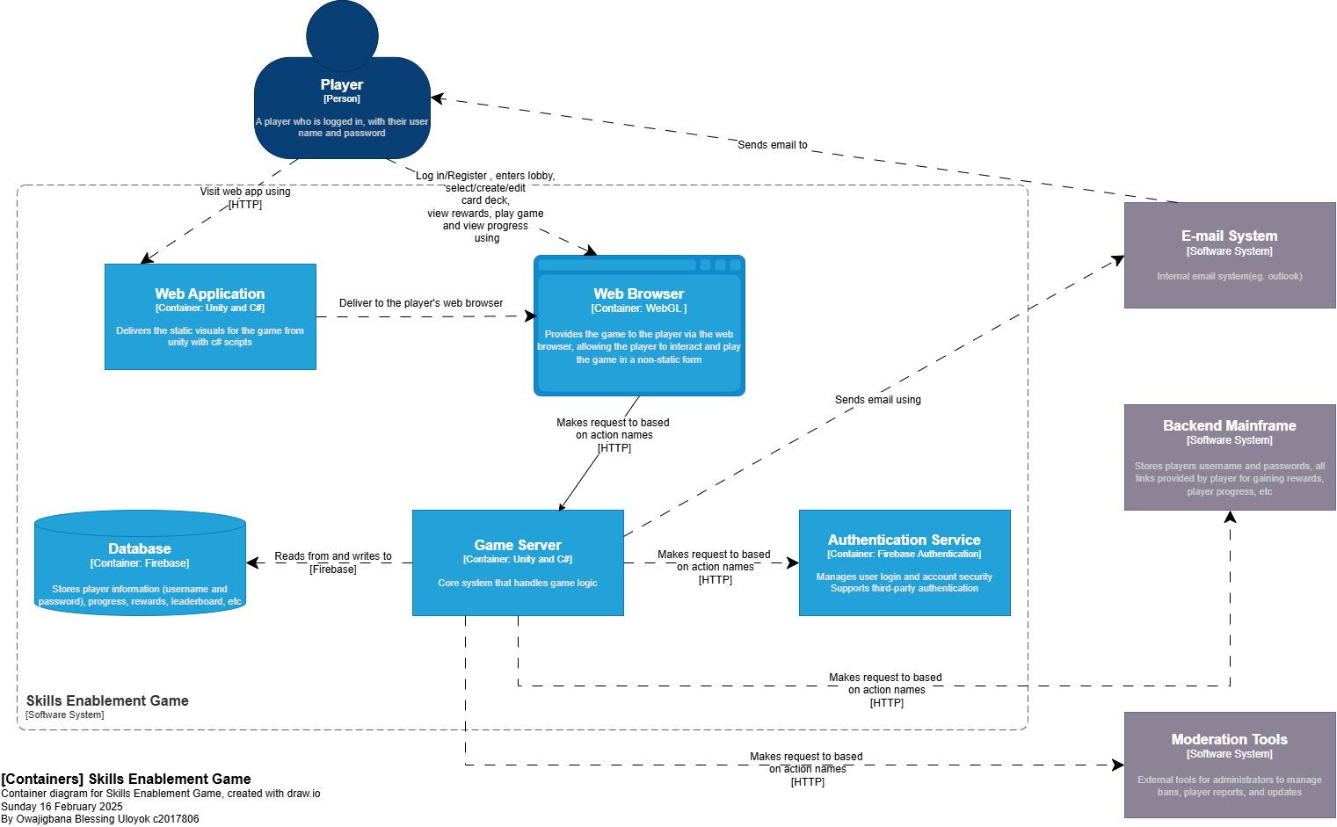

## ER Diagram: [ER_Diagram.png](https://drive.google.com/file/d/1jjzJoD6hxgc7lWygf5Y_EFombWTwfAOA/view)

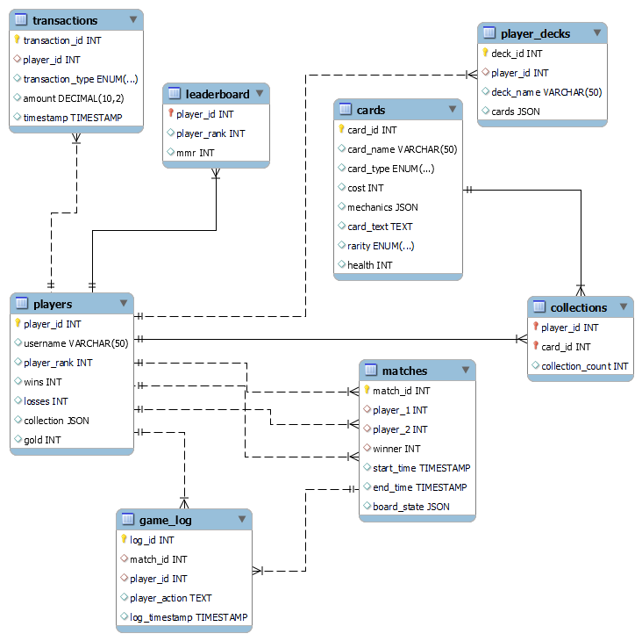

# Appendix 1: Tasks Completed

*Table 1-Tasks Completed by each Member:*

|  |  |
| --- | --- |
| Name: | Tasks Completed: |
| Blessing | Project Overview, Statement and Objectives  Container Diagram  Context Diagram  ER Diagram |
| Emmanuel | User story and Acceptance test  User personal |
| Saeed | Non Functional Requirements/User Roles |
| Elekir | Use case diagram  Sequence diagram |
|  |  |

# Appendix 2: GitHub Repository

Add here a link to your GitHub Repository.

*Table 2 - GitHub Usernames*

|  |  |  |
| --- | --- | --- |
| **Student name** | **GitHub name** | **GitHub Link** |
| Owajigbana Blessing Uloyok | M00nlightbee | <https://github.com/M00nlightbee/work-diary> |
| Emmanuel Atiso | Emmanuel-Atiso |  |
| Niven Nishanthan | NivenNishanthan05 | <https://github.com/NivenNishanthan05/PSP-IBM-Work-Diary> |
|  |  |  |
|  |  |  |

# References

Kumar, S. (2021, November 30). *5 Common problems faced by students in eLearning and how to overcome them*. eLearning Industry. <https://elearningindustry.com/5-common-problems-faced-by-students-in-elearning-overcome#:~:text=Technical%20Issues.%20Many%20students%20are%20not%20provided,System%20and%20their%20learning%20experience%20becomes%20problematic>

Kondrat, B. S. (n.d.). *10 elearning Challenges + Solutions [2025]*. <https://www.educate-me.co/blog/elearning-challenges>

Binder, M. (2024, April 3). *7 Top Challenges with Online Learning For Students (and Solutions)*. Thinkific. <https://www.thinkific.com/blog/challenges-with-online-learning/>

Kapadia, V. (2024, August 6). The Top 10 E-Learning Challenges Faced by L&D Professionals. *Gyrus Systems*. <https://www.gyrus.com/blogs/the-top-10-e-learning-challenges-faced-by-l-and-d-professionals#:~:text=Among%20the%20leading%20concerns%2C%20all%20employees%20are,engaged%20at%20a%20cognitive%20and%20emotional%20level>.

*We’re skilling 30 million people globally by 2030 | IBM*. (n.d.). <https://www.ibm.com/impact/initiatives/2030>

Wikipedia contributors. (2025, January 25). *Hearthstone*. Wikipedia. Retrieved February 1, 2025, from <https://en.wikipedia.org/wiki/Hearthstone?utm_source>

Bookprinting. (2024, November 30). How to make custom digital game cards in 2024 - GoBook Printing. *Gobook Printing*. <https://www.gobookprinting.com/how-to-make-custom-digital-game-cards/>

Brazie, A. (2025, January 2). Video Game Mechanics: A Beginner's Guide (with Examples). *Game Design Skills*. <https://gamedesignskills.com/game-design/video-game-mechanics/>

Filler, D., Tureaud, C., Marion, M., Seidman, D., Ersavas, M. T., Delapena, M., & Individual. (1998, August 20). *CA2344693A1 - Digital trading card, system, and method - Google Patents*. <https://patents.google.com/patent/CA2344693A1/en>

*framework guide to creating a TCG/CCG | BGG*. (n.d.). BoardGameGeek. <https://boardgamegeek.com/thread/970421/framework-guide-to-creating-a-tcgccg>

Juegoadmin. (2024, September 27). *The Ultimate Beginner’s Guide to Game Mechanics*. Juego Studio. <https://www.juegostudio.com/blog/the-ultimate-beginners-guide-to-game-mechanics#:~:text=Yes%2C%20when%20designing%20new%20game,mechanics%20enhance%20the%20player%20experience>.

Nebuso. (2025, January 4). Online Collectible Card Games: A Comprehensive guide | Legends of Elysium. *Legends of Elysium*. <https://legendsofelysium.io/blog/online-collectible-card-games-a-comprehensive-guide/?srsltid=AfmBOopxbIXbWjylkfjz0Wb0H4xfQpL6KaWvM6a-CUDcWqI-1Wivf_P5>

Patrick_Yu. (2022, July 5). *What is a Digital Collectible Card Game?* Acer Corner. <https://blog.acer.com/en/discussion/151/what-is-a-digital-collectible-card-game>

QATestLab. (2022, April 11). *Digital Collectible Card Games | QATestLab*. QATestLab | QA Testing Company. <https://game.qatestlab.com/projects/digital-collectible-card-game/>

*What are the essential game mechanics for a successful game?* (2023, December 25). www.linkedin.com. <https://www.linkedin.com/advice/0/what-essential-game-mechanics-successful-skills-game-development-0b3tf>

*MOSCOW Analysis | SHU Development Process*. (n.d.). SHU Development Process. <https://aserg.codeberg.page/shu-dev-process/en/modelling/analysis/moscow-analysis/#presentation>