
Smart Grocery Recommender System Using Machine
Learning
Intelligent Shopping Companion
Prepared and submitted by: Group 2
Goli Likitha Reddy
Matthew Townsend
Vito Valenzano
As part of the requirement for the course:
CS 542: Machine Learning
Instructor: Dr. Amir Manzour
SUNY Polytechnic Institute
State University of New York

Contents
• Abstract
• Introduction
2.1 Background
2.2 Problem Statement
2.3 Project Objectives
2.4 Scope of the Study
• Dataset Description
3.1 Source of Data
3.2 Data Features
3.3 Preprocessing Steps
• System Architecture
4.1 High-Level System Overview
4.2 Workflow Diagram
4.3 Component Interaction
• Methodology
5.1 Association Rule Mining (Apriori Algorithm)
- Frequent Itemsets
- Support, Confidence, Lift
5.2 Customer Segmentation (K-Means Clustering)
- Feature Engineering
- Cluster Selection
5.3 Time Series Forecasting
- Daily Aggregation
- Model Training
- Evaluation Metrics
• System Implementation
6.1 Apriori Module
6.2 Clustering Module
6.3 Time Series Module
6.4 Data Helper Module
6.5 Main Program Execution
6.6 Web UI (index.html + index.css)
• Results & Analysis
7.1 Top Association Rules
7.2 Frequent Itemsets
7.3 Cluster Analysis
7.4 Time Series Forecast Output
7.5 Key Insights
• Discussion
• Conclusion
• Future Work
• References

Abstract
Modern retail environments generate large volumes of transaction data that can be used to extract meaningful insights about customer behavior and product relationships. This project presents a Smart Grocery Recommender System that analyzes real transaction data using classical machine learning techniques. The system integrates:
- Market Basket Analysis using Apriori
- Customer Segmentation using K-Means and DBSCAN
- Sales Forecasting using Prophet
The dataset contains 38,765 transactions, 3,898 unique customers, and hundreds of unique grocery items. The project pipeline is implemented across multiple Python modules and visualized through a modern web-based interface. Results reveal strong product associations, well-defined customer segments, and predictable sales patterns. The system demonstrates how machine learning can enhance retail intelligence and generate actionable recommendations.

Chapter 1

Problem Statement
Retail businesses often struggle to understand customer purchasing behavior, forecast demand, and generate personalized recommendations. Customers may forget frequently purchased items, miss complementary items, or lack visibility into products relevant to their habits.
This project aims to solve four key problems:
- Identify which products are frequently purchased together
- Recommend items a customer is most likely to buy based on their basket
- Group customers into meaningful segments based on behavior
- Predict future demand trends to support stocking decisions
The Smart Grocery Recommender System combines Apriori, clustering, and time-series forecasting to provide a complete machine-learning solution for grocery analytics.
Chapter 2

Dataset Overview
The dataset (Groceries_dataset.csv) consists of transaction-level data with:
Column | Description
Member_number | Unique customer ID
Date | Purchase date (dd-mm-yyyy)
itemDescription | Purchased grocery item

Dataset Properties
- Size: 38,765 transactions
- Unique members: 3,898
- Unique items: ~170+
- Time span: Two years of transaction history

Why this dataset is ideal:
- Market-basket (transactional) format
- Enough density for Apriori algorithm
- Allows customer-level aggregation for clustering
- Suitable for Prophet-based forecasting

Chapter 3
Data Preprocessing
Data preprocessing occurs in dataHelper.py and TimeSeries.py.

Steps Performed:

Load Data
data = pd.read_csv('data/Groceries_dataset.csv')

Convert Date Format
Dates are parsed and sorted:
df['Date'] = pd.to_datetime(df['Date'], format='%d-%m-%Y')
df = df.sort_values('Date')

Group Transactions per Customer
sort_member_numbers() creates:
{
member_id: [item1, item2, item3, ...],
...
}

Handle Missing / Invalid Data
Rows with invalid date formats are removed.

Prepare Dataset for:
- Apriori: One-hot encoded matrix
- Clustering: Feature matrix of 4 customer metrics
- Forecasting: Daily aggregated transaction data
These preprocessing rules guarantee clean, structured inputs for all ML models.
Chapter 4

Methodology

4.1 Market Basket Analysis (Apriori)
Implemented in Apriori.py.

Transaction Encoding
Using TransactionEncoder():
- Converts each customer’s list of items into a one-hot encoded matrix.

Frequent Itemsets
frequent_itemsets = apriori(df, min_support=0.01, use_colnames=True)

Association Rule Mining
rules = association_rules(frequent_itemsets, metric="confidence", min_threshold=0.5)

Rule Ranking
- Top frequent items by support
- Top rules by confidence
- Top rules by lift

Recommendation Engine
predict_for_customer() checks if all antecedents ⊆ basket and recommends consequents.

4.2 Customer Segmentation (K-Means + DBSCAN)
Implemented in Clustering.py.

Feature Engineering
For each customer:
- total_items purchased
- unique_items
- avg_basket_size
- diversity_ratio (unique_items / total_items)

Feature Scaling
scaler = StandardScaler()
scaled = scaler.fit_transform(df[feature_cols])

Determine Optimal K
Using the Elbow + Silhouette method:
- Runs K-means from k=2 to k=10
- Computes inertia and silhouette score
- Picks best k

K-Means Clustering
kmeans = KMeans(n_clusters=optimal_k, n_init=10)
clusters = kmeans.fit_predict(scaled_features)

DBSCAN Clustering
Used for comparison:
dbscan = DBSCAN(eps=0.5, min_samples=5)

6 Visualization Plots Generated
- PCA scatter
- Cluster size bar chart
- Normalized feature comparison
- Boxplots (total items, unique items)
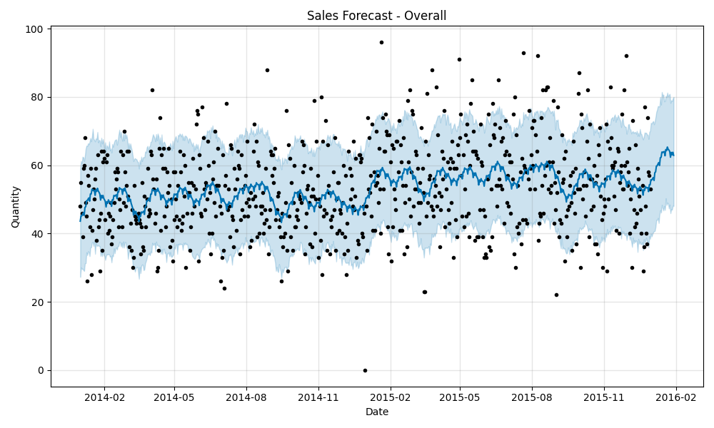
- Heatmap of cluster metrics

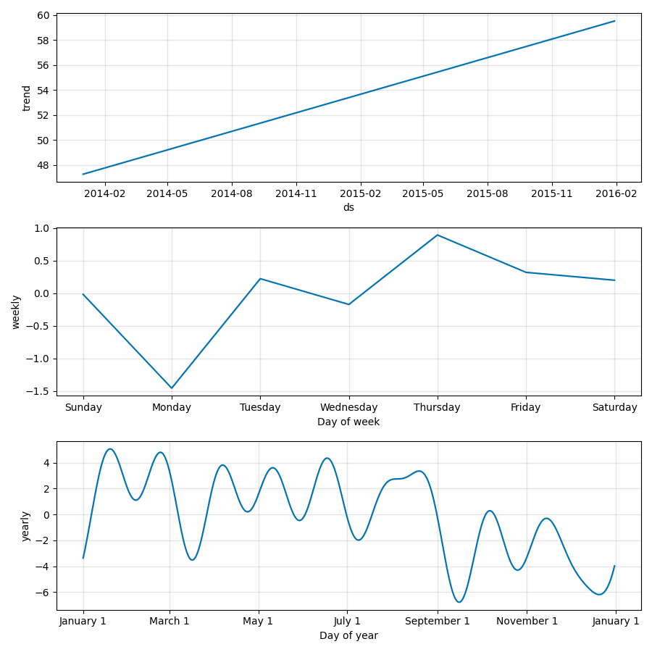
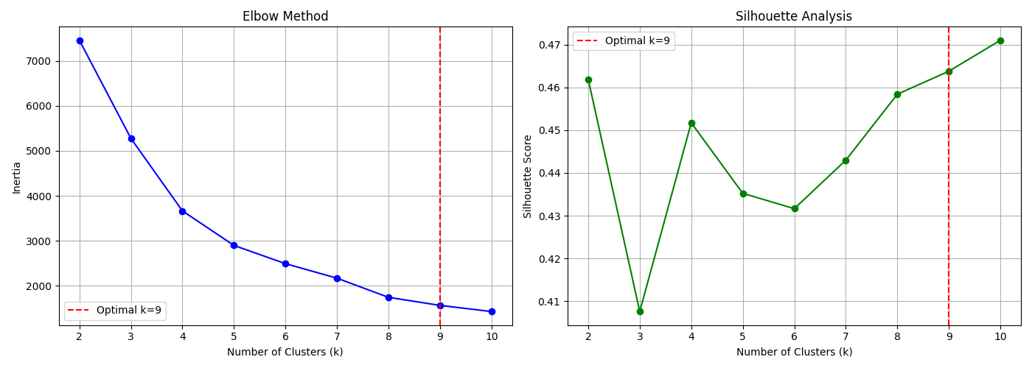
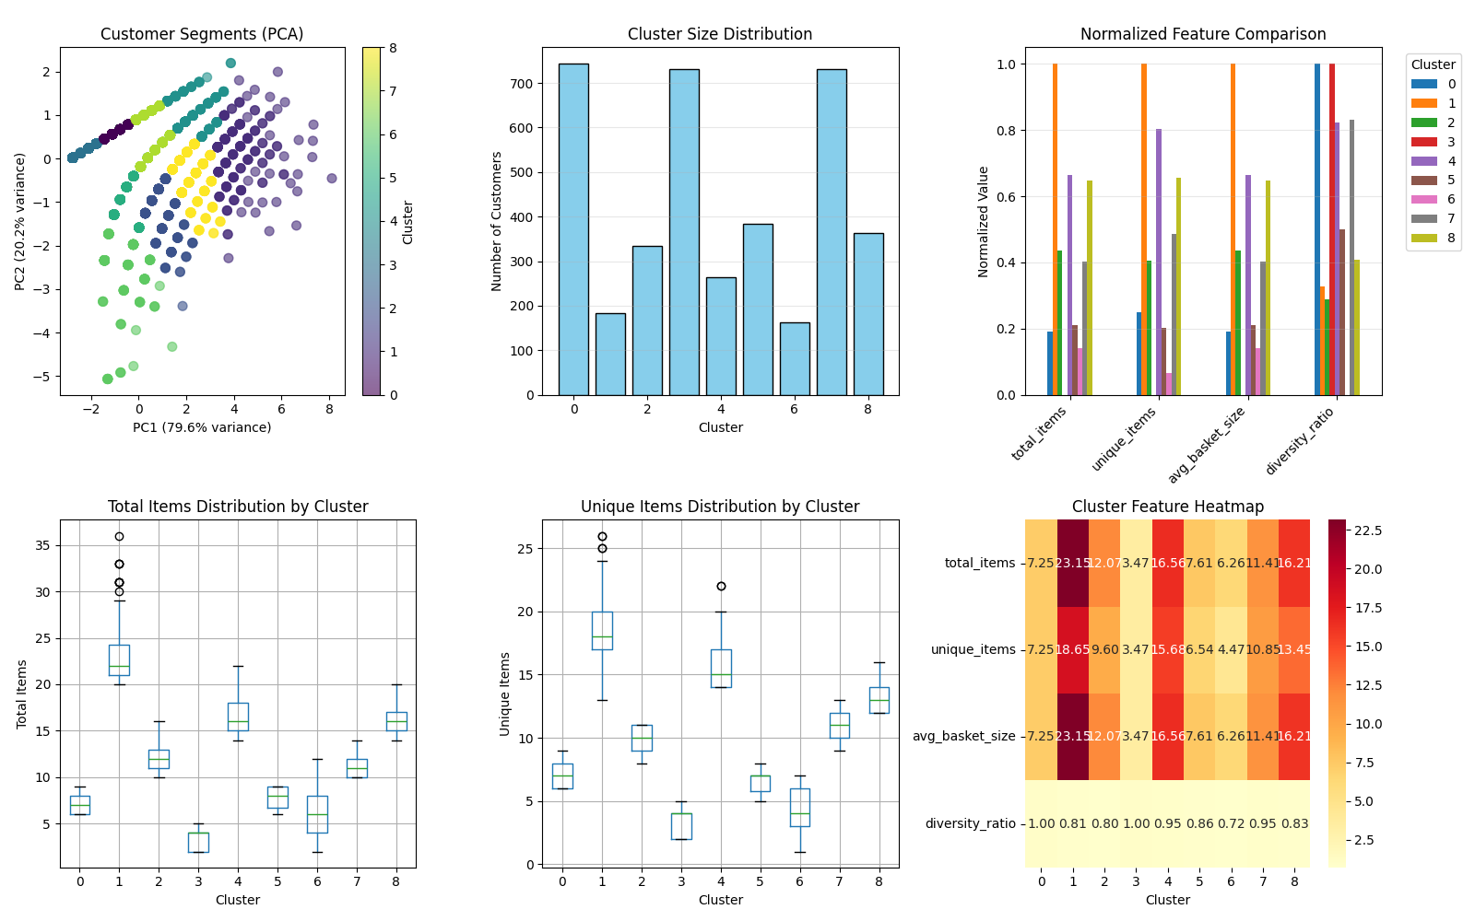

Segment Interpretation
Clusters are labeled:
- Light Shoppers
- Regular Customers
- Premium Shoppers
- Bulk Buyers
Each cluster includes:
- Top items
- Business recommendations

4.3 Time-Series Forecasting (Prophet)
Implemented in TimeSeries.py.

Use Prophet
model = Prophet(
yearly_seasonality=True,
weekly_seasonality=True,
changepoint_prior_scale=0.05
)

Aggregated Daily Data
daily_data = data.groupby('Date').size()

Forecasting 30 Days Ahead
Model outputs:
- yhat (prediction)
- yhat_lower, yhat_upper (confidence interval)

Metrics
Mean Absolute Error (MAE):
mae = np.mean(np.abs(actual - predicted))

Forecast Visualizations
- Full forecast curve
- Trend decomposition
- Seasonal components

Chapter 5
System Workflow
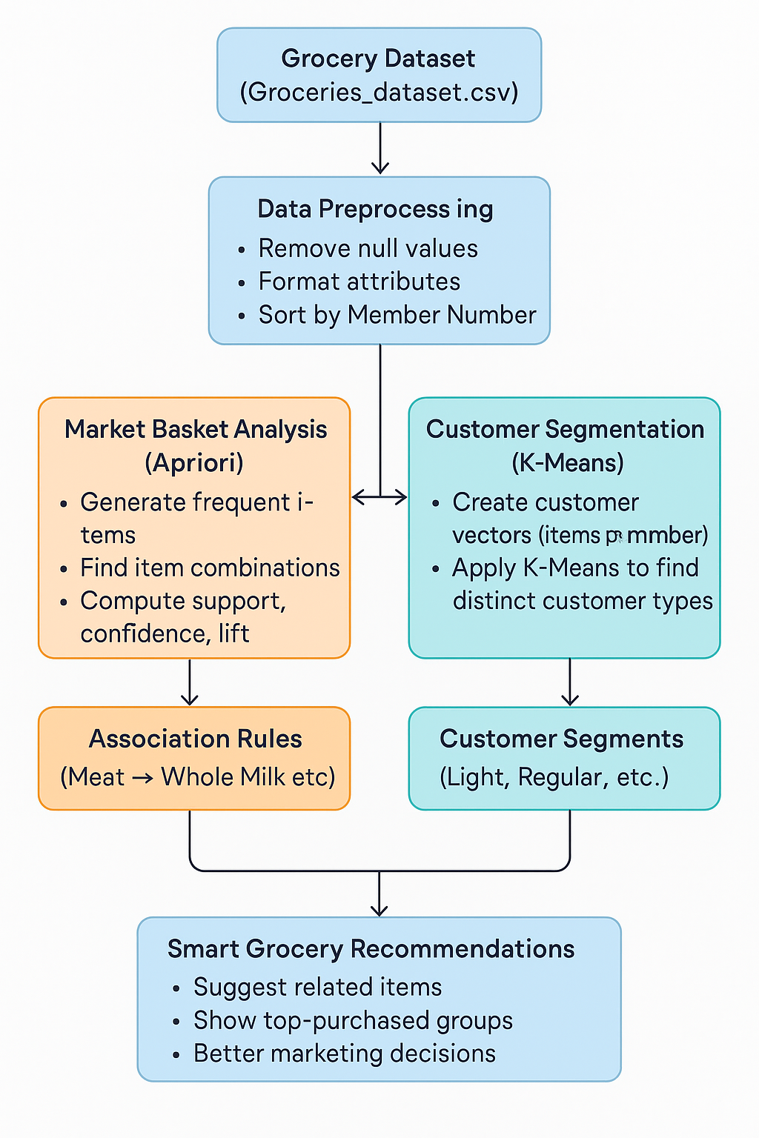
The workflow of the Smart Grocery Recommender System is designed to process raw transaction data and generate meaningful insights for both customers and retailers. The system operates through three major stages: data preprocessing, pattern mining, and customer analysis, ultimately producing actionable grocery recommendations.

1. Data Input (Groceries Dataset)
The system begins with the Groceries_dataset.csv, which contains thousands of real retail transactions. Each entry includes:
- Member number
- Date of purchase
- Item purchased
This forms the foundational dataset for the entire machine learning pipeline.

2. Data Preprocessing
Before applying any ML models, the raw transaction data is cleaned and structured.
This stage includes:
- Removing null or inconsistent values
- Formatting date and item attributes
- Grouping items by Member_number
- Creating customer-level baskets
This step ensures that the dataset is standardized and ready for analysis.

3. Market Basket Analysis (Apriori Algorithm)
In this stage, all shopping baskets are fed into the Apriori algorithm.
Its purpose is to find:
- Frequently purchased item combinations
- Strong associations between products
- Key metrics such as support, confidence, and lift
The output contains association rules such as:
“If a customer buys meat and domestic eggs → they are likely to buy whole milk.”
These rules directly power the recommendation engine.

4. Customer Segmentation (K-Means Clustering)
The system creates customer feature vectors using:
- Total items bought
- Unique items
- Shopping diversity
- Basket size
The K-Means clustering algorithm groups customers into meaningful segments like:
- Light Shoppers
- Regular Customers
- Premium Shoppers
- Bulk Buyers
This segmentation helps businesses target each cluster with the right marketing strategy.

5. Recommendation Generation
Finally, results from both Apriori and K-Means are merged to create a complete intelligence system:
- Apriori outputs product-to-product recommendations
- K-Means provides customer group–level insights
- The system identifies cross-sell opportunities
- Helps retailers optimize promotions, inventory, and marketing campaigns

Chapter 6

Discussion and Conclusion
The Smart Grocery Recommender System effectively applies machine learning to uncover meaningful purchasing patterns within real grocery transaction data. Using the Apriori algorithm, the system identifies strong associations between items and highlights which products are frequently bought together. These insights, measured through support, confidence, and lift, help reveal cross-selling opportunities and common shopping habits such as the consistent presence of whole milk, vegetables, and rolls/buns in customer baskets.
In parallel, K-Means clustering provides a clear segmentation of customers into groups such as Light Shoppers, Regular Customers, Premium Shoppers, and Bulk Buyers. Each segment displays distinct shopping behaviors, enabling targeted marketing strategies and more personalized customer engagement. By analyzing both item-level relationships and customer-level characteristics, the system delivers a comprehensive understanding of grocery shopping behavior.
Overall, the project demonstrates that even simple transactional data can offer valuable insights when processed with appropriate machine learning techniques. The combined approach of association rule mining and customer segmentation produces actionable intelligence for improving product recommendations, promotions, and inventory decisions. The system is scalable, practical, and suitable for real-world retail applications, with potential for future enhancements such as integrating additional models or real-time recommendation interfaces.

Chapter 7

References
- Agrawal, R., & Srikant, R. (1994). Fast algorithms for mining association rules. Proceedings of the 20th International Conference on Very Large Databases (VLDB).
- Han, J., Pei, J., & Kamber, M. (2012). Data Mining: Concepts and Techniques (3rd ed.). Morgan Kaufmann.
- Tan, P.-N., Steinbach, M., & Kumar, V. (2018). Introduction to Data Mining (2nd ed.). Pearson.
- Wu, X., Kumar, V., Quinlan, J. R., et al. (2008). Top 10 algorithms in data mining. Knowledge and Information Systems, 14(1), 1–37.
- MacQueen, J. (1967). Some methods for classification and analysis of multivariate observations. Proceedings of the 5th Berkeley Symposium on Mathematical Statistics and Probability.
- Brijs, T., Swinnen, G., Vanhoof, K., & Wets, G. (2011). Using association rules for product assortment decisions: A case study. Expert Systems with Applications, 38(3), 1824–1831.
- Hahsler, M., Chelluboina, S., Hornik, K., & Buchta, C. (2011). The arules R-Package ecosystem: Analyzing interesting patterns from large transaction datasets. Journal of Machine Learning Research, 12, 1977–1981.
- Grover, P., & Kar, A. K. (2017). Big data analytics in retail: A review. Journal of Retailing and Consumer Services, 39, 11–20.
- Kumar, S., & Singh, R. (2020). Customer segmentation using machine learning: A comparative study. International Journal of Advanced Computer Science, 10(4), 45–52.
- Mooney, C. H., & Roddick, J. F. (2013). Sequential pattern mining—Approaches and algorithms. ACM Computing Surveys, 45(2), 27.
- .

