**Mentorness Internship Program (Batch-MIP-DA-06)**

**Data Analyst Intern**

**Project Name: Airplane Crash Analysis**

**Task 3**

Mitali Nitin Kubal

Temporal Analysis

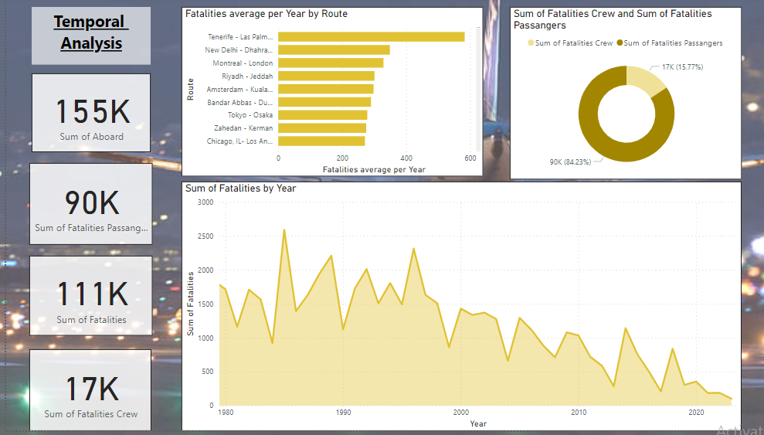

Geospatial Analysis

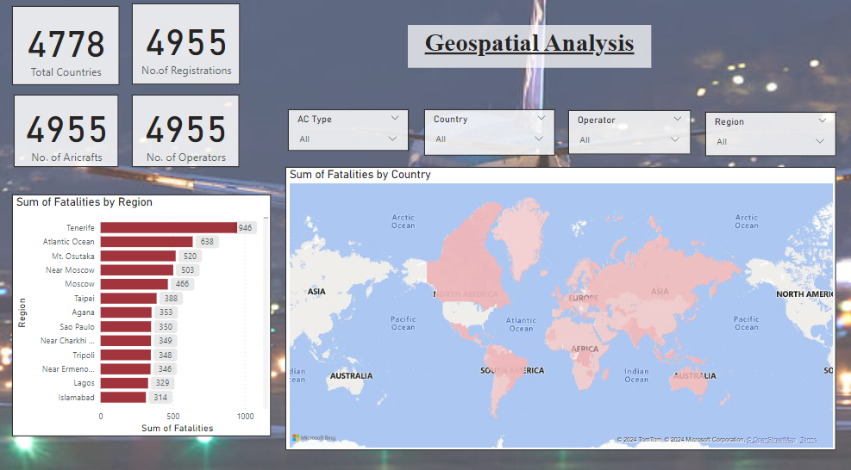

Fatility Trends

