**Mentorness Internship Program (Batch-MIP-DA-06)**

**Data Analyst Intern**

**Project Name: Decode Gaming Behavior**

**Game Analysis Task 2**

Mitali Nitin Kubal

1. Extract `P_ID`, `Dev_ID`, `PName`, and `Difficulty_level` of all players at Level 0.

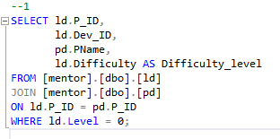

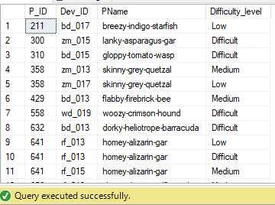

1. Find `Level1_code`wise average `Kill_Count` where `lives_earned` is 2, and at least 3 stages are crossed.

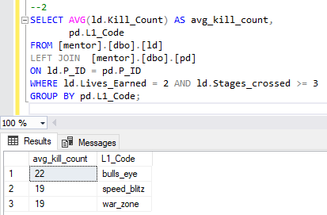

1. . Arrange the result in decreasing order of the total number of stages crossed.

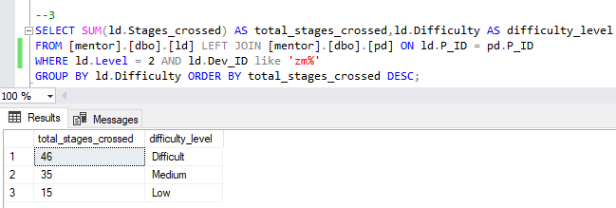

1. Extract `P_ID` and the total number of unique dates for those players who have played games on multiple days.

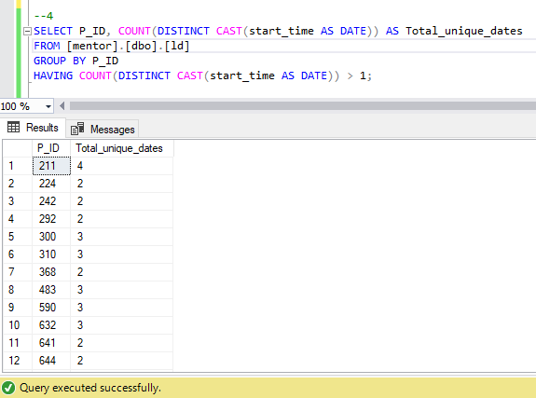

1. Find `P_ID` and levelwise sum of `kill_counts` where `kill_count` is greater than the average kill count for Medium difficulty.

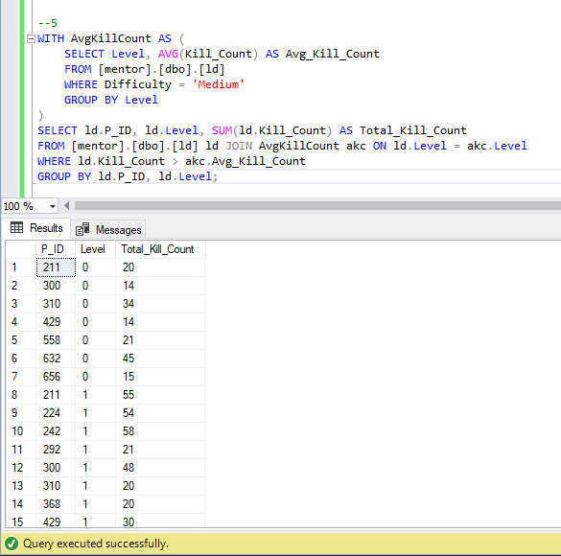

1. Find `Level` and its corresponding `Level_code`wise sum of lives earned, excluding Level 0. Arrange in ascending order of level.

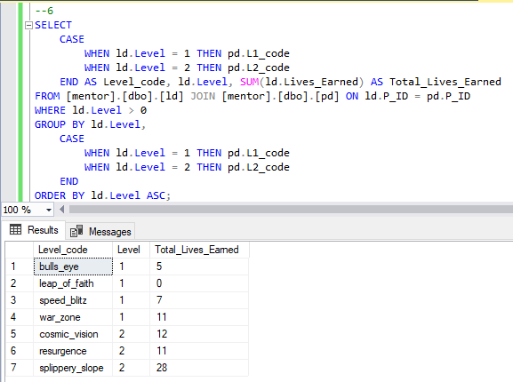

1. Find the top 3 scores based on each `Dev_ID` and rank them in increasing order using `Row_Number`. Display the difficulty as well.

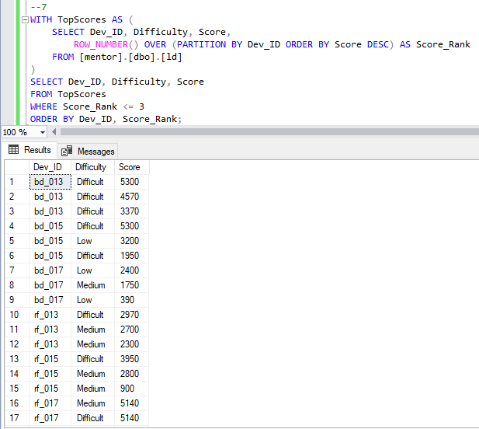

1. Find the `first_login` datetime for each device ID.

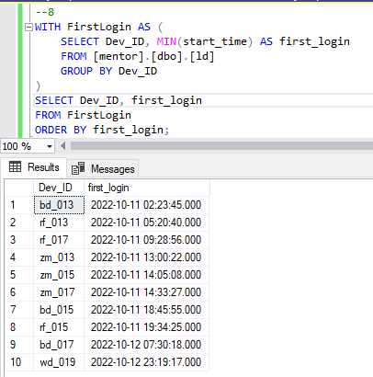

1. Find the top 5 scores based on each difficulty level and rank them in increasing order using `Rank`. Display `Dev_ID` as well.

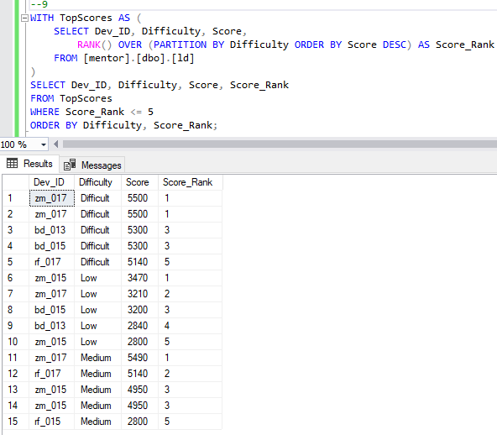

1. Find the device ID that is first logged in (based on `start_datetime` for each player (`P_ID`). Output should contain player ID, device ID, and first login datetime.

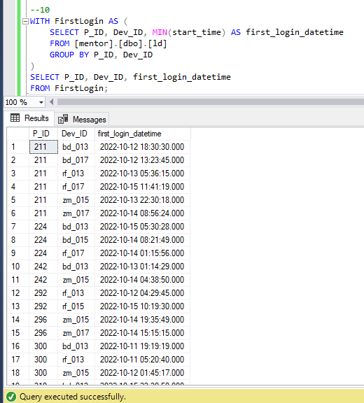

1. For each player and date, determine how many `kill_counts` were played by the player so far.
2. Using window functions

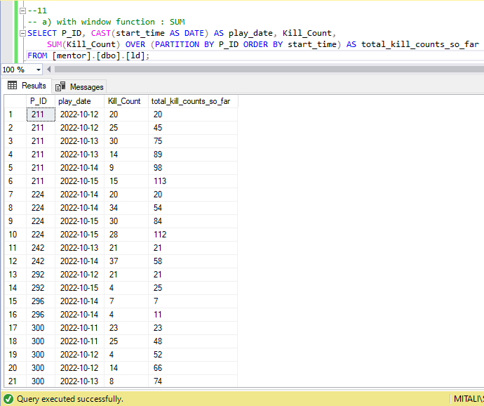

1. Without window function

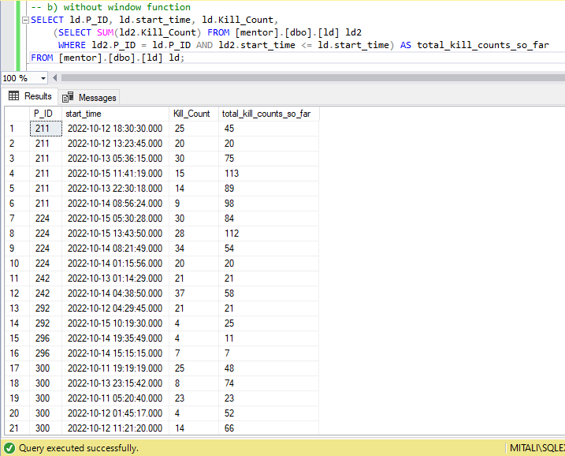

1. Find the cumulative sum of stages crossed over `start_datetime` for each `P_ID`, excluding the most recent `start_datetime`.

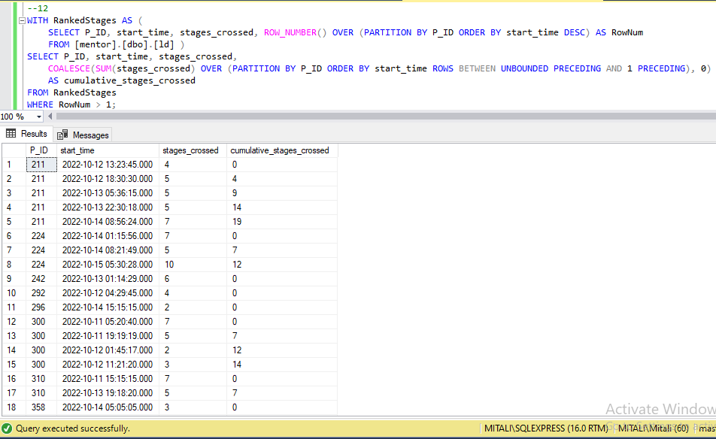

1. Extract the top 3 highest sums of scores for each `Dev_ID` and the corresponding `P_ID’.

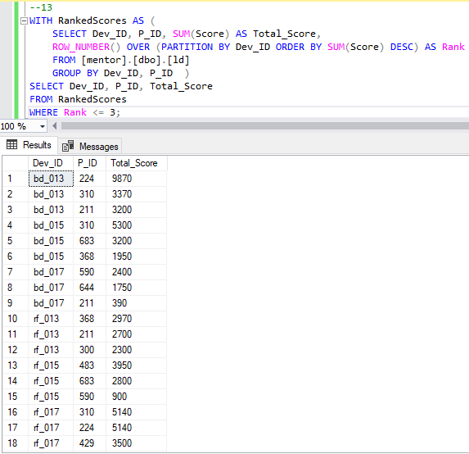

1. Find players who scored more than 50% of the average score, scored by the sum of scores for each `P_ID’.

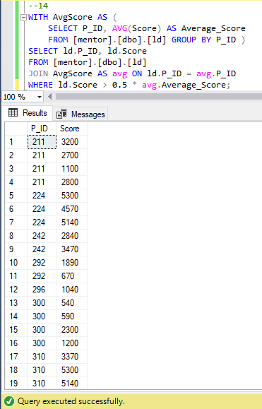

1. Create a stored procedure to find the top `n` `headshots_count` based on each `Dev_ID` and rank them in increasing order using `Row_Number`. Display the difficulty as well.

