

TASK 3: EMPLOYEE DATA ANALYSIS

MITALI NITIN KUBAL

[mitali.kubal2001@gmail.com](mailto:mitali.kubal2001@gmail.com)

Greetings,

I am excited to embark on a virtual internship assigned by Psyliq, focused on data analysis using employee datasets. Leveraging advanced Excel functions, I aim to gain valuable insights and deepen my understanding of the dataset. As a student pursuing MSc in Statistics, this internship offers a unique opportunity to apply my skills in a practical setting, enhancing my proficiency in analyzing complex data.

The dataset provided encompasses various facets of employee data, including employee engagement survey responses, recruitment details, and training information. Key variables such as Employee ID, Name, Location, Gender, Department, and Race are included. Through these tasks, I aspire not only to meet the internship requirements but also to contribute meaningfully to the exploration of data analysis dynamics through evidence-based insights.

**Aim:**

To analyze the given datasets and perform the tasks provided.

1. Can you create a pivot table to summarize the total number of employees in each department?

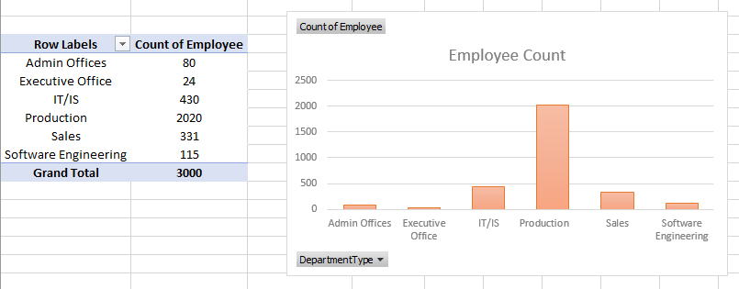

1. Apply conditional formatting to highlight employees with a "Performance Score" below 3 in red.

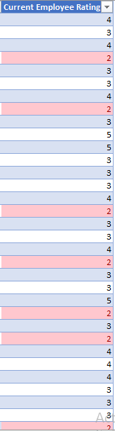

1. Calculate the average "Satisfaction Score" for male and female employees separately using a pivot table.

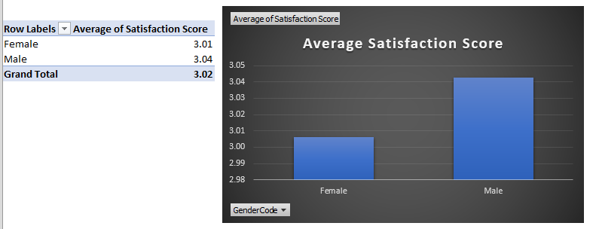

1. Create a chart to visualize the distribution of "Work-Life Balance Score" for different job functions.

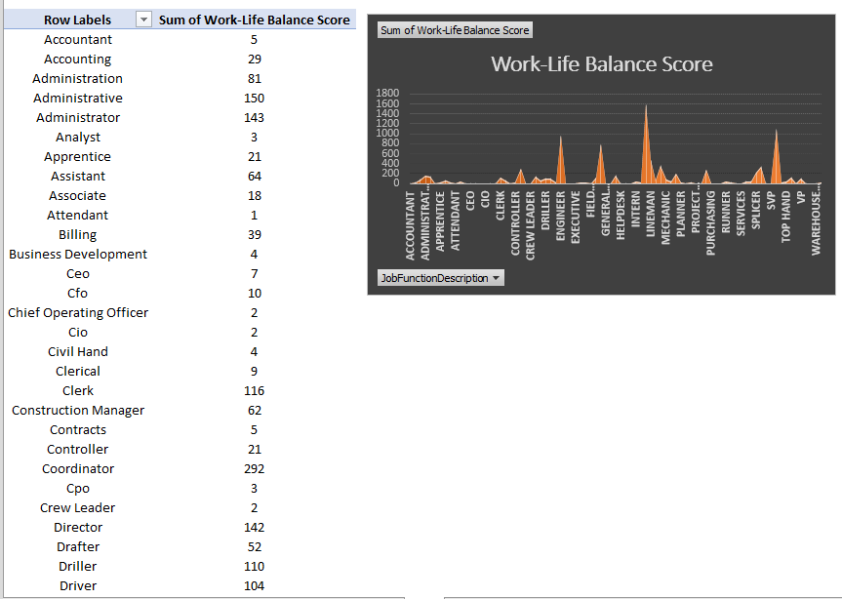

1. Filter the data to display only terminated employees and find out the most common "Termination Type."

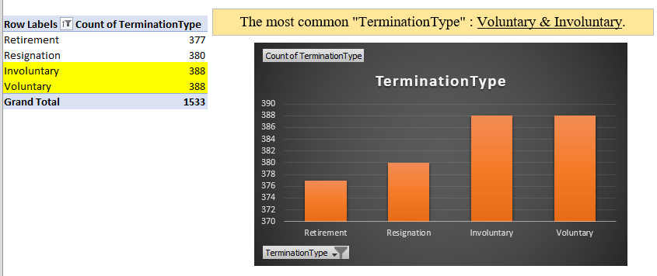

6) Calculate the average "Engagement Score" for each department using a pivot table.

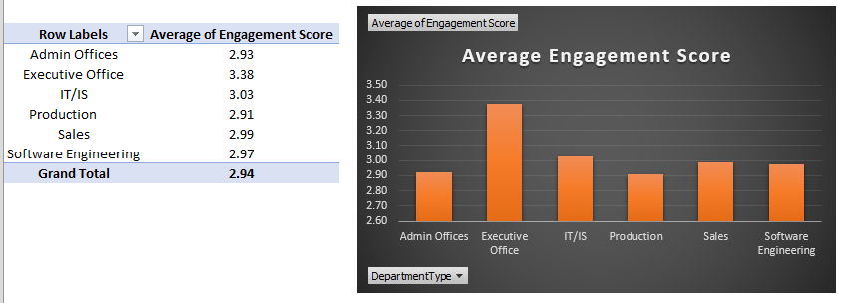

7) Use VLOOKUP to find the supervisor's email address for a specific employee.

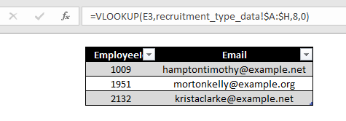

8) Can you identify the department with the highest average "Employee Rating?"

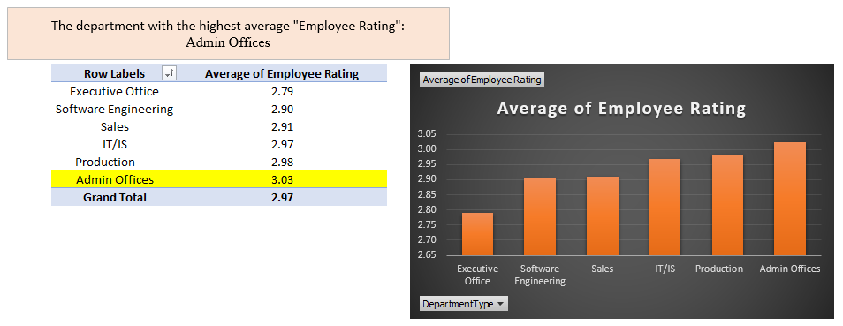

9) Create a scatter plot to explore the relationship between "Training Duration (Days)" and "Training Cost."

10) Build a pivot table that shows the count of employees by "RaceDesc" and "GenderCode."

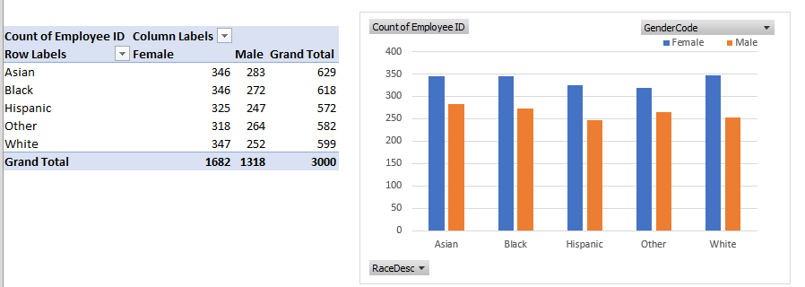

11) Use INDEX and MATCH functions to find the "Training Prog ram Name" for an employee with a specific ID.

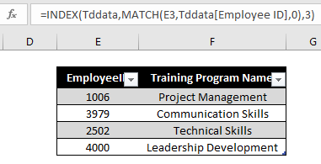

12) Create a multi-level pivot table to analyze the "Performance Score" by "BusinessUnit" and "JobFunctionDescription."

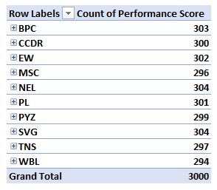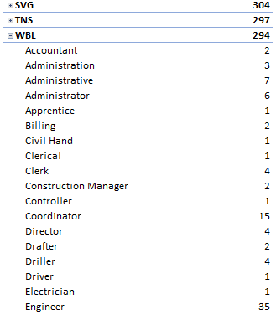

13) Design a dynamic chart that allows users to select and visualize the performance of any employee over time.

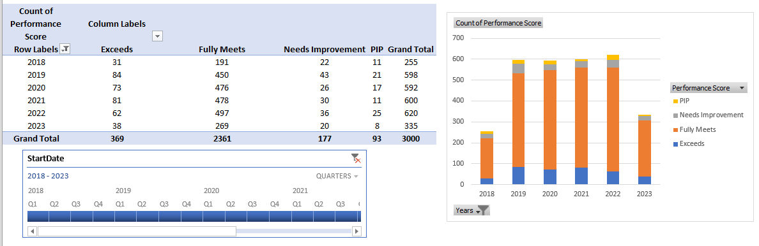

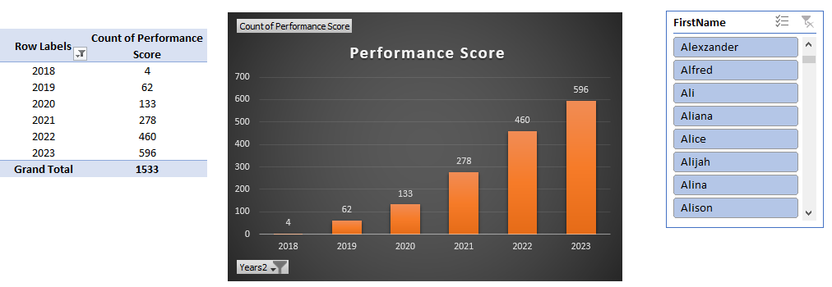

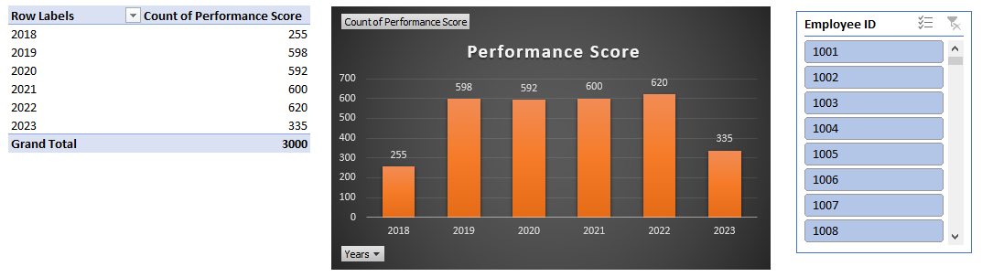

14) Calculate the total training cost for each "Training Program Name" and display it in a bar chart.

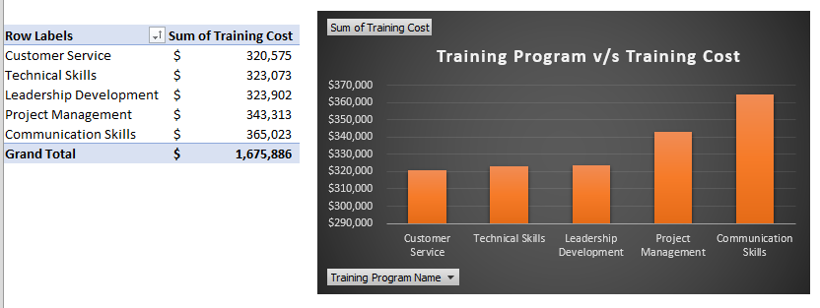

15) Apply advanced conditional formatting to highlight the top 10% and bottom 10% of employees based on "Current Employee Rating.

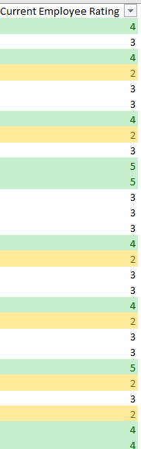

16) Use a calculated field in a pivot table to determine the average "Engagement Score" per year.

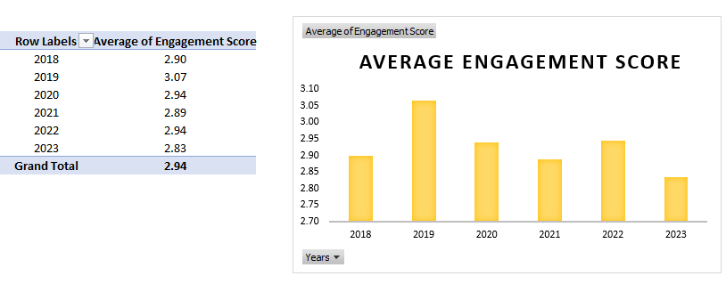

17) Can you build a macro that automates the process of updating and refreshing all pivot tables in the workbook?

* Go to developer tab.
* Click on “visualbasic”.
* Click on new module.
* Type in macro code.
* Close VBA editor.
* Execute macro by ALT+F8 & select Refresh Pivot

18) Create a histogram to understand the distribution of "ExitDate" for terminated employees.

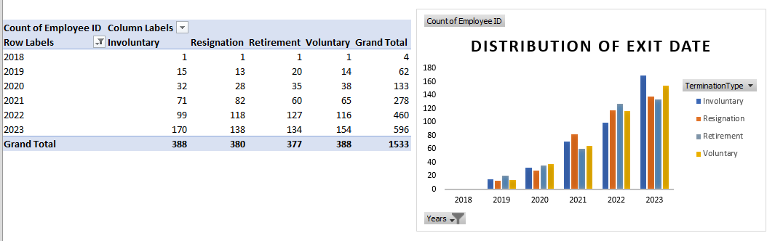

19) Utilize the SUMPRODUCT function to calculate the total training cost for employees in a specific location.

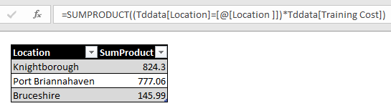

20) Develop a dashboard that provides an overview of key HR metrics, including headcount, performance, and training costs, using charts and pivot tables.

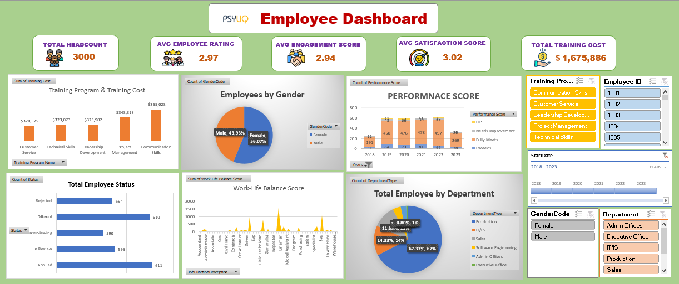

Thank you…