Tutorial – Pointers

1. Given below is a simple program which uses pointers. Explain what is happening in this program. Execute it in visual studio and check whether it gives the expected output.

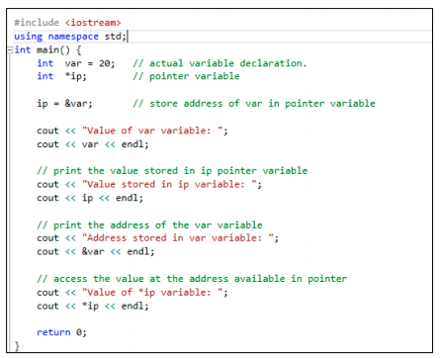

1. Write a program to take two user inputs and find the largest value by passing the two inputs to a

function. Use pass by reference using pointers to implement the function. (function should accept 2

pointer variables as parameters)

1. Implement a program that will input 5 values to an array using a pointer and print the array values using the same pointer. Implement the following steps. Observe the difference of using pointers and direct array access.

Steps:

Create an array

Create a pointer

Assign the array’s address to the pointer

Take inputs using the pointer (in a for loop)

Print the array values using the pointer

1. What is a double pointer? Search the internet to find it. Implement a double pointer in the question one and print the value using it.
2. Below program implements the bubble sort algorithm using a pointer. Understand the program and Implement the program in visual studio.

