Mohid REHMAN
[Company name] [Company address]
Graphical Calculator

Contents
Analysis of the Problem 2
Problem description: 2
Problem summary 2
Target Market 2
Client Introduction 2
Client interview 3

Analysis of the Problem

Problem description:
Graphing calculators are an increasingly necessary piece of equipment in the world of mathematics, especially in those modules which involve further mathematics, statistics, and numerical methods. However, the high cost of these devices such as the Casio FX-CG50 make them inaccessible for many students. These calculators can often cost upwards of £150, a significant burden placed upon students, especially when there is little to no support provided by many schools. Furthermore, these calculators often have outdated software and lack many new modern features which require a complicated software upgrade procedure. Sometimes adding a new feature could require purchasing an entirely new model, which would be more expensive and place an even greater financial strain on the students.
This project aims to provide a more affordable and cost-effective graphing calculator, that runs on low-cost hardware. The software should include essential mathematical functions, graph plotting, as well as various topics such as calculators, matrices, and numerical methods. It will be designed to work on both desktop environments using a dedicated application, as well as on a physical device, incorporating a low-cost microcontroller such as a Raspberry Pi. A colour LCD would also be used alongside this to provide a clear and intuitive interface for the user.

Problem summary
There is a clear lack of affordable alternatives to current graphing calculators. Many students cannot afford high-end models, which are required for them to participate in their mathematics courses. Schools also do not have the budget to provide these devices for every student, due to their budget limitations. This project aims to address these issues, by developing a budget-friendly alternative graphing calculator. It aims to include most features offered by commercial graphing calculators, as well as any additional ones if required.

Potential user identification
A graphing calculator is an essential piece of equipment in the world of mathematics and further mathematics. They allow anyone to be able to calculate complex mathematical equations that would otherwise take extremely long if done by hand.
Teachers | Students
 | A-Level Students | Lower year Students
This product could be useful for mathematics teachers, as having the same calculator as students means that they would be able to access all the same features as them. The teachers would also be able to teach the students how to use the calculators as they might not know about the various features and what they are used for. | A-level students would find an affordable graphing calculator very useful, as the a-level course requires a lot more advanced features than the standard calculator.

Client Introduction
My client is Mr Daniel Blanchard, a maths and further maths teacher at Langley grammar school. He often teaches the sixth form classes and notices many students do not have the proper graphing calculators required for their course. Mr Blanchard has noted that the tools offered by the graphing calculators are vital for their course and make their examinations easier due to their ability to solve complex mathematical equations. He has also agreed to provide feedback on the design of the software and will act as the primary user during testing.

Client interview

I have made a list of questions to ask my client, and hope to get a better understanding of how calculators are used in A level maths and further maths, as well was what features are important in classroom and exam settings. This helps to identify both essential and useful features for a calculator design, while also highlight the limitations of existing options.

How often are calculators used in your classes?

Calculators are used in almost every lesson, especially in further maths. Students rely on them for solving equations, checking answers, and graphing complex functions.

What are the most important features a calculator needs to have in the current A-Level curriculum?

Key features include graph plotting, numerical equation solving, matrix calculations, differentiation/integration (symbolic or numerical), and statistical functions. These tools are necessary for topics in both maths and further maths.

What are some challenges students face with current calculator options?

The main issues are cost and complexity. Graphing calculators like the Casio fx-CG50 are expensive, and many students find the interface unintuitive at first. Also, not all models are allowed in exams, which causes confusion.

How much do you think a graphing calculator should cost?

Ideally under £50. The current models range from £70–£120, which can be a barrier for students, especially those from lower-income households.

Are there any extra features you would want to see in a calculator?

A better UI, a touchscreen would be great, and potentially a way to export graphs or calculations (e.g., via USB or QR code). Also, simple help prompts or built-in tutorials would support learning.

Do you think a calculator should be a physical device, computer software, or both?

A physical device is necessary for exams, but software versions are helpful for classwork and homework. Ideally, both should exist and be interchangeable so students can practise on one and use the other in exams.

How helpful are the graphing capabilities on a graphing calculator compared to a regular one?

Incredibly helpful. They allow students to visualise functions, identify roots and intersections, and understand transformations much faster than working manually.

What are the most essential non-graph-related functions on a calculator?

Matrix operations, complex numbers, numerical solving, calculus tools (like integration and differentiation), and statistical calculations (like regression analysis) are all vital for the A-Level syllabus.

Is there anything else you think is missing and would like to see in a calculator?

I’d like to see a more interactive experience - something that feels modern and supports learning. Even a colour screen, a better way to handle equations, or step-by-step breakdowns would be a huge improvement over existing models.

Interview Summary
After interviewing the client, I have made a list of what he needs, and what he wants in a potential solution.
Some points the client mentioned that are important in a calculator:
- Graph Plotting
- Solve Numerical Methods
- Matrix operations
- Calculus tools
- Statistical Calculations
Some points the client has said are desirable but not absolutely necessary:
- Affordable price, at most £50 for the product
- Intuitive UI and ease of use
- Step-by-step solution breakdowns
- Colour screen
- Software version to use as an alternative to the physical device

Research
I will need to research the different ways of making the physical calculator, such as what the main board should be, how to connect it to some sort of screen, and also learn how to make the underlying PCB. I will then need to find out how to write the software for it, which will need to compile to run on both a computer and on the physical device as well.

Hardware Platform
For the main controller, I have 2 options: either a small Linux computer, or a microcontroller. Both of these have their own pros and cons which I will explore in this section.
Microcontroller:
Advantages | Disadvantages
- Would have a lower power draw, making it run for longer off a small battery/cell.  - The boot time would be almost instant, because there is no OS to load  - A microcontroller would also be a lot cheaper to buy than a Linux single board computer. | - The processing power in a microcontroller is not that good, and complex functions or graphs may take some time to compute.  - The onboard memory in most microcontrollers is very limited, up to a few megabytes in most cases. This means I would need to take extra care in my programming  - The lower computing power would also mean I would need to heavily optimize my code to run efficiently on the microcontroller.

Linux computer:
Advantages | Disadvantages
- Would have higher processing power than a microcontroller, meaning that equations and functions can be solved quicker  - Easier interface with a display, can use interfaces such as HDMI, VGA for video signals | - The price is usually a big higher for a single board computer, averaging at around £20 for lower end options, compared to around £5 for a microcontroller  - It may also take a lot longer than a microcontroller to start up since the computer would need to load an OS before it can run any programs  - The battery life would be a lot worse on a single board computer since it is a lot less efficient to be running a full operating system in the background

Research
The research aspect of this topic can be broken down into the following topics which are the different features of the calculator:
- Evaluating expressions
- Misc. operations
- Statistics
  - Binomial probability and cumulative distributions
  - Normal cumulative and inverse normal distributions
  - Poisson probability and cumulative distributions
- Graph plotting
- Equation solving
  - Solve unknown
  - Simultaneous Equations
  - Polynomials
- Numerical Methods
  - Solutions of equations
  - Curve fitting/regression
  - Numerical integration and differentiation
- UI Libraries

Evaluating Expressions
For the main calculator part of the program, the computer needs to know how to evaluate an expression given in a string.
There are a few different ways I can parse the expression string into something that can be solved. There is no simple eval()function in C++ so I will have to make my own. The methods of this will be in parser.cpp. For example, a very basic left-to-right parser, where it simply scans across the string, performing operations are quite straightforward.

ALGORITHM

This is an extremely basic example of how the program could parse through a string and evaluate it. There are quite a few drawbacks by using this however, for example the expression is evaluated as-is from left to right, meaning that multiplication would not take priority over addition or subtraction. For example, 2+2*4 would return 16 and not 10 like it should. One example of how we can combat this is by using Dijkstra’s Shunting yard algorithm, which takes an expression in infix notation (the ‘standard’ mathematical notation with operators in between numbers, e.g. 2+4), and parses it into a postfix notation string (where operators follow their operands, e.g. 2 4 +), which makes it easier to follow mathematical rules of operation orders.
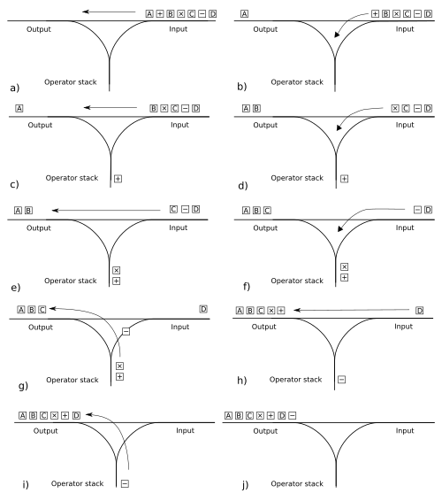
For example, if we want to evaluate the expression $1+2×3-4$, the procedure would be as follows:
Converting to postfix notation
Tokens | Token | Output | Operator Stack | Notes
['1', '+', '2', '×', '3', '-', '4'] |  | [] | [] | Numbers and operators separated into array elements
['+', '2', '×', '3', '-', '4'] | '1' | ['1'] | [] | First token is integer so push to output
['2', '×', '3', '-', '4'] | '+' | ['1'] | ['+'] | Next token is an operator so push to operator stack
['×', '3', '-', '4'] | '2' | ['1', '2'] | ['+'] | Integer pushed to output
['3', '-', '4'] | '×' | ['1', '2'] | ['+', '×'] | '×' has a higher priority than '+' so push to operator stack
['-', '4'] | '3' | ['1', '2', '3'] | ['+', '×'] | Integer pushed to output
['4'] | '-' | ['1', '2', '3', '×'] | ['+'] | '-' has a lower priority than '×', so '×' is popped from the operator stack and pushed to the output
['4'] | '-' | ['1', '2', '3', '×', '+'] | [] | '-' has equal priority to '+', so '+' is popped from the operator stack and pushed to the output
['4'] | '-' | ['1', '2', '3', '×', '+'] | ['-'] | '-' is then added to the operator stack
[] | '-' | ['1', '2', '3', '×', '+', '4'] | ['-'] | Integer pushed to output
[] | '4' | ['1', '2', '3', '×', '+', '4', '-'] | [] | Remaining operators ('-') pushed to output one by one since there are no more input tokens.

This will leave us with 1 2 3 × + 4 –, which is easier to evaluate than what we had before.

Evaluating the postfix:
Tokens | Token | Output | Notes
['1', '2', '3', '×', '+', '4', '-'] |  | []
['2', '3', '×', '+', '4', '-'] | '1' | ['1'] | '1' pushed to output
['3', '×', '+', '4', '-'] | '2' | ['1', '2'] | '2' pushed to output
['×', '+', '4', '-'] | '3' | ['1', '2', '3'] | '3' pushed to output
['+', '4', '-'] | '×' | ['1', '6'] | '×' is an operator, so pop last 2 elements of output, and compute them with the operator. So here, compute 2×3 which is 6
['4', '-'] | '+' | ['7'] | '+' is an operator, so pop last 2 elements and compute with operator: 6 + 1 = 7.
['-'] | '4' | ['7', '4'] | '4' pushed to output
[] | '-' | [‘3’] | '-' is an operator, so compute 7 – 4 which is 3

Which results in an output of 3, which is the correct solution to 1 + 2 × 3 – 4

Another alternative is the recursive descent parsing algorithm. Instead of converting the expression into a different notation, recursive descent works directly on the original infix notation by breaking it down into a series of recursive functions that preserve operator precedence.
There are separate functions for the different parts of the expression, such as one for addition/subtraction, one for multiplication/division, and one for handling numbers and brackets. An expression like 2 + 2 * 4 would therefore be evaluated as 2 + (2 x 4) without needing an extra conversion step.
One of the main advantages of recursive descent is code clarity. The code retains the original formatting of the expression and is similar to the mathematical language as well, making it easy to read and debug. Adding more functions such as sin(x) is more straightforward, as you can simply add another parsing function to the parser.

Parsing and evaluating using recursive descent:
Function Call | Remaining Tokens | Operation | Result
expression() | 1 + 2 × 3 − 4 | parse first term
term() | 1 + 2 × 3 − 4 | parse factor | 1
expression() | + 2 × 3 − 4 | + found
term() | 2 × 3 − 4 | parse factor | 2
term() | × 3 − 4 | × found
factor() | 3 − 4 | multiply | 6
expression() | − 4 | add | 1 + 6 = 7
expression() | − 4 | - found
term() | 4 | parse factor | 4
expression() |  | subtract | 7 − 4 = 3

Statistics

The Binomial Distribution
The binomial distribution is a way of calculating probabilities of a random event occurring n times when the probability of success is known. One such example of when this may be useful is calculating the probabilities of different outcomes when flipping a number of coins.
For example, when flipping 2 coins, there are 4 possible outcomes:
[Heads, Heads]
[Heads, Tails]
[Tails, Heads]
[Tails, Tails]
Here, if we wanted to work out the probability of getting 2 heads, the process is relatively simple. Using the formula $\frac{Number of favourable outcomes}{Total number of possible outcomes}$, so the probability would be $\frac{1}{4}$ or 0.25. This could also be done by using the formula $P(A∩B)=P(A)×P(B)$, where A is the first coin and B is the second coin. However, things aren’t so simple when you want to work out the probability of a different combination of events, such as 1 heads and 1 tails.
Since there are 2 possible ways of getting 1 heads and 1 tails ( [Heads, Tails] and [Tails, Heads] ), you would need to use the binomial distribution formula:
$$P\left(X=k\right)= \left({n \atop k}\right)p^{k}{\left(1-p\right)}^{n-k}$$
Where $\left({n \atop k}\right)$ is the number of ways to choose k successes from n outcomes, calculated by the formula
$$\frac{n!}{k!\left(n-k\right)!}$$
Using the formula, we can work out the probability of any combination of events occurring in $n$ trials, with $k$ successes and $p$ probability of success in one trial. Going back to the example, the probability of getting 1 heads and 1 tails when flipping a coin 2 times would be calculated using the formula, with a 0.5 probability of success, 2 trials and 1 successful trial:
$$P\left(X=1\right)= \left({2 \atop 1}\right){0.5}^{1}{\left(1-0.5\right)}^{2-1}=0.5$$
This can be proven true as shown by the following probability tree diagram:
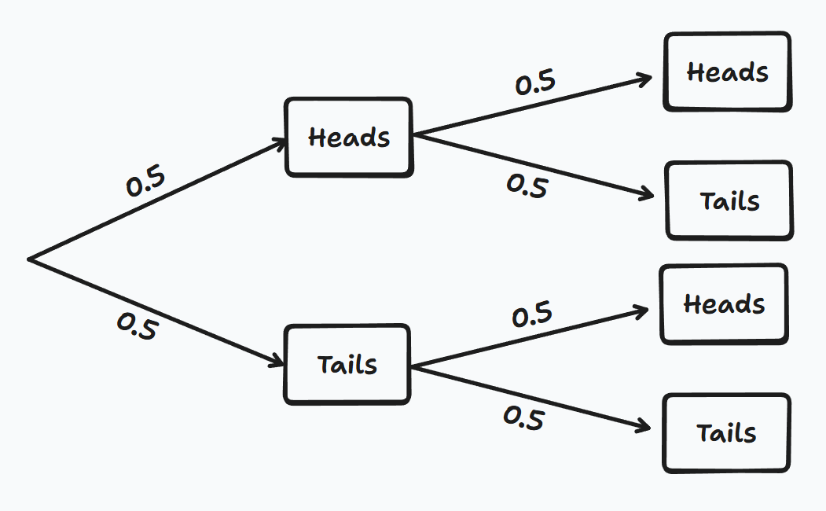
As shown above, the probability of getting [Heads, Tails] is (0.5*0.5) = 0.25, and the same is true for getting [Tails, Heads]. Combining these two results by adding them (union of 2 probabilities) and you get 0.5, the same as the result shown by the binomial formula.
The binomial distribution formula might look a bit unnecessarily complex, however this quickly scales up as the number of trials increases. For example, if a coin was flipped 100 times, then working out each combination of getting a certain number of heads would take an overly long time to calculate and is made a lot easier by using the formula.

Binomial Cumulative Distribution
Similar to the Binomial probability distribution mentioned above, the binomial cumulative distribution is a way of calculating the probability of getting up to a certain number of successes in a fixed number of trials, in the form $P(X≤x)$. This distribution is similar to the previous one, except it adds all of the probabilities from 0 – x to work it out. For example, if trying to work out $P(X≤3)$, the calculator would do $P\left(X=3\right)+ P\left(X=2\right)+P\left(X=1\right)+ P\left(X=0\right)$. In the previous section we found out how to calculate these kinds of probabilities and the binomial cumulative distribution is simply the sum of many such probabilities. As a result, the general formula of this distribution can be shown using the formula
$$P\left(X≤k\right)=\sum_{k=0}^{x}{\left({n \atop k}\right)p^{k}{(1-p)}^{n-k}}$$

Normal Cumulative Distribution
The normal distribution is a way of modelling continuous data that tends to cluster around an average value. Things like height, weight or exam scores. The normal distribution takes the shape of a bell curve, the highest point being in the middle and a symmetric falloff on both sides.
The normal distribution takes 2 values:
- The mean (μ) which represents the highest point on the graph
- The standard distribution σ, which is a measure of how spread out the data is
If the standard distribution is small, then more of the data is close to the mean, and if it is large, then the curve is flatter and more spread out.
Generally the following rules are a good approximation of the percentage of data that is 1, 2 or 3 standard deviations away from the mean:
- Within 1σ (μ ± 1σ): about 68% of the data
- Within 2σ (μ ± 2σ): about 95% of the data
- Within 3σ (μ ± 3σ): about 99.7% of the data
Since the normal distribution uses continuous data rather than discrete, the probability of getting a specific value (e.g. 175cm) is extremely low. Instead, the probability is calculated over a range of values, such as between 170 and 180cm.
To calculate these probabilities, we use the cumulative distribution function. This gives us the probability that X is less than or equal to a certain value. The formula for his is as follows:
$$f\left(x\right)=\frac{1}{σ\sqrt{2π}}e^{-\frac{{\left(x-μ\right)}^{2}}{2σ^{2}}}$$
To work out the probability of a result in between 2 values, this curve is integrated between the two:
$$P\left(a≤X≤b\right)=\int_{a}^{b}{\frac{1}{σ\sqrt{2π}}e^{-\frac{{\left(x-μ\right)}^{2}}{2σ^{2}}}}$$

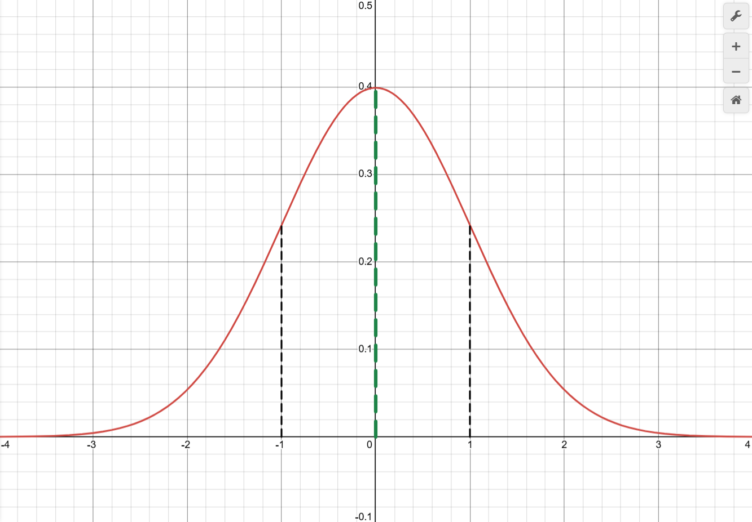

Inverse normal distribution
The inverse normal distribution is used when we have a probability and are trying to work out the value that corresponds to it. Instead of calculating the probability of a value lying within a range, the inverse normal distribution finds the point on the curve where a known percentage of data lies below it.
For example, this can be used to find percentiles, such as exam grade boundaries. The inverse normal distribution can be used to find the score that corresponds to the top 10% of test takers.
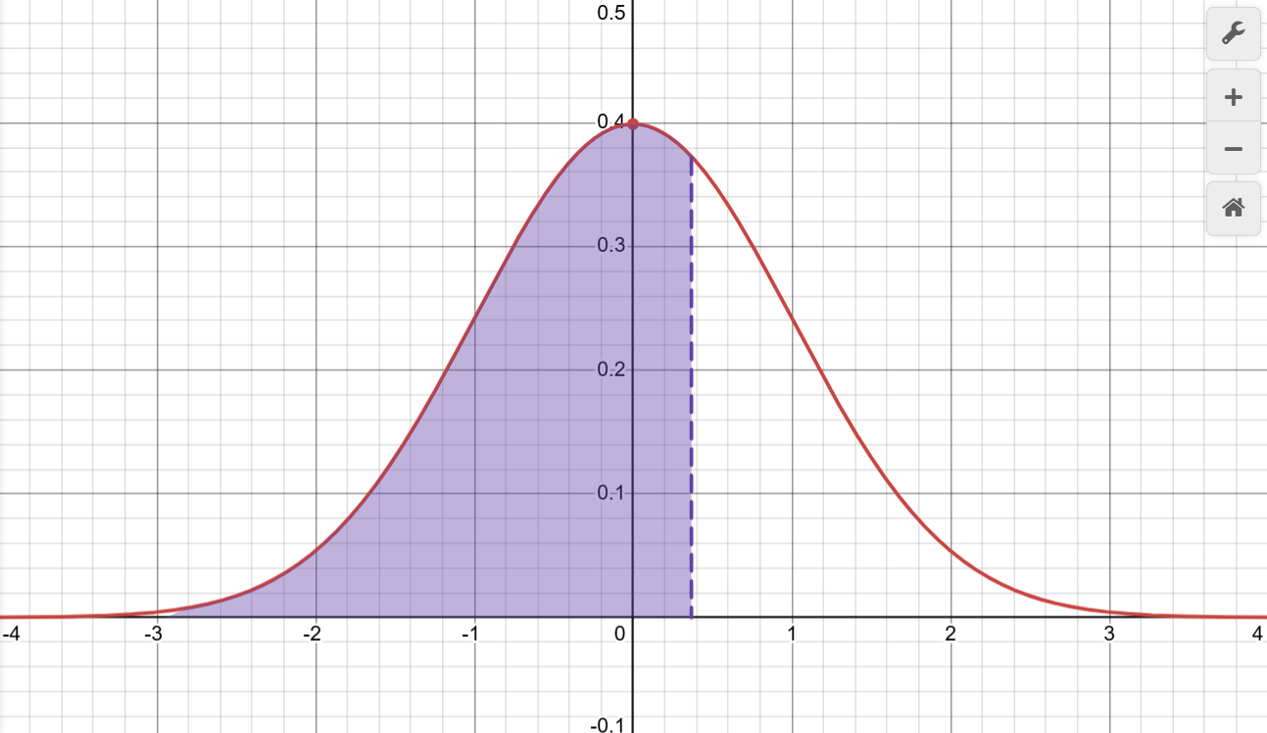
Calculating this requires use of the Gauss inverse error function, however this is very difficult to compute as it involves complex mathematics and has no simple algebraic implementation. Instead, we can use a polynomial approximation of this function called the Peter John Acklam’s approximation
Given the probability $p$, the mean $μ$, and the standard deviation $σ$, the value of $x$ such that $P\left(X≤x\right)=p$ can be worked out by first reducing the problem to a standard normal distribution with mean 0 and standard deviation 1.
If $p<0.5$, $t=\sqrt{-2ln⁡(p)}$.
If $p>0.5$, $t=\sqrt{-2ln⁡(1-p)}$.
This converts the probability into a number that can be approximated accurately. Now the value of $z$ can be approximated using the fraction:
$$z=t-\frac{c_{0}+c_{1}t+c_{2}t^{2}}{1+d_{1}t+d_{2}t^{2}+d_{3}t^{3}}$$
The values for $c_{i}$ and $d_{i}$ are the standard Acklam coefficients and are listed below:
$$c_{0​}=2.515517$$
$$c_{1}=0.802853$$
$$​c_{2}=0.010328​$$
$$d_{1}=1.432788$$
$$​d_{2}=0.189269$$
$$d_{3​}=0.001308​$$
If $p<0.5$, use $z=-z$.
Finally, scale back using the formula
$$x=μ+σz$$
to give the final x value for which the probability is p.

UI Libraries
When making the UI of the calculator, I have to pick a suitable UI library that will allow me to compile the software to run on both PC and on the physical calculator. Here are the options I found:
UI Library | Details
µGFX | - Good low level control for rendering  - Stable software so unlikely to stop working  - Less friendly API when building more complex layouts  - No desktop simulator meaning code cannot be tested on PC.
Adafruit GFX | - Very lightweight and fast  - Easy to draw text and graphics to displays  - Simple to use with a microcontroller  - No built-in UI components or layout system  - Complex interfaces must be implemented manually  - No desktop simulator for testing on PC
LVGL | - Proper UI components such as buttons, labels, etc.  - Designed specifically for embedded systems  - Easy to use styling and layout system  - Well documented usage  - Desktop simulator available meaning code can compile to run on windows  - Memory usage is slightly higher than other low-level alternatives
Qt | - Very polished and professional UI framework  - Powerful layout and animation system  - Windows support  - High memory/storage requirements  - Complex build system
Custom UI | - Full control over how components are rendered  - No abstraction  - Requires a lot more development effort  - Easy to make bugs/inconsistent UI  - Nothing built in meaning everything needs to programmed from scratch.

Existing Solutions

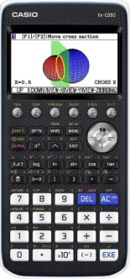
Casio FX-CG50
The Casio FX-CG50 is a high-end graphing calculator usually used in colleges and sixth forms for A-level further mathematics or similar courses. It has a variety of features such as:
- Matrices
- Statistics
- Spreadsheet
- 2D and 3D Graph plotting
Pros | - Has a wide range of functions  - Allowed for use in examinations  - Does not require an internet connection  - Physical buttons which may be a better user experience
Cons | - The price of this calculator is relatively high, at around £100 this is one of the most expensive options available  - The size of this calculator is a lot bigger than most other calculators, with a thickness of 3cm

Overall, this is one of the best options for a calculator on the market currently, however some people may find the price a little steep for what it s worth.

Casio fx-991EX CLASSWIZ
The Casio fx-991EX is a very popular and advanced scientific calculator. Students from both A-level and GCSE courses in both mathematics and physics use it in their learning. This calculator has many advanced features such as:
- Equation and inequality solver
- Matrix and vector calculations
- Statistical distribution calculations
- Spreadsheet function
Pros | - wide range of scientific and statistical functions  - Allowed for use in examinations  - Relatively affordable compared to graphing calculators
Cons | - Does not support graphing functions  - Small, non-touch monochrome display with no backlight

Desmos
Desmos is a desktop and mobile application that can be accessed through any modern web browser with an internet connection. It is used widely used by GCSE and A-Level students for visualising mathematical functions and viewing them interactively. Desmos supports a wide array of features such as:
- 2D graphing of functions, inequalities, parametric equations
- Sliders to manipulate variables in real time
- Graphing 3D equations
- Tables for inputting multiple values
Pros | - Intuitive and easy to learn interface  - Interactivity makes it easier to visualise the effect of manipulating different variables  - Free to use on desktop and mobile
Cons | - Requires a device with an internet connection, so would not be allowed in exams  - Lacks physical buttons which users might find an inconvenience
The Desmos graphing calculator is a very good demonstration of what the possibilities are for a calculator, however since this requires a device with an internet connection, this would be limited to classroom use only and would not be allowed for use in exams.

Windows Calculator
The Windows build in calculator is a desktop application included with Microsoft Windows operating systems. It is often used by people for quick calculations and has a few different modes depending on what the user needs:
- Standard and scientific calculations
- Trigonometry, logarithms and exponentials
- Unit/currency conversion
- Graphing is included in newer versions of Windows
Pros | - Pre-installed on all Windows devices  - Simple and easy to use interface  - Includes different modes for whatever the user wants to calculate
Cons | - Not allowed in exams, since it requires a computer  - Relatively basic graphing features  - Requires access to a Windows device.

The windows calculator is also a good beginner friendly calculator, however this also has the problem that it can not be used in exams.

iOS Calculator
The iOS and iPadOS calculator is a built in application available on both Apple iPhones and iPads. It is commonly used for everyday calculations, and on iPadOS offers some extra functionality through a larger display. The calculator supports a range of features such as:
- Standard and scientific calculations
- Trigonometry, logarithms and exponentials
- Basic unit conversions.
Pros | - Pre-installed on all Apple iOS and iPadOS devices  - Clean and easy to use interface  - Scientific mode easily accessible by simply rotating the device to landscape mode.
Cons | - Not allowed in exams, since it requires a computer  - No graphing capabilities on iOS  - Requires access to an Apple device
The iPhone calculator is another example of a well designed, functional calculator however it also has the same drawback as the other digital calculators in that it is not allowed for use in exams since it requires a prohibited device.

Overall, the Casio fx-991ex CLASSWIZ calculator is one of the best options available for a low price. At a higher price point the fx-CG50 is also a very good option to use. My calculator should be a balance between these two options, being as feature-rich as the fx-CG50 while keeping the low price of the fx-991ex.

Objectives
Based on the research done on the client and any existing solutions, I have made the following objectives for my project:
- A solution must be created to provide students with an affordable alternative to current graphing calculators on the market, being able to support all the features needed in the A-level course.
  - The system must support basic mathematical operations (arithmetic, trigonometric etc.)
  - The system must be accurate and precise to at least 6 decimal places
  - Variables and constants (such as x and y) should be able to be stored in memory
  - The system must operate reliably, giving the correct answer to equations.
- The system should be able to manage calculations, graphing and numerical methods efficiently
  - Implement an expression parser capable of evaluating complex mathematical expressions
  - Add a graphing with the ability to plot at least one graph at a time, with the ability to zoom and pan around.
  - Create a visual aid to visualise different numerical methods, e.g. numerical integration, differentiation and solutions to equations.
  - Add statistical functions such as mean, median and standard deviation
  - Calculations must compute within at most 1 second for the majority of inputs.
- A hardware platform should be used to create a portable standalone device
  - Will run on a raspberry pi or similar microcontroller
  - An LCD display should be used to display both numerical and graphical outputs clearly
  - A physical keypad will be used to control all functions and features of the calculator
  - The system boots up in at most 2 seconds
  - The system should have a battery life of at least 2 hours
- Expression evaluation
  - Implement a parser using the shunting yard algorithm that solves expressions according to the correct order of operations
  - Make sure clear error messages are given for syntax errors or invalid expressions
- Statistics
  - It should be able to calculate statistics, including mean, median, variance and standard deviation
  - Compute and display probability distributions for binomial, normal and poisson distributions.
  - Allow the user to input data sets from an interface on screen
- Graph plotting
  - The system should be able to plat single and multiple functions on the display with clearly labelled axes
  - The graph can be zoomed or panned
- Equation solving
  - Solve single variable equations including at least linear and quadratic polynomials
  - Solve simultaneous equations with 2 or more unknowns
  - Display all correct solutions clearly on the display
  - Provide appropriate error messages on the display for invalid inputs
- Numerical methods
  - Be able to solve equations numerically using methods such as the newton Raphson method
  - Display in a visual way the processes of numerical differentiation and integration on the display.
  - Calculate curve fitting for linear and polynomial fits, being also able to plot this on a graph
  - Allow the user to save and store functions for use throughout the interface.
- Mechanics
  - Support solving SUVAT kinematics problems for A-level kinematics
  - Provide a two page interface, the input page and then the results page
  - Validate that at least three inputs are provided before calculating.

Sources
https://www.johndcook.com/blog/normal_cdf_inverse

Design

Overview
This project aims to create an affordable alternative to many graphing calculators currently on the market today. The application is constructed using the C programming language and relies on a matrix of switches to pass button presses through to the software, with an optional extra piece of software that can run on a computer and “emulate” what it would run like without having the physical device.
The program will present the user with a main menu on first start, allowing them to select between different modes such as calculations, scientific functions, graphing, and numerical methods. Each mode will have a clear interface designed to be used on a small display. User input from the keypad will be processed by a dedicated button handler, and then passed to the main programming logic.
The calculators programming will be modular, with separate components responsible for each of the different features. This approach makes the system easier to maintain and extend. The overall goal is to provide a students with a capable calculator that supports the A-level maths curriculum while remaining more affordable than current alternatives.

Structure hierarchy chart

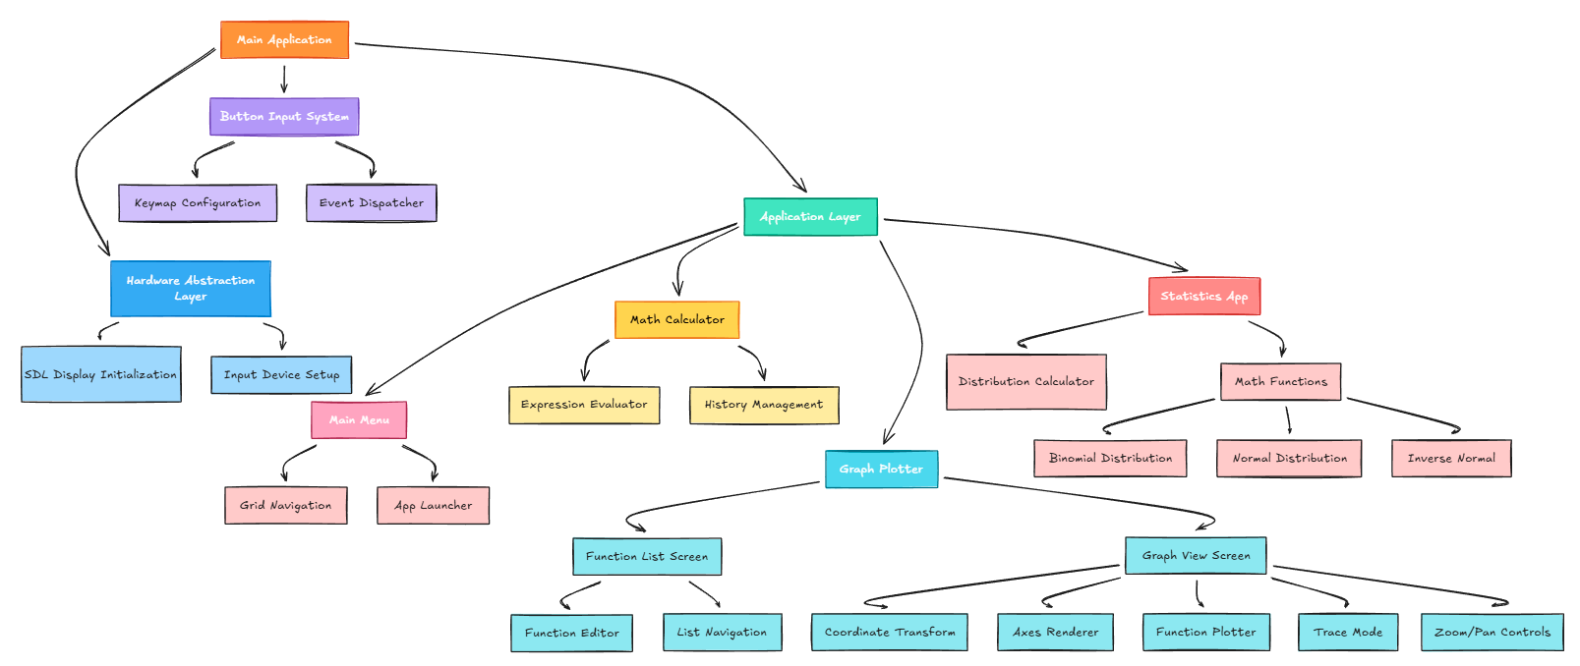
When the application loads, the hardware abstraction layer is intialised for display output and input devices before entering the main application. User interaction is mainly through the button input system, where keys are mapped from a file and dispatched as events to the main application. Here, when a call for an application to open is made, the control of the system is handed over to that specific file, where keypresses are passed to and controls the screen rather than the main menu user interface. The graph plotter has two components, the function list screen and the graph list screen. In the function list screen, the user is able to edit up to 4 functions to be drawn onto the screen. In the graph view screen, coordinate axes are rendered and the function is plotted over this, with options to trace or zoom/pan around the graph.

System flowchart
