**Introduction to Astro-pi and the Sense Hat**

**Using Python**

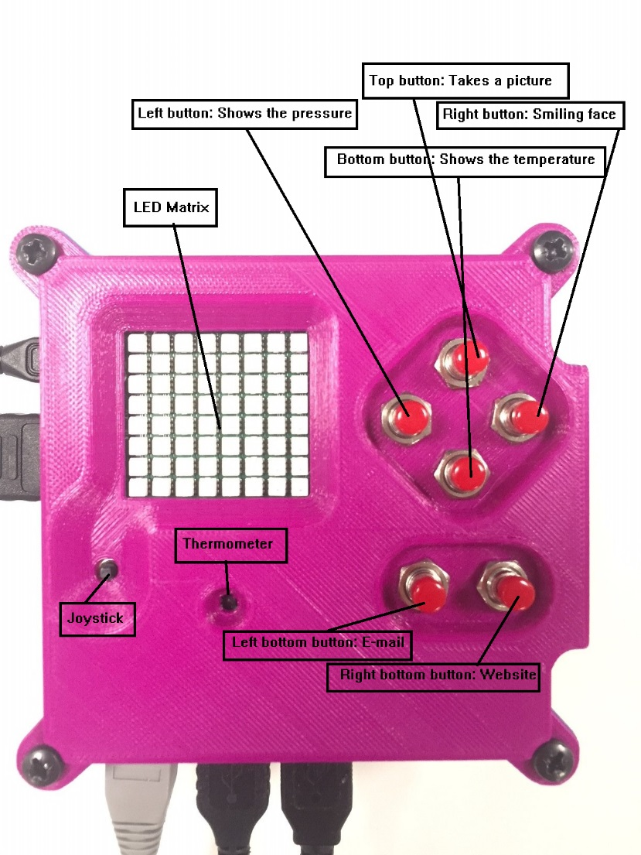

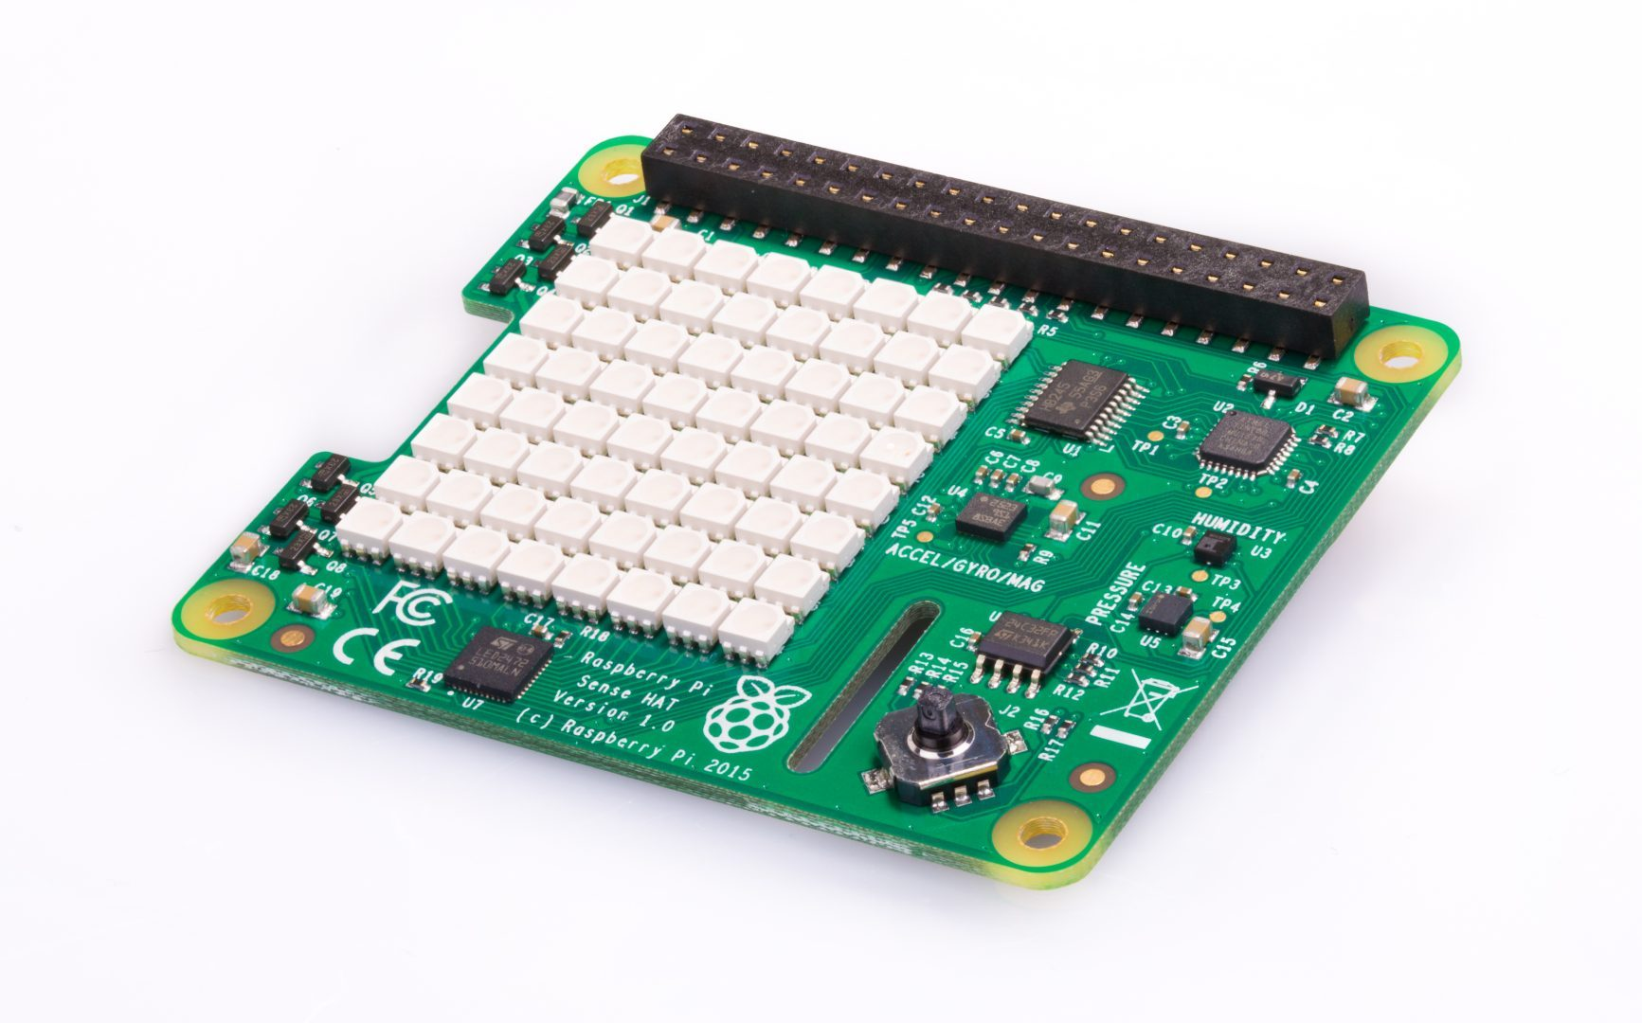

What is a Sense HAT?

The Sense HAT is an add-on board for the Raspberry Pi, made especially for the [Astro Pi](http://astro-pi.org/) competition. The board allows you to make measurements of temperature, humidity, pressure, and orientation, and to output information using its built-in LED matrix.

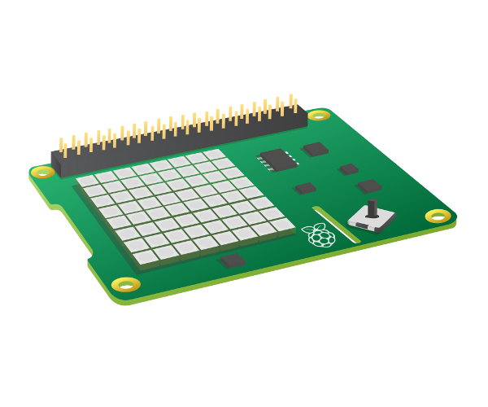

If you don’t have access to a real Sense HAT, you can use an emulator.

Online Sense HAT emulator

There is an online emulator you can use in your browser to write and test code for the Sense HAT.

**Online Sense HAT emulator**

There is an online emulator you can use in your browser to write and test code for the Sense HAT.

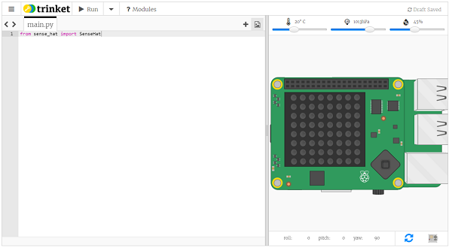

* Open an internet browser, go to <https://trinket.io/sense-hat> and delete the existing demo code which is in the editor.
* If you would like to save your work, you will need to [create a free account](https://trinket.io/signup) on the Trinket website.

**Sense HAT emulator on the Raspberry Pi**

If you are using a Raspberry Pi, there is a Sense HAT emulator included in the Raspbian operating system.

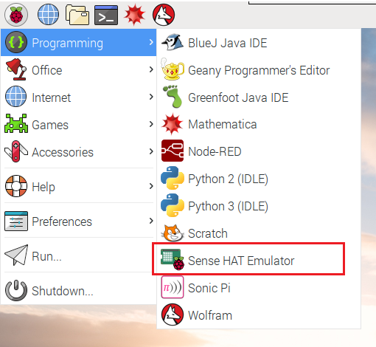

* From the main menu, select Programming > Sense HAT emulator to open a window containing the emulator.
* If you are using this version of the emulator, your program must import from sense_emu instead of sense_hat:

from sense_emu import SenseHat

If you later want to run your code on a real Sense HAT, just change the import line as shown below. All other code can remain exactly the same.

from sense_hat import SenseHat

**Displaying text**

Display the text “Egham Raspberry Jam is awesome” on your Sense HAT’s LED display.

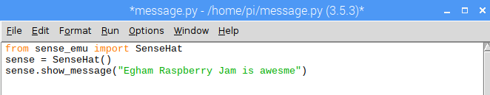

Now click on Run and Run Module, you should see the emulator pop up and your message start to scroll on the screen.

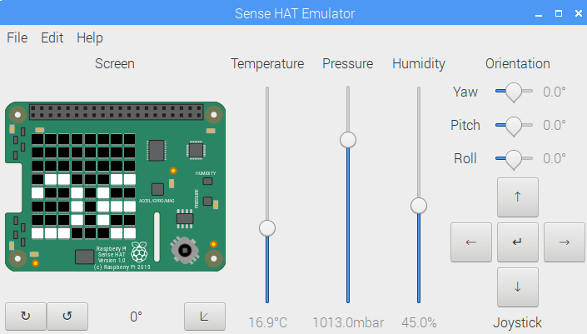

Free thinkers:

Please have a go at displaying your name or message, what did you need to change? Please ask if you need some help!

**ADDING COLOUR**

When we want to represent a colour in a computer program, we can do this by defining the amounts of red, blue, and green that make up that colour. These amounts are usually stored as a single byte and therefore as a number between 0 and 255.

Here’s a table showing some colour values:

| **Red** | **Green** | **Blue** | **Colour** |
| --- | --- | --- | --- |
| 255 | 0 | 0 | Red |
| 0 | 255 | 0 | Green |
| 0 | 0 | 255 | Blue |
| 255 | 255 | 0 | Yellow |
| 255 | 0 | 255 | Magenta |
| 0 | 255 | 255 | Cyan |
|  |  |  |  |

You can find a nice colour picker to play with at: <https://www.w3schools.com/colors/colors_rgb.asp>

text_colour: alters the colour of the text and is defined via three values to specify red, green, and blue.

back_colour: alters the colour of the background

Now let’s make our message a little more colourful

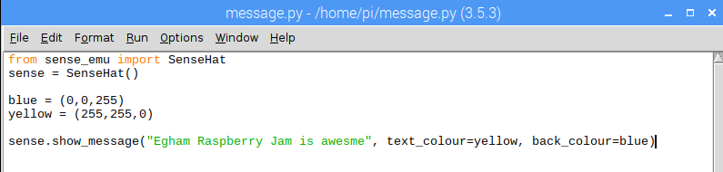

Free Thinkers:

Can you change the text and background colours?

**Display colour**

You can fill the whole LED matrix with a single colour by using the clear method with the colour you’ve picked.

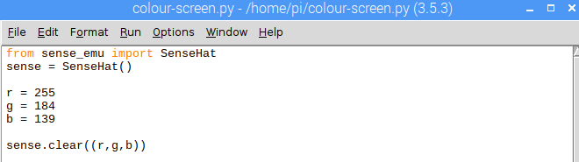

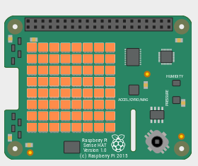

Free thinkers:

Can you change the display colour?

**Display a picture**

The Sense HAT’s LED matrix uses a coordinate system with an x- and a y-axis. The numbering of both axes begins at 0 (not 1) in the top left-hand corner. Each LED can be used as one pixel of an image, and it can be addressed using an x, y notation.

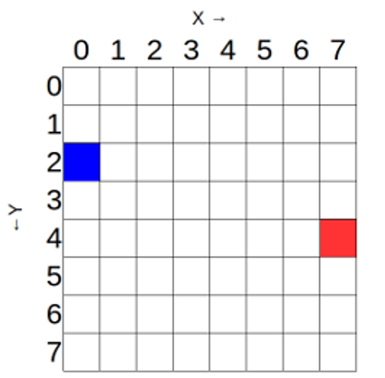

The blue pixel is at coordinates 0, 2.  
The red pixel is at coordinates 7, 4.

You can set pixels (LEDs) individually using the set_pixel() method.

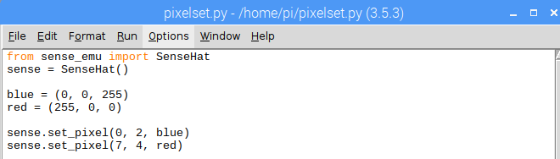

Free Thinkers:

Light up the pixels (LEDs) in the four corners of the matrix in a colour of your choice.

**Setting multiple pixels**

Setting pixels individually can work brilliantly, but it gets rather complex when you want to set multiple pixels. To change all the pixels in one go with the set_pixels command.

You may be tempted to try to draw shapes on the Sense HAT’s LED matrix by using the set_pixel command over and over. However, there is a set_pixels command with which you can change all 64 LEDs using one single line of code!

Have a go with the code below and see if you can create your own Steve from Minecraft

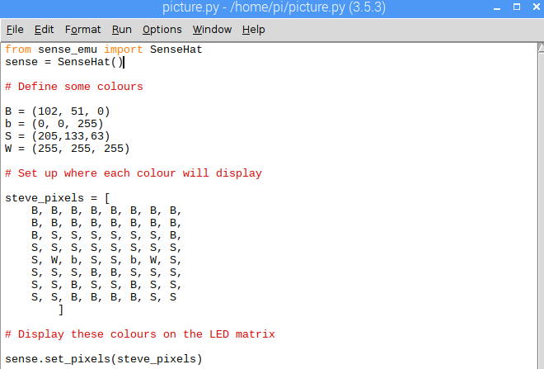

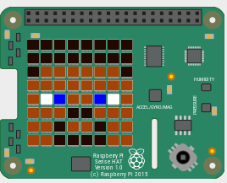

**Setting orientation**

So far, all our text and images have appeared the same way up, with the HDMI port at the bottom. However, this may not always be the true orientation of the Sense HAT (especially in outer space), so sometimes you might want to change the orientation of the LED matrix.

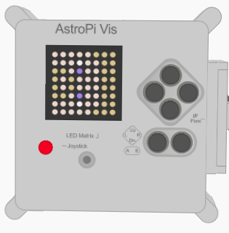

Oh no! Steve is sideways!

You can change the orientation of the LED matrix display on the Sense HAT. Use the set_rotation() method to rotate the screen one of four ways: by 0, 90, 180, or 270 degrees.

For example, to rotate your display by 180 degrees you’d use this code:

sense.set_rotation(270)

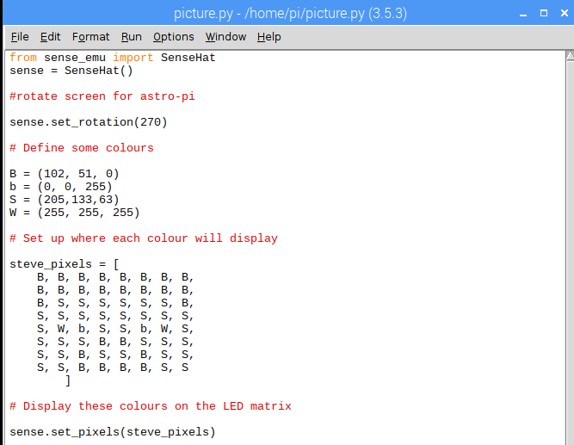

**Sensing the environment**

### Reading pressure with the Sense HAT

pressure = sense.get_pressure()

print(pressure)

**Detecting temperature with the Sense HAT**

temp = sense.get_temperature()

print(temp)

**Detecting humidity with the Sense HAT**

humidity = sense.get_humidity()

print(humidity)

**Display the sensor outputs**

Create a scrolling text display which keeps people informed about the current pressure, temperature, and humidity readings.

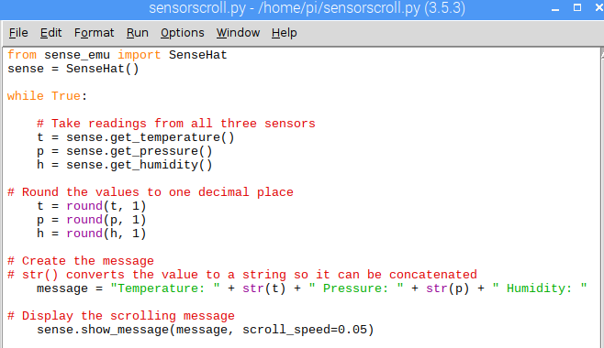

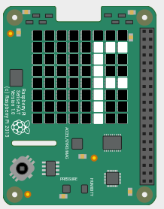

Notice we are now forcing the rotation of the display to work with Astro-pi (ISS)

**Grand finale:**

Let’s create a useful example from everything we just learnt.

**In groups (min 2, max 4)**

1: Create a greetings message (with your name’s)

2: Measure and display the temperature

3: Show a picture on the display

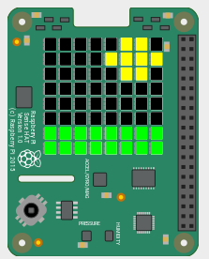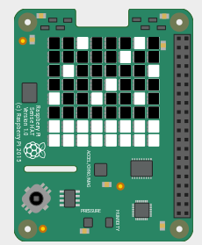

Free thinkers:

Can you display an image depending on the temperature?

If its hot maybe a sunshine, if its cold some snow?

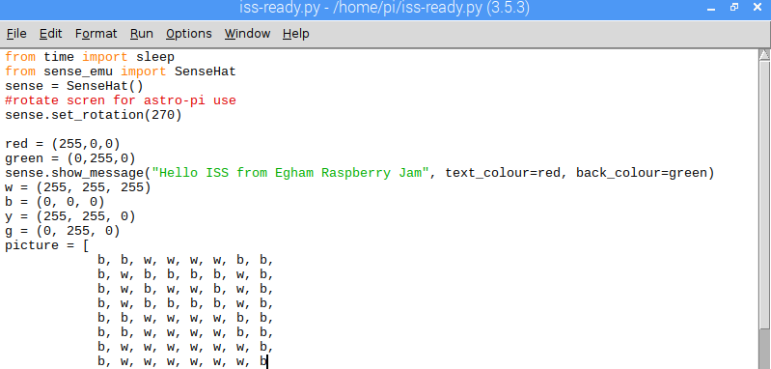

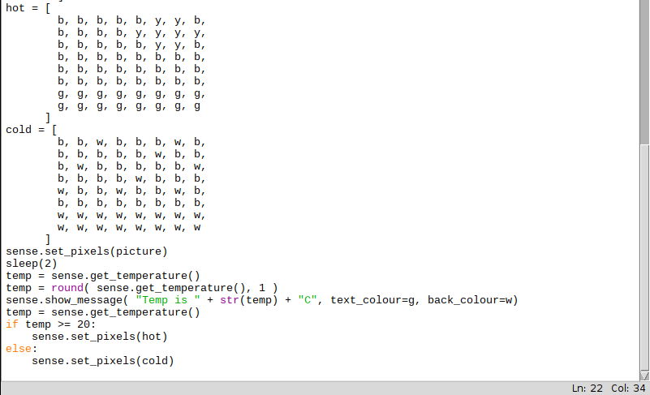

**14 or younger?**

**Mission Zero**

<https://astro-pi.org/missions/zero/>

The code must show a greeting message (in any of the ESA Member or Associate States’ languages) and the measured temperature inside the ISS on the LED matrix. Graphics can also be used to display the message and the temperature.

• The code should take no longer than 30 seconds to finish. Codes that take longer will be shut down when running on the ISS.

• All entries will be run on the ISS provided they contain no obscenities and respect the mission requirements and constraints described here.

**Over 14 but under 19?**

**Introducing Mission Space Lab**

<https://astro-pi.org/missions/space-lab/>

Students will work like real scientists by designing their own experiment. Choose one of the following themes for your project:

Life in space

You will make use of Astro Pi Vis (Ed) in the European Columbus module. You can use all of its sensors, but you cannot record images or videos.

Life on Earth

You will make use of Astro Pi IR (Izzy), which will be aimed towards the Earth through a window. You can use all its sensors as well as its infrared camera.