**PowerSDR 2.7.2 ke9ns Feature Additions: (Bells and Whistles)**

**Read the BCD Time coded sub-carrier from Radio Station WWV:** Select a frequency (1=2.5mhz, 2=5.0mhz, 3=10mhz, 4=15mhz). Check the “Use WWV” check box (in Spotter window) to use Radio Station WWV BCD (binary coded decimal) 100hz sub-carrier. Added Tone Detection routine. Will not work well in noisy or low signal situations. PowerSDR must be in ADMIN mode to allow to sync your PC.   
 **NIST (National Institute of Standards and Technology) PC Time Sync:** If you run PowerSDR in ADMIN mode, you can use the “Time Sync” button (in the Spotter window) to sync your PC time clock to NIST. **NCDXF Beacon Scanner:   
This feature gives you a direct method of determining radio wave propagation conditions(i.e. band conditions) for the 20m,17m, 15m,12m, and 10m bands. A System of 18 stations, around the world, transmitting (24hrs / day) in 10 second intervals on 5 frequencies (5 separate stations simultaneously) on 14.1mhz, 18.11mhz, 21.15mhz, 24.93mhz, and 28.2mhz. (Repeating every 3 minutes).Your PC clock must be accurately set to make sure PowerSDR matches up with the Beacon stations.**Under the “Spotter” window is a “Beacon Chk” button with Fast & Slow Scan options. You will see a list of Beacon stations (upper left corner) and the current 5 stations transmitting). With “Map Calls” checked, you will see all 18 stations (and each of their 5 frequencies).   
  
Slow Scan: Starts on 14.1mhz beacon and listens for 3minutes (1 complete loop) for 18 stations and records their signal strength, then moves to 18.11mhz, and so on, until 28.2mhz. 15 minutes total time. You can select the starting band 1 through 5. 1=14.1mhz up to 5=28.2mhz.  
Fast Scan: Scans through all 5 Beacon frequencies (1 second per beacon) in a single 10 second interval, and records the signal strength on each frequency. It repeats this quick 5 frequency scan 18 times to get a complete Beacon map in 3 minutes, but is not as accurate as the Slow Scan.  
  
Colors On the World Map: Gray = Not scanned yet. Violet = Currently Scanning, Red = Not detected, Orange = Weak, Yellow =Light, Green =Strong.  
On the SPOTTER window: All 18 stations x 5 frequencies are listed (total of 90 entries)  
As the stations and frequencies are scanned, signal data is added to the SPOTTER entries.  
-NA dBm = Not Scanned yet. S9 -018dBm = S9 signal level, but only -18 dBm above the noise level.

At the Start of any Scan, the Mode is changed to CWU with filters set to 550hz - 650hz. This is to try and eliminate extraneous noise. Prior operating Mode and Filter High/Low settings are restored when the scan is finished.  
  
See <http://www.ncdxf.org/beacon/index.html> for further details  
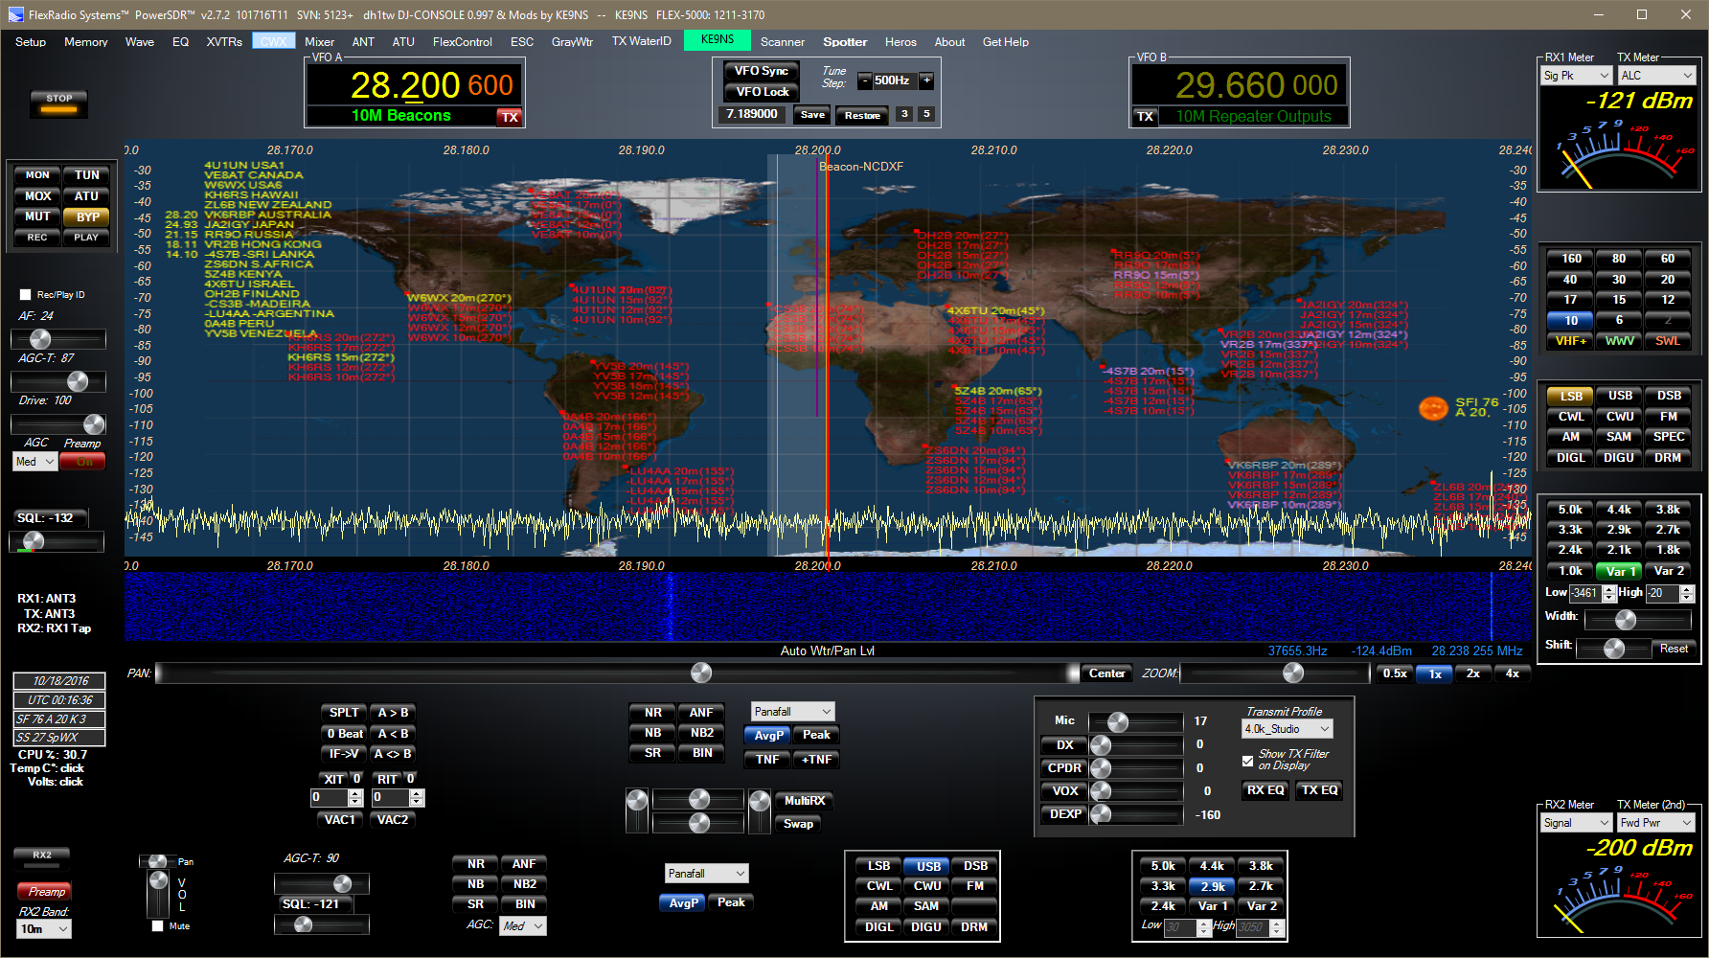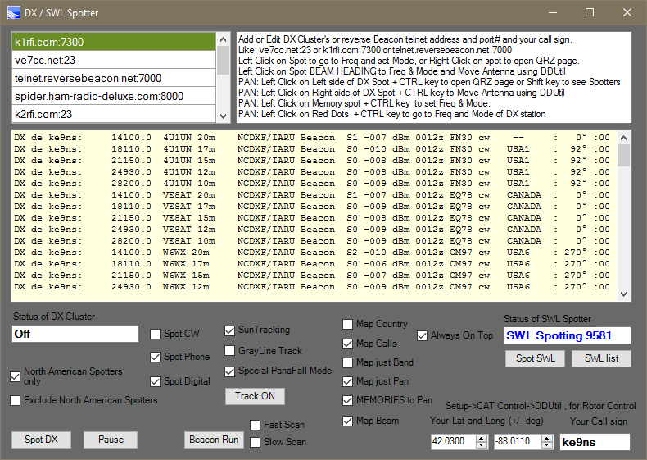

**SWL Additional list**: SWL2.csv provided by ke9ns adds SWL and HF Utility frequencies not found in the eibispace.de SWL.csv file. PowerSDR stiches SWL.csv and SWL2.csv together when you run the SWL spotter. SWL2 Currently added spots for ALE, DSC, HFDL and NCDXF Beacon signals  
 **DX Beam Heading:** Enter in your Lat and Long next to your Call sign in the Spotter window, and see Beam heading from your Station. Map Checkbox to see beam headings on the Tracking Map.  
Beam Headings passed to **DDUtil** Antenna Rotor control for Automatic antenna direction point.

**Automatic Antenna Control:** Setup->CAT Control->Enable Rotor. You must select 1 side of a virtual COM port pair. The other side of the COM pair connects to DDUtil. DDUtil will automatically convert the beam heading into the proper format for your Rotor control.  
Left Click on the BEAM HEADING of a DX spot in the Spotter window to Move Antenna  
OR, Left Click on the Right Side of a DX Spot + CTRL Key in the Panadapter to Move Antenna   
In DDUtil open setup form->AntRtr and setup your antenna Rotor control(s).  
 Then go to setup form->Ports->RCP1->Rotor Port and the “Other side” of the COM pair from PowerSDR.

**VFOA Sliding function:**Left Click on the PAN: text button (on the main console window) to activate (turns RED). Now changing frequency of VFOA will not scroll display, but instead slide the VFOA bandpass across the display.  
  
**Panadapter Small Signal Scaling:**  
Left Click on the ZOOM: text button (on the main console window) to activate (turns RED). The Scale of the Panadapter windows will temporarily change to zoom in on small signals. Click again to go back to normal scale.  
 **Memory (Scheduling & Recording):**You can now save a start Date & Time to change Frequency and optionally Record the Event for a specified Duration (up to 120 minutes). You can set the Schedule for individual Memories by Week (based on Day of the Week. Example: Every Monday), or by Month (based on the Day of Week and the Week of the Month (Last Thursday of every month). To stop, uncheck both Week and Month boxes for the Memory. Drops the Recording SR to 48k and saves as MP3 to save space.  
 **SWL:** Shortwave stations not only appear in Panadapter window, but also a separate screen, showing currently operating stations by Frequency, name, origin, and operating window. Left Click to select a station to go to. You can also search by station name. Attempt to parse out the operating Mode based on type of station.  
 **WWV:**Add 25mhz to list. 1) CTRL + RIGHT CLICK on the WWV button, or 2) delete all the database files so PSDR starts over from scratch.  
 **Space Weather:**NOAA Solar Flux Index, A-Index, K-Index, Radio Blackout Level, Geomagnetic Storm Level, and SIDC Daily “Estimated International Sunspot Number” EISN. Updated at the top of every hour. Turns Red when a Radio or Geo storm present or the K-Index > 4.  
 **CWX Panel:**Check “Poll CW KEY” to allow transmit interrupt of the CWX messages and keyboard.  
CWX panel and Console CW panel now sync WPM changes.  
Prevent PSDR crash when quickly clicking between message queue’s. **BandStack Display:**To Open: Left Click on the BandStack indicator(s) (located top center of PowerSDR console) and a BandStack screen will display all memories in the BandStack for the current band, and highlight the current Index.  
To ADD new BandStack to the list: Hit the CTRL button and RIGHT Click on the Band button.  
RIGHT CLICK on a Bandstack memory to LOCK (freeze) or UNLOCK a memory  
LEFT CLICK on a Bandstack memory to go to that memory Frequency  
To UPDATE a memory, the current Bandstack memory must be unlocked. Select new Frequency, then either Left Click on a different memory in the Bandstack, OR click on the same BAND button again to go to the next Bandstack in memory.  
NOTE: Frequency, Mode, and Filter are saved/updated only if the memory is unlocked

**RX1 Mute:**Checkbox appears next to main AF slider only when RX2 enabled. Checking this box allows you to mute just RX1 and listen to just RX2, but still send RX1 audio over VAC to the PC (i.e. for digital work)  
 **Griffin PowerMate USB Knob:**PowerMate control added to PowerSDR. Setup->General->User Interface. You can select to active the PowerMate, or unselect to use external programs to control PowerMate Knob.  
Windows should automatically find the Driver for Powermate. So you should not install or run any other PowerMate program. DJConsole also built in now, instead of having 2 separate versions of PowerSDR.  
 **2nd TX Meter function:**Using the RX2 meter, you can now select a 2nd TX meter (as long as you’re not using RX2 while transmitting: Setup->General->RX2->Auto Mute RX2 unchecked).  
Example: Set TX Meter to “ALC”, Set TX 2nd Meter to “Fwd Pwr”.  
 You activate this feature from: Setup->Transmit->TX 2nd meter Active checked. This works with the Flex-1500, 3000, and 5000.

**Saved Memories Mapped directly to Panadapter:**When selected from the Spotter window, all your saved Memories will appear directly on the Panadapter based on where you currently are (both RX1 and RX2). The Panadapter shows: Name 1st, Group 2nd. When you Left Click in on a Memory shown in the Panadapter, the Memory is loaded up so the saved Mode, Filters, etc will be set.  
If you find a new signal you wish to save as a new Memory: Hit the ALT & M keys, then go to the Memory Window to change the Name and Group to whatever you want.  
Add NET’s, Repeaters, Beacons, Easypal, SSTV frequencies, etc. etc.

**Panadapter Fill Color and Transparency:**Right Click on CENTER button to open up Setup->Appearance->Display  
You can now Select Pan Fill color and Transparency.

**MultiRX:**  
Right Click on MultiRX to Reset it back to VFOA when you activate it.  
OR  
Right Click on “Zoom:” text Setup->Display and check box MultiRX Auto Reset so it always Resets back to VFOA

**DX Spot: Frequency hopping directly from Map:**Left Click on any Red Dot on the Map and hit the CTRL key to go directly to the DX spot Frequency, mode and split. **DX Spot: Country or Call sign directly to World Map:**A Red Dot appears directly on the map for every DX Spot on the DX list.   
Select either DX Country or DX call sign to appear directly on the Equirectangular map.  
 **Sun Tracking (with NOAA space weather):**High resolution algorithm tracks Sun across Equirectangular Projection map (embedded into PowerSDR) based on UTC time and Day of Year for Declination (Solstice’s and Equinox’s )  
Solar Flux Index and A-Index appear next to Sun on Panadapter. Updates every hour.  
  
**Special Panafall mode:**When viewing the Sun or Gray Line TRACK, you can select a special Panafall mode which is 80% Panadapter and 20% Waterfall (as opposed to a standard 50-50%) just for RX1  
   
**Gray Line Tracking (with Sunset and Dusk areas):**  
High resolution algorithm updates in 1min intervals.  
Right Click on “Center” button on main screen to open Setup Panel to select the Color and Alpha (transparency) of the Gray Line.  
  
**Equirectangular Projection (embedded into PowerSDR):**  
When you open the Spotter Window and Click on the “Track” button (with Either Sun or Gray Line Tracking enabled), the current Background image changes to the Equirectangular map.  
  
**TNF (adjustable Width):**  
Right Click on the TNF buttons and you can select the Width of the next TNF created. Standard is 100hz, but can go as high as 600hz.  
  
**Reset buttons for NR, ANF, NB, NB2 buttons:**  
Right Click on any NR, ANF, or NB button and go directly to the adjustment panel for making changes to the noise filters. Factory default Reset buttons have now been added.

**Record / Play ID CheckBox:**  
When Selected the “Rec” button Sets the Drive to 0, and keys the Flex to allow you to record your voice. When the “Play” button is pushed, the Flex will Transmit the last recording. NOTE: the Wave->Options->POST-Audio must be set for this to work. This will automatically be set properly when the Rec/Play ID box is checked.

**Quick Audio Save Folder Option:**  
When QuickAudio Save Folder box is checked (under the Wave Menu Item), A new QuickAudio file is saved each time you Record. Right Click on the “Play” button to see the folder with all the recordings. You can Right Click on any File to rename. Highlight any file you want to play and Click “OPEN” button. When you Click on the “Play” button the selected Recording will play until you select another file or select another file, but click the “Cancel” button instead of “Open”, and the Flex will return to playing the Last recording made. Wave->QuickAudio Create MP3 checkbox, saves a WAV file and an MP3 file (For emailing the audio files to friends)

**Right Click on Buttons:**  
Right Click on many button to go directly to the setup menu for their function, including Antenna descriptions found on left side of screen. Waterfall ID callsign box takes you to the database folder. Transmit profile takes you to the setup->transmit. NR,ANF,NB button take you to the setup->DSP->Options. RX/TXEQ takes you to the EQ settings menu. Right Click + CTRL on Band button creates a new bandstack memory. Play button takes you to the Quickaudio folder.

**DX Spotter screen:**File DXMemory.xml now saves all your DX clusters.  
Type the URL of a DX Telnet Cluster (or ReverseBeacon) along with the PORT# and your Call sign.  
Click on the “Spot DX” button to connect up and start spotting.  
When the “DX Parser” is checked, PowerSDR will attempt to determine the Mode and Split from the DX spot frequency and DX spotter comments, then set the Flex accordingly   
cw,ssb,rtty,psk,Olivia,msk,etc.  
You can also check to select only North American, or Exclude North American Spotters.  
You can also check to select only CW, Phone (AM,SSB,FM), or Digital (rtty,psk,packet,etc)  
You can also check to select the Mode(s) you want to see spots for: CW, Digital, Phone.  
DX Spotter Window: Click on any DX spot and go directly to that spot (if DX parse checked, then also set mode). Left click on the Left side of any DX spot + CTRL key to open up QRZ web page of DX Spot  
Panadapter Window: Click on any DX spot in Panadapter, then Hit the CTRL keyboard button to open up QRZ page, or Hit the Shift Key (toggle) and view the Spotter in the Panadapter.  
Spotting works on both RX1 and RX2.  
  
**SWL Spotter:**  
Right Click on the “Callsign” waterID box (at the top menu line) and place the SWL.csv file into this folder to allow for spotting Shortwave signals.  
Click on any Shortwave station viewed in the Panadapter, then Hit the CTRL keyboard button, to open your Web Browser and Google the Shortwave station. Works only on RX1.

**Band Scanner:**  
Work in Progress band scanner  
Automatically adjusts to current band limits your on.  
Select Step (khz) and Step Rate (mSec).   
Push “Scan Band” button to start scanner. Stops then reach end or “Scan Band” pushed again or Squelch level exceeded.  
  
**Memory (Hyperlinking):**  
Drag and Drop any URL (from your Web Browser [excluding Edge browser] URL address line) directly onto any highlighted Memory. Now Right Click on that particular highlighted memory at any time to directly open your Web Browser to that stored Hyperlink.   
Drag and Drop any File (from your Desktop or File Explorer) directly onto any highlighted Memory. Now Right Click on that particular highlighted memory to open up that File directly using the default opening program associated with that file type.  
Also Drag & Drop (File or URL) to the “Add” button to create memory and Hyperlink at the same time.

**Shortwave Bands (SWL):**  
All the standard Shortwave bands are now a set of Band buttons. Click the “SWL” button to display all the shortwave bands, complete with Band Stacking.

**Band Stacking (all Bands):**  
Right Click + CTRL button on top of and Band Button to add a Band Stack memory.  
You can view the current Band Stack your on and the Total Stack# for the current Band Selected at the Top of the screen (just under the Tune Step readout).  
  
**Monitor Feature (Pre and Post processed Audio):**AM and FM modes now have Pre-Processed audio available to the Monitor “MON“. The Flex-1500 can only do this via the VAC function, not the built in headphone jack.  
“MON“ button now has “MONpr” for Pre processed audio and “MONps” for Post processed audio (which is only available for SSB on all radio models).   
Reduced the TUNE audio level (temporarily) in the monitor  
Properly change the AF slider to say MON during Transmit or TUNE, since that is its function (except if you have RX2 set to stay on when transmitting).  
  
**Continuum Mode (RX1 only):**  
Waterfall is used to display Peak band power vs time (5 second intervals), for both Receive and Transmit.  
  
**Waterfall History Moves with Frequency change (in Panafall mode):**The waterfall history (in Panafall mode) now always moves with a change in frequency. At some point, if you keep scrolling (changing frequency) in one direction, you will hit the edge of this feature and the Waterfall will clear and restart over. There is also a checkbox setting in Setup->Display to allow for a wider waterfall to avoid this (but uses more cpu time). Dark areas in the waterfall (that appear as you move) are areas with no valid history. In this way, the waterfall you see is always valid history for the current Panadapter display your viewing.  
 **Auto Waterfall and Panadapter Display Level:**Left Click on the “**Zoom:**” slider text button on the main screen to automatically adjust the **Panadapter Scale** between small signal and standard. Small signal values are not saved into memory.  
Left Click on the “**Auto Wtr/Pan Lvl**” button on the main screen to automatically set the current waterfall display Low level. Work in both Receive and Transmit. Setup->Display now have separate low level for RX2 and for Transmit levels. The Transmit High level is now 0db  
Right Click on the “**Auto Wtr/Pan Lvl**” button on the main screen to automatically set the current Panadapter Grid Min value (base line of the Panadapter signal on the screen).

Right Click on Zoom: text to go directly to:  
Setup->Display-> auto grid level slider to adjust the threshold of the automatic setting  
Setup->Display-> auto Water level slider to adjust the threshold of the automatic setting  
  
**Average Button:**  
Click on the “**Avg**” button (when viewing in Panafall mode) and you can select “**AvgB**” which selects averaging on both Panadapter and Waterfall, or “**AvgP**” which selects averaging on just the Panadapter and sets the Waterfall to normal (which allows for better viewing). Works for both RX1 and RX2

**Transmit Bandwidth:**  
Now both Flex-1500 and Flex-3000 can transmit up to 10khz wide. The Flex-3000 can also select 192khz SampleRate.  
  
**Gray Waterfall:**Click on the “**GrayWtr**” button at the top menu line to set the Waterfall to Gray Scale Mode. This mode shows more detail and allows for viewing of Waterfall text and images.

**Panafall Modes:**RX1 and RX2 can have Panafall mode on together, or RX1 in Panafall and RX2 in Panadapter mode.  
The screen is divided either in ½, 1/3, or ¼ sections. Now a special Panafall mode just for RX1 allows for 80% Pan and 20% water.

**TX Waterfall ID:**  
Type your Call sign or some text into the Callsign box (at top menu line of PowerSDR) and move mouse away and wait for box to turn GREEN. Click on the “TX WaterID” button to key Flex and transmit that text into the Waterfall of the Flex.  
It does not matter what Sample Rate your Radio is set for (Setup->General->Audio->Primary), but Lower Sample rates (48k or 96k show up better than 192k. This is because the resolution of the display is always 4096 data points for the entire display, no matter what the Sample Rate. So a Lower Sample Rate means higher resolution. But it always transmits at 48k SR no matter what the radio is set at.  
  
NOTE: Wave->Options->POST-Audio must be set for this to work.  
If you want more gain output on the image go to Wave->TX Gain and increase it. And you can also increase the Drive. Just don’t exceed the ALC.  
  
To see what your transmitting better, hit the auto water level button as its transmitting. Also hit the GrayWtr button at the top, and it will show up better transmitting and receiving Waterfall ID’s. Easypal uses Waterfall ID’s as well.  
  
The Speed of your waterfall (Setup->Display->FPS) will affect how it looks (stretched out or scrunched) when receiving. When you transmit your FPS does not affect what others will see, just how it looks in the waterfall on your radio.

**WaterID Images:**  
Right Click on the Callsign window at the top. A folder will open where you can place small 24bit grayscale or color bitmap images. (i.e. test.bmp)  
  
To transmit the bitmap image, type in the name of the file with a . at the end (ie. test. )  
Wait for the window to turn Green, Now hit the “**TX WaterID**” button

Same conditions apply to image as a Text Call sign as far as output level, SR, graywtr, etc..

**KHZ and MHZ Frequency entry (for below 50mhz):**  
Now you can enter in KHZ directly into the VFOA or VFOB. 3800 sets to 3.8 Mhz  
720 set to 0.720 Mhz. 28300 sets to 28.3 Mhz

**Incorporate DJ Console code into PowerSDR:**Setup->General->User Interface  
 **New Analog Meters:**Add TR7 and Curved Analog Meters as well as a larger Edge meter. Click on the Meter box to toggle between meters. Added new color codes meter types: SWL, Power, ALC  
  
**Meter Peak Hold Feature:**  
Added a Peak / Hold feature with a 2nd Red needle to hold the Peak value for an extra second.  
  
**PA Temp and Volt Readings on main screen (Flex 3000 and 5000 only)**  
Click on the Temp or Volt text on left side of screen to activate. Update rate is tied to CPU% update rate in Setup->Display.  
  
**Proper S9 reading for both HF and VHF/UHF bands:**  
Added -93dbm S9 reading for Frequencies above 30mhz