TwonkyScrobbler - V1.0.0.0
By Andrew Garratt http://www.insanityworks.co.uk
http://last.fm/users/nerdsville

This application is based on the Kexp Radio Scrobbler by Markus Palme (http://www.codeplex.com/kexpscrobbler/) and is designed to scrobble the last played song from the TwonkyMedia 4.1 or later media by TwonkyVision to the http://last.fm social networking website.

Developed and tested on Windows XP Sp2

Requires the .NET Framework 2.0

1. TwonkyMedia Server Setup

Requires TwonkyMedia server version 4.1 or later which exports RSS audio feeds to allow non-uPnP devices such as the Sony PSP® to stream audio files directly from the media server.

There is no specific setup required

2. TwonkyScrobbler Setup

It is likely that the TwonkyScrobbler will be run on the same PC that is running the server, however it is perfectly possible to connect to a remote server running on another machine.

2.1 Installation
There is no installer simply extract the zip file into a directory of your choice. Three files are supplied, TwonkyScrobbler.exe, log4net.dll and TwonkyScrobbler.exe.config.

Opening the TwonkyScrobbler.exe will present you with the following display

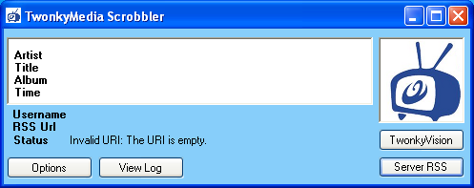

The top panel shows the details of the last audio file processed, currently unpopulated and details of the current status, last.fm username and RSS URL. The status may well show “Invalid URI: The URI is empty” as the TwonkyScrobbler needs configuring.

2.2 Configuration
Use the Options button to open the configuration control.

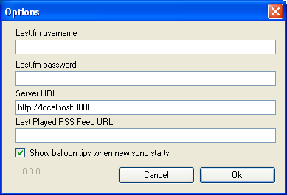

Last.fm username
enter your last.fm username in here

Last.fm password
enter your last.fm password in here

Server URL
Set the URL of the web service on the computer running the TwonkyMedia server (including the port number, by default 9000)

This would be http://localhost:9000 assuming the TwonkyScrobbler is running on the same PC as the server.

You can check this URL by entering it into a web browser, you should see something like this

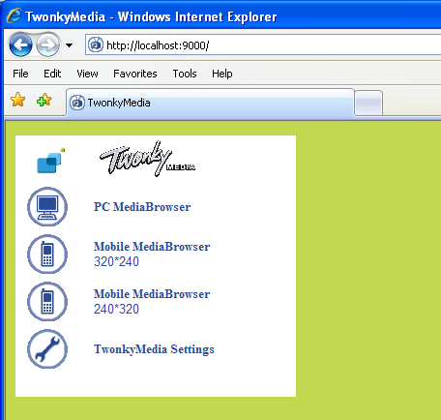

Last Played RSS Feed URL
This is the URL of the appropriate RSS feed, see section 2.3.

Show Balloon tips when new song starts
Set this as required.

Click OK to return to main screen.

2.3 Configuring RSS Feed.

Assuming you have configured the Server URL correctly if you now click the Server RSS button on the main screen a web browser will open up showing the RSS feeds available from the TwonkyMedia server.

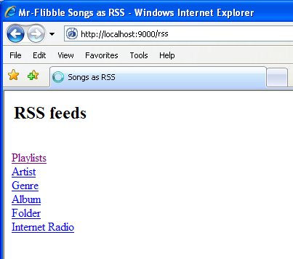

Now open the Playlists link, then on the next page open the - Last played – link. The URL/address of this page is what you require. Copy this address and then go back to the options panel and put it in the Last Played RSS Feed URL box.

This URL has the form http://localhost:9000/rss/feed/1$11$201405894.xml
The numbers seem randomly assigned, so will be unique to your server setup.

Assuming you have done everything correctly the TwonkyScrobble will then monitor this feed every 30 seconds and if the last entry changes it will extract the appropriate details, update the display and queue it to send to the last.fm/audioscrobbler server.

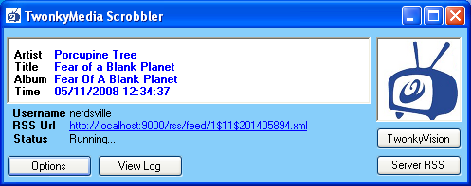

The played time of this file is used to determine if it is a new song to be submitted.

3. Notes

This program is very likely to have bugs/issues and is supplied as is.

This application was developed for my own personal use and I am making it available as a courtesy. You use completely at your own risk – no liability will be accepted for any damage or loss caused by this application.

This is a work in development and no support is available.

4. Bugs/Known Issues

The RSS feeds from the TwonkyMedia server appear to be buggy, from observation it appears the last entry in the -last played- feed appears to be correct, however there is no guarantee that it will be on your setup.

If there are problems with your feeds then I recommend you rebuild the server database.

I have assumed that the TwonkyMedia server RSS feed contains just audio files I have no idea what will happens if other files are present in the feed.

The time on the server PC must be correct as this is used to determine the status of submissions.

Certain special characters in artists/titles etc may be displayed incorrectly.

The data sent is not derived from the actual files but from the data in the RSS feed, incorrectly tagged files will produce spurious results.

