***Did the Gelmini reform improve the probability of South Italian students to enroll universities more than those in the North? Towards an exploration of geographical and socio-economic drivers in assessing the impact of the 2014 new funding scheme***

***Abstract***

*A convincing evaluation of the causal impact of the 2014 reform in Italian University funding on the probability of 18-34 Italians to enroll university requires an exogenous source of variation in the choice of enrolling tertiary education. This paper explores the exploitation in geographical difference in the level of university attainment as exogenous determinant of the choice to attend university. An analysis of repeated cross-sectional Household Surveys in 2014 and 2016 reveals that for 18-34 aged members of Italian households with residence in the Southern regions (South and Islands) the probability of enrolling university increased 6,52 percentage points more in the two years following the funding reform in respect to those with residence in the Northern regions (North-West, North-East, Center). When having residence in the South is considered as an exogenous determinant of university choice the difference in the probability increase is more than 50% bigger than the one observable by looking at a simple mean comparison between repeated LPM models. Since the literature reports that many are the endogenous factors contributing to the university choice of young Italians (Carbone et al. 2020, Biagi et al. 2011, Cattaneo et al. 2015, Pitti et al. 2011) a kernel propensity score matched difference in difference design by geographical and time dimension is needed to try to identify causally the impact of the funding scheme reform and to assess its efficacy in increasing the probability of Southern regions Italians to enroll university by making the funding scheme more competitive and less anchored to the history of the institution. The results affirm that by looking differences in the correlation between the probability of enrolling in 2014 and in 2016 with coming from a region in South is understated affirming that the reform in the fund scheme, by abandoning the historical expenses approach in determining the amount of the funding, is increasing more the probability of student of the South than of students from the North to enroll university.*

**Introduction**

The *Gelmini reform* represents the peak of an administrative initiative to improve the efficiency of the Italian higher education (Pitti et al. 2011). It was also one of the most contested reforms in the last 20 years of Italian public policy and it coincided with the after-2008 crisis periods of cuts in the public funding. The reform was announced in 2010 and then the different parts of it became laws in the following years (Carbone et al. 2020). In this paper I focus on one of the last parts of the reform that was implemented at the end of 2014 and determined a permanent shift in the funding scheme of Italian universities that was advanced with the goal to allocate more efficiently the funding among universities (Donina et al. 2020) and I attempt to assess its causal impact on the probability on enrolling university of 18-34 Italians with different socio-economic characteristics coming from different Areas of the country.

I analyze Italian ISTAT repeated cross-sectional data on Household Expenses and University enrollment in 2014 and 2016 together with MIUR longitudinal data on enrollment and graduations in Italian Universities aggregated at regional level to assess the impact of the Gelmini reform on the probability of 18-34 members of households to enroll university in different regions of Italy (ISTAT 2014, ISTAT 2016, MIUR 2020). The literature shows how in the Italian setting the probability of enrolling in university is strongly related to the geographical location of residence of the household (Pitzalis & Porcu 2015, Panichella 2009), so I exploit the difference between the impact on the South and Island regions and on the North and Center regions in effect of the *Gelmini reform* on the probability to enroll university. I use propensity score matching to obtain a repeated cross-sectional sample that contains individuals comparable in terms of observable characteristics and I integrate a non-experimental declination of the difference in difference method using time and geographical location as dimensions. I find that the resulting estimates are substantially higher than the difference between repeated LPM models in the non-matched sample, and I find no evidence against the hypothesis that geographical residence is an exogenous determinant of university choice.

The reminder of the paper proceeds as follows: in Section 1 the context is described together with the explanation of what changed in the university funding scheme after the reform; in Section 2 a short literature review on the link between socioeconomic status, geographical position and university choice that motivates the model at the back of the empirical analysis presented; in Section 3 the data are described together with the empirical estimation model and the identification strategy, in Section 4 the results are reported and discussed and then the paper concludes.

1. ***Gelmini reform* and what changed in the Italian University System**

The *Gelmini reform* represents the peak of an administrative initiative to improve the efficiency of the Italian higher education (Pitti et al. 2011). The reform was announced in 2010 and in December 2014 a change in the allocative formula of the core budget of Italian university was implemented with the aim to increase allocation efficiency. It was part of a bigger set of reforms through the primary, secondary and tertiary Italian education cycles. With the ministerial decree 815/2014 there has been a departure from the assumption that the historical expenditures imply unjustified differentiation in the unitary cost per “student”. The reform has in fact changed the allocation formula of the FFO *(Fondo di Finanziamento Ordinario*) the annual basic operational grant of Italian universities. Before the implementation the formula was based on historical expenditures to determine how much is the cost for student, while after the policy the approach was substituted with a “standard cost for student” systematic calculation of the cost for student in each university (Donina et al. 2020). Donina et al. (2020) tested if there has actually been an efficient redistribution and rebalance of the resources with the new founding formula and found that the new allocation rewarded university underfunded with the historical quota and created a concrete quasi-market and encouraged universities to make their students graduate in time. The mechanism highlighted by Donina et al. (2020) is that universities that grew in enrolment just before the introduction of the new formula have taken advantage of the reallocation because managed to graduate more students.

One of the aims of the reform was to create a more competitive environment for universities so that the public support to the offer of Higher Education could be more efficiently allocated throughout the country. And one of the main issues in terms of allocation in the setting is the fact that the literature finds how the students from the South have a higher propensity to move to study out of their region and the additional cost of moving can represent a barrier to the enrolment for the less sure high-school students and less wealthy households (Pitti et al. 2011, Boero & Laureti 2005).

Therefore, in this paper I try to leverage on the heterogeneity in the impact of the reform by looking at his impact on the South and on the North and controlling for socio-economic characteristics of the household. I use as a control two variables that should be showing the mechanism through which the reform has influenced the funding as reported by the literature. The universities with a positive growth in graduates should be benefiting from the reform, and also as reported by Donina et al. (2020) a higher number of enrolled students is a good predictor of the number of graduates in the future so I consider as controls two dummies indicating the presence of positive growth in the number of graduates and enrolled in the region aggregate from which each Household have declared residence.

1. **The interrelation between enrollment in university geography and socio-economic status**

The literature that analyzes the relationship between the geographical distribution of the higher education offer and the characteristics of the higher education demand founds different results in different countries’ contexts: Frenette (2006) in Canada finds that the likelihood of enrolling in university is decreasing together with a higher distance from the university and this effect is more pronounced for low-income individuals. While Gibbons and Vignoles (2010) in the UK find that there is no significant effect on the decision to enroll but there is on the choice among institutions. In Italy due to the regional divide in terms of economic development (Vaona & Ascari 2010) there is a difference in the regional quality of the universities (Pitti et.al 2011) that brings the probability of enrolling to be lower in the Southern regions of the country.

I exploit this difference looking at the difference between the impact in the Northern and the Southern regions after matching the sample on observable characteristics between the two years. There is no explicit treatment, all the regions have been subject to the reform, the model is similar to a difference in differences implemented with non-experimental data thanks to propensity score matching and the two dimensions are one the time dimension and the second the geographical dimension that works an indicator of the treatment intensity. The idea at the core of the empirical strategy is that by switching to a funding scheme that benefited the more performative universities instead of those with a longer history the institutions in the South should have relative advantage because there is a lower number of historical universities in the South and therefore more room of improvement to benefit from the fund.

The identification strategy aimed to reduce endogeneity in the university choice model is relying on the parallel trend assumption (Angrist & Pischke 2008). Looking at EU-NUTS 3 level longitudinal data from 2000 to 2020 is possible to observe how Southern regions have had a parallel trend to the Northern ones in the past 20 years, they are just moving on different levels as it shown in Figure 1.

***Figure 1: Roughly parallel trends but different levels in enrollment in tertiary education in Southern and Northen regions of Italy***

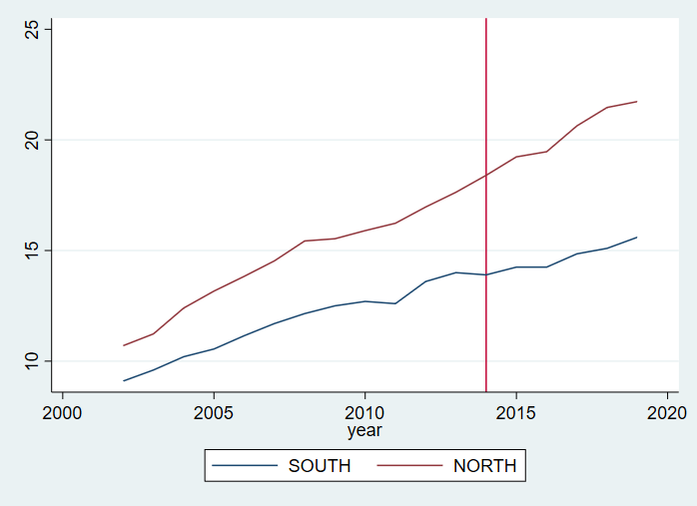

*Notes: North Average is the sum of the North-East, North-West and Center divided by three while the South average is the sum of Southern regions and Islands divided by two. Data are longitudinal at Area level taken from the Eurostat database sub-country NUTS 3 tertiary education attainment rate in the 18-64 population.*

In Figure 1 above it is observable how there was some small deviations from the trend, especially in 2008 for the North and in 2011 for the South, in the past but the two lines before 2014 are following a roughly parallel path. The small peaks in the past are reporting that is not the first time that the two zones react differently to reforms, but those deviations are always temporary and the line seems, before 2016, to always come back to the parallel trend. Part of the side goals of this paper is to analyze if the change in the funding scheme have changed the past propensity to come back to the trend more deeply than past reforms.

1. **Data, Model and Identification Strategy**

I measure the enrolment in university as the presence of expenses related to attending university in the Household Survey in 2014 and 2016, this can be done because even if a student is attending HE thanks to a scholarship there is anyway the need to pay the administrative enrollment tax that will appear in the survey. The fact that the household had an expense related to university in either 2014 or 2016 makes the dummy for pooled enrolment be 1. This variable is the outcome variable of the university choice model that I’m estimating.

I first estimate a simple Linear Probability Model to look at the correlation between the socio-economic characteristics and the geographical residence of the Households and their university choice before and after the funding reform using the following model:

(1)

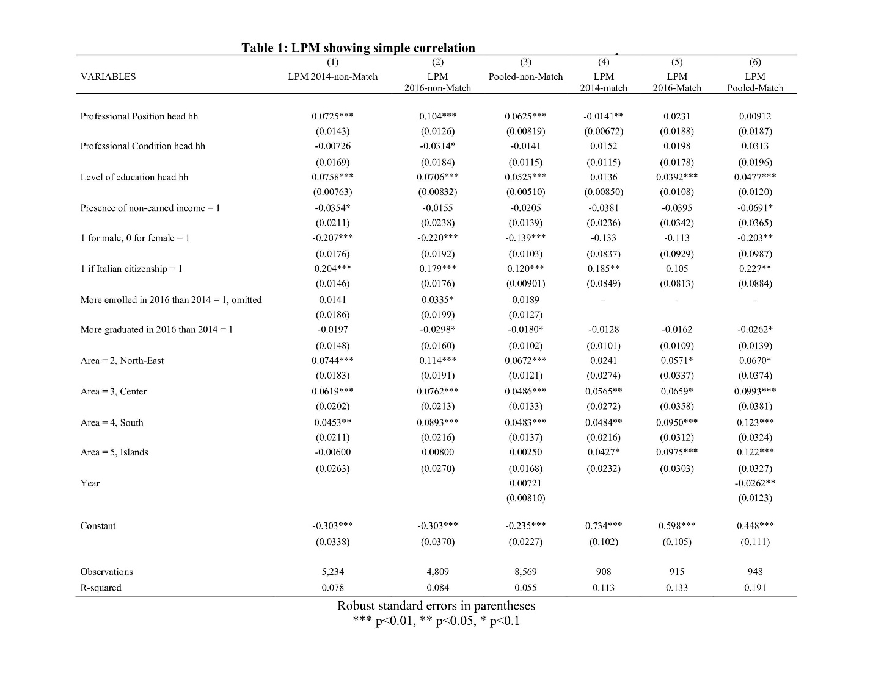

*Notes: the More enrolled and more graduated controls are assigned on the basis of the region of residence, those are regional level aggregate dummies. The control More enrolled in 2016 is omitted for the matched sample because of collinearity. While the control Year is added only in the Pooled version. The presence of non-earned income is a dummy indicating if the head of the household is declaring any non-earned income in the Istat surveys. The control for the Professional Position is accounting for the professional category (eg. entrepreneur, service employee, white collar employee) while the Professional Condition is accounting for the role that the head of the household covers inside of his work place (eg. CE0, manager, Assistant).*

I observe that looking at simple correlation it is visible how being from a Southern region is correlated in the 2014 sample with a 4.53 % higher probability of enrolling with reference to the North-west Area baseline category, a 2,91% lower probability of enrolling university in respect to the Households with residence in the North East and 1,66% lower in respect to the Center at baseline. In the 2016 sample correlation results is visible how there is a positive increase both for the Islands coefficient, that change in sign but do not gain significance, and for the Southern Area coefficient that grows in magnitude and gains significance. The coefficient for North-East increase of 3.96% while the one of South increased if 4.4% so the raw difference in the increase is of 0.44 percentage points. The same direction in the correlation can be seen also in a simple mean comparison with aggregated areas as in Table 2 where North is aggregating North-east, North-west, and Center while South is aggregating Southern regions and Islands.

**Table 2: Mean comparison for Northern and Southern regions in 2014 and in 2016**

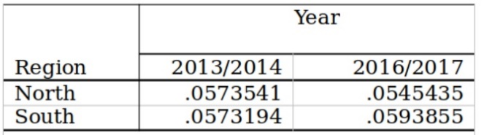

Then I use the user written STATA command *diff* to use propensity score matching in a setting that resemble a difference in difference design (Villa, Juan M., (2012) estimating equation (2).

(2)

Where the outcome variable is the enrolment in university and is a vector of covariates that are being balanced in the matching process based on the propensity score and it contains in the preferred specification: the sex, the Italian citizenship, the level of education of the head of the household, the professional condition and position of the head of the household, the presence of non-earned income, the year and the fact that in the region of residence there were more graduated and enrolled students in 2016 than in 2014. The propensity score algorithm divides the sample in 8 blocks because this number of blocks ensures that the mean propensity score is not different for treated and controls in each block and says that the balancing property is satisfied.

The propensity score matching is ensuring that the two surveys, from 2014 and 2016, are comparable in terms of observable characteristics in predicting the “treatment” of coming from the South. This is needed because the data I’m using are not panel data following the households in time, but instead a repeated cross-section that is not automatically balanced as is shown in Table 3, where in Panel A is reported the t-test of balance for the covariates in respect to the time dimension and in Panel B in respect to the geographical dimension. In this way I ensure also that the South and the North groups are comparable in terms of covariates.

From Table 3 Panel A it is visible how the citizenship, the professional position of the head of the households and his level of education are not balances between the samples in the two different years in the non-matched sample. While in Panel B it is observable that all the covariates beside the year are significantly unbalances between observations in South and in North.

Recognizing the need to balance the sample in both dimensions I use the computed propensity score to match the two groups and I keep only the matched observations. After doing it I’m left with 939 observations, before I had 5.134 observations.

In Table 4 is reported the t-test of equal variances on the matched sample and it is visible that there is a significant increase in the balance of the covariates in both dimensions.

**Table 3: T-test of covariates by Geographical and Time dimensions before matching** 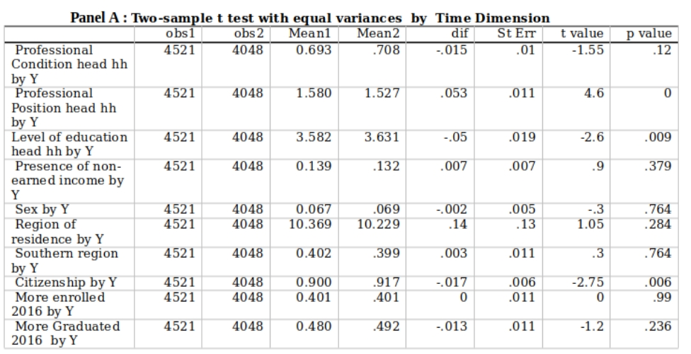

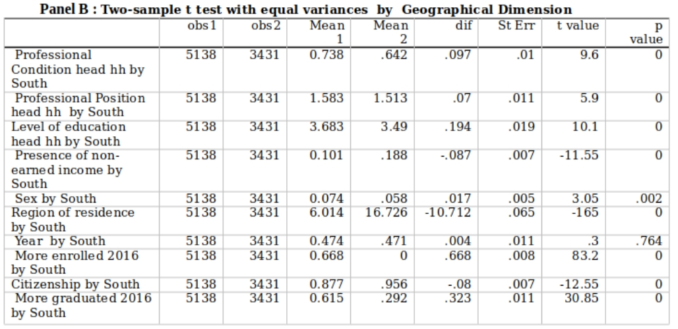

To estimate (2) I use a Kernel Matching estimator that matches all treated subjects with a weighted average of all controls using weights that are inversely proportional to the distance between the propensity scores of the “treated” and the “control” groups. Then I implement a difference in difference design both in the non-matched and in the matched sample, using a propensity score calculated in each sample (one for the big sample and one for the small matched one). The *diff* command as the LPM estimation for (1) has run using White-Robust standard errors allowing for heteroskedasticity (Zeileis 2004). Alternative specifications with clustered standard errors(not reported in the paper) at region times level of propensity score have been explored in the analysis but without finding significant results. The idea beyond trying to cluster at this level was to obtain enough clusters by using the interaction that was supposed to be meaningful because the error might vary in a similar way within groups of people with the same estimated propensity score in each region (Abadie et al. 2017). Furthermore, in estimating (2) the command used allows for a repeated cross-section setting and this option is specified. It is also specified the logit option so that it is estimating a non-linear probability model imposing a logistic distribution of the error term. The results are not directly interpretable in Table 5 margins are reported and interpretable in terms of probability

**Table 4: T-test of covariates balance in the matched sample**

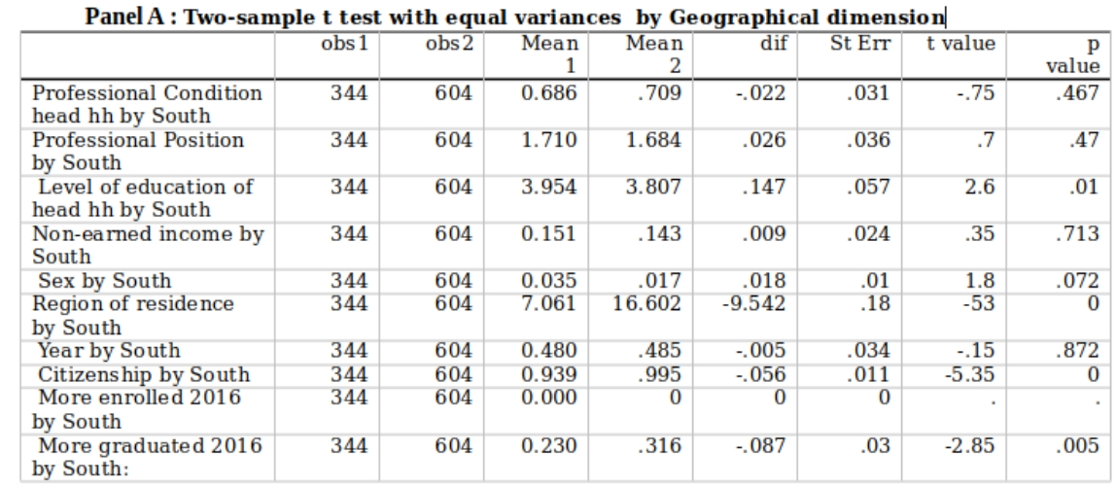

1. **Results and Discussion:**

The main results of the estimation of (2) are reported in Table 5 below for both the non-matched and the matched sample. The estimation shows how all grows in magnitude and significance when estimating (2) on the smaller but matched sample. This is coherent with the fact that even if reducing the size of the sample determines a loss in terms of statistical power, having a matched sample means that more of the variance in the probability of enrolling can be explained by the terms specified in the model because the data are more comparable both between years and between groups. The diff-in-diff estimate is marginally significant at a 90% CI in the matched sample indicating that coming from the South is determining a 6.52 percentage points larger increase that coming from the North between 2014 and 2016 in the probability of enrolling university. The results in the matched sample are t-tested as reported in Table 6 showing that the test is rejecting the null hypothesis that the results are not significantly different from 0.

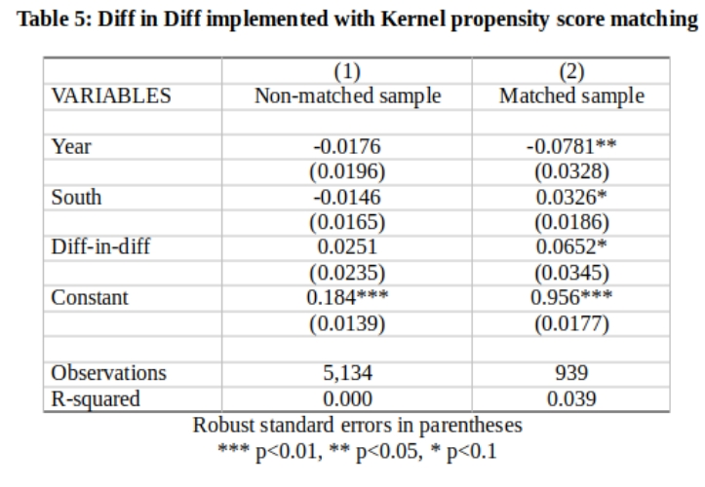

The results are in line with the policy goal of improving student allocation; the funding reform seems to have improved more the probability of enrolling in universities of the group that was on a lower level (Miller et al. 2021). What is not clear is through which mechanism this is happening. In the regression the controls for having more enrolled and or in 2016 than in 2014 are included following the findings of Donina et al. (2020) that show how having more enrolled and graduates brings to a bigger share of the funds allocation with the new scheme encouraging more meritocracy in the distribution (Miller et al. 2021). But how it is also visible in Table 1 that those keep being insignificant also when the model is estimated on the matched sample. One of the potential, although in anyway exclusive, explanation for these results is that by financing more the universities that grew in those years Southern universities are better financed and therefore more students that wouldn’t had be able to attend if there was the need to sustain a relocation cost (Pitti et al. 2011, Scalera & Vecchione 2020) facing a better quality of the Southern universities. Looking at the comparison between columns 1-3 and columns 4-6 in Table 1 we see that in terms of raw correlation the coefficient for the professional condition is loosing significance one the sample is matched indicating that the estimate was driven by the covariate imbalance between the 2014 and the 2016 sample. In Table 5 only the main coefficients estimates are reported and the Diff-in diff coefficient is the only one that the estimation strategy is trying to identify causally.

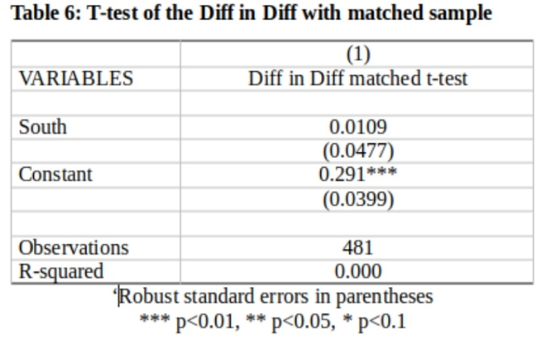

*Notes: The balancing test is obtained only at the baseline and by using the kernel option STATA is weighting the covariates and obtaining the differences by using a linear regression.*

**Conclusion**

Many are the endogenous factors in determining the decision to enroll university of Italian 18-34 Households members (Cattaneo et al. 2015). Those are confounding the estimate of a simple Linear Probability Model estimating the drivers of the University choice in 2014 and in 2016 as reported in Table 1 columns 1-3. But applying a kernel propensity score matched diff-in diff as reported in Table 5 by leveraging on the assumption that there is a difference in levels but not in the slope of the enrolment to university trend in the South and in the North of the country is possible to identify a 6.52 percentage points stronger average effect for HHs members coming from the South. Hence these findings are confirming that if the policy by giving less comparative advantage to older universities, placed mostly in the North-Center have increased significantly more the probability of enrolling students from the South in the short run. The identification strategy is relying on the parallel trend assumption and the fact that the Southern regions reacted differently to the Northern ones to reforms in the past together with the dualism that characterize the country from a socio-economic point of view are both the reasons at the back of the empirical strategy and the main treat to causal identification. In this paper propensity score matching is used to reduce the heterogeneity , at least in the observables, to one dimension and tackle the treat. In conclusion, with richer data a more accurate estimate could be obtained controlling for ability of the young Italians for example or controlling for the type of high-school attended (Chapman 1981, Chapman 1979), otherwise all this factors are confounding the simple LPM correlation and are controlled for the in diff in diff only if the assumptions holds.

**References:**

Abadie A., Athey S. Imbens W.G., Wooldridge J.,(2017),When Should You Adjust Standard Errors for Clustering?, *National Bureau of Economic Research Working Paper Series, No. 24003, November 2017*

Angrist, J.D., & Pischke, J. (2008). *Mostly Harmless Econometrics*: *An Empiricist's Companion*, Cap.4, Princeton: Princeton University Press

Biagi B. ,Faggian A., McCann P. (2011) Long and Short Distance Migration in Italy: The Role of Economic, Social and Environmental Characteristics, *Spatial Economic Analysis, 6:1, 111-131*

Boero G. & Laureti T.& Naylor R. (2005), "An econometric analysis of student withdrawal and progression in post-reform Italian Universities *,"Working Paper CRENoS 200504, Centre for North South Economic Research, University of Cagliari and Sassari, Sardinia*

Cattaneo M., Malighetti M., Meoli M., Paleari S., (2015) “The dynamics of university competition for students in Italy”, *Working paper*

Carbone D., (2020), Dieci anni dopo. Come è cambiato il sistema universitario italiano con la riforma Gelmini, *Working Paper, Dipartimento di Giurisprudenza Scienze Politiche Economiche e Sociali, Università del Piemonte Orientale*

Chapman W. D., A Model of Student College Choice, *The Journal of Higher Education , Sep. - Oct., 1981, Vol. 52, No. 5 (Sep. - Oct., 1981), pp. 490-50*

Chapman, D. W., and R. H. Johnson. (1979), Influences on Students' College Choice: A Case Study. Ann Arbor, *Mich.: Project CHOICE, School of Education, University of Michigan*

Donina et al. (2020), The standard cost reform in Italy Redistribution and rebalance in higher education funding*, Working Paper*

Eurostat (2021), Students enrolled in tertiary education by education level, program orientation, sex and NUTS2 regions*, Data source, EDUC_UOE_ENRT06*

Gibbons S., Vignoles A., (2012), Geography, choice and participation in higher education in England, [Regional Science and Urban Economics,](https://www.sciencedirect.com/journal/regional-science-and-urban-economics)[*Volume 42, Issues 1–2*](https://www.sciencedirect.com/journal/regional-science-and-urban-economics/vol/42/issue/1)*, January 2012, Pages 98-113*

Lee J.,Little D.T. (2017), A practical guide to propensity score analysis for applied clinical research*, Behaviour Research and Therapy, Volume 98, Pages 76-90*

Istat. (2016) Household Budget Survey*, UniData, Bicocca Data Archive, Milan, Study Number SN185, Data file version 1.0*

Istat. (2014) Household Budget Survey*, UniData, Bicocca Data Archive, Milan, Study Number SN162, Data file version 1.0*

Kristel Miller, James Cunningham, Erik Lehmann. (2021) [Extending the university mission and business model: influences and implications](https://www.tandfonline.com/doi/abs/10.1080/03075079.2021.1896799), *Studies in Higher Education 46:5, pages 915-925.*

MIUR (2020) Enrolled by institution*, Longitudinal data sample from Open Data resources*

MIUR (2020) Graduated by institution*, Longitudinal data sample from Open Data resources*

Panichella, N. (2009). La mobilità territoriale dei laureati meridionali: vincoli, strategie e opportunità, *Polis, 2, 221-246*.

Pitti G., V. Pipitone, Fulantelli G., Allegra M., (2011) The University Choice in Italy: Differences between North and South, *in "Rivista economica del Mezzogiorno, Trimestrale*

Pitzalis M., Porcu M. (2015). Northern Passage. How Can the Italian University field be restructured?, *Analisi e Punti di vista, Scuola Democratica 3/2015*

Scalera D., Vecchione, G., (2020), Does skilled migration reduce investment in human capital? An investigation on educational choices in Italian regions (2001–2016), *Vol 71 , Metroeconomica*

Villa, Juan M., (2012), "[Simplifying the estimation of difference in differences treatment effects with Stata](https://ideas.repec.org/p/pra/mprapa/43943.html)*,"*[*MPRA Paper*](https://ideas.repec.org/s/pra/mprapa.html)*43943, University Library of Munich, Germany*.

Weldegebriel, Zerihun. (2016). Social Protection and Vulnerability to Climate Shocks: a Panel Data Evidence from Rural Ethiopia. Ethiopian Journal of Social Sciences and Humanities. 12. 99-137

Zeileis A (2004). “Econometric Computing with HC and HAC Covariance Matrix Estimators.” Journal of Statistical Software, 11(10*), 1-17*