- General Information on Dataset:

- Dataset Name: Food 101

- Classes selected: Pizza, Hamburger, Fried Rice, Ice Cream, and Sushi (5 in total)

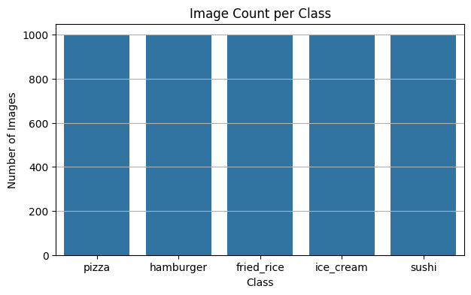
- Total number of samples is 5000 (1000 per class)

- The images size is 224x224 with batch size 32 and normalized using MobileNetV2 preprocessing

- Training: 70% = 3500 images

- Validation: 15% = 750 images

- Testing: 15% = 750 images
- Implementation Details:

- Feature Extraction Phase:
      - Used MobileNetV2 pretrained on ImageNet as a fixed feature extractor and removes top layers include_top=false and used average pooling
      - Number of features = 1280 per images due to average pooling
      - The dimension of resulting features is a vector of shape (1280,) per image so train = (3500,1280) and Validation = Test = (750,1280)
      - StandardScaler is used for normalization and fit on training set and applied on validation and test

- Model-Specific:

Logistic:

Hyperparameters:
max_iter=2000, C=10, solver=”saga”, multi_class=”multinomial”

K-Means:

Hyperparameters:
n_clusters=6, n_init=10, random_state=42
Cross-Validation:
No Cross-Validation is used because dataset is split into fixed train, validation and testing sets

- Results details:
Logistic:
Loss:
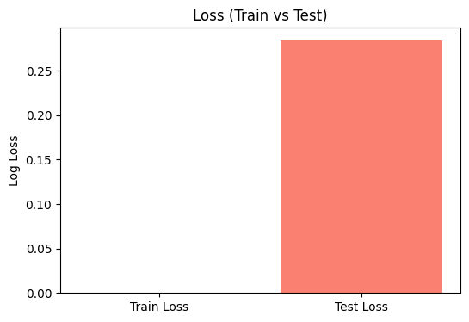

Confusion Matrix:
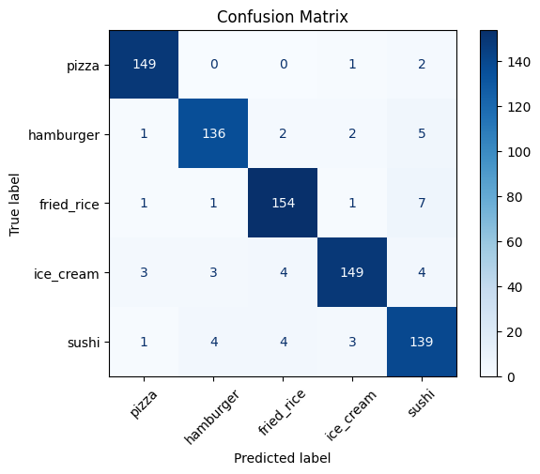

ROC Curve:
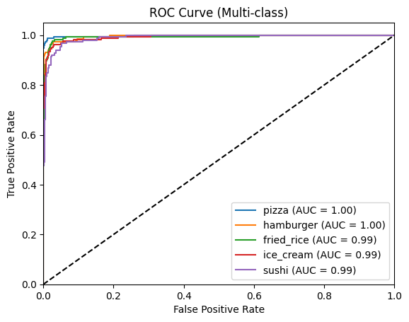

Accuracy:
Classification Report
 | Precision | Recall | F1-score | Support
Pizza | 0.96 | 0.98 | 0.97 | 152
Hamburger | 0.94 | 0.93 | 0.94 | 146
Fried Rice | 0.94 | 0.94 | 0.94 | 164
Ice Cream | 0.96 | 0.91 | 0.93 | 163
Sushi | 0.89 | 0.92 | 0.90 | 151
Accuracy |  |  | 0.94 | 776
Macro Avg | 0.94 | 0.94 | 0.94 | 776
Weighted Avg | 0.94 | 0.94 | 0.94 | 776
Train Accuracy | 100.00%
Test Accuracy | 93.69%

K-Means:
Loss:
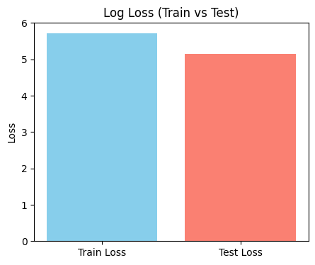

Confusion Matrix:
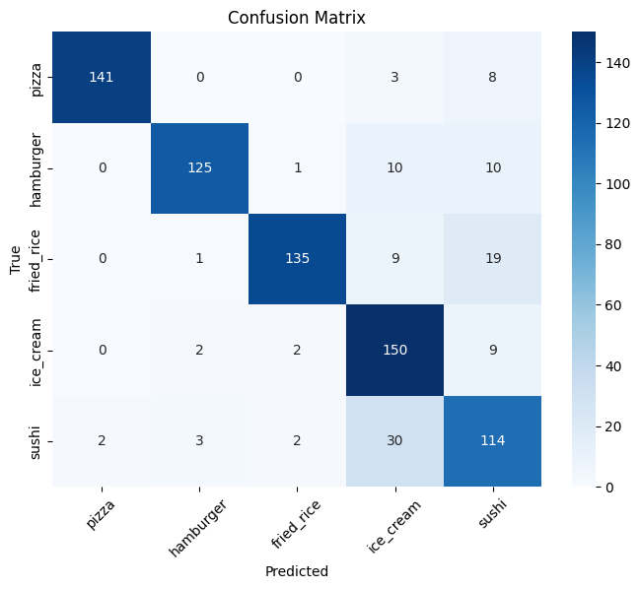

ROC Curve:
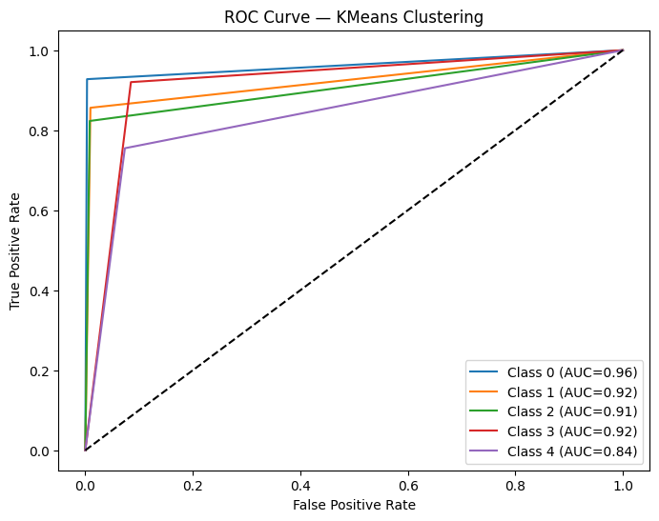

K-Means Clusters:
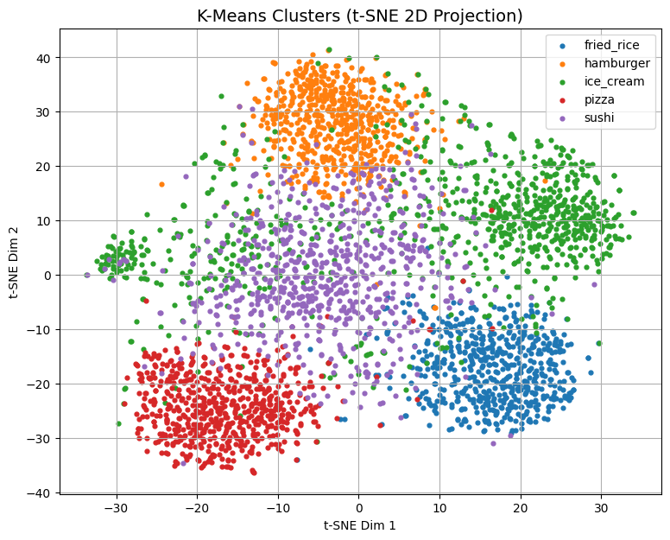

Accuracy:
Classification Report
 | Precision | Recall | F1-score | Support
Pizza | 0.99 | 0.93 | 0.96 | 152
Hamburger | 0.95 | 0.86 | 0.90 | 146
Fried Rice | 0.96 | 0.82 | 0.89 | 164
Ice Cream | 0.74 | 0.92 | 0.82 | 163
Sushi | 0.71 | 0.75 | 0.73 | 151
Accuracy |  |  | 0.86 | 776
Macro Avg | 0.87 | 0.86 | 0.86 | 776
Weighted Avg | 0.87 | 0.86 | 0.86 | 776
Train Accuracy | 84.15%
Test Accuracy | 85.70%

